Web Design document
Jasper Cox – SOFT166 WEB DEV
Web design document

Wireframes

Home Page
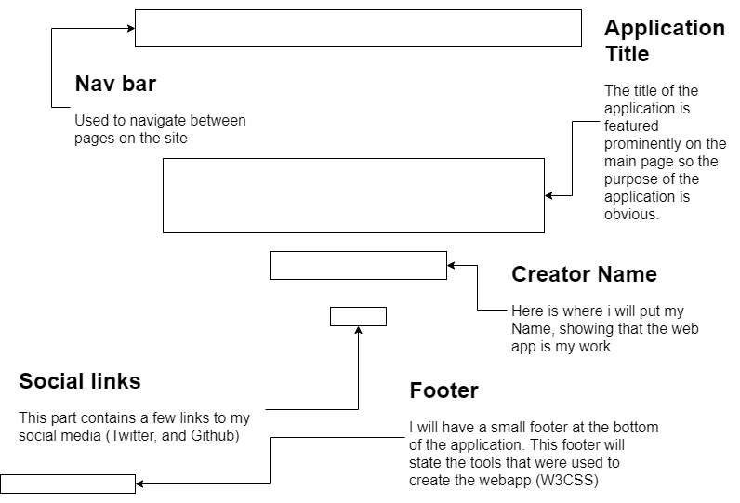

About Page
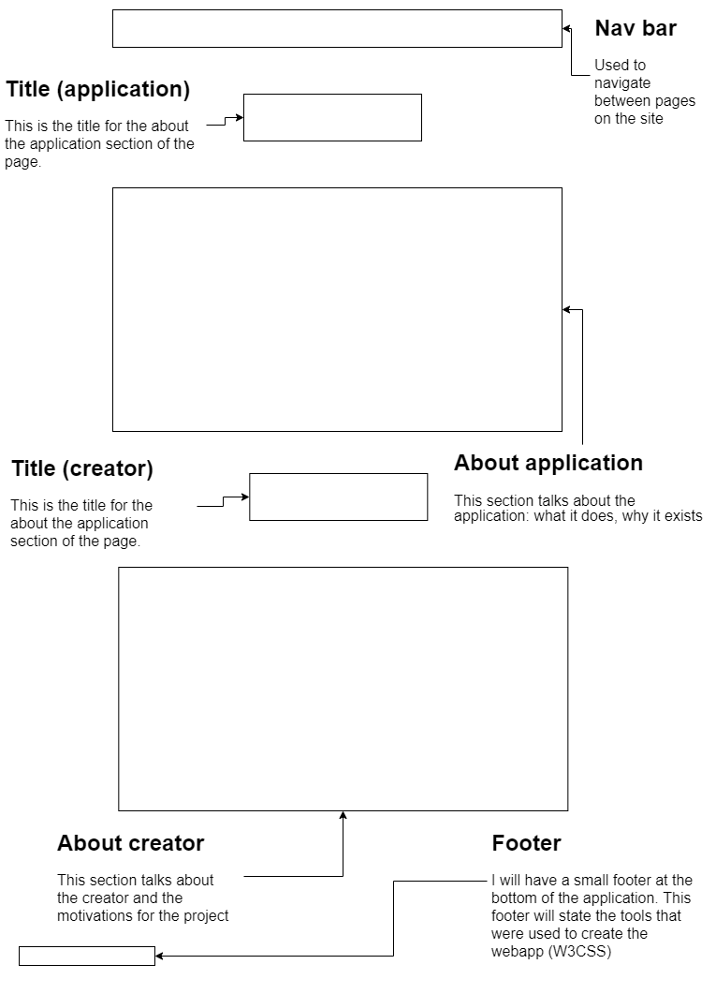

Application Page

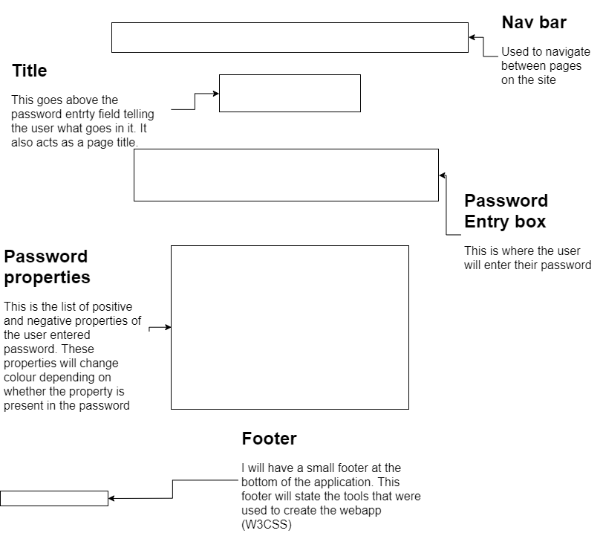

Key Page
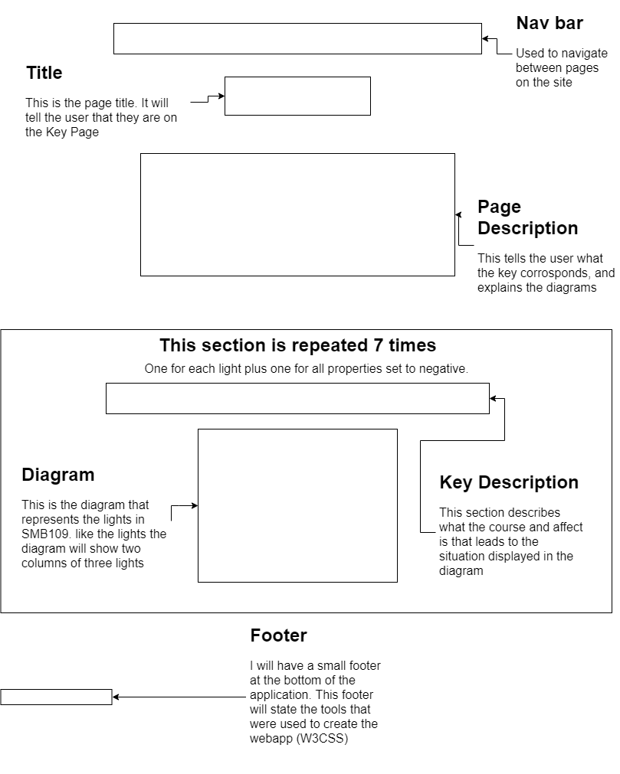

Wireframe feedback:

The main feedback I got for my wireframes was that on the Application page there is no way to clear the password. This is not much of a problem on desktop as it is easy to “ctrl-A, backspace”, but on mobile clearing a password is difficult. To counteract this issue I have added a clear screen button to the design. (figure 1) .

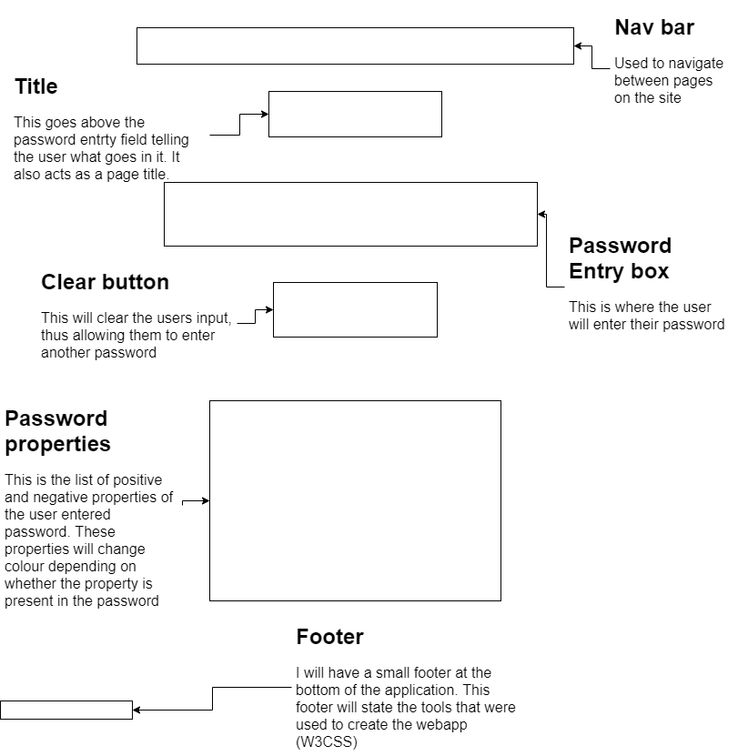Figure 1

Site feedback

It was pointed out to me that the key page made very poor use of space, as there is a single column of both diagram and image (Figure 2). I agree with that point and have decided to follow the person in questions suggestion by separating the column into a grid. This grid would have to be able to adapt to smaller screens (become a single column again)

I achieved this using the “w3-third” class which allowed me to position three divisions next to each other when there was space, and automatically place them one on top of the other, when there was not. This is shown in figure 3.

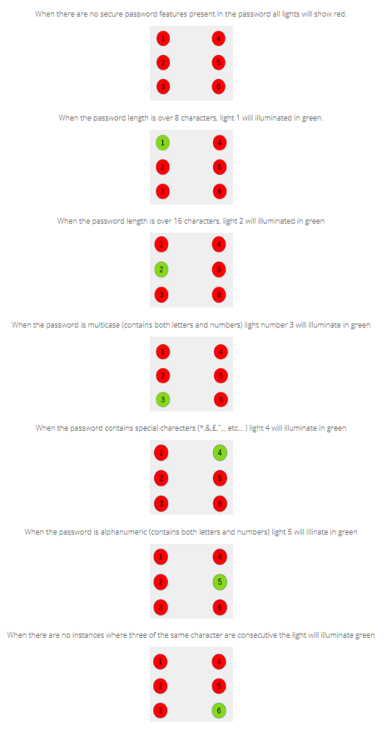Figure 2
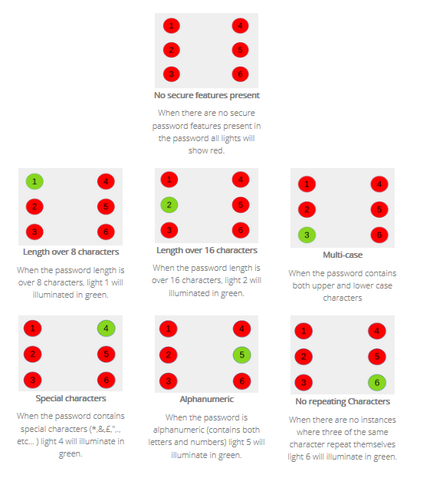Figure 3

Sitemap

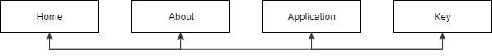
I have chosen to use a navigation bar as the sole method of navigating the website. This navigation bar is available on all pages which means that each page is capable of directing the user to any other page. I have done this as it makes navigating the site quicker and less frustrating for the user. An alternative method I could have used is to only have a navigation bar on the home page, and have every page have a back button. I did not choose that deign as I found it annoying having to go to the home page every time I had to go to another page. Having a single navigation bar across all four pages allowed me to maintain the three click rule.

Image documentation

Images used in key:

I have used seven total images on my site. All of these images are in the Key page. The images are used as a visual representation of which lights (in SMB109) will be lit in which colour. All of the images used in this web-app were created by me using LibreOffice draw.
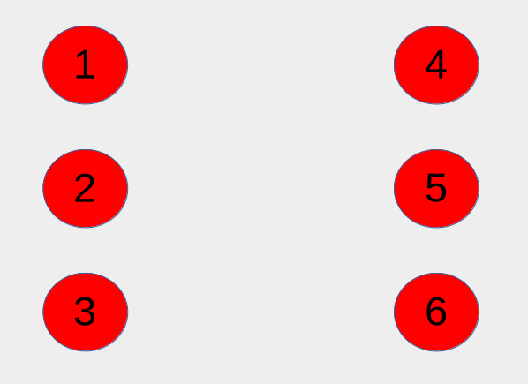
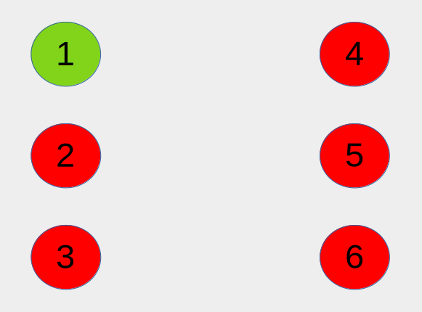
This image is used to show that when there are none of the six password features present in the password that the user entered into the site; all the lights are set to red.
This image is used to show that when the users password is over 8 characters in length the first (top left) light will illuminate.
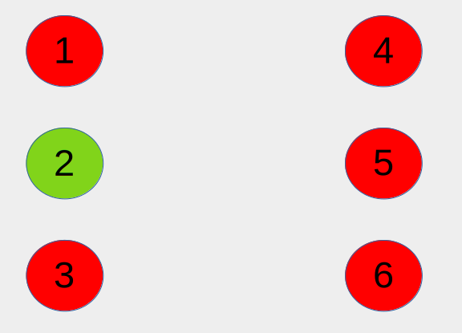
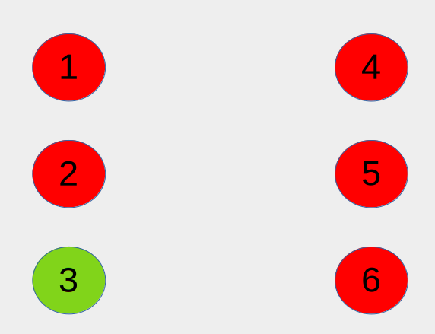
This image is used to show that when the users password is over 16 characters long the third (middle left) will illuminate.
This image is used to show that when the user enters a password which is multi-case (both upper and lower case characters) the third (bottom left) light will illuminate
This image is used to show that when the user enters a password which contains a special character (*,&,£,",., etc... ) light four (top right) will illuminate
This image is used to show that when the user enters a password which is alphanumeric (contains both numbers and letters) the fifth (middle right) will illuminate.
This image is used to show that when the user enters a password which contains no repeating characters the sixth (bottom right) light will illuminate in green.

Web Accessbility Initiative (WAI)

feedback acquired from the Demo session

URL’s

Trello:https://trello.com/b/Zs2Zzbjb/soft166-website
Github: https://github.com/Jasper-27/Soft166Assignment

