The Titanic dataset is a popular dataset for learning and testing data science techniques. In this project, the provided data was used to train a model that predicts whether or not a given passenger will survive the sinking of the Titanic. The primary goal of this project was to create an effective model to do this. To do this, the data was pre-processed, a classification algorithm known as XGBoost was trained and then fit to the test data, and the results were evaluated. The algorithm ended with an F₁ score of roughly 0.8, indicating good precision and recall, meaning the model predicts whether a passenger will survive or not fairly accurately.

The data was sourced from Kaggle, a website that hosts many toy datasets for testing purposes (Adegoke, 2023). The Titanic dataset can be downloaded as a CSV file. In order to work with the data and create the model, this CSV was opened in a Jupyter notebook as a Pandas dataframe. Pandas is a common library for manipulating tables in Python due to its flexibility and ease of use, which is why it was selected here (Koshti, 2024). Jupyter notebooks allow for smaller sections of code to be run independently, making testing and iterating easy (Pryke, 2025). Scikit-learn was the other primary library used, as it provides helpful functions for everything from data pre-processing to model evaluation (Kaul, 2024).

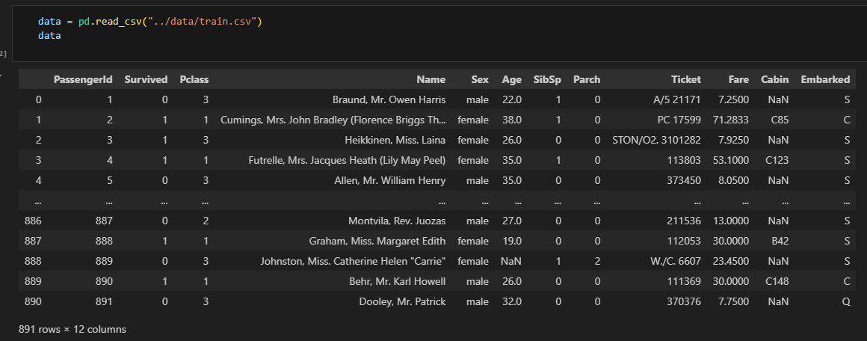
Figure 11 – Loading the CSV data as a dataframe

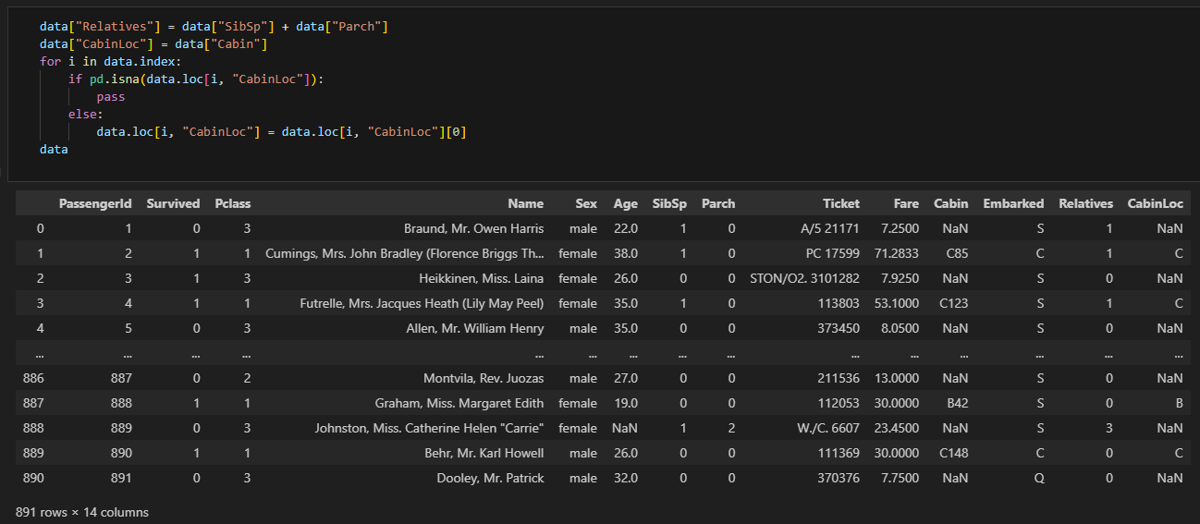
Figure 12 – Creating the Relatives and CabinLoc columns

As mentioned previously, the data was first imported into Python from a CSV using Pandas, which automatically formats the CSV into a dataframe, a Python object much like a table as shown in figure 11. Two new columns were created, the first being a ‘Relatives’ column that combined the ‘SibSp’ and ‘Parch’ columns, seen in figure 12. SibSp is a count of the number of siblings or spouses a passenger had aboard the Titanic, and Parch is a count of the number of parents or children similarly. These were combined into one to perform manual feature selection. The more columns a dataset has, the more irrelevant data will be contained in the dataset that the model will try and account for, so if a dataset has too many columns it will be less accurate than if it only had the most useful features (Salih, 2023). For this reason, feature selection is an important part of modelling. The other column that was created was called ‘CabinLoc’, and was based on the ‘Cabin’ column. The Cabin column contained the room number of the passenger with a letter signifying a category, but these values are different for most customers, so don’t provide much new information. The category letter might be more useful however, as it could mean the deck the cabin was located on, and therefore distance from lifeboats, or it might be linked to the class of the passenger, both of which could influence survival rate. The CabinLoc column extracts just the letter from the Cabin column so it can be used instead, providing more relevant information to the model. One potential improvement to this project would be to try and extract a more useful column from the Name column, such as the title of the passenger, which could allow analysis such as whether marriage status impacted the survival odds of female passengers.

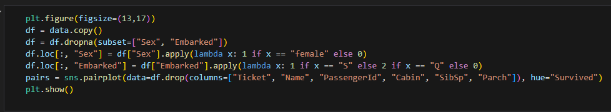
Figure 13 – Visualisation pre-processing

Different pre-processing was performed on the data for the visualisation and the modelling. A set of graphs were created to visualise the correlation between the features, as well as show how they link to survival rate, shown in figure 14, with the pre-processing in figure 13. For this, rows containing null values in the Sex or Embarked columns were dropped as there weren’t many so the graphs wouldn’t change much without their inclusion. Values remaining in these columns were converted from string categories to numerical categories so they could be rendered on the graph. Finally, a number of columns were dropped, as they wouldn’t be used in the modelling so weren’t relevant to check.

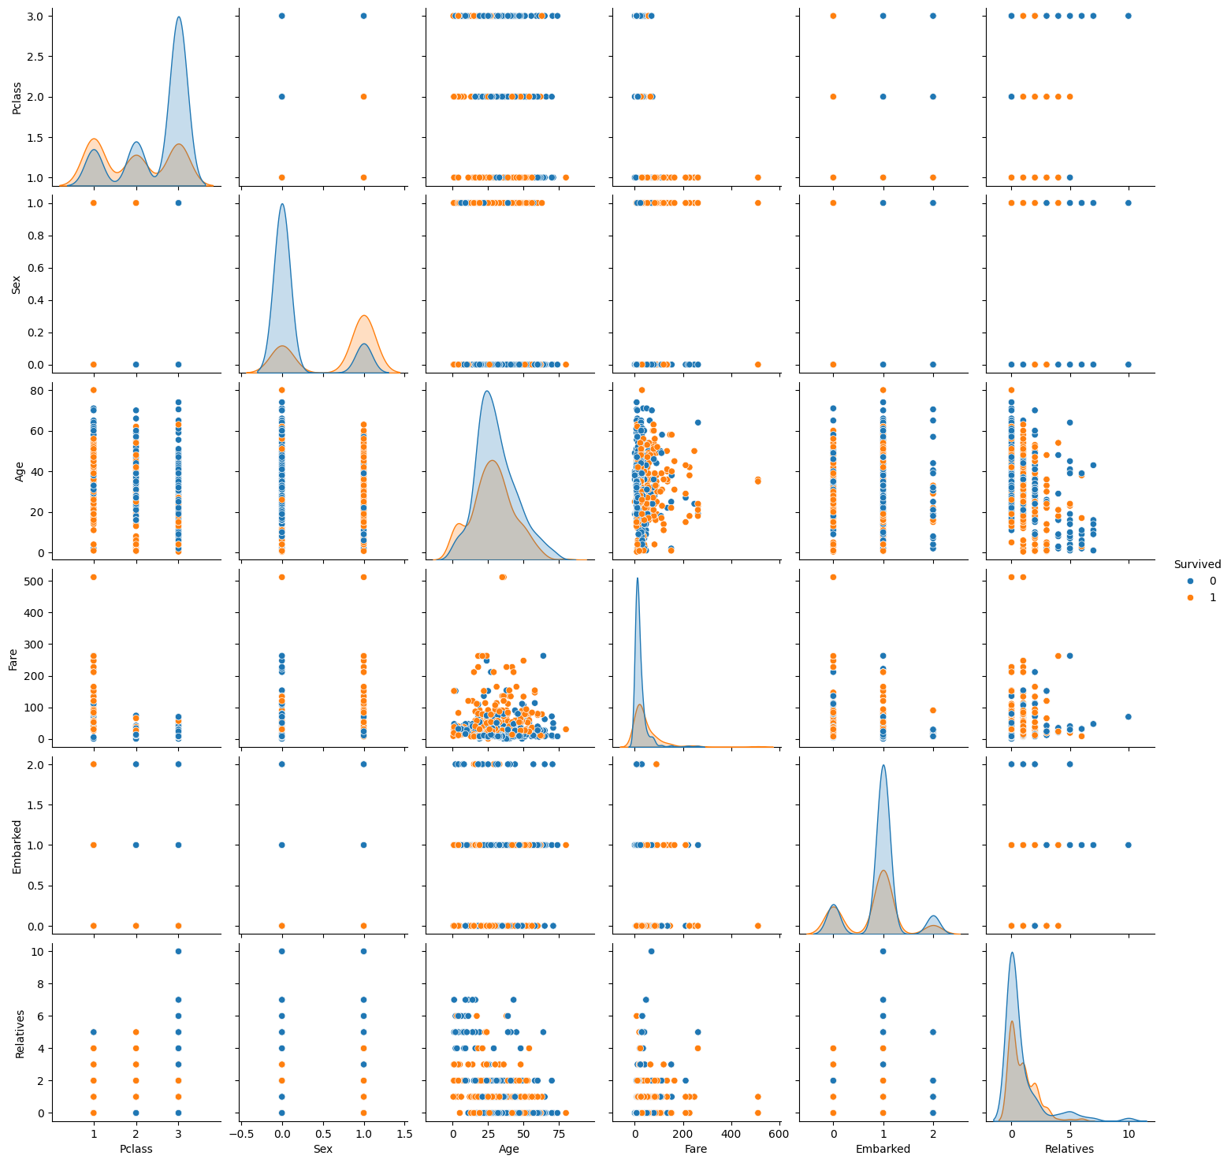
Figure 14 – Visualisation results

The graph itself had a plot for each pair of remaining features, arranged in a grid. Mismatched features have a scatter plot to show the correlation between the features (Yi, 2025), and the points are coloured based on whether the passenger survived. For the graphs where the same feature was the x and y axis, the graph is a layered kernel density estimate, estimating the probability density of passengers who survived and who didn’t separately (Drapala, 2023). For example, the top left graph showing the kernel density estimate of the Pclass feature, meaning the ticket class, shows that holders of 1st class tickets were more likely to survive than not, but holders of 3rd class tickets were much more likely to die. There are few features that show significant correlation, which is good as it means they all provide unique information for the model – if two correlated strongly, it would likely be beneficial to remove one of them (Unhale, 2021).

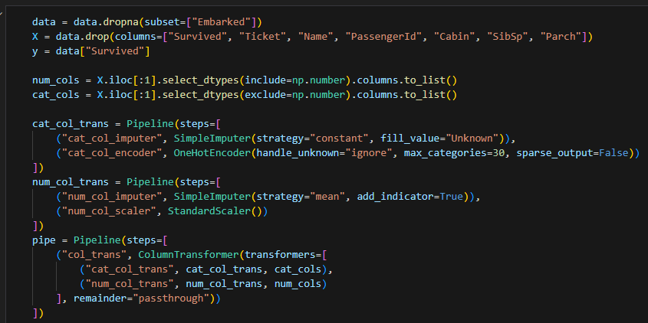
Figure 15 – Modelling pre-processing

For the modelling, different pre-processing was done, seen in figure 15. First, rows containing null values in the Embarked were dropped, as there were only a couple so it’s not worth training the model to account for them. Next, all columns that weren’t being used for training were dropped. These mostly included columns with high cardinality (Pawar, 2025), as described with the Cabin column previously, such as Name or Ticket. Additionally, the columns that the newly created columns replaced were dropped. This was done as part of splitting the data into the features and the target for training. The numerical and categorical columns were identified to be pre-processed separately. The categorical columns had any missing values imputed with a new category, ‘Unknown’, in case they still provided helpful information. They were then encoded using one-hot encoding, as the model can only take numerical features as input, so categorical columns must be encoded to make them numerical (Brownlee, 2020). One-hot encoding is a common and simple method to do this. The numerical columns had any missing values imputed with the mean of the column.

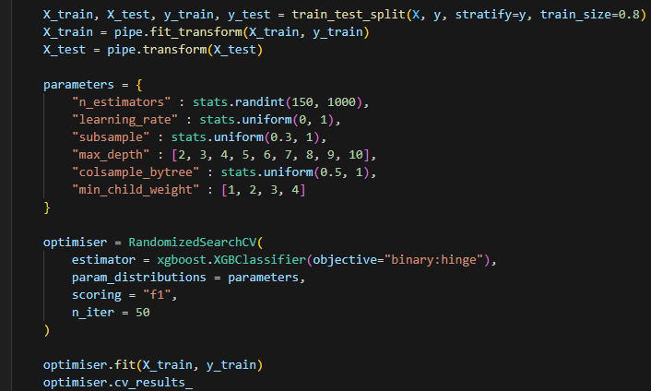
Figure 16 – Hyperparameter optimisation

For the modelling itself, first the hyperparameters were optimised using a randomised search of a given space, shown in figure 16. Several distributions were set for the parameters being optimised, using ranges of common values (Gupta, 2021), then a function was used to randomly select from the options and test the result with the classifier. The metric for evaluation used in this project was the F₁ score, which is the harmonic mean of the precision and recall. The precision is the proportion of true positives from all marked positives and the recall is the proportion of true positives from all real positives. The F₁ score ranges between 0 and 1, with 1 being perfect precision and recall and 0 meaning at least one of the precision and recall was 0 (Sasaki, 2007). The objective of the classifier was always set to binary hinge, meaning it predicts either 0 or 1, in this case meaning died or survived respectively. The classifier used was an XGBoost classifier, which is fundamentally a decision tree algorithm. It creates a set of rules to split the data into sections, picking the optimal possible split at each branch, to split the data into passengers it predicts survived and passengers it predicts died (James et al., 2023). 50 iterations of random parameters were tested, and the best set selected to use to fit the model. Finally, to assess the results, the trained model was used on the reserved test set, and the F₁ score calculated on the predictions to evaluate the model. This resulted in a final score of 0.8, which is fairly high (close to 1), shown in figure 17. This implies that this classifier, these pre-processing steps, and the optimised parameters are useful for predicting whether or not a passenger survived the Titanic sinking. A potential improvement to this project would be testing more algorithms to select the most effective one, rather than just using one that is theoretically suited to it without comparison.

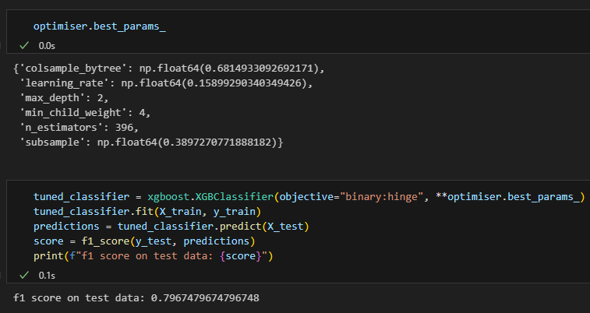
Figure 17 – Modelling results

There are few ethical and legal obligations for this project. The Titanic sinking is a well-known and studied historical disaster (Tikkanen, 2025), no passengers are alive today (Pearse, 2009), and no potentially sensitive information is stored about them. The data is publicly available, and the results of the analysis are only being stored privately, as well as also not containing any sensitive information. Some bias may have occurred with certain features containing more missing data than others, but as this is historical data about a specific event (meaning additional data cannot be collected), ignoring or imputing the values are the only options to mitigate this.

In conclusion, this project successfully used techniques such as data cleaning, feature selection, and optimisation, to create an effective machine learning model to predict whether a passenger would survive the sinking of the Titanic. The high F₁ score demonstrates this, but the project could be improved by trying alternative algorithms and extracting a more useful column from the Name feature.

Bibliography

Pryke, B. (2025). How to Use Jupyter Notebook: A Beginner’s Tutorial. Available at: https://www.dataquest.io/blog/jupyter-notebook-tutorial/ (Accessed: 7/9/25).

Brownlee, J. (2020). Why One-Hot Encode Data in Machine Learning? Available at: https://machinelearningmastery.com/why-one-hot-encode-data-in-machine-learning/ (Accessed: 7/9/25).

Adegoke, J. (2023). A Beginner’s Guide to Kaggle for Data Science. Available at: https://www.makeuseof.com/beginners-guide-to-kaggle/ (Accessed: 7/9/25).

Koshti, M. (2024). Why is Pandas Popular in Data Science? Available at: https://medium.com/@mayurkoshti12/why-is-pandas-popular-in-data-science-5a14ea7e25b4 (Accessed: 7/9/25).

Kaul, S. (2024). A Comprehensive Guide to Scikit-Learn: Machine Learning in Python with Code Examples. Available at: https://medium.com/@sumit.kaul.87/a-comprehensive-guide-to-scikit-learn-machine-learning-in-python-with-code-examples-8e4670877d03 (Accessed: 7/9/25).

Salih, S. (2023). Curse of Dimensionality: An Intuitive Exploration. Available at: https://towardsdatascience.com/curse-of-dimensionality-an-intuitive-exploration-1fbf155e1411/ (Accessed: 7/9/25).

Yi, M. (2025). A complete guide to scatter plots. Available at: https://www.atlassian.com/data/charts/what-is-a-scatter-plot (Accessed: 7/9/25).

Drapala, J. (2023). Kernel Density Estimation explained step by step. Available at: https://towardsdatascience.com/kernel-density-estimation-explained-step-by-step-7cc5b5bc4517/ (Accessed: 7/9/25).

Unhale, T. (2021). Feature Selection – Pearson Correlation. Available at: https://www.kaggle.com/code/tanmayunhale/feature-selection-pearson-correlation (Accessed: 7/9/25).

Pawar, S. (2025). Cardinality-Based Feature Selection: Filter Out the Noise in Your Data. Available at: https://medium.com/@shridharpawar77/cardinality-based-feature-selection-filter-out-the-noise-in-your-data-052f5d3a05f0 (Accessed: 7/9/25).

Gupta, A. (2021). XGBoost Hyperparameters – Explained. Available at: https://amangupta16.medium.com/xgboost-hyperparameters-explained-bb6ce580501d (Accessed: 7/9/25).

Sasaki, Y. (2007). “The truth of the F-measure”, Teach Tutor Mater, 1(5), pp. 1-5.

James, G., Witten, D., Hastie, T., Tibshirani, R., Taylor, J. (2023). An Introduction to Statistical Learning. Cham: Springer Cham.

Tikkanen, A. (2025). Titanic. Available at: https://www.britannica.com/topic/Titanic (Accessed: 7/9/25).

Pearse, D. (2009). Last Titanic survivor, a baby put in a lifeboat, dies at 97. Available at: https://www.theguardian.com/world/2009/jun/01/last-titanic-survivor-dies (Accessed: 7/9/25).

