——JAVA篇
Java图形界面（1）
一、练习目标:
- 熟悉GUI中的布局管理器
（BorderLayout、FlowLayout ，GridLayout ）
二、练习时间与作业要求：
本次练习一共需要180分钟。翻译练习写在JAVA笔记本上，书面作业写在JAVA家庭作业本上。
后面的书面作业不包括在这个时间范围内。
三、翻译练习：
将下面要求翻译的内容，写在记事本上（阴影部分不写出来，要求看懂）

Controlling layout
The way that you place components on a form in Java is probably different from any other GUI system you’ve used. First, it’s all code; there are no “resources” that control placement of components. Second, the way components are placed on a form is controlled not by absolute positioning but by a “layout manager” that decides how the components lie based on the order that you add( ) them. The size, shape, and placement of components will be remarkably different from one layout manager to another. In addition, the layout managers adapt to the dimensions of your applet or application window, so if the window dimension is changed, the size, shape, and placement of the components can change in response.
JApplet, JFrame JWindow, and JDialog can all produce a Container with getContentPane( ) that can contain and display Components. In Container, there’s a method called setLayout( ) that allows you to choose a different layout manager. Other classes, such as JPanel, contain and display components directly, so you also set the layout manager directly, without using the content pane.
In this section we’ll explore the various layout managers by placing buttons in them (since that’s the simplest thing to do). There won’t be any capturing of button events because these examples are just intended to show how the buttons are laid out.

BorderLayout
Applets use a default layout scheme: the BorderLayout (a number of the previous examples have changed the layout manager to FlowLayout). Without any other instruction, this takes whatever you add( ) to it and places it in the center, stretching the object all the way out to the edges.
However, there’s more to the BorderLayout. This layout manager has the concept of four border regions and a center area. When you add something to a panel that’s using a BorderLayout, you can use the overloaded add( ) method that takes a constant value as its first argument. This value can be any of the following:
BorderLayout. NORTH | Top
BorderLayout. SOUTH | Bottom
BorderLayout. EAST | Right
BorderLayout. WEST | Left
BorderLayout.CENTER | Fill the middle, up to the other components or to the edges
If you don’t specify an area to place the object, it defaults to CENTER.
Here’s a simple example. The default layout is used, since JApplet defaults to BorderLayout:
//: c14:BorderLayout1.java
// Demonstrates BorderLayout.
//<applet code=BorderLayout1 width=300 height=250></applet>
import javax.swing.*;
import java.awt.*;
import com.bruceeckel.swing.*;
public class BorderLayout1 extends JApplet {
public void init() {
Container cp = getContentPane();
cp.add(BorderLayout.NORTH, new JButton("North"));
cp.add(BorderLayout.SOUTH, new JButton("South"));
cp.add(BorderLayout.EAST, new JButton("East"));
cp.add(BorderLayout.WEST, new JButton("West"));
cp.add(BorderLayout.CENTER, new JButton("Center"));
}
public static void main(String[] args) {
Console.run(new BorderLayout1(), 300, 250);
}
} ///:~

For every placement but CENTER, the element that you add is compressed to fit in the smallest amount of space along one dimension while it is stretched to the maximum along the other dimension. CENTER, however, spreads out in both dimensions to occupy the middle.

FlowLayout
This simply “flows” the components onto the form, from left to right until the top space is full, then moves down a row and continues flowing.
Here’s an example that sets the layout manager to FlowLayout and then places buttons on the form. You’ll notice that with FlowLayout, the components take on their “natural” size. A JButton, for example, will be the size of its string.
//: c14:FlowLayout1.java
// Demonstrates FlowLayout.
// <applet code=FlowLayout1 width=300 height=250></applet>
import javax.swing.*;
import java.awt.*;
import com.bruceeckel.swing.*;
public class FlowLayout1 extends JApplet {
public void init() {
Container cp = getContentPane();
cp.setLayout(new FlowLayout());
for(int i = 0; i < 20; i++)
cp.add(new JButton("Button " + i));
}
public static void main(String[] args) {
Console.run(new FlowLayout1(), 300, 250);
}
} ///:~
All components will be compacted to their smallest size in a FlowLayout, so you might get a little bit of surprising behavior. For example, because a JLabel will be the size of its string, attempting to right-justify its text yields an unchanged display when using FlowLayout.
四、上机练习：
首先创建一个project，按照下面给定的截图练习布局管理器。
（要求代码自己手写，继承Frame类，每个练习编写一个单独的类）
1．实现如下图所示效果：
BorderLayout
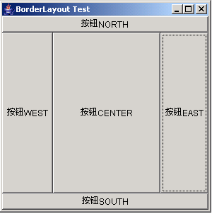

FlowLayout
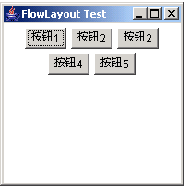
GridLayout
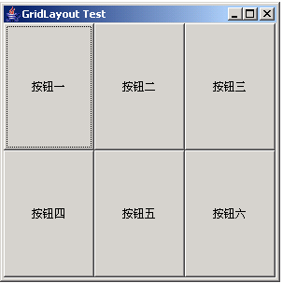

五、书面作业
1．布局管理器 BorderLayout 、FlowLayout、 GridLayout 各自有什么特点？

