Estuarine morphology estimator V1.0

*Authors: J.R.F.W. Leuven1 & S.L. Verhoeve*[1]*, Last update: 19 November 2018*

## Introduction

A tool has been developed that will predict the morphology of estuaries form all over the world. The model will generate bar patterns, typical bed levels, flow conditions, inundation duration and salinities based on solely the along-channel estuary width profile and the tidal amplitude. The model is based on the empirical relations as given in the papers by Leuven et al. (2016, 2018a, 2018b) and salinity predictors of Savenije (1993), Brockway (2006) and Gisen et al. (2015). A description of the tool is given in Leuven et al. (2018c).

Below follows a description of the files present in the download. Then, a description is given of what input data is required and how this should be saved. Third, it is described what preparations are needed in order to be able to run the model (program download and installation). In the last section a description is given on how to run the model after the preparations.

## Files present in downloaded folder ‘EAME’

The following files and folders should be present in the downloaded folder. These files should not be moved/renamed/deleted. *Copying* the files to another location is not a problem.

- folder '_pycache_'

- folder 'Examples'

- folder 'Results'

- file 'input_variables.xls'

- file 'Instructions.docx' (this file)

- file 'Model_v1_0.py'

- a number of example '.csv' files with along-channel width profiles

## Input data

The model is designed to work with a minimal amount of input data. The input data will consist of three components: (1) the along-channel width profile of the estuary, (2) essential variables and (3) non-essential variables.

(1) Along-channel width profile: a .csv file with two columns, in which the second column contains the channel width, measured on a regularly spaced interval. The width profile can be measured by hand with for example Google Earth. Alternatively the full estuary outline can be digitised and subsequently the width of equally spaced transects can be extracted using GIS software (see for example Leuven et al., 2018a). The tool download comes with a few sample '.csv' files of estuary outlines.

(2) The variables are dependent on the estuary and on the estuary outline and have to be specified in an '.xls' file. The variables consist out of ‘essential parameters’ and ‘switches’, or non-essential parameters. The essential parameters are required to run the tool. The non-essential parameters only affect certain parts of the model which can be switched off for faster runtimes. Therefore, if this information is not of importance these variables can be neglected (however, **cannot** be left out!).

The variables you have to specify (‘essential parameters’) in the .xls are:

* The name of the file with along-channel width profile, e.g. ‘Western_scheldt.csv’.
* The spacing between points in the width profile in meters.
* The amplitude of the tides at both the mouth of the estuary and the riverside of the estuary. Also, the duration of a tidal cycle of the tides has to be specified. This is the time of one tidal cycle which is defined as the time from maximum high (low) water level to maximum high (low) water level (default is semi-diurnal tide with T = 12.4 hours).
* The shape factor of the channel for the river side and the mouth of the estuary. The shape factor can have a value between 1 and 2 and determines whether the channel is perfect rectangular (1) or V-shaped (2) in cross section. If unknown, default values of 1.5 and 1.9 for sm and sr respectively should be good.
* The width of the river at the tidal limit. If the along-channel width profile does not extend up to the tidal limit, the river width at the tidal limit should be specified. Otherwise, the most landward width of the along-channel width profile can be used. This width is used to estimate river discharge, in case river discharge is not specified in the non-essential parameters.
* A name which will be added in front of all the output figures.

(3) The optional parameters (‘switches’) in the .xls are:

* Hypsometry: if 1, hypsometry graphs will be saved for each cross-section.
* Discharge: if 1, discharge of landward river can be specified. This gives more accurate results then when discharge is estimated based on river width.
* Salinity: if 1, salinity will be calculated. To do so, salinity at the mouth and fresh water salinity are required as input.
* r and z: if 1, the r and z parameters in the hypsometric shape of Strahler (1952) can be set to a constant value. It is not advised to use this, unless you want to create an along-channel uniform hypsometry.
* Excel: if 1, an output file with all data in excel will be created. This increases computational time.
* Depth measured: if 1, measured depth at the mouth and landward river will be used instead of calculations based on river discharge and tidal prism. If 1, the maximum depth at the mouth and upstream river have to be specified.

## Preparations

* Save the downloaded folder ‘zip_Estuarine_Morphology_Estimator’ to your designated location. The location where you save it does not matter, but the name of the folder should remain the same including the folder structure.
* Save the excel file with the outline data in the correct format (.csv) in this folder: column A consists the transect numbers and column B consists the width of the transects. Row 1 is used for the headers.
* Open the file ‘Input_variables.xls’. In this file the input variables are specified.
* In column E example values are given, based on the Western Scheldt (Leuven et al., 2018a).
  + *Note: more examples of other estuaries are given in column T-Z. The width profile of these examples can also be found in the folder (EAME).*
* The name of the file containing the outline data has to be specified in cell C2
  + *Example: ‘Western_scheldt.csv’*
* The input variables have to be specified in row 3 till 25. Row 3 to 10 have to be specified because they are site specific, row 11 to 25 are switches determining whether additional manual input is given or extra results is given. These can all be set to zero without major impacts on the results.
  + *The initial input is based on data of the Western Scheldt (NL).*
  + *Either the river discharge (qr) has to be specified, or this should be put to zero and the width of the river at no tidal influence (wr) should be specified.*
* Save the file in the folder ‘zip_Estuarine_Morphology_Estimator’.
* The file can now be closed
* Download the latest version of Python, including the working environment ‘Spyder’
  + <http://winpython.github.io>
  + *Example: WinPython 3.6.2.0Qt5-64bit (*) Changelog, Packages and Downloads*
    - Click downloads
    - Click: *WinPython-64bit-3.6.2.0Qt5.exe*
    - The download will start automatically within 10 seconds
* Double click the downloaded file. The setup will now load which might take a couple of minutes.
* Click ‘I Agree’ to accept the license of agreement in order to proceed the installation.
* Choose a location where to install the program (Destination folder).
  + *Example: C:\Program Files\WinPython-64bit-3.6.2.0Qt5*
* After installing, open the destination folder and double click on the application ‘Spyder.exe’. Now the Spyder program will open and will look like Figure 1. This might take a moment.

2

4

6

8

1

3

5

7

9

10

11

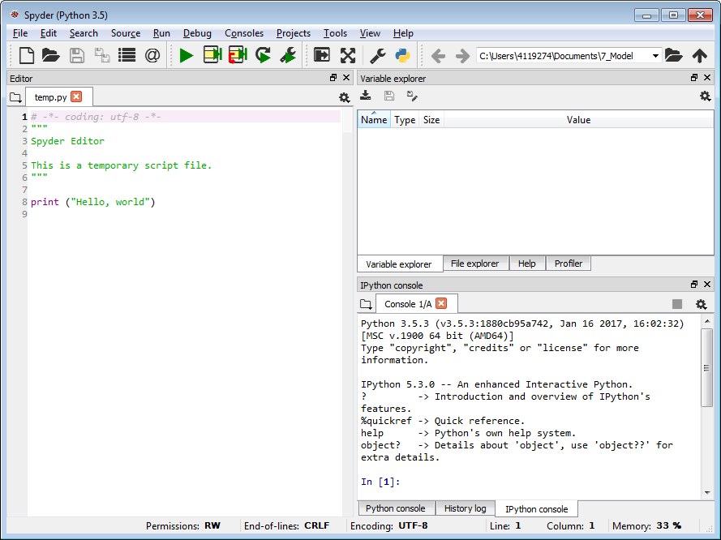

Figure : The Spyder interface

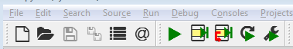

Figure : The button bar

## Running the model:

* Open the model from the downloaded folder in Spyder
  + Click on the dropdown list *File,* than on *Open…;* or click on the 2nd button on the Button Bar (Figure 2).
  + Navigate to the location where the folder ‘EAME’ is saved and open this folder.
  + Selected the file ‘Model_v0’ and click ‘Open’
* Run the model
  + Click on *Run,* and again *Run;*  or click on the 7th button on the Button Bar (Figure 2).
    - Note: for the first run the “Run settings for […].py” menu pops up. No adjustments have to be made. Click *Run* to advance
* Now the model will run. During the run the square in the upper right corner of the ‘IPython Console’ will turn red (Figure 3). If the run is finished this square will turn grey again. The run can be interrupted/stopped by clicking this red square.

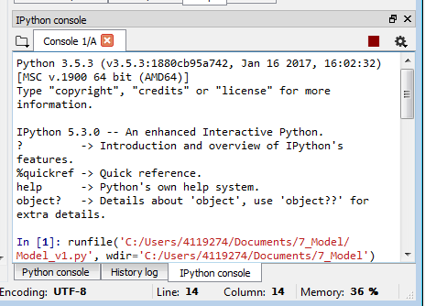

Figure : IPython console

* If the run has finished the results are written into the ‘Results’ folder. In the IPython console the runtime of different sections of the model will be given.
  + Example:

In [1]: runfile('C:/Users/4119274/Documents/EAME/Model_v0.py', wdir='C:/Users/4119274/Documents/EAME')

--- 0.0010001659393310547seconds for importing data---

--- 80.71707081794739 seconds plotting hypsometry graphs---

--- 0.16101622581481934 seconds for hypsometry calculations---

--- 3.566356658935547 seconds creating graphs---

--- 3.9273927211761475 seconds total run---

The model is now finished running

* Spyder can now be closed.

## Results

The result of the model run will be found in the downloaded folder (‘…\EAME\Results’). In this folder the figures and data of the model run will be saved.

All results show along-channel profiles. Some results are split into different zones based on the depth below high water level. In that case the results only comply for that area. The zones are:

* Intertidal high: between high water level and mean water level.
* Intertidal low: between low water level and mean water level.
* Subtidal: below low water level.
* Shallow subtidal: between low water level and low water level minus one amplitude.
* Deep subtidal: below the low water level minus one amplitude (below shallow subtidal)

The following figures will be created:

* Bar width: the estimated width of individual bars.
* Braiding index: number of channels and bars in cross-section, calculated as the ratio of excess width to bar width.
* Depth: a map with the average depth below the maximum water level.
* Inundation time: a map with relative inundation durations, 1 being submerged for the entire tidal cycle and 0 being dry permanent.
* Salinity: the salinity along the estuary calculated with three different methods and the mean of Gisen et al. (2015) and Savenije (1993).
* Tidal prism: along-channel local tidal prism calculated with three different methods.
* Along-channel flow velocity: maximum and average per cross-section are given for the peak tidal flow velocity and the average per cross-section for the tidal average flow velocity is given.
* Flow velocity maps: the average velocity over half a tidal cycle and the peak flow velocity are shown.
* Width of zones: the width of the different zones, both cumulative and relative to the total width.
* Depth of zones: the average bed level of the different zones.
* Flow velocity within zones: the average of the peak and average flow velocities per zone.
* Overview: figure including the bed level, inundation, peak flow velocity and salinity maps.

## References

Brockway, R., Bowers, D., Hoguane, A., Dove, V., & Vassele, V. (2006). A note on salt intrusion in funnel-shaped estuaries: Application to the Incomati estuary, Mozambique, *Estuarine, Coastal and Shelf Science*, vol. 66, 1–5.

Gisen, J., Savenije, H.H., & Nijzink, R. (2015). Revised predictive equations for salt intrusion modelling in estuaries, *Hydrology and Earth System Sciences*, vol. 19, pp. 2791–2803.

Leuven, J.R.F.W., Kleinhans, M.G., Weisscher, S.A.H. & van der Vegt, M. (2016). Tidal sand bar dimensions and shapes in estuaries. *Earth-Science Reviews*, 161, (pp. 204-223).

Leuven, J.R.F.W., Haas, T. de, Braat, L. & Kleinhans, M.G. (2018a). Topographic forcing of tidal sand bar patterns for irregular estuary planforms, *Earth Surface Processes and Landforms*, DOI:10.1002/esp.4166

Leuven, J.R.F.W., Selaković, S. & Kleinhans, M.G. (2018b). Morphology of bar-built estuaries: empirical relation between planform shape and depth distribution, *Earth Surface Dynamics,* DOI:10.5194/esurf-2018-18

Savenije, H.H. (1993). Predictive model for salt intrusion in estuaries, *Journal of Hydrology*, vol. 148, pp. 203–218.

Leuven, J.R.F.W., Verhoeve, S.L., van Dijk, W.M., Selaković, S. & Kleinhans, M.G. (2018c). Empirical estimator for bed levels, flow velocity and salinity in estuaries with limited data, *Remote Sensing (SI:* *Remote Sensing of Flow Velocity, Channel Bathymetry, and River Discharge)*.

Strahler, A.N. (1952). Hypsometric (area-altitude) analysis of erosional topography, Bulletin of the Geological Society of America, vol. 63, pp 1117-1142.

1. Utrecht University, Faculty of Geosciences, Department of Physical Geography: Coastal dynamics, fluvial systems, and global change. Contact: [j.r.f.w.leuven@uu.nl](mailto:j.r.f.w.leuven@uu.nl) / [mail@jasperleuven.nl](mailto:mail@jasperleuven.nl)