**DOCUMENTATION**

**GROUP 4**

Lee Izzy Frixx Jose

Jasper Manlusoc

Daniel Villano

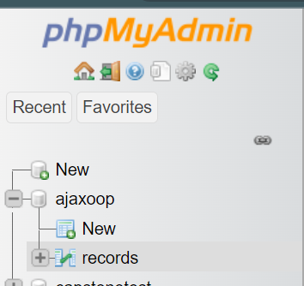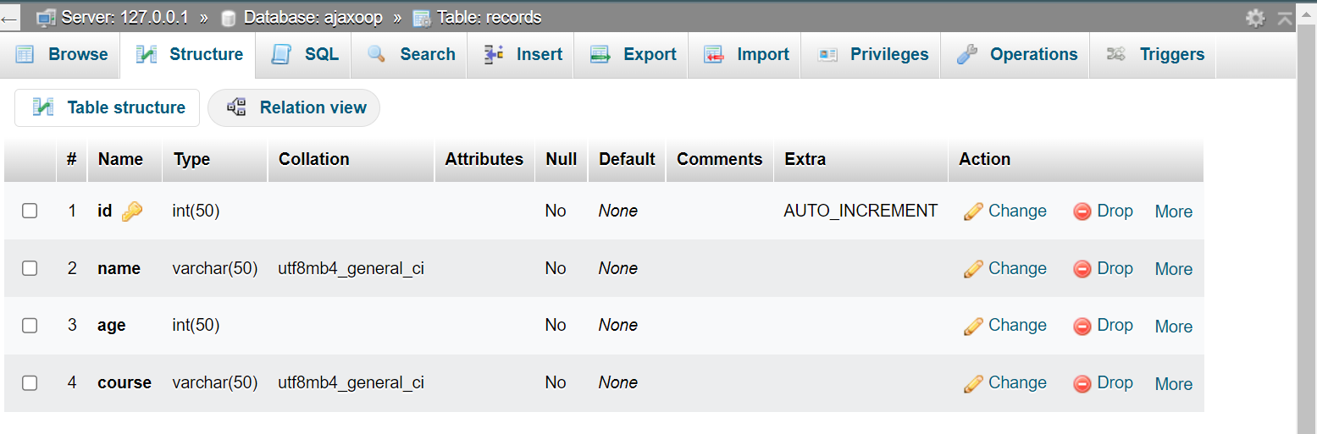**Database**

This shows the database used in the system

**CRUD Output**

**Text fields are required to fill-out**

There is a message shows that the fields is required to fill-out in order for the data to save in the database.

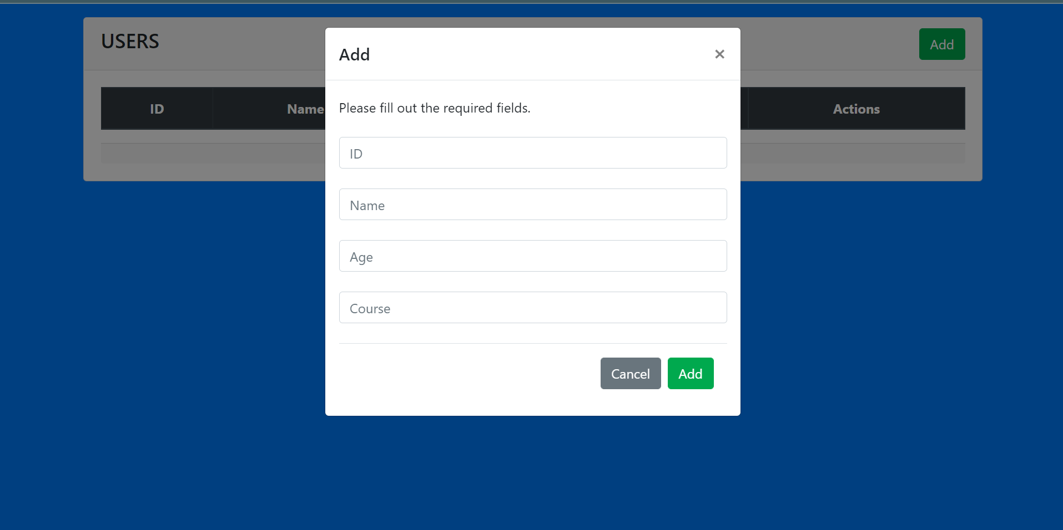

**Sample Output**

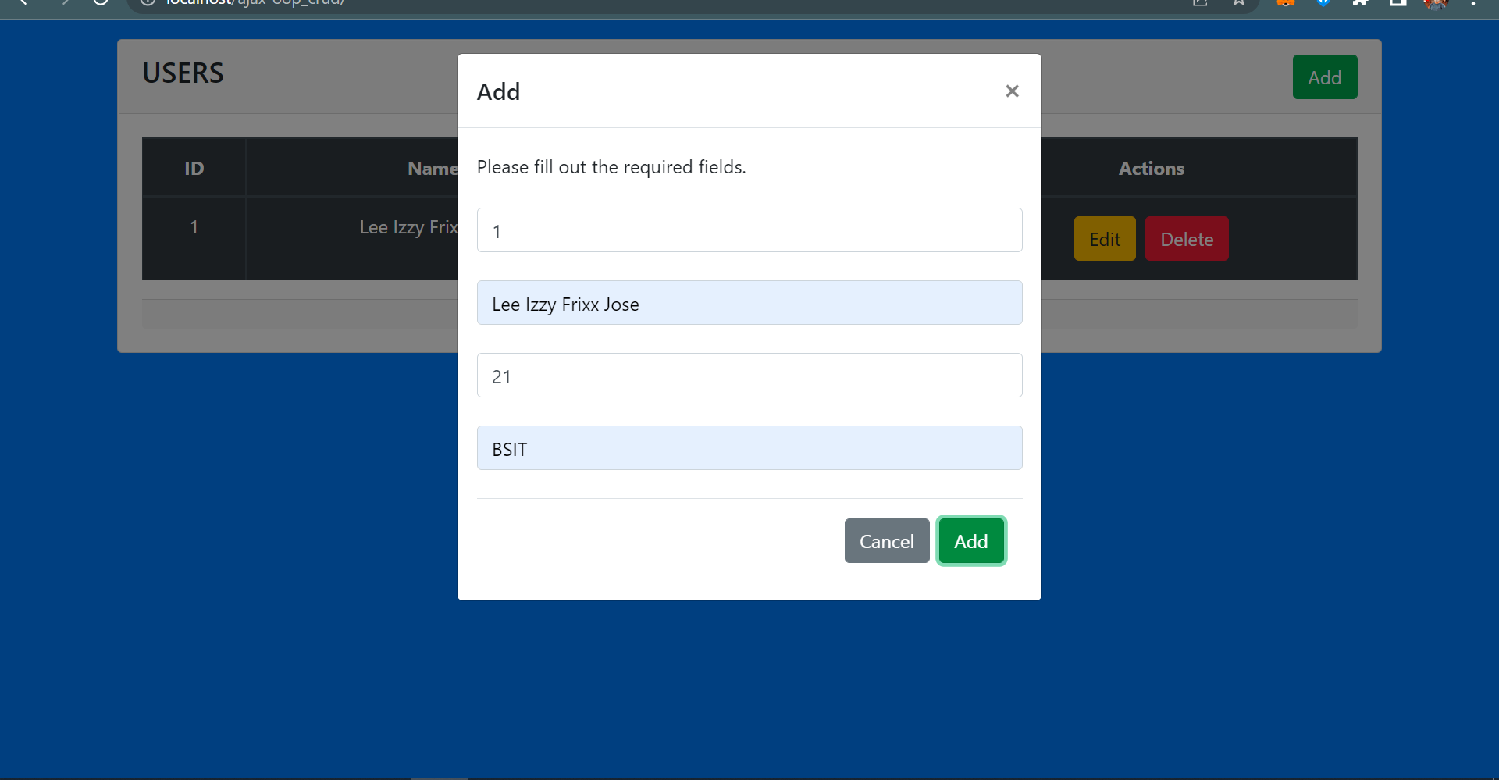**Adding a new user in the table using AJAX**

**More names added in the table**

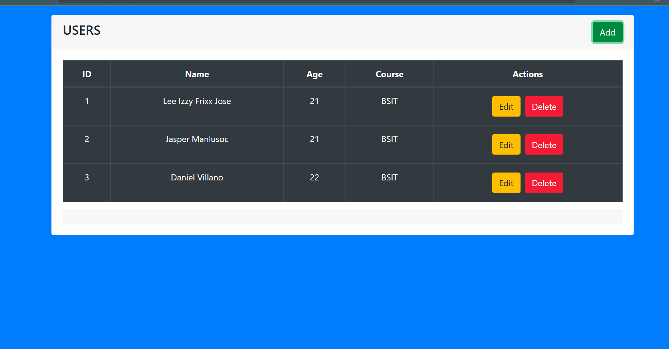

**Changing the values of the user using the ID of 1**

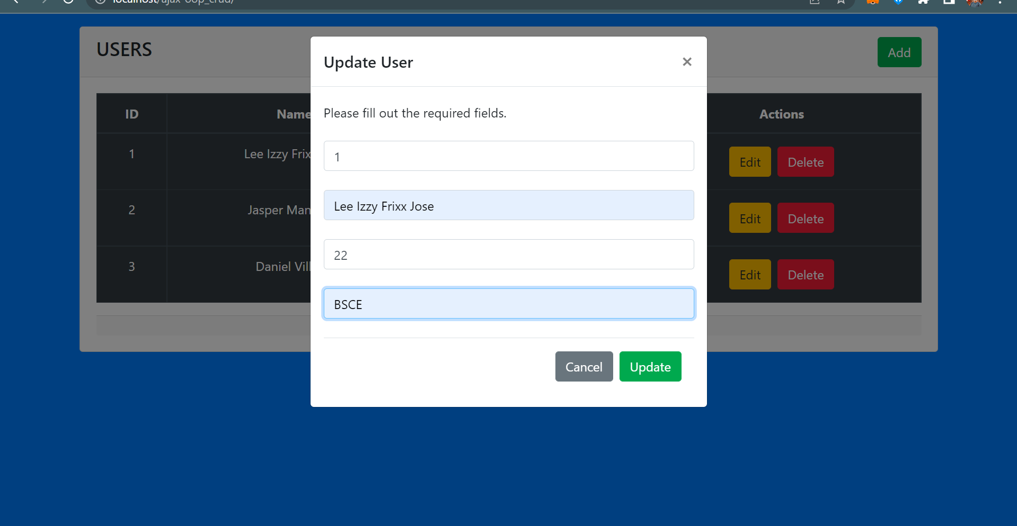

**Successfully updated the values or course of the ID=1**

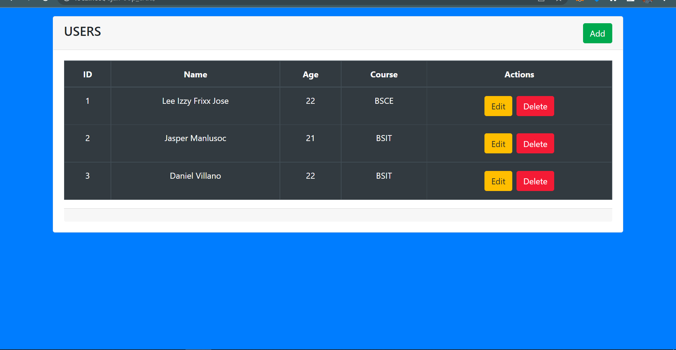

**Lastly, the Delete button will remove or delete a values**

**The example deleting the entry number 2**

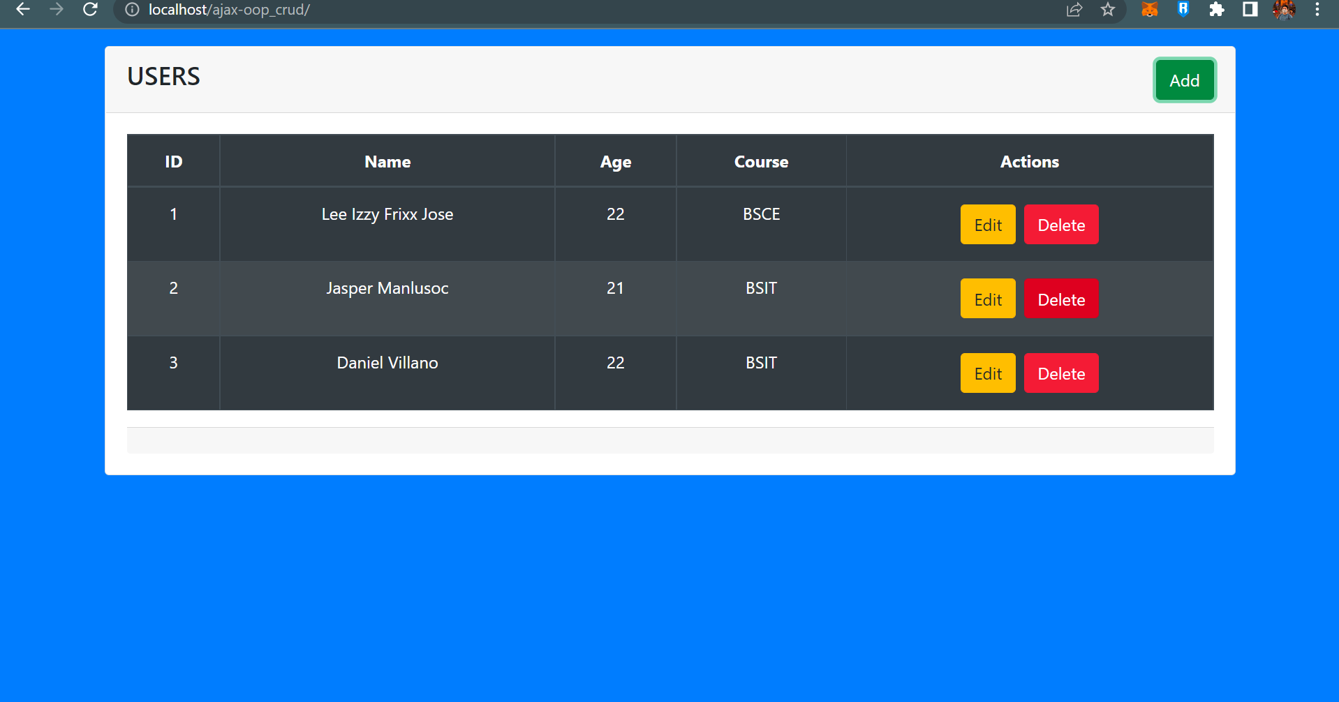

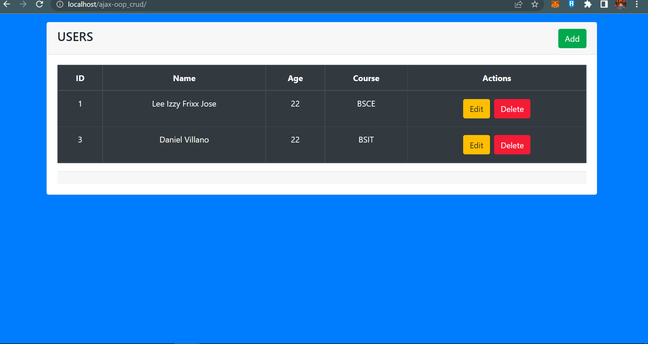

**Shows the successfully deleted entry number**

**Then, lastly deleting all of the users in the table**

