Module instantiation and FSM

This document describes an example design that instantiates several modules and uses an FSM to control the modules.

Problem description:
There are four operands a0, a1, b0, b1. We design a HW architecture that computes a0+b0 and then a1+b1. The architecture generates a result_ready signal for each of the two results.

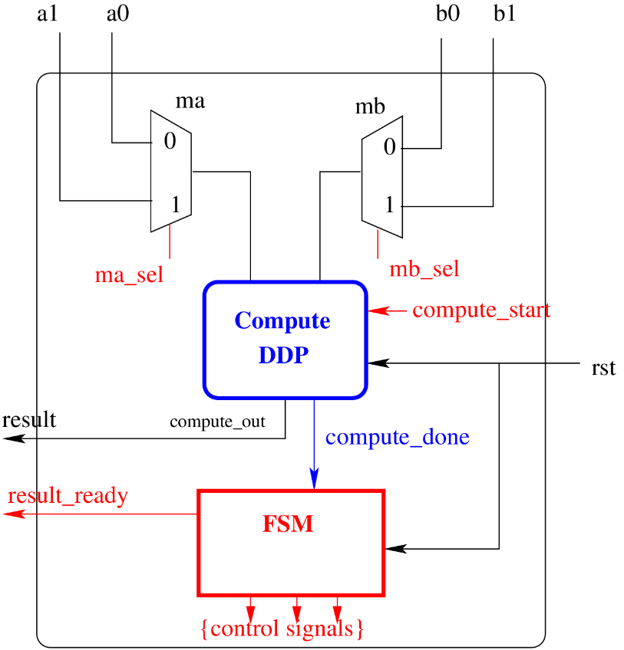

HW Architecture:
The above figure shows an architecture for the required computation. The “compute_ddp” block is responsible for the computations “a0+b0” and “a1+b1”. There are two multiplexers ma and mb to to choose the two input operands for the “compute_ddp” block. The “compute_start” control signal is used to initiate an addition in the “compute_ddp” block. After finishing an addition (for e.g. a0+b0), the compute_done signal is set high by the “compute_ddp” block.

The FSM is responsible for generating the control signals (shown in red color). It also checks the compute_done signal to know if the “compute_ddp” block has finished a computation. In the Verilog files, the FSM is implemented using two variables state and nextstate.

Sample Verilog Codes:
Please check in Toledo

Timing Diagram

