# How to make a stacked chart

## 1, prepare data Source

## 2, import/configuring a data source

1. open eclipse Repository Explorer

Window->Show View->Other-> Repository Explorer->OK

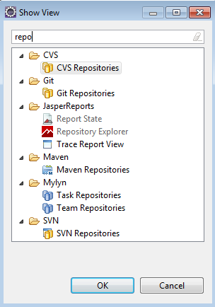

1. Data Adapters -> create Data Adapters -> CSV file

Name -> char_stacked. (your chart name )

File -> choose your local stacked.csv file.

Click button -> Get column names from the first row of the file

Choose -> Use query executor mode (the report must use the CSV query language)

Choose -> Skip the first line (the column names will be read from the first line )

Click button -> Finish

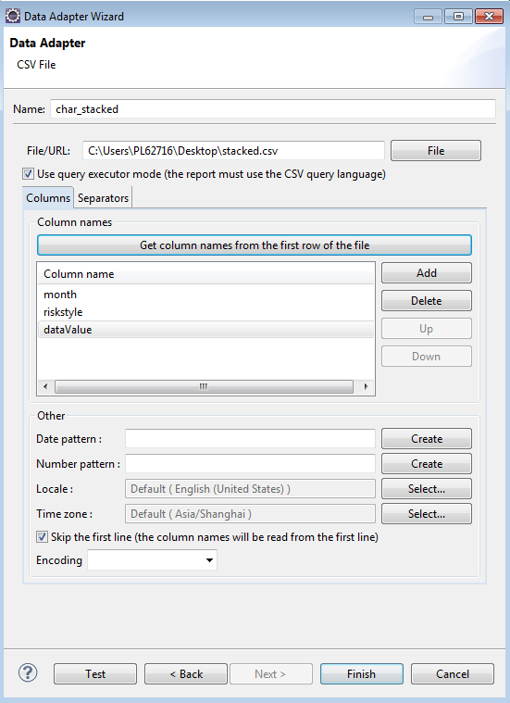

## 3, create a jasper file.

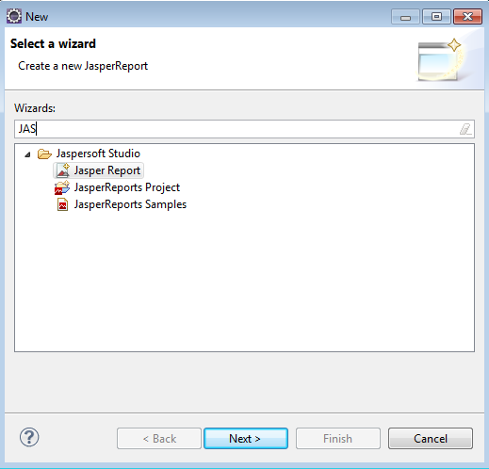

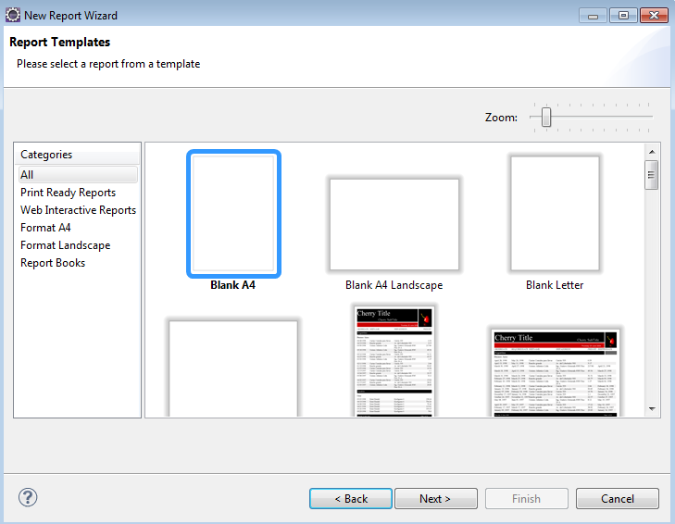

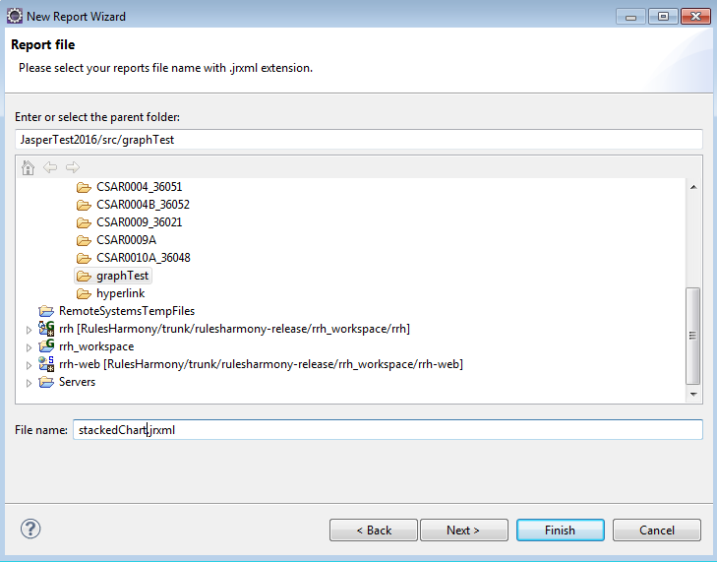

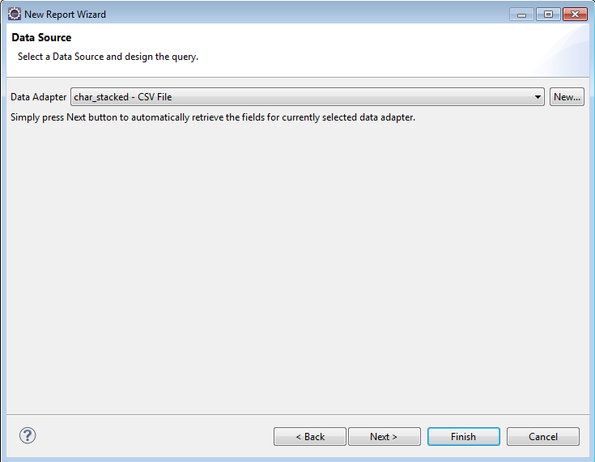

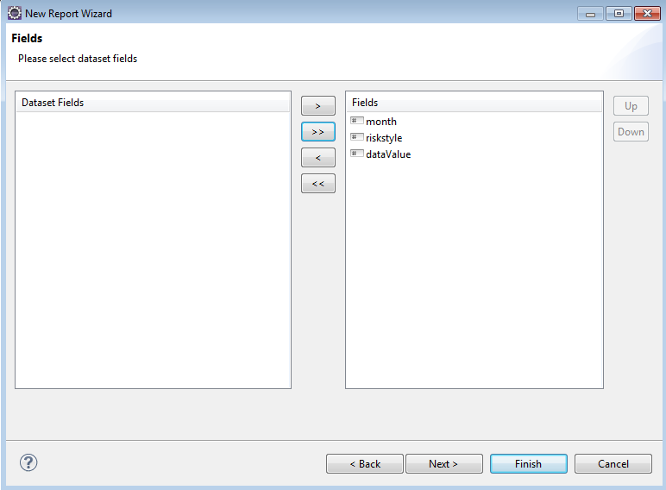

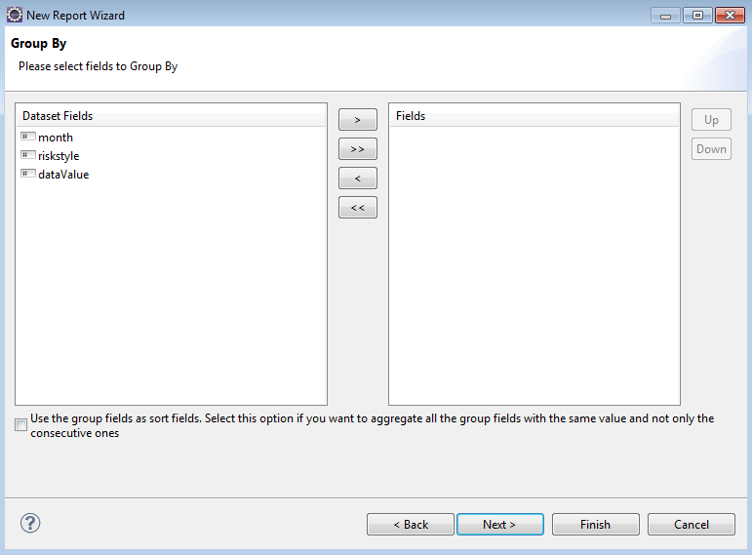

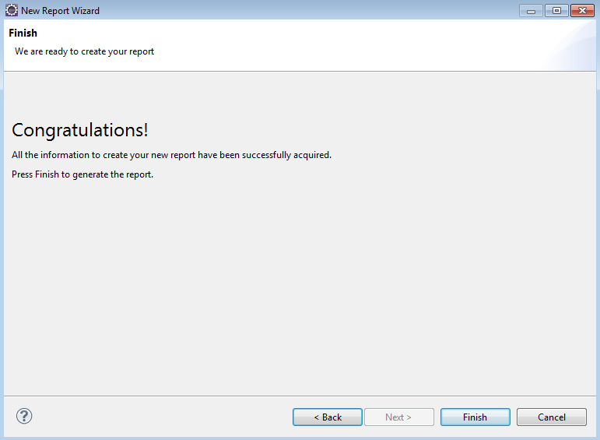

## 4, make stacked chart.

1. Only keep Summary, delete Title, Page Header, Column Header, Detail 1, Column Footer, Page Footer.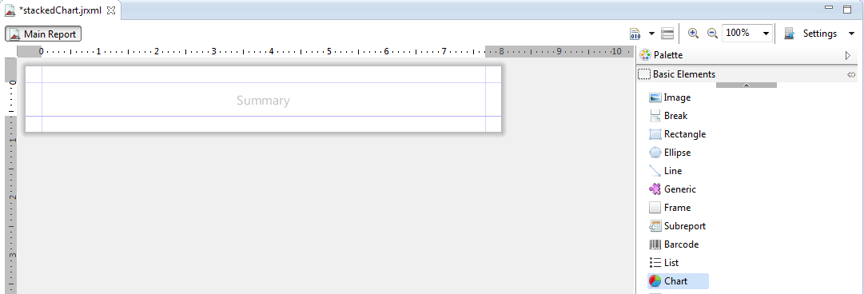
2. drag chart from Palette to Summary.

Choose -> Stacked Bar, Next.

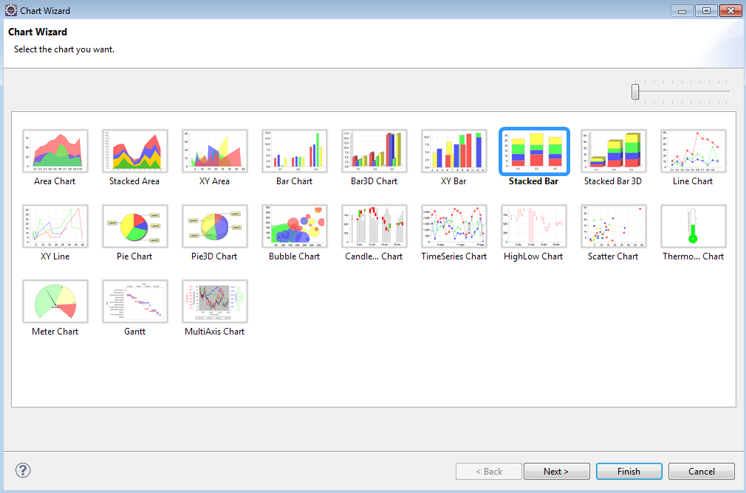

1. Chart Data Configuration.

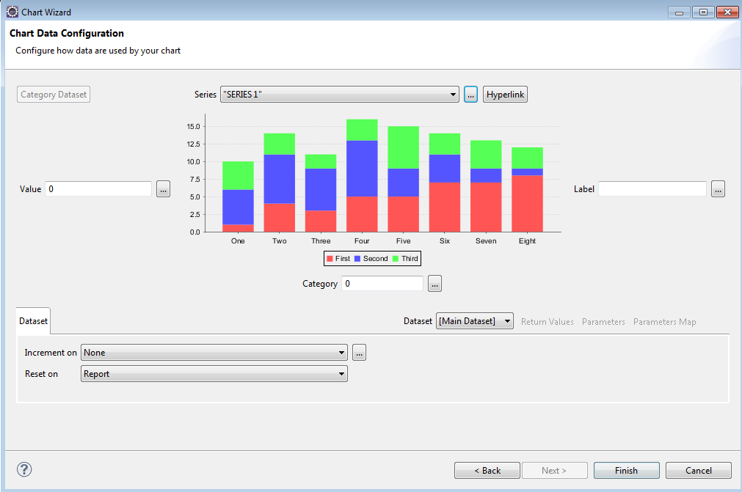

Series:

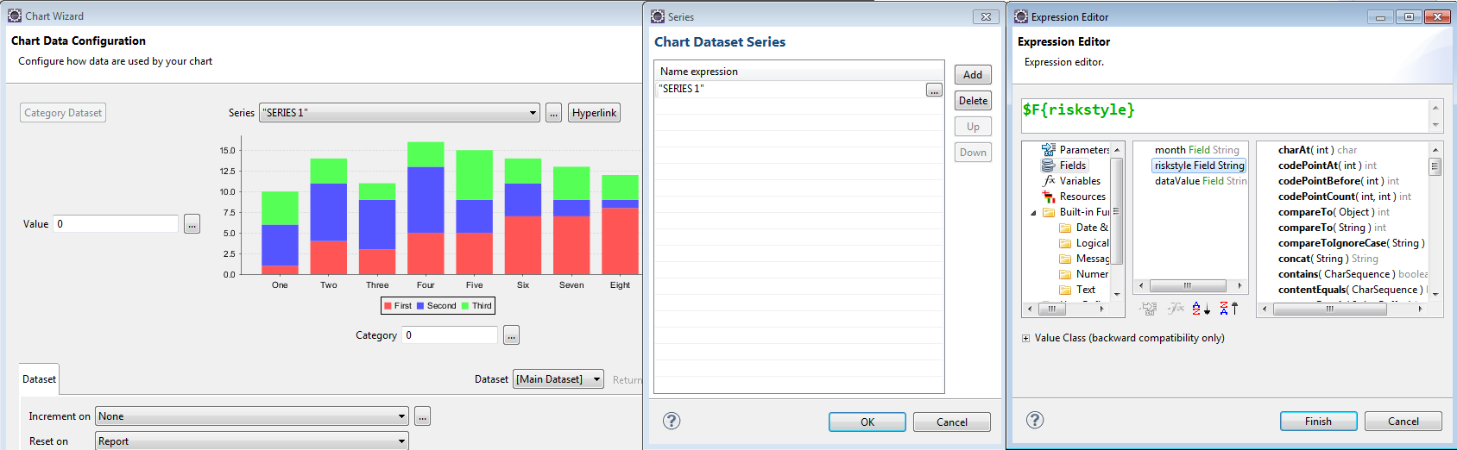

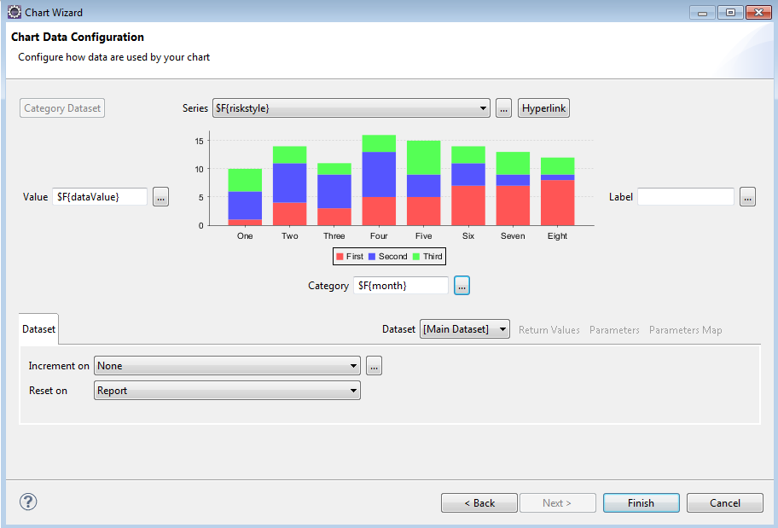

## 5, solutions to some problems:

1. Document is Empty.

We already configuration the csv data and use it, csv file also have data, but error is document is Empty, this maybe did not configuring the language.

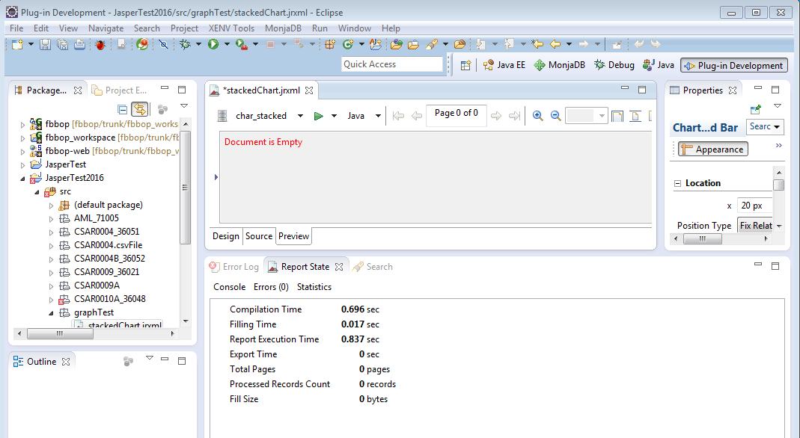

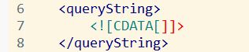 -----------------🡪 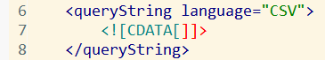

1. Cast problem.

We can change the data type.

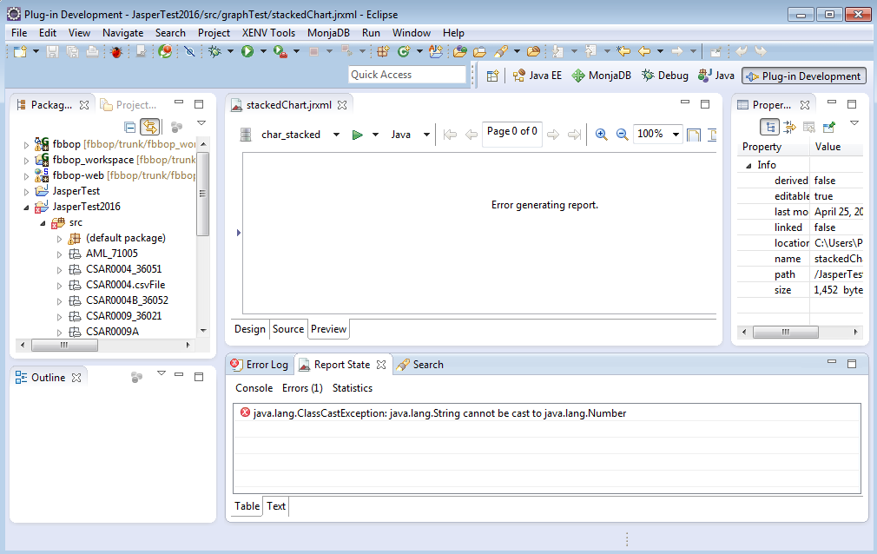

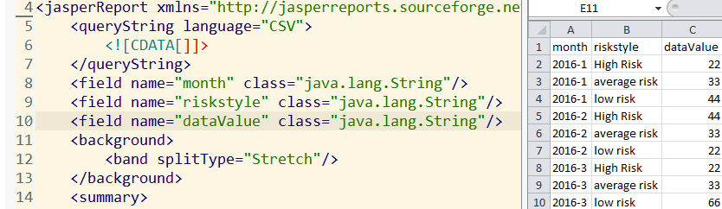

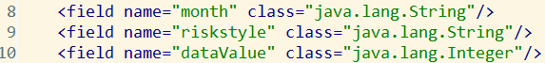

1. Unable to get value for CSV field.

This problem, we can check data config again, sometimes our first time configuration has no effect. Need to check again.

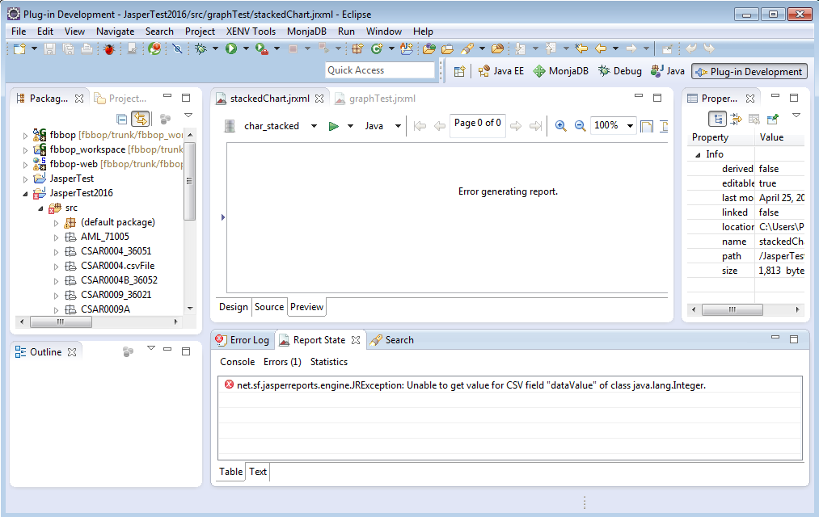

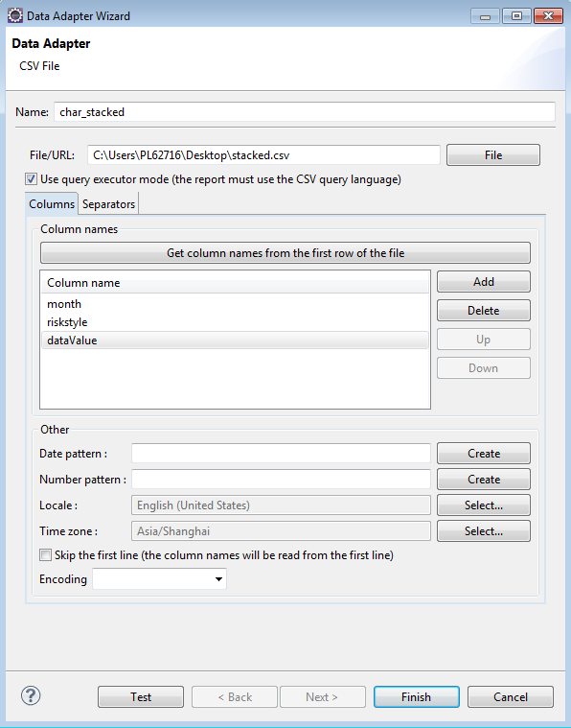

This configuration does not work, so we need to choose again, then click Finish button.

Now, click preview, we can see the stacked chart.

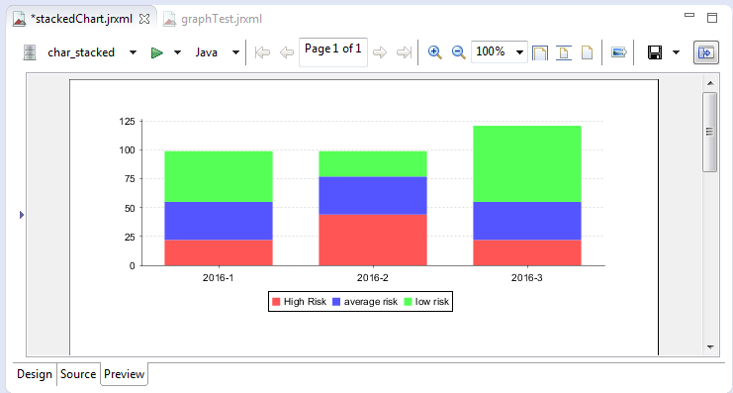

## How to change bar color?

We can use Chart Plot -> Series Colors. Add the color which we want to change.

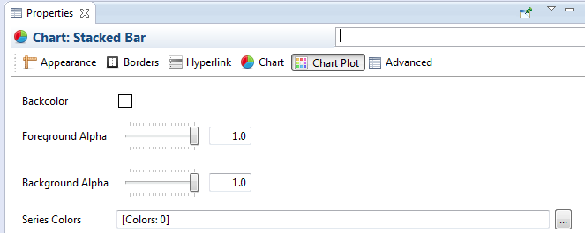

## How to change Legend position?

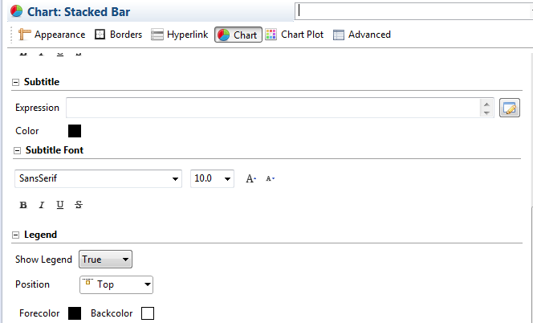

## How to add a chart title?

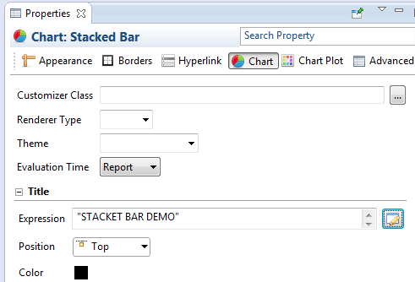

Preview

