# How to create a crosstab has two row group?

## Now, according to the left of the data, create a report like right side.

## 1, prepare data source.



## 2, import/configuring a data source. (refer stacked chart.docx)

## 3, create a jasper file. ( refer stacked chart.docx)

## 4, create a crosstab.

1. Drag crosstab to left.
2. Create crosstab.

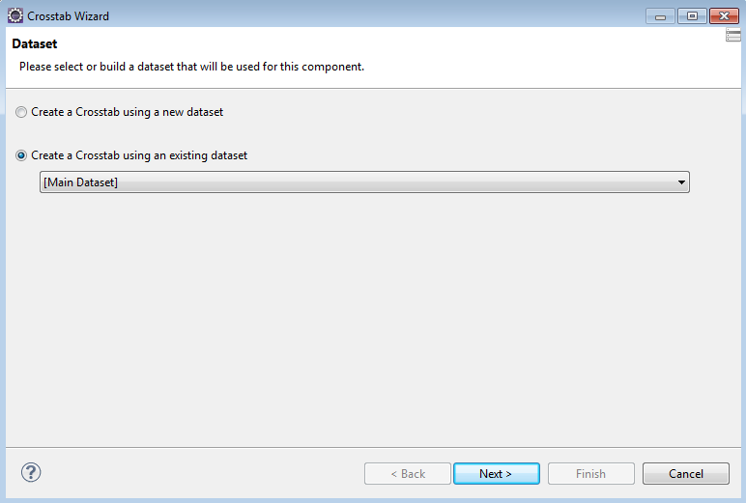

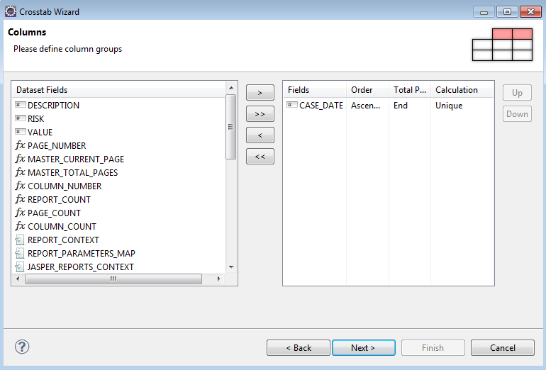

We need to group by two rows.

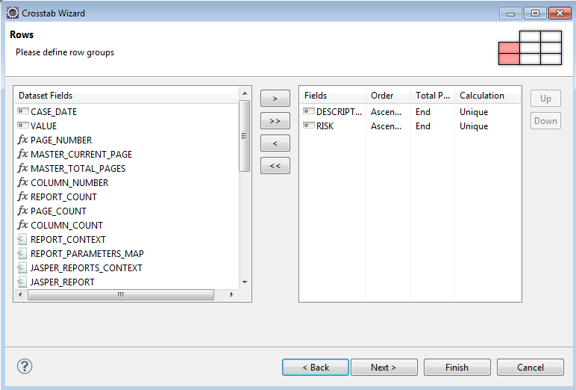

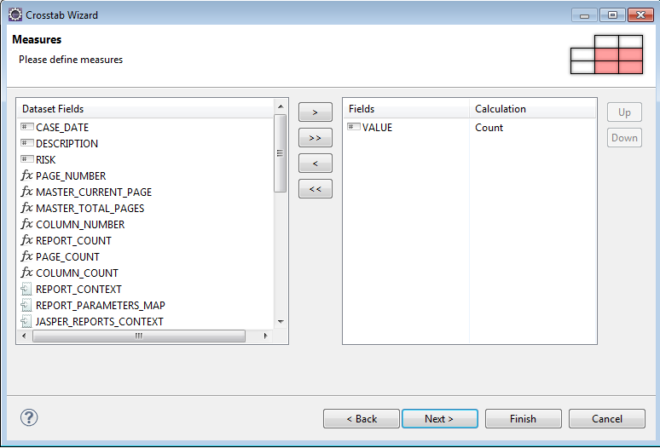

We can choose show the grid or not.

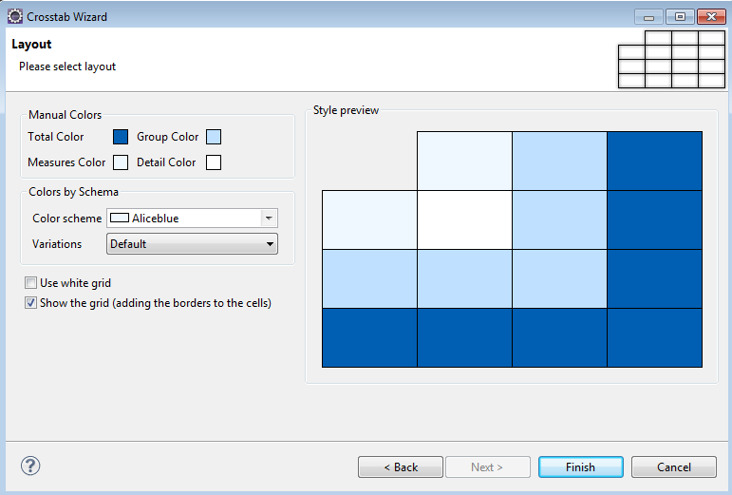

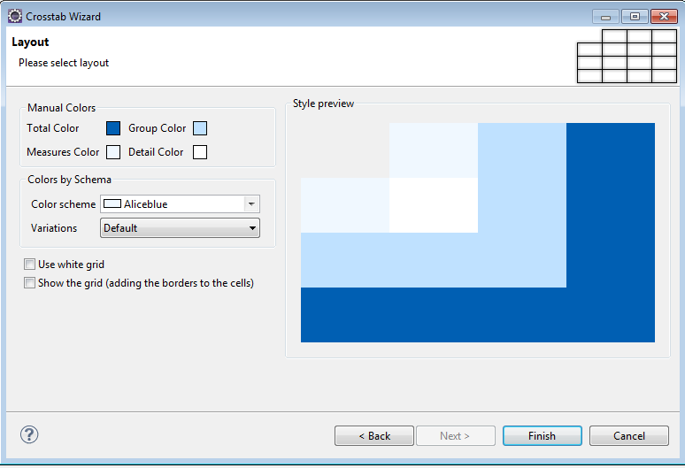

## 5, preview.

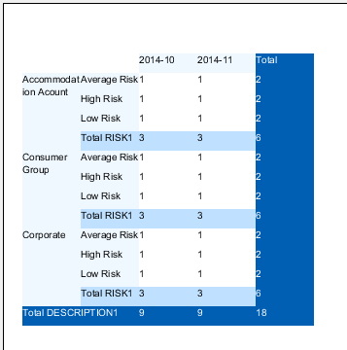

## 6, optimization.

How to make the crosstab to what we want?

1. How to delete total column/total row?

First, look at the Row Groups, there are two parts, one is DESCRIPTION1, another is RISK1. It means crosstab grouping rows depends on “DESCRIPTION”, “RISK” two columns.

Let us see the DESCRIPTION1. also two parts, header and total.

When we click the right side “Header DESCRIPTION1”, we can see which part it belongs to from left side graph, the same to “Total DESCRIPTION1”.

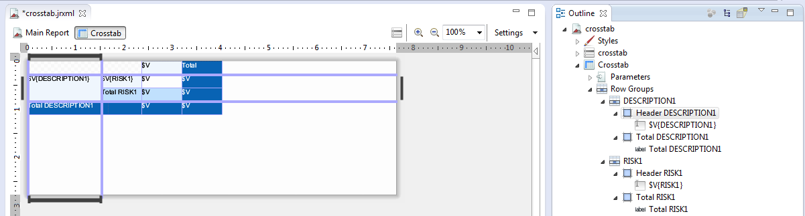

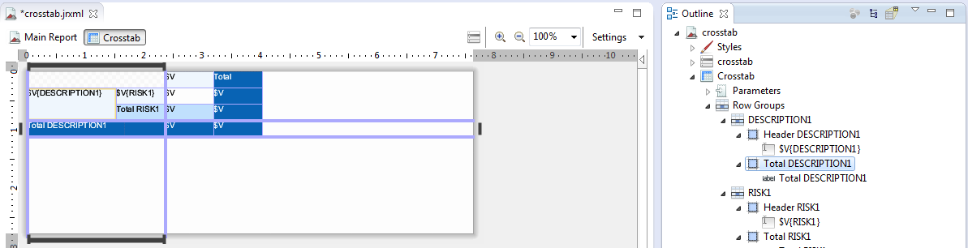

By default, the total column at the end of a row or column.

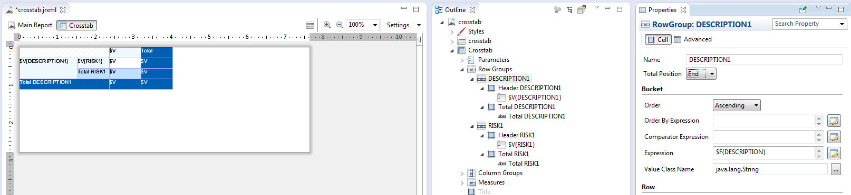

We can change “Row Groups” -> “DESCRIPTION1” -> “Total Position” from “End” to “None”. Then we can see the “Total DESCRIPTION1” row on the left graph disappeared. Column Groups do the same modifications.

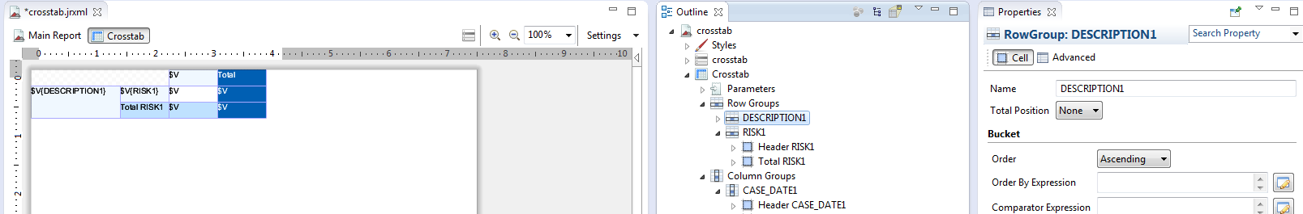

Preview

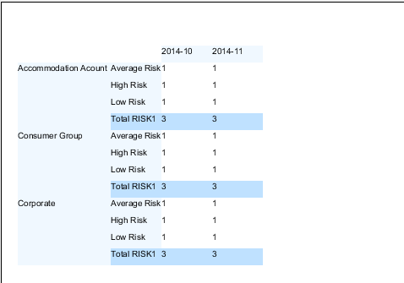

1. How to put the total column on the front?

I.e. Row Groups -> Risk1.

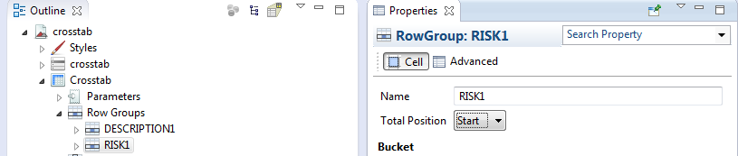

Preview

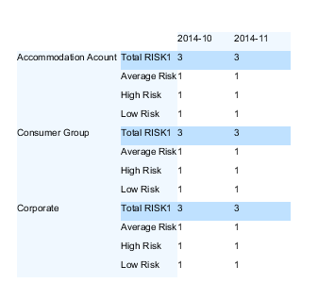

1. How to move row group description from left to top?

Here is how to replace “Total Risk1”,”DESCRIPTION1”?

Delete label “Total RISK1”.

Palette click “Text Field” -> click “Total RISK1”

Double click “Text Field” we just now created, change the value.

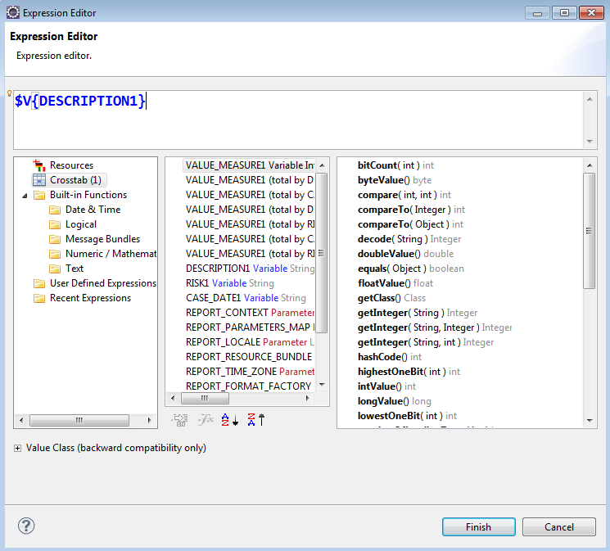

Preview

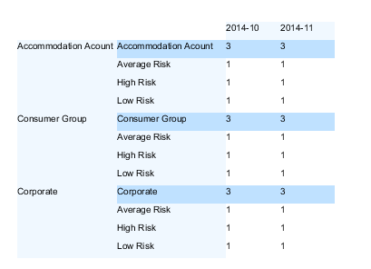

1. How to hide left side description?

Change “DESCRIPTION1” width to “0px”

Change “Header DESCRIPTION1” width to “0px”

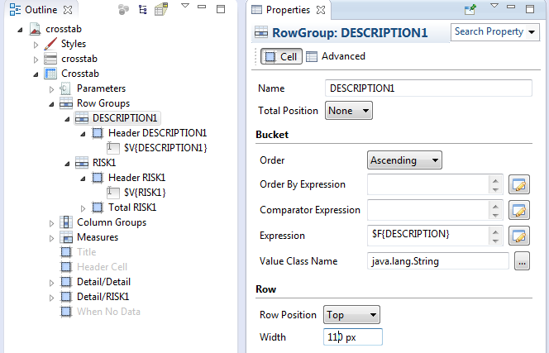

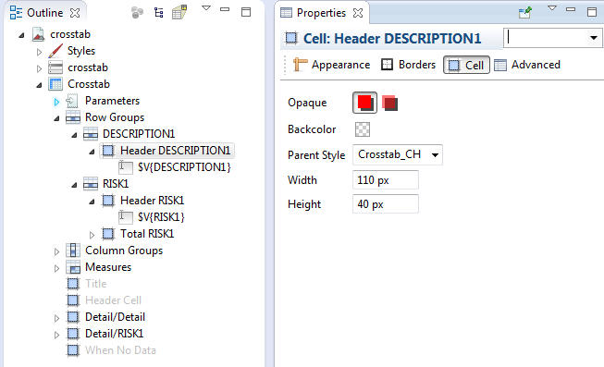

Preview

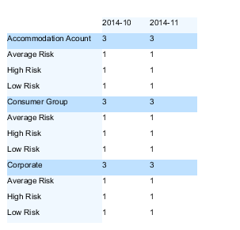

1. How to change the data value ?

By default, the data value is calculated by count. We need to change it to Sum.

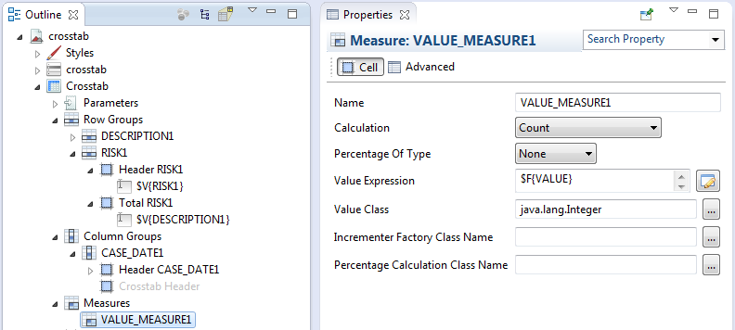

Preview

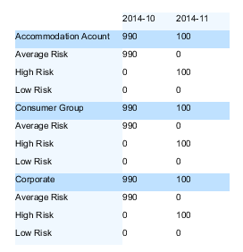

1. How to change the back color / fore color?

Choose the cell which you want to change.

Click “Backcolor”, change color.

Deselect “Transparent”.

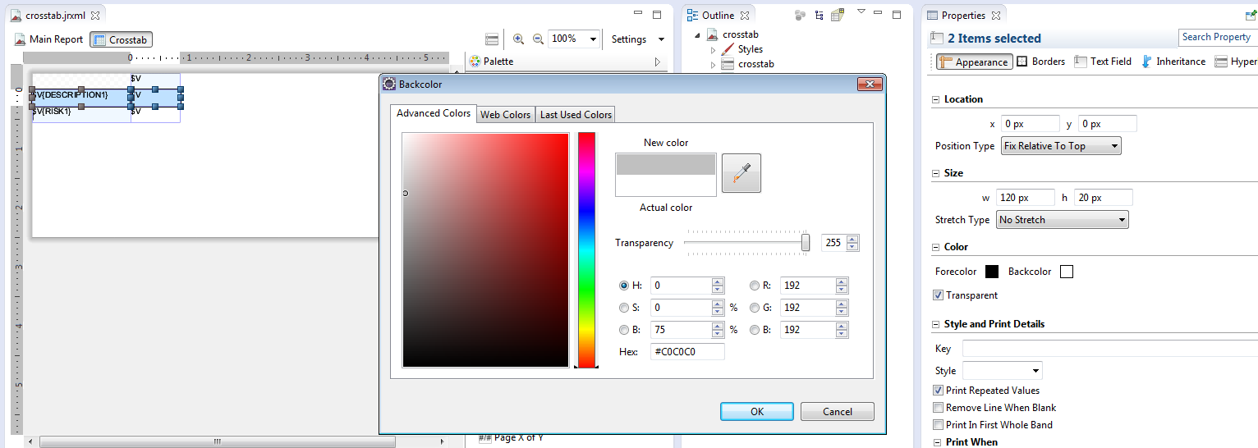

Preview

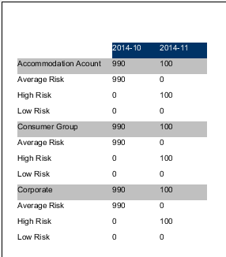

1. How to add “Header Cell”?

Right click “Header Cell” -> “Create Crosstab Header”

Drag a “Text Field” to “Crosstab Header”

Change the default value to empty. Then add header color.

Preview

