Question 1

1. Mode of $f_{μ|x}$ is 9.7 with Metropolis-hasting.

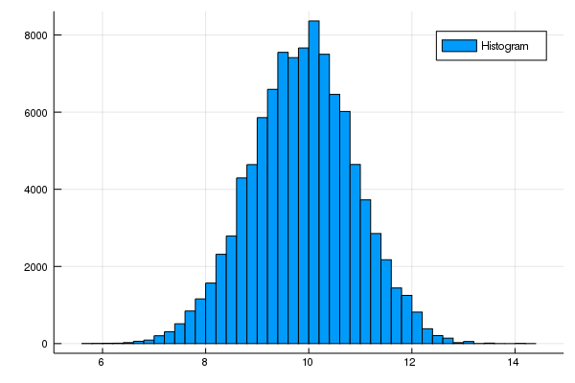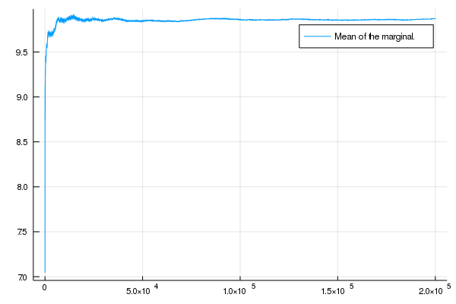

(b) Mode