Image Classification with SVM

SVM (Support Vector Machines) are a popular and effective machine learning algorithm used in image classification. This separates the images into different classes and groups. The issues I faced with this assignment was installing everything. I was a bit frustrated with it but then I started doing research and it took a very long time but I eventually got it. Tensorflow was the library I had the biggest issue with because I downloaded the newest version of Python, Tensorflow wasn’t compatible because they didn’t have a new enough version to work with the newest version of python. During my research, I found that other people had the same problem and that downloading an older version of Python ensured compatibility with the required libraries. After I figured that out, everything else went smoothly. Figuring out where and how to download the libraries was also a challenge but I found videos that helped me and I got the hang of it.

An SVM is a computer algorithm that uses machine learning to classify data. It’s used in many things such as image recognition and speech recognition. It is generally good for handling complex and high dimensional data especially if it’s non linear. Using SVC(kernel='linear') applies a linear decision boundary to separate classes, making it ideal for problems where data is linearly separable. If the data is not linearly separable, other kernels like rbf or poly might be more appropriate.

This is image is from the assignment:

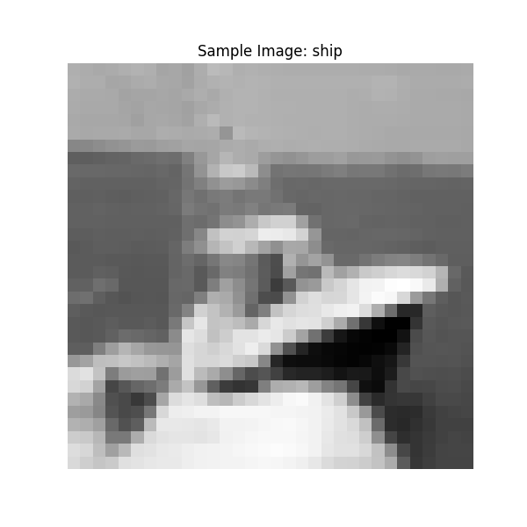

This image ended up very pixelated and in black, gray, and white colors.