Cambridge Mark Scheme Correction Appeal

Submitted to: Cambridge International Examinations
Subject: 9618 Computer Science, Question 2 (c) (ii), Mark Scheme Answer Correction
Status: Accepted — "1" added to accepted answers

The Question
Paper: 9618/13/M/J/23 (or equivalent AS-Level Computer Science paper)
Question 2 (c) (ii): State the number of transistors contained in each cell of flash memory.
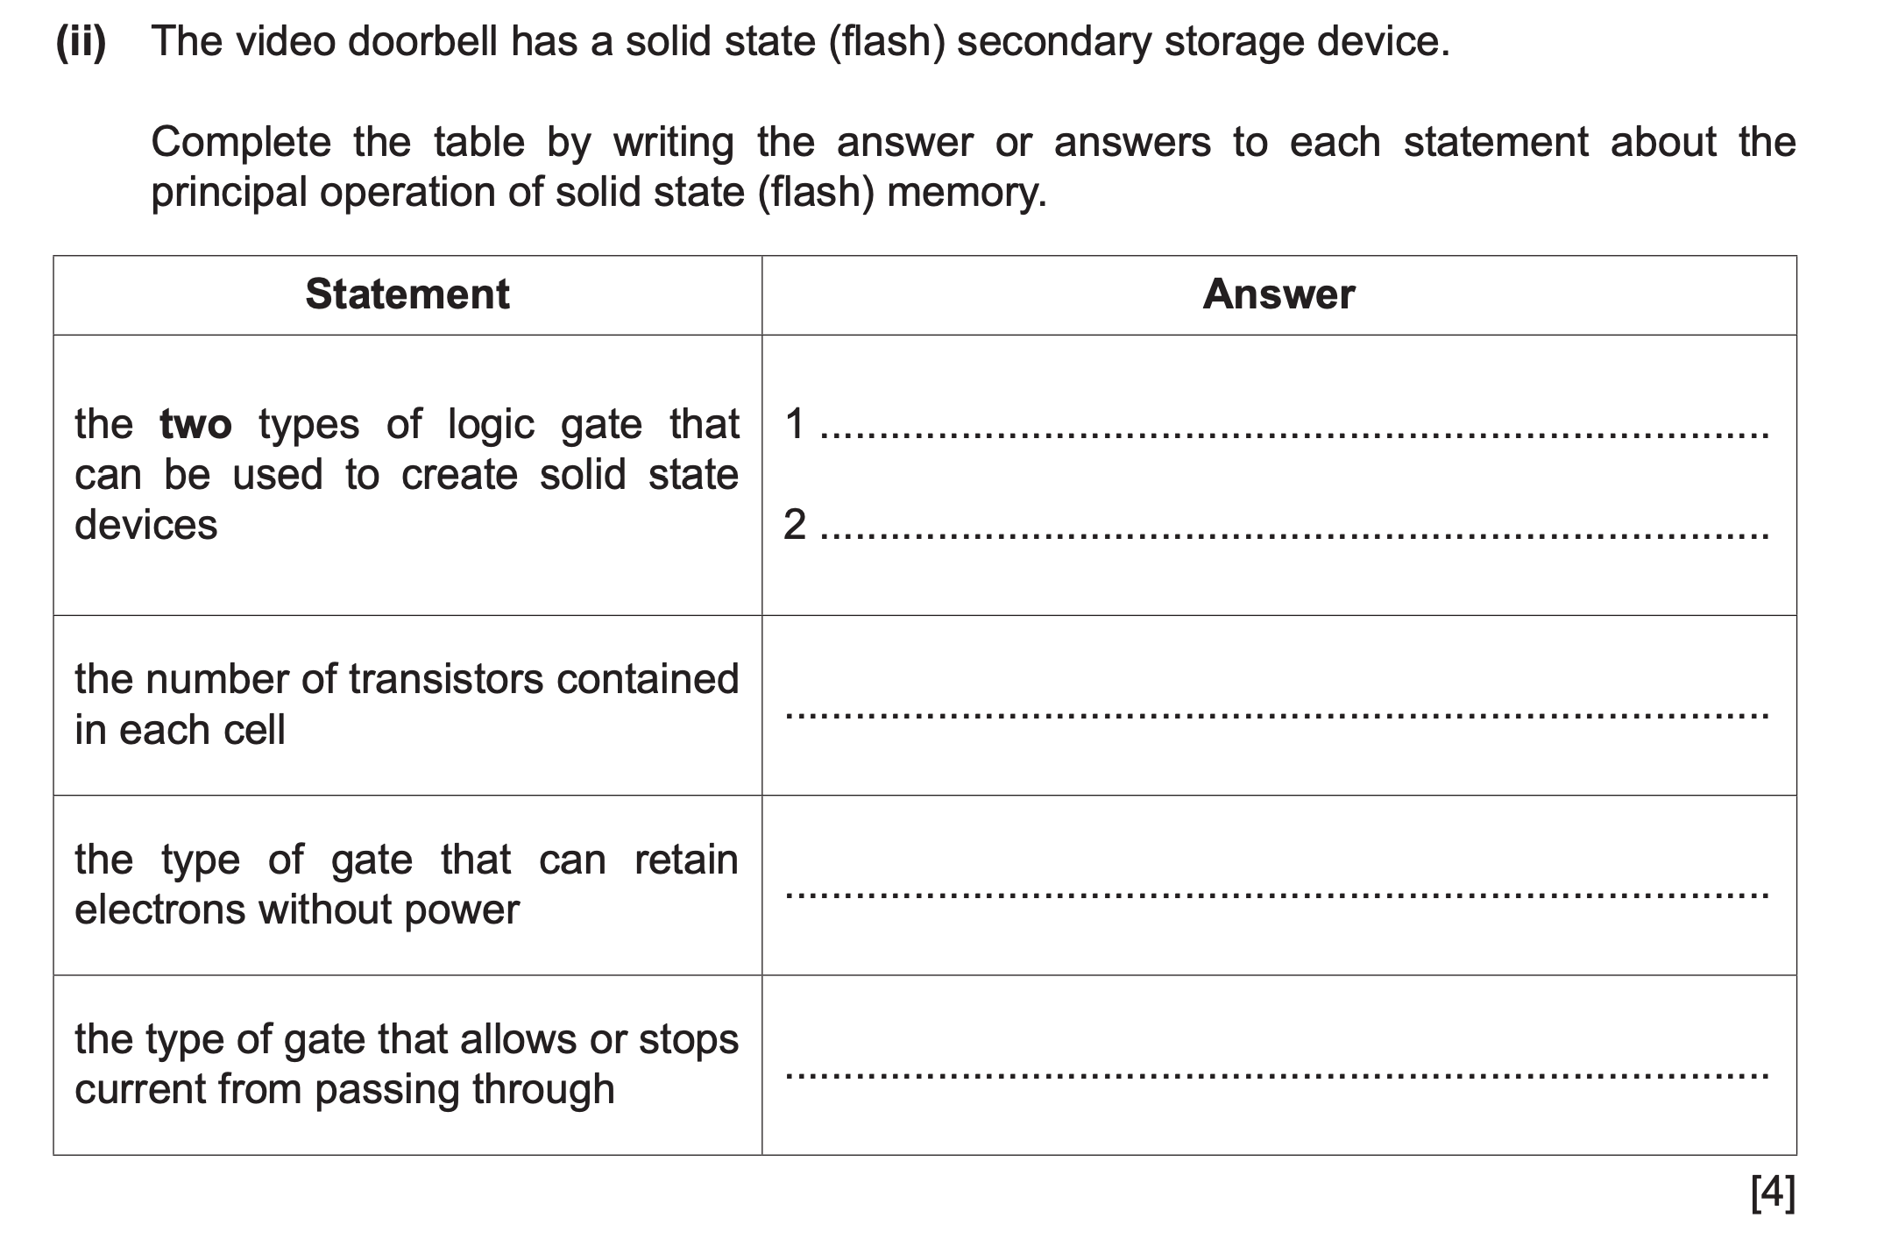
Original Mark Scheme Answer: 2
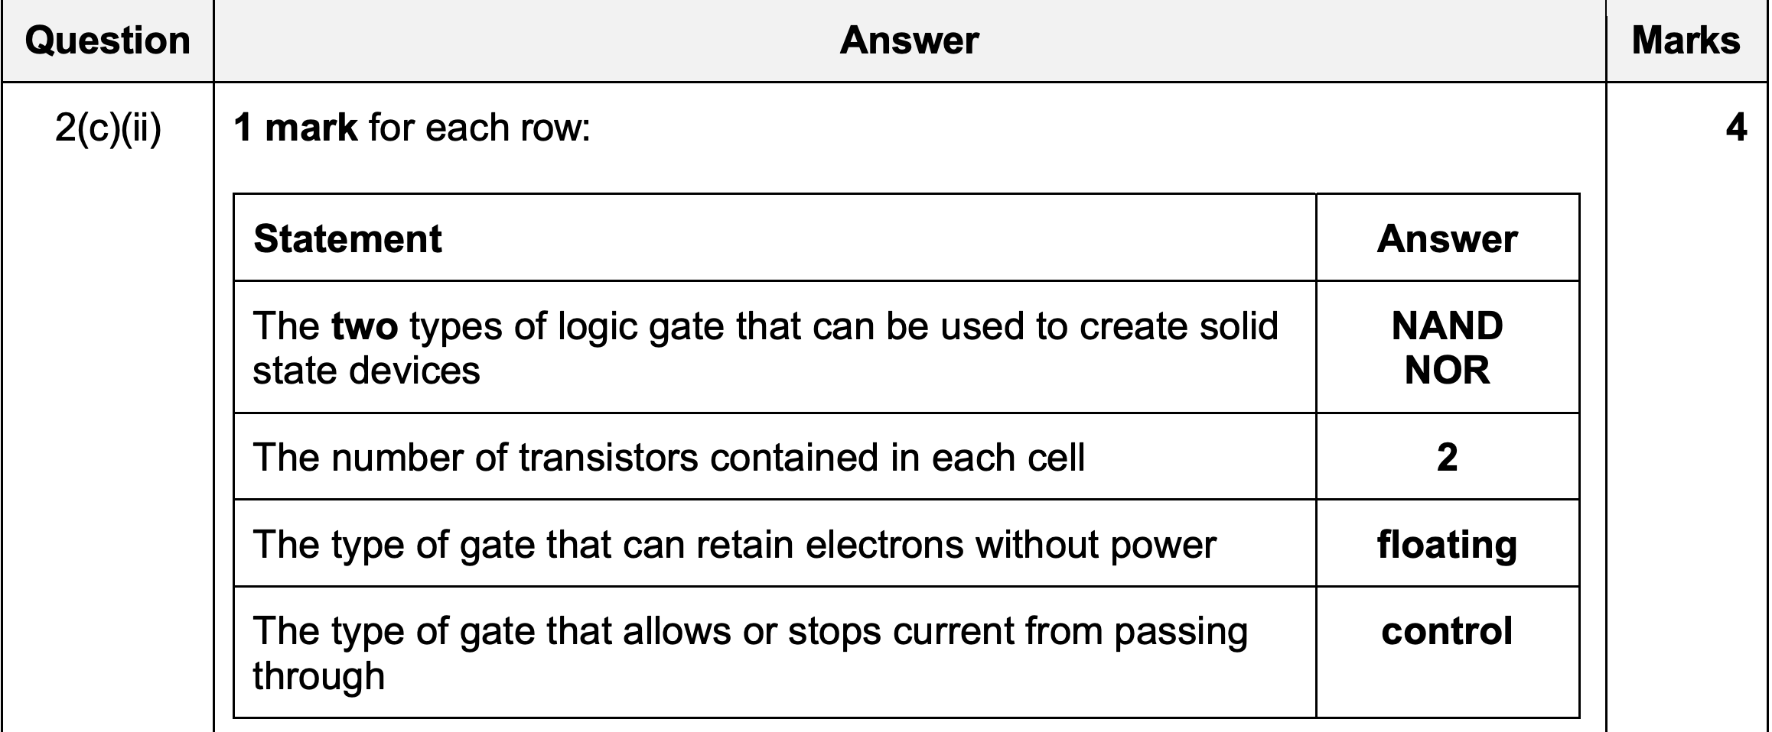

My Argument
The mark scheme answer of "2" is incorrect or, at minimum, incomplete. A flash memory cell contains one transistor, not two. The correct answer should be 1, or both 1 and 2 should be accepted.

Technical Evidence

Source 1: Wikipedia, Flash Memory
"In flash memory, each memory cell resembles a standard metal-oxide-semiconductor field-effect transistor (MOSFET) except that the transistor has two gates instead of one."
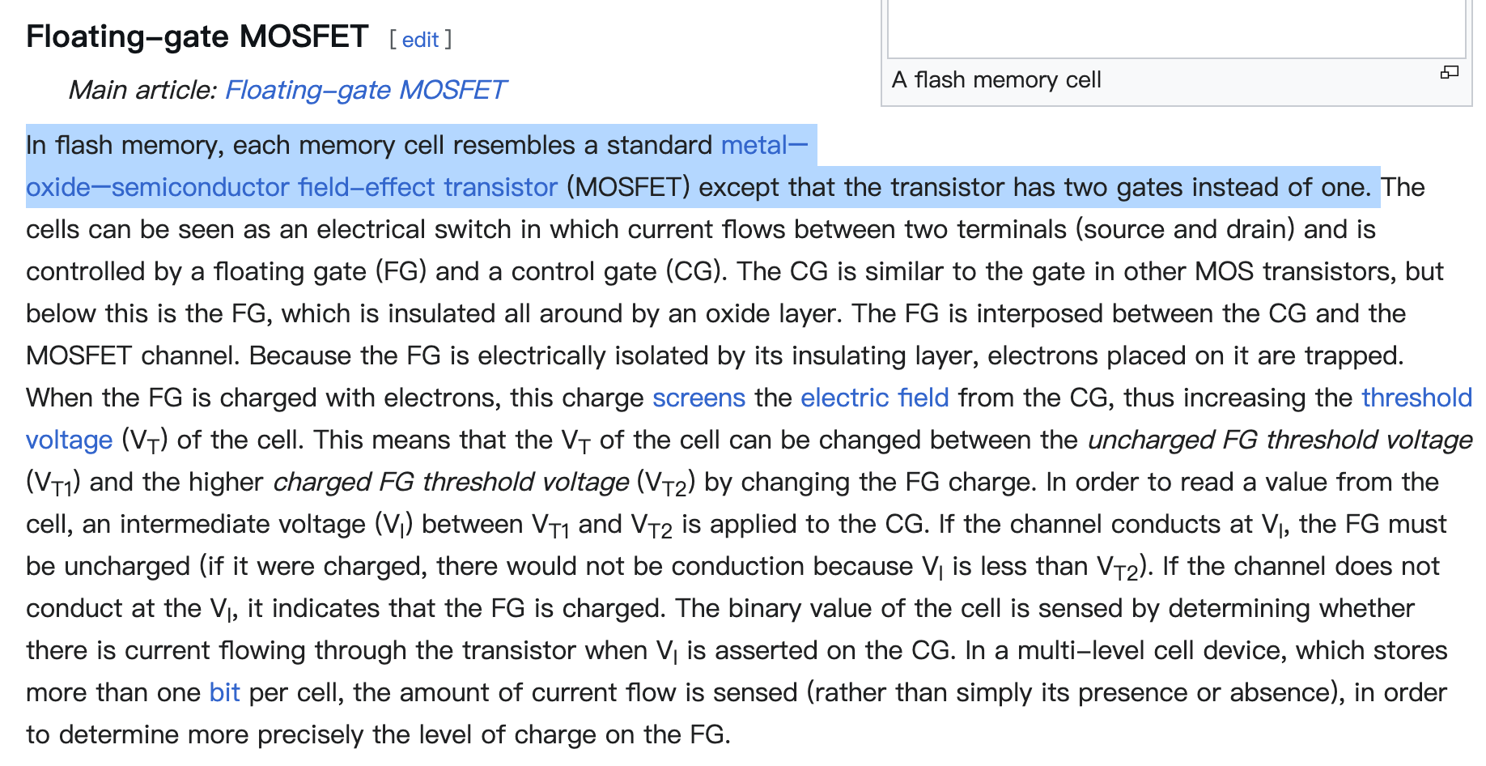
A cell with two gates is still fundamentally one transistor. The dual-gate structure (control gate + floating gate) is what enables the cell to store a bit, but the physical device count remains a single transistor per cell.

Source 2: NAND Flash Architecture
In both NAND and NOR flash architectures, each memory cell is built around a single floating-gate MOSFET. The two gates serve different functions:
Control Gate: Connected to the word line; controls read/write operations.
Floating Gate: Electrically isolated; traps charge to represent 0 or 1.
These two gates belong to the same transistor. Counting them as two separate transistors conflates gates with transistors, which are distinct concepts in semiconductor physics.

Source 3: Comparison with DRAM/SRAM
Memory Type | Transistors per Cell
DRAM | 1 transistor + 1 capacitor
SRAM | 6 transistors (typical)
Flash (NAND) | 1 transistor (floating-gate MOSFET)
Flash (NOR) | 1 transistor (floating-gate MOSFET)

If the mark scheme counts flash as having 2 transistors, it would place flash between DRAM and SRAM in density, which contradicts the well-established fact that flash memory achieves higher density than DRAM precisely because it uses only one transistor per cell.

Why Students Could Reasonably Answer "1"
1. Textbook definitions: Many A-Level textbooks describe a MOSFET as "a transistor," and a flash cell as "a MOSFET with an additional floating gate," implying one transistor with extra structure, not two transistors.
2. Exam board precedent: In the same syllabus (9618), students are taught that DRAM uses "one transistor and one capacitor per cell." If a flash cell is structurally similar (one transistor with additional components), answering "1" is a logical inference.
3. Real-world knowledge: Students who have studied hardware outside the syllabus, through personal interest, online courses, or additional reading, would encounter the standard industry description of flash as a "single-transistor cell." Penalizing these students for deeper knowledge contradicts the educational purpose of the qualification.

The Mark Scheme's Likely Reasoning (and Why It's Misleading)
The mark scheme likely counts each gate as a separate "transistor equivalent" or conflates the floating gate with a second transistor. However:
- A transistor is a three-terminal semiconductor device (source, drain, gate). A flash cell has one source, one drain, and a channel. It is one transistor.
- The floating gate is a component of the transistor, not a separate transistor.
- If the syllabus intends to highlight the dual-gate structure, the question should ask about "gates" rather than "transistors."

Timeline of Appeal
Date | Event
[First submission] | Submitted initial evidence citing Wikipedia and semiconductor references
[Rejected] | Cambridge dismissed the appeal without changing the mark scheme
[Second submission] | Resubmitted with expanded evidence: comparison diagrams, additional sources (semiconductor textbooks, NAND flash datasheets), and a line-by-line analysis of the mark scheme's contradiction with standard MOSFET theory
[~2 months later] | Cambridge acknowledged the issue and added "1" as an accepted answer to the mark scheme

Conclusion
This correction matters beyond one mark on one paper. It ensures that students who study hardware rigorously, who read beyond the textbook, who check primary sources, who think from first principles, are not penalized for their depth of understanding. If an exam board's mark scheme contradicts the technical reality of the devices it examines, the mark scheme should yield to the evidence.

Document prepared by Jiazhou Wu (Jasper) as part of a formal appeal to Cambridge International Examinations.

