**PERSONAL KEY INDICATORS OF HEART DISEASES**Date: March 13th, 2023  
TEAM BULL

**Background**  
Heart diseases also known as Cardiovascular diseases (CVDs) are the leading cause of death globally, taking an estimated 17.9 million lives each year. About half of all Americans (47%) have at least 1 of 3 key risk factors for heart disease: high blood pressure, high cholesterol, and smoking.

In this white paper, we analyze a dataset to determine the major factors that contribute to the likelihood of developing heart disease. We will see various interactive visuals of the data obtained from the diagnosis of the patients and if they have the disease or not.

The visuals and insights can help the public understand the key factors affecting heart diseases which might prompt them to take proactive measures to mitigate the risks of having heart disease. It will also significantly reduce the time taken by the medical professional to determine the patients’ problems.

**Problem Statement**  
Heart disease is a leading cause of mortality in most races in the United States, with high blood pressure, high cholesterol and smoking being the key risk factors. The 2020 Annual CDC survey data of 300k adults related to their health status contains information on risks factors as well as other key.   
The problem is how to utilize the CDC survey data to identify patterns for the likelihood of heart disease in people. Also, poor data visualization is one of the factors which creates one of the biggest overarching problems in the healthcare industry.

**Solution**  
Power BI is the interactive data visualization software used in this project for creating, striking, engaging, and meaningful data visualizations that can help to break down even the most complex and convoluted healthcare problems into manageable component parts, giving solution providers a new level of insight into how to deliver the highest quality care to patients while succeeding with their strategic goals.

**Methodology**The dataset used in this analysis is the 2020 Annual CDC survey data of 300+ thousand adults related to their health status and contains 18 attributes, including heart disease status, body mass index (BMI), smoking status, alcohol drinking status, stroke history, physical health, mental health, difficulty walking, gender, age category, race, diabetic status, physical activity, general health, sleep time, asthma history, kidney disease history, and skin cancer history. PowerBi was used to create visualizations and explore the relationships between these attributes and heart disease status.

**Findings**Our analysis, of the dataset, revealed that males were 1.6x more likely than females to have heart disease due to the effects of behavioural risk factors.  
Heart Disease diagnosis is most positively affected by the following 4 factors:

1. **Age**: Older adults aged 60 and over are 3.6x more likely than Adults aged 31 – 59, and 21x more likely than young adults aged 18-30, to have heart disease. Heart disease can happen at any age, but the risk goes up as we age partly because they are more likely to develop risk factors for heart disease, such as high blood pressure, high cholesterol, obesity, diabetes, and a sedentary lifestyle.

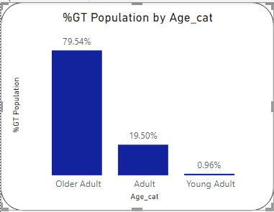

   2. **Mental health**: Grouped into 3 categories as Extreme (>15), Serious (between 6 -15) and Mild (< 6). Individuals who reported poor mental health 6 – 15 times in the past 30 days had a significantly higher likelihood of having heart disease.

Mental health conditions such as anxiety and depression can cause physiological changes in the body that increase the risk of heart disease. For example, chronic stress can lead to high blood pressure and inflammation, which can damage the blood vessels and increase the risk of heart disease.  
  
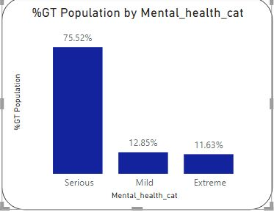

   3. **Smoking** was another major factor, with smokers having a significantly higher likelihood of developing heart disease compared to non-smokers.

This may be attributed to the negative effects of smoking on the blood vessels supplying blood to the heart, and on oxygen distribution.  
  
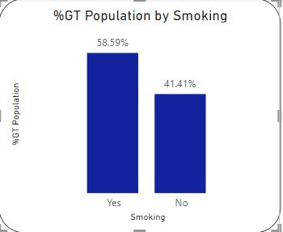

   4. **Race** was also found to be a significant factor, with Hispanic Whites and Asians having the lowest likelihood for heart disease than other racial groups.

On further drilling , it was discovered it had more to do with the culture prevalent in those races rather than the race being a causal factor on its own.  
  
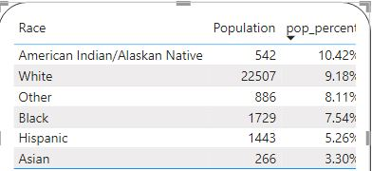

**Conclusion**The analysis highlights *age, mental health, smoking, and race* as major factors associated with heart disease. These findings can be used to develop targeted interventions and prevention strategies to reduce the incidence and prevalence of heart disease. Further research is needed to explore the underlying mechanisms that link these factors to heart disease and to identify additional risk factors that may be important for prevention and treatment.

According to WHO, the effects of behavioural risk factors may show up in individuals. Identifying those at highest risk of CVDs and ensuring they receive appropriate treatment can prevent premature deaths.

**References**

Dataset factors explanation – <https://www.kaggle.com/onatto/predicting-heart-disease-a-detailed-guide> (Kaggle)

US Department of Health and Human Services, Center for Disease Control and Prevention, and Coordinating Center for Health Promotion, “Heart Disease”, Washington DC 2022

Vector art - <https://www.freepik.com/vectors/people> (People vector created by katemangostar - [www.freepik.com](http://www.freepik.com/))

World Health Organisation, Health-center, https://www.who.int/health-topics/cardiovascular-diseases