AMORE’S
DOODLE
Product blueprint & free-build guide
A private shared canvas, playful drawing games and messaging space for two.

The two visual identities
The app will have two selectable color themes based on the reference images you supplied. Both themes use calm, warm neutrals and a deep signature color.
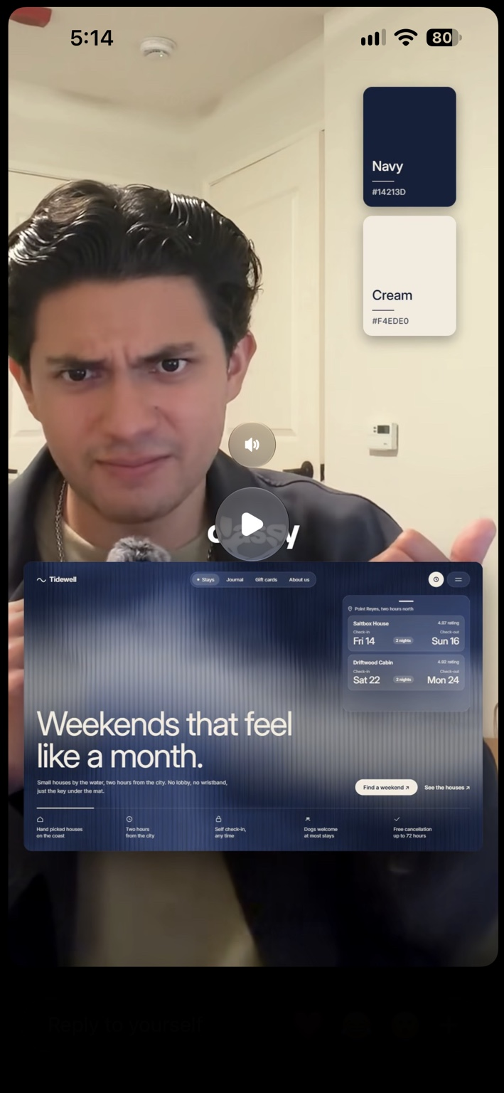
Theme A — Navy & Cream
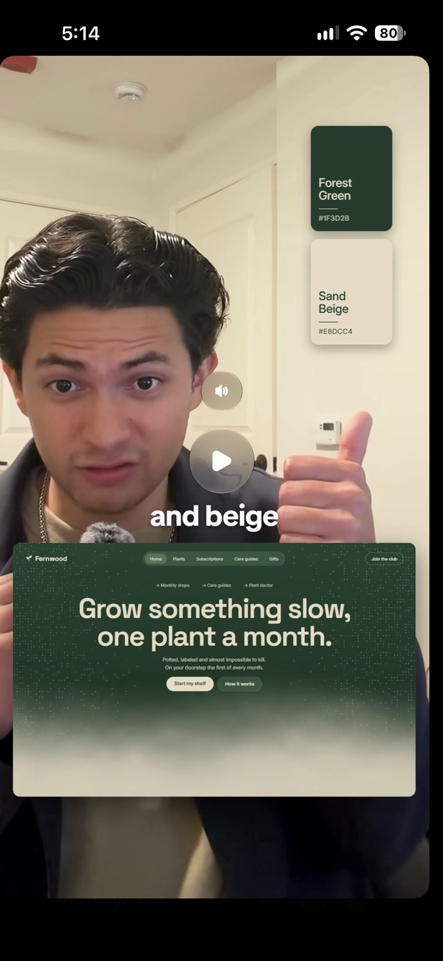
Theme B — Forest Green & Sand Beige
Theme | Primary | Background / surface | Suggested use
Navy & Cream | Navy #14213D | Cream #F4EDE0 | Default theme; calm, editorial, premium
Forest & Sand | Forest Green #1F3D2B | Sand Beige #E8DCC4 | Alternate theme; warm, natural, relaxed

Implementation note: store the selected theme in the user profile or local preferences. Use CSS variables so every screen, button, canvas toolbar and chat bubble changes consistently.

1. Product overview
Amore’s Doodle is a private, mobile-first Progressive Web App (PWA) designed for two invited people. Both users open the same app link on their iPhones and add it to their Home Screens. They can draw on a shared live canvas, play a turn-based guessing game, save artwork, send sketches in chat and exchange private text messages.
- Primary goal: make it delightful and reliable for two people, not build a public social network.
- Target devices: iPhone Safari / iOS Home Screen PWA; responsive desktop browser for development and testing.
- Distribution: one hosted URL shared privately; no App Store submission required.
- Product principle: keep the first release focused. Add advanced features only after the shared canvas and messaging are dependable.

2. Version 1 feature scope
Feature | What it does | MVP priority
Private two-person room | Create a room, invite the second person with a one-time code or invite link, restrict membership to two accounts. | Must have
Live shared canvas | Both users draw in one room; strokes appear on the other device in near real time. | Must have
Drawing tools | Pen, color palette, brush size, eraser, undo own recent stroke, clear with confirmation. | Must have
Private messages | One-to-one text chat, timestamps, emoji support, newest messages and realtime updates. | Must have
Send doodle in chat | Save/export a canvas image and attach it to a chat message. | Must have
Doodle gallery | Save finished drawings, show creator and date, reopen or share in chat. | Must have
Guess my drawing | One person chooses a secret prompt and draws; the other submits guesses; show result and switch turns. | Phase 2
Presence / typing | Show online status and a lightweight typing indicator where supported. | Phase 2
Push notifications | Optional notifications for new messages; iOS PWA support has version and installation requirements. | Later

Not in the first release: voice/video calls, public discovery, group rooms, complex moderation systems, AI image generation or paid subscriptions. These add cost and complexity without helping validate the core idea.

3. User journey
- You open the app and create an account using email authentication.
- Create a private room and generate an invitation for your girlfriend.
- She opens the invite, creates her account and joins the room. The backend verifies that the room has only two members.
- Both land on the home screen: Shared Canvas, Chat, Gallery and Guessing Game.
- When either person draws, the app sends stroke events to the room. The other phone renders those events on its canvas.
- Either person can save the finished canvas. The image is stored and appears in the shared gallery.
- A saved doodle can be attached to a private chat message.

4. Recommended free technology stack
Layer | Technology | Purpose / reason
Frontend | React + Vite | Fast setup, familiar JavaScript ecosystem, easy PWA build.
Styling | Tailwind CSS + CSS variables | Responsive layouts and both color themes.
Animation | Framer Motion | Small UI transitions, modal and page animations; keep motion subtle.
Drawing | HTML Canvas API | Pointer/touch drawing, rendering strokes and exporting PNG.
Backend platform | Supabase free tier | Authentication, Postgres database, Realtime and object storage in one service.
Hosting | Vercel free tier or another free static host | Deploy the built frontend and share one HTTPS URL.
Source control | GitHub | Private repository and version history; check current plan limits.

Avoid adding a separate custom server for the MVP. Supabase can handle the first version’s authentication, database, realtime events and image storage. This keeps deployment simple.

5. Architecture and realtime design
The iPhones do not connect directly to each other. Each browser connects securely to the hosted app and Supabase. Supabase relays authorized realtime events and stores durable records.
iPhone A (PWA) ⇄ HTTPS / Supabase ⇄ iPhone B (PWA)
Canvas event flow:
- On pointer-down / pointer-move, capture normalized coordinates (0–1), color, width and stroke ID.
- Render the local stroke immediately so drawing feels responsive.
- Broadcast compact stroke segments through a room-scoped Supabase Realtime channel. Do not insert every pointer-move into the database.
- The receiving phone listens to the same authorized room channel and draws the incoming segments.
- On pointer-up, persist a completed stroke or periodically checkpoint the canvas. This lets a user reconnect without losing the whole drawing.
- When saving, export the canvas to PNG and upload it to a private Storage bucket; insert metadata in the doodles table.
Important: use throttling or batching for pointer-move events, handle reconnects, and test on real mobile Safari. Realtime delivery is best-effort; durable saved artwork must come from Storage/database, not from assuming every transient event was received.

6. Suggested database structure
Table | Important fields | Notes
profiles | id, display_name, avatar_url, theme | id maps to authenticated user.
rooms | id, name, created_by, created_at | Private room record.
room_members | room_id, user_id, joined_at | Enforce maximum two members with a secure database function/transaction.
messages | id, room_id, sender_id, body, doodle_id, created_at | Text and optional saved-doodle attachment.
doodles | id, room_id, creator_id, storage_path, title, created_at | Private image metadata; image bytes live in Storage.
strokes (optional) | id, room_id, author_id, stroke_json, created_at | Use only if persistent stroke history/undo is needed; avoid one row per pointer event.
game_rounds (phase 2) | id, room_id, drawer_id, prompt, status, winner_id, created_at | Protect secret prompt from the guesser's query until reveal.

Use UUID primary keys, foreign keys, created_at timestamps and indexes on room_id + created_at for messages and doodles. Keep secrets and service-role keys out of frontend code.

7. Privacy and security requirements
- Enable Supabase Row Level Security (RLS) on every table exposed to the client.
- Only authenticated room members may read or write that room’s messages, doodles and membership data.
- A room invitation should be random, expiring and single-use where practical. Do not use predictable room IDs as passwords.
- Do not expose the Supabase service-role key in Vite environment variables or browser bundles. The anon/publishable key is designed for client use only when RLS is correctly configured.
- Use a private Storage bucket and Storage policies that check room membership.
- Validate message length, upload file type and upload size. Escape/render user text safely.
- Provide a leave-room or delete-room option and agree together on what content is retained.
- This is private access control, not end-to-end encryption. Do not describe the MVP as end-to-end encrypted unless a separate encryption design is implemented and reviewed.

8. Free budget and realistic limitations
Service | Free approach | Limitations to understand
Development | React, Vite, Tailwind, Canvas, Framer Motion | Open-source tools; no license fee for this use.
Backend | Supabase Free | Usage quotas apply; free projects may pause after inactivity; no guaranteed production SLA.
Hosting | Vercel Hobby / free static hosting | Plan terms and usage limits apply; verify commercial-use terms if the project becomes a business.
Domain | Use the free host subdomain | A custom domain usually costs money; not needed for testing.
iPhone installation | Safari → Share → Add to Home Screen | It is a PWA, not an App Store native app. Some iOS capabilities differ from native apps.
Apple Developer Program | Not required | No App Store listing or native TestFlight distribution in this plan.

Zero-cost target means no paid subscriptions, custom domain, Apple Developer membership or paid APIs for the MVP. Free tiers can change and are subject to quotas and provider terms. Monitor usage and avoid storing huge numbers of high-resolution images.

9. Step-by-step build plan
Step 1 — Create the project — Install Node.js LTS and Git. Create a Vite React app, install Tailwind using its current Vite setup, add React Router if needed, and create a GitHub repository.
Step 2 — Build the visual shell — Create mobile-first pages: Welcome/Login, Home, Shared Canvas, Chat, Gallery, Guessing Game and Settings. Add the two theme palettes as CSS variables and a theme toggle.
Step 3 — Configure Supabase — Create a free Supabase project. Enable email authentication, create the tables and private Storage bucket, then write and test RLS policies before connecting the UI.
Step 4 — Private room and invite — Implement create room, invite code/link, join flow and server-side enforcement of the two-member limit. Test a third account is rejected.
Step 5 — Canvas locally — Build drawing with Pointer Events so touch and mouse work. Add color, brush size, eraser, clear and export-to-PNG. Test scrolling is disabled only while drawing on the canvas.
Step 6 — Realtime canvas — Join a room-specific Realtime channel. Broadcast stroke segments, throttle event volume, render remote strokes and handle reconnects. Add save/checkpoint support.
Step 7 — Private chat — Implement message list, send form, timestamps, realtime subscription and doodle attachments. Add pagination rather than loading unlimited history.
Step 8 — Gallery and guessing — Upload PNGs to private Storage, show gallery cards and add a simple turn-based guessing round with protected prompts.
Step 9 — PWA and polish — Add manifest, app icons, theme colors, install instructions, responsive layout, loading states, empty states and accessible touch targets.
Step 10 — Deploy and test — Deploy to a free HTTPS host. Add the URL to both iPhone Home Screens. Test two separate accounts, simultaneous drawing, reconnects, chat, gallery access and unauthorized access.

10. Suggested project folder structure
amores-doodle/
├── public/
│ ├── icons/
│ └── manifest.webmanifest
├── src/
│ ├── app/
│ │ ├── App.jsx
│ │ └── routes.jsx
│ ├── components/
│ │ ├── BottomNav.jsx
│ │ ├── ThemeToggle.jsx
│ │ ├── ProtectedRoute.jsx
│ │ └── Avatar.jsx
│ ├── features/
│ │ ├── auth/
│ │ ├── room/
│ │ ├── canvas/
│ │ ├── chat/
│ │ ├── gallery/
│ │ └── guessing/
│ ├── lib/
│ │ └── supabase.js
│ ├── hooks/
│ ├── styles/
│ │ └── themes.css
│ └── main.jsx
├── .env.example
├── package.json
└── README.md

11. iPhone installation and testing
- Deploy the PWA to an HTTPS URL.
- On each iPhone, open the URL in Safari (not an in-app browser).
- Tap Share → Add to Home Screen → Add.
- Open the new Home Screen icon and sign in with the separate account.
- Join the same private room using the invitation.
- Keep both phones awake during initial realtime testing; test backgrounding and returning to the app separately.
iOS note: installable PWAs support a useful app-like experience, but browser lifecycle, background execution, notifications and storage behavior differ from native iOS apps. Do not promise reliable background delivery of chat messages in the first version.

12. MVP acceptance checklist
- ☐ Only the two invited accounts can join the private room.
- ☐ A third account cannot read room messages or doodles.
- ☐ Both phones see the same drawing while both are online.
- ☐ A reconnect does not silently erase the last saved artwork.
- ☐ Undo and clear actions behave predictably on both devices.
- ☐ Messages appear on both phones and retain their order.
- ☐ Doodle attachments open only for room members.
- ☐ Both themes have readable contrast and consistent colors.
- ☐ The app is usable at iPhone screen sizes without horizontal scrolling.
- ☐ The app works after closing and reopening from the Home Screen.

13. Estimated effort
Milestone | Estimated focused effort | Deliverable
Visual shell + themes | 3–5 hours | Polished responsive screens
Auth + private room | 3–5 hours | Two-person invitation flow
Canvas + realtime | 6–10 hours | Shared live drawing
Chat + doodle sharing | 4–7 hours | Private messages and attachments
Gallery + guessing game | 4–7 hours | Saved drawings and simple game
PWA + testing + deployment | 3–5 hours | Installable app on both iPhones

A focused MVP is roughly 2–4 days of concentrated work for someone comfortable with React, with extra time likely needed for realtime edge cases, Supabase policies and iOS testing.

14. Recommended build order
Do not build every feature at once. The fastest path is:
- First: polished home screen, login and private two-person room.
- Second: local drawing canvas, then live stroke sync between the two phones.
- Third: private text chat and send-doodle attachment.
- Fourth: gallery, then guessing game.
- Last: optional notifications, typing indicators and extra animations.

15. Reference links
- React documentation: https://react.dev/
- Vite documentation: https://vite.dev/guide/
- Tailwind CSS documentation: https://tailwindcss.com/docs
- Supabase documentation: https://supabase.com/docs
- Supabase Realtime: https://supabase.com/docs/guides/realtime
- Supabase Row Level Security: https://supabase.com/docs/guides/database/postgres/row-level-security
- Supabase Storage: https://supabase.com/docs/guides/storage
- MDN Canvas API: https://developer.mozilla.org/en-US/docs/Web/API/Canvas_API
- MDN Pointer Events: https://developer.mozilla.org/en-US/docs/Web/API/Pointer_events
- Vercel documentation: https://vercel.com/docs

