Minor Project Report On

**Inventory Management System**

For partial fulfillment of the requirement of award Of

**Diploma in Computer Engineering**



**Guru Nanak Dev Polytechnic College, Gill Park (Ludhiana)**

**SUBMITTED BY**

Amanjot Singh(170176202488) Arshdeep Singh(170176202492) Jaspreet Singh(170176202514)

**SUBMITTED TO**

S. Hardeep Singh Jawanda, HOD Computer Engineering Department

**Batch 2017-2020**

# Acknowledgement

We express our gratitude to the Principal Er. Surinder Singh Ubhi for having providing me facilities to do the project successfully.

We would like to express our special thanks of gratitude to our teachers Er. Hardeep Singh Jawanda who gave us golden opportunity to do this project on inventory management system, which also helped us in doing a lot of research and we came to know about many new things. We are really thankful to them. Secondly we are thankful to our parents and friends who helped me lot in finishing this project within limited time. We are not making this project only for marks but also to increase knowledge. We have taken efforts in this project. However, it would not have possible without the help and kind support of many individuals and organizations would like to extend my sincere thanks to all of them.

We thank our God for providing me with everything that we required in completing my project

We would like to express our gratitude towards our parents for their kind co- operation and encouragement which help me in the completion of this project.

We would like to express our special gratitude and thanks to industry persons for giving me such attention and time.

Our thanks and appreciation also to our classmates in developing the project and to the people who have willingly help us out with their abilities.

**INDEX**

1. Introduction 1
2. Acknowledgement 2
3. Index 3
4. Existing system (Analysis) 4
5. Need of system analysis 5
6. Proposed system 6
7. Project objective,project goals 7
8. Hardware and software requirements 8
9. Overview of python 9 - 15
10. Overview of database 16 – 20
11. Overview of tkinter 21 – 24
12. System design 25
13. Testing 26 – 29
14. Maintenance 30
15. Coding 31 – 59
16. Annexure 60 – 69
17. Bibliography 70

# Existing System study (Analysis)

Existing system is very slow and inefficient. Report generation is also not an easy task in the current situation. Also if the report is generated then calculations are done manually that leads to more errors. There is lot of manual word involved in current system and mistake in one detail can lead to wrong generation of page. No proper collection of requirements leads a huge problem for this system. This system is enhancing manual work and also more energy is wasted to allocate the inventory arrangement.

## Disadvantages of Existing system:-

* Time Consuming
* Less Efficient
* Less user friendly

# System Analysis

**System analysis** means to analysis means to analyse the system. It is a collection of notations, methodologies and tools that are used to collect the detail and analyse a problem situation before designing and implementing the system. "The process of studying a procedure or business to identify its goals and purposes and create systems and procedures that will achieve them in an efficient way”. Every synthesis builds upon the results of a preceding analysis, and every analysis requires a subsequent synthesis to verify and correct its results. The field of systems analysis relates closely to requirement analysis or to operations research. It is also "an explicit formal inquiry carried out to help a decision maker identify a better course of action and make a better decision than she might otherwise have made

.

# Needs of System Analysis

* 1. **System Objective:-** It is necessary to define the system objective. It is historically in operation and lost the main purpose of achievements.
  2. **System Boundaries:-** It is necessary to establish the system boundaries which would define the scope and coverage of the system. It helps to understand the functional boundaries in the system. It also helps to identify input and output of various sub-systems.
  3. **System Importance:-** It is necessary to understand the importance of the system in the organization. It would help the designer to decide the design feature of the system.
  4. **Nature of the System:-** The analysis of the system will help the system designer to understand the nature of the system one should be adaptable to that system. It is also the responsibilities of system analysts to choose the system.
  5. **Role of the System as an Interface:**- The system many times acts as an interface to the other systems. It is necessary to understand the existing role of the system as an interface.
  6. **Understanding of Resource Needs:-** The analysis of the system helps in defining the resource requirements in terms of the hardware and software.

# Proposed System

## User Friendly

This system is user friendly for the retrieval and storing of data. And it is fast to store the data. It is maintained efficiently. The graphical user interface is implemented in this proposed system. It is more efficient than existing system.

## Reports Are Easily Generated

Reports like seating arrangements can be easily generated in this proposed system by that user can generate the report as per the requirement and their wish for the duration of month or the day but not in the middle of the session.

## Very Less Paper Work

The proposed system requires very less paper work. All the data is entered into the computer immediately and reports can be generated by the help of computers. So that work will become very easy because there is no need to keep data on more papers.

## Computer Operator Control

Computer operator control is available so rate of errors will be less. Storing and retrieving of information is simple. So work can be done correct time and also good in speed.

* **Project Scope:-**Now days when everything is online, how is it possible that estate left web application behind? The scope of the project is the designing an application and it will be given to a college for future use.

## Project Objectives:-

1. The admin should have all the type of authority.
2. The admin should update the inventory system.
3. The admin user can completely manage the all inventory details.

## Project Goals :-

* **Planned Approach Towards working:-** The working in the organization will be well planned and organized information as well as its storage.
* **Accuracy:-** The level of accuracy in the proposed system cannot be decided because here students and staff can upload their information.
* **Reliability:-** The reliability of the proposed system will be high due to the above stated reason for the increased reliability of the system is that now there would be proper storage of information.

# Hardware and Software Requirements

Whenever a product is designed for its good functioning and for fulfilling all its operation, some type of operation is required. it include hardware and software processing hardware processing include use of all physical device like processor and motherboard etc.. Software processing involve code which is built to make the product in an executable state. The processing environment for this project include: -

## Hardware Requirements:-

Processor : 2.70 GHz and Above Main Memory : 2GB

Hard Disk : 100GB

Disk Space : 100MB

Keyboard : ANY

Mouse : ANY

Monitor : ANY

## Software Requirements:-

Operating System : Window

Languages : PYTHON

Data Base : MySql

Editor Used : PyCharm, Visual Studio Code

**Overview of Python**

=> What is Python?

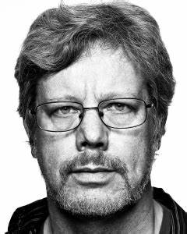Python is a popular programming language. It was created by Guido van Rossum, and released in 1991

It is used for:

1. Web development (server-side)
2. Software development
3. Mathematics
4. System scripting
5. Data science

Guido van Rossum

=> What can Python do?

1. Python can be used on a server to create web applications.
2. Python can be used alongside software to create workflows.
3. Python can connect to database systems. It can also read and modify files.
4. Python can be used to handle big data and perform complex mathematics.
5. Python can be used for rapid prototyping, or for production-ready software development.

=> Why Python?

1. Python works on different platforms (Windows, Mac, Linux, Raspberry Pi, etc.).
2. Python has a simple syntax similar to the English language.
3. Python has syntax that allows developers to write programs with fewer lines than some other programming languages.
4. Python runs on an interpreter system, meaning that code can be executed as soon as it is written. This means that prototyping can be very quick.
5. Python can be treated in a procedural way, an object-orientated way or a functional way.

=>Python compared to other programming languages.

1. Python was designed for readability, and has some similarities to the English language with influence from mathematics.
2. Python uses new lines to complete a command, as opposed to other programming languages which often use semicolons or parentheses.
3. Python relies on indentation, using whitespace, to define scope; such as the scope of loops, functions and classes. Other programming languages often use curly-brackets for this purpose

=> Class

Class is a scope area or template which is used to design the purpose of work or task it starts with ‘class’ keyword followed by their name and with the scope.

E.g. - classclassname {

}

=> Object

Object is a real time world entity the object can be seen, it has behaviour it has property. Object is a memory area inside the RAM, object has behaviour and attributes where the behaviour is method and attribute is property or data member.

“**Object means to occupy any space in RAM**”

=> Method

It is a group of instruction which is used to perform the specific task by the project

=>languages

In programming there are mainly two types of language i.e.

* Programming language
* Scripting language

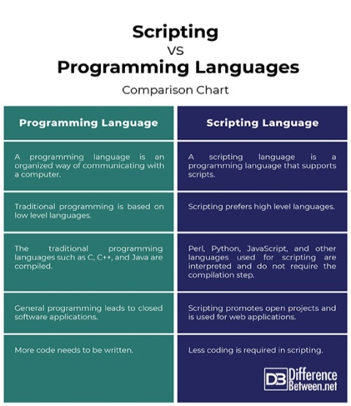To understand the basic difference you can see the difference between both.

Python is interpreted scripting language. Python variable is closely coupled with objects database as the object had by the variable. Type of the object with change. In one program, one variable can hold different type of object. This concept is known as ‘juggling’.

=> Data types in python

Like other programming language python also has data types. These data types are discussed below.

* + **String** – use to write string data. E.g. –hello.
  + **Int –** use to write integer data. E.g. – 12.
  + **Float –**use to write floating data. E.g. –12.3.
  + **Bool –** use to write Boolean data. E.g. – true.
  + **List –** use to write data in list. E.g. – [1, 2, 3, 4].
  + **Tuple –** use to write data in form of tuple. E.g. – (1, 2, 3, 4).
  + **Set** – use to write data in the form of set. E.g. – {1, 2, 3, 4}.
  + **Dict –** use to write data in the form of dict. E.g. – {‘id’:101, ‘name’: ‘abc’}

=> Operators

Operators are used to specify a particular operation in a program. There are mainly five types of operators in python.

* **Arithmetic operators –** use to specify arithmetic operations. It include operations like +, -, *, /, %, //.
* **Assignment operators –** use to specify assignment operations. It include operators like =, +=, -=, *=, %=, /=, //=.
* **Membership operators –** use to specify membership operations. There are operators like is, is not.
* **Logical operators –** use to specify logical operations. There are operators like or, and, not.
* **Identical operators –** use to specify identical operations. There are operators like in, not in.

**In python we define the memory in multiple parts.**

=> Stack

In this memory area, all the variables name, method name, constructor name are stored

**Heap memory area –** in this memory area only object is stored.

**Class area or memory area –** In this memory area all the member i.e. data member or method belong to class is stored.

=> Conditional statements

There will be various situations while writing a program when you will have to take care of different possible conditions that might arise while execution of the program. In such situations, if conditions can be used.

* If condition - if keyword and the conditional expression is ended with a **colon**. In some conditional expression is introduced that is supposed to return a Boolean value, i.e., True or False. If the resulting value is True then it is executed, which is mentioned below if condition.

E.g. -a = 7

b = 0

If (b < a):

Print (“b is greater than a”)

* If-Else condition – The statement itself tells that if a given condition is true then execute the statements present inside if block and if the condition is false then execute the else block.

E.g. – num = 5

If (num > 10):

Print (“number is greater than 10”)

Else:

Print (“number is less than 10”)

Print (“This statement will always be executed”)

* Elif condition – Elif statements are similar to if-else statements but elif statements evaluate multiple conditions.

E.g. – num = 10

If (num == 0):

Print (“Number is Zero”)

Elif (num > 5):

Print (“Number is greater than 5”)

Else:

Print (“Number is smaller than 5”)

* Nested If-Else condition -An if statement present inside another if statement which is present inside another if statements and so on.

E.g. – num = 5

If (num >0):

Print (“number is positive”)

If (num<10):

Print (“number is less than 10”)

=> lists

The list is a most versatile data type available in Python which can be written as a list of comma-separated values (items) between square brackets. Important thing about a list is that items in a list need not be of the same type. Internally we use the resizable array at data structure that means as the number of object increase in the list, the size of the list increase automatically. Lists implements all the data structure type and sorting list has predefined method to sort ascending or descending order.

Creating a list is as simple as putting different comma-separated values between square brackets. E.g. – list1 = ['physics', 'chemistry', 1997, 2000];

list2 = [1, 2, 3, 4, 5];

list3 = ["a", "b", "c", "d"]

=> Dictionary

Python have dictionary object which is used to store the data as user defined key and user defined values.

E.g. – dict = {'Name': 'Zara', 'Age': 7, 'Class': 'First'}

=> Functions

A function is a block of organized, reusable code that is used to perform a single, related action. Functions provide better modularity for your application and a high degree of code reusing or we can define function as a group of instruction which is used to perform a specific task.

🡪 Purpose of function

* Increase the efficiency – that means one set of logic can implement multiple time in single file or in multiple file.
* Performance – that means less consumption of memory that is RAM function consume memory only when they are called after produce output it release memory immediately.

🡪 Types of Function

* Function have no arguments and no return type

E.g. – def fun ( ):

Print (“welcome to python”)

Fun ()

* Function have argument and no return type

E.g. – def fun (name)

Print (“your name is”, name)

Fun (“govind”)

Name=input (“enter name”)

Fun (name)

* Function have argument and return type

E.g. – def fun (a+b)

Return a+b

A = int (input (“enter value”))

B = int (input (“enter value”))

Sum fun3 (a, b)

Print (“sum=”, sum)

* Function have no argument but have return type

E.g. – def fun ( ):

Return (“all employees’ record”)

Print (fun ( ))

=> Recursion

Recursion is a way of programming or coding a problem, in which a function calls itself one or more times in its body. Usually, it is returning the return value of this function call. If a function definition fulfils the condition of recursion, we call this function a recursive function.

e.g. – def rec (a)

If a<=10:

Print (a)

a+=1

rec (a)

There is one more type of recursive function known as mutually recursive function

In this two or more function call each other in place of calling itself.

E.g. – def rec1 (a):

If a<=10:

Print (“rec1=”, a)

a+=1

rec2 (a)

def rec2 (a)

If a<=10:

Print (“rec2”,a)

a+=1

rec1 (a)

rec (1)

=> Module

This concept includes the data of one file to another file either the file inside the same folder or package or in different folder or package. In python package represents the logical container which contain similar type of class or file or we can say that A module allows you to logically organize your Python code. Grouping related code into a module makes the code easier to understand and use. A module is a Python object with arbitrarily named attributes that you can bind and reference. Simply, a module is a file consisting of Python code. A module can define functions, classes and variables. A module can also include runnable code.

E.g. - def print_func (par):

Print "Hello: “par”

Return

**Overview of Database**

=> Introduction

The Python standard for database interfaces is the Python DB-API. Most Python database interfaces adhere to this standard.

You can choose the right database for your application. Python Database API supports a wide range of database servers such as −

* GadFly
* mSQL
* MySQL
* PostgreSQL
* Microsoft SQL Server 2000
* Informix
* Interbase
* Oracle
* Sybase

We used MySQL to create database in python we created with the help of xampp.

=> Xampp

XAMPP is a free and open _source cross platform web server solution stack package developed by Apache Friends, consisting mainly of the Apache HTTP Server, Maria DB database, and interpreters for the scripts written in the PHP and Perl programming languages. Since most actual Web server deployments use the same components as XAMPP, it makes transitioning from a local test server to a live server possible.

=> Installation of xampp

* Install XAMPP.
* Assume you install xampp in your C drive, so go to: C:\xampp\htdocs.
* Create your own folder;name it for example as **tutorialspoint.**
* Now create your first PHP program in xampp and name it as**“add.php”**.

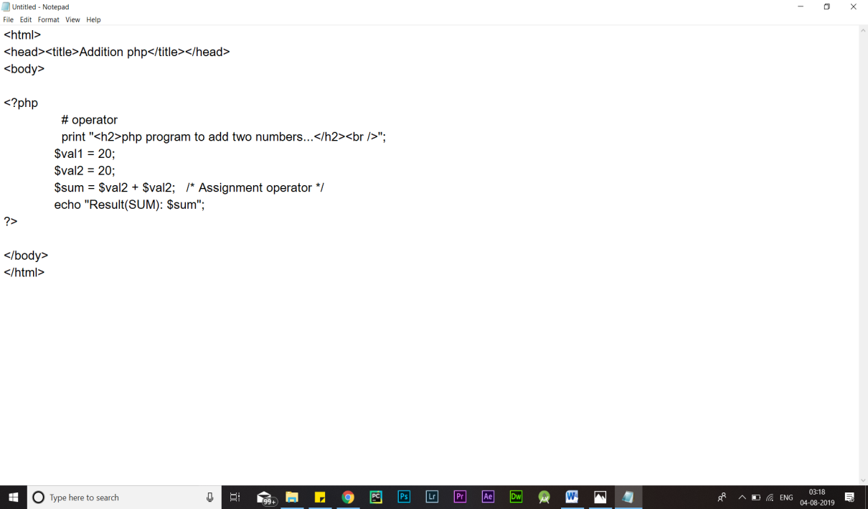

* 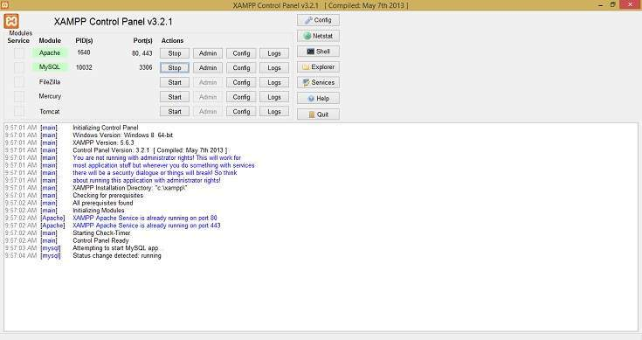Now double click on “**XAAMP CONTROL PANEL**” on desktop and START “**Apache**”
* 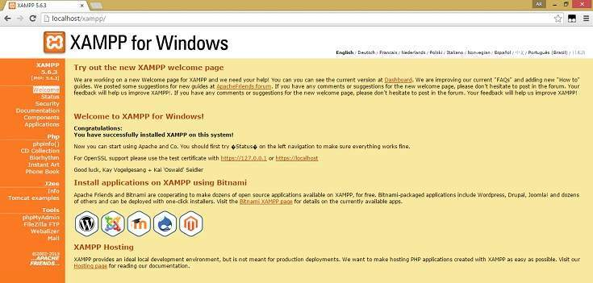Type **local host** on your browser and press enter:
* Now type the following on Browser

**http://localhost/tutorialspoint/**  
 below screenshot shows PHP files created under folder “tutorialspoint”

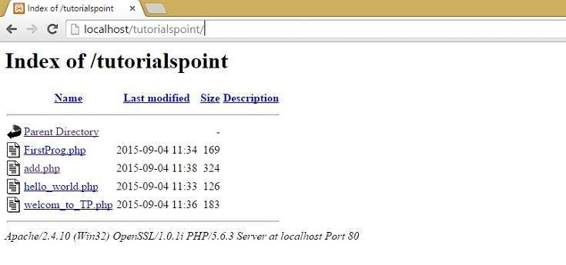

* Click on “**add.php**” and it will show the following.

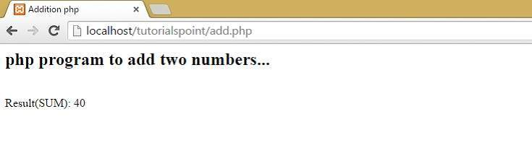

=> Queries

Database has different queries to perform specific function . we had divided queries in 4 types.

* + DML – these are used for data manipulation, It include operations like insert, delete.
  + DDL – these are used for data definition, it include functions like create, alter, drop.
  + DCL – these are used for data control, it include functions like grant, revoke.
  + TCL – these are used for transaction control, it include operations like begin, comment, rollback.

**For establishing connection we use command “mysql –u root –p”**

=> Oops in python

Object us a memory area inside the RAM, the object property is also called as instance method.

Class is like a template or a scope where we define the method and data member to perform the task we have object level data member and method and class level data member methods.

=> Casing

* Pascal casing – every word’s first letter is big like A, B, C, D, P, O.
* Camel casing – first letter of word is small and the next letter is capital.
* Snake casing – like dept_name where the underscore (_) take place in small words.

=> Method

It is a group of instruction which is used to perform a specific task.

E.g. -

Class C:

def my_method(self):

Print "I am a C"

c = C()

c.my_method ()

=> Constructor

Constructors are generally used for instantiating an object. The task of constructors is to initialize (assign values) to the data members of the class when an object of class is created. In Python the __init__ () method is called the constructor and is always called when an object is created.

E.g. – class A:

Def __int__ (self):

print (“constructor is called”)

Def __int__ (self):

print (“destructor is called”)

=> Overloading

Operator overloading lets you redefine the meaning of operator respective to your class. It is the magic of operator overloading that we were able to use the + operator to add two numbers objects, as well as concatenate two string objects.

=> Overriding

Override means having two methods with the same name but doing different tasks. It means that one of the methods overrides the other. If there is any method in the superclass and a method with the same name in a subclass, then by executing the method, the method of the corresponding class will be executed.

=> Inheritance

When parent class is extended by the child class then child class can inherit all the

public and protected property of parent class that means it can access all data members and method which are public and protected this relation is called Inheritance .These are mainly of five types :-

* Single inheritance
* Multiple inheritance
* Multilevel inheritance
* Hierarchical inheritance
* Hybrid inheritance

**Overview of Tkinter**

=> Introduction

Python provides various options for developing graphical user interfaces (GUIs). Most important are listed below.

* **Tkinter** − Tkinter is the Python interface to the Tk GUI toolkit shipped with Python. We would look this option in this chapter.
* **WXPython** − this is an open-source Python interface for windows [http://wxpython.org](http://wxpython.org/).
* **JPython** − JPython is a Python port for Java which gives Python scripts seamless access to Java class libraries on the local machine [http://www.jython.org](http://www.jython.org/).

Tkinter is the standard GUI library for Python. Python when combined with Tkinter provides a fast and easy way to create GUI applications. Tkinter provides a powerful object-oriented interface to the Tk GUI toolkit.

Creating a GUI application using Tkinter is an easy task. All you need to do is perform the following steps −

* Import the *Tkinter* module.
* Create the GUI application main window.
* Add one or more of the above-mentioned widgets to the GUI application.
* Enter the main event loop to take action against each event triggered by the user.

In Tkinter the main work we do is that we put different widgets on the screen and provide some command to them when clicked, solet’s discuss different widgets in Tkinter.

=> Button

The Button widget is used to add buttons in a Python application. These buttons can display text or images that convey the purpose of the buttons. You can attach a function or a method to a button which is called automatically when you click the button.

=> Canvas

The Canvas is a rectangular area intended for drawing pictures or other complex layouts. You can place graphics, text, widgets or frames on a Canvas.

=> Check button

The Check button widget is used to display a number of options to a user as toggle buttons. The user can then select one or more options by clicking the button corresponding to each option.

=> Entry

The Entry widget is used to accept single-line text strings from a user.

=> Frame

The Frame widget is very important for the process of grouping and organizing other widgets in a somehow friendly way. It works like a container, which is responsible for arranging the position of other widgets.

=> Label

This widget implements a display box where you can place text or images. The text displayed by this widget can be updated at any time you want.

=> List box

The List box widget is used to display a list of items from which a user can select a number of items.

=> Menubutton

A menubutton is the part of a drop-down menu that stays on the screen all the time. Every menubutton is associated with a Menu widget that can display the choices for that menubutton when the user clicks on it.

=> Menu

The goal of this widget is to allow us to create all kinds of menus that can be used by our applications. The core functionality provides ways to create three menu types: pop-up, top-level and pull-down.

=> Message

This widget provides a multiline and noneditable object that displays texts, automatically breaking lines and justifying their contents.

=> Radiobutton

This widget implements a multiple-choice button, which is a way to offer many possible selections to the user and lets user choose only one of them.

=> Scale

The Scale widget provides a graphical slider object that allows you to select values from a specific scale.

=> Scrollbar

This widget provides a slide controller that is used to implement vertical scrolled widgets, such as Listbox, Text and Canvas. Note that you can also create horizontal scrollbars on Entry widgets.

=> Text

Text widgets provide advanced capabilities that allow you to edit a multiline text and format the way it has to be displayed, such as changing its colour and font.

=> Toplevel

Toplevel widgets work as windows that are directly managed by the window manager. They do not necessarily have a parent widget on top of them.

=> Spinbox

The Spinbox widget is a variant of the standard Tkinter Entry widget, which can be used to select from a fixed number of values.

=> Panned windows

A PanedWindow is a container widget that may contain any number of panes, arranged horizontally or vertically.

=> Labelframe

A labelframe is a simple container widget. Its primary purpose is to act as a spacer or container for complex window layouts.

=> Geometry management

All Tkinter widgets have access to specific geometry management methods, which have the purpose of organizing widgets throughout the parent widget area. Tkinter exposes the following geometry manager classes: pack, grid, and place.

* [The pack () Method](https://www.tutorialspoint.com/python/tk_pack.htm) − this geometry manager organizes widgets in blocks before placing them in the parent widget.
* [The grid () Method](https://www.tutorialspoint.com/python/tk_grid.htm) − this geometry manager organizes widgets in a table-like structure in the parent widget.
* The place () Method − this geometry manager organizes widgets by placing them in a specific position in the parent widget.

# System Design

Design or system design is the fourth phase of the System Development Lifecycle which is basically a transformation of a system analysis. It is creative and challenging phase of System Development Lifecycle. It is designed according to the logical design that how should it is automated, how should we use the readymade software, how should we design local area networking and how much technologies might be used in the system.

#  

**User**

**Database**

**Inventory**

**System**

**STOCK**

**DELETED ITEMS**

**STATIONARY**

**ASSET**

**CONTY**

## Testing

## Software testing:-

Software testing is the process used to measure the [quality](http://en.wikipedia.org/wiki/Software_quality) of developed [computer](http://en.wikipedia.org/wiki/Computer_software) [software](http://en.wikipedia.org/wiki/Computer_software). Usually, quality is constrained to such topics as [correctness](http://en.wikipedia.org/wiki/Correctness), completeness, [security](http://en.wikipedia.org/wiki/Computer_security_audit), but can also include more technical requirements as described under the [ISO](http://en.wikipedia.org/wiki/International_Organization_for_Standardization) standard [ISO 9126](http://en.wikipedia.org/wiki/ISO_9126), such as capability, [reliability](http://en.wikipedia.org/wiki/Reliability), [efficiency](http://en.wikipedia.org/wiki/Algorithmic_efficiency), [portability](http://en.wikipedia.org/wiki/Porting), [maintainability](http://en.wikipedia.org/wiki/Maintainability), compatibility, and [usability](http://en.wikipedia.org/wiki/Usability). Testing is a process of technical investigation, performed on behalf of stakeholders, that is intended to reveal quality-related information about the product with respect to the context in which it is intended to operate.

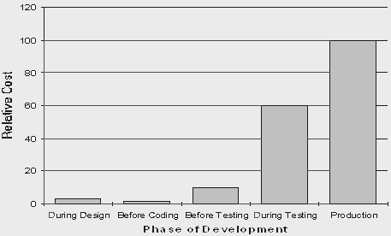

## White box, black box, and grey box testing

White box and black box testing are terms used to describe the point of view that a test engineer takes when designing test cases. Black box testing treats the software as a black-box without any understanding as to how the internals behave. Thus, the tester inputs data and only sees the output from the test object. This level of testing usually requires thorough test cases to be provided to the tester who then can simply verify that

for a given input, the output value (or behavior), is the same as the expected value specified test case.

**White box testing**, however, is when the tester has access to the internal data structures, code, and algorithms. For this reason, unit testing and debugging can be classified as white-box testing and it usually requires writing code, or at a minimum, stepping through it, and thus requires more skill than the black-box tester. If the software in test is an interface or API of any sort, white-box testing is almost always required.

In recent years the term grey box testing has come into common usage. This involves having access to internal data structures and algorithms for purposes of designing the test cases, but testing at the user, or black-box level. Manipulating input data and formatting output do not qualify as grey-box because the input and output are clearly outside of the black-box we are calling the software under test. This is particularly important when conducting integration testing between two modules of code written by two different developers, where only the interfaces are exposed for test.

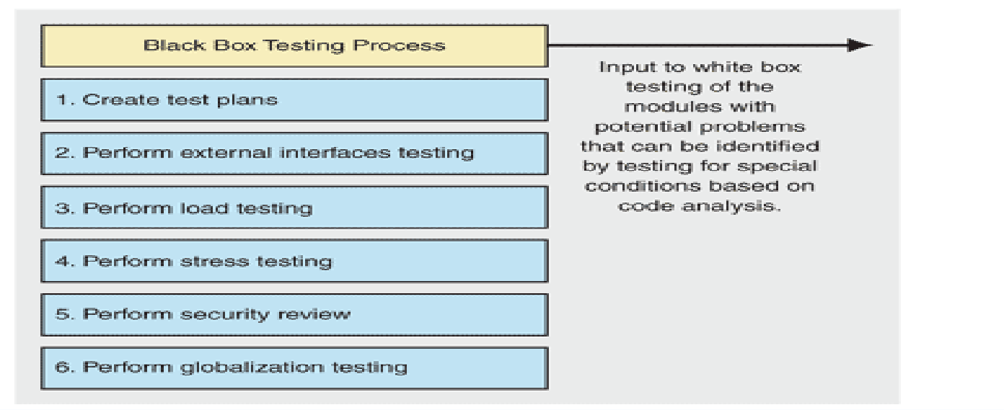**Grey box testing** could be used in the context of testing a client-server environment when the tester has control over the input, inspects the value in a SQL database, and the output value, and then compares all three (the input, sql value, and output), to determine if the data got corrupt on the database insertion or retrieval.

* **Unit testing** tests the minimal software component, or module. Each unit (basic component) of the software is tested to verify that the detailed design for the unit has been correctly implemented. In an Object-oriented environment, this is usually at the class level, and the minimal unit tests include the constructors and destructors.
* **Integration testing** exposes defects in the interfaces and interaction between integrated components (modules). Progressively larger groups of tested software components corresponding to elements of the architectural design are integrated and tested until the software works as a system.
* **Functional testing** tests at any level (class, module, interface, or system) for proper functionality as defined in the specification.
* **System testing** tests a completely integrated system to verify that it meets its requirements.
* **System integration** testing verifies that a system is integrated to any external or third party systems defined in the system requirements.
* **Acceptance testing** can be conducted by the end-user, customer, or client to validate whether or not to accept the product. Acceptance testing may be performed as part of the hand-off process between any two phases of development.
  + **Alpha testing** is simulated or actual operational testing by potential users/customers or an independent test team at the developers' site. Alpha testing is often employed for off-the-shelf software as a form of internal acceptance testing, before the software goes to beta testing.
  + **Beta testing** comes after alpha testing. Versions of the software, known as beta versions, are released to a limited audience outside of the company. The software is released to groups of people so that further testing can ensure the product has few faults or bugs. Sometimes, beta versions are made available to the open public to increase the feedback field to a maximal number of future users.

It should be noted that although both Alpha and Beta are referred to as testing it is in fact use immersion. The rigors that are applied are often unsystematic and many of the basic tenets of testing process are not used. The Alpha and Beta period provides insight into environmental and utilization conditions that can impact the software.

After modifying software, either for a change in functionality or to fix defects, a regression test re-runs previously passing tests on the modified software to ensure that the modifications haven't unintentionally caused a regression of previous functionality. Regression testing can be performed at any or all of the above test levels. These regression tests are often automated.

# Maintenance

The maintenance phase involves making changes to hardware, software, and documentation to support its operational effectiveness. It includes making changes to improve a system’s performance, correct problems, enhance security, or address user requirements. To ensure modifications do not disrupt operations or degrade a system’s performance or security, organizations should establish appropriate change management standards and procedures.

Routine changes are not as complex as major modifications and canusually be implemented in the normal course of business. Routine change controls should include procedures for requesting, evaluating, approving, testing, installing, and documenting software modifications. Maintaining accurate, up-to-date hardware and software inventories is a critical part of all change management processes. Management should carefully document all modifications to ensure accurate system inventories. Management should coordinate all technology related changes through an oversight committee and assign an appropriate party responsibility for administering software patch management programs. Quality assurance, security, audit, regulatory compliance, network, and end- user personnel should be appropriately included in change management processes. Risk and security review should be done whenever a system modification is implemented to ensure controls remain in place.

For maintenance of the software:

1. The database has to be updated regularly according to new available information.
2. Redundant and false information must be removed from the database.
3. Newer version of PYTHON and MYSQL can be used for up gradation of software and to improve the overall performance of the system.

# Index.html

**<!doctype html>**

**<html lang="en">**

**{% load static %}**

**<link rel="shortcut icon" href="{%static 'images/linklogo.png' %}">**

**<img src="{% static 'images/linklogo.png' %}" style="display:none;">**

**<!-- Pre-loader screen -->**

**<style>**

**@media screen and (min-width: 150px)**

**{**

**.my-pre-loader{position: absolute;width: 100%;height: 100%;background-color: rgb(255, 231, 255);z-index: 99;touch-action: none;}**

**.my-pre-loader .my-loader {**

**position: absolute;**

**top: 50%;**

**left: 40%;**

**margin-left: 10%;**

**transform: translate3d(-50%, -50%, 0);}**

**.my-pre-loader .dot {**

**width: 18px;**

**height: 18px;**

**background: #3ac;**

**border-radius: 100%;**

**display: inline-block;**

**animation: slide 1s infinite;}**

**.my-pre-loader .dot:nth-child(1) {animation-delay: 0.1s;background: #32aacc;}**

**.my-pre-loader .dot:nth-child(2) {animation-delay: 0.2s;background: #64aacc;}**

**.my-pre-loader .dot:nth-child(3) {animation-delay: 0.3s;background: #96aacc;}**

**.my-pre-loader .dot:nth-child(4) {animation-delay: 0.4s;background: #c8aacc;}**

**.my-pre-loader .dot:nth-child(5) {animation-delay: 0.5s;background: #faaacc;}**

**@-moz-keyframes slide {**

**0% {transform: scale(1);}**

**50% {opacity: 0.3;transform: scale(2);}**

**100% {transform: scale(1);}**

**}**

**@-webkit-keyframes slide {**

**0% {transform: scale(1);}**

**50% {opacity: 0.3;transform: scale(2);}**

**100% {transform: scale(1);}**

**}**

**@-o-keyframes slide {**

**0% {transform: scale(1);}**

**50% {opacity: 0.3;transform: scale(2);}**

**100% {transform: scale(1);}**

**}**

**@keyframes slide {**

**0% {transform: scale(1);}**

**50% {opacity: 0.3;transform: scale(2);}**

**100% {transform: scale(1);}**

**}**

**.my-pre-loader .my-loading:after {**

**position: absolute;**

**font-size: 21px;**

**content: '.';**

**font-family: lato;**

**animation: dots 1s steps(5, end) infinite;}**

**@keyframes dots {**

**0%, 20% {color: rgba(0,0,0,0);text-shadow:.25em 0 0 rgba(0,0,0,0),.5em 0 0 rgba(0,0,0,0);}**

**40% {color: rgb(0, 0, 0);text-shadow:.25em 0 0 rgba(0,0,0,0),.5em 0 0 rgba(0,0,0,0);}**

**60% {text-shadow:.25em 0 0 rgb(0, 0, 0),.5em 0 0 rgba(0,0,0,0);}**

**80%, 100% {text-shadow:.25em 0 0 rgb(0, 0, 0),.5em 0 0 rgb(0, 0, 0);}}**

**.my-pre-loader .my-loader h2{text-align: left;font-family: Merriweather;font-weight: bold;font-size: 21px;margin-left: 6px;margin-top: 10px;}**

**}**

**body{overflow: hidden;}**

**@media screen and (min-width: 600px)**

**{**

**.my-pre-loader{position: absolute;width: 100%;height: 100%;background-color: rgb(255, 231, 255);z-index: 99;}**

**.my-pre-loader .my-loader {**

**position: absolute;**

**top: 50%;**

**left: 40%;**

**margin-left: 10%;**

**transform: translate3d(-50%, -50%, 0);**

**}**

**.my-pre-loader .dot {**

**width: 34px;**

**height: 34px;**

**background: #3ac;**

**border-radius: 100%;**

**display: inline-block;**

**animation: slide 1s infinite;**

**}**

**.my-pre-loader .dot:nth-child(1) {animation-delay: 0.1s;background: #32aacc;}**

**.my-pre-loader .dot:nth-child(2) {animation-delay: 0.2s;background: #64aacc;}**

**.my-pre-loader .dot:nth-child(3) {animation-delay: 0.3s;background: #96aacc;}**

**.my-pre-loader .dot:nth-child(4) {animation-delay: 0.4s;background: #c8aacc;}**

**.my-pre-loader .dot:nth-child(5) {animation-delay: 0.5s;background: #faaacc;}**

**@-moz-keyframes slide {**

**0% {transform: scale(1);}**

**50% {opacity: 0.3;transform: scale(2);}**

**100% {transform: scale(1);}**

**}**

**@-webkit-keyframes slide {**

**0% {transform: scale(1);}**

**50% {opacity: 0.3;transform: scale(2);}**

**100% {transform: scale(1);}**

**}**

**@-o-keyframes slide {**

**0% {transform: scale(1);}**

**50% {opacity: 0.3;transform: scale(2);}**

**100% {transform: scale(1);}**

**}**

**@keyframes slide {**

**0% {transform: scale(1);}**

**50% {opacity: 0.3;transform: scale(2);}**

**100% {transform: scale(1);}**

**}**

**.my-pre-loader .my-loading:after {**

**position: absolute;**

**font-size: 34px;**

**content: '.';**

**font-family: lato;**

**animation: dots 1s steps(5, end) infinite;}**

**@keyframes dots {**

**0%, 20% {color: rgba(0,0,0,0);text-shadow:.25em 0 0 rgba(0,0,0,0),.5em 0 0 rgba(0,0,0,0);}**

**40% {color: rgb(0, 0, 0);text-shadow:.25em 0 0 rgba(0,0,0,0),.5em 0 0 rgba(0,0,0,0);}**

**60% {text-shadow:.25em 0 0 rgb(0, 0, 0),.5em 0 0 rgba(0,0,0,0);}**

**80%, 100% {text-shadow:.25em 0 0 rgb(0, 0, 0),.5em 0 0 rgb(0, 0, 0);}}**

**.my-pre-loader .my-loader h2{text-align: left;font-family: Merriweather;font-weight: bold;font-size: 34px;margin-left: 14px;margin-top: 20px;}**

**}**

**</style>**

**<div class="my-pre-loader" id="p-loader">**

**<div class="my-loader">**

**<div class="dot"></div>**

**<div class="dot"></div>**

**<div class="dot"></div>**

**<div class="dot"></div>**

**<div class="dot"></div>**

**<br><h2><p class="my-loading">Loading</p></h2>**

**</div>**

**</div>**

**<script>**

**function myloader(){**

**var l = document.getElementById("p-loader");**

**l.style.display = "none";**

**document.body.style.overflow = 'visible';**

**}**

**</script>**

**<!-- main-website-content -->**

**<head>**

**<!-- Required meta tags -->**

**<meta charset="utf-8">**

**<meta name="viewport" content="width=device-width, initial-scale=1, shrink-to-fit=no">**

**<!-- Bootstrap CSS -->**

**<link rel="stylesheet" href="https://stackpath.bootstrapcdn.com/bootstrap/4.4.1/css/bootstrap.min.css" integrity="sha384-Vkoo8x4CGsO3+Hhxv8T/Q5PaXtkKtu6ug5TOeNV6gBiFeWPGFN9MuhOf23Q9Ifjh" crossorigin="anonymous">**

**<link rel="stylesheet" href="https://cdnjs.cloudflare.com/ajax/libs/font-awesome/4.7.0/css/font-awesome.min.css">**

**<link rel="stylesheet" href="https://fonts.googleapis.com/css?family=Lato|Pacifico|Raleway|Merriweather&display=swap" onload="myloader()">**

**<title>Emotional Intelligence Test</title>**

**</head>**

**<script>history.pushState(null, null, '/');window.history.back();</script>**

**<script src="//code.jquery.com/jquery-1.11.1.min.js"></script>**

**<script language=JavaScript>**

**$(document).ready(function (e) {**

**$(document).bind("contextmenu",function(e) {**

**return false;**

**});**

**});**

**</script>**

**<script>**

**document.onkeydown = function(e){**

**if (e.ctrlKey &&**

**(e.keyCode === 67 ||**

**e.keyCode === 86 ||**

**e.keyCode === 85 ||**

**e.keyCode === 73 ||**

**e.keyCode === 117)) {**

**return false;}**

**else{**

**if (e.keyCode === 123)**

**{**

**return false;**

**}**

**else {**

**return true;**

**}**

**};}**

**</script>**

**<!-- As a heading -->**

**<!-- CSS -->**

**<style>**

**html{scroll-behavior: smooth;}**

**\* {margin:0;padding:0}**

**body{overscroll-behavior-y: none;}**

**@media screen and (min-width: 150px)**

**{**

**#nav1{**

**height: 65px;**

**box-shadow: 0 6px 6px 0 rgba(0, 0, 0, 0.183);**

**-webkit-animation-name: fade;**

**-webkit-animation-duration: 0.8s;**

**animation-name: fade;**

**animation-duration: 0.8s;}**

**#nav2{**

**height: 65px;**

**box-shadow: 0 6px 6px 0 rgba(0, 0, 0, 0.183);**

**display: none;**

**-webkit-animation-name: fade;**

**-webkit-animation-duration: 0.5s;**

**animation-name: fade;**

**animation-duration: 0.5s;}**

**@-webkit-keyframes fade {**

**from {opacity: .2}**

**to {opacity: 1}**

**}**

**.container{width: 95%;}**

**.img-thumbnail{**

**height: 47vw;**

**}**

**.logo{**

**font-weight: bold;**

**margin-top: 8px;**

**}**

**.nav_img{**

**height: 55px;**

**margin-top: -8px;**

**}**

**.menu{**

**position: absolute;**

**margin-left: -16px;**

**margin-top:80px;**

**/* margin-top: 139.2px; */**

**top: -24px;**

**width: 100%;**

**color: rgb(255, 255, 255);**

**background-color: rgba(255, 255, 255, 0.979);**

**text-align: center;**

**display: none;**

**box-shadow: 0 5px 5px 0 rgba(0, 0, 0, 0.183);**

**right: 0;}**

**.menu a{**

**font-size: 1vw;**

**display: flex;**

**margin: 10px;**

**margin-right: 10px;**

**text-align: center;**

**padding-left: 23%;**

**padding-right: 28%;**

**font: 17px lato;**

**color: rgb(0, 0, 0);**

**border-radius: 5px;**

**text-decoration: none;**

**text-transform: uppercase;**

**border: 2px solid transparent;**

**padding-bottom: 0.425em;**

**padding-top: 0.425em;**

**transition: border-color 200ms linear 0ms;}**

**.menu a:hover{border-color: #c6c6c6;}**

**.btn-container{display: inline-flex;margin-top: 10px;}**

**.menu-button a{**

**margin-left: 15px;**

**text-decoration: none;**

**float: right;**

**position: relative;**

**/* right: 50; */**

**/* top: -4; */**

**margin-top: -15px;**

**padding-right: 1vw;**

**/* padding-top: 2.4vw; */**

**font-size: 42px;**

**font-family: pacifico;**

**font-weight: bolder;**

**color: #00851f;**

**transition: 0.2s ease;**

**-ms-transform: translate(3%, 11%);}**

**.menu-button a:hover{color: rgb(0, 0, 0);}**

**.menu i a .btn2{display: inline-flex;color: rgb(0, 0, 0);border: none; font: 17px lato;font-weight: bold;text-transform: uppercase;padding: 0px;background-color: white;}**

**.menu i a .btn2:hover{background-color: rgba(255, 255, 255, 0);}**

**.btn-container i{display: none;}**

**.btn-outline-success{**

**margin-top: -2px;**

**color:#258e3e;**

**border: 0.5px solid #0b9f2e;**

**display: inline-block;**

**font-size: 10px;**

**transition: all 150ms linear;}**

**.menu b a button{display: none;}**

**.menu .main-btn2{display: none;margin: 0px;padding: 0px;}**

**.btn-outline-success:hover{background-color: #10ba38;}**

**.heading{font-weight: bold;font-size: 25px;}**

**.navbar{height: 70px;}**

**.card-h{font-size: 5vw;height: 8px;vertical-align: middle;}**

**.card-body{font-weight:lighter;font: 1vw lato;text-align: justify;}**

**.card-img{margin-top: 10px;height: 100%;width: 100%;}**

**.card-title{font: 5.4vw lato;font-weight: bold;}**

**.def-head{font: 4.2vw lato;font-weight: bold;}**

**.card-text{font-weight: lighter;font: 3.9vw lato;text-align: justify;}**

**.card-desktop{display: none;}**

**.card-mobile{display: block;}**

**.form{**

**background-color: rgba(245, 243, 243, 0.7);**

**/* height: 150px; */**

**border-radius: 5px;**

**}**

**.received{display: none;margin: 10px;}**

**.received img{width: 22%;height: 22%;margin: 0px;margin-top: 75px;margin-bottom: 30px;}**

**.received h2{font-family: pacifico;font-weight: normal;font-size: 24px;}**

**.received h4{font-family: Raleway;color: rgb(216, 173, 216);font-weight: lighter;margin-bottom: 70px;font-size: 16px;}**

**.feedback-container{margin: 20px;}**

**.feedback-container a{font-weight: lighter;font: 7vw pacifico;}**

**.feedback-container p{font: 4.6vw lato;color: rgb(198, 161, 198);text-align: left;margin-top: -6px;}**

**.feedback-container input{margin: 8px;margin-left: 0px;margin-top: 15px;}**

**.rating{text-align: left;}**

**.rating p{color: rgb(57, 53, 53);font-family: raleway;}**

**.rating label{color: rgb(126, 124, 124);font: 4vw raleway;}**

**/* .rating input{height: 2vw;width: 1vw;} */**

**.comment{font-family: lato;padding-bottom: 20px;}**

**.feedback-container b input{width: 90px;margin-bottom: 20px;font-size: 12px;}**

**.ip-boxes{**

**font-family: lato;**

**display: inline-block;**

**width: 100%;**

**}**

**.ip-boxes input{**

**font-size: 12px;**

**}**

**.comment textarea{**

**font-size: 12px;**

**}**

**.spinner-border{color: #10ba38;height: 24px;width: 24px;margin-right: 5px;margin-bottom: 0px;margin-left: -35px;display: none;padding: 8px;}**

**.footer1{**

**position: relative;**

**background:rgb(0, 0, 0) ;**

**height: 74vh;**

**width: auto;**

**color: white;}**

**.footer-heading-1{margin-left: 33vw;margin-top: 3vh;font:4vh lato;}**

**.footer-heading-2{margin-left: 35vw;margin-top: 1vh;font:4vh lato;}**

**.footer-left-content{**

**font-family: lato;**

**font-size: 1.5vh;**

**margin-left: 22vw;**

**margin-top: 1.8vh;**

**}**

**.footer-center-content{**

**font-family: lato;**

**font-size: 1.5vh;**

**margin-left: 59vw;**

**margin-top: -19.7vh;**

**}**

**.footer-right-content{**

**font-family: lato;**

**margin-left: 10vw;**

**margin-top: 1vh;**

**}**

**.footer1 a{text-decoration: none;}**

**.fa{height: 20px;width: 80px;}**

**.ri{**

**display: flex;**

**flex-direction: column;**

**float: left;**

**font-size: 20px;**

**margin-left: 58.4vw;**

**margin-top: -185px;}**

**.ri i{color: #818181;text-decoration: none;font-size: 2.3vh;}**

**.ri i:hover{color: rgb(240, 240, 240);text-decoration: none;}**

**.adj{**

**color: #818181;**

**padding-bottom: 2px;**

**font-size: 2.3vh;}**

**.adj:hover{color: rgb(226, 226, 226);}**

**.footer2{**

**background:rgb(14, 12, 12) ;**

**height: 6vh;**

**bottom: 2px;**

**font-size: 1.3vh;}**

**.footer2_content{width: 80%;font-weight: lighter;color: rgb(194, 190, 190);font-size: 1.8vh;}**

**/* width */**

**::-webkit-scrollbar {width: 10px;}**

**/* Track */**

**::-webkit-scrollbar-track {background-color: rgb(240, 240, 240);box-shadow: inset 0 0 7px rgb(182, 182, 182);}**

**/* Handle */**

**::-webkit-scrollbar-thumb {background:rgba(19, 236, 240, 0.837); border: 1px solid rgba(0, 0, 0, 0.279);border-radius: 30px;}**

**}**

**@media screen and (min-width: 350px)**

**{**

**#nav1{**

**height: 70px;**

**box-shadow: 0 6px 6px 0 rgba(0, 0, 0, 0.183);**

**-webkit-animation-name: fade;**

**-webkit-animation-duration: 0.8s;**

**animation-name: fade;**

**animation-duration: 0.8s;}**

**#nav2{**

**height: 70px;**

**box-shadow: 0 6px 6px 0 rgba(0, 0, 0, 0.183);**

**display: none;**

**-webkit-animation-name: fade;**

**-webkit-animation-duration: 0.5s;**

**animation-name: fade;**

**animation-duration: 0.5s;}**

**@-webkit-keyframes fade {**

**from {opacity: .2}**

**to {opacity: 1}**

**}**

**.container{width: 90%;}**

**.img-thumbnail{**

**height: 45vw;**

**}**

**.logo{**

**font-weight: bold;**

**margin-top: -0px;**

**}**

**.nav_img{**

**height: 58px;**

**margin-top: -10px;**

**}**

**.card-header{height: 45px;}**

**.menu{**

**position: absolute;**

**margin-left: -16px;**

**margin-top:80px;**

**/* margin-top: 139.2px; */**

**top: -10px;**

**width: 100%;**

**color: rgb(255, 255, 255);**

**background-color: rgba(255, 255, 255, 0.979);**

**text-align: center;**

**display: none;**

**box-shadow: 0 5px 5px 0 rgba(0, 0, 0, 0.183);**

**right: 0;}**

**.menu a{**

**display: flex;**

**margin: 10px;**

**margin-left: 12px;**

**text-align: center;**

**padding-left: 30%;**

**padding-right: 28%;**

**font: 17px lato;**

**color: rgb(0, 0, 0);**

**border-radius: 5px;**

**text-decoration: none;**

**text-transform: uppercase;**

**border: 2px solid transparent;**

**padding-bottom: 0.425em;**

**padding-top: 0.425em;**

**transition: border-color 200ms linear 0ms;}**

**.menu a:hover{border-color: #c6c6c6;}**

**.btn-container i{display: inline-flex;}**

**.menu-button a{**

**margin-left: 15px;**

**text-decoration: none;**

**float: right;**

**position: relative;**

**/* right: 50; */**

**/* top: -4; */**

**margin-top: -11px;**

**padding-right: 1vw;**

**/* padding-top: 2.4vw; */**

**font-size: 42px;**

**font-family: pacifico;**

**font-weight: bold;**

**color: #00851f;**

**transition: 0.2s ease;}**

**.menu-button a:hover{color: rgb(0, 0, 0);}**

**.menu i a{display: none;}**

**.menu b a button{display: none;}**

**.menu .main-btn2{display: none;}**

**.btn-outline-success{**

**margin-top: -2px;**

**color:#258e3e;**

**border:1.2px solid #0b9f2e;**

**display: inline-block;**

**font-size: 16px;}**

**.btn-outline-success:hover{background-color: #10ba38;}**

**.heading{font-size: 30px;}**

**.navbar{height: 70px;}**

**.card-h{font-size: 4.5vw;height: 35px;vertical-align: middle;}**

**.card-body{font-weight:lighter;font: 1vw lato;text-align: justify;}**

**.card-img{margin-top: 10px;height: 100%;width: 100%;}**

**.card-title{font: 4.7vw lato;font-weight: bold;}**

**.def-head{font: 3.6vw lato;font-weight: bold;}**

**.card-text{font-weight: lighter;font: 3.4vw lato;text-align: justify;}**

**.card-desktop{display: none;}**

**.card-mobile{display: block;}**

**.form{**

**background-color: rgba(245, 243, 243, 0.7);**

**border-radius: 5px;**

**}**

**.received{display: none;}**

**.received img{width: 22%;height: 22%;margin: 0px;margin-top: 75px;margin-bottom: 30px;}**

**.received h2{font-family: pacifico;font-weight: normal;}**

**.received h4{font-family: Raleway;color: rgb(216, 173, 216);font-weight: lighter;margin-bottom: 70px;}**

**.feedback-container{margin: 20px;}**

**.feedback-container a{font-weight: lighter;font: 5.5vw pacifico;}**

**.feedback-container p{font: 3.6vw lato;color: rgb(198, 161, 198);}**

**.feedback-container input{margin: 8px;margin-left: 0px;}**

**.rating{text-align: left;}**

**.rating p{color: rgb(57, 53, 53);font-family: raleway;}**

**.rating label{color: rgb(126, 124, 124);font: 3.3vw raleway;}**

**.comment{font-family: lato;padding-bottom: 20px;}**

**.feedback-container b input{width: 110px;margin-bottom: 20px;font-size: 2.3vh;}**

**.ip-boxes{**

**font-family: lato;**

**display: inline-block;**

**width: 100%;**

**}**

**.ip-boxes input{**

**font-size: 3.1vw;**

**}**

**.comment textarea{**

**font-size: 3.1vw;**

**}**

**.footer1{**

**position: relative;**

**background:rgb(0, 0, 0) ;**

**height: 74vh;**

**width: auto;**

**color: white;}**

**.footer-heading-1{margin-left: 31vw;margin-top: 3vh;font:4vh lato;}**

**.footer-heading-2{margin-left: 33.5vw;margin-top: 1vh;font:4vh lato;}**

**.footer-left-content{**

**font-family: lato;**

**font-size: 1.5vh;**

**margin-left: 16vw;**

**margin-top: 1.8vh;**

**}**

**.footer-center-content{**

**font-family: lato;**

**font-size: 1.5vh;**

**margin-left: 68vw;**

**margin-top: -19.7vh;**

**}**

**.footer-right-content{**

**font-family: lato;**

**margin-left: 3vw;**

**margin-top: 1vh;**

**}**

**.footer1 a{text-decoration: none;}**

**.fa{height: 20px;width: 80px;}**

**.ri{**

**display: flex;**

**flex-direction: column;**

**float: left;**

**font-size: 20px;**

**margin-left: 72.4vw;**

**margin-top: -185px;}**

**.ri i{color: #818181;text-decoration: none;font-size: 2.3vh;}**

**.ri i:hover{color: rgb(248, 248, 248);text-decoration: none;}**

**.adj{**

**color: #818181;**

**padding-bottom: 2px;**

**font-size: 2.3vh;}**

**.adj:hover{color: rgb(226, 226, 226);}**

**.footer2{**

**background:rgb(14, 12, 12) ;**

**height: 6vh;**

**bottom: 2px;**

**font-size: 2vh;}**

**.footer2_content{width: 70%;font-weight: lighter;color: rgb(194, 190, 190);font-size: 1.8vh;}**

**/* width */**

**::-webkit-scrollbar {width: 10px;}**

**/* Track */**

**::-webkit-scrollbar-track {background-color: rgb(240, 240, 240);box-shadow: inset 0 0 7px rgb(182, 182, 182);}**

**/* Handle */**

**::-webkit-scrollbar-thumb {background:rgba(19, 236, 240, 0.837); border: 1px solid rgba(0, 0, 0, 0.279);border-radius: 30px;}**

**}**

**@media screen and (min-width: 405px)**

**{**

**.menu{**

**position: absolute;**

**margin-left: -16px;**

**margin-top:80px;**

**/* margin-top: 139.2px; */**

**top: -10px;**

**width: 100%;**

**color: rgb(255, 255, 255);**

**background-color: rgba(255, 255, 255, 0.979);**

**text-align: center;**

**display: none;**

**box-shadow: 0 5px 5px 0 rgba(0, 0, 0, 0.183);**

**right: 0;}**

**.menu a{**

**display: flex;**

**margin: 10px;**

**margin-left: 12px;**

**text-align: center;**

**padding-left: 35%;**

**padding-right: 32%;**

**font: 17px lato;**

**color: rgb(0, 0, 0);**

**border-radius: 5px;**

**text-decoration: none;**

**text-transform: uppercase;**

**border: 2px solid transparent;**

**padding-bottom: 0.425em;**

**padding-top: 0.425em;**

**transition: border-color 200ms linear 0ms;}**

**.card-header{height: 55px;}**

**.menu a b{text-align: center;}**

**.menu a:hover{border-color: #c6c6c6;}**

**.footer2{**

**background:rgb(14, 12, 12) ;**

**height: 3vh;**

**bottom: 2px;**

**font-size: 2vh;}**

**.footer2_content{width: 100%;font-weight: lighter;color: rgb(194, 190, 190);font-size: 1.7vh;}**

**}**

**@media screen and (min-width: 600px)**

**{**

**.container{width: 100%;}**

**.menu{**

**position: absolute;**

**margin-left: -16px;**

**margin-top:80px;**

**/* margin-top: 139.2px; */**

**top: -10px;**

**width: 100%;**

**color: rgb(255, 255, 255);**

**background-color: rgba(255, 255, 255, 0.979);**

**text-align: center;**

**display: none;**

**box-shadow: 0 5px 5px 0 rgba(0, 0, 0, 0.183);**

**right: 0;}**

**.menu a{**

**display: flex;**

**margin: 10px;**

**margin-left: 12px;**

**text-align: center;**

**padding-left: 40%;**

**padding-right: 32%;**

**font: 17px lato;**

**color: rgb(0, 0, 0);**

**border-radius: 5px;**

**text-decoration: none;**

**text-transform: uppercase;**

**border: 2px solid transparent;**

**padding-bottom: 0.425em;**

**padding-top: 0.425em;**

**transition: border-color 200ms linear 0ms;}**

**.card-container{display:inline-flex;flex-direction: row;}**

**.card-header{height: 70px;}**

**.mycard{width: 50%;}**

**.m{margin-right: 10px;}**

**.card-h{font-size: 2.8vw;height: 4.3vw;vertical-align: middle;}**

**.card-img1{margin-top: 65px;margin-left: 10px;height: 70%;width: 97%;}**

**.card-title{font: 3vw lato;font-weight: bold;}**

**.def-head{font: 2.1vw lato;font-weight: bold;}**

**.card-text{font-weight: lighter;font:2vw lato;text-align: justify;}**

**.form{**

**background-color: rgba(245, 243, 243, 0.7);**

**/* height: 150px; */**

**border-radius: 5px;**

**}**

**.feedback-container{margin: 20px;}**

**.received{display: none;}**

**.received img{width: 22%;height: 22%;margin: 0px;margin-top: 75px;margin-bottom: 30px;}**

**.received h2{font-family: pacifico;font-weight: normal;}**

**.received h4{font-family: Raleway;color: rgb(216, 173, 216);font-weight: lighter;margin-bottom: 70px;}**

**.feedback-container a{font-weight: lighter;font: 4.2vw pacifico;border-bottom: 2px solid thistle;}**

**.feedback-container p{font: 2.3vw lato;color: rgb(198, 161, 198);margin-top: 3px;}**

**.feedback-container input{margin: 8px;margin-left: 0px;}**

**.rating{text-align: left;}**

**.rating p{color: rgb(57, 53, 53);font-family: raleway;margin-left: 4px;}**

**.rating label{color: rgb(126, 124, 124);font: 2.3vw raleway;}**

**.rating input{height: 1.8vw;width: 1.8vw;}**

**.comment{font-family: lato;padding-bottom: 20px;}**

**.feedback-container b input{width: 130px;margin-bottom: 20px;font-size: 2.6vh;}**

**.ip-boxes{**

**font-family: lato;**

**display: inline-block;**

**width: 100%;**

**}**

**.ip-boxes input{font-size: 2.1vw;}**

**.comment textarea{font-size: 2.1vw;}**

**.footer1{**

**position: relative;**

**background:rgb(0, 0, 0) ;**

**height: 74vh;**

**width: auto;**

**color: white;}**

**.footer-heading-1{margin-left: 38vw;margin-top: 3vh;font:4vh lato;}**

**.footer-heading-2{margin-left: 39.5vw;margin-top: 1vh;font:4vh lato;}**

**.footer-left-content{**

**font-family: lato;**

**font-size: 1.5vh;**

**margin-left: 20vw;**

**margin-top: 1.8vh;**

**}**

**.footer-center-content{**

**font-family: lato;**

**font-size: 1.5vh;**

**margin-left: 68vw;**

**margin-top: -19.7vh;**

**}**

**.footer-right-content{**

**font-family: lato;**

**margin-left: 7vw;**

**margin-top: 1vh;**

**/* margin-right:20px;**

**margin-left: 65vw;**

**margin-top: -28.3vh; */**

**}**

**.footer1 a{text-decoration: none;}**

**.fa{height: 20px;width: 80px;}**

**.ri{**

**display: flex;**

**flex-direction: column;**

**float: left;**

**font-size: 20px;**

**margin-left: 63.4vw;**

**margin-top: -185px;}**

**.ri i{color: #818181;text-decoration: none;font-size: 2.3vh;}**

**.ri i:hover{color: rgb(248, 248, 248);text-decoration: none;}**

**.adj{**

**color: #818181;**

**padding-bottom: 2px;**

**font-size: 2.3vh;}**

**.adj:hover{color: rgb(226, 226, 226);}**

**.footer2{**

**background:rgb(14, 12, 12) ;**

**height: 6vh;**

**bottom: 2px;**

**font-size: 2vh;}**

**.footer2_content{width: 70%;font-weight: lighter;color: rgb(194, 190, 190);font-size: 1.8vh;}**

**}**

**@media screen and (min-width: 900px)**

**{**

**#nav1{**

**height: 86px;**

**box-shadow: 0 6px 6px 0 rgba(0, 0, 0, 0.183);**

**-webkit-animation-name: fade;**

**-webkit-animation-duration: 0.8s;**

**animation-name: fade;**

**animation-duration: 0.8s;}**

**#nav2{**

**height: 86px;**

**box-shadow: 0 6px 6px 0 rgba(0, 0, 0, 0.183);**

**display: none;**

**-webkit-animation-name: fade;**

**-webkit-animation-duration: 0.3s;**

**animation-name: fade;**

**animation-duration: 0.3s;}**

**@-webkit-keyframes fade {**

**from {opacity: .2}**

**to {opacity: 1}**

**}**

**.container{width: 100%;}**

**.img-thumbnail{height: auto;}**

**.menu{**

**box-shadow: none;**

**position: relative;**

**width: 76%;**

**float: right;**

**text-align: right;**

**margin-right: -8vw;**

**margin-top: 0px;**

**top: 0px;**

**background-color: rgba(255, 255, 255, 0);**

**display: inline;**

**transform: translate(0%, 0%);**

**-ms-transform: translate(0%, 11%);**

**}**

**.menu a{**

**display: inline-block;**

**margin: 8px 0.4vw;**

**padding: 9px 0.9vw;**

**font: 17px lato;**

**font-weight: bold;**

**color: rgb(0, 0, 0);**

**border-radius: 5px;**

**text-decoration: none;**

**text-transform: uppercase;**

**border: 0px solid transparent;**

**border-bottom: 4px solid transparent;**

**padding-bottom: 0.850em;**

**transition: all 250ms linear 0s;cursor: default;}**

**.menu .active,.menu a:hover {border-bottom-color: #097e24;padding-bottom: 0.630em;}**

**/* .menu i a{**

**border-bottom: 0px transparent;**

**} */**

**.btn-container{display: none;}**

**.menu-button a{display: none;}**

**.menu b a button{display: inline-block;}**

**.menu .main-btn2{display:inline-block;border-bottom: none;margin-right: -18px;margin-left: 10px;}**

**.btn2{display: none;margin: 0px;padding: 0px;}**

**.menu i a .btn2{display: none;}**

**.menu i a{display: inline-block;border-bottom: 0px;}**

**.logo{**

**font-weight: bold;**

**margin-top: -10px;**

**-ms-transform: translate(0%, 11%);**

**}**

**.nav_img{**

**height: 70px;**

**margin-top: -20px;**

**}**

**.btn-outline-success{**

**margin-top: -2px;**

**color:#258e3e;**

**border:1.2px solid #0b9f2e;**

**display: inline-block;**

**font-size: 18px;**

**font-weight: bold;}**

**.btn-outline-success:hover{background-color: #10ba38;}**

**.heading{font-size: 38px;}**

**.navbar{height: 11.8vh;}**

**.card-h{font-size: 3vh;height: 2vw;}**

**.card-container{display:inline-flex;flex-direction: row;}**

**.mycard{width: 50%;}**

**.m{margin-right: 10px;}**

**.card-img1{margin-top: 25px;margin-left: 7px;height: 80%;width: 100%;}**

**.card-title{font-weight: bold;font: 4vh lato;}**

**.def-head{font: 2.6vh lato;font-weight: bold;}**

**.card-text{font-weight: lighter;font: 2.5vh lato;text-align: justify;}**

**.card-desktop{display: block;margin-top: -7px;}**

**.card-mobile{display: none;}**

**.card-header{height: 50px;}**

**.form{**

**margin-top: 20px;**

**background-color: rgba(245, 243, 243, 0.557);**

**/* height: 120px; */**

**border-radius: 8px;**

**box-shadow: 0 6px 14px 6px rgba(0, 0, 0, 0.057), 0 14px 20px 5px rgba(0, 0, 0, 0.03), 0 1px 12px -3px rgba(0, 0, 0, 0.102);**

**transition: all 200ms linear;**

**}**

**.form:hover{background-color: rgba(245, 243, 243, 0.748);box-shadow: 0 0px 12px 8px rgba(0, 0, 0, 0.067), 0 18px 14px 5px rgba(0, 0, 0, 0.044), 0 8px 18px -2px rgba(0, 0, 0, 0.129)}**

**.received{display: none;}**

**.received img{width: 22%;height: 22%;margin: 0px;margin-top: 75px;margin-bottom: 30px;}**

**.received h2{font-family: pacifico;font-weight: normal;display: inline-block;font-size: 30px;}**

**.received h2::after{border-radius: 20px;content: "";margin-left: 27%;margin-right: 25%;display: block;height: 3px;background: rgba(198, 91, 198, 0.612);transition: margin 500ms;}**

**.form:hover>.received h2::after{margin-left: 3%;margin-right: 0%;}**

**.received h4{font-family: Raleway;color: rgb(203, 114, 203) ;font-weight: lighter;margin-bottom: 65px;margin-top: 15px;font-size: 28px;}**

**.feedback-container{margin: 40px;margin-top: 0px;}**

**.feedback-container a{font-weight: lighter;font: 2.1vw pacifico;display: inline-block;border-bottom: 0px;margin-top: 20px;}**

**.feedback-container a::after{border-radius: 20px;content: "";margin-left: 27%;margin-right: 25%;display: block;height: 3.3px;background: rgba(198, 91, 198, 0.612);transition: margin 700ms;}**

**.form:hover>.feedback-container a::after{margin-left: -2%;margin-right: -5%;}**

**.feedback-container p{font: 1.4vw raleway;color: rgb(203, 114, 203);margin-left: 5px;}**

**.rating{text-align: left;}**

**.rating p{color: rgb(133, 133, 133);font-family: raleway;}**

**.rating label{color: rgba(125, 122, 122, 0.891);font: 1.1vw raleway;display: inline-block;}**

**.rating label::after{border-radius: 20px;content: "";margin-left: 50%;margin-right: 50%;display: block;height: 1.5px;background: rgba(169, 166, 166, 0.83);transition: margin 100ms;}**

**.rating label:hover::after{margin-left: 3%;margin-right: -3%;}**

**.rating label:hover{color: rgba(96, 96, 96, 0.946);}**

**.rating input{height: 1vw;width: 1vw;}**

**.comment{font-family: lato;padding-bottom: 20px;}**

**.feedback-container b input{width: 150px;margin-bottom: 20px;font-size: 2.6vh;}**

**input[type='radio']:hover:after{width: 15px;**

**height: 0.9vw;**

**width: 0.9vw;**

**border-radius: 15px;**

**top: -1.5px;**

**/* left: -1px; */**

**position: relative;**

**content: '';**

**display: inline-block;**

**visibility: visible;**

**border: 1px solid rgba(152, 152, 152, 0.245);**

**background-color: rgba(193, 185, 185, 0.313);}**

**.ip-boxes{**

**font-family: lato;**

**display: inline-flex;width: 100%;**

**}**

**.ip-boxes input{font-size: 1.2vw;}**

**.comment textarea{font-size: 1.2vw;}**

**.spinner-border{color: #10ba38;height: 24px;width: 24px;margin-right: 5px;margin-bottom: 0px;margin-left: -35px;display: none;padding: 10px;}**

**.footer1{**

**position: relative;**

**margin-top: -40px;**

**background:rgb(0, 0, 0) ;**

**height: 43.5vh;**

**width: auto;**

**color: white;}**

**.footer-heading-1{margin-left: 27vw;margin-top: 8vw;font: 3.7vh lato;}**

**.footer-heading-2{margin-left: 67vw;margin-top: -32.6vh;font: 3.7vh lato;}**

**.footer-left-content{**

**font-family: lato;**

**font-size: 1.5vh;**

**margin-left: 15vw;**

**margin-top: 6vh;**

**}**

**.footer-center-content{**

**font-family: lato;**

**font-size: 1.5vh;**

**margin-left: 40vw;**

**margin-top: -20vh;**

**}**

**.footer-right-content{**

**font-family: lato;**

**margin-right:20px;**

**margin-left: 55vw;**

**margin-top: -7px;**

**}**

**.fa{**

**height: 20px;**

**width: 30px;**

**}**

**.ri{**

**font-size: 18px;**

**display: inline;**

**float: left;**

**margin-left: 12.8vw;**

**margin-top: -12px;**

**}**

**.ri i{color: #818181;text-decoration: none;font-size: 2.3vh;}**

**.ri i:hover{color: rgb(240, 240, 240);text-decoration: none;}**

**.footer1 a{text-decoration: none;}**

**.adj{**

**color: #696969;**

**padding-bottom: 2px;**

**font-size: 2.3vh;**

**text-decoration: none;**

**transition: all 30ms linear;**

**/* padding: 5px; */**

**}**

**.adj:hover{color: rgb(208, 208, 208);}**

**.footer2{**

**background:rgb(10, 9, 9) ;**

**height: 3.1vh;**

**bottom: 2px;**

**font-size: 2vh;**

**}**

**.footer2_content{**

**font-weight: lighter;**

**color: rgb(194, 190, 190);**

**font-size: 2.1vh;}**

**/* width */**

**::-webkit-scrollbar {width: 15px;}**

**/* Track */**

**::-webkit-scrollbar-track {background-color: rgba(240, 240, 240, 0.292);box-shadow: inset 0 0 7px rgb(152, 152, 152); }**

**/* Handle */**

**::-webkit-scrollbar-thumb {background:rgba(11, 255, 218, 0.857); border: 1.5px solid rgba(0, 0, 0, 0.395);border-radius: 30px;}**

**::-webkit-scrollbar-thumb:hover{background:rgba(11, 238, 204, 0.877);}**

**}**

**@media screen and (min-width: 1100px)**

**{**

**.card-header{height: 4.2vw;}**

**}**

**@media screen and (min-width: 1200px)**

**{**

**.menu{**

**box-shadow: none;**

**position: relative;**

**width: 76%;**

**float: right;**

**text-align: right;**

**margin-right: -8vw;**

**margin-top: 0px;**

**top: 0px;**

**background-color: rgba(255, 255, 255, 0);**

**display: inline;**

**transform: translate(3%, 0%);**

**-ms-transform: translate(3%, 11%);}**

**}**

**/* common code */**

**.ri i{color: #818181;text-decoration: none;}**

**.ri i:hover{color: rgb(240, 240, 240);text-decoration: none;}**

**#myBtn{**

**display: none;**

**position: fixed;**

**height: 45px;**

**width: 44px;**

**bottom: 33px;**

**right: 13px;**

**z-index: 5;**

**border: none;**

**outline: none;**

**background-color: rgb(228, 10, 10);**

**padding: 0px;**

**padding-left: 0px;**

**padding-right: 0px;**

**border-radius: 40px;**

**-webkit-transition: all 0.2s ease-in-out;**

**-moz-transition: all 0.2s ease-in-out;**

**transition: all 0.2s ease-in-out;**

**}**

**#myBtn:hover {**

**padding: 7px;**

**padding-left: 1px;**

**padding-right: 1px;**

**padding: 0px;**

**}**

**.top-btn-img{**

**height: 34px;**

**width: 32px;**

**bottom: 33px;**

**right: 13px;**

**padding: 2px;**

**padding-left: 2px;**

**padding-right: 2px;**

**border-radius: 40px;**

**-webkit-transition: all 0.2s ease-in-out;**

**-moz-transition: all 0.2s ease-in-out;**

**transition: all 0.2s ease-in-out;}**

**.top-btn-img:hover {**

**height: 45px;**

**width: 44px;**

**bottom: 33px;**

**}**

**.spinner-border{color: #10ba38;height: 24px;width: 24px;margin-right: 5px;margin-bottom: 0px;margin-left: -35px;display: none;padding: 10px;}**

**#myBtn:hover>.top-btn-img{height: 45px;width: 44px;bottom: 17px;}**

**.myprogress-container {**

**position: fixed;**

**width: 100%;**

**height: 3px;**

**background: #24eb5600;**

**z-index: 5;**

**}**

**.myprogress-bar {**

**border-radius: 100px;**

**position: absolute;**

**height: 3px;**

**background: #fa54a7;**

**border: 1px solid #ba45c9;**

**width: 0%;**

**z-index: 5;**

**transition: 300ms ease;**

**}**

**.footer2_content a{text-decoration: none;color: rgb(193, 193, 193);}**

**.footer2_content a:hover{color: white;font-weight: normal;font-family: raleway;}**

**</style>**

**<!-- HTML -->**

**<body style="-webkit-touch-callout: none;-webkit-user-select: none;-khtml-user-select: none;-moz-user-select: none;-ms-user-select: none;user-select: none;" oncontextmenu="return false;" onresize="resize()" onscroll="" onload="checkTimesfn()">**

**<script>**

**function resize(){**

**var a = document.getElementById("flex");**

**var b = document.getElementById("flex1");**

**var nav1 = document.getElementById("nav1");**

**if (window.innerWidth>900)**

**{**

**a.style.display = "block";**

**// nav1.style.position = "relative";**

**b.style.display = "block";**

**}**

**else**

**{**

**a.style.display = "none";**

**b.style.display = "none";**

**}**

**}**

**</script>**

**<div class="myprogress-container" id="barContainer">**

**<div class="myprogress-bar" id="myBar"></div>**

**</div>**

**<nav class="navbar navbar-light" style="background-color: #24eb56;border-radius: 0 0 20px 20px;width: 100%;z-index: 4;" id="nav1">**

**<div class="logo"><img src="{% static 'images/logo2.png'%}" draggable="false" class="nav_img"><b class="heading">EI Test</b></font></a></div>**

**<ul class="menu" id="flex">**

**<a href='/' class="active"><b>Home</a>**

**<a href="#Introduction" onclick="myFunction1()"><b>Introduction</a>**

**<a href="#Feedback"><b>Feedback</a>**

**<a href="#Contact"><b>Contact Us</a>**

**<b><a href="EI_Test" class="main-btn2"><button type="button" class="btn btn-outline-success">Start Test</button></a></b>**

**<i><a href="EI_Test" class="main-btn"><button type="button" class="btn2">Start Test</button></a></i>**

**</ul>**

**<div class="btn-container">**

**<i><a href="EI_Test" class="main-btn"><button type="button" class="btn btn-outline-success">Start Test</button></a></i>**

**<h1 class="menu-button"><a href="javascript:void(0);" onclick="myFunction()"><b><b>=</a></b></b></h1>**

**</div>**

**</nav>**

**<nav class="navbar navbar-light" style="background-color: #24eb56;border-radius: 0 0 20px 20px;width: 100%;z-index: 4;position: fixed;left: 0px;" id="nav2">**

**<div class="logo"><img src="{% static 'images/logo2.png'%}" draggable="false" class="nav_img"><b class="heading">EI Test</b></font></a></div>**

**<ul class="menu" id="flex1">**

**<a href='/' class="active"><b>Home</a>**

**<a href="#Introduction" onclick="myFunction1()"><b>Introduction</a>**

**<a href="#Feedback"><b>Feedback</a>**

**<a href="#Contact"><b>Contact Us</a>**

**<b><a href="EI_Test" class="main-btn2"><button type="button" class="btn btn-outline-success">Start Test</button></a></b>**

**<i><a href="EI_Test" class="main-btn"><button type="button" class="btn btn-outline-success btn2">Start Test</button></a></i>**

**</ul>**

**<div class="btn-container">**

**<i><a href="EI_Test" class="main-btn"><button type="button" class="btn btn-outline-success">Start Test</button></a></i>**

**<h1 class="menu-button"><a href="javascript:void(0);" onclick="myFunction2()"><b><b>=</a></b></b></h1>**

**</div>**

**</nav>**

**<script>**

**z = 1**

**y = 1**

**function myFunction() {**

**var x = document.getElementById("flex");**

**if (z === 1)**

**{x.style.display = "block";z = 2}**

**else {if (z === 2){x.style.display = "none";z = 1}}**

**}**

**function myFunction1() {**

**var x = document.getElementById("nav");**

**if (y === 1)**

**{**

**if (window.screenX>400)**

**{**

**x.style.display = "none";**

**}**

**}**

**}**

**function myFunction2() {**

**var x = document.getElementById("flex1");**

**if (z === 1)**

**{x.style.display = "block";z = 2}**

**else {if (z === 2){x.style.display = "none";z = 1}}**

**}**

**</script>**

**<button onclick="topFunction()" id="myBtn" data-toggle="tooltip" data-placement="top" title="Go to Top" ><img src="{% static 'images/top.png'%}" draggable="false" class="top-btn-img"></button>**

**<script>**

**var mybutton = document.getElementById("myBtn");**

**var nav1 = document.getElementById("nav1")**

**var nav2 = document.getElementById("nav2")**

**window.onscroll = function() {scrollFunction(),progressbar()};**

**function scrollFunction() {**

**if (document.body.scrollTop > 200 || document.documentElement.scrollTop > 200) {**

**mybutton.style.display = "block";**

**} else {**

**mybutton.style.display = "none";**

**}**

**if (document.body.scrollTop > 140 || document.documentElement.scrollTop > 140) {**

**nav2.style.display = "inline-flex";**

**} else {**

**nav1.style.display = "inline-flex";**

**}**

**if (document.body.scrollTop > 140 || document.documentElement.scrollTop > 140) {**

**nav1.style.display = "none";**

**} else {**

**nav2.style.display = "none";**

**}**

**}**

**function progressbar() {**

**var winScroll = document.body.scrollTop || document.documentElement.scrollTop;**

**var height = document.documentElement.scrollHeight - document.documentElement.clientHeight;**

**var scrolled = (winScroll / height) * 100;**

**document.getElementById("myBar").style.width = scrolled + "%";**

**if (document.body.scrollTop > 200 || document.documentElement.scrollTop > 200) {**

**document.getElementById("myBar").style.position = "fixed";}**

**else{document.getElementById("myBar").style.position = "relative";}**

**}**

**function topFunction() {**

**document.body.scrollTop = 0;**

**document.documentElement.scrollTop = 0;**

**}**

**</script>**

**<div class="container">**

**<img src="{% static 'images/banner.png'%}" alt="..." class="img-thumbnail mt-3" draggable="false">**

**<div class="card-container">**

**<div class="card my-2 mycard m">**

**<div class="card-header">**

**<center><h3 class="card-h">No Right Or Wrong Answers</h3></center>**

**</div>**

**<div class="card-body">**

**<blockquote class="blockquote mb-0">**

**<p class="card-text">There is no right or wrong way of using emotional intelligence. There are positive and negative implications for all the different scores within the questionnaire, which are explained in the reports.</p style="font-size: 3vh;">**

**</blockquote>**

**</div>**

**</div>**

**<!-- Introduction link --><a name="Introduction"></a><!-- About link --><a name="About"></a>**

**<div class="card my-2 mycard">**

**<div class="card-header">**

**<center><h3 class="card-h">Detailed Reports</h3></center>**

**</div>**

**<div class="card-body">**

**<blockquote class="blockquote mb-0">**

**<p class="card-text">Understand a person�s strengths and limitations, how they react under pressure, how well they develop new relationships and how self-motivated and adaptable they are.</p>**

**</blockquote>**

**</div>**

**</div>**

**</div>**

**<div class="card mb-3" style="max-width: 100%;">**

**<div class="row no-gutters">**

**<div class="col-md-6">**

**<img src="{% static 'images/EI.jpg'%}" class="card-img card-img1" draggable="false">**

**</div>**

**<div class="col-md-6">**

**<div class="card-body">**

**<h5 class="card-title">Introduction</h5>**

**<p class="card-text">Now a days Life is full of stress and strain that can�t be avoided , we all have to work and manage it.**

**Man is a social animal , during his lifetime he interacts with many Individuals in society to have happy , peaceful , smooth and successful life , he must acquire some skills ,with the help of which , he can sail through the up�s and down�s that comes in his way. </p>**

**<p class="def-head">EI Defination:</p><!-- Services link --><a name="Services"></a>**

**<p class="card-text">Emotional intelligence is the ability to understand, use, and manage your own emotions in positive ways to relieve stress, communicate effectively, empathize with others, overcome challenges and defuse conflict.**

**Emotional intelligence is one of the most important attribute of a good leader and manager.**

**The emotional Intelligence can be expressed in terms of Emotional Quotient that is (EQ) .**

**</p>**

**</div>**

**</div>**

**</div>**

**</div>**

**<!-- feedback link --><a name="Feedback"></a>**

**<div class="card-desktop">**

**<div class="card mb-3" style="max-width: 100%;">**

**<div class="row no-gutters">**

**<div class="col-md-6">**

**<div class="card-body">**

**<!-- <h5 class="card-title">Card title</h5> -->**

**<p class="card-text" style="margin-top: 3%;">We have a MCQ test of Emotional Intelligence, which can help you know how much you are emotionally intelligent with a graph. We also provide Average results of other people who attempted our test ,which will definitely help you to compare your result and to improve yourself.</p>**

**<a href="EI_Test"><button type="button" class="btn btn-outline-success" style="font-weight: lighter;">Start Test</button></a>**

**</div>**

**</div>**

**<div class="col-md-6">**

**<img src="{% static 'images/pic2.png'%}" class="card-img" style="height: 100%;margin: 0px;" draggable="false">**

**</div>**

**</div>**

**</div>**

**</div>**

**<div class="card-mobile">**

**<div class="card mb-3" style="max-width: 100%;">**

**<div class="row no-gutters">**

**<div class="col-md-6">**

**<img src="{% static 'images/pic2.png'%}" class="card-img" style="height: 100%;margin: 0px;" draggable="false">**

**</div>**

**<div class="col-md-6">**

**<div class="card-body">**

**<!-- <h5 class="card-title">Card title</h5> -->**

**<p class="card-text" style="margin-top: 3%;">We have a MCQ test of Emotional Intelligence, which can help you know how much you are emotionally intelligent with a graph. We also provide Average results of other people who attempted our test ,which will definitely help you to compare your result and to improve yourself.</p>**

**<a href="EI_Test"><button type="button" class="btn btn-outline-success" style="font-weight: lighter;float: right;margin-bottom: 15px;">Start Test</button></a>**

**</div>**

**</div>**

**</div>**

**</div>**

**</div>**

**<!-- feedback -->**

**<form method="POST" action="Sending-Email" onsubmit="changebtn()" onload="checkTimesfn()">**

**{% csrf_token %}**

**<div class="form">**

**<div class="received" id="fr"><center><img src="{% static 'images/Received.png'%}" draggable="false"><br><h2>Received</h2><br><h4>Thanks for your Feedback</h4><br></center></div>**

**<div class="feedback-container" style="text-align: center;" id="fc">**

**<!-- style="border-bottom: 2px solid rgb(169, 112, 169);" -->**

**<a>Feedback</a>**

**<p style="padding-top: 2.5vh;margin-bottom: -0.4px;">Please provide your feedback, your feedback will helps us understand what we do well and where we can improve.</p>**

**<div class="ip-boxes">**

**<input type="text" class="form-control" id="name" placeholder="Name" name="name" spellcheck="false" required> <input type="email" class="form-control" id="email" placeholder="Email" name="email" spellcheck="false" required>**

**</div>**

**<div class="rating">**

**<p><br>Please describe your experience :</p>**

**<p>**

**<label class="radio-inline"><input type="radio" name="experience" id="radio_experience" value="Very Good" required>Very Good</label>&nbsp;&nbsp;**

**<label class="radio-inline"><input type="radio" name="experience" id="radio_experience" value="Good" required>Good</label>&nbsp;&nbsp;**

**<label class="radio-inline"><input type="radio" name="experience" id="radio_experience" value="Neutral" required>Neutral</label>&nbsp;&nbsp;**

**<label class="radio-inline"><input type="radio" name="experience" id="radio_experience" value="Bad" required>Bad</label>&nbsp;&nbsp;**

**<label class="radio-inline"><input type="radio" name="experience" id="radio_experience" value="Very Bad" required>Very Bad</label>&nbsp;&nbsp;**

**</p>**

**</div>**

**<div class="comment">**

**<textarea class="form-control" type="textarea" name="comments" id="comments" placeholder="Additional Comments..." maxlength="6000" rows="6" spellcheck="false"></textarea>**

**</div>**

**<div class="spinner-border" role="status" id="loader">**

**</div>**

**<b><input type="submit" class="btn btn-outline-success" style="font-weight: bold;font-family: raleway;text-align: center;" id="submit" value="Submit"></input></b>**

**</div>**

**</div>**

**</form>**

**<script>**

**function checkTimesfn() {**

**var check = "{{check_Times}}"**

**if(check > 0)**

**{**

**document.getElementById("fc").style.display = "none";**

**document.getElementById("fr").style.display = "block";**

**}**

**else**

**{**

**document.getElementById("fc").style.display = "block";**

**document.getElementById("fr").style.display = "none";**

**}**

**}**

**function changebtn() {**

**document.getElementById("submit").value = "Submitting...";**

**document.getElementById("loader").style.display = "inline-block";**

**}**

**</script>**

**</div>**

**<footer style="border-radius: 15px 15px 0 0;" class="footer1">**

**<h2 class="footer-heading-1"><br>Useful Links</h2>**

**<div class="footer-left-content">**

**<a class="adj" href='/'>Home</a><br><br>**

**<a class="adj" href="#Introduction">Introduction</a><br><br>**

**<a class="adj" href="#Services">Services</a><br><br>**

**<a class="adj" href="#Contact">Contact Us</a><br>**

**</div>**

**<div class="footer-center-content">**

**<a class="adj" href="#About">About</a><br><br>**

**<a class="adj" href="#Feedback">Feedback</a><br><br>**

**<a class="adj" href="#">Review</a><br><br>**

**<a class="adj" href="#">Help</a><br><br>**

**</div>**

**<!-- Contact Link --><a name="Contact"></a>**

**<h2 class="footer-heading-2">Contact Us</h2>**

**<div class="footer-right-content">**

**<div style="font-size: 1.6vh;"><br>**

**<h5 style="margin-left: 12vw;">&nbsp;&nbsp;Email:</h5><br><h3 style="margin-left: 12.3vw;color: rgb(167, 167, 167);" class="adj">&nbsp;&nbsp;Developers732@gmail.com<br><br></h3>**

**<h5 style="margin-left: 12vw;">&nbsp;&nbsp;Phone No.:</h5><br><h5 style="margin-left: 12.3vw;color: rgb(167, 167, 167);" class="adj">&nbsp;&nbsp;{{ph_no}}</h5><br>**

**<div class="ri">**

**<a href="https://www.facebook.com/Computer-Project-Developer-111692383787502/"><i class="fa fa-facebook-official"></i></a>**

**<a href="https://pin.it/2KsOsO5"><i class="fa fa-pinterest-p"></i></a>**

**<a href={{whatsapp}}><i class="fa fa-whatsapp"></i></a>**

**<a href={{insta}}><i class="fa fa-instagram"></i></a>**

**<a href="https://twitter.com/Develop56535589"><i class="fa fa-twitter"></i></a>**

**</div>**

**</div>**

**</div>**

**</footer>**

**<footer class="footer2 unselectable"></b></b></b></b></b></b>**

**<center><div class="footer2_content">&copy; 2020 - All Rights Reserved - GNDPC | Designed By <a href="https://www.instagram.com/official.khalsa_/">Amanjot</a> & Jaspreet</div></center>**

**</footer>**

**</body>**

**</html>**

Result.html

<!doctype html>

<html lang="en">

{% load static %}

<link rel="icon" href="{%static 'images/linklogo.png' %}" sizes="300x300">

<script src="//code.jquery.com/jquery-1.11.1.min.js"></script>

<script language=JavaScript>

$(document).ready(function (e) {

$(document).bind("contextmenu",function(e) {

return false;

});

});

</script>

<script>

document.onkeydown = function(e){

if (e.ctrlKey &&

(e.keyCode === 67 ||

e.keyCode === 86 ||

e.keyCode === 85 ||

e.keyCode === 73 ||

e.keyCode === 117)) {

return false;}

else{

if (e.keyCode === 123)

{

return false;

}

else {

return true;

}

};}

</script>

<head>

<!-- Required meta tags -->

<meta charset="utf-8">

<meta name="viewport" content="width=device-width, initial-scale=1, shrink-to-fit=no">

<link rel="stylesheet" href="https://cdnjs.cloudflare.com/ajax/libs/font-awesome/4.7.0/css/font-awesome.min.css">

<!-- Bootstrap CSS -->

<link rel="stylesheet" href="https://stackpath.bootstrapcdn.com/bootstrap/4.4.1/css/bootstrap.min.css" integrity="sha384-Vkoo8x4CGsO3+Hhxv8T/Q5PaXtkKtu6ug5TOeNV6gBiFeWPGFN9MuhOf23Q9Ifjh" crossorigin="anonymous">

<title>Result</title>

<!-- <script type="text/javascript">

history.pushState(null, null,null);

</script> -->

<script>

window.onbeforeunload = function() {

return "Data will be lost if you leave the page, are you sure?";

};

</script>

<script>

jQuery(document).ready(function($) {

if (window.history && window.history.pushState) {

$(window).on('popstate', function() {

var hashLocation = location.hash;

var hashSplit = hashLocation.split("#!/");

var hashName = hashSplit[1];

if (hashName !== '') {

var hash = window.location.hash;

if (hash === '') {

// alert('Back button was pressed.');

window.location='/';

return false;

}

}

});

window.history.pushState('forward', null, './#forward');

}

});

</script>

<style>

@media screen and (min-width: 100px)

{

.container{width: 98%;margin: 0px;padding: 0px;}

#chart_div{height: 230px;width: 100%;margin-bottom: 20px;}

nav{box-shadow: 0 5px 5px 0 rgba(0, 0, 0, 0.183);}

.logo{

/* margin-top: -0px; */

}

.nav_img{

height: 8vh;

margin-top: -8px;

}

.menu{

z-index: 99;

position: absolute;

margin-left: -16px;

margin-top: 0px;

top: 72px;

width: 100%;

color: rgb(255, 255, 255);

background-color: rgba(255, 255, 255, 0.979);

display: none; }

.menu a{

display: flex;

margin: 10px;

margin-right: 40px;

padding-left: 16.5%;

padding-right: 18%;

font: 17px lato;

color: rgb(0, 0, 0);

border-radius: 5px;

text-decoration: none;

text-transform: uppercase;

border: 2px solid transparent;

padding-bottom: 0.425em;

padding-top: 0.425em;

transition: border-color 200ms linear 0ms;}

.menu a:hover{border-color: #c6c6c6;}

.menu-button a{

margin-left: 15px;

text-decoration: none;

float: right;

position: relative;

/* right: 50; */

/* top: -4; */

margin-top: -11px;

padding-right: 1vw;

/* padding-top: 2.4vw; */

font-size: 42px;

font-family: pacifico;

font-weight: bolder;

color: #005d16;

transition: 0.2s ease;}

.menu-button a:hover{color: rgb(0, 0, 0);}

.heading{font-size: 30px;}

.navbar{height: 70px;}

.d-flex{width: 47%;padding-top: 12vh;}

.footer1{

position: relative;

background:rgb(0, 0, 0) ;

height: 74vh;

width: auto;

color: white;}

.footer-heading-1{margin-left: 33vw;margin-top: 3vh;font:4vh lato;}

.footer-heading-2{margin-left: 35vw;margin-top: 1vh;font:4vh lato;}

.footer-left-content{

font-family: lato;

font-size: 1.5vh;

margin-left: 22vw;

margin-top: 1.8vh;

}

.footer-center-content{

font-family: lato;

font-size: 1.5vh;

margin-left: 59vw;

margin-top: -19.7vh;

}

.footer-right-content{

font-family: lato;

margin-left: 10vw;

margin-top: 1vh;

/* margin-right:20px;

margin-left: 65vw;

margin-top: -28.3vh; */

}

.footer1 a{text-decoration: none;}

.fa{height: 20px;width: 80px;}

.ri{

display: flex;

flex-direction: column;

float: left;

font-size: 20px;

margin-left: 58.4vw;

margin-top: -185px;}

.adj{

color: #818181;

padding-bottom: 2px;

font-size: 2.3vh;}

.adj:hover{color: white;}

.footer2{

background:rgb(14, 12, 12) ;

height: 8vh;

bottom: 2px;

font-size: 1.8vh;}

.footer2_content{color: rgb(194, 190, 190);font-size: 1.8vh;width: 85%;}

/* width */

::-webkit-scrollbar {

width: 10px;

}

/* width */

::-webkit-scrollbar {

width: 10px;

}

/* Track */

::-webkit-scrollbar-track {

background-color: rgb(240, 240, 240);

box-shadow: inset 0 0 7px rgb(182, 182, 182);

}

/* Handle */

::-webkit-scrollbar-thumb {

background:rgba(19, 236, 240, 0.837);

border: 1px solid rgba(0, 0, 0, 0.395);

border-radius: 30px;

}

}

@media screen and (min-width: 350px)

{

.container{width: 95%;margin: 0px;padding: 0px;}

#chart_div{height: 350px;width: 100%;margin-bottom: 30px;}

nav{box-shadow: 0 5px 5px 0 rgba(0, 0, 0, 0.183);}

.logo{

/* margin-top: -0px; */

}

.nav_img{

height: 8vh;

margin-top: -8px;

}

.menu{

z-index: 99;

position: absolute;

margin-left: -16px;

margin-top: 0px;

top: 72px;

width: 100%;

color: rgb(255, 255, 255);

background-color: rgba(255, 255, 255, 0.979);

display: none; }

.menu a{

display: flex;

margin: 10px;

margin-right: 40px;

padding-left: 24.5%;

padding-right: 22%;

font: 17px lato;

color: rgb(0, 0, 0);

border-radius: 5px;

text-decoration: none;

text-transform: uppercase;

border: 2px solid transparent;

padding-bottom: 0.425em;

padding-top: 0.425em;

transition: border-color 200ms linear 0ms;}

.menu a:hover{border-color: #c6c6c6;}

.menu-button a{

margin-left: 15px;

text-decoration: none;

float: right;

position: relative;

/* right: 50; */

/* top: -4; */

margin-top: -11px;

padding-right: 1vw;

/* padding-top: 2.4vw; */

font-size: 42px;

font-family: pacifico;

font-weight: bolder;

color: #005d16;

transition: 0.2s ease;}

.menu-button a:hover{color: rgb(0, 0, 0);}

.heading{font-size: 30px;}

.navbar{height: 70px;}

.d-flex{width: 37%;padding-top: 17vh;}

.footer1{

position: relative;

background:rgb(0, 0, 0) ;

height: 74vh;

width: auto;

color: white;}

.footer-heading-1{margin-left: 31vw;margin-top: 3vh;font:4vh lato;}

.footer-heading-2{margin-left: 33.5vw;margin-top: 1vh;font:4vh lato;}

.footer-left-content{

font-family: lato;

font-size: 1.5vh;

margin-left: 16vw;

margin-top: 1.8vh;

}

.footer-center-content{

font-family: lato;

font-size: 1.5vh;

margin-left: 68vw;

margin-top: -19.7vh;

}

.footer-right-content{

font-family: lato;

margin-left: 3vw;

margin-top: 1vh;

/* margin-right:20px;

margin-left: 65vw;

margin-top: -28.3vh; */

}

.footer1 a{text-decoration: none;}

.fa{height: 20px;width: 80px;}

.ri{

display: flex;

flex-direction: column;

float: left;

font-size: 20px;

margin-left: 72.4vw;

margin-top: -185px;}

.ri i{color: #818181;text-decoration: none;font-size: 2.3vh;}

.ri i:hover{color: rgb(248, 248, 248);text-decoration: none;}

.adj{

color: #818181;

padding-bottom: 2px;

font-size: 2.3vh;}

.adj:hover{color: rgb(226, 226, 226);}

.footer2{

background:rgb(14, 12, 12) ;

height: 6vh;

bottom: 2px;

font-size: 2vh;}

.footer2_content{width: 70%;font-weight: lighter;color: rgb(194, 190, 190);font-size: 1.8vh;}

/* width */

::-webkit-scrollbar {

width: 10px;

}

/* width */

::-webkit-scrollbar {

width: 10px;

}

/* Track */

::-webkit-scrollbar-track {

background-color: rgb(240, 240, 240);

box-shadow: inset 0 0 7px rgb(182, 182, 182);

}

/* Handle */

::-webkit-scrollbar-thumb {

background:rgba(19, 236, 240, 0.837);

border: 1px solid rgba(0, 0, 0, 0.395);

border-radius: 30px;

}

}

@media screen and (min-width: 800px)

{

#chart_div{height: 450px;width: 100%;margin-bottom: 40px;}

nav{box-shadow: 0 6px 6px 0 rgba(0, 0, 0, 0.183);}

#nav{height: 85px;}

.menu{

position: relative;

width: 77%;

float: right;

text-align: right;

margin-right: -6vw;

margin-top: 0px;

top: 0px;

background-color: rgba(255, 255, 255, 0);

display: inline;}

.menu a{

display: inline-block;

margin: 10.5px 0.4vw;

padding: 14px 0.9vw;

font: 17px lato;

font-weight: bold;

color: rgb(0, 0, 0);

border-radius: 5px;

text-decoration: none;

text-transform: uppercase;

border: 0px solid transparent;

border-bottom: 4px solid transparent;

padding-bottom: 0.850em;

transition: all 250ms linear 0s;cursor: default;}

.menu .active,.menu a:hover {border-bottom-color: #097e24;padding-bottom: 0.630em;}

.menu-button a{display: none;}

.logo{

margin-top: -8px;

}

.nav_img{

height: 10vh;

margin-top: -17px;

}

.btn-outline-success{

margin-top: -2px;

color:#258e3e;

border:1.2px solid #0b9f2e;

display: inline-block;

font-size: 18px;

font-weight: bold;}

.btn-outline-success:hover{background-color: #10ba38;}

.heading{font-size: 5vh;}

.navbar{height: 11.8vh;}

.d-flex{width: 12%;padding-top: 22vh;}

.footer1{

position: relative;

margin-top: -40px;

background:rgb(0, 0, 0) ;

height: 47vh;

width: auto;

color: white;}

.footer-heading-1{margin-left: 27vw;margin-top: 8vw;font: 3.7vh lato;}

.footer-heading-2{margin-left: 67vw;margin-top: -32.6vh;font: 3.7vh lato;}

.footer-left-content{

font-family: lato;

font-size: 1.5vh;

margin-left: 15vw;

margin-top: 6vh;

}

.footer-center-content{

font-family: lato;

font-size: 1.5vh;

margin-left: 40vw;

margin-top: -20vh;

}

.footer-right-content{

font-family: lato;

margin-right:20px;

margin-left: 55vw;

margin-top: -7px;

}

.fa{

height: 20px;

width: 30px;

}

.ri{

font-size: 18px;

display: inline;

float: left;

margin-left: 12.8vw;

margin-top: -12px;}

.footer1 a{text-decoration: none;}

.adj{

color: #818181;

padding-bottom: 2px;

font-size: 2.3vh;

text-decoration: none;

}

.adj:hover{

color: white;

}

.footer2{

background:rgb(10, 9, 9) ;

height: 3.1vh;

bottom: 2px;

font-size: 2vh;

}

.footer2_content{

color: rgb(194, 190, 190);

font-size: 2.1vh;}

/* width */

::-webkit-scrollbar {

width: 15px;

}

/* Track */

::-webkit-scrollbar-track {

background-color: rgb(240, 240, 240);

box-shadow: inset 0 0 7px rgb(182, 182, 182);

}

/* Handle */

::-webkit-scrollbar-thumb {

background:rgba(19, 236, 240, 0.837);

border: 1px solid rgba(0, 0, 0, 0.395);

border-radius: 30px;

}

}

.card a{font: 4.8vh raleway;font-weight: bold;display: inline-block;color: rgb(64, 64, 64);margin-top: 13px;margin-bottom: 8px;}

.card a::after{border-radius: 100px;content: "";margin-left: 27%;margin-right: 25%;display: block;height: 3.5px;background: rgb(29, 206, 121);transition: margin 800ms;}

.container:hover>.card a::after{margin-left: 3%;margin-right: 0%;}

.footer2_content a{text-decoration: none;color: rgb(193, 193, 193);}

.footer2_content a:hover{color: white;font-weight: normal;font-family: raleway;}

/* @media screen and (min-width: 1220px)

{#chartContainer{height: 500px;width: 80%}} */

/* #chart_div{height:500px;margin: 20px;} */

</style>

</head>

<body style="-webkit-touch-callout: none;-webkit-user-select: none;-khtml-user-select: none;-moz-user-select: none;-ms-user-select: none;user-select: none;" onresize="resize()">

<nav class="navbar navbar-light" style="background-color: #24eb56;border-radius: 0 0 20px 20px;" id="nav">

<div class="logo"><img src="{% static 'images/logo2.png'%}" draggable="false" class="nav_img"><b class="heading">EI Test</b></font></a></div>

<ul class="menu" id="flex">

<a href='/'><b>Home</a>

<a href='/' onclick="sc()"><b>Introduction</a>

<a href='/'><b>Feedback</a>

<a href='/'><b>Contact Us</a>

</ul>

<div class="btn-container">

<h1 class="menu-button"><a href="javascript:void(0);" onclick="myFunction()"><b><b>=</a></b></h1>

</div>

</nav>

<script>

z = 1

function myFunction() {

var x = document.getElementById("flex");

if (z === 1)

{x.style.display = "block";z = 2}

else {if (z === 2){x.style.display = "none";z = 1}}

}

</script>

<script>

function resize(){

var x = document.getElementById("flex");

if (window.innerWidth>800)

{

x.style.display = "block";

}

else

{

x.style.display = "none";

}

google.charts.setOnLoadCallback(drawMaterial);

}

</script>

<br><br><center>

<div class="container">

<div class="card" style="border: 1.5px solid silver;">

<center><a>Result</a></center>

<script type="text/javascript" src="https://www.gstatic.com/charts/loader.js"></script>

<center>

<div class="container"><br>

<div id="chart_div">

<div class="d-flex align-items-center">

<div class="spinner-border ml-auto text-success" role="status" aria-hidden="true"></div>&nbsp;

<strong class="text-success">Loading...</strong>

</div>

</div>

</div></center>

</div>

</div></center><br><br>

<!-- var data = google.visualization.arrayToDataTable([

['Fields', 'Your', 'Average'],

['Happiness', {{happi}}, {{happi_avg}}],

['Stress', {{stress}}, {{stress_avg}}],

['Self\nMotivation', {{motivat}}, {{motivate_avg}}],

['Emotion\nManagement', {{emo}}, {{emo_avg}}],

['Adaptability', {{adapt}}, {{adapt_avg}}],

['Axiety', {{anxiety}}, {{anxiety_avg}}]

]); -->

<script type="text/javascript">

google.charts.load('current', {packages: ['corechart', 'bar']});

google.charts.setOnLoadCallback(drawMaterial);

function drawMaterial() {

var data = google.visualization.arrayToDataTable([

['Fields', 'Your', 'Average'],

['Happiness', {{happi}}, {{happi_avg}}],

['Stress', {{stress}}, {{stress_avg}}],

['Self\nMotivation', {{motivat}}, {{motivate_avg}}],

['Emotion\nManagement', {{emo}}, {{emo_avg}}],

['Adaptability', {{adapt}}, {{adapt_avg}}],

['Anxiety', {{anxiety}}, {{anxiety_avg}}]

]);

var materialOptions = {

colors: ['#ffd917','silver'],

fontSize:19,

chart: {

// title: 'Result'

},

hAxis: {

title: 'Range',

minValue: 0,

textStyle : {fontSize: 19 }

},

vAxis: {

title: 'Fields'

},

bars: 'horizontal',

isStacked: true

};

var materialChart = new google.charts.Bar(document.getElementById('chart_div'));

materialChart.draw(data, materialOptions);

}

</script>

<footer style="border-radius: 15px 15px 0 0;" class="footer1">

<h2 class="footer-heading-1"><br>Useful Links</h2>

<div class="footer-left-content">

<a class="adj" href='/'>Home</a><br><br>

<a class="adj" href="/">Introduction</a><br><br>

<a class="adj" href="/">Services</a><br><br>

<a class="adj" href="/">Contact Us</a><br>

</div>

<div class="footer-center-content">

<a class="adj" href="/">About</a><br><br>

<a class="adj" href="/">Feedback</a><br><br>

<a class="adj" href="/">Review</a><br><br>

<a class="adj" href="/">Help</a><br><br>

</div>

<!-- Contact Link --><a name="Contact"></a>

<h2 class="footer-heading-2">Contact Us</h2>

<div class="footer-right-content">

<div style="font-size: 1.6vh;"><br>

<h5 style="margin-left: 12vw;">&nbsp;&nbsp;Email:</h5><br><h3 style="margin-left: 12.3vw;" class="adj">&nbsp;&nbsp;Developers732@gmail.com<br><br></h3>

<h5 style="margin-left: 12vw;">&nbsp;&nbsp;Phone No.:</h5><br><h5 style="margin-left: 12.3vw;" class="adj">&nbsp;&nbsp;+1 (306) 998-6774</h5><br>

<div class="ri">

<a href="https://www.facebook.com/Computer-Project-Developer-111692383787502/"><i class="fa fa-facebook-official adj"></i></a>

<a href="https://pin.it/2KsOsO5"><i class="fa fa-pinterest-p adj"></i></a>

<a href="https://api.whatsapp.com/send?phone=13069886774&text=Hello"><i class="fa fa-whatsapp adj"></i></a>

<a href="https://www.instagram.com/Developer732/"><i class="fa fa-instagram adj"></i></a>

<a href="https://twitter.com/Develop56535589"><i class="fa fa-twitter adj"></i></a>

</div>

</div>

</div>

<!-- <h3>Find Us Online</h3> -->

<!-- <h6 class="facebook"><img src="fb.png"></h6>&nbsp;

<h6 class="pinterest"><img src="pinterest.png"></h6>&nbsp;

<h6 class="in"><img src="in.png"></h6>&nbsp;

<h6 class="insta"><img src="insta.png"></h6>&nbsp;

<h6 class="twitter"><img src="twitter.png"></h6>&nbsp; -->

</footer>

<footer class="footer2 unselectable"></b></b></b></b></b></b>

<center><div class="footer2_content">&copy; 2020 - All Rights Reserved - GNDPC | Designed By <a href="https://www.instagram.com/official.khalsa_/">Amanjot</a> & Jaspreet</div></center>

</footer>

<!-- Optional JavaScript -->

<!-- jQuery first, then Popper.js, then Bootstrap JS -->

<script src="https://code.jquery.com/jquery-3.4.1.slim.min.js" integrity="sha384-J6qa4849blE2+poT4WnyKhv5vZF5SrPo0iEjwBvKU7imGFAV0wwj1yYfoRSJoZ+n" crossorigin="anonymous"></script>

<script src="https://cdn.jsdelivr.net/npm/popper.js@1.16.0/dist/umd/popper.min.js" integrity="sha384-Q6E9RHvbIyZFJoft+2mJbHaEWldlvI9IOYy5n3zV9zzTtmI3UksdQRVvoxMfooAo" crossorigin="anonymous"></script>

<script src="https://stackpath.bootstrapcdn.com/bootstrap/4.4.1/js/bootstrap.min.js" integrity="sha384-wfSDF2E50Y2D1uUdj0O3uMBJnjuUD4Ih7YwaYd1iqfktj0Uod8GCExl3Og8ifwB6" crossorigin="anonymous"></script>

</body>

</html>

**Annexure**

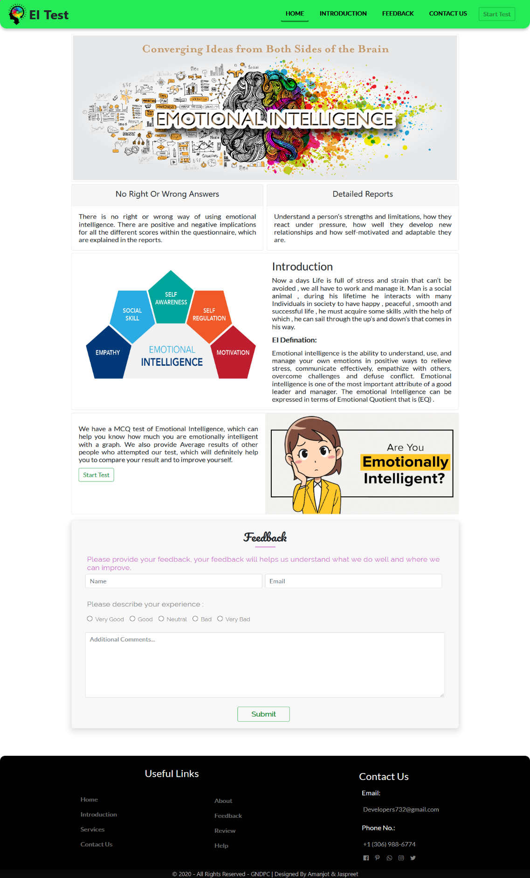

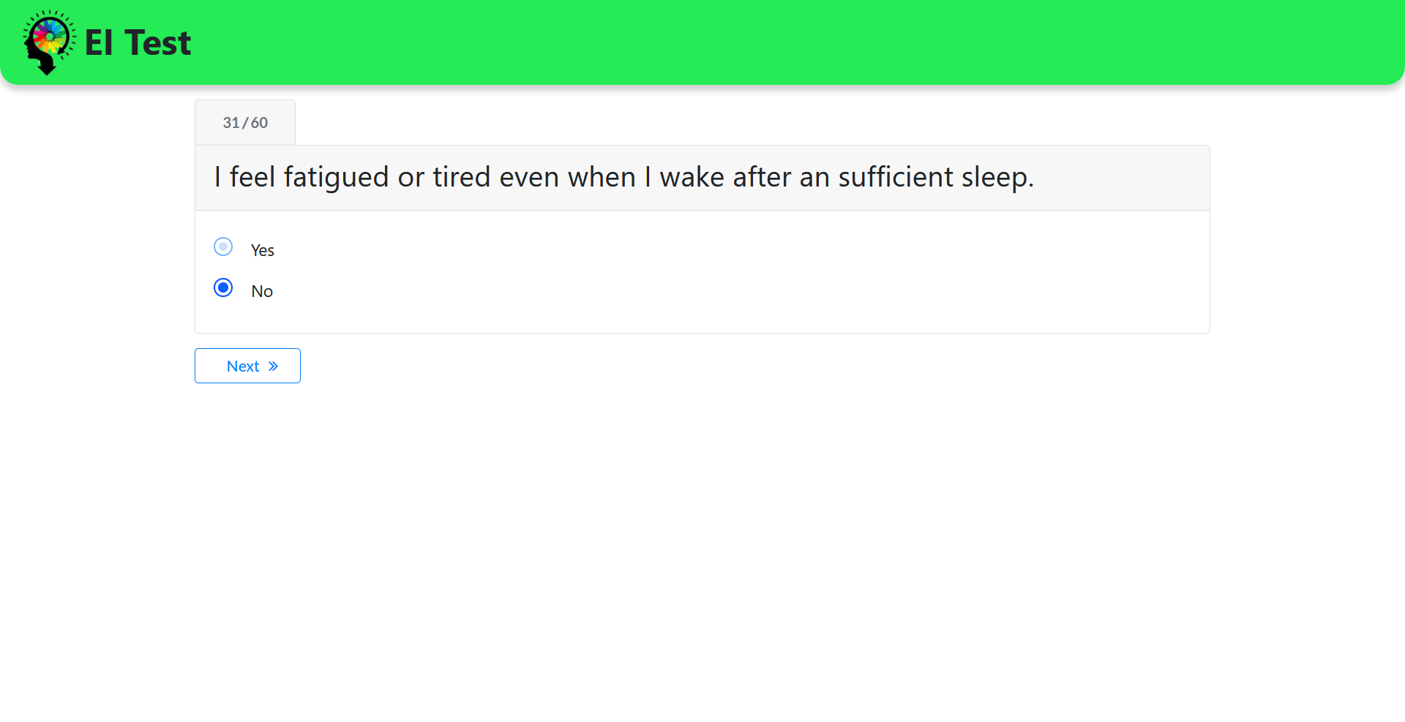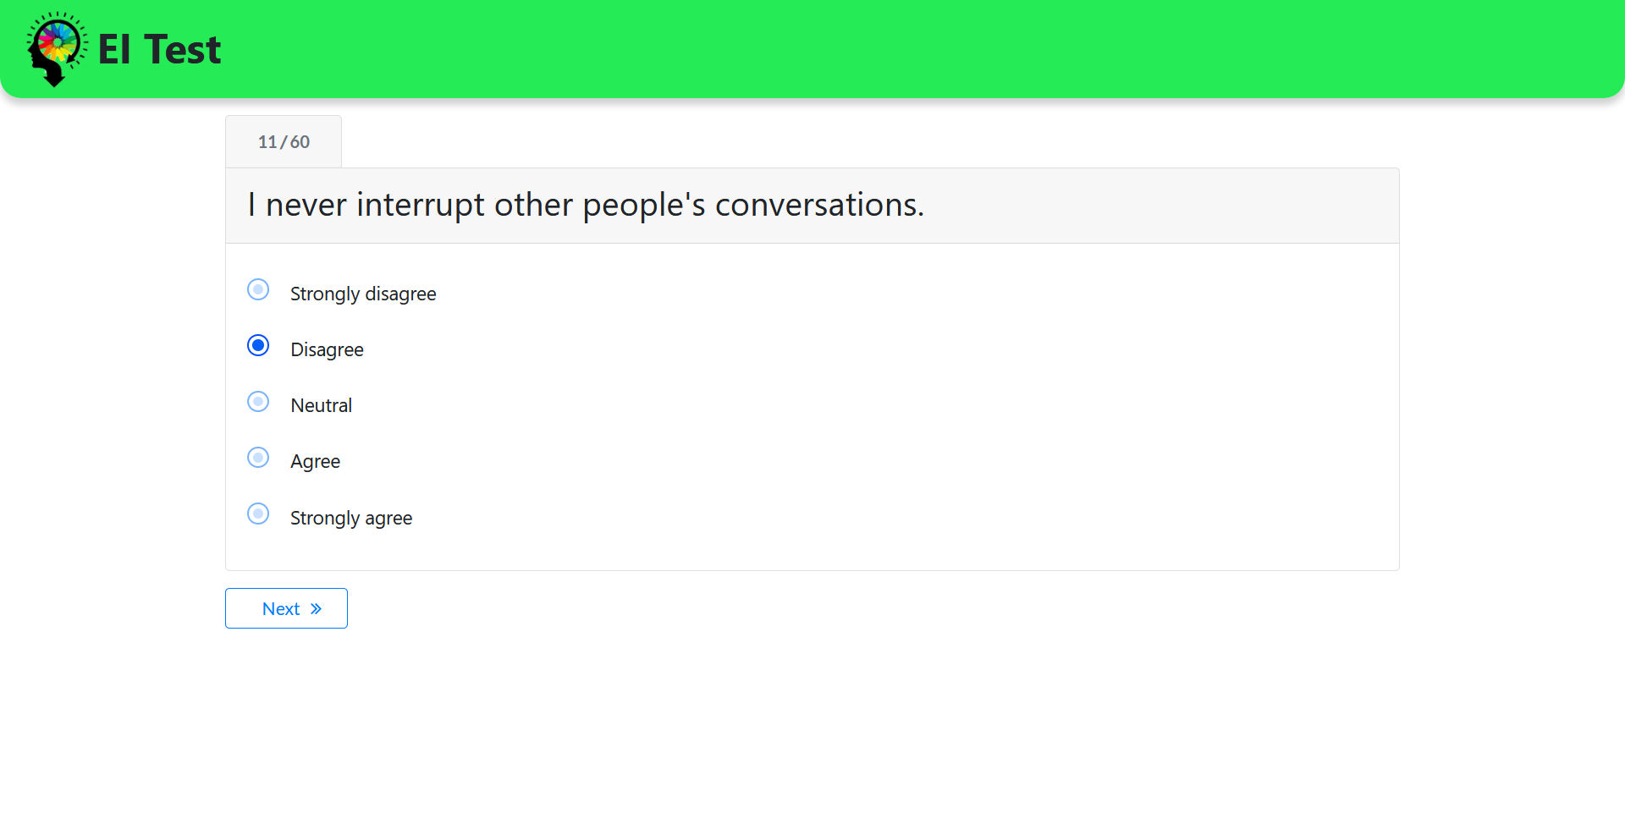

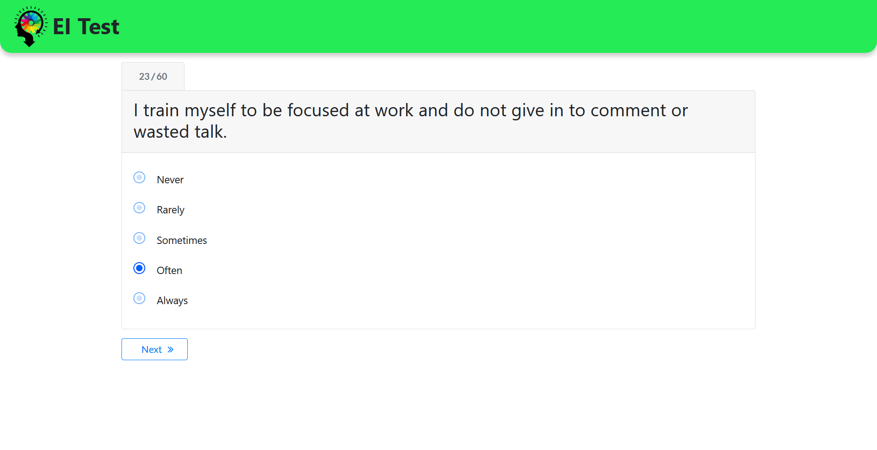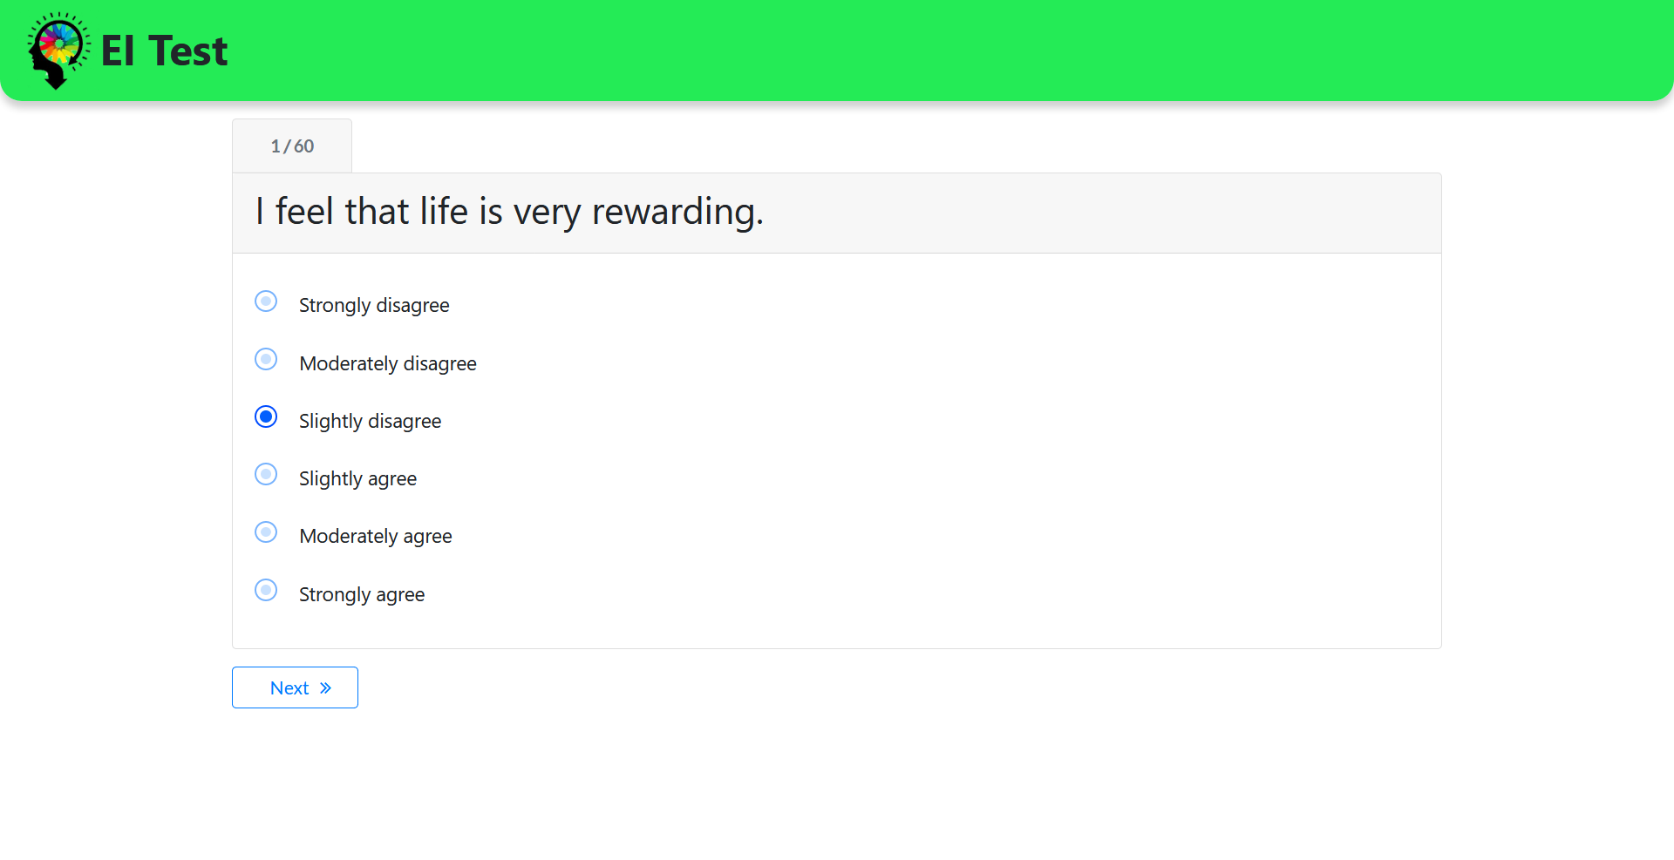

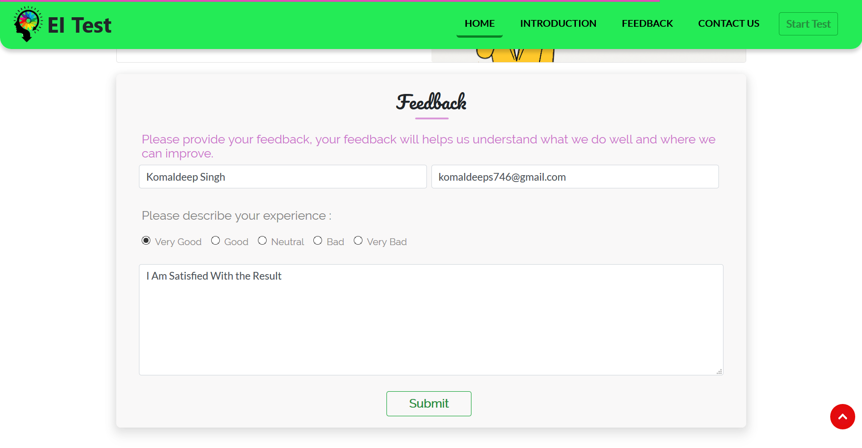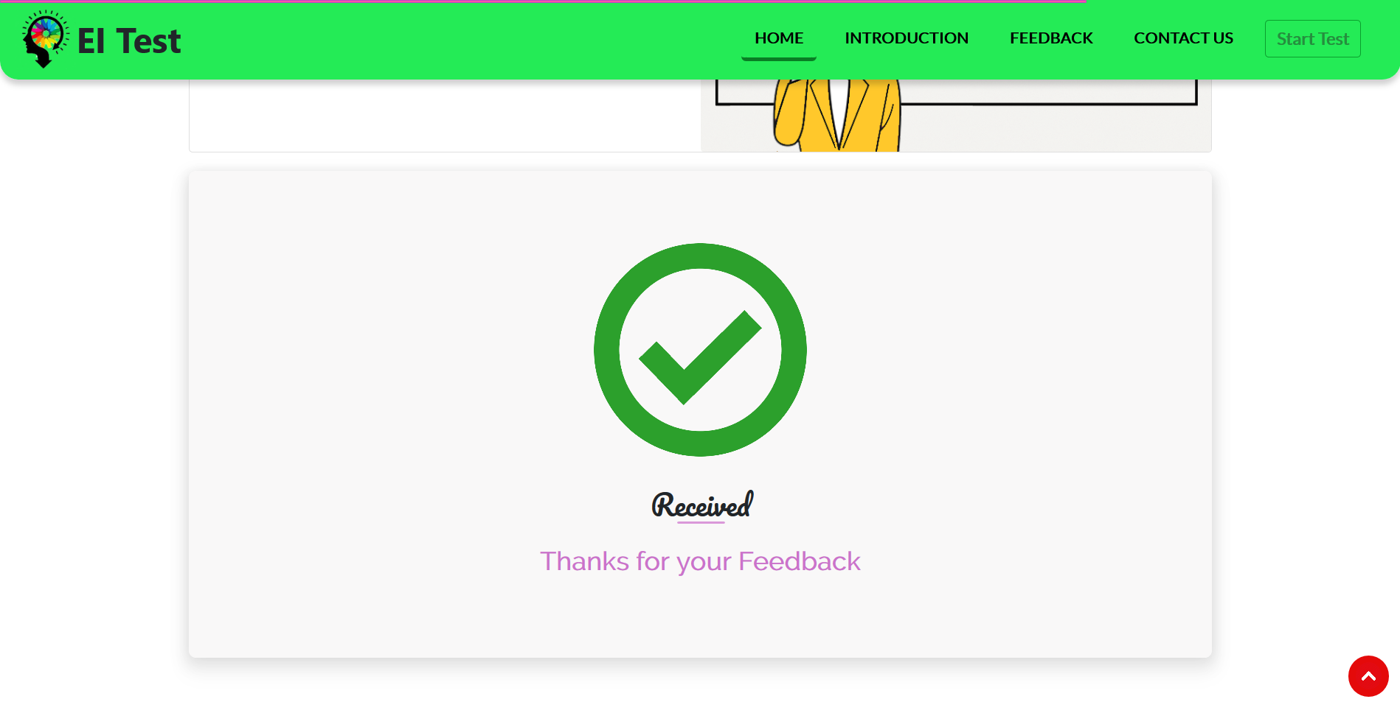

# 

# Bibliography

References

• College logo - https://targetstudy.com/files/img/2/19296/L_21227.gif

• Guido van Rossum

https://tse1.mm.bing.net/th?id=OIP.s5FXOxg1AF9M29gYR0IvMgAAAA&pid=Api&P=0&w=300&h=300

• Xampp pics - https://blog.templatetoaster.com/wp-content/webp-express/webp-images/doc-root/wp-content/uploads/2019/04/How-to-Install-XAMPP-on-Windows.jpg.webp

• Tkinter - https://www.tutorialspoint.com/python/python_gui_programming

• Python - https://www.tutorialspoint.com/python/index.htm

• Database - https://www.tutorialspoint.com/python/python_database_access.htm