

**PROJECT REPORT**

**“LOCAL CHEMIST APP”**

**SUBMITTED IN PARTIAL FULLFILMENT OF THE DEGREE**

**OF**

**BACHELOR OF TECHNOLOGY**

**IN**

**COMPUTER SCIENCE AND ENGINEERING**

**Submitted By: Jaspreet Kaur**

**RollNo:12101188**

**DEPARTMENT OF COMPUTER SCIENCE & ENGINEERING PUNJABI UNIVERSITY**

**PATIALA-147002**

**ACKNOWLEDGEMENT**

It is my pleasure to be indebted to various people who directly or indirectly contributed to the development of my project and who influenced my thinking behavior and acts during the course of our study.

I express my sincere gratitude to all the teachers for providing me with an opportunity to work on this project and help me to complete my work on time.

Special thanks to Er. Ram Singh, my project mentor for their Support cooperation, and motivation provided to me during the development of the project for his constant inspiration presence, and blessings.

Moreover, he provided valuable suggestions and precious time in accomplishing our project report.

Lastly, I would like to thank the almighty and my parents for their moral support and my friends with whom I shared my day-to-day experience and received lots of suggestions that improved my quality of work.

**WITH REGARDS**

**Jaspreet Kaur**

**TABLE OF CONTENTS**

**1. Abstract………………………………………………………………(4)**

**2. Introduction………………………………………………………….(5)**

**3. System Specification……………………………………....…………(6)**

**4. Problem Statement………………………………….…….…………(7)**

**5. Proposed System………………………………………….………….(8)**

**6. Feasibility Study…………………..………………………..………..(8)**

**7. Project Description.…………………………………………………(9)**

**8. System Study and Analysis…………………………………………(9)**

**9. Literature Survey……………………………………………………(10)**

**10. Need for Proposed System……………………………………….(11)**

**11. Characteristics of Proposed System……………………………..(11)**

**12. Project Code………………………………………………………(11-18)**

**13. Screenshots………………………………………………………..(19-21)**

**14. Conclusion………………………………………………………...(22)**

**ABSTRACT**

Local Chemist App software is used for billing purposes in hospitals as well as chemist shops. Local Chemist App software has proven to be beneficial for doctors as well as chemist shop owners with the help of this Local Chemist App basically used for time conservation this Local Chemist App is totally based on computers so there is very less possibility of errors possible during the billing.

The result generator enables the teachers and the students to calculate their results which are clearly and fairly calculated Result in greater conserves the time for a teacher. Since the result generator is made available to us in an offline mode also it is an advantage for the teachers as they can easily calculate the result in an offline mode also.

When the result is calculated the user is able to see all the grades along with marks and also the percentage of a particular student.

**INTRODUCTION**

- Managing our health can be a daunting task, especially when it comes to keeping track of medications and their costs. That’s why we’ve developed a local chemist app with a built-in billing system that calculates the total price of your medicines, making it easier than ever to manage your healthcare expenses.

-

- Our app is designed to connect you with local chemists, providing a seamless and hassle-free way to purchase your medications. With features such as real-time inventory updates, prescription management, and secure payment options, our app takes the stress out of managing your health.

-

- But our app isn’t just about convenience. It’s also about transparency. Our billing system provides a clear and detailed breakdown of the costs of your medications, allowing you to make informed decisions about your healthcare. And with features such as automatic receipt generation and expense tracking, managing your healthcare expenses has never been easier.

-

- We believe that technology has the power to improve our lives, and our local chemist app with a billing system that calculates the total price of medicines is just one example of how we’re making that happen. Join us on our journey to revolutionize healthcare and discover the benefits of a connected community.

**SYSTEM SPECIFICATION**

**Hardware Requirements:**

1. Processor – Core i5
2. RAM – 16GB
3. SSD – 512 GB
4. Mouse – Standard Mouse
5. Keyboard – Standard Keyboard
6. Processor Speed – 3.4 GHZ

**SOFTWARE REQUIREMENTS:**

1. Operating System – Microsoft Windows 11
2. Front–End – JUPYTER NOTEBOOK
3. Python

**PROBLEM STATEMENT**

While local chemist app software can greatly benefit retail pharmacy, medical store, chemist or pharma distribution businesses, there may be some challenges or problems that users may encounter when using these software. Some potential problems that users may face when using local chemist app software include:

* Technical issues: Like any software, local chemist app software may experience technical issues such as bugs, crashes, or compatibility problems. These issues can disrupt the user experience and may require technical support to resolve.
* Usability issues: Depending on the design and layout of the software, some users may find it difficult to navigate or use certain features. This can result in a steep learning curve and may require additional training or support to overcome.
* Integration issues: Local chemist app software may need to integrate with other systems or software used by the business, such as accounting or inventory management systems. If the integration is not seamless, it can result in data inconsistencies or errors.
* Cost: Depending on the features and capabilities of the software, the cost of using a local chemist app software can vary. Some businesses may find the cost of using these software to be prohibitive.

Overall, while local chemist app software can provide many benefits to businesses, it is important for users to be aware of potential challenges or problems that they may encounter when using these software.

**Proposed System**

The system or program is basically designed for getting knowledge about BILLING sand the design used to make it.

**Feasibility Study**

**Technology:**

This system is technically feasible because the system is activated by computers and recent technology. We use both user and server interaction which is powerful and very user-friendly. Also, with the help of Jupyter Notebook, it is easy to generate the game without any hesitation or difficulties.

**Education:**

It is feasible in the form of education as well. As the program supports study information that Is the result declaration with which we can declare whether a person has qualified or not. Also, we use Jupyter Notebook to operate it so it can be executed offline also which is a plus point whereas in other generators internet is required.

**PROJECT DESCRIPTION**

**Need For the Software:**

Chemist app software can greatly benefit retail pharmacy, medical store, chemist or pharma distribution businesses. These software can help streamline and automate various aspects of the business, such as inventory management, billing, and accounting. By using a chemist app software, businesses can save time, increase efficiency, and improve their overall operations.

For example, real-time inventory management allows businesses to track the sale and purchase of medicines or products in their stock at the batch level. This helps them stay informed of MRP, purchase rate, landing rate, profit margins for each item in the stock and also notifies them of any expiry or stock outs from inventory. Superfast billing for customers allows businesses to create GST or non-GST invoices or bills and share them with their customers over SMS, email or WhatsApp in less than a minute. Simplified business reports & analytics provide businesses with free, simple, easy data analytics and actionable insights for better profits.

Overall, the use of chemist app software can greatly benefit businesses by helping them manage their operations more effectively and efficiently.

**Problem Description:**

The system is mainly used by the vendor . It reduces the time consumption and a lot of paperwork. For a single operation to be performed it requires numerous entries which are mandatory to declare the bill of customer.

**SYSTEM STUDY AND ANALYSIS:**

**Existing System:**

1. The existing system is a manual system.
2. The manual system is prone to error.
3. This system involves a lot of manual entries with the application to perform the desired task.
4. Time delay between the user and the customer is reduced
5. For this reason, a new system is invented

**LITERATURE SURVEY**

The automated declaration software has now become an inseparable part of our daily life and it has gained such an important place that it’s strange to think it was ever cutting-edge technology of life without this helpful software which not only eases the life of students but also for the teachers. Results have been important for both the students and as well as for the teachers for the student it tells about the qualification and for the teachers it tells about the hard work they have done which is highlighted through the result card. Result generator software is more than software as it could not only calculate the marks but also can specify the qualification of a student.

**Local chemist App mainly consists of:**

**Display Screen:**

Local chemist app software typically consists of a user interface with a display screen that allows users to interact with the software and perform various tasks. The specific design and layout of the display screen can vary depending on the software, but it generally includes features such as navigation menus, buttons, and input fields to facilitate user interaction.

The display screen of a local chemist app software is designed to be user-friendly and intuitive, allowing users to easily navigate the software and perform tasks such as managing inventory, creating invoices, and generating reports. The display screen may also include visual aids such as icons, images, and color coding to help users quickly identify different functions and features.

Overall, the display screen of a local chemist app software is an important component that enables users to effectively interact with the software and manage their business operations.

**Storage Device:**

It is used to temporarily store a database of a student which is provided by the user input through a keypad and also by following a certain step.

**Processor:**

The processor is configured to receive the input signals from the input device and access the database of a student’s information in response to the input signals to obtain data about the student’s result. The processor after receiving the certain information which is to be fulfilled Processor then processes that information that is the marks to calculate the result of a student. Besides this the result generator allows the user to proceed any further

**NEED FOR PROPOSED SYSTEM**

Local chemist app software can greatly benefit retail pharmacy, medical store, chemist or pharma distribution businesses. These software can help streamline and automate various aspects of the business, such as inventory management, billing, and accounting. By using a chemist app software, businesses can save time, increase efficiency, and improve their overall operations.

For example, real-time inventory management allows businesses to track the sale and purchase of medicines or products in their stock at the batch level. This helps them stay informed of MRP, purchase rate, landing rate, profit margins for each item in the stock and also notifies them of any expiry or stock outs from inventory. Superfast billing for customers allows businesses to create GST or non-GST invoices or bills and share them with their customers over SMS, email or WhatsApp in less than a minute. Simplified business reports & analytics provide businesses with free, simple, easy data analytics and actionable insights for better profits.

**CHARACTERISTICS OF PROPOSED SYSTEM**

**User Friendly:**

The proposed software is user-friendly because the retrieval and storing of data is fast and data is maintained efficiently moreover the software provided in the proposed system provides users to deal with the system very easily.

**Bills are Easily Generated:**

Bills can be easily generated in the proposed system so the user can generate the bills as per the requirement .

**Very Less Paperwork:**

The proposed system requires very less paperwork all the data is fetched into the computer immediately and bills can generated.

**Computer Operator Control:**

Computer operator controls will be there so no chance of errors moreover storing and receiving information is quite easy so, work can be done speedy on time

**Project Code**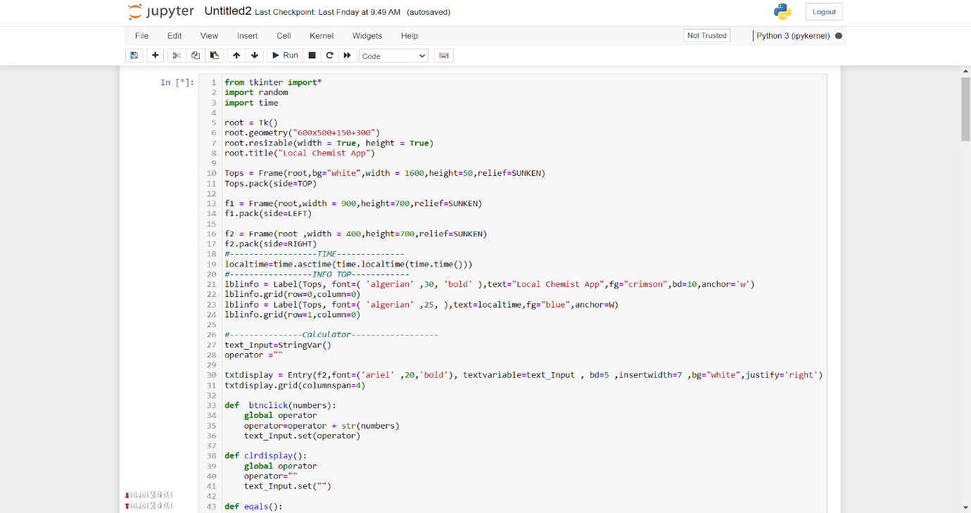

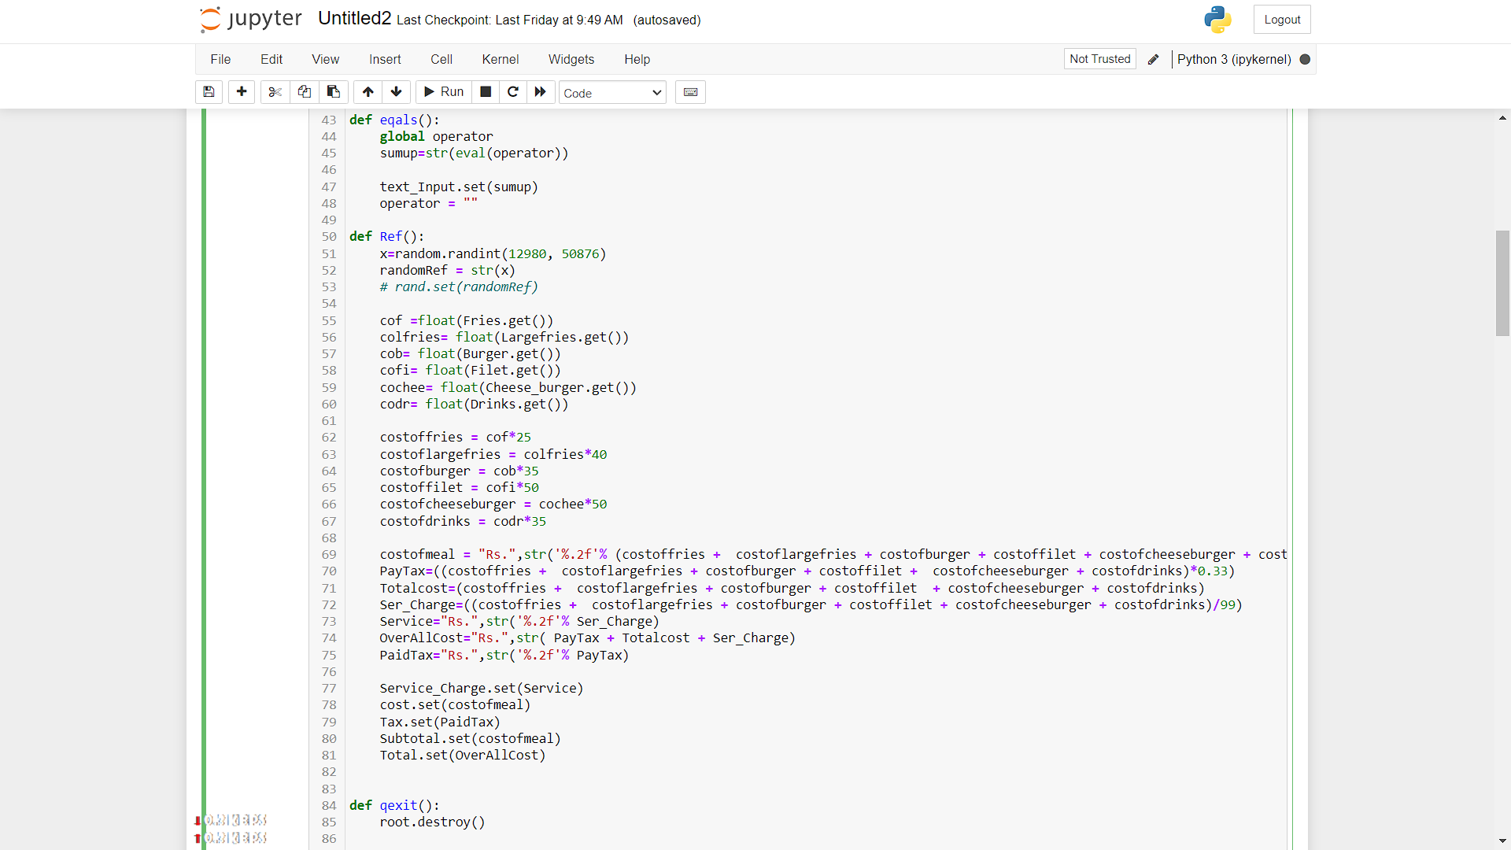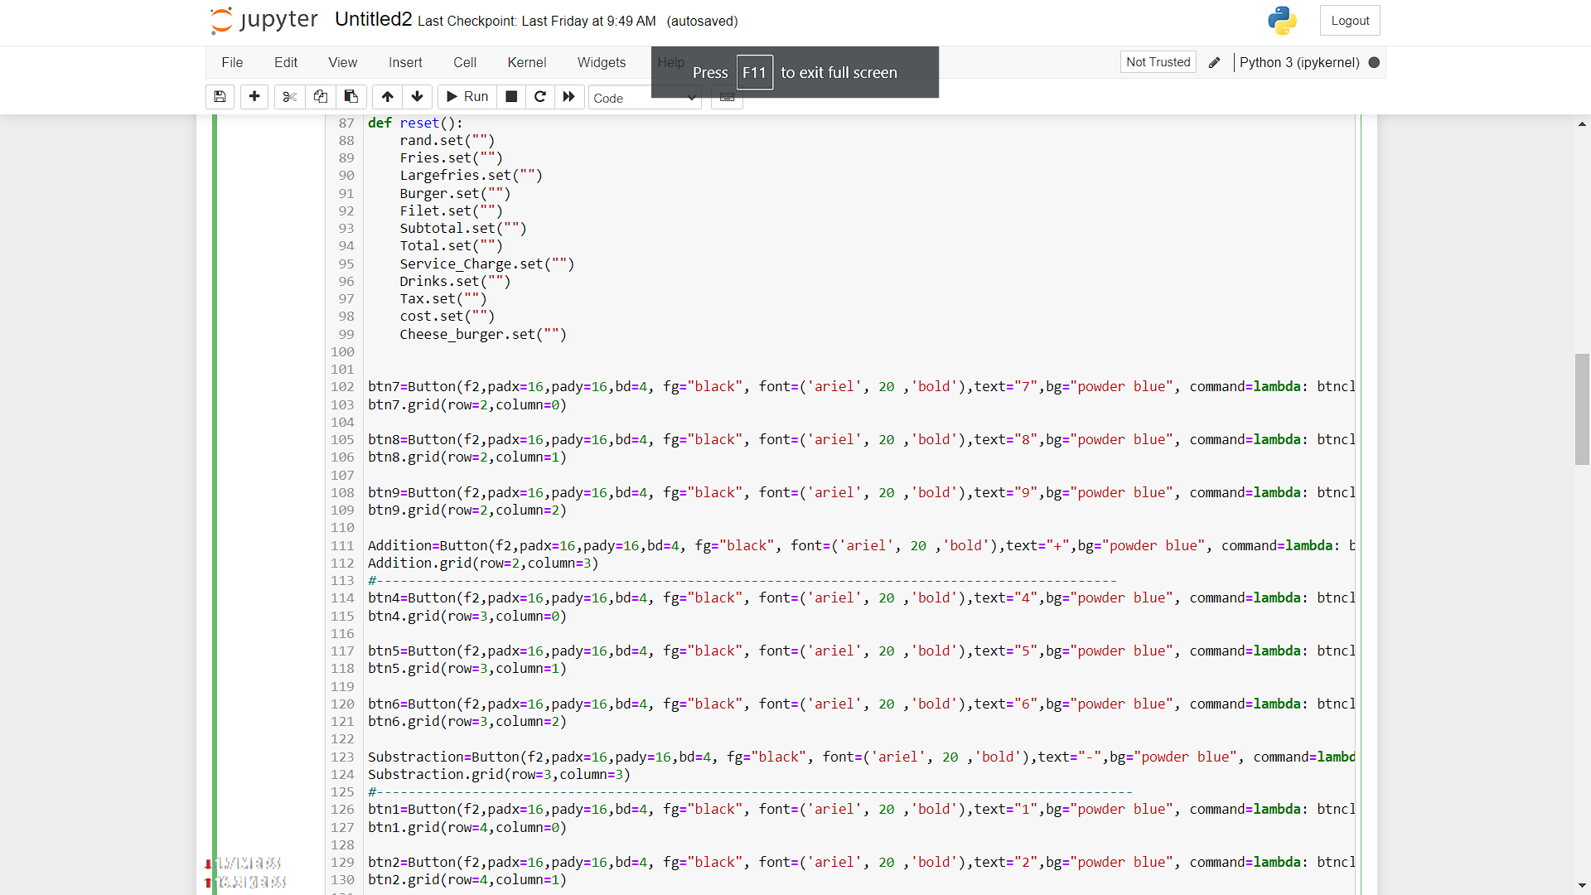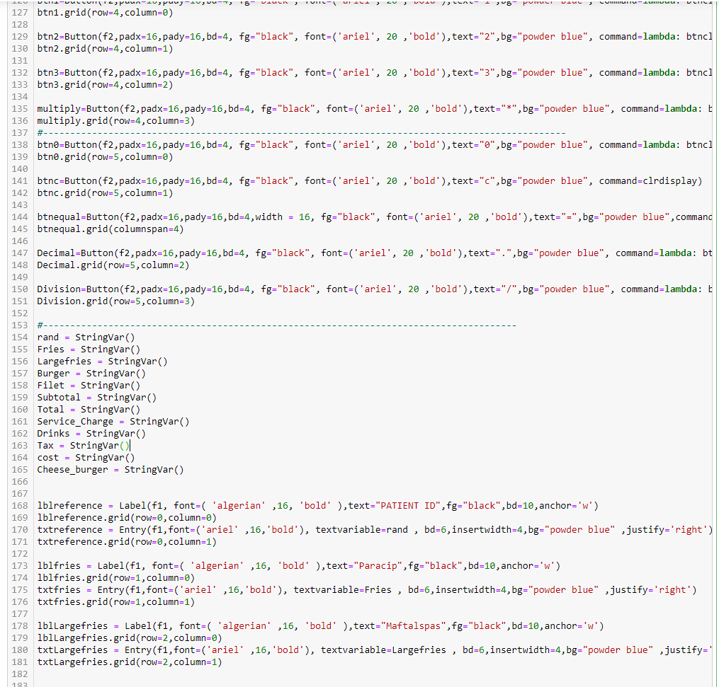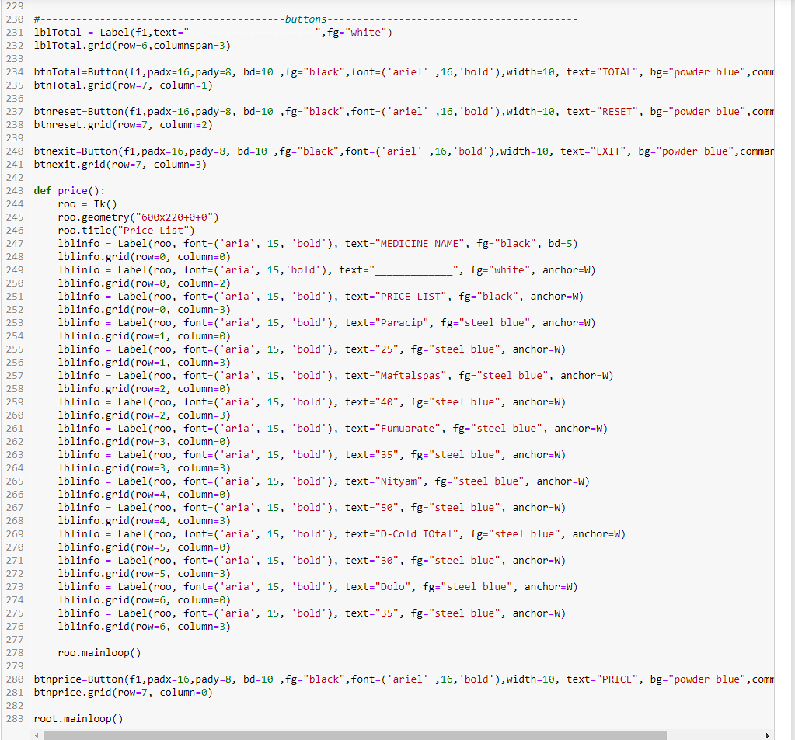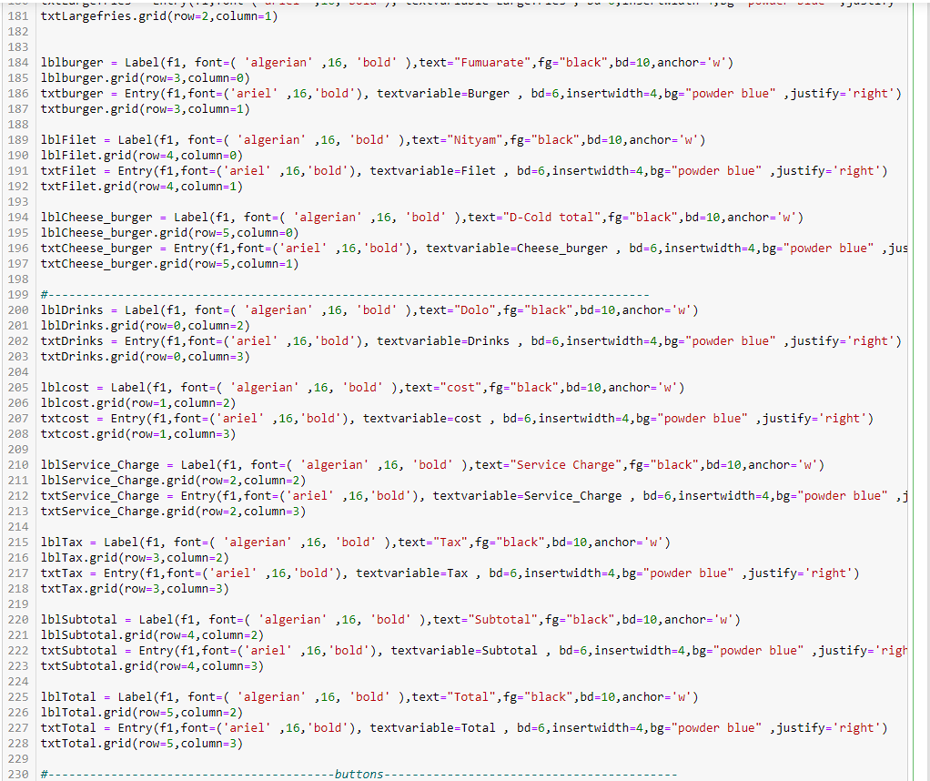****

**SCREENSHOT**

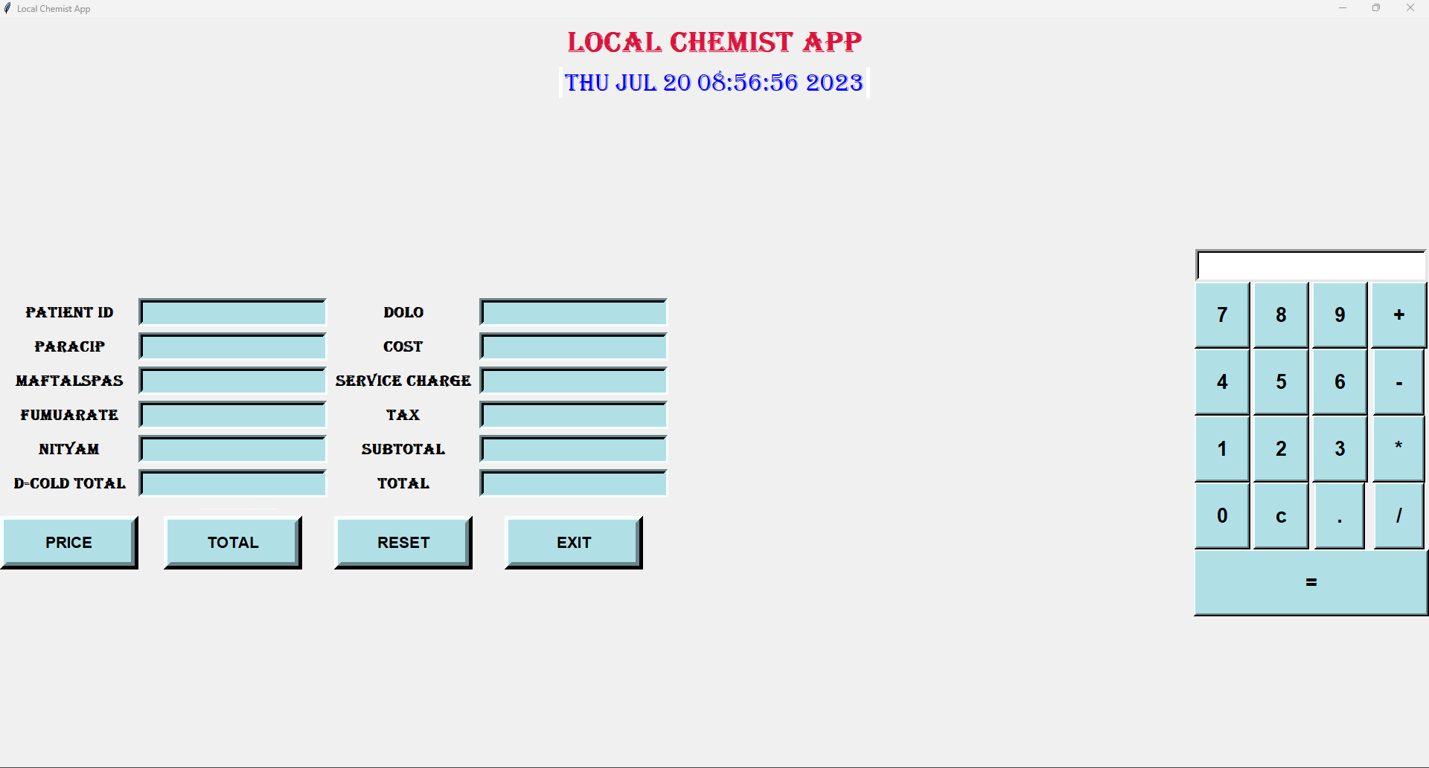

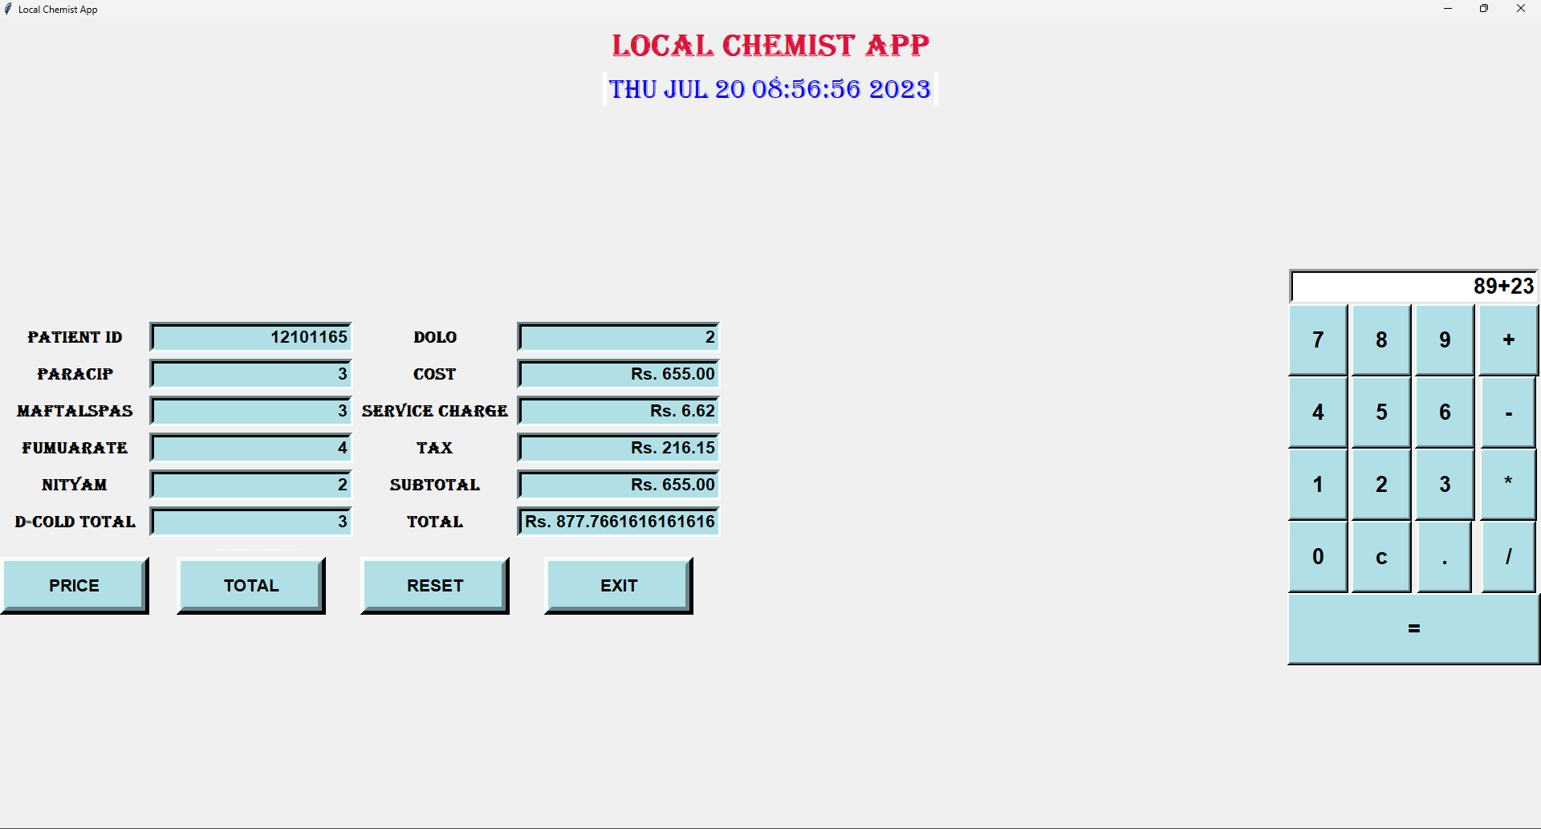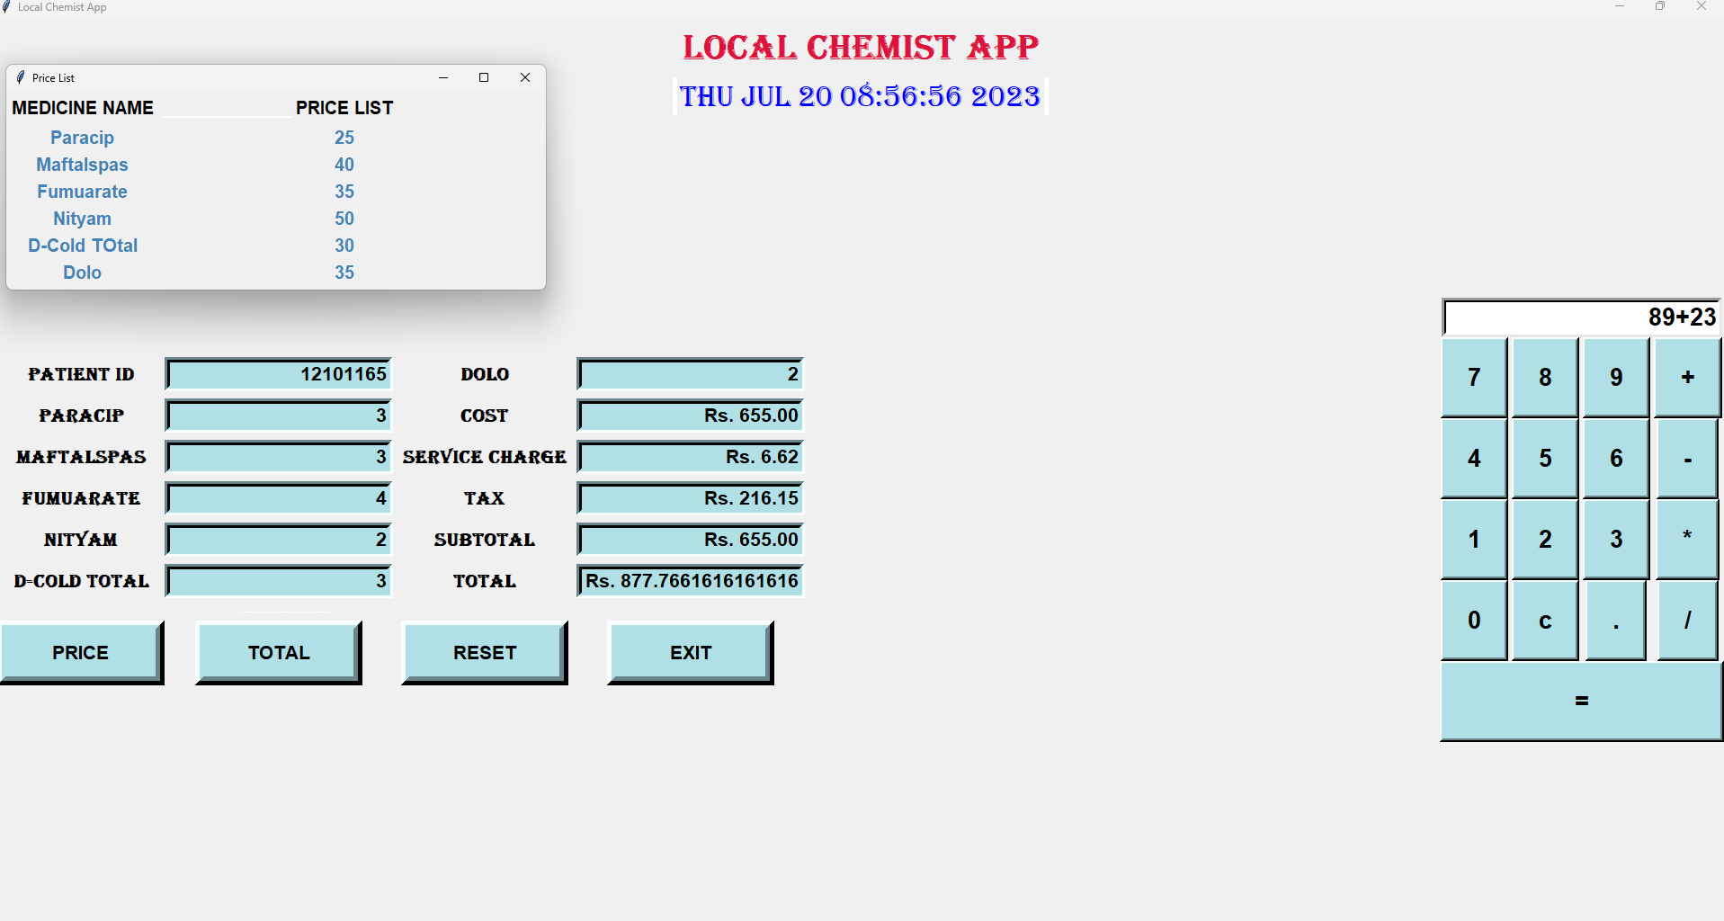

**CONCLUSION**

The project has really been faithful and informative. It has made us learn and understand the many trivial concepts of Python Language. As we have used Python and Tkinter as a GUI It provides Various controls such as bottoms, label, and text boxes to build a user-friendly application the fast-growing use of the Internet confirms the good future at the scope of the proposed project find D has taught us a valuable lifelong lesson about the improvements and working and interacting in a group or individual.