

Language Detector by Jassandip Shina

Language Detector

Idea:

I’ve been using text editors for a while now and realized that we still have to specify what language we are using. I’m proposing to use machine learning to figure out which language a person is coming in. Currently sites like GitHub use the file extension to determine the language written in the file, my software will instead read the lines themselves and determine language was used.

Technology:

Python3, Flask, Spacey, HTML, Paperspace

Model:

CNN

Datasets:

Code provided from GitHub acquired through:

https://api.github.com/search/repositories?q=language:python

https://api.github.com/search/repositories?q=language:js

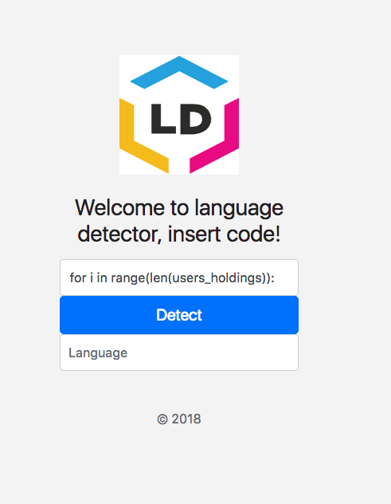

Will output over here the name of the language

Type or paste code here

