**Synopsis**- **A farmer’s e-shop**

Introduction- A farmer’s e-shop as its name suggest is an online platform for farmers to sell their crops to a particular customer, or to a particular market which means that the seller has an option to make its product available to targeted customers or to make it available to everyone. A customer’s dashboard shows the products available to him/her. After a customer selects from a list of available crops, a request is sent to a seller, which when accepted by the seller, a notification is sent in return to the customer providing seller’s contact details. After this, the seller and customer may contact each other and meet at a suitable location for the transaction. Since this portal is targeted for farmers, interface will be simple, with large and simple font and most importantly, an option to translate the page to Hindi, which is most common.

Functionalities- Users of this product include sellers, who are basically farmers, customers, farmers or non-farmers, who want to buy crops. For using this portal, they will first register and provide their basic details, contact details, address and whether they want to sign in as a seller or a customer. Both, sellers and customers will have a slightly different dashboard to work with, simple in any case.

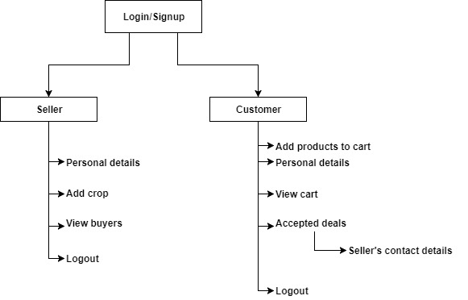

These are the basic functionalities of the portal and other information related to a crop will be added as well, when a seller add a crop and products shown to customer will first be sorted on the basis of location by default which may be changed by applying filters, like how fresh a crop is, etc., on the available crops. And money exchange will be person to person, so no online transactions, and security is ensured by sellers, by limiting its customers if necessary. So, this is an overview of how this whole process will work.