Assignment 2- Case Study

Stage 3 Lab Activities

SmartCare Domain Modelling
AI OFF -> AI ON -> COMPARE -> VERIFY | 1 hour

A - Requirements Review
Highlight nouns, verbs and business rules in SmartCare v0.2.
Patients, Practitioner, receptionist, staff

FR-01: consistent appointment status
FR-02: reduce duplicate data
FR-03: ease of finding data
FR-04: larger history storage
FR-05: simple GUI or interface
FR-06: Secure data
FR-07: reduce the use of spreadsheets and paper records
FR-08: Secure data
FR-09: Reliability

B - Candidate Classes
Record candidate concepts, supporting requirements, state and behaviour.
Candidate concept | Supporting requirements | State | Behavior
Patient | Appointments | Personal details | Get appointments, get check ups
Practitioner | Appointment | Doctor details, schedule | Check patients

C - CRC Cards
Create CRC cards for Patient, Practitioner and Appointment.
Class | Responsibility | Collaborators
Patient | Book appointments, get checked, pay fee’s | Appointments, Practitioners
Practitioner | Check for appointments, check patients, know there schedule | Appointments, patients
Appointment | Create appointments, update appointments details | Patient, practitioner

D - UML Model
Draw classes, attributes, operations, associations and multiplicities.
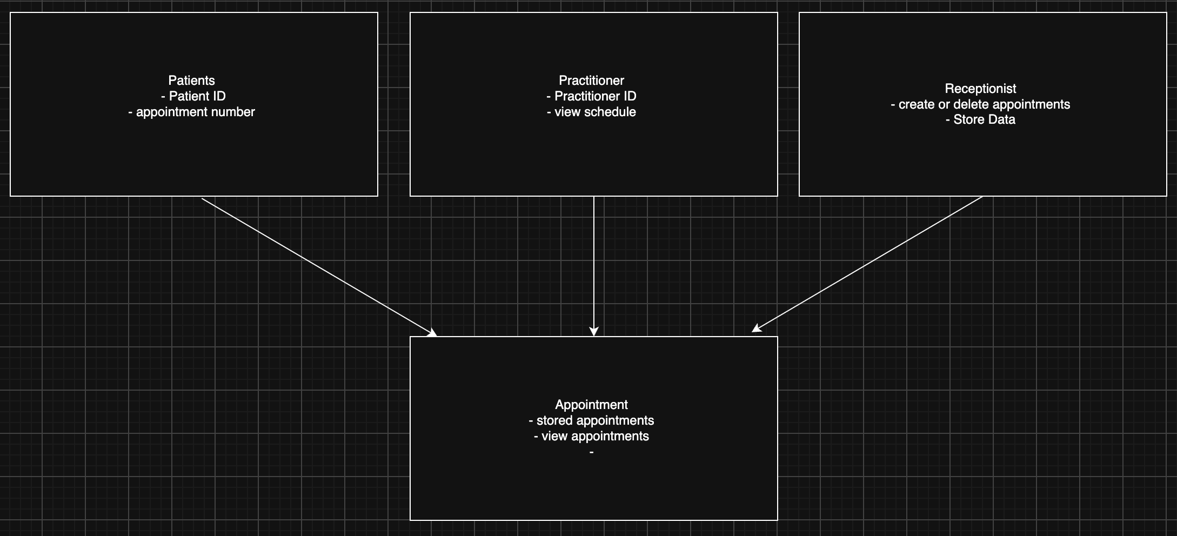

E - AI Design Review
Ask AI to suggest classes and relationships using only confirmed requirements; require supporting requirement IDs.
R1 - consistent appointment status
Candidate class’s R1 – Appointment, Appointment status
R2 - reduce duplicate data
Candidate class’s R2 – Data repository or database
R3 - Secure data
Candidate class’s R3 – User, Security manager or authentication service.
R4 - simple GUI or interface
Candidate class’s R4 – User interface, GUI

F - Compare and Decide
Record at least one accepted, modified and rejected AI suggestion.
R1 suggestions accepted.
R2 suggestions accepted.
R3 suggestions accepted.
R4 suggestions accepted.

G - Python Skeletons
Create simple Patient, Practitioner and Appointment class skeletons.

H - Consistency Check
Check model-code consistency; do not implement full behaviour yet.
The code so far shows most of the necessary classes and what they are.

Reflection
What modelling decision was hardest? Where did AI over-design? What evidence supported your final choices?
AI didn’t really over design anything, many things it said were things I’ve already discussed and thought of.

