SmartCare v0.3 - Domain Model Workbook
Week 6 student resource

Requirement-to-Concept Trace
Requirement | Concept | State/behaviour | Decision
consistent appointment status | Appointments | Booking appointments, viewing appointments | Keep
reduce duplicate data | Appointments | Not one appointment that is duplicated | Keep
Secure data | Patients, practitioner, appointments | Keep data safe | Keep
simple GUI or interface | Appointments, receptionists, | Quick and efficient data search | Keep

CRC Cards

Patient
Responsibilities | Collaborators
Book appointments, get checked, pay fee’s | Appointments, Practitioners

Practitioner
Responsibilities | Collaborators
Check for appointments, check patients, know there schedule | Appointments, patients

Appointment
Responsibilities | Collaborators
Create appointments, update appointments details | Patient, practitioner

Optional class
Responsibilities | Collaborators

UML Class Diagram
Insert/draw UML here. Include defensible relationships and multiplicities.
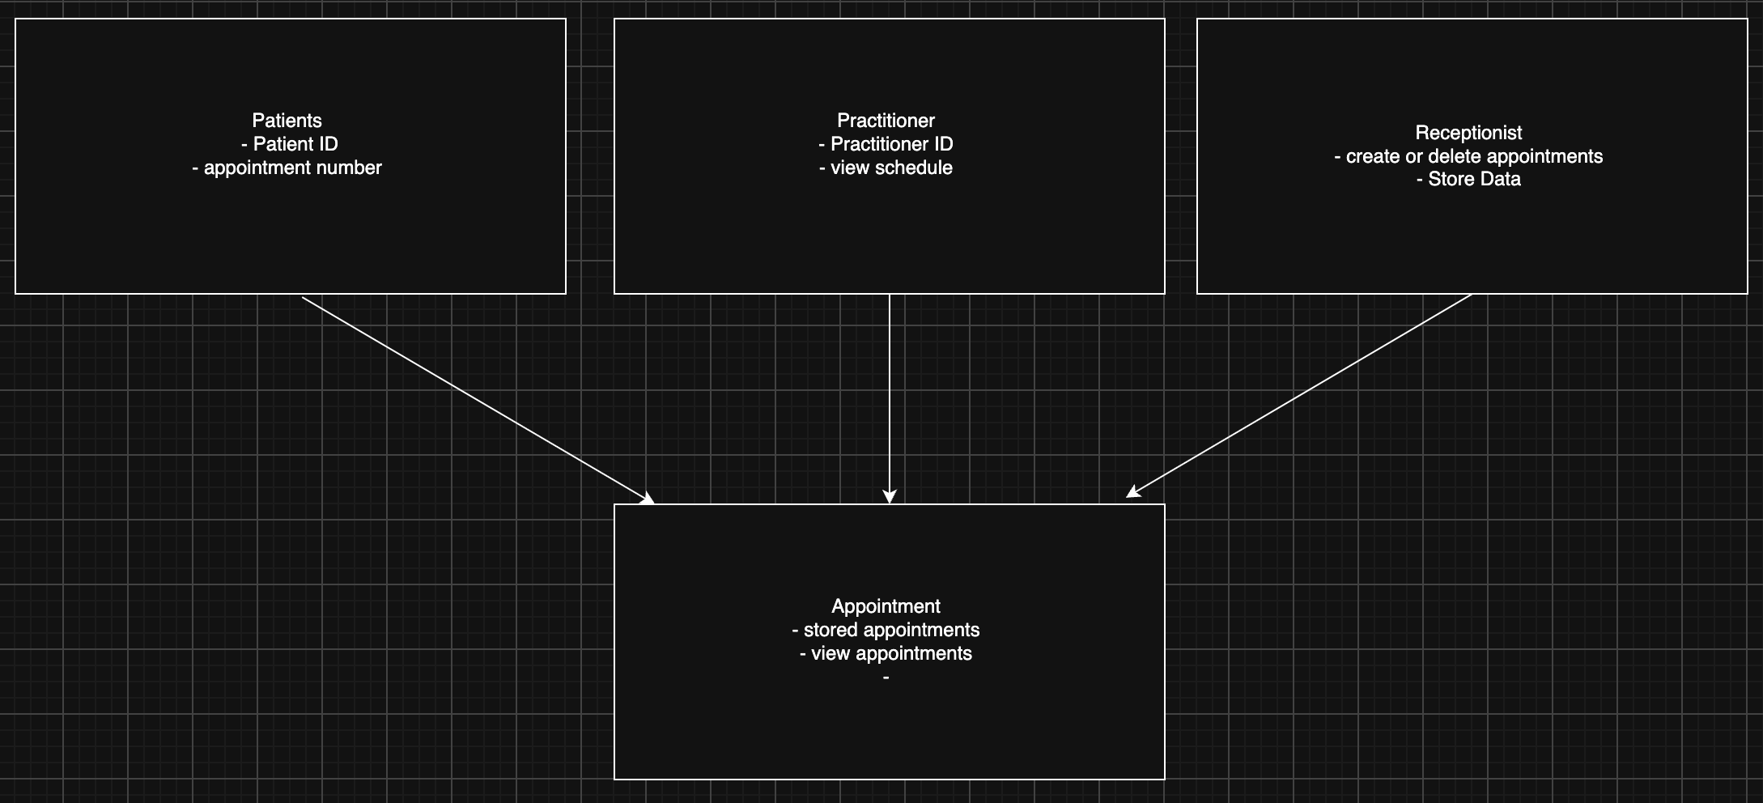

Design Rationale
Explain class selection, responsibility allocation and key relationships.
Patients – we need patient details. We are to store patient details. Patient details connect with appointments.
Practitioner – we need practitioner details. We are to store practitioner schedules. Practitioner’s details connect with appointments.
Receptionist – we need receptionists to take care of clinic details. We are to take care of appointments. Receptionists connect with appointments.

AI Design Review Record
AI suggestion | Evidence | Decision | Reason | Model change
Appointment status | Case study ask for status check features. | Keep | Keep track of appointments and other important details | Yes
Data repository or database | Case study says they have duplicate data | Keep | Having duplicate data is not efficient and on piece of data could be saying something else then the other one even though it’s the same data. | Yes
User, security manager, authentication service | The case study does not specify the security of data but this is an great suggestion | Keep | This will allow to keep the data safer. | Yes
Simple GUI or interface | The case study specify the ease of use | Keep | Being bae to easily use the software will ensure efficient and great work performance | Yes

