SYSTEM DESIGN
Databases — Relational, NoSQL
& Scaling Techniques
FAANG-Level Interview Preparation Guide

Based on Arpit Bhayani — Asli Engineering · Enhanced with additional depth
Topics: Relational DBs · ACID · Isolation Levels · DB Scaling · Sharding & Partitioning · NoSQL Types · Picking the Right DB

Module 01

Relational Databases
Databases are the most critical component of any system. They make or break a system. The wrong choice — or a poorly configured database — can bring down a product that is otherwise perfectly designed.

Why Relational Databases Exist
Computers first did "accounting" — ledgers are rows and columns. Databases were developed to support accounting. Hence, the key properties were: data consistency, data durability, data integrity, constraints, and everything in one place.
Because of these accounting roots, relational databases provide TRANSACTIONS with full ACID guarantees.

ACID Properties
ACID is the set of four guarantees that relational databases provide to ensure correctness even in the face of failures, crashes, and concurrent access.

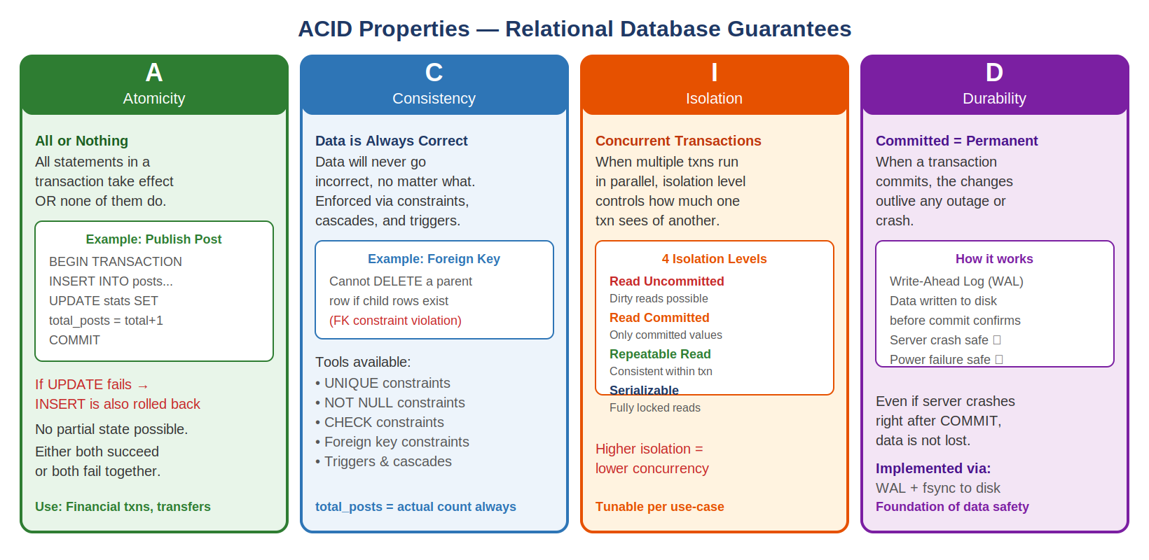

A — Atomicity
All statements within a transaction take effect, or NONE of them do. There is no partial state.
- Example: Publishing a post and incrementing total_posts must both succeed or both fail together.
- BEGIN TRANSACTION → INSERT into posts → UPDATE stats SET total_posts = total_posts+1 → COMMIT
- If the UPDATE fails, the INSERT is automatically rolled back. Database never has a post without a count.
- Implementation: Write-Ahead Log (WAL) enables rollback of uncommitted changes on failure.

C — Consistency
Data will never go incorrect, no matter what. The database enforces rules through constraints, cascades, and triggers. You have the necessary tools to ensure data is always in a valid state.
- Foreign key checks: cannot delete a parent row if child rows exist (configurable, can be tuned).
- Constraints: UNIQUE, NOT NULL, CHECK, DEFAULT — all enforced by the DB engine.
- The guarantee: total_posts always equals the actual count of entries in the posts table for that user.
- Your own note: Consistency in ACID is different from the C in CAP theorem — ACID-C is about DB-level invariants.

I — Isolation
When multiple transactions execute in parallel, the isolation level determines how much one transaction's changes are visible to others. This is a tunable knob — see Module 2 for all four levels.
- Key question: Should changes done at a point in Txn1 be visible to Txn2 BEFORE Txn1 commits?
- Higher isolation = more correctness, lower concurrency and throughput.
- Lower isolation = higher concurrency, risk of reading stale or dirty data.

D — Durability
When a transaction commits, the changes outlive any outage. Even if the server crashes right after COMMIT, the data is not lost.
- Implementation: Write-Ahead Log (WAL) — data written to persistent storage before COMMIT returns.
- fsync() ensures data survives power failures by flushing OS buffer to physical disk.
- This is the foundation of data safety — without it, committed transactions could vanish on crash.

Interview Takeaway — ACID
You pick relational databases for RELATIONS and ACID. If the question involves financial transactions, user account operations, anything requiring "all-or-nothing" behavior, or referential integrity — relational database with ACID is the answer.
Key distinction: ACID Consistency (application-level invariants) is NOT the same as CAP Consistency (all nodes see the same data at the same time). Mention this to impress interviewers.

Module 02

Database Isolation Levels
Isolation levels are a tunable parameter in relational databases. They control the trade-off between data correctness and concurrency. Understanding all four levels — and the anomalies they prevent — is essential for senior interviews.

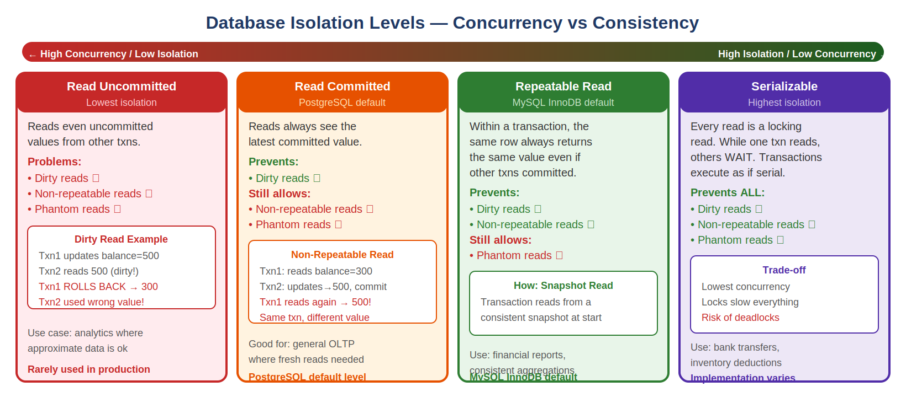

The Three Anomalies
Anomaly | What Happens | Example
Dirty Read | Read an uncommitted value from another transaction that later rolls back | Txn1 sets balance=500 (not committed). Txn2 reads 500. Txn1 rolls back to 300. Txn2 used wrong value.
Non-Repeatable Read | Same query returns different results within the same transaction | Txn1 reads balance=300. Txn2 commits balance=500. Txn1 reads balance again → gets 500, not 300.
Phantom Read | Same range query returns different ROWS within same transaction | Txn1 counts orders WHERE status=NEW → 5 rows. Txn2 inserts a new order. Txn1 counts again → 6 rows.

Four Isolation Levels
Level | Dirty Read | Non-Repeatable | Phantom Read | Performance | Default In
Read Uncommitted | Possible ✗ | Possible ✗ | Possible ✗ | Highest | Rare
Read Committed | Prevented ✓ | Possible ✗ | Possible ✗ | High | PostgreSQL
Repeatable Read | Prevented ✓ | Prevented ✓ | Possible ✗ | Medium | MySQL InnoDB
Serializable | Prevented ✓ | Prevented ✓ | Prevented ✓ | Lowest | Explicit choice

Read Uncommitted
Reads even uncommitted values from other transactions — the infamous "dirty read". Rarely used in production.
- Use case: approximate analytics where slight inaccuracies are acceptable.
- Risk: a transaction reads a value that another transaction later rolls back — business logic uses wrong data.

Read Committed
Reads always see the latest committed value. No dirty reads, but multiple reads of the same row within one transaction can return different results (non-repeatable read).
- PostgreSQL default isolation level.
- Good for: general OLTP where you always want the freshest committed data.
- Risk: your transaction might see an inconsistent view if rows change while you are reading.

Repeatable Read
Within a transaction, the same row always returns the same value even if other transactions committed changes. Implemented via snapshot isolation — transaction reads from a consistent snapshot taken at its start.
- MySQL InnoDB default isolation level.
- Good for: financial reports, aggregations that need a consistent view across multiple queries.
- Note: MySQL's Repeatable Read also prevents phantom reads in many cases via gap locking — check your engine docs.

Serializable
Every read is a locking read. While one transaction reads, others must wait. Transactions execute as if they ran serially one after another.
- Prevents ALL three anomalies — strongest guarantee.
- Cost: lowest concurrency, highest lock contention, risk of deadlocks.
- Use: bank transfers, inventory deductions, flash sales with limited stock.
- Important: Storage engines can alter the implementation — always read your DB documentation before changing isolation levels.

Interview Takeaway — Isolation Levels
Interviewers love asking about isolation levels. The key trade-off: higher isolation = lower concurrency. For payment systems use Serializable or Repeatable Read. For user feeds and analytics use Read Committed. Know that MySQL defaults to Repeatable Read while PostgreSQL defaults to Read Committed.
Bonus point: Serializable does NOT always use table locking. Modern implementations use Serializable Snapshot Isolation (SSI) in PostgreSQL and gap/next-key locking in MySQL InnoDB.

Module 03

Database Scaling Techniques
Databases are the most important component of any system. Scaling them is critical — and the techniques apply to both relational and non-relational databases. Always start simple and add complexity only when needed.

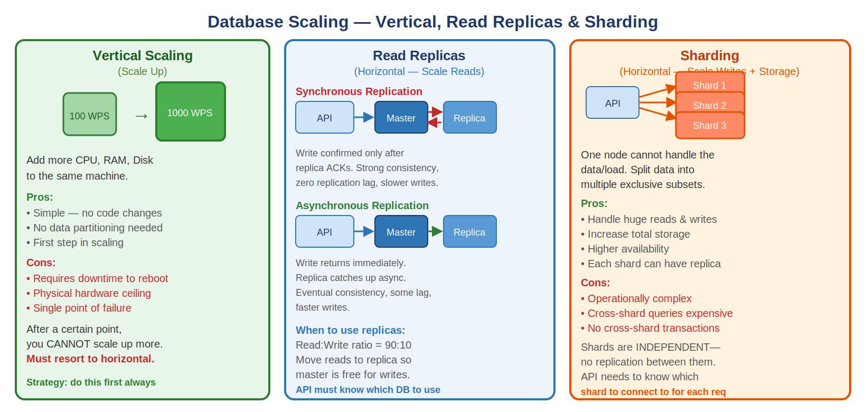

The Scaling Journey
A database is just a process (mysqld, mongod) running on a virtual machine. Here is the typical progression:
- Start: single DB server, serving 100 WPS. Product grows → DB is overloaded.
- Step 1: Vertical scale — give it more CPU, RAM, Disk. Now handles 200 WPS.
- Step 2: Product goes viral → 1000 WPS. Vertical scale again. Now handles 1000 WPS.
- Step 3: Need 1500 WPS but vertical scaling has hit its physical hardware limit.
- Step 4: Horizontal scaling — add more DB nodes, split the data (sharding).

Strategy 1: Vertical Scaling (Scale Up)
Add more CPU, RAM, and Disk to the existing database server. Simplest approach — no code changes required.
Advantages  - Simple — no application code changes  - No data partitioning or routing needed  - No replication lag or consistency issues  - Best first step before any horizontal scaling  - Managed databases (RDS, Cloud SQL) make this trivial | Disadvantages  - Requires downtime during reboot/resize  - Physical hardware ceiling — you cannot go beyond the largest machine  - Single point of failure — one machine, one risk  - Expensive at the top end (largest instances cost disproportionately)  - Does not help with geographic distribution

Strategy 2: Read Replicas (Horizontal — Scale Reads)
When your read:write ratio is 90:10 or higher, the bottleneck is read throughput. Add replica nodes that serve reads, freeing the master for writes.

Synchronous Replication
Write is confirmed only AFTER the replica acknowledges it. Both master and replica have the data before success is returned to the client.
- Properties: Strong consistency, zero replication lag, slower writes (must wait for replica).
- Use when: data loss is completely unacceptable (financial systems, audit logs).
- Cost: higher write latency — every write must round-trip to replica before completing.

Asynchronous Replication
Write returns to client immediately after master commits. Changes are copied to replica asynchronously in the background.
- Properties: Eventual consistency, some replication lag, faster writes.
- Use when: slight staleness is acceptable (user feeds, analytics, product listings).
- Risk: if master crashes before replication, replica may be slightly behind — potential data loss.

API Design with Replicas
API servers must be aware of master vs replica. Pattern: all writes go to master, reads go to replica. Many ORMs support this natively (e.g. read_from :replica in Rails, separate connection pools in Django).
Challenge: after a write, immediately reading from replica may return stale data (replication lag). Solution: read your own writes from master for a short window, or use synchronous replication for critical paths.

Strategy 3: Sharding (Horizontal — Scale Writes + Storage)
When one node cannot handle the data volume or write load, split data into multiple exclusive subsets across multiple independent database nodes.
- Each database server is a shard — completely independent, no replication between shards.
- Writes on a particular row/document go to one particular shard — routing is deterministic.
- API server must know which shard to connect to for each operation.
- Some databases have a built-in proxy that handles routing (MongoDB mongos, Vitess for MySQL).
- Each shard can have its own read replica for additional read scaling and HA.

Aspect | Read Replicas | Sharding
What scales | Read throughput | Write throughput + total storage capacity
Data layout | Same data on all nodes | Different data on each node (mutually exclusive)
Cross-node queries | Trivial — data is on every node | Very expensive — must query all shards and merge
Complexity | Low — simple replication setup | High — routing logic, resharding, cross-shard txns
Consistency | Replication lag possible | No issue — each row lives on one shard only
Use when | Read-heavy (90:10 read:write) | Write-heavy or data too large for one node

Interview Takeaway — Scaling
Always scale in this order: (1) Vertical first — simplest, no code changes. (2) Read replicas when read:write is 90:10+. (3) Sharding when write throughput or storage exceeds single-node capacity.
Common mistake: jumping to sharding too early. Sharding adds enormous operational complexity. Exhaust vertical and replica options first.
Key shard metric to mention: shard key selection. A bad shard key causes hot shards (one shard gets 80% of traffic). Good shard keys distribute load evenly — user_id with consistent hashing is a common choice.

Module 04

Sharding and Partitioning
These two terms are often used interchangeably but have a precise technical distinction. Understanding both — and knowing when to use each — is critical for senior system design interviews.

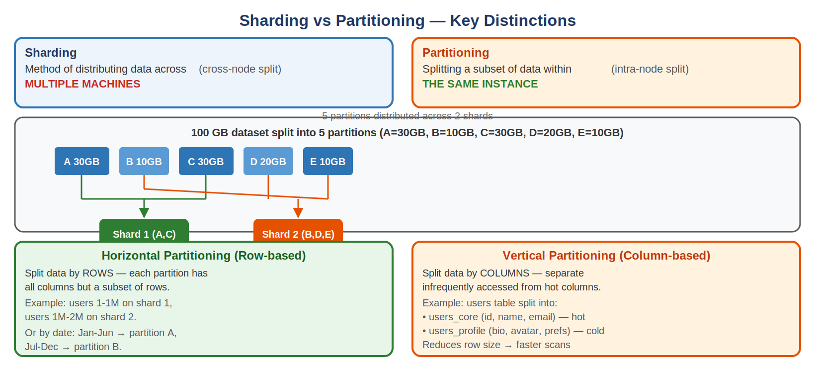

Sharding  Method of distributing data across MULTIPLE machines (nodes). Each machine is a shard.  - Involves network — data lives on different servers  - Increases total storage AND throughput  - Requires routing layer to direct requests  - Shards are independent — no replication between them  Example: user_id 1-1M on Server A, 1M-2M on Server B | Partitioning  Splitting a subset of data within the SAME instance. Logical division, one machine.  - No network — all partitions on same server  - Improves query performance via partition pruning  - DB engine handles routing internally  - Can combine: partition data THEN distribute partitions across shards  Example: orders table partitioned by year within one MySQL server

Partitioning Strategies

Horizontal Partitioning (Row-based)
Split by rows — each partition contains all columns but a different subset of rows. This is what most people mean when they say "partitioning".
- Range partitioning: orders from Jan-Jun → partition A, Jul-Dec → partition B.
- Hash partitioning: hash(user_id) % N determines which partition. Even distribution.
- List partitioning: country = "IN" → partition Asia, country = "US" → partition Americas.
- Key benefit: queries with a partition key filter only scan the relevant partition (partition pruning).

Vertical Partitioning (Column-based)
Split by columns — frequently accessed columns in one partition, infrequently accessed in another. Reduces row size and speeds up scans.
- Example: users_core (id, name, email) — accessed on every request.
- users_extended (bio, avatar_url, preferences, address) — accessed only on profile page.
- Benefit: smaller row size → more rows fit in memory → faster sequential scans.

The Sharding Decision Matrix
Combination | What It Means | When to Use
No Sharding + No Partitioning | Single DB, single table | Small datasets, early stage products
No Sharding + Partitioning | Single DB, table partitioned internally | Medium datasets, query performance optimization
Sharding + No Partitioning | Multiple DB nodes, unpartitioned tables | High write load, large datasets across nodes
Sharding + Partitioning | Multiple DB nodes, each internally partitioned | Large scale systems — e.g. Cassandra, DynamoDB

Interview Takeaway — Sharding & Partitioning
Most people use the terms interchangeably — oversimplification. The precise distinction: sharding = cross-machine, partitioning = same machine. In practice: a database is sharded while the data is partitioned.
Shard key selection is the hardest problem in sharding. Bad choices cause hot shards. Good shard keys are: high cardinality, evenly distributed, and appear in most query WHERE clauses. User_id is often a good shard key for user-facing services. Avoid timestamp as a shard key — all writes go to the latest shard.

Module 05

Non-Relational Databases (NoSQL)
"NoSQL" is a broad generalization — it means any database that is non-relational. But this does NOT mean all NoSQL databases are similar. Each type solves a different problem and has unique properties.

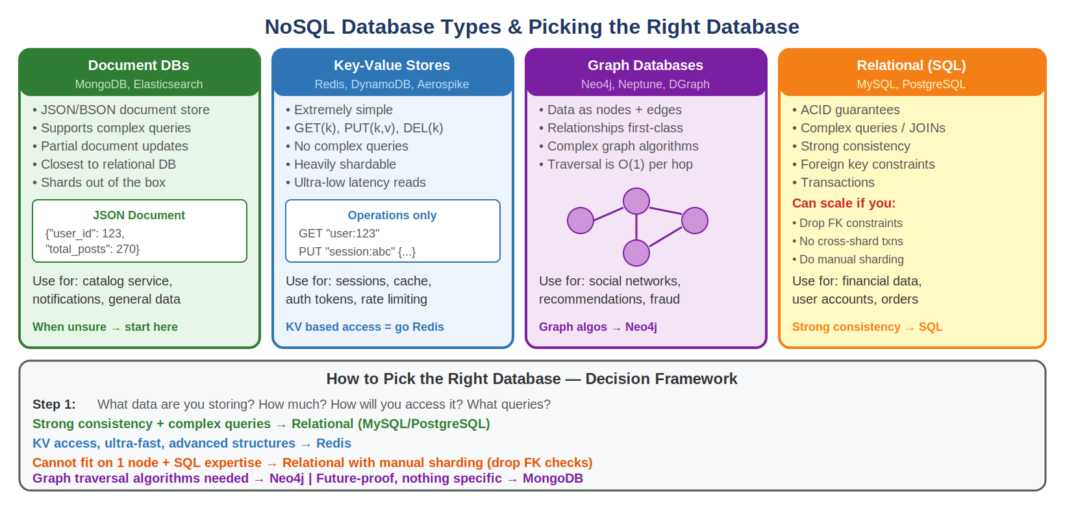

What Makes NoSQL Interesting at Scale
Most non-relational databases SHARD out of the box — horizontal scalability is built-in. This is the main reason teams reach for NoSQL.
Why NoSQL scales easily: (1) No cross-table relations or constraints to maintain. (2) Data is modelled to be sharded — designed for split across multiple nodes from the start.
Important: If you relax these same constraints on a relational DB (drop FK checks, no cross-shard transactions, manual sharding), you can scale it too!

Type 1: Document Databases
MongoDB, Elasticsearch. JSON/BSON document store — closest to relational databases in capability.
Feature | Detail
Data model | JSON/BSON documents — flexible schema, nested structures
Query capability | Supports complex queries, aggregations, text search — almost like SQL
Partial updates | Can update individual fields without re-writing the entire document
Sharding | Built-in horizontal sharding (MongoDB mongos router, Elasticsearch shards)
Use cases | In-app notifications, product catalog, content management, general-purpose storage
When to choose | Nothing specific needed but want to future-proof — start with MongoDB

Type 2: Key-Value Stores
Redis, DynamoDB, Aerospike. Extremely simple databases — only GET, PUT, DELETE operations. No complex queries.
Feature | Detail
Data model | Key maps to a value — string, JSON, or binary
Operations | GET(key), PUT(key, value), DEL(key) — that is it
Query support | None — no WHERE clauses, no aggregations, no JOINs
Performance | Sub-millisecond latency — fastest reads of any DB type
Sharding | Heavily shardable — consistent hashing across nodes
Use cases | Session storage, auth tokens, rate limiting, caching, leaderboards, pub/sub
Note | You can use relational DBs and document DBs AS key-value stores for many use cases

Type 3: Graph Databases
Neo4j, Neptune, DGraph. Store data as nodes (entities), edges (relationships), and properties. Traversal between connected nodes is O(1) per hop — no JOINs needed.
- Nodes represent entities: User, Post, Product.
- Edges represent relationships: FOLLOWS, BOUGHT, LIKES — relationships are first-class citizens.
- Example: (Arpit)-[BOUGHT]->(iPad). Finding who Arpit follows is a direct pointer traversal.
- Power: multi-hop traversals — friends of friends, people who bought what you bought.
- Use cases: social networks (follow graphs), recommendation engines, fraud detection (ring detection), knowledge graphs.
- When to choose: sophisticated graph algorithms are required — shortest path, PageRank, community detection.

Interview Takeaway — NoSQL
Common misconception: people pick NoSQL because "relational DBs do not scale." This is wrong. Relational DBs CAN scale with sharding — they just require more manual work (drop FK checks, no cross-shard transactions).
Real reason to pick NoSQL: the data model or access pattern is fundamentally different. Highly nested JSON → Document DB. Pure K/V access → Redis. Graph traversals → Neo4j.

Module 06

Picking the Right Database
It is not a fight between SQL and NoSQL. Every database is designed to solve a particular problem really well. Each kind of database picks a segment of use cases with slight overlap between them.

The 5-Question Framework — Ask Before Picking Any DB
1. What data are you storing? (structure, relationships, flexibility needed)
2. How MUCH data will you be storing? (GB, TB, PB — does it fit on one node?)
3. How will you be ACCESSING the data? (by key, by range, by relation, by text search)
4. What kind of QUERIES will you be firing? (simple K/V lookups, complex JOINs, graph traversals)
5. Any SPECIAL features you expect? (expiration/TTL, pub/sub, geospatial, ACID, full-text search)

Decision Framework
Condition | Recommended DB | Reasoning
Data fits on 1 node + need strong consistency + complex queries | Relational (MySQL/PostgreSQL) | ACID guarantees, JOINs, constraints all available
Data fits on 1 node + KV access + need ultra-fast reads | Redis | Sub-ms latency, advanced data structures (sorted sets, bitmaps)
Data fits on 1 node + need advanced data structures (leaderboards, pub/sub) | Redis | Sorted sets, Pub/Sub, Bloom filters, HyperLogLog built-in
Data cannot fit on 1 node + SQL expertise + can do manual sharding | Relational + manual sharding | Drop FK checks, no cross-shard txns — relational still works
Data cannot fit on 1 node + simple KV access pattern | DynamoDB / MongoDB / Aerospike | Built-in sharding, scales horizontally by default
Need sophisticated graph algorithms | Neo4j / Neptune | Native graph traversal, shortest path, community detection
Nothing specific but want to future-proof | MongoDB | Flexible schema, built-in sharding, good query support

SQL Can Scale — The Misconception
The most common interview misconception: "I will use MongoDB/Cassandra because MySQL does not scale." This is WRONG. Here is how to scale a relational database:
- Do NOT use foreign key constraints (drop them in the application layer instead).
- Do NOT use cross-shard transactions (design data model to avoid cross-shard writes).
- Implement manual sharding — route requests based on shard key in the application.
This is exactly what companies like Instagram (PostgreSQL), Shopify (MySQL), and GitHub (MySQL) do at massive scale.

Every DB Has Peculiar Properties
Every single database has some peculiar properties and guarantees. If you need those specific properties, you pick that database.
Cassandra: always-on writes, tunable consistency, wide-column model → used for IoT, time-series, user activity.
Elasticsearch: full-text search with relevance scoring, aggregations → used for search boxes, log analytics.
InfluxDB / TimescaleDB: time-series data, downsampling, retention policies → metrics, monitoring, IoT.
Do not memorise all databases — understand the tradeoffs and ask the right 5 questions.

Module 07

FAANG-Style Interview Questions & Answers

Q1: Explain ACID. Where would each property be critical in a payment system?

Answer
In a payment system (e.g. transferring $100 from Account A to Account B):
- Atomicity: DEBIT from A and CREDIT to B must both succeed or both fail. If DEBIT succeeds but CREDIT fails, money vanishes. Atomicity prevents this via transaction rollback.
- Consistency: Account balance can never go negative (CHECK constraint). Total money in system stays constant (enforced by business logic + constraints).
- Isolation: Two concurrent transfers from Account A must not both read the same balance and both deduct — that would allow overdrafts. Use Serializable or SELECT FOR UPDATE to lock the row.
- Durability: After the transfer COMMITS, it must survive a server crash. WAL + fsync ensures this.

Follow-up Questions
What isolation level would you use for a bank transfer? (Serializable or Repeatable Read with SELECT FOR UPDATE)
How does a database implement Durability? (Write-Ahead Log — changes written to log before data files)
What is the difference between Consistency in ACID and Consistency in CAP? (ACID-C = application invariants; CAP-C = all nodes agree on same value)

Q2: Your read:write ratio is 95:5 and your DB is slow. How do you scale?

Answer
- First confirm the bottleneck is reads (use monitoring — check CPU, IOPS, slow query log).
- Add a read replica (async replication). Route all SELECT queries to replica.
- Add a caching layer (Redis) in front of the DB for the hottest queries — reduces DB reads further.
- Add database indexes on the most frequent query patterns — often fixes 80% of slow read problems before any infrastructure changes.
- If replica still overloaded: add more replicas and load-balance reads across them.
- If write throughput also becomes a bottleneck later: introduce sharding on user_id or tenant_id.

Follow-up Questions
What is replication lag and how does it affect your application? (Answer: replica may be seconds behind master — your own writes may not appear immediately; use read-your-own-writes pattern)
What is the difference between sync and async replication? (Answer: sync = strong consistency but slower writes; async = eventual consistency but faster writes)
How do you handle a replica that is significantly behind the master? (Answer: monitor lag metric, implement lag threshold — if lag > N seconds, route that read to master instead)

Q3: Design the data storage layer for a social network (like Twitter) at 100M users.

Answer
- Users table: MySQL sharded by user_id. Strong consistency needed for login/auth. Use bcrypt hashes, email UNIQUE constraint.
- Posts/Tweets: MySQL or Cassandra. If mostly append-only + high write volume → Cassandra (always-on writes, wide-column). If rich query patterns needed → MySQL with sharding by user_id.
- User timeline (feed): Redis sorted set per user (key = user_id, score = timestamp, member = tweet_id). Fast O(log N) inserts and range queries. Cap at last 800 tweets.
- Media (images, videos): S3 / Blob storage. Never store binary blobs in relational DB.
- Search (full-text on tweets): Elasticsearch. Separate write path: tweet written to MySQL, async event to Kafka, Kafka consumer indexes into Elasticsearch.
- Graph (follows/followers): Neo4j or custom adjacency list in MySQL. Neo4j for complex graph queries (mutual friends, 2nd-degree connections).

Follow-up Questions
How would you handle celebrity accounts with 50M followers? (Hybrid fan-out: pre-compute timelines for normal users, on-read merge for celebrity posts)
What isolation level for the "follow" operation? (Read Committed is sufficient — follow is idempotent)
How do you shard the users table? (By user_id using consistent hashing — ensures even distribution as users grow)

Q4: When would you choose MongoDB over MySQL? Justify technically.

Answer
Choose MongoDB (Document DB) over MySQL when:
- Schema is flexible and evolving: different users have different profile fields (e.g. marketplace sellers vs buyers). MongoDB's schema-less documents accommodate this without migrations.
- Hierarchical / nested data: a product catalog with categories, attributes, and variants that differ per category. In MySQL this requires complex schema; in MongoDB it is one document.
- Horizontal scaling is required from day 1: MongoDB shards out of the box. MySQL sharding requires significant engineering effort.
- No strong transactional requirements: catalog browsing, notification storage, user preferences — eventual consistency is acceptable.
Keep MySQL when:
- Multi-table ACID transactions are required (orders, payments, inventory).
- Complex aggregations across tables (JOINs are first-class in SQL).
- You have strong consistency requirements and your team knows SQL well.

Follow-up Questions
Does MongoDB support transactions now? (Yes, since v4.0 — multi-document ACID transactions are supported, but with performance overhead)
What is the trade-off of a flexible schema? (Benefit: easier evolution; Cost: no schema enforcement at DB level, must validate in application code)
Can you do complex aggregations in MongoDB? (Yes, via Aggregation Pipeline — but SQL GROUP BY is generally more expressive and optimized)

Module 08 — Quick Reference

Trade-off Reference Card

DB Selection Decision Matrix
Use Case | Best DB | Why
Financial transactions, payments | MySQL / PostgreSQL | ACID, strong consistency, FK constraints
User sessions, auth tokens, caching | Redis | Sub-ms latency, TTL support, KV simplicity
Product catalog, CMS, notifications | MongoDB | Flexible schema, nested docs, built-in sharding
Social graph, recommendations, fraud | Neo4j / Neptune | Graph traversal O(1) per hop, native graph algos
Full-text search on user content | Elasticsearch | Relevance scoring, inverted index, aggregations
Time-series metrics / monitoring | InfluxDB / TimescaleDB | Downsampling, retention policies, time-range queries
Event streaming / audit log | Apache Kafka | Durable log, replay, multiple consumers, high throughput
Big Data / analytics at rest | S3 + Athena / Redshift | Column-store, cheap storage, SQL on S3

Key Interview Vocabulary
- ACID: Atomicity, Consistency, Isolation, Durability — guarantees of relational databases.
- Isolation Levels: Read Uncommitted, Read Committed, Repeatable Read, Serializable — ordered by isolation strength.
- Anomalies: dirty read, non-repeatable read, phantom read — what different isolation levels prevent.
- Scaling: vertical (scale up), horizontal (scale out), read replicas (read scale), sharding (write + storage scale).
- Replication: synchronous (strong consistency, slow writes), asynchronous (eventual consistency, fast writes).
- Sharding vs Partitioning: cross-machine vs same-machine data split.
- Shard key: determines which shard a row goes to — must be high cardinality and evenly distributed.
- NoSQL types: Document (MongoDB), Key-Value (Redis), Graph (Neo4j), Wide-Column (Cassandra), Time-Series (InfluxDB).
- CAP Theorem: Consistency, Availability, Partition Tolerance — only 2 of 3 guaranteed.
- WAL: Write-Ahead Log — mechanism behind Durability and crash recovery.

