Spark row distribution, shuffle & join — a worked example
This walks through one concrete 12-row dataset end to end: how the rows land on executors, what happens physically during a groupBy shuffle, and how a join resolves — with the actual row-level numbers at every step.

Part A — Concept notes
A quick reference for the mechanics, before we ground them in real row-level numbers in Part B.

A1. Cluster architecture: how data lands on executors
- The driver plans the job and builds the execution DAG; it does not hold the data itself.
- Input data is split into partitions (roughly one per file block, ~128MB by default) and each partition is assigned to a task.
- Executors run tasks in parallel, each working only on the partitions assigned to it, in memory.
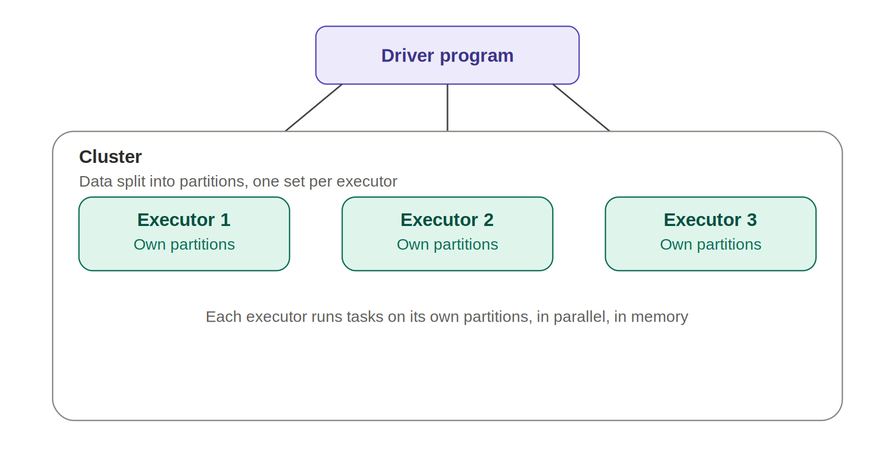

A2. Transformations: narrow vs. wide
- Narrow transformations (map, filter, select) — each output partition depends on exactly one input partition. No data crosses the network.
- Wide transformations (groupBy, join, distinct, orderBy, repartition) — an output partition can depend on many input partitions. This is what forces a shuffle.
- Every wide transformation is a stage boundary: the stage before it must finish writing shuffle output before the next stage can start reading it.

A3. Shuffle mechanics
- Map side: each task computes a partial result locally first (e.g. a partial sum per key) before anything moves.
- Exchange: partial results are hashed by key and written to disk, then fetched over the network by the task that owns that key's hash bucket.
- Reduce side: each task combines the partials it received into the final result for its keys.
- Cost drivers: number of shuffle partitions, key skew, and total bytes written/read — this is almost always the most expensive part of a Spark job.
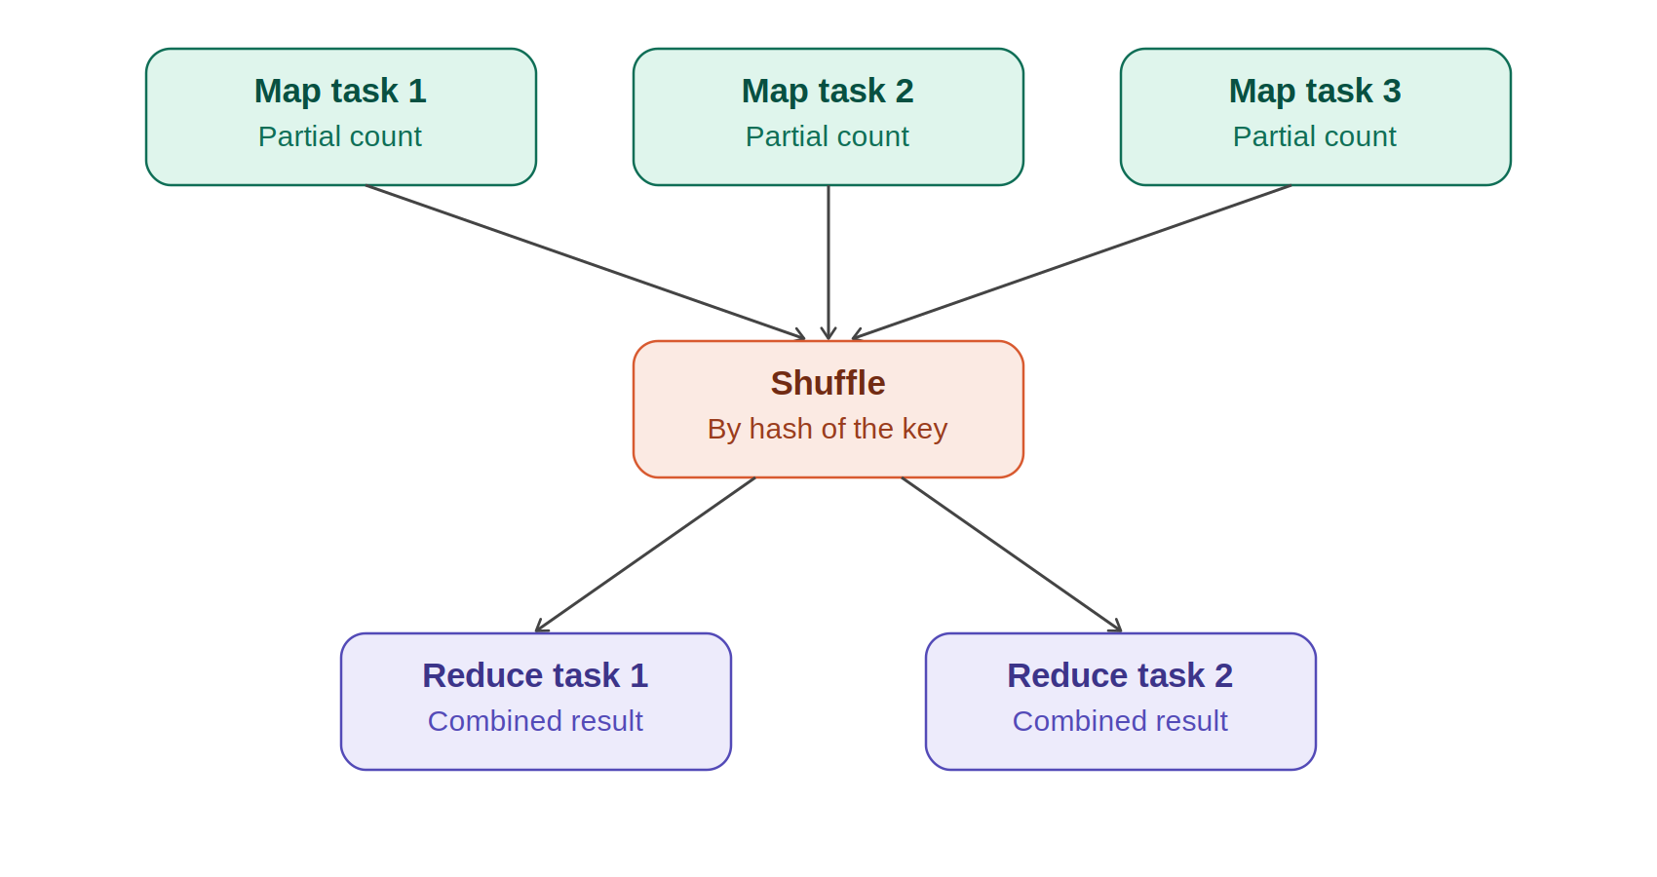

A4. Join strategies
Strategy | When Spark picks it | Shuffle involved?
Broadcast hash join | One side is small enough to fit in memory (under autoBroadcastJoinThreshold, default 10MB) | No — small side is copied to every executor
Shuffle sort-merge join | Both sides are large | Yes — both sides shuffled by the join key, then merged locally
Shuffle hash join | Both sides large but one fits in memory per-partition; less common than sort-merge | Yes — same shuffle, cheaper local join step
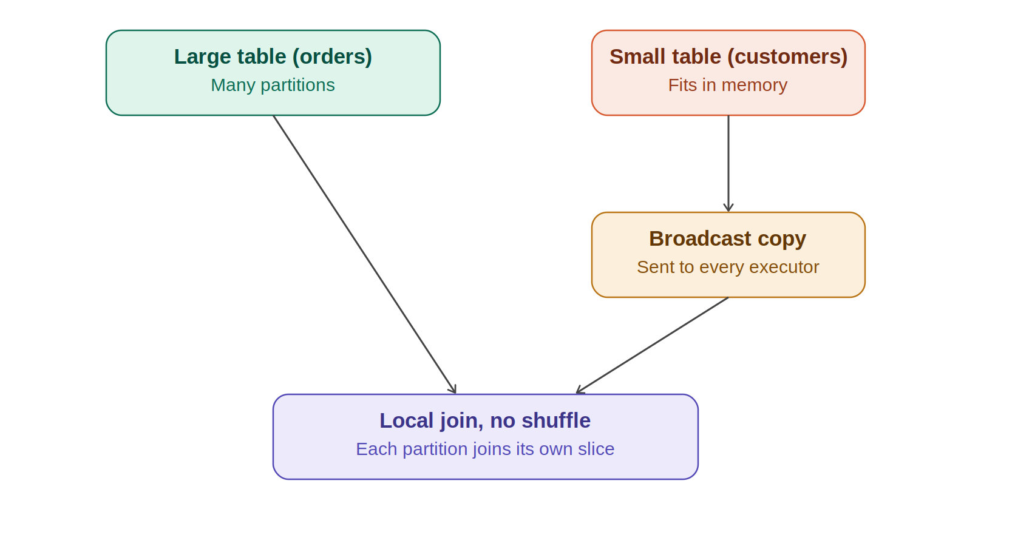
Adaptive Query Execution (AQE) can change these decisions at runtime — e.g. switching a planned shuffle join to a broadcast join once it sees the actual size of a table after filtering, or splitting a skewed partition into smaller pieces automatically.

A5. Key tuning knobs
Setting | What it controls
spark.sql.shuffle.partitions | Number of partitions used for shuffles (joins, aggregations). Default 200 — often needs tuning to data volume.
spark.sql.autoBroadcastJoinThreshold | Size limit under which a table is broadcast instead of shuffled for a join. Default 10MB.
spark.sql.adaptive.enabled | Turns on AQE: dynamic partition coalescing, join strategy switching, and skew join handling.
spark.sql.adaptive.skewJoin.enabled | Lets AQE split an oversized (skewed) shuffle partition into smaller sub-partitions.
spark.memory.fraction | Share of executor JVM heap used for execution + storage memory (the rest is reserved for user code).

Part B — Worked example: watch it happen on real rows
Same mechanics as Part A, traced through one concrete 12-row dataset so every number can be checked by hand.

1. The sample dataset
We'll use a small orders table. In real Spark this would be millions of rows across hundreds of files, but the mechanics are identical at any scale — only the partition and row counts change.
Row | order_id | customer_id | region | amount
1 | 1 | 101 | APAC | 250
2 | 2 | 102 | APAC | 400
3 | 3 | 103 | US | 150
4 | 4 | 104 | EU | 300
5 | 5 | 105 | US | 220
6 | 6 | 106 | APAC | 500
7 | 7 | 107 | EU | 180
8 | 8 | 108 | US | 90
9 | 9 | 109 | APAC | 310
10 | 10 | 110 | EU | 275
11 | 11 | 111 | US | 600
12 | 12 | 112 | EU | 145

2. How these rows land on executors
When Spark reads the source file, it splits it into partitions based on file blocks/splits — not by the value of any column. With 12 rows and 3 executors, a typical split is 4 rows per partition, in file order. Nothing here is grouped by region or customer_id yet; that only happens later, during a shuffle.
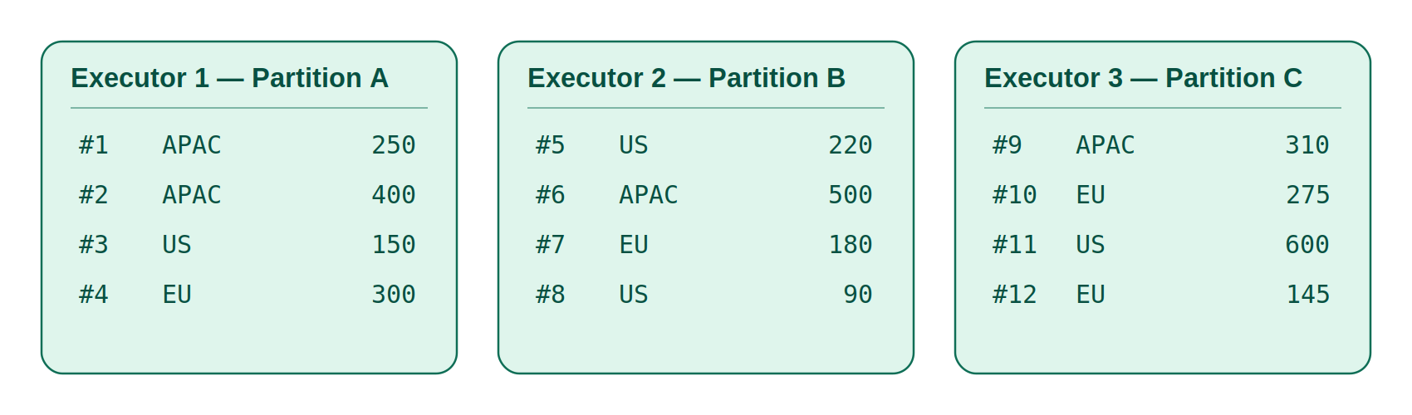
Executor | Partition | Rows it holds (order_id) | Row count
Executor 1 | Partition A | 1, 2, 3, 4 | 4
Executor 2 | Partition B | 5, 6, 7, 8 | 4
Executor 3 | Partition C | 9, 10, 11, 12 | 4
Key point: at this stage, an executor's rows have nothing in common by region or customer — the split is purely positional. Executor 1 happens to hold one row each of APAC, US, and EU. This is exactly why a groupBy needs a shuffle: the data isn't organized by key yet.

3. groupBy("region").sum("amount") — the shuffle, step by step
Here's the whole shuffle in one picture: local partial sums per executor, routed by key, combined into final totals. The step-by-step tables below walk through exactly how each number was produced.
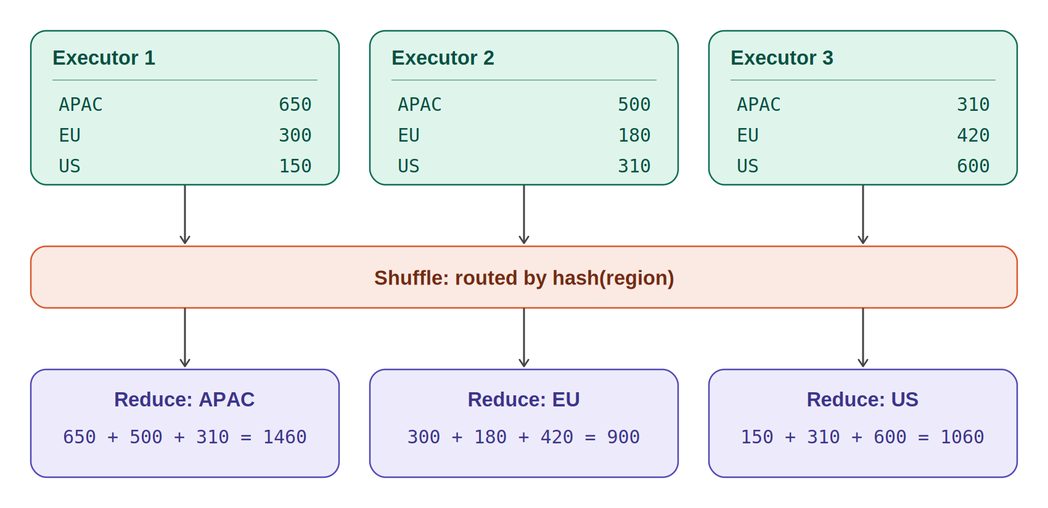

3a. Map side: each executor aggregates locally first
Before any data moves across the network, each executor computes a partial sum per region using only the rows it already has. This is the map-side (partial) aggregation.
Executor | Region | Rows used | Partial sum
Executor 1 | APAC | 1 (250), 2 (400) | 650
Executor 1 | US | 3 (150) | 150
Executor 1 | EU | 4 (300) | 300
Executor 2 | US | 5 (220), 8 (90) | 310
Executor 2 | APAC | 6 (500) | 500
Executor 2 | EU | 7 (180) | 180
Executor 3 | APAC | 9 (310) | 310
Executor 3 | EU | 10 (275), 12 (145) | 420
Executor 3 | US | 11 (600) | 600
Only 9 small numbers exist at this point, not the 12 original rows. This is exactly what makes reduceByKey / DataFrame groupBy cheap compared to a naive groupByKey, which would ship all 12 raw rows across the network instead of these 9 partial sums.

3b. The shuffle: partials are routed by hash(region)
Now the actual shuffle happens: Spark hashes the "region" value of each partial result and sends it to whichever reduce task owns that hash bucket. Every partial for the same region — no matter which executor produced it — converges on one reduce task.
Partial result (from) | region | value | sent to
Executor 1 | APAC | 650 | Reduce task: APAC
Executor 1 | US | 150 | Reduce task: US
Executor 1 | EU | 300 | Reduce task: EU
Executor 2 | US | 310 | Reduce task: US
Executor 2 | APAC | 500 | Reduce task: APAC
Executor 2 | EU | 180 | Reduce task: EU
Executor 3 | APAC | 310 | Reduce task: APAC
Executor 3 | EU | 420 | Reduce task: EU
Executor 3 | US | 600 | Reduce task: US
The highlighted rows all land on the same "APAC" reduce task even though they came from three different executors — this cross-network movement, driven purely by the key's hash, is the shuffle itself. This is the step explain() shows as an Exchange(hashpartitioning(region, N)) node, and it's the step that costs disk I/O + network time.

3c. Reduce side: final combine
Each reduce task now sums the partials it received. This is the final, correct answer — and it matches summing all 12 original rows directly.
Reduce task | Partials received | Final sum
APAC | 650 + 500 + 310 | 1460
EU | 300 + 180 + 420 | 900
US | 150 + 310 + 600 | 1060

4. Join example: orders ⋈ customers
Now a small dimension table — customers — needs to be joined onto the orders. Because it's small enough to fit comfortably in memory, Spark uses a broadcast join instead of shuffling the (much larger) orders table.
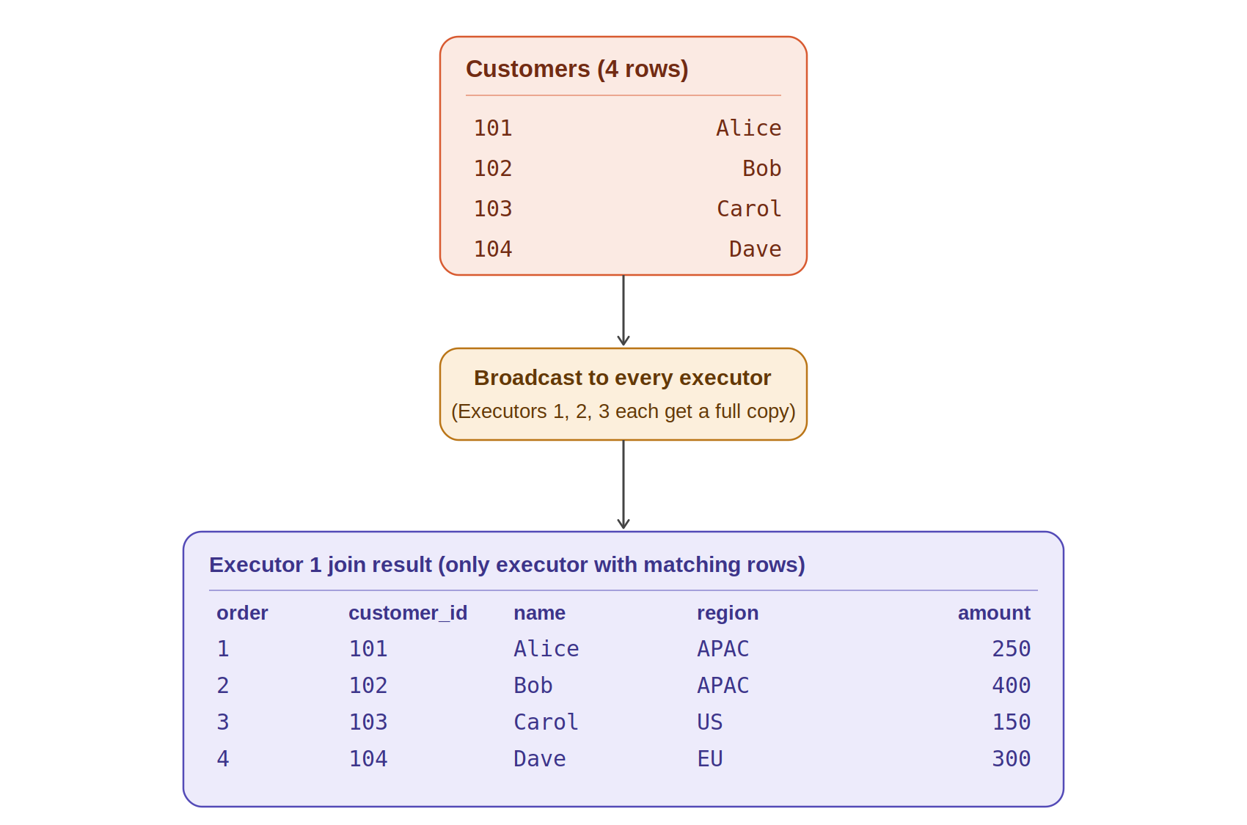

4a. The small table
customer_id | name
101 | Alice
102 | Bob
103 | Carol
104 | Dave

4b. Broadcast: the full customers table is copied to every executor
Executor | Has orders partition | Receives broadcast copy of customers? | Rows it can match locally
Executor 1 | Partition A (orders 1-4) | Yes — full 4-row table | 101, 102, 103, 104
Executor 2 | Partition B (orders 5-8) | Yes — full 4-row table | 101, 102, 103, 104
Executor 3 | Partition C (orders 9-12) | Yes — full 4-row table | 101, 102, 103, 104
No shuffle of the orders table happens at all. Every executor already has everything it needs locally: its own orders partition plus a full copy of customers. Each one just does an in-memory hash join against its own rows.

4c. Result, produced independently by each executor
order_id | customer_id | name | region | amount | produced by
1 | 101 | Alice | APAC | 250 | Executor 1
2 | 102 | Bob | APAC | 400 | Executor 1
3 | 103 | Carol | US | 150 | Executor 1
4 | 104 | Dave | EU | 300 | Executor 1
Executors 2 and 3 also run the join locally, but none of their rows (order_id 5-12, customer_id 105-112) match the 4 customers in this small table, so they contribute nothing to the output — no error, no cross-executor communication needed, just empty results from those tasks.

4d. If both tables were large instead
If customers had millions of rows too, Spark could not broadcast it. Instead it would shuffle both orders and customers by customer_id — exactly like the groupBy shuffle in Section 3, but keyed on customer_id instead of region — so that matching customer_id values from both tables land on the same executor, then sort-merge the two local slices together.

Summary
- Rows are split into partitions positionally when read — not grouped by key yet.
- A wide transformation like groupBy forces a shuffle: partial results are hashed by key and physically moved so every value for a key reaches one task.
- A broadcast join avoids that shuffle for the large side by copying the small side everywhere instead — the join becomes purely local, per-executor work.
- A shuffle (sort-merge) join is what happens when neither side is small enough to broadcast: both sides get shuffled by the join key first.

