Robust Phishing Detection against Adversarial Evasion Attacks Using Random Forest Models

Jasmeet Singh
Chitkara University Institute of Engineering and Technology Chitkara University Punjab, India
jasmeet449.be22@chitkara.edu.in

Tamanna
Chitkara University Institute of Engineering and Technology Chitkara University Punjab, India
tamanna885.be22@chitkara.edu.in

Tanishpreet Kaur
Chitkara University Institute of Engineering and Technology Chitkara University Punjab, India
tanishpreet895.be22@chitkara.edu.in

Ronit Sachdeva
Chitkara University Institute of Engineering and Technology Chitkara University Punjab, India
ronit2184.be22@chitkara.edu.in

Isha Kansal
Chitkara University Institute of Engineering and Technology Chitkara University Punjab, India
isha.kansal@chitkara.edu.in

Abstract
Phishing attacks continue to evolve in complexity, leveraging sophisticated URL obfuscation, domain spoofing, and dynamic webpage manipulation techniques to evade traditional detection mechanisms. While machine learning models—particularly Random Forest (RF) classifiers—have demonstrated high accuracy in phishing detection, they remain susceptible to adversarial evasion attacks.
This study investigates the vulnerability of RF-based phishing detection systems against two prominent adversarial attack techniques: Fast Gradient Sign Method (FGSM) and Projected Gradient Descent (PGD). Using a large-scale dataset of 88,647 samples with 111 engineered features, we evaluate baseline model performance and its degradation under adversarial conditions.
The baseline RF model achieved an accuracy of 97.4% on clean data, which dropped significantly to 82.1% under FGSM and 77.6% under PGD attacks. To address this, adversarial training was implemented by augmenting the training data with adversarial examples. Post-training results showed a substantial improvement in robustness, with accuracy rising to 91.3% (FGSM) and 89.2% (PGD).
These findings demonstrate that adversarial training enhances model resilience and provides a practical framework for deploying robust phishing detection systems in real-world cybersecurity environments.

Keywords: Phishing Detection, Adversarial Attacks, Random Forest, FGSM, PGD, Adversarial Training, Cybersecurity.

1 Introduction
Phishing is one of the most prevalent cyber threats, targeting users through deceptive emails, websites, and messages to extract sensitive information such as login credentials, banking details, and personal data. With the rapid expansion of online services, phishing attacks have become more targeted and technically advanced.
Traditional detection systems, including blacklist-based and rule-based approaches, are insufficient against zero-day phishing attacks due to their static nature. Machine learning models, particularly ensemble methods like Random Forest, have shown superior performance by capturing complex patterns in URL and webpage features.
However, recent advancements in adversarial machine learning reveal that even high-performing models can be manipulated through carefully crafted perturbations. These adversarial inputs are designed to deceive models while appearing benign to users.
This research aims to:
- Evaluate RF model robustness against adversarial attacks
- Analyze the impact of FGSM and PGD attacks
- Implement adversarial training as a defense strategy
- Improve detection reliability in real-world scenarios

2 Literature Review
Early phishing detection methods relied on:
- Blacklists (e.g., Google Safe Browsing)
- Heuristic rules (URL patterns, suspicious keywords)
Limitations:
- Ineffective against new (zero-day) attacks
- Easily bypassed by obfuscation techniques
Machine Learning Approaches:
- Decision Trees
- Support Vector Machines (SVM)
- Random Forest (RF)
- Neural Networks

Among these, RF stands out due to:
- High accuracy
- Resistance to overfitting
- Interpretability
Adversarial Attacks:
- FGSM: Single-step gradient-based attack
- PGD: Iterative, stronger attack
Defense Mechanisms:
- Adversarial Training
- Defensive Distillation
- Input Sanitization
However, scalability and robustness trade-offs remain key research challenges.

3 Methodology
3.1 System Architecture
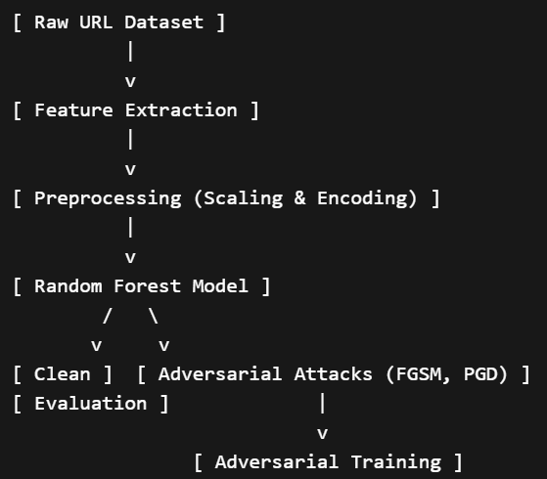

3.2 Dataset Description
- Total Samples: 88,647
- Features: 111
- Class Distribution:
  - Phishing: 50%
  - Legitimate: 50%

3.3 Feature Categories
Category | Description | Examples
Lexical Features | URL structure characteristics | URL length, symbols, digits
Domain Features | Domain-related metadata | Domain age, WHOIS info
Content Features | HTML and JavaScript properties | Script tags, iframe usage
Behavioral Features | User interaction patterns | Redirect chains, pop-ups

3.4 Data Preprocessing
- No missing values detected
- Label encoding for categorical variables
- Standardization using Z-score normalization
- Train-Test Split: 80:20 (Stratified)

3.5 Random Forest Model
Random Forest was selected due to:
- Ensemble learning capability
- High dimensional handling
- Robustness to noise

Hyperparameters optimized via:
- Grid Search
- 5-fold Cross Validation

3.6 Adversarial Attacks
FGSM (Fast Gradient Sign Method)
x′=x+ϵ⋅sign(∇xJ(θ,x,y))x' = x + \epsilon \cdot \text{sign}(\nabla_x J(\theta, x, y))x′=x+ϵ⋅sign(∇x​J(θ,x,y))
- Single-step attack
- Fast but less powerful
PGD (Projected Gradient Descent)
xt+1=Πx+S(xt+α⋅sign(∇xJ(θ,xt,y)))x_{t+1} = \Pi_{x+\mathcal{S}} \left( x_t + \alpha \cdot \text{sign}(\nabla_x J(\theta, x_t, y)) \right)xt+1​=Πx+S​(xt​+α⋅sign(∇x​J(θ,xt​,y)))
- Multi-step iterative attack
- Stronger and more effective

3.7 Defense: Adversarial Training
- Augmented dataset with adversarial samples
- Model trained on both clean and perturbed data
- Improves generalization and robustness

4 Experimental Setup
4.1 Evaluation Metrics
- Accuracy
- Precision
- Recall
- F1 Score

5 Results and Analysis
5.1 Baseline Performance
Model | Accuracy | Precision | Recall | F1 Score
Random Forest (Clean) | 0.974 | 0.975 | 0.973 | 0.974

Table 1: Baseline Performance on Clean Data
5.2 Performance Under Adversarial Attacks
Attack Type | Accuracy
FGSM | 0.821
PGD | 0.776
FGSM + Adversarial Training | 0.913
PGD + Adversarial Training | 0.892

Table 2: Model Performance Under Adversarial Attacks

5.3 Performance Comparison Chart
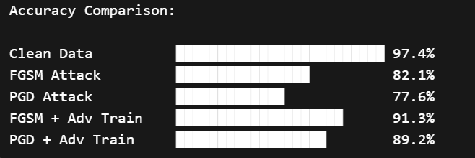

5.4 Key Observations
- Significant accuracy drop under adversarial attacks
- PGD is more destructive than FGSM
- Adversarial training restores most performance
- Trade-off between robustness and slight complexity increase

6. Discussion
The results highlight the critical vulnerability of machine learning models in adversarial environments. Despite high baseline accuracy, RF models can be easily misled without proper defenses.
Adversarial training proves effective but introduces:
- Increased training time
- Computational overhead
Future improvements could include:
- Hybrid models (RF + Deep Learning)
- Real-time detection systems
- Adaptive adversarial defenses

7. Conclusion
This study demonstrates that while Random Forest classifiers are highly effective for phishing detection, they are vulnerable to adversarial attacks such as FGSM and PGD. However, incorporating adversarial training significantly improves model robustness, making it a viable defense mechanism.
The findings emphasize the importance of integrating adversarial resilience into cybersecurity systems to ensure reliability in real-world deployments.

8. Future Work
- Integration with deep learning models
- Real-time phishing detection systems
- Advanced adversarial defense techniques
- Deployment in browser-based security tools

