Recruitment Agency

Contents:

1.Business Description

1.1 Business background_______________2

1.2 Problems. Current Situation__________2

1.3 Benefits from implementing DB, Project vision _________________________________2

2.Model Description

2.1 Definition & Acronyms_____________3

2.2 DB scheme_______________________3

2.3 Table Description__________________4

Business Description

* 1. Business background

We have average-sized recruitment agency. Our recruitment agency helps to connect candidates(jobseekers) with employers who are looking to fill job vacancies. Our agency acts as a bridge between job seekers and employers to ensure that both parties are satisfied with the hiring process. We provide a variety of services to job seekers, such as job matching, resume building, and interview preparation. For employers, we provide job postings, candidate screening, and recruitment advice.

1.2 Problems. Current Situation

Before implementing a database system, our agency was facing challenges with managing candidate and employer data. We had multiple spreadsheets and manual processes for tracking job postings, job applications, and candidate information. This resulted in difficulties in identifying job matching opportunities for job seekers and employers and maintaining data accuracy.

1.3 Benefits from implementing a database. Project Vision

Implementing a database system will enable our agency to manage candidate and employer data more efficiently and accurately. Our project vision is to create a database system that enables us to:

* Store and manage candidate and employer data in a centralized location
* Match job seekers with relevant job postings
* Track job applications and their status
* Provide employers with an easy-to-use platform for job posting and candidate screening

Model Description

2.1 Definitions & Acronyms

PK: Primary Key

FK: Foreign Key

INT: Integer

VARCHAR: Variable Character

TEXT: Character with unlimited length

DATE: Date

2.2 DB Scheme

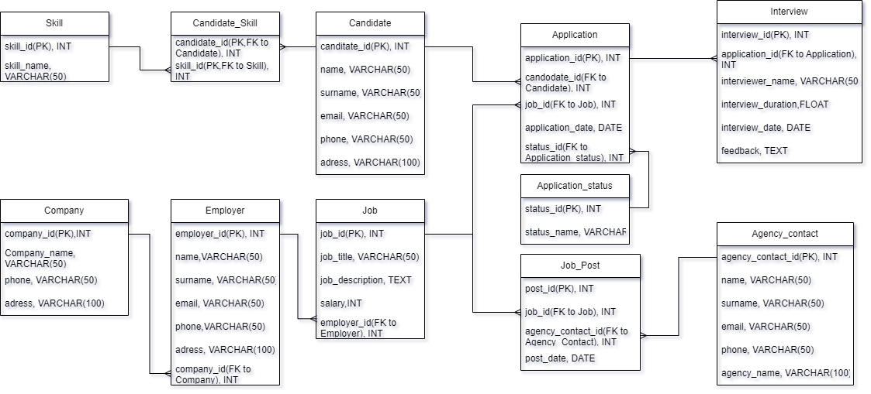

2.3 Objects

**Candidates**

Description: Represents a job seeker and contains personal information such as their name, email, and phone number.

|  |  |  |  |  |
| --- | --- | --- | --- | --- |
| Table name | Field name | Field description | Data type | example |
| Candidates | candidate_id | PK | int | 100 |
|  | name |  | Varchar(50) | Jasurbek |
|  | surname |  | Varchar(50) | Sharofiddinov |
|  | email |  | Varchar(50) | jasur@gmail.com |
|  | phone |  | Varchar(50) | +999999999 |
|  | adress |  | Varchar(50) | Tashkent, UZ |

**Skill**

Description: Contains a list of skills that job seekers can add

|  |  |  |  |  |
| --- | --- | --- | --- | --- |
| Table name | Field name | Field description | Data type | example |
| Skill | Skill_id |  | Int | 123 |
|  | Skill_name |  | Varchar(50) | Python |

**Candidate_Skill**

Description: Represents the relationship between a Candidate

and their skills.

|  |  |  |  |  |
| --- | --- | --- | --- | --- |
| Table name | Field name | Field description | Data type | Example |
| Candidate_Skill | candidate_id | PK,FK to Candidate table | int | 123 |
|  | skill_id | PK,FK to Skill table | int | 100 |

**Employer**

Description: Contains information about an employer,

|  |  |  |  |  |
| --- | --- | --- | --- | --- |
| Table name | Field name | Field description | Data type | Example |
| Employer | employer_id | PK | Int | 1 |
|  | name |  | Varchar(50) | Yekaterina |
|  | surname |  | Varchar(50) | Karimova |
|  | email |  | Varchar(50) | karmoa@gmail.com |
|  | phone |  | Varchar(50) | +998992929292 |
|  | adress |  | Varchar(100) | London, UK |

**Company**

Description: Contains information about the companies which employer works

|  |  |  |  |  |
| --- | --- | --- | --- | --- |
| Table name | Field name | Field description | Data type | Example |
| Company | company_id | PK | Int | 2 |
|  | company_name |  | Varchar(50) | EPAM |
|  | phone |  | Varchar(50) | +99899549959 |
|  | adress |  | Varchar(100) | Tashkent 34, Yunusobod district |
|  |  |  |  |  |

**Job**

Description: contains information about the job title, description, location, salary range, and the employer who posted the job.

|  |  |  |  |  |
| --- | --- | --- | --- | --- |
| Table name | Field name | Field description | Data type | Example |
| Job | job_id | PK | Int | 1 |
|  | job_title |  | Varchar(50) | Python developer |
|  | job_description |  | TEXT | As a python developer you will develop high scalable project… |
|  | salary |  | Int | 1200 |
|  | employer_id | FK to Employer table | int | 123 |

**Agency_Contact**

Description: Represents a contact person within an employer company and contains information such as their name, email, phone number, and the company they work for.

|  |  |  |  |  |
| --- | --- | --- | --- | --- |
| Table name | Field name | Field description | Data type | Example |
| Agency_contact | agency_contact_id | PK | Int | 12 |
|  | name |  | Varchar(50) | Olga |
|  | surname |  | Varchar(50) | Tursunova |
|  | email |  | Varchar(50) | turs@gmail.com |
|  | phone |  | Varchar(50) | +991854914 |
|  | agency_name |  | Varchar(50) | Person Hunters |
|  |  |  |  |  |

**Job_Post**

Description: Represents the relationship between a job and the agency contact who posted the job

|  |  |  |  |  |
| --- | --- | --- | --- | --- |
| Table name | Field name | Field description | Data type | Example |
| Job_Post | post_id | PK | INT | 1 |
|  | job_id | FK to Job table | INT | 123 |
|  | agency_contact_id | FK to Agency_Contact table | INT | 12 |
|  | post_date |  | DATE | 12.04.2023 |
|  |  |  |  |  |

**Application**

Description: Represents a job application and contains information about the candidate who applied, the job they applied for, the date of the application, and the application status.

|  |  |  |  |  |
| --- | --- | --- | --- | --- |
| Table name | Field name | Field description | Data type | Example |
| Application | application_id | PK | INT | 1 |
|  | candidate_id | FK to Candidate table | INT | 123 |
|  | job_id | FK to Job table | INT | 100 |
|  | application_date |  | DATE | 09.04.2023 |
|  | application_status_id |  | INT | 1 |

**Application_Status**

Description: Contains a list of possible application statuses, such as "New", "In Review", "Rejected", or "Hired".

|  |  |  |  |  |
| --- | --- | --- | --- | --- |
| Table name | Field name | Field description | Data type | Example |
| Application_status | status_id | PK | Int | 1 |
|  | status_name | “Hired”,”Rejected”,”Applied”,” New”.. | Varchar(50) | New |

**Interview**

Description: Represents an interview and contains information about the date and time of the interview, the job seeker who will be interviewed, and the interviewer(s)

|  |  |  |  |  |
| --- | --- | --- | --- | --- |
| Table name | Field name | Field description | Data type | Example |
| Interview | interview_id | PK | INT | 1 |
|  | application_id |  | INT | 2 |
|  | interviewer_name |  | VARCHAR(50) | John Treiler |
|  | interview_duration | Duration in hours | Float | 1.5 |
|  | interview_date |  | DATE | 15.04.2023 |
|  | feedback |  | TEXT | This candidate has some decent knowledge in…. |