COURSEWORK SUBMISSION FORM
STUDENT USE |  | STAFF USE
Module Name | Web Technologies | First Marker’s  (acts as signature)
Module Code | 4BUIS011C | Second Marker’s  (acts as signature)
Lecturer Name | Bunyod Khoshimkhujaev | Agreed Mark
UoW Student IDs |  | For Registrar’s office use only (hard copy submission)
WIUT Student IDs | 00005317
Deadline date | 15.11.2017
Assignment Type | GroupIndividual

SUBMISSION INSTRUCTIONS

COURSEWORKS must be submitted in both HARD COPY (to the Registrar’s Office) and ELECTRONIC unless instructed otherwise.
For hardcopy submission instructions refer to: http://intranet.wiut.uz/Shared%20Documents/Forms/AllItems.aspx - Coursework hard copy submission instructions.doc
For online submission instructions refer to: http://intranet.wiut.uz/Shared%20Documents/Forms/AllItems.aspx - Coursework online submission instructions.doc

MARKERS FEEDBACK (Continued on the next page)

Site Plan
Here is the link for the website. (www.jacciesstore.ml)
Introduction
There were 12 choices of company/direction where I found “Clothing store” is the most interesting for me, for which I created my own web site. Nowadays, textile industry has been developing day by day and from my point of view, I consider one of the most effective ways to advertise the production is utilize web site.
Audience Profile
Why I think online store is so useful?
Actually, every 2nd people have an access to the internet, at a current millennium. People, step by step are starting to book and buy clothes online from their favorite brands such as “Gucci”, “Polo”, “Nike” and etc. Online store advantages are:
- You don’t have to go to the boutique and choose suitable clothes by wasting so many times. You will be able to choose it online by sitting at home, what`s more, there will be available sizes, colors, prices and all product details.
- If you will not be satisfied with the product of one brand you can just exit from that page and enter to the page of another brand where you can find your favorite clothes.
- In official pages of brands, products are totally guaranteed by the administration of productions. You can return bought products if they have any problems.

Goals and Objectives
Personally, it is my first website that I created. I tried to make it as much beautiful and accurate as I could. I aimed to make it more animated with JavaScript. One of the most useful functions for making my home page beautiful is “carousel” function. Hopefully, it attracts visitors with its changing. Attracting clients’ attentions is my biggest goal.

Functions and Features
Actually, my website is not so high quality and well designed. Moreover, there is lack of JavaScript functions and animations. However, I tried to make it interesting with adding beautiful backgrounds, and different images in every aspect of pages. In Home, Women`s Shoes and Men`s Jeans pages, I added carousel functions with different animations for each of them. There is hide, show, disabled buttons and next/previous (load Gallery) functions in Women`s Dress page. Each page has scroll-up button which works by JavaScript codes. Contact page has form where you will be able to see invalid error for incorrect texting password/name.

Navigation
As to navigation bar, I used linear navigation bar. This style of navigation bar is used in more than half of popular clothing store web sites. It is because, linear style is clear showed what options you can choose. The class of this navigation I took from the reliable source (bootstrap.com). On the Left corner, Brand of the site is placed. Women and Men are dropdowns which included three links in each. At the end, on the right corner you can find Contact page as well as About.
I am looking forward to get my feedback and outcome to my web site, and I will work on further development of this cite.
Evaluation

Evaluation of Competitors’ Websites

I chose Levi`s and Tommy Hilfiger as my competitors` for my web site. Actually, if you glance at the Levi`s/Tommy Hilfiger site, you will feel an enormous difference between my and their web site. However, the way of building a website is very close to each other. I can compare them as a Hypermarket while mine is a mini-market. A design of navigation of Levi`s is very looks like mine.

Levi`s navigation:

Jaccies navigation (mine):

Both of the web sites have linear navigation bar.
Moreover, the problem that I have occurred is that it is being difficult to open my site in some browsers (except Google Chrome). For example, in Mozilla, after 5th attempt, I was able to open my web site (www.jacciesstore.ml). Websites Levi`s and TOMMY HILFIGER were created very professionally. There is used a number of professional codes of JavaScript, JQuery(lib.) and etc.

Also, I used functions like “Carousel” in a very simple way. For example, on my Home page there are three .png pictures on carousel with interval 2 seconds. Yet, there is a commercial short-movie on the home page of GUCCI, VERSACE, and TOMMY HILFIGER.
http://global.tommy.com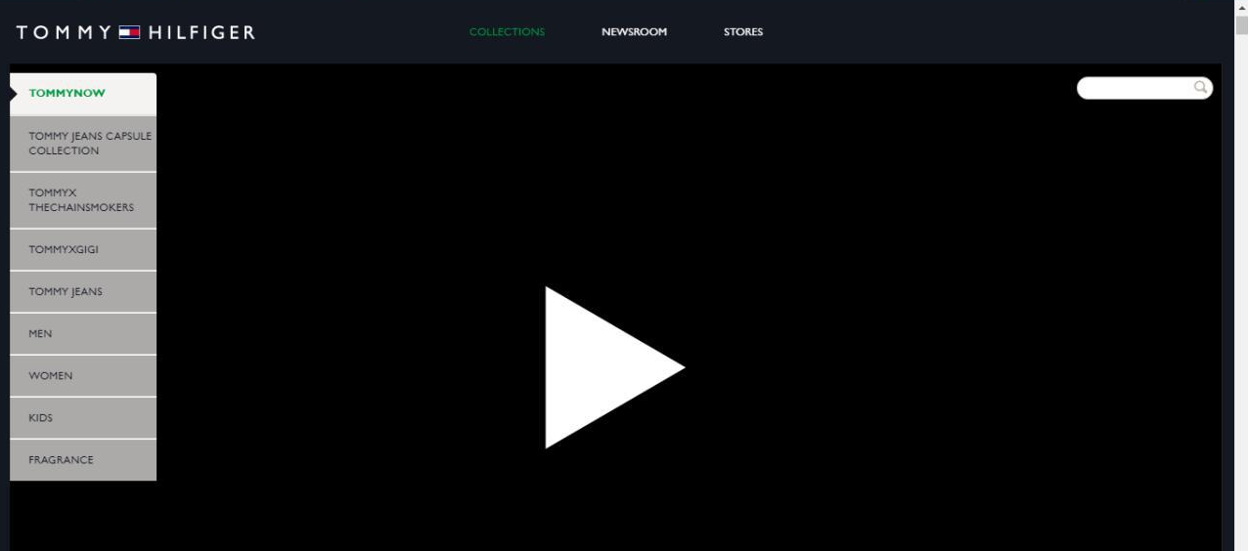
The difference on home page

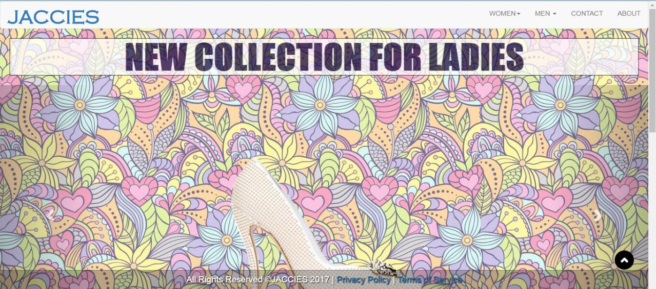

Links and Screenshots of the both competitors are displayed here:

http://www.levi.com

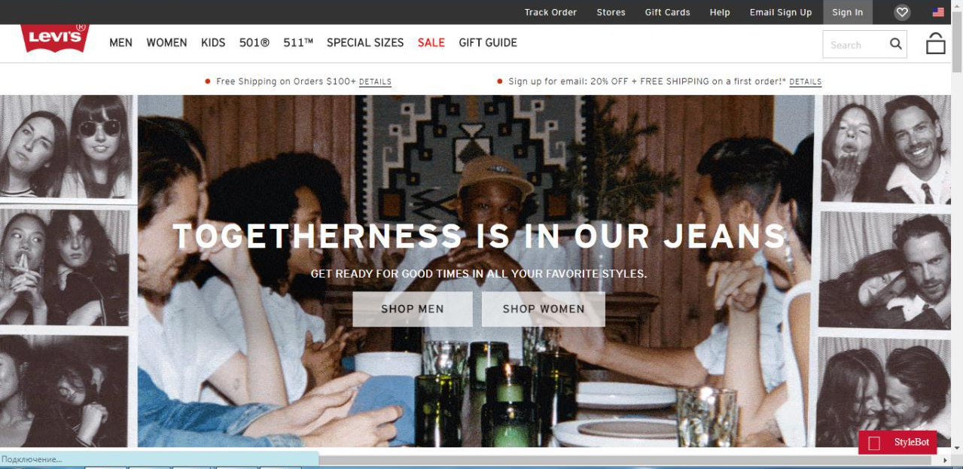

http://global.tommy.com
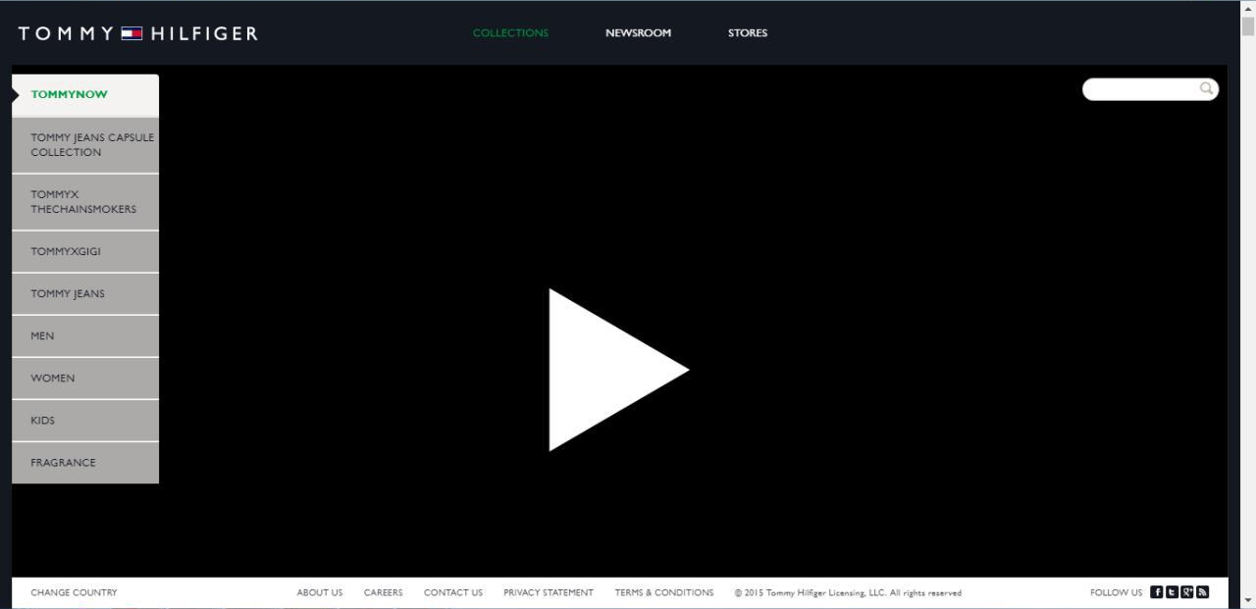

Usability
I made a small questionnaire which included 10 questions related to my website. I called four of my friends and asked them to use my website, but I did not tell them that it was my web site. I asked them to look through pictures and galleries of clothes. The only problem that they occurred is buying process. There is no (buy) button in my website as it is just a catalogue of the brand JACCIES. Then I told them that it is my web site and asked them the following questions.

- What can you tell about the design of the website?
- Is it easy to use?
- How loud sounds JACCIES? Is it appropriate name for a website?
- What do you think about colors?
- Is not Background so light?
- How easy to find or contact us?
- Is it good to write more information about the product details?
- Does it look like a professional websites?
- How is your first reaction to a 3D Gallery?
- Would have you bought clothes from JACCIESSTORE?

Answers were satisfied me and made me glad. Four of them really liked the design of website, yet one of them commented that pink background is not appropriate for clothing store. There were no difficulty to utilize the web site, every button and dropdowns were very clear to them. Two of them really liked the name of brand while others ignored that it is not so professional name for the brand. All liked colors, pictures and backgrounds, even once commented super. As for the contact, “map and address of location are very useful to add website” said one of my friends, and agreed others.” As it is small website, it is not so lightly looks like a professional work, but further by adding a lot of codes it can be one of the best web site ever” was commented by them. Moreover, their reaction for 3D Gallery was like “wow”. They really liked it and I think it is good to add animations in web sites like 3D, carousel, slides and etc. At the end of my questionnaire, they joked that they would have not been bought any clothes www.jacciesstore.ml due to the price of the products.

WORD COUNT: 1090 words.

References

PinInterest (2017). Wallpaper [image]. Available from https://ru.pinterest.com/pin/238479742747664224/ [Accessed 30 October 2017].

Gucci Official Site – Redefining modern luxury fashion. (2017). Gucci.com. Available from https://www.gucci.com/us/en/ [Accessed 3 November 2017].

Fashion Clothing & Accessories (2017). Versace. Available from http://www.versace.com [Accessed 5 November 2017].

Levi's® (2017). Levi.com. Available from http://www.levi.com/US/en_US/category/men/clothing/ [Accessed 5 November 2017].

Bootsnipp.com (2017). Bootsnipp.com. Available from https://bootsnipp.com/user
[Accessed 11 November 2017].

W3Schools Online Web Tutorials (2017). W3schools.com. Available from https://www.w3schools.com [Accessed 6 November 2017].

Pictures (images) are from my own gallery.

