Medical Data Engineering Project
Cloud Track – Architecture & ApproachAWS CLOUD SUBMISSION
Cleveland Clinic – Healthcare Data Analytics
Team ID: PTID-CDE-AUG-26-11113
Project ID: PRCL-01 – Cleveland Clinic – Healthcare Data Analytics
Project Members: Subhranshu Priyaranjan, Bhargavi Kuchuri, Jaswanth Valluripalli, Mounika Karri
Region: Asia Pacific (Mumbai) – ap-south-1
Submission date: 24th September 2026

1. Objective
Build a cloud-based healthcare data engineering pipeline that ingests CSV datasets, standardizes
and validates them with AWS Glue/PySpark, stores analytics-ready data in Amazon S3, queries the
data with Amazon Athena, and generates an automated daily report through AWS Lambda and
EventBridge Scheduler.

2. Implemented Cloud Architecture
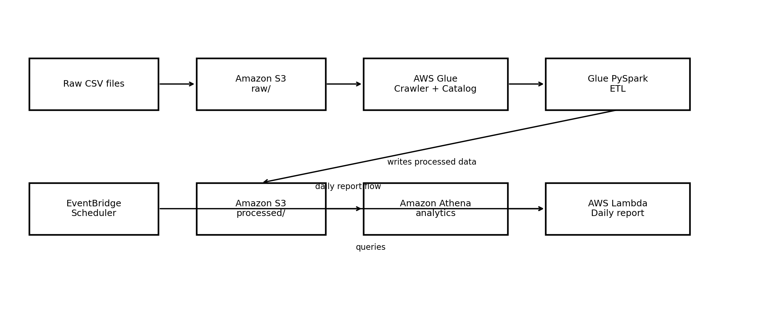
Figure 1. Implemented cloud data flow.

3. Data Sources
- patients.csv – 2,300 rows
- appointments.csv – 12,000 rows
- billing.csv – 5,000 rows
- branches.csv – 100 rows
- doctors.csv – 200 rows
- lab_reports.csv – 7,500 rows
- prescriptions.csv – 9,000 rows
- surgeries.csv – 1,500 rows

4. S3 Storage Design
Raw files are stored under s3://medical-data-engineering-oh/raw/ using one folder per dataset. Glue writes transformed datasets under s3://medical-data-engineering-oh/processed/. Daily Lambda reports are written under s3://medical-data-engineering-oh/reports/.
The bucket is private, public access is blocked, and default encryption is enabled. A lifecycle rule aborts incomplete multipart uploads after seven days.

5. AWS Glue Crawlers and Data Catalog
The raw crawler scans the raw S3 prefix and creates eight source tables in the medical_data_engineering Glue database. A second crawler scans processed data and creates nine processed tables using the processed_ prefix.
The doctor_other_branches relationship was normalized from a multi-valued doctor field. The processed relationship was validated at 384 rows and 384 unique doctor/branch relationships.

6. PySpark ETL
The Glue ETL job medical-data-engineering-etl uses Glue 5.1 / Spark 3.5 / Python 3. The job reads CSV files from S3, standardizes column names to snake_case, trims string values, converts date columns to Spark DateType using M/d/yyyy, MM/dd/yyyy, and yyyy-MM-dd formats, converts obvious numeric fields, normalizes doctor_other_branches, removes duplicates, and writes nine processed CSV datasets back to S3.
A date parsing issue was identified during validation because source dates such as 4/2/2021 were not reliably parsed by the original conversion. The ETL was updated to support the source formats and rerun successfully. Athena validation confirmed populated date_of_consultation values.

7. Athena Analytics
Analysis | SQL logic | Validated result
Daily patient visits | GROUP BY date_of_consultation | 1,344 consultation dates; 12,000 total visits
Revenue | SUM(total_bill) | 128,137,627.30
Common diagnoses | GROUP BY diagnosis ORDER BY count DESC LIMIT 10 | Top 10 returned successfully

8. Lambda Daily Report
The Lambda function medical-data-engineering-daily-report runs three Athena queries: total patient visits, total billed revenue, and the top ten diagnoses. It prints the report to CloudWatch Logs and saves a text report to the S3 reports/ prefix.
The successful test returned statusCode 200, 12,000 visits, total revenue of 1.2813762729999977E8, and the S3 report location s3://medical-data-engineering-oh/reports/daily_report_2026-09-23.txt. Execution took approximately 7.04 seconds and the Lambda timeout was configured to 60 seconds.

9. EventBridge Scheduler
The EventBridge Scheduler schedule medical-data-engineering-daily-report is enabled and targets the Lambda function. It uses a recurring cron schedule at 09:00 in the Asia/Calcutta (UTC+05:30) time zone and sends an empty JSON payload {}.

10. IAM and Security
- Glue execution role has read access to raw S3 data and write access to processed S3 data.
- Lambda execution role has Athena query permissions, Glue Data Catalog read permissions, processed S3 read access, Athena result-location access, and report write access.
- EventBridge Scheduler uses a dedicated execution role to invoke the Lambda.
- No credentials or passwords are included in this submission package.

11. Validation and Results
The final processed row counts are: appointments - 12,000; billing - 5,000; branches - 100; doctor_other_branches - 384; doctors - 200; lab_reports - 7,500; patients - 2,300; prescriptions - 9,000; surgeries - 1,500. Athena returned 1,344 unique consultation dates.

12. Submission Contents
- Architecture and approach document
- AWS console screenshots
- Glue PySpark ETL script
- Lambda daily report script
- Athena SQL queries
- Generated daily report
- Validation evidence and row counts
- README

13. Scope Note
The cloud implementation for this submission uses Amazon S3, AWS Glue, Amazon Athena, AWS Lambda, and EventBridge Scheduler.

