**ABSTRACT**

This project focuses on road object detection using OpenCV and the YOLOv8m pretrained model. The workflow includes the creation of a custom dataset using the LabelImg Python application for image annotation. The annotated images are then used to train the YOLOv8m model. The final stage involves the prediction of objects in random images or videos. By leveraging the power of OpenCV and the pretrained YOLOv8m model, this project achieves accurate and efficient road object detection. It demonstrates the importance of utilizing pretrained models and custom datasets for effective object detection tasks in real-world scenarios, contributing to advancements in autonomous driving and traffic surveillance systems.

**I. INTRODUCTION**

Road object detection is a crucial task in computer vision, with applications ranging from autonomous driving to traffic surveillance. The combination of OpenCV, a versatile computer vision library, and YOLO (You Only Look Once) models has emerged as a powerful solution for efficient and accurate object detection on roads. OpenCV provides essential tools for image processing, post-processing, and visualization, while YOLO models offer state-of-the-art performance in real-time object detection.

The integration of OpenCV and YOLO models brings significant benefits to road object detection systems. OpenCV simplifies implementation with its high-level API and rich feature set, enabling essential tasks such as

preprocessing and visualization. YOLO models utilize deep neural networks, leveraging

advanced architectures and anchor-based techniques to achieve exceptional accuracy and efficiency in detecting road objects.

In this project, we explore the potential of OpenCV and the YOLOv8m pretrained model for road

object detection. OpenCV's functionalities are utilized for image preprocessing, post-processing, and visualization, while the YOLOv8m model, pretrained on large-scale datasets, provides robust detection capabilities. By combining OpenCV and YOLOv8m, we aim to contribute to the advancement of road object detection, enabling safer and more intelligent transportation systems.

**II. MOTIVATION**

This project is motivated by the increasing demand for accurate and efficient road object detection in practical applications such as autonomous driving and intelligent transportation systems. The ability to detect and classify objects on the road, including vehicles, pedestrians, and traffic signs, is crucial for enhancing road safety and optimizing traffic flow. The advancements in deep learning and computer vision, particularly models like YOLOv8m, provide an opportunity to develop a robust and real-time road object detection system. By leveraging the capabilities of OpenCV and YOLOv8m, this project aims to contribute to the advancement of road safety and intelligent transportation systems.

Through this project, we aim to address the practical challenges of road object detection by utilizing the strengths of OpenCV and YOLOv8m. By combining these technologies, we can develop an accurate and efficient system for detecting objects on the road. This project is motivated by the desire to enhance road safety, optimize traffic management, and enable the development of intelligent transportation systems.

**III. PRIOR WORKS**

Previous studies have successfully utilized YOLOv5 and OpenCV for road object detection. These works highlighted the advantages of YOLOv5's improved performance and OpenCV's flexibility in handling image data. The combined approach demonstrated accurate detection and classification of road objects, including vehicles, pedestrians, and traffic signs. By leveraging YOLOv5's enhanced capabilities and OpenCV's versatile functionalities, these studies achieved efficient and reliable road object detection in various challenging scenarios.

**IV. OUR APPROACH**

In this project, we propose an approach for road object detection using OpenCV and the YOLOv8m pretrained model. Our approach involves several key steps to achieve accurate and efficient detection of objects on the road.

1) Dataset Creation: We create a custom dataset specifically tailored for road object detection. Using a Python application called LabelImg, we annotate the road images by drawing bounding boxes around the objects of interest, such as vehicles, pedestrians, and traffic signs. This annotated dataset serves as the foundation for training the YOLOv8m model.

2) Training the YOLOv8m Model: The annotated dataset is used to train the YOLOv8m model, a pretrained variant of the YOLO family of models. By optimizing the model's parameters and loss function through techniques like backpropagation and gradient descent, we aim to enable the model to learn and generalize the features necessary for accurate object detection on the road.

3) Image Preprocessing: Prior to inference, we apply preprocessing steps to the input images using OpenCV. This may include resizing, normalization, and other transformations to ensure compatibility and optimize the performance of the YOLOv8m model.

4) Object Detection: The preprocessed images are passed through the trained YOLOv8m model for object detection. The model predicts bounding boxes and class probabilities for the detected objects, enabling precise localization and classification of road objects.

5) Post-processing: To refine the detection results, we apply post-processing techniques using OpenCV. This may involve non-maximum suppression to eliminate redundant detections and filtering based on confidence thresholds, ensuring accurate and reliable object detection.

6) Visualization: Finally, we visualize the detected objects on the road images by drawing bounding boxes or overlaying labels to indicate their respective classes. This enhances the interpretability and usability of the detected object information.

Through this approach, we aim to develop a robust road object detection system that leverages the power of OpenCV and the pretrained YOLOv8m model. However, our ambitions go beyond mere detection. We seek to extend the system to provide comprehensive and actionable insights for road safety and traffic management.

One avenue of extension is to incorporate real-time object tracking, enabling us to not only detect objects but also track their movements over time. This capability can enhance situational awareness and facilitate the analysis of object trajectories, contributing to proactive measures in accident prevention and traffic optimization.

Furthermore, we plan to explore the integration of advanced algorithms for object classification, allowing us to discern between different types of vehicles, pedestrians, and road infrastructure elements. This additional level of classification can provide valuable information for traffic statistics, road infrastructure planning, and optimizing traffic flow in dynamic environments.

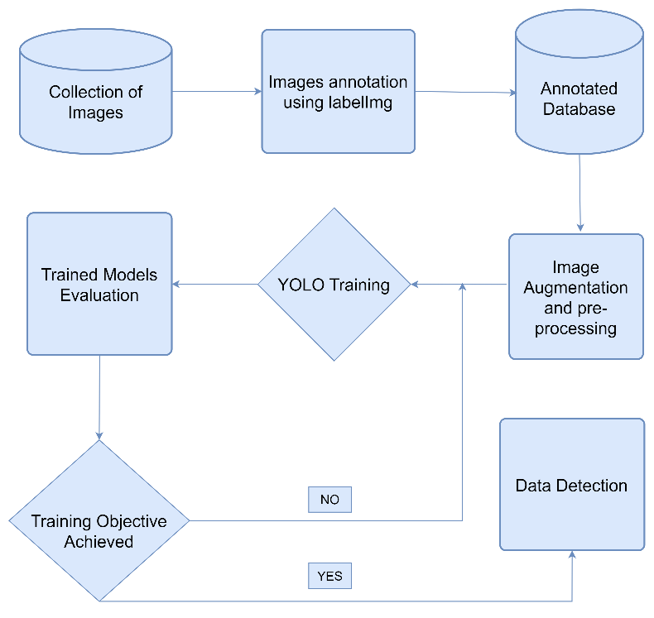

*Fig-1.0 Flow Chart*

**V. RESULTS:**

**INPUT:**

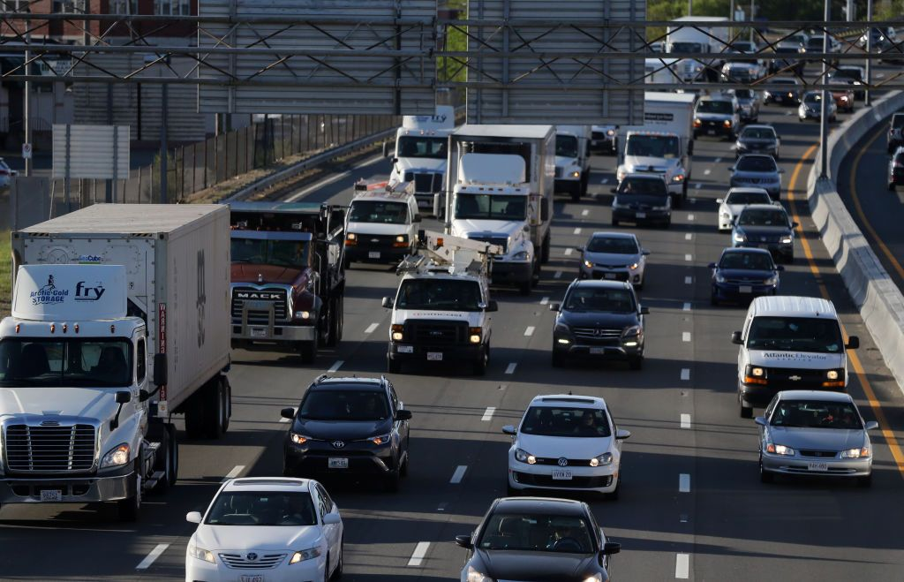

*Fig-2.0*

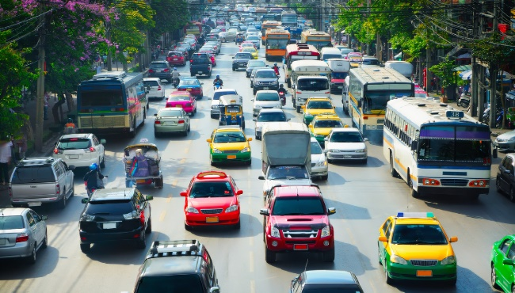*Fig-3.0*

**OUTPUT:**

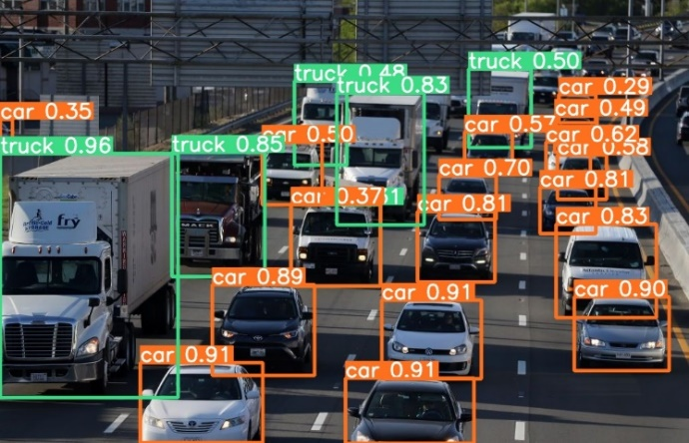

*Fig-4.0*

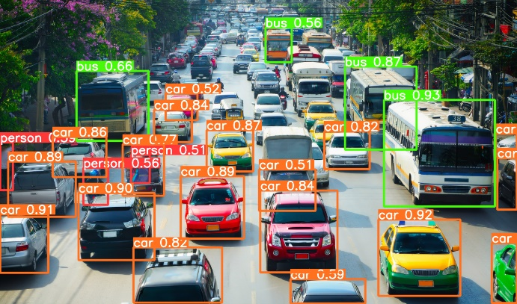

*Fig-5.0*

**VI. CONCLUSION:**

In conclusion, the Road Object Detection using YOLOv8m project is an advanced computer vision system that utilizes the YOLOv8m algorithm for real-time object detection on the road. With its high accuracy and efficiency, the project aims to enhance road safety, support autonomous driving, and improve traffic management, making it a

valuable contribution to the field of computer vision and road transportation systems.

By providing clear installation instructions, usage guidelines, and opportunities for contribution, the project encourages collaboration and further development. It is hoped that this project will inspire advancements in road object detection, paving the way for innovative applications in the fields of autonomous driving, traffic management, and beyond.

Overall, the Road Object Detection using YOLOv8m project represents a significant step forward in computer vision and deep learning-based approaches to road safety. Its potential impact on improving road infrastructure and reducing accidents makes it a valuable contribution to the field.

**VII. FUTURE WORK EXTENSION**

The Road Object Detection using YOLOv8m project opens up several possibilities for future work and extensions. Some potential areas of focus include:

Improved Object Recognition: Enhancing the accuracy and robustness of object recognition by incorporating advanced deep learning techniques, such as attention mechanisms or contextual information, to better identify and classify objects on the road.

Real-Time Tracking: Integrating object tracking algorithms with the detection system to enable real-time tracking of detected objects over consecutive frames, allowing for better analysis of object trajectories and behavior.

Multi-Camera Systems: Extending the project to support multiple camera inputs, enabling comprehensive surveillance and analysis of road scenes from different perspectives, enhancing object detection accuracy and providing a more comprehensive view of the environment.

Integration with Traffic Management Systems: Integrating the road object detection system with existing traffic management systems to provide real-time data on traffic flow, congestion, and object detection statistics, enabling better decision-making and optimizing traffic management strategies.

Adapting to Challenging Road Conditions: Investigating the performance of the object detection system in challenging road conditions such as adverse weather (rain, fog, snow) or low-light environments, and developing techniques to improve object detection in such scenarios.

Hardware Acceleration: Exploring hardware acceleration techniques, such as using specialized processors (e.g., GPUs, FPGAs) or optimizing the model architecture, to achieve even faster and more efficient real-time object detection on embedded systems or resource-constrained devices.

Incremental Learning: Implementing incremental learning techniques to continually update and refine the object detection model over time, allowing it to adapt to changing road scenarios, new object classes, and evolving traffic patterns.

By pursuing these future work extensions, the Road Object Detection using YOLOv8m project can continue to evolve and contribute to the advancement of road safety, autonomous driving, and traffic management systems.

**REFERENCES:**

<https://github.com/ultralytics/ultralytics.git>

<https://www.geeksforgeeks.org/libraries-in-python/>

<https://www.geeksforgeeks.org/introduction-to-opencv/>

**Link to Solution:**