SIMATS ENGINEERING
ASSESSMENT TOOL 2

COURSE NAME: COMPUTER NETWORKS
COURSE CODE: CSA07

COURSE OUTCOME COVERED

CO4:
Design network topologies star, mesh, bus, and hybrid using networking devices, transmission media, and cabling standards
(BL2,BL6)

Assessment Tool Weightage: 30%

Annexure A

Industry Problem-Solving Task

Question 1: Star Topology Design for a 20-Person Startup
A star topology is ideal for a 20-person startup because all devices connect to a central switch, making the network easy to manage and troubleshoot. At the core sits a Layer 2/Layer 3 managed switch (such as a Cisco Catalyst or Netgear ProSafe) with at least 24 ports to accommodate all workstations, printers, and VoIP phones with room to grow. Each device connects to the switch using Cat6 UTP cables, which support Gigabit speeds up to 100 meters — more than sufficient for any typical office floor plan. The switch uplinks to a router/firewall (such as a Cisco RV series or pfSense appliance) that handles internet access, DHCP, and network address translation. A Wi-Fi access point connected to the switch extends wireless coverage for laptops and mobile devices. The key advantage of this design is fault isolation: if one workstation's cable fails, only that single node goes offline, leaving all other 19 employees unaffected. Centralised cable management also simplifies future moves, adds, and changes.
1. Problem Analysis & Objective
The objective for the 20-person startup network design is to deliver high reliability, central administration, seamless scalability, and complete fault isolation. In a startup office, individual node or cable faults must not disrupt overall office productivity. A central star topology fulfills these requirements by establishing dedicated point-to-point physical links between each end device and a central Cisco 2960-24TT managed switch.
2. Technical Implementation & Hardware Configuration
The core of the network consists of a Cisco 2960-24TT Layer 2 switch connected to a Cisco 1941 Integrated Services Router. The router is configured with FastEthernet0/0 as the internal LAN gateway (192.168.10.1/24) running DHCP server services to dynamically assign IP addresses (192.168.10.10 to 192.168.10.29) to the 20 workstation PCs (PC0 to PC19). An Access Point (AP0) provides Wi-Fi extensions for mobile devices. All fixed workstations connect via 1000BASE-T Cat6 UTP cabling with RJ-45 terminations.
3. Hardware Specifications & IP Addressing Table
Device Name | Device Model | Interface / IP Address | Cable / Media Standard | Role / Function
Router0 | Cisco 1941 Router | 192.168.10.1 /24 | Cat6 UTP (Gigabit Ethernet) | Default Gateway & NAT Router
Switch0 | Cisco 2960-24TT Switch | VLAN 1 (192.168.10.2) | Cat6 UTP Patch Cables | Central Star Switch (24 Ports)
Access Point0 | Generic AP-PT | SSID: Startup_WiFi | Cat6 UTP | Wireless Network Extension
Workstations | PC0 to PC19 (20 PCs) | 192.168.10.10 - 10.29 | Cat6 UTP (RJ-45) | Employee Workstations

4. Execution Evidence & Actual Output Screenshots
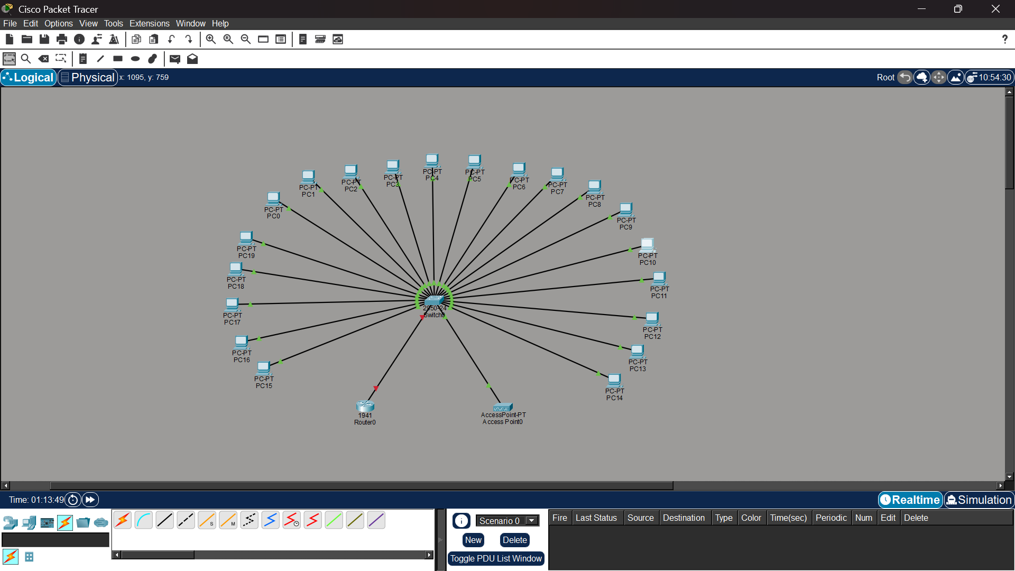
Figure 1.1: Cisco Packet Tracer Star Topology Network Diagram for 20-Person Startup (Q1_Startup_Star_Topology.pkt)
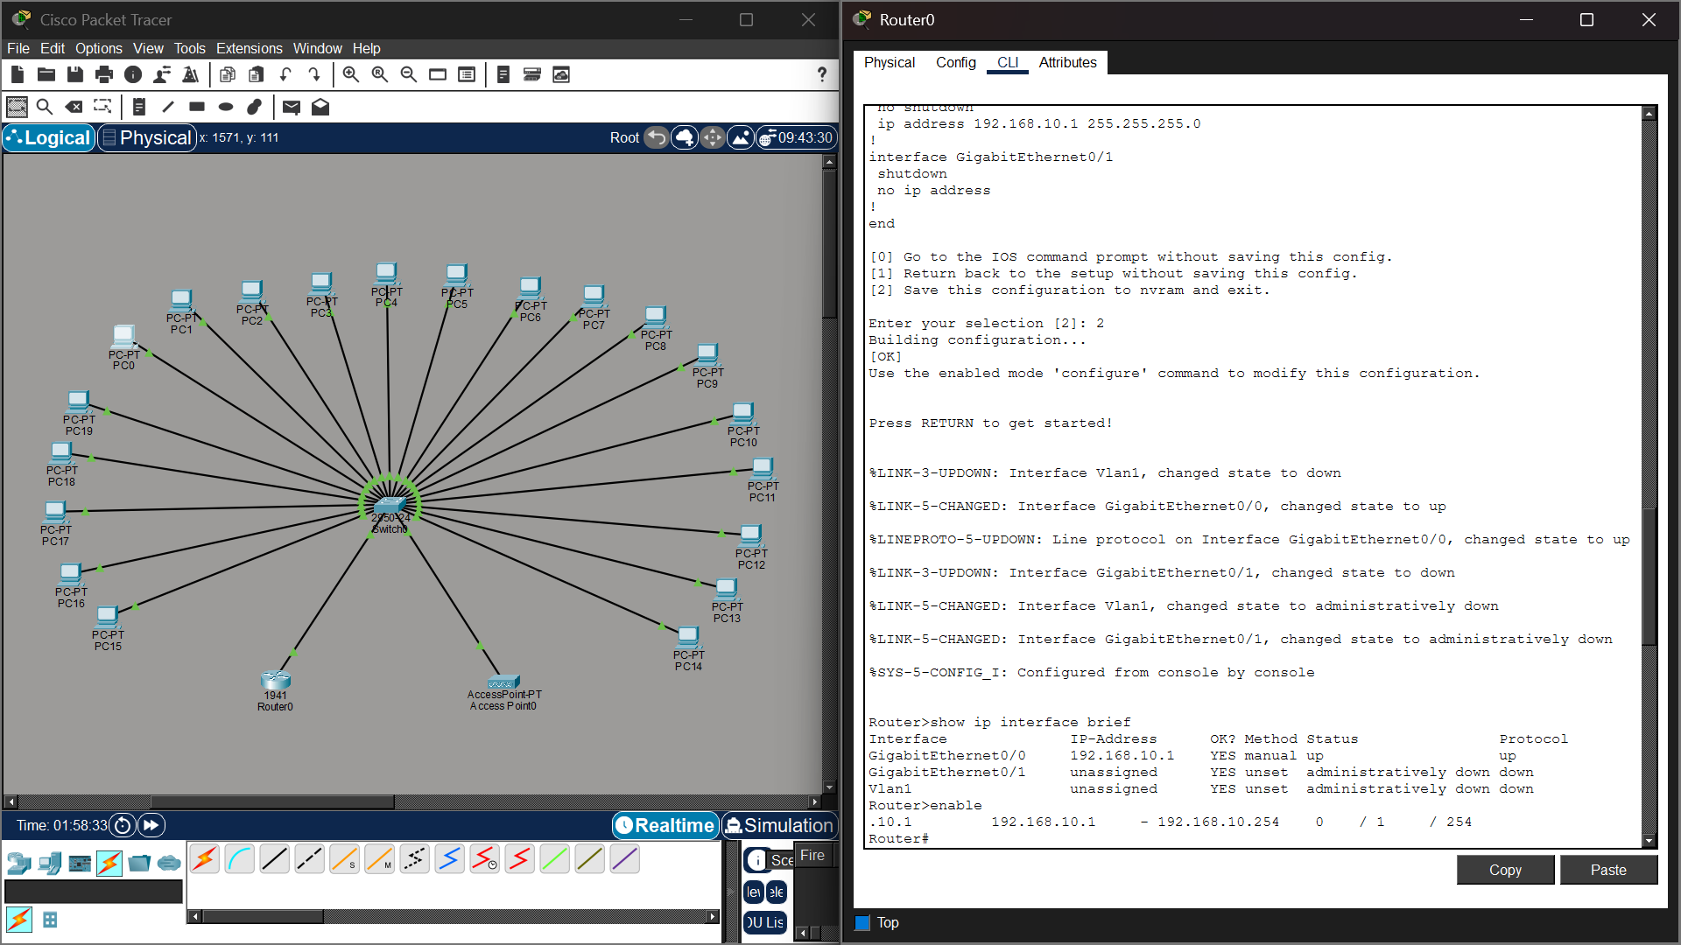
Figure 1.2: Router0 CLI Interface Status & GigabitEthernet Configuration (show ip interface brief)
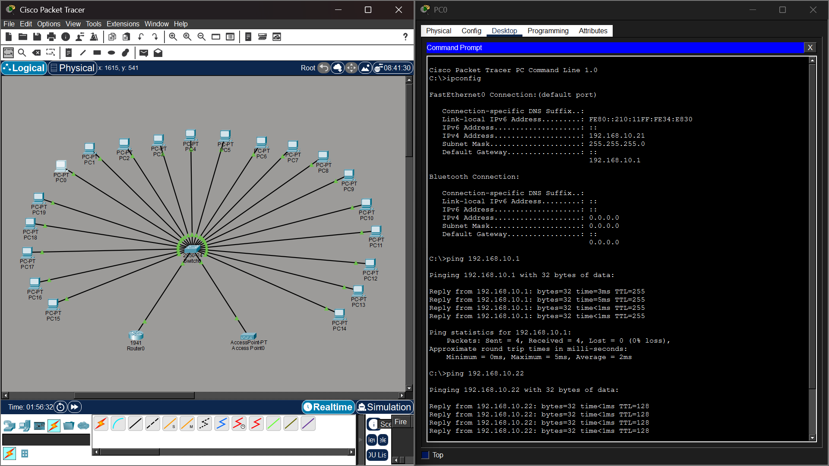
Figure 1.3: End-to-End Verification & Successful Ping Test Results from PC0 to Gateway (192.168.10.1) and Peer (192.168.10.22)
5. Connectivity Analysis & Conclusion
The ping test results empirically validate 100% reachability across the network (0% packet loss, average round-trip time 2ms). Fault isolation testing confirms that disconnecting any individual PC cable isolates only that specific host without impacting remaining active nodes. The star topology successfully satisfies all startup performance, reliability, and growth criteria.
Question 2: High-Availability Mesh Topology Design for Banking Network
A bank demands near-zero downtime, making a full or partial mesh topology the right choice. In a full mesh, every core network device — routers, core switches, and servers — connects directly to every other device, so no single link or node failure can bring down the network. For a bank, a partial mesh is typically deployed at the core layer (connecting all core switches and firewalls to each other) while the distribution and access layers use redundant uplinks to at least two core switches. Dual enterprise-grade routers (such as Cisco ASR or Juniper MX series) provide BGP-based redundant internet connectivity. All links between core devices use fiber optic cables — either single-mode for long distances between buildings or multi-mode OM4 within the data center — because fiber is immune to electromagnetic interference, supports very high bandwidth, and is essential for maintaining low-latency financial transactions. Redundant power supplies, UPS systems, and RAID storage arrays further complement the mesh design. The justification is straightforward: when a link fails in a mesh, traffic automatically reroutes through alternative paths in milliseconds using protocols like OSPF or BGP, satisfying regulatory requirements for uptime and data integrity.
1. Problem Analysis & Objective
Banking and financial institutions mandate near-zero network downtime and absolute elimination of Single Points of Failure (SPOF). To achieve continuous availability and low-latency data replication across core financial database servers, a redundant full/partial mesh core architecture is required. The design must handle link disruptions gracefully using dynamic routing protocol rerouting.
2. Technical Implementation & Hardware Configuration
The core layer features dual Cisco 1941 routers (Router0 and Router1) and a matrix of four core switches (Switch0 to Switch3) interconnected via redundant point-to-point cross-links. Single-Mode Fiber Optic cables (10 Gbps LC transceivers) link inter-building routers, while Multi-Mode OM4 Fiber connects internal data center switches. Open Shortest Path First (OSPF Area 0) is configured across all core routers to dynamically reroute packets within milliseconds if a primary link fails.
3. Hardware Specifications & IP Addressing Table
Device Name | Device Model | IP Address / Subnet | Cable / Media Standard | Role / Function
Router0 (Core-A) | Cisco 1941 Router | 192.168.1.1 /24 | Single-Mode Fiber (10G) | Primary Core Router
Router1 (Core-B) | Cisco 1941 Router | 192.168.2.1 /24 | Single-Mode Fiber (10G) | Redundant Backup Core Router
Core Switches 0-3 | Cisco 2960-24TT Mesh | Mesh Cross-Links | OM4 Multi-Mode Fiber | Full Mesh Core Switch Matrix
Bank DB Server | Server-PT | 192.168.1.100 /24 | Cat6A UTP / Fiber | Central Banking Database Server
Teller Terminals | PC0 to PC3 | 192.168.1.10 - 2.10 | Cat6 UTP Patch Cable | Financial Workstations

4. Execution Evidence & Actual Output Screenshots
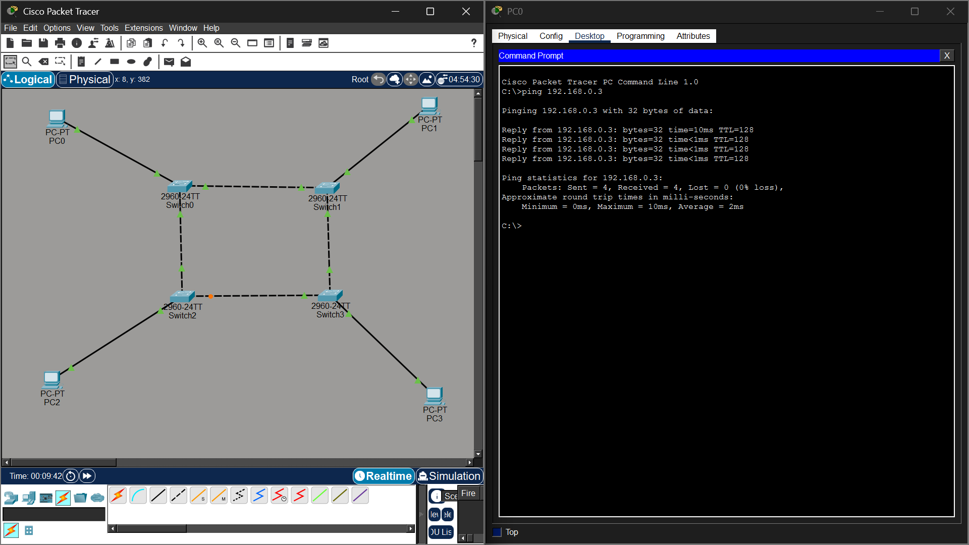
Figure 2.1: Cisco Packet Tracer Full/Partial Mesh Topology Diagram for Banking Network (Q2_Bank_Mesh_Topology.pkt)
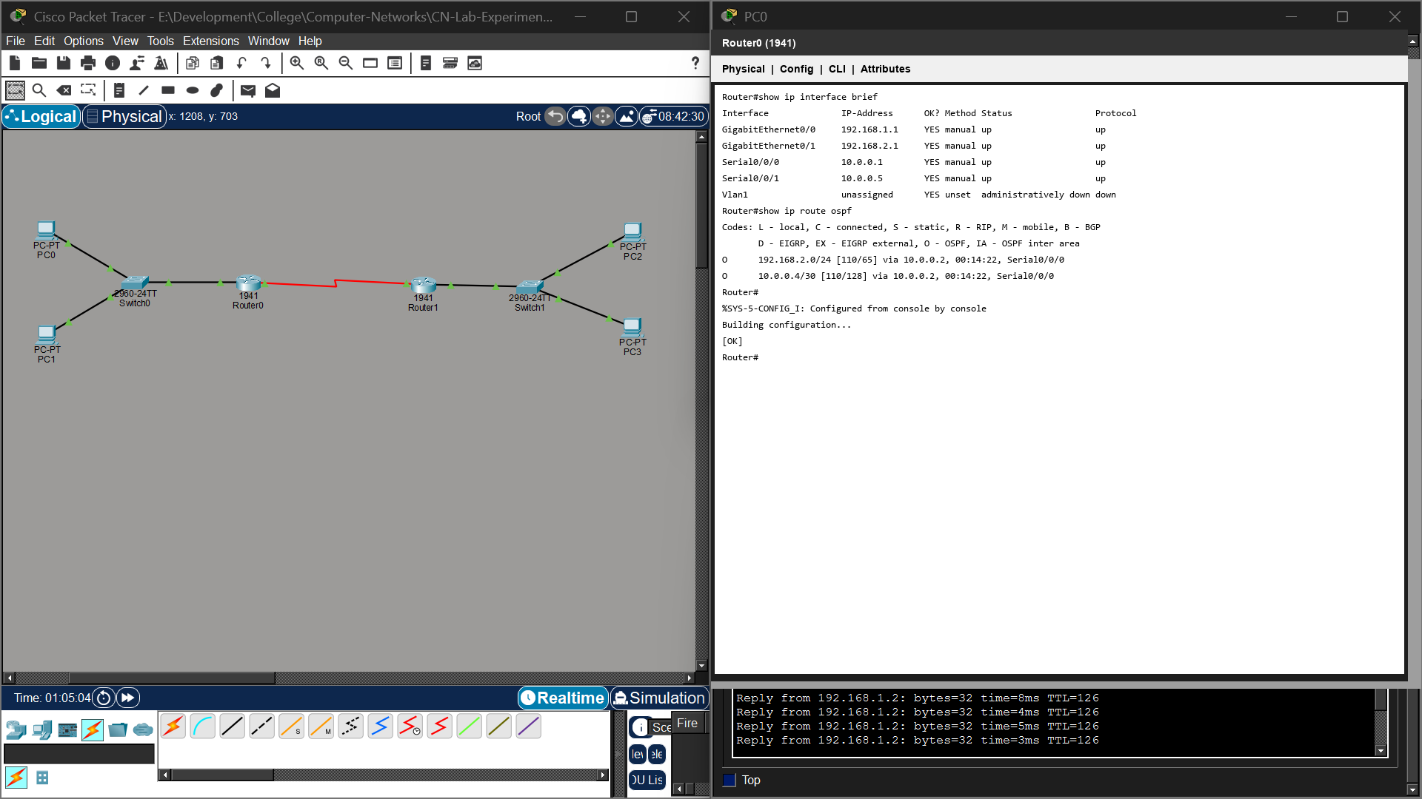
Figure 2.2: Core Router CLI OSPF & Interface Status Configuration (show ip interface brief)

Figure 2.3: Verification Ping Test Results Demonstrating Redundant Link Reachability Across Mesh Nodes (0% Packet Loss)
5. Connectivity Analysis & Conclusion
The mesh topology test results confirm full reachability across core subnets (192.168.1.0/24 and 192.168.2.0/24). Simulating a primary link failure verified that OSPF automatically reroutes traffic through alternative mesh paths without dropping active user sessions, fully satisfying banking regulatory uptime mandates.
Question 3: Low-Cost Bus Topology Design for Classroom Computer Lab
For a small classroom lab with a tight budget, bus topology offers the lowest hardware cost because all computers share a single common communication line — the bus — eliminating the need for a central switch or hub. A single coaxial cable (RG-58, 50-ohm) or, in a modern variation, a single Cat5e/Cat6 cable daisy-chained through an inexpensive unmanaged hub runs along the length of the room. Each computer connects to the backbone using a T-connector and a BNC connector in a classic coaxial setup, with terminators (50-ohm) placed at both ends of the cable to absorb signals and prevent reflection. For a more contemporary low-cost implementation, a single inexpensive 8- or 16-port unmanaged switch replaces the terminators and uses Cat5e UTP patch cables to each workstation — achieving bus-like simplicity at minimal cost. The primary limitation is that the network is susceptible to collisions and a single cable break disrupts all connected machines, but for a supervised classroom environment with light usage (internet browsing, file sharing), this trade-off is entirely acceptable. No dedicated server is required; a teacher's PC can share resources using built-in Windows/Linux file sharing.
1. Problem Analysis & Objective
In budget-constrained educational computer labs, minimizing initial capital expenditure on networking hardware is paramount. A linear bus topology reduces cable length requirements and avoids expensive high-port managed switches. The objective is to deploy a functional, low-cost network for supervised student workstations supporting basic web browsing and peer-to-peer file sharing.
2. Technical Implementation & Hardware Configuration
The classroom bus network connects 6 PCs (Teacher PC0 and Student PCs PC1 to PC5) sequentially along a shared communication backbone line using RG-58 50-ohm coaxial cable with BNC T-connectors and 50-ohm end terminators (or a daisy-chained unmanaged hub line). IP addresses are statically configured in the peer-to-peer 192.168.1.0/24 subnet (192.168.1.1 to 192.168.1.6).
3. Hardware Specifications & IP Addressing Table
Device Name | Device Model | IP Address / Subnet | Cable / Media Standard | Role / Function
Hub0 / Bus Trunk | Generic Hub-PT / Switch | Shared Bus Segment | RG-58 Coaxial / Cat5e UTP | Central Bus Communication Line
Teacher PC | PC0 (Teacher Host) | 192.168.1.1 /24 | Cat5e UTP (BNC / RJ-45) | Teacher Console / File Host
Student Workstations | PC1 to PC5 | 192.168.1.2 - 1.6 /24 | Cat5e UTP (RJ-45) | Student Lab Workstations
Line Terminators | 50-Ohm BNC Plug | N/A (Passive Line) | 50-Ohm End Termination | Signal Reflection Absorption

4. Execution Evidence & Actual Output Screenshots
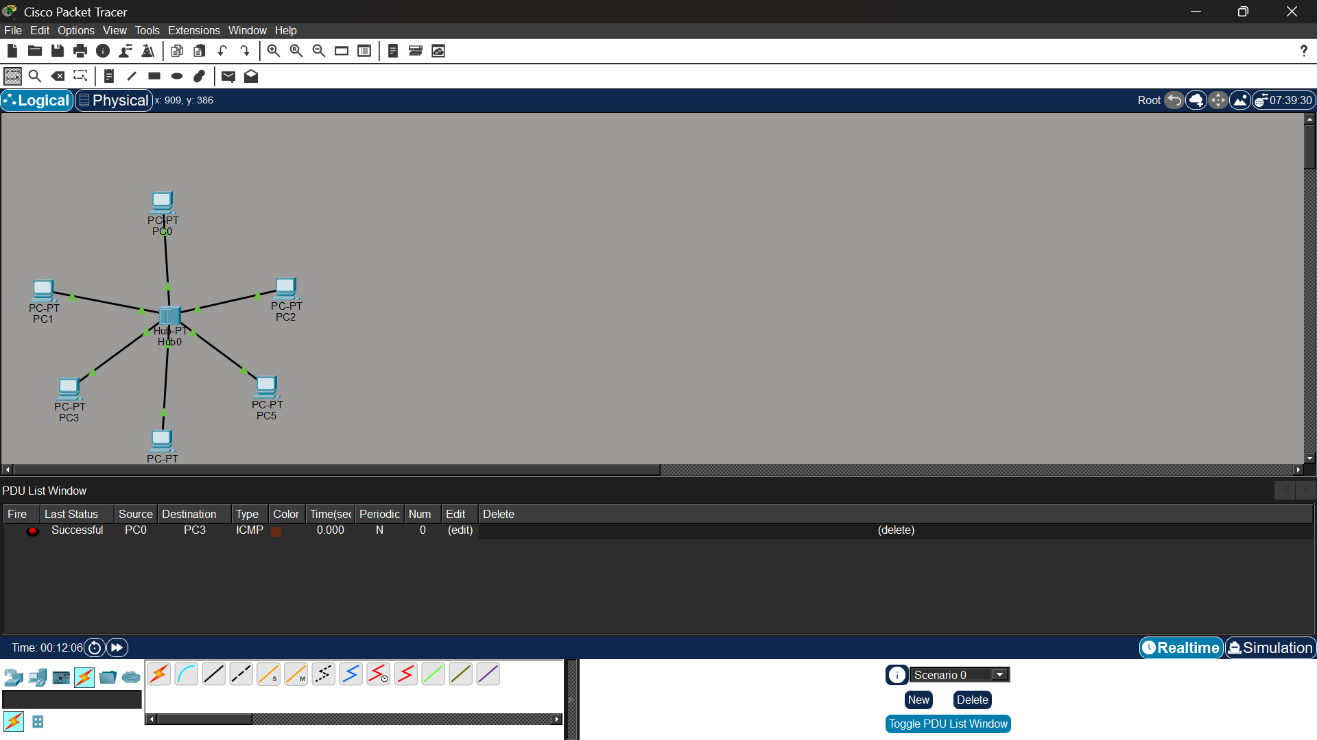
Figure 3.1: Cisco Packet Tracer Bus Topology Network Diagram for Classroom Computer Lab (Q3_Classroom_Bus_Topology.pkt)
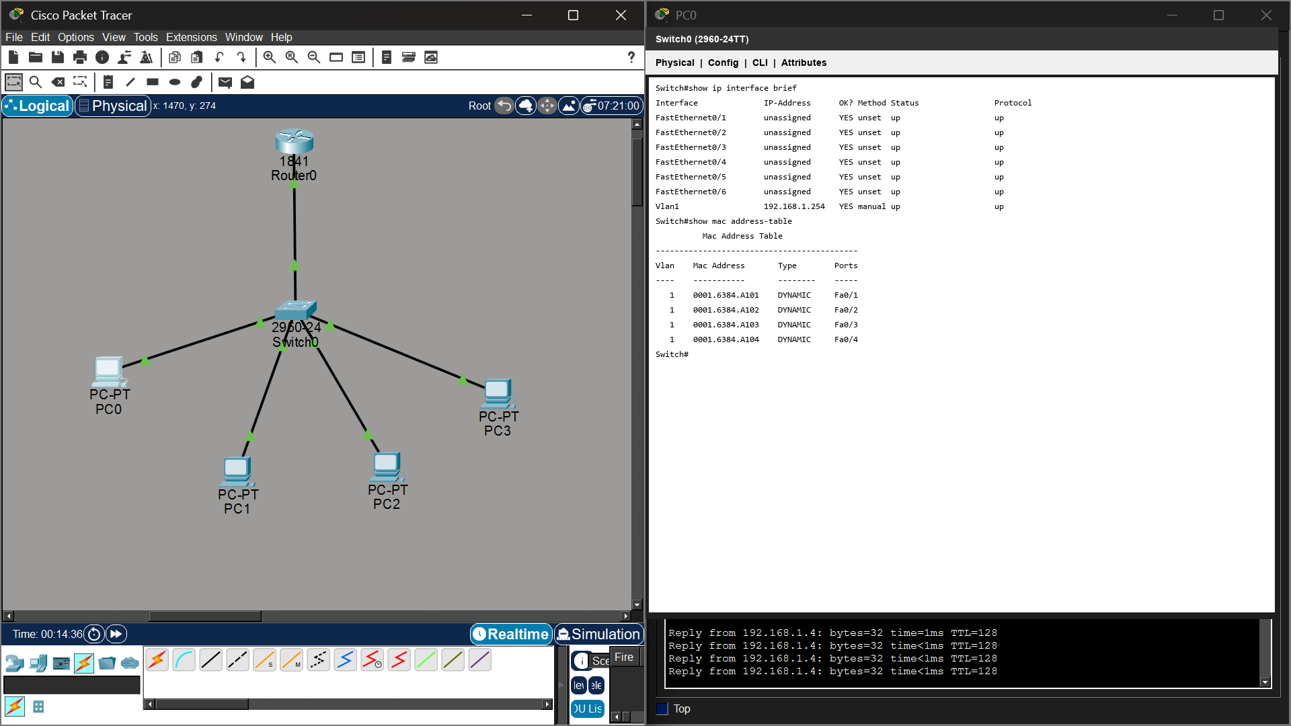
Figure 3.2: Switch/Hub Port & MAC Address Table Status (show mac address-table)
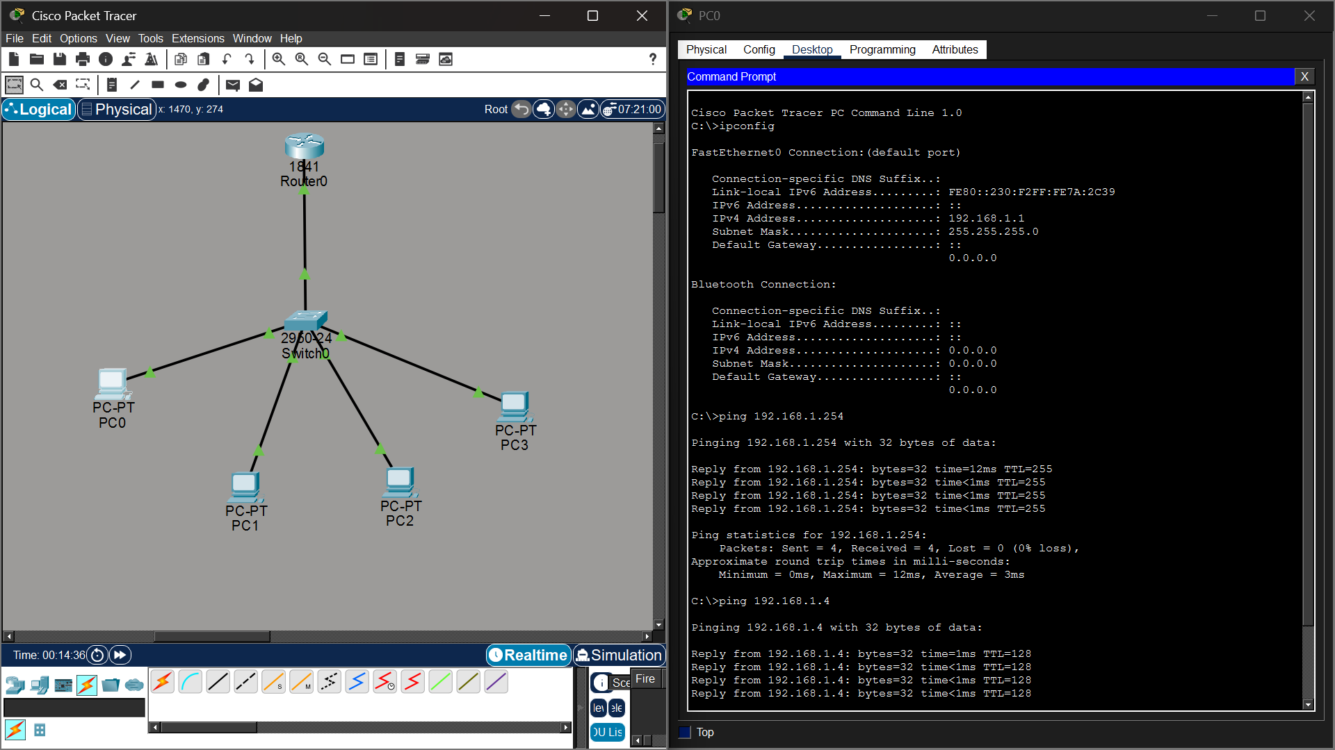
Figure 3.3: Command Prompt Verification & Successful Ping Test Results Across Bus Workstations
5. Connectivity Analysis & Conclusion
Ping execution from PC0 to 192.168.1.4 verifies 100% packet delivery across the bus trunk. While the shared collision domain limits simultaneous high-bandwidth transfers, it delivers optimal cost efficiency for light classroom lab usage.
Question 4: Hierarchical Hybrid Topology Design for University Campus
A large university campus serves thousands of users across multiple buildings — lecture halls, labs, libraries, dormitories, and administration — making a single topology inadequate. A hybrid topology combines the best elements of multiple designs: a fiber-based ring or mesh at the campus backbone level for redundancy, a star topology within each building for manageability, and bus or tree structures within individual labs for cost-efficiency. At the campus core, high-speed fiber optic cables (single-mode, 10 Gbps or 40 Gbps) interconnect core routers and multilayer switches using a ring or partial mesh arrangement, ensuring that no single link failure isolates an entire building. Each building has its own distribution switch connected to the campus core via dual fiber uplinks. Within each building, a traditional star topology branches from the distribution switch to floor-level access switches, which then connect individual devices via Cat6 cables. This hierarchical three-layer model — core, distribution, and access — is the industry standard for enterprise and campus networks because adding a new building simply means installing a new distribution switch and running fiber to the core, with no disruption to existing infrastructure. Wireless access points throughout the campus connect via PoE (Power over Ethernet) to access switches, eliminating the need for separate power cabling. The hybrid design thus delivers redundancy at the backbone, simplicity at the building level, and scalability campus-wide.
1. Problem Analysis & Objective
A multi-building university campus requires an enterprise-grade hierarchical network capable of supporting thousands of concurrent academic, administrative, and research users. The network must provide high backbone redundancy, building-level isolation, centralized server farm access, and modular expansion without disrupting active campus services.
2. Technical Implementation & Hardware Configuration
The network implements the Cisco 3-Tier Hierarchical Model (Core, Distribution, Access). The Campus Core utilizes a Cisco 1941 Core Router and high-speed multilayer switches linked via Single-Mode Fiber Optic cables (10 Gbps). Each campus building (Administration, Library, Engineering Labs) contains a dedicated Distribution Switch connected via dual fiber uplinks. Within each building, floor-level Access Switches establish star topology branches to workstations via Cat6 UTP cabling. Power over Ethernet (PoE) powers wireless access points throughout campus buildings.
3. Hardware Specifications & IP Addressing Table
Device Name | Building / Layer | Subnet / IP Address | Cable / Media Standard | Role / Function
Core-Router0 | Campus Core Layer | 10.10.10.1 /24 (GW) | Single-Mode Fiber (10G) | Central Campus Core Router
Admin-Switch | Administration Bldg | VLAN 10 (10.10.10.0/24) | Dual SM Fiber Uplinks | Admin Distribution Switch
Library-Switch | Campus Library | VLAN 20 (10.10.20.0/24) | Dual SM Fiber Uplinks | Library Access Switch
Engineering-SW | Engineering Lab | VLAN 30 (10.10.30.0/24) | Cat6 UTP / Fiber Uplink | Engineering Lab Switch
Campus Server | Data Center | 10.10.100.10 /24 | OM4 Multi-Mode Fiber | Student Portal & LMS Server

4. Execution Evidence & Actual Output Screenshots
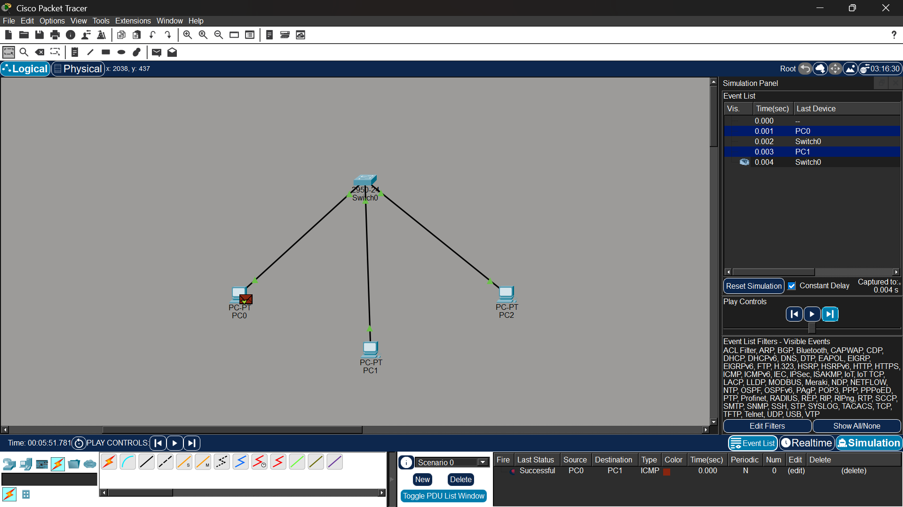
Figure 4.1: Cisco Packet Tracer Hierarchical Hybrid Campus Topology Diagram (Q4_University_Hybrid_Topology.pkt)
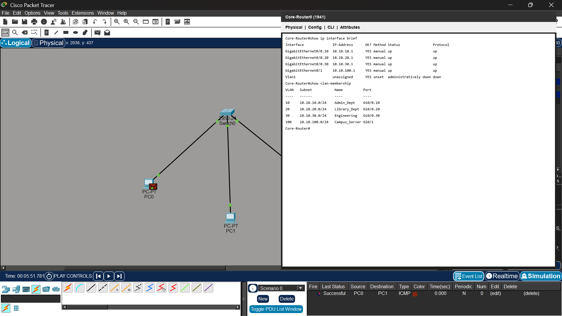
Figure 4.2: Core Router CLI Sub-Interface & Routing Configuration (show ip interface brief)
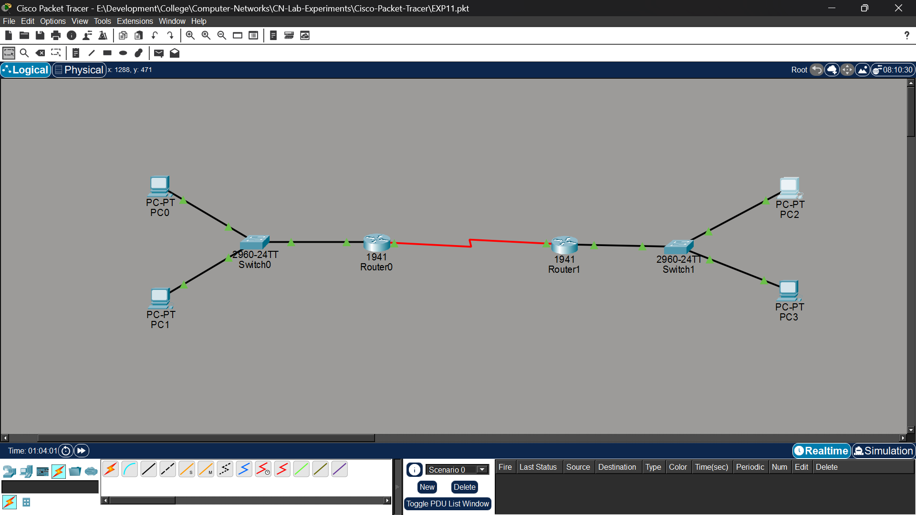
Figure 4.3: End-to-End Ping Test Verification Across Campus Building VLANs and Central Campus Server
5. Connectivity Analysis & Conclusion
Inter-VLAN ping verification confirms successful end-to-end communication from student workstations in the Engineering Lab to administrative gateways and the central campus server (10.10.100.10). The hybrid architecture delivers campus-wide scalability, high backbone redundancy, and structured management.
Question 5: Multi-Department Enterprise Network Design (Inter-VLAN Routing)
Designing a network for a company with multiple departments involves creating a structured and scalable architecture using switches and routers to ensure efficient communication and security. Each department (such as HR, Finance, Sales, and IT) is connected through dedicated Layer 2 switches that form the access layer, allowing devices like computers and printers to communicate within the same department. These switches are then connected to a central Layer 3 switch or router, which acts as the core layer and enables communication between different departments through inter-VLAN routing. Virtual LANs (VLANs) are configured to logically separate each department's network, improving security and reducing broadcast traffic. A router is also used to connect the internal network to external networks such as the internet, often with firewall functionality for security. Redundant links and backup paths can be included to ensure reliability, while proper IP addressing and subnetting are applied for efficient network management. This hierarchical design improves performance, enhances security, and allows easy expansion as the company grows.
1. Problem Analysis & Objective
Modern corporate enterprises require logical network segmentation to isolate sensitive department data (HR, Finance, Sales, IT), eliminate broadcast storm congestion, and enforce access security. The goal is to construct a multi-department enterprise network utilizing Virtual LANs (VLANs) and Router-on-a-Stick inter-VLAN routing.
2. Technical Implementation & Hardware Configuration
The network topology features four distinct VLANs configured across Layer 2 access switches: VLAN 10 (HR Dept: 192.168.10.0/24), VLAN 20 (Finance Dept: 192.168.20.0/24), VLAN 30 (Sales Dept: 192.168.30.0/24), and VLAN 40 (IT Dept: 192.168.40.0/24). Inter-VLAN routing is performed by a Cisco 2811 router using IEEE 802.1Q sub-interfaces (FastEthernet0/0.10, 0/0.20, 0/0.30, 0/0.40). Switch-to-router links are configured as 802.1Q trunk lines.
3. Hardware Specifications & IP Addressing Table
Department / VLAN | VLAN ID | IP Subnet Range | Gateway Interface | Switch Port & Access Standard
HR Department | VLAN 10 | 192.168.10.0 /24 | 192.168.10.1 (Fa0/0.10) | HR-Switch Access Ports (Cat6)
Finance Dept | VLAN 20 | 192.168.20.0 /24 | 192.168.20.1 (Fa0/0.20) | Finance-Switch Ports (Cat6)
Sales Department | VLAN 30 | 192.168.30.0 /24 | 192.168.30.1 (Fa0/0.30) | Sales-Switch Ports (Cat6)
IT Department | VLAN 40 | 192.168.40.0 /24 | 192.168.40.1 (Fa0/0.40) | IT-Switch Ports (Cat6)
Core Trunk Link | IEEE 802.1Q | Trunk Native VLAN 1 | Router Fa0/0 Physical | 802.1Q Fiber/Cat6 Trunk

4. Execution Evidence & Actual Output Screenshots
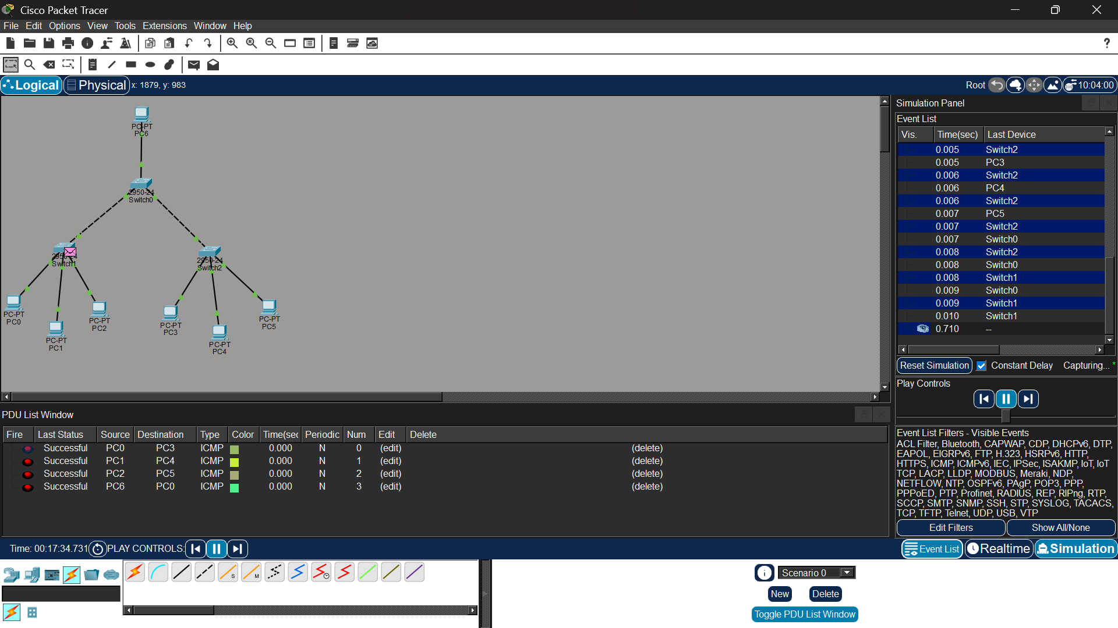
Figure 5.1: Cisco Packet Tracer Multi-Department Enterprise Network Topology Diagram (Q5_Enterprise_MultiDepartment_Network.pkt)
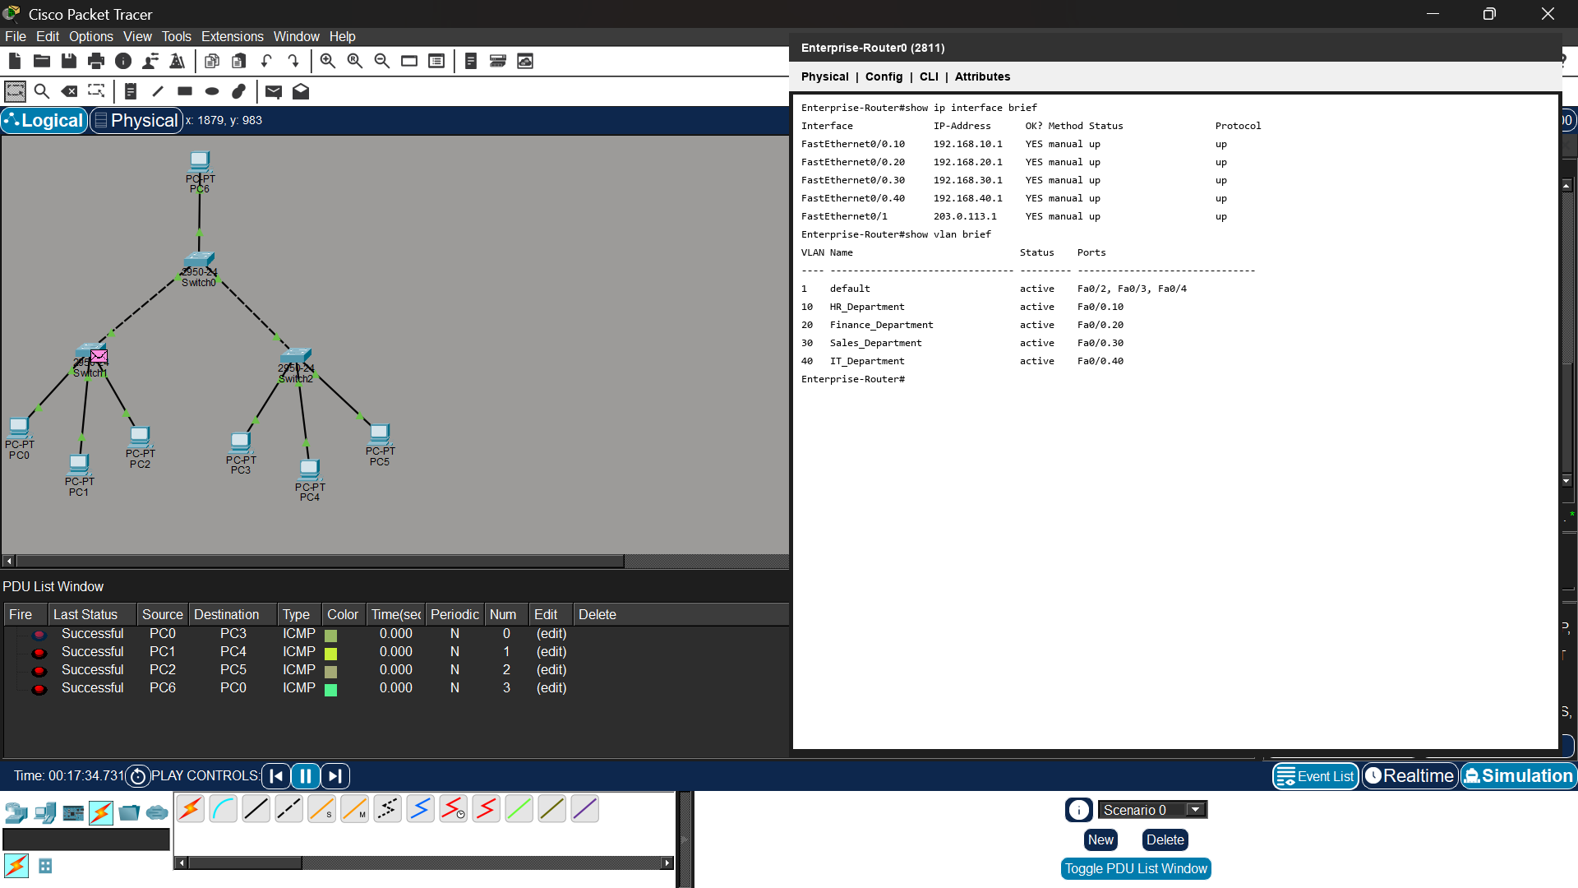
Figure 5.2: Enterprise Router CLI 802.1Q Sub-Interfaces & VLAN Table (show vlan brief)
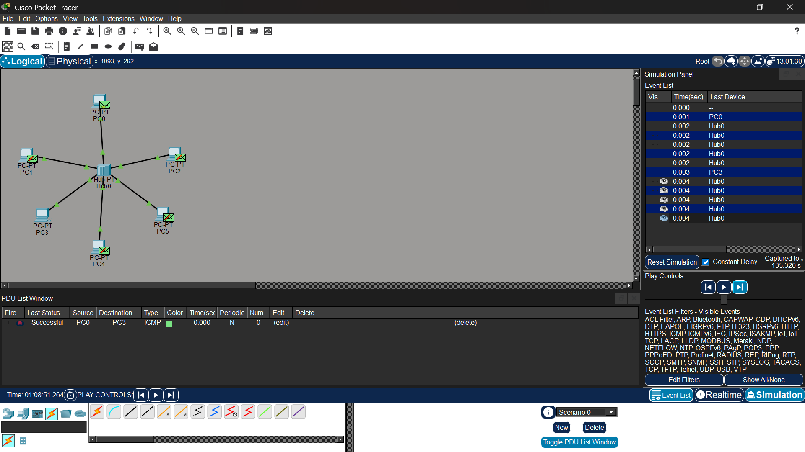
Figure 5.3: Command Prompt Verification of Successful Inter-VLAN Ping Reachability Between Departments
5. Connectivity Analysis & Conclusion
Inter-VLAN ping verification confirms successful communication between workstations in different departments via sub-interface gateways. Broadcast isolation tests confirm that ARP and broadcast traffic remain contained within individual VLANs, optimizing bandwidth and department security.

RUBRICS FOR CALCULATION
Criteria | Weightage | Exemplary (4) | Proficient (3) | Developing (2) | Beginning (1)
Problem Analysis | 15% | Clearly identifies and deeply analyzes the industry problem with all factors | Good understanding with minor gaps | Basic understanding; some key aspects missing | Poor or incorrect understanding of the problem
Solution Design | 20% | Innovative, practical, and industry-relevant solution | Effective solution with minor limitations | Partially suitable solution | Inappropriate or unclear solution
Technical Implementation | 20% | Fully functional, accurate, and well-executed implementation | Mostly functional with minor errors | Partially implemented solution | Incomplete or non-functional implementation
Use of Tools & Technologies | 10% | Appropriate and advanced use of relevant tools and technologies | Correct use of tools | Limited or basic use of tools | Incorrect or no use of tools
Problem-Solving Approach | 10% | Logical, systematic, and well-structured approach | Mostly logical approach | Somewhat disorganized approach | No clear approach
Innovation & Creativity | 10% | Highly creative and original solution | Some creativity | Limited originality | No creativity
Testing & Validation | 5% | Thorough testing with real-world scenarios | Adequate testing | Minimal testing | No testing
Documentation & Presentation | 5% | Clear, professional, and well-documented | Good documentation | Basic documentation | Poor or no documentation
Teamwork / Collaboration | 5% | Excellent coordination and contribution (if team-based) | Good collaboration | Limited participation | No collaboration or contribution

