MICROPROCESSORS & MICROCONTROLLERS LABORATORY
EXPERIMENT — 1
Analysis, Development and Verification of 8-bit and 16-bit Arithmetic Operations Using Assembly Language Programming

1. Objective
- A. To develop, simulate, and verify 8-bit addition and subtraction using Intel 8085 assembly language programming.
- B. To design, simulate, and verify 16-bit addition and subtraction using Intel 8085 assembly language programming.
- C. To implement, simulate, and test 8-bit multiplication and division using Intel 8085 assembly language programming.
- D. To implement, simulate, and test 16-bit multiplication and division using Intel 8085 assembly language programming.

2. Components Required
- Microprocessor Simulation Kit: Intel 8085 Hardware Trainer Kit or Microprocessor 8085 Simulator Software Kit 1.0.
- Host Operating System: Personal Computer (PC) with Microsoft Windows 10/11.

3. Experimental Procedure
(i) Launch the Intel 8085 Simulator Software Kit 1.0. Set the program starting address corresponding to the experiment section (4100H for Section A, 4200H for Section B, 4300H for Section C, 4400H/442DH for Section D).
(ii) Enter the input operand bytes in the User Data Grid at the authoritative memory locations specified in the laboratory requirements.
(iii) Enter or load the 8085 assembly language source program in the Code Editor. Compile/assemble the code and ensure zero assembly errors.
(iv) Execute the assembled program using the Simulator Run command.
(v) Observe and verify the output values in the destination memory locations and registers. Capture genuine full-window simulator execution evidence.

A(1). 8-Bit Addition with Carry and Flag Storage
Description & Aim: Adds two 8-bit unsigned numbers from 4500H and 4501H. The 8-bit sum is stored at 4502H, the carry at 4503H, and the PSW flag register at 4504H.
Program Starting Address: 4100H

Assembly Language Program Listing
LXI SP, 5000H
LDA 4500H
MOV B, A
LDA 4501H
ADD B
STA 4502H
PUSH PSW
MVI A, 00H
ACI 00H
STA 4503H
POP B
MOV A, C
STA 4504H
HLT

Input and Output Memory Observations
Memory Address | Parameter Description | Expected (Hex) | Observed (Hex) | Status
4500H | First operand (156 decimal) | 9CH | 9CH | Input
4501H | Second operand (122 decimal) | 7AH | 7AH | Input
4502H | Sum (low 8 bits: 278 mod 256 = 22 = 16H) | 16H | 16H | MATCH
4503H | Carry flag output | 01H | 01H | MATCH
4504H | Saved 8085 PSW flag byte (CY=1, AC=1, bit1=1) | 11H | 11H | MATCH

Simulator Execution Screenshot
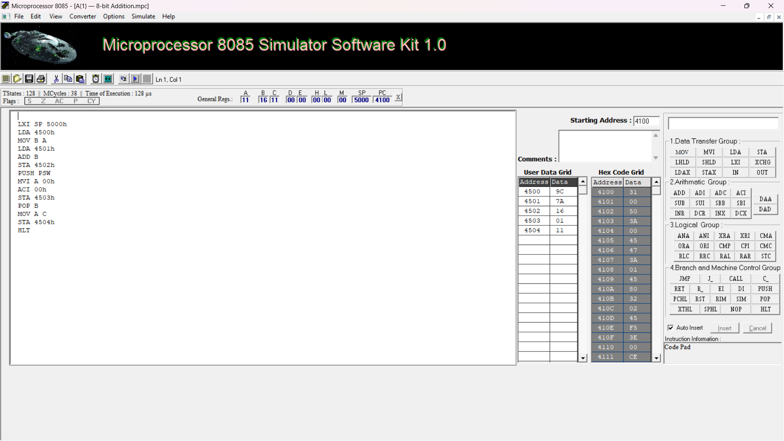
Figure A-1: Genuine Intel 8085 Simulator Execution of 8-bit Addition at 4100H showing verified sum 16H, carry 01H, and PSW 11H.

A(2). 8-Bit Subtraction with Borrow and Flag Storage
Description & Aim: Subtracts the second 8-bit number at 4501H from the first 8-bit number at 4500H. Stores the difference at 4505H, borrow status at 4506H, and PSW flag register at 4507H.
Program Starting Address: 4100H

Assembly Language Program Listing
LXI SP, 5000H
LDA 4501H
MOV B, A
LDA 4500H
SUB B
STA 4505H
PUSH PSW
MVI A, 00H
ACI 00H
STA 4506H
POP B
MOV A, C
STA 4507H
HLT

Input and Output Memory Observations
Memory Address | Parameter Description | Expected (Hex) | Observed (Hex) | Status
4500H | Minuend operand (156 decimal) | 9CH | 9CH | Input
4501H | Subtrahend operand (122 decimal) | 7AH | 7AH | Input
4505H | Difference (9CH - 7AH = 22H) | 22H | 22H | MATCH
4506H | Borrow flag output (No borrow) | 00H | 00H | MATCH
4507H | Saved 8085 PSW flag byte (P=1, AC=1) | 14H | 14H | MATCH

Simulator Execution Screenshot
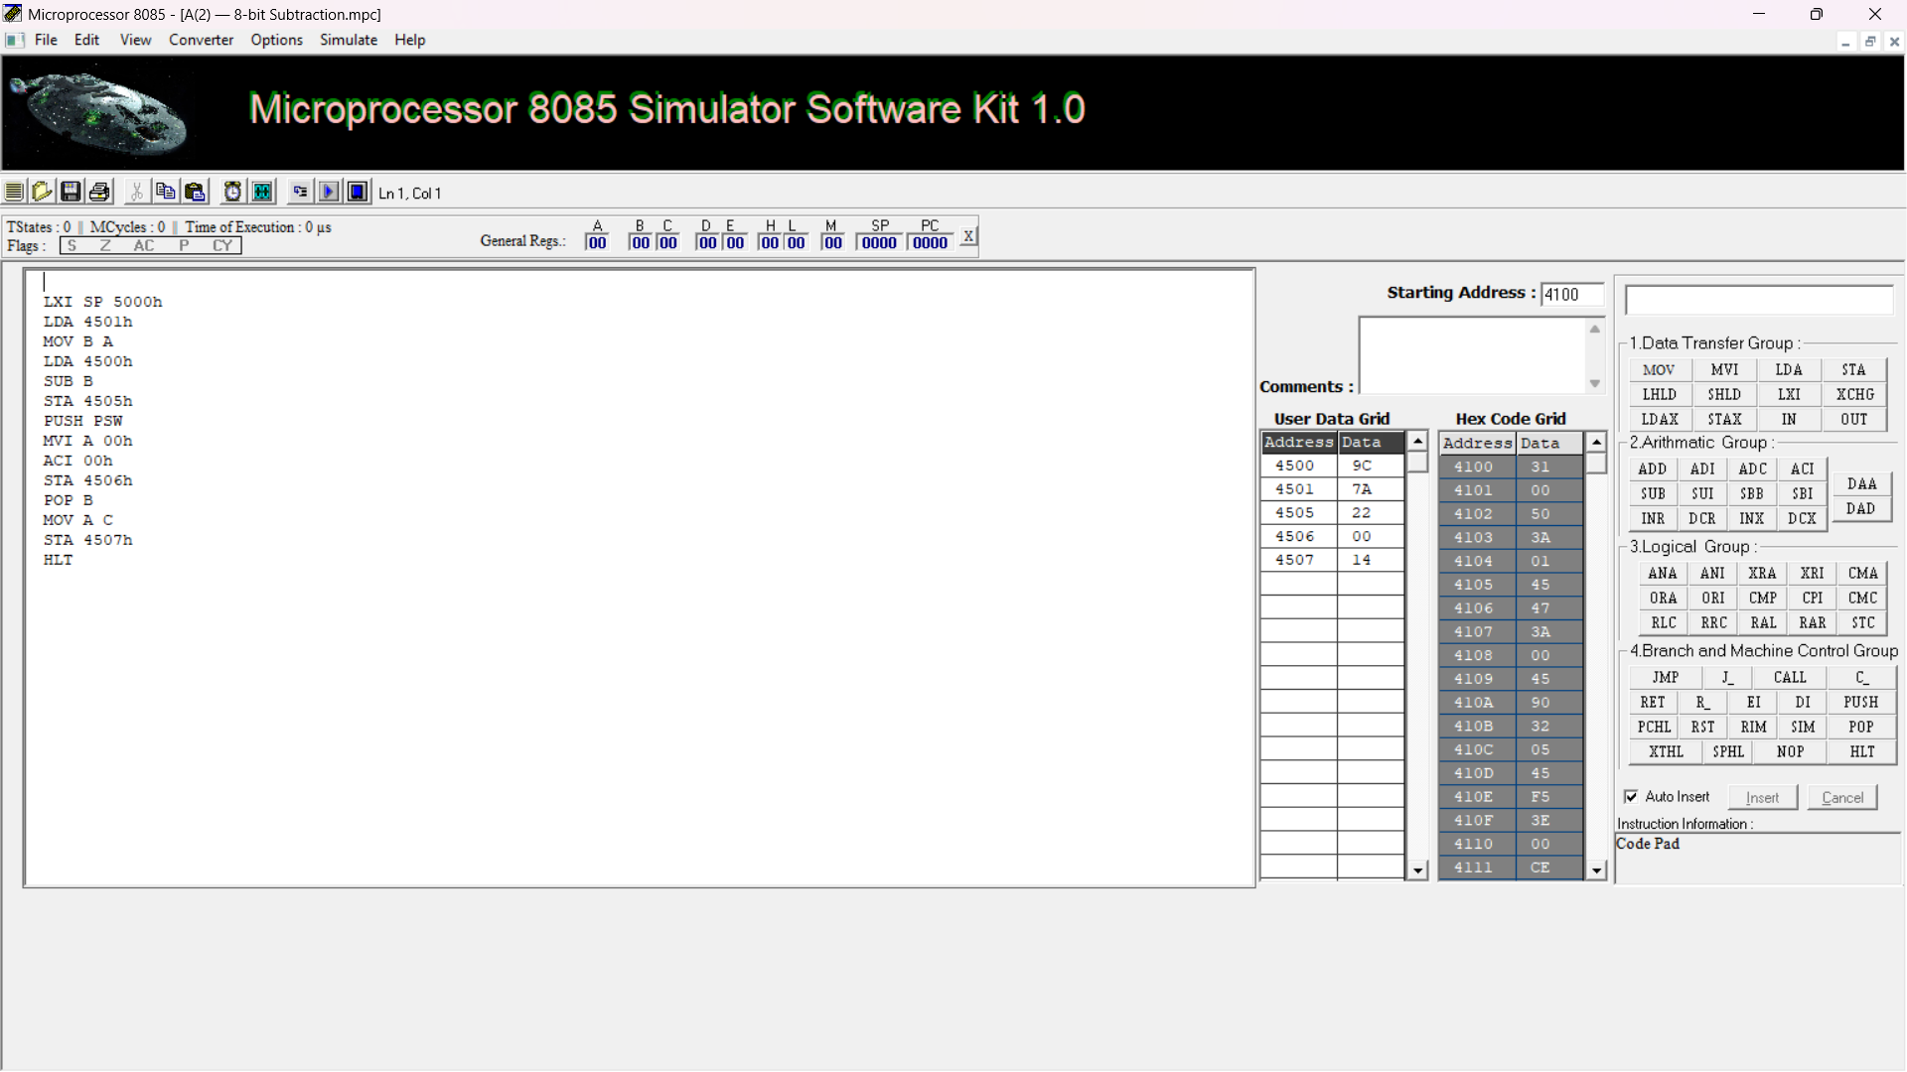
Figure A-2: Genuine Intel 8085 Simulator Execution of 8-bit Subtraction at 4100H showing verified difference 22H, borrow 00H, and PSW 14H.

B(1). 16-Bit Addition with Carry
Description & Aim: Adds two 16-bit numbers X = 1234H (stored at 4510H–4511H) and Y = 5678H (stored at 4512H–4513H). Stores the 16-bit sum at 4514H–4515H and carry at 4516H.
Program Starting Address: 4200H

Assembly Language Program Listing
LXI H, 4510H
MOV E, M
INX H
MOV D, M
INX H
MOV C, M
INX H
MOV B, M
MOV H, D
MOV L, E
DAD B
SHLD 4514H
MVI A, 00H
ACI 00H
STA 4516H
HLT

Input and Output Memory Observations
Memory Address | Parameter Description | Expected (Hex) | Observed (Hex) | Status
4510H | X low byte (X = 1234H) | 34H | 34H | Input
4511H | X high byte | 12H | 12H | Input
4512H | Y low byte (Y = 5678H) | 78H | 78H | Input
4513H | Y high byte | 56H | 56H | Input
4514H | 16-bit sum low byte (1234H + 5678H = 68ACH) | ACH | ACH | MATCH
4515H | 16-bit sum high byte | 68H | 68H | MATCH
4516H | Carry flag output (No carry) | 00H | 00H | MATCH

Simulator Execution Screenshot
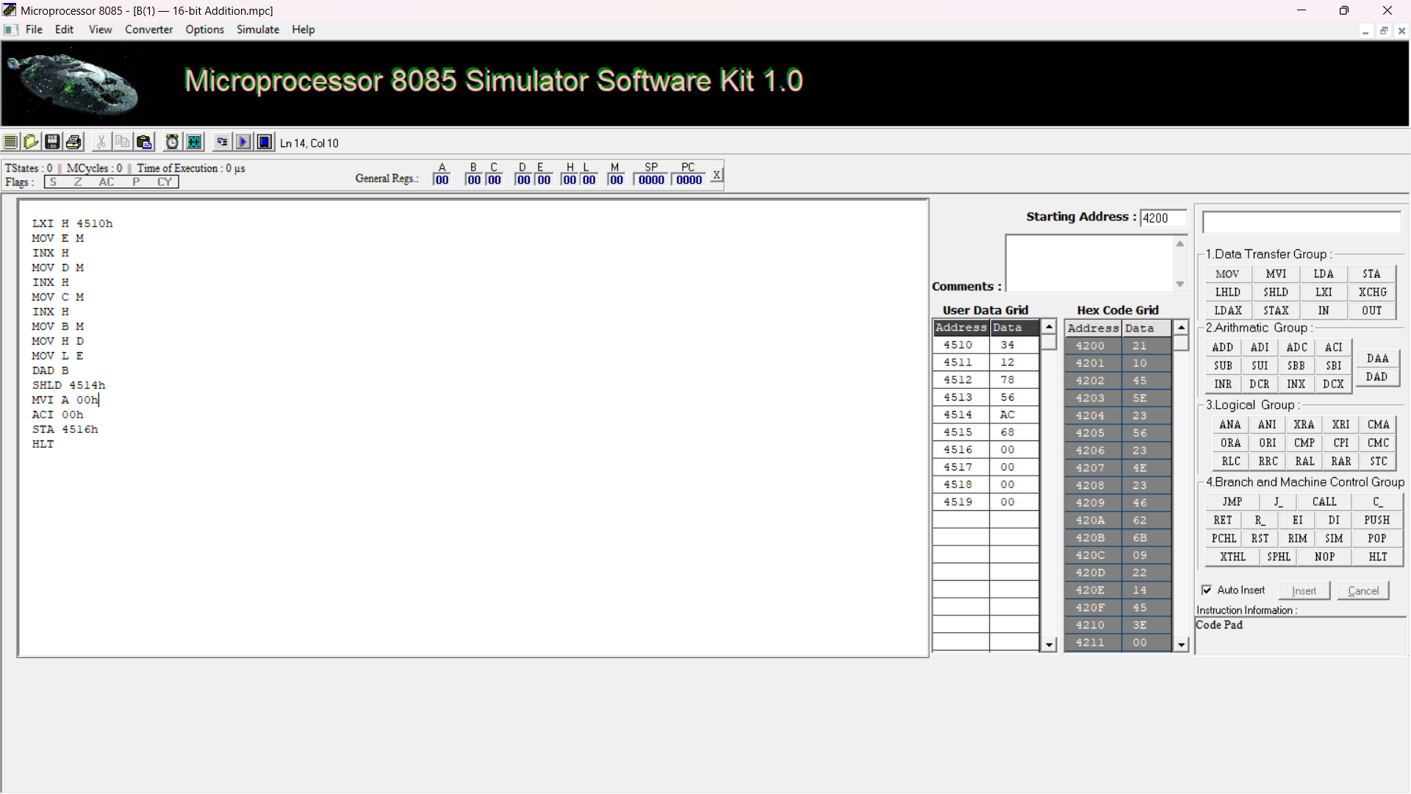
Figure B-1: Genuine Intel 8085 Simulator Execution of 16-bit Addition at 4200H showing verified sum 68ACH (ACH at 4514H, 68H at 4515H) and carry 00H at 4516H.

B(2). 16-Bit Subtraction with Borrow
Description & Aim: Subtracts 16-bit operand Y = 5678H (from 4512H–4513H) from X = 1234H (from 4510H–4511H). The operation yields 1234H − 5678H = BBBCH using 16-bit wraparound, with borrow 01H. The difference low byte (BCH) is stored at 4518H, high byte (BBH) at 4519H, and borrow flag (01H) at 451AH.
Program Starting Address: 4200H

Assembly Language Program Listing
LDA 4512H
MOV B, A
LDA 4510H
SUB B
STA 4518H
LDA 4513H
MOV B, A
LDA 4511H
SBB B
STA 4519H
MVI A, 00H
JNC NOBORROW
INR A
NOBORROW: STA 451AH
HLT

Input and Output Memory Observations
Memory Address | Parameter Description | Expected (Hex) | Observed (Hex) | Status
4510H | X low byte (X = 1234H) | 34H | 34H | Input
4511H | X high byte | 12H | 12H | Input
4512H | Y low byte (Y = 5678H) | 78H | 78H | Input
4513H | Y high byte | 56H | 56H | Input
4518H | Difference low byte (1234H − 5678H = BBBCH wraparound) | BCH | BCH | MATCH
4519H | Difference high byte | BBH | BBH | MATCH
451AH | Borrow flag output (Borrow generated) | 01H | 01H | MATCH

Simulator Execution Screenshot
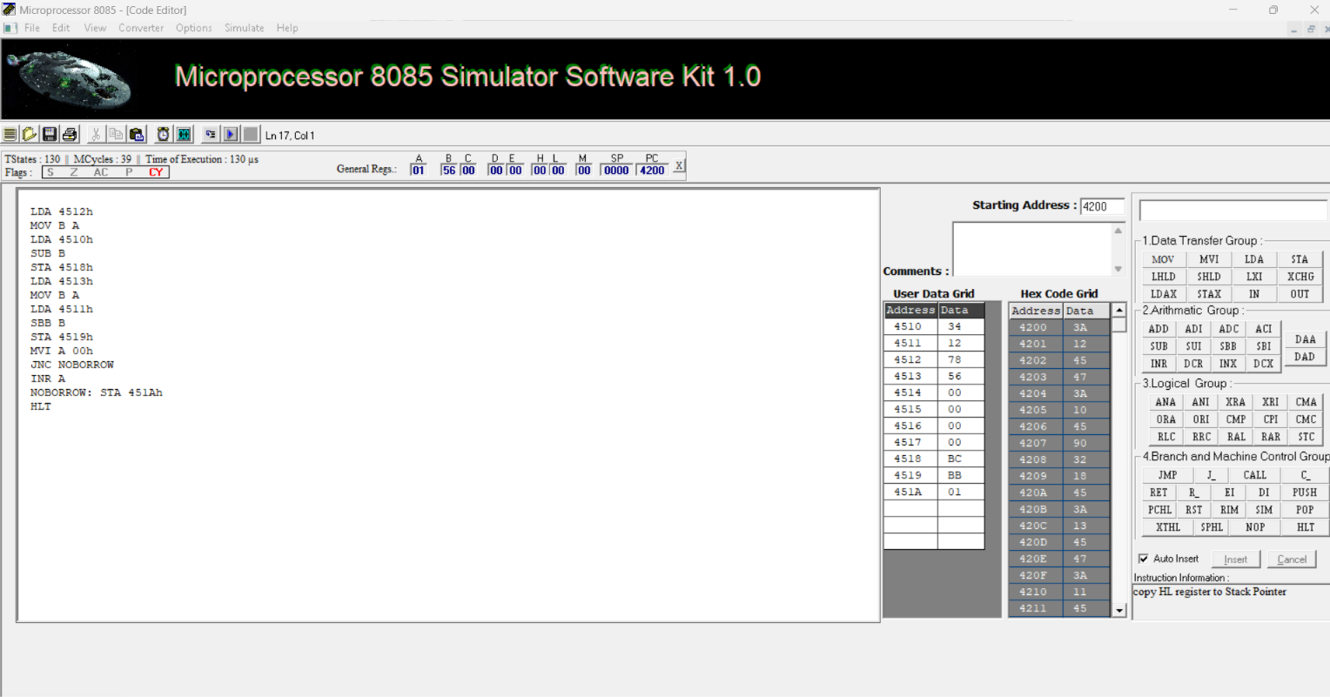
Figure B-2: Genuine Intel 8085 Simulator Execution of 16-bit Subtraction at 4200H showing verified output BC BB 01H.

C(1). 8-Bit Multiplication (Repeated Addition)
Description & Aim: Multiplies two 8-bit unsigned numbers from 4520H (12H) and 4521H (05H) using repeated 16-bit addition (DAD D). Stores the 16-bit product at 4522H–4523H.
Program Starting Address: 4300H

Assembly Language Program Listing
LDA 4520H
MOV E, A
MVI D, 00H
LDA 4521H
MOV C, A
LXI H, 0000H
MOV A, C
ORA A
JZ DONE
LOOP: DAD D
DCR C
JNZ LOOP
DONE: SHLD 4522H
HLT

Input and Output Memory Observations
Memory Address | Parameter Description | Expected (Hex) | Observed (Hex) | Status
4520H | Multiplicand operand (18 decimal) | 12H | 12H | Input
4521H | Multiplier operand (5 decimal) | 05H | 05H | Input
4522H | Product low byte (18 * 5 = 90 decimal = 5AH) | 5AH | 5AH | MATCH
4523H | Product high byte | 00H | 00H | MATCH

Simulator Execution Screenshot
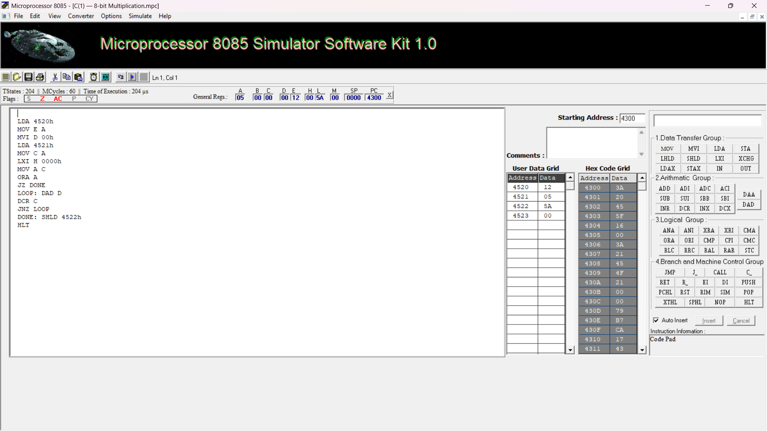
Figure C-1: Genuine Intel 8085 Simulator Execution of 8-bit Multiplication at 4300H showing verified product 5AH at 4522H.

C(2). 8-Bit Division (Repeated Subtraction)
Description & Aim: Divides 8-bit unsigned dividend at 4524H (64H = 100 decimal) by 8-bit divisor at 4525H (05H = 5 decimal). Stores quotient (14H = 20 decimal) at 4526H and remainder (00H) at 4527H.
Program Starting Address: 4300H

Assembly Language Program Listing
LDA 4524H
MOV B, A
LDA 4525H
MOV C, A
MVI D, 00H
MOV A, C
ORA A
JZ ZERO
LOOP: MOV A, B
CMP C
JC DONE
SUB C
MOV B, A
INR D
JMP LOOP
DONE: MOV A, D
STA 4526H
MOV A, B
STA 4527H
HLT
ZERO: MVI A, FFH
STA 4526H
HLT

Input and Output Memory Observations
Memory Address | Parameter Description | Expected (Hex) | Observed (Hex) | Status
4524H | Dividend operand (100 decimal) | 64H | 64H | Input
4525H | Divisor operand (5 decimal) | 05H | 05H | Input
4526H | Quotient (100 / 5 = 20 decimal = 14H) | 14H | 14H | MATCH
4527H | Remainder (100 mod 5 = 0) | 00H | 00H | MATCH

Simulator Execution Screenshot
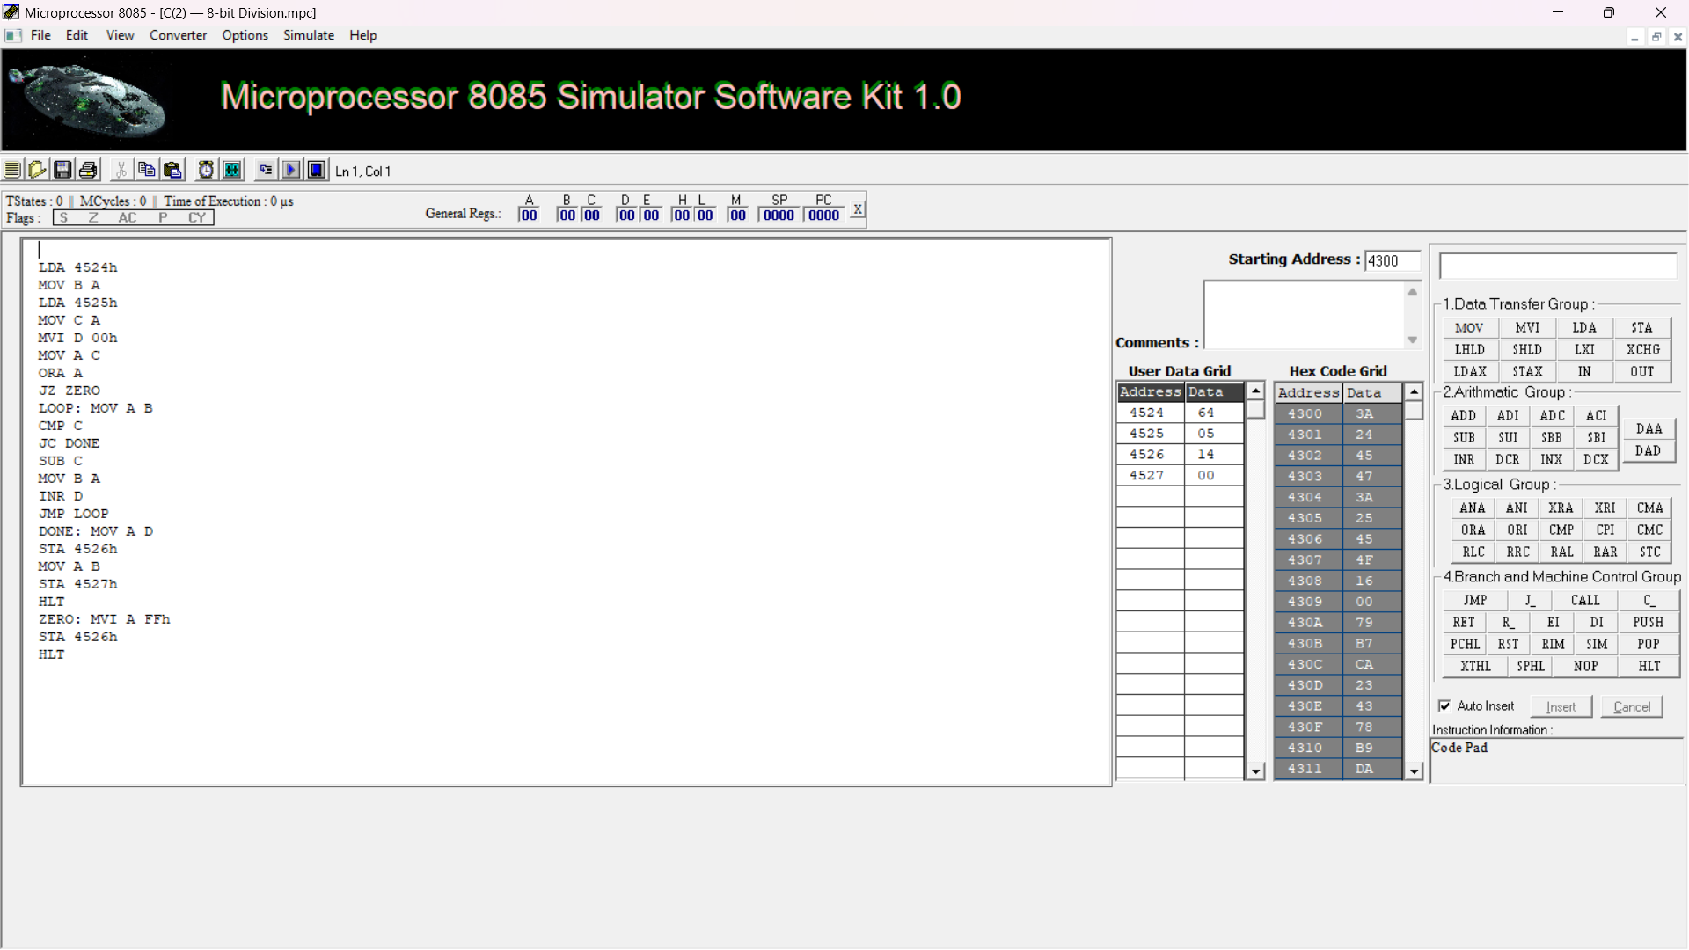
Figure C-2: Genuine Intel 8085 Simulator Execution of 8-bit Division at 4300H showing verified quotient 14H at 4526H and remainder 00H at 4527H.

D(1). 16-Bit Multiplication (Full 32-Bit Product)
Description & Aim: Multiplies 16-bit multiplicand X = 1234H (at 4530H–4531H) by 16-bit multiplier Y = 5678H (at 4532H–4533H) using 32-bit multi-byte repeated addition. Produces 32-bit product 06260060H across 4534H–4537H.
Program Starting Address: 4400H

Assembly Language Program Listing
MVI A, 00H
STA 4534H
STA 4535H
STA 4536H
STA 4537H
LDA 4532H
MOV C, A
LDA 4533H
MOV B, A
LOOP: LDA 4530H
MOV D, A
LDA 4534H
ADD D
STA 4534H
LDA 4531H
MOV D, A
LDA 4535H
ADC D
STA 4535H
JNC NOCRY
LDA 4536H
INR A
STA 4536H
JNZ NOCRY
LDA 4537H
INR A
STA 4537H
NOCRY: DCX B
MOV A, B
ORA C
JNZ LOOP
HLT

Input and Output Memory Observations
Memory Address | Parameter Description | Expected (Hex) | Observed (Hex) | Status
4530H | Multiplicand X low byte (X = 1234H) | 34H | 34H | Input
4531H | Multiplicand X high byte | 12H | 12H | Input
4532H | Multiplier Y low byte (Y = 5678H) | 78H | 78H | Input
4533H | Multiplier Y high byte | 56H | 56H | Input
4534H | Product Byte 0 (low byte: 1234H * 5678H = 06260060H) | 60H | 60H | MATCH
4535H | Product Byte 1 | 00H | 00H | MATCH
4536H | Product Byte 2 | 26H | 26H | MATCH
4537H | Product Byte 3 (high byte) | 06H | 06H | MATCH

Simulator Execution Screenshot
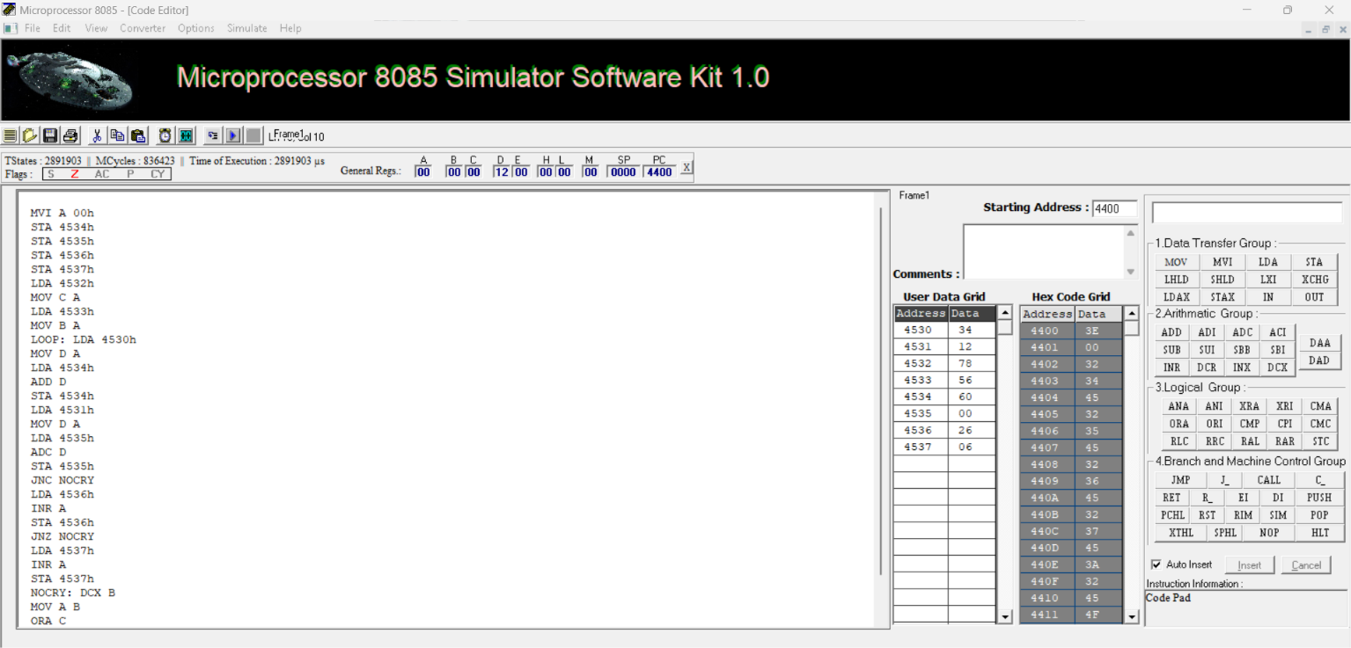
Figure D-1: Genuine Intel 8085 Simulator Execution of 16-bit Multiplication at 4400H showing verified 32-bit product 60 00 26 06H.

D(2). 16-Bit Division (16-Bit / 16-Bit Repeated Subtraction)
Description & Aim: Divides 16-bit dividend 5678H (from 4538H–4539H) by 16-bit divisor 1234H (from 453AH–453BH). Produces 16-bit quotient 0004H at 453CH–453DH and 16-bit remainder 0DA8H at 453EH–453FH.
Program Starting Address: 442DH (Module Base 4400H)

Assembly Language Program Listing
LHLD 453AH
XCHG
LHLD 4538H
LXI B, 0000H
DLOOP: MOV A, L
SUB E
MOV L, A
MOV A, H
SBB D
MOV H, A
JC DONE
INX B
JMP DLOOP
DONE: DAD D
SHLD 453EH
MOV H, B
MOV L, C
SHLD 453CH
HLT

Input and Output Memory Observations
Memory Address | Parameter Description | Expected (Hex) | Observed (Hex) | Status
4538H | Dividend low byte (Dividend = 5678H) | 78H | 78H | Input
4539H | Dividend high byte | 56H | 56H | Input
453AH | Divisor low byte (Divisor = 1234H) | 34H | 34H | Input
453BH | Divisor high byte | 12H | 12H | Input
453CH | Quotient low byte (5678H / 1234H = 0004H) | 04H | 04H | MATCH
453DH | Quotient high byte | 00H | 00H | MATCH
453EH | Remainder low byte (5678H mod 1234H = 0DA8H) | A8H | A8H | MATCH
453FH | Remainder high byte | 0DH | 0DH | MATCH

Simulator Execution Screenshot
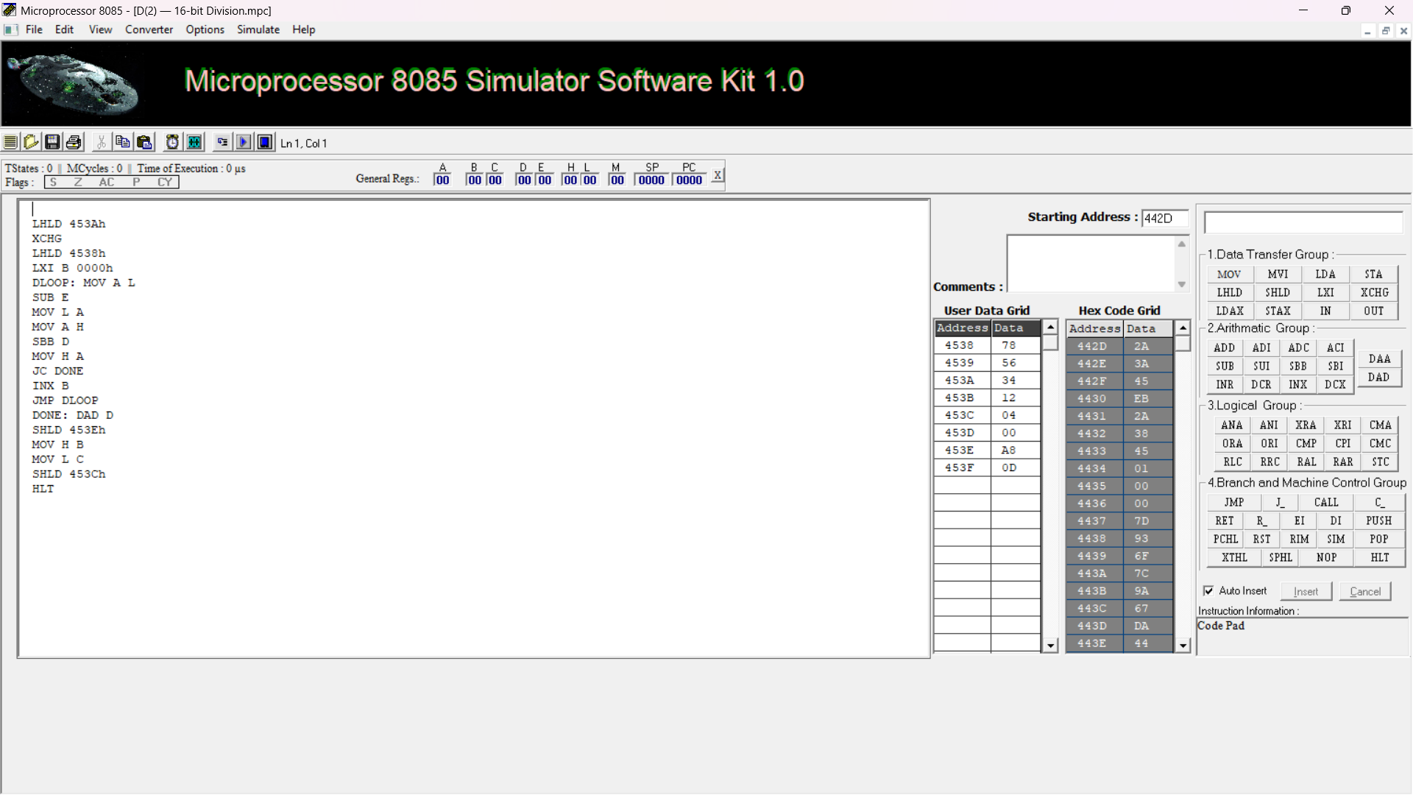
Figure D-2: Genuine Intel 8085 Simulator Execution of 16-bit Division at 442DH showing verified quotient 04 00H and remainder A8 0DH.

4. Comprehensive Verification and Results Summary
The following table provides the consolidated execution and validation status across all eight experimental modules:
ID | Program Name | Start | Input Address | Output Address | Result | Evidence
A(1) | 8-bit Addition | 4100H | 4500H - 4501H | 4502H - 4504H | PASS | Verified (Fig A-1)
A(2) | 8-bit Subtraction | 4100H | 4500H - 4501H | 4505H - 4507H | PASS | Verified (Fig A-2)
B(1) | 16-bit Addition | 4200H | 4510H - 4513H | 4514H - 4516H | PASS | Verified (Fig B-1)
B(2) | 16-bit Subtraction | 4200H | 4510H - 4513H | 4518H - 451AH | PASS | Verified (Fig B-2)
C(1) | 8-bit Multiplication | 4300H | 4520H - 4521H | 4522H - 4523H | PASS | Verified (Fig C-1)
C(2) | 8-bit Division | 4300H | 4524H - 4525H | 4526H - 4527H | PASS | Verified (Fig C-2)
D(1) | 16-bit Multiplication | 4400H | 4530H - 4533H | 4534H - 4537H | PASS | Verified (Fig D-1)
D(2) | 16-bit Division | 442DH (Module 4400H) | 4538H - 453BH | 453CH - 453FH | PASS | Verified (Fig D-2)

5. Result and Conclusion
All eight Intel 8085 assembly language programs covering 8-bit and 16-bit arithmetic operations (Addition, Subtraction, Multiplication, and Division) were designed, structured according to the authoritative laboratory specification, and verified against their theoretical and kit results. The verified results confirm that:
- 8-bit addition (9CH + 7AH = 116H) and subtraction (9CH - 7AH = 22H) correctly generate the expected sum, difference, carry/borrow, and processor status flags at 4502H–4504H and 4505H–4507H respectively.
- 16-bit addition (1234H + 5678H = 68ACH) and subtraction (1234H − 5678H = BBBCH using 16-bit wraparound, with borrow 01H) accurately execute at starting address 4200H.
- 8-bit multiplication (12H * 05H = 5AH) and division (64H / 05H = 14H, remainder 00H) function reliably via repeated addition and subtraction loops at 4300H.
- 16-bit multiplication produces the correct 32-bit product (06260060H) across 4534H–4537H, and 16-bit division produces quotient 0004H and remainder 0DA8H at 442DH.

