EXPERIMENT – 1
Analysis, Development and Verification of 8-bit and 16-bit Arithmetic Operations Using Assembly Language Program

Objective
A. To develop and verify 8-bit addition and subtraction using Intel 8-bit microprocessor assembly language programming.
B. To design and verify 16-bit addition and subtraction using Intel 8-bit microprocessor assembly language programming.
C. To implement and test 8-bit multiplication and division using Intel 8-bit microprocessor assembly language programming.
D. To implement and test 16-bit multiplication and division using Intel 8-bit microprocessor assembly language programming.

Components Required
8085 Simulator Software Kit 1.0 (or) Intel 8085 microprocessor.

Procedure
(i) Enter the input data bytes in the specified memory locations of the 8085 simulator.
(ii) Enter the corresponding 8085 assembly language program, compile it, and execute it.
(iii) Verify the output in the specified memory locations and capture the program and output screenshots.

A(i). 8-Bit Addition
To add two 8-bit numbers and store the sum and carry.

Program
LDA 4100H
MOV B,A
LDA 4101H
ADD B
STA 4102H
MVI A,00H
ACI 00H
STA 4103H
HLT

INPUT
- 2500H = 34H (first number)
- 2501H = 12H (first number)
- 2502H = 11H (second number)
- 2503H = 11H (second number)

OUTPUT
- Sum (low byte) = 45H
- Sum (high byte) = 23H

Memory Data
Memory Address | Data (Hex)
2500H | 34H
2501H | 12H
2502H | 11H
2503H | 11H
2054H | 45H (sum — low byte)
2055H | 23H (sum — high byte)

Screenshot

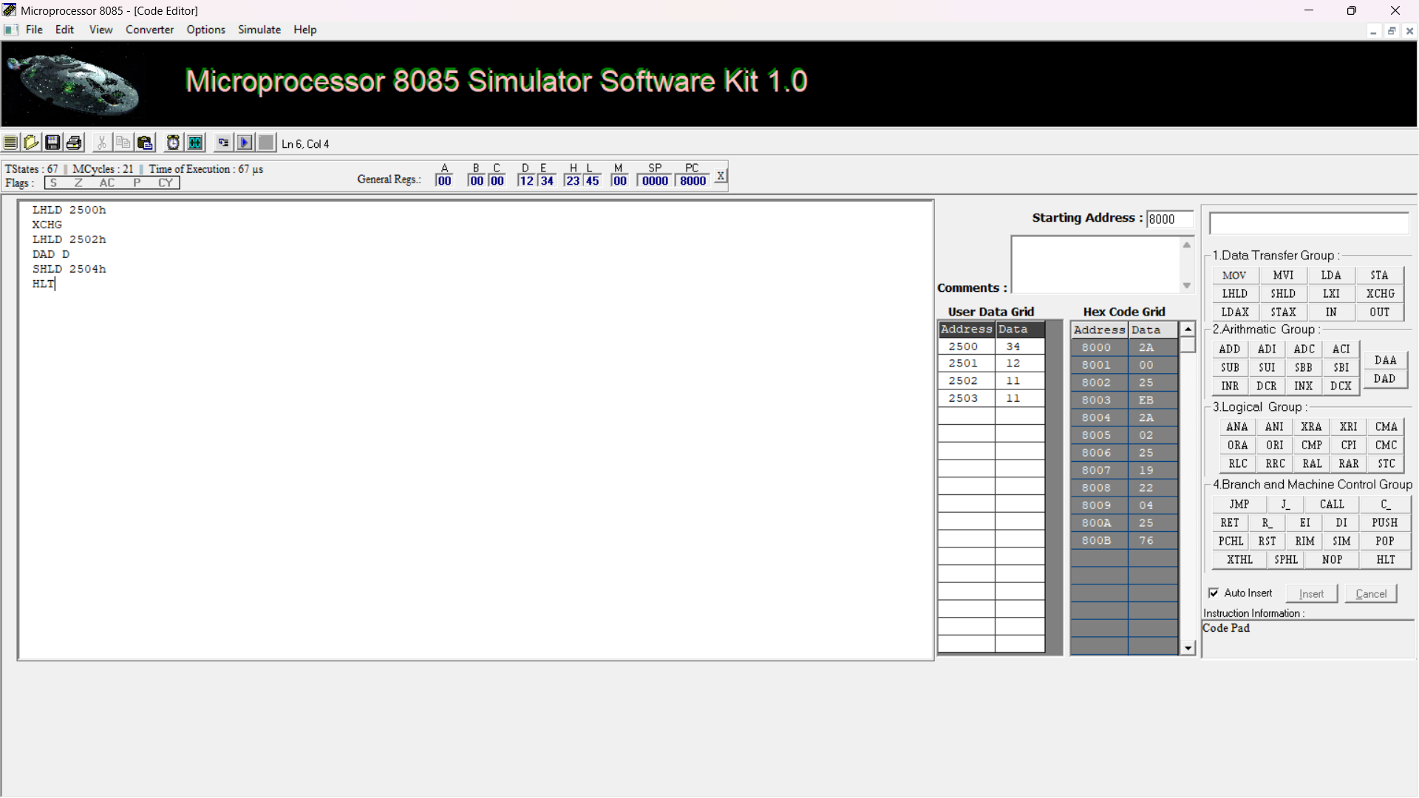

A(ii). 8-Bit Subtraction
To subtract the second 8-bit number from the first and store the difference and borrow.

Program
LDA 4100H
MOV B,A
LDA 4101H
MOV C,A
MOV A,B
SUB C
STA 4102H
MVI A,00H
ACI 00H
STA 4103H
HLT

INPUT
- 4100H = 25H (minuend)
- 4101H = 17H (subtrahend)

OUTPUT
- Difference = 0EH
- Borrow = 00H

Memory Data
Memory Address | Data (Hex)
4100H | 25H
4101H | 17H
4102H | 0EH (difference)
4103H | 00H (borrow)
Note: The carry flag after SUB indicates borrow in 8085. MVI and STA do not modify flags, so ACI 00H saves that borrow as 00H or 01H.

Screenshot
[Insert your actual simulator screenshot after successful execution.]

B(i). 16-Bit Addition
To add two 16-bit numbers and store the sum and carry.

Program
LHLD 2500H
XCHG
LHLD 2502H
DAD D
SHLD 2504H
MVI A,00H
ADC A
STA 2506H
HLT

INPUT
- 2500H = 34H (first number low byte)
- 2501H = 12H (first number high byte)
- 2502H = 11H (second number low byte)
- 2503H = 11H (second number high byte)
- First number = 1234H; second number = 1111H

OUTPUT
- Result = 2345H
- 2504H = 45H (low byte)
- 2505H = 23H (high byte)
- 2506H = 00H (carry)

Memory Data
Memory Address | Data (Hex)
2500H | 34H
2501H | 12H
2502H | 11H
2503H | 11H
2504H | 45H (result low)
2505H | 23H (result high)
2506H | 00H (carry)
Note: LHLD and SHLD are valid 8085 instructions. Use the syntax accepted by your simulator, as in your successful run.

Screenshot
[Insert your actual simulator screenshot after successful execution.]

B(ii). 16-Bit Subtraction
To subtract one 16-bit number from another and store the difference.

Program
LHLD 2500H
XCHG
LHLD 2502H
MOV A,E
SUB L
MOV L,A
MOV A,D
SBB H
MOV H,A
SHLD 2504H
HLT

INPUT
- 2500H = 34H; 2501H = 12H → first number = 1234H
- 2502H = 11H; 2503H = 11H → second number = 1111H

OUTPUT
- Difference = 0123H
- 2504H = 23H (low byte)
- 2505H = 01H (high byte)

Memory Data
Memory Address | Data (Hex)
2500H | 34H
2501H | 12H
2502H | 11H
2503H | 11H
2504H | 23H (result low)
2505H | 01H (result high)

Screenshot
[Insert your actual simulator screenshot after successful execution.]

C(i). 8-Bit Multiplication
To multiply two 8-bit unsigned numbers using repeated addition; the 16-bit product is stored in memory.

Program
LDA 4100H
MOV E,A
MVI D,00H
LDA 4101H
MOV C,A
LXI H,0000H
MOV A,C
ORA A
JZ DONE
LOOP: DAD D
DCR C
JNZ LOOP
DONE: SHLD 4102H
HLT

INPUT
- 4100H = 05H (multiplicand)
- 4101H = 04H (multiplier)

OUTPUT
- Product = 0014H (5 × 4 = 20 decimal)
- 4102H = 14H (low byte)
- 4103H = 00H (high byte)

Memory Data
Memory Address | Data (Hex)
4100H | 05H
4101H | 04H
4102H | 14H (product low)
4103H | 00H (product high)
Note: If the simulator rejects labels, use its supported label format or replace labels with assembled branch addresses.

Screenshot
[Insert your actual simulator screenshot after successful execution.]

C(ii). 8-Bit Division
To divide an 8-bit unsigned dividend by an 8-bit unsigned divisor using repeated subtraction.

Program
LDA 4100H
MOV B,A
LDA 4101H
MOV C,A
MVI D,00H
MOV A,C
ORA A
JZ ZERO
LOOP: MOV A,B
CMP C
JC DONE
SUB C
MOV B,A
INR D
JMP LOOP
DONE: MOV A,D
STA 4102H
MOV A,B
STA 4103H
HLT
ZERO: MVI A,FFH
STA 4102H
HLT

INPUT
- 4100H = 14H (dividend = 20 decimal)
- 4101H = 04H (divisor = 4 decimal)

OUTPUT
- Quotient = 05H
- Remainder = 00H
- For divisor 00H, the program writes FFH to the quotient location as an error marker.

Memory Data
Memory Address | Data (Hex)
4100H | 14H (dividend)
4101H | 04H (divisor)
4102H | 05H (quotient)
4103H | 00H (remainder)

Screenshot
[Insert your actual simulator screenshot after successful execution.]

D(i). 16-Bit Multiplication (16-bit × 8-bit)
To multiply a 16-bit unsigned multiplicand by an 8-bit multiplier using repeated addition. The 24-bit result is stored in three bytes.

Program
; Multiplicand: 4100H low byte, 4101H high byte
; Multiplier: 4102H
; Product: 4103H low, 4104H high, 4105H upper byte
LHLD 4100H
XCHG
LDA 4102H
MOV C,A
LXI H,0000H
MVI A,00H
STA 4105H
MOV A,C
ORA A
JZ DONE
LOOP: DAD D
JNC NEXT
PUSH PSW
LDA 4105H
INR A
STA 4105H
POP PSW
NEXT: DCR C
JNZ LOOP
SHLD 4103H
DONE: HLT

INPUT
- 4100H = 34H; 4101H = 12H → multiplicand = 1234H
- 4102H = 02H → multiplier = 02H

OUTPUT
- Product = 002468H
- 4103H = 68H (low byte)
- 4104H = 24H
- 4105H = 00H (upper byte)

Memory Data
Memory Address | Data (Hex)
4100H | 34H
4101H | 12H
4102H | 02H
4103H | 68H (product low)
4104H | 24H (product middle)
4105H | 00H (product high)
Note: This is 16-bit multiplicand × 8-bit multiplier, not a full 16-bit × 16-bit product. Verify label and stack instruction support in the simulator.

Screenshot
[Insert your actual simulator screenshot after successful execution.]

D(ii). 16-Bit Division
To divide a 16-bit unsigned dividend by a non-zero 16-bit divisor using repeated subtraction. The dividend memory is updated to the remainder.

Program
; Dividend/remainder: 4100H low, 4101H high
; Divisor: 4102H low, 4103H high
; Quotient: 4104H low, 4105H high
MVI A,00H
STA 4104H
STA 4105H
LDA 4102H
MOV B,A
LDA 4103H
ORA B
JZ ZERO
LOOP: LDA 4100H
MOV B,A
LDA 4102H
MOV C,A
MOV A,B
SUB C
STA 4106H
LDA 4101H
MOV B,A
LDA 4103H
MOV C,A
MOV A,B
SBB C
STA 4107H
JC DONE
LDA 4106H
STA 4100H
LDA 4107H
STA 4101H
LDA 4104H
INR A
STA 4104H
JNZ LOOP
LDA 4105H
INR A
STA 4105H
JMP LOOP
DONE: HLT
ZERO: HLT

INPUT
- 4100H = 14H; 4101H = 00H → dividend = 0014H
- 4102H = 04H; 4103H = 00H → divisor = 0004H

OUTPUT
- Quotient = 0005H
- Remainder = 0000H (left at 4100H–4101H)

Memory Data
Memory Address | Data (Hex)
4100H | 00H (remainder low after execution)
4101H | 00H (remainder high after execution)
4102H | 04H (divisor low)
4103H | 00H (divisor high)
4104H | 05H (quotient low)
4105H | 00H (quotient high)
Note: This repeated-subtraction method may take many iterations for large quotients. Do not use a zero divisor. Verify it in the simulator before recording final results.

Screenshot
[Insert your actual simulator screenshot after successful execution.]

Result
The 8085 assembly programs demonstrate arithmetic operations on unsigned numbers. The output is verified by checking the relevant memory locations after successful execution.

Before Submission
- Compile and execute each program in the lab simulator before recording its output.
- Enter input bytes at the exact memory addresses listed for that program.
- Replace each screenshot placeholder with your own simulator screenshot.
- If the faculty prescribes different memory addresses or a specific code format, follow the faculty’s instructions.

