EXPERIMENT — 1
Analysis, Development and Verification of 8-bit and 16-bit Arithmetic Operations Using Assembly Language Programming

1. Objective
- A. To develop, simulate, and verify 8-bit addition and subtraction using Intel 8085 assembly language programming.
- B. To design, simulate, and verify 16-bit addition and subtraction using Intel 8085 assembly language programming.
- C. To implement, simulate, and test 8-bit multiplication and division using Intel 8085 assembly language programming.
- D. To implement, simulate, and test 16-bit multiplication and division using Intel 8085 assembly language programming.

2. Components and Tools Required
- Microprocessor Simulation Kit: Microprocessor 8085 Simulator Software Kit 1.0 (or Intel 8085 Hardware Kit).
- Host Operating Environment: Windows 11 x64, Visual Studio / VB6 Runtime Environment.
- Development & Verification Tools: PowerShell 7/Windows CLI Automation Suite, Python docx/verification framework.

3. Experimental Procedure
(i) Launch the Intel 8085 Simulator Software Kit 1.0. Set the program starting address corresponding to the experiment section (4100H for Section A, 4200H for Section B, 4300H for Section C, 4400H/442DH for Section D).
(ii) Enter the input operand bytes in the User Data Grid at the authoritative memory locations specified in the laboratory requirements.
(iii) Enter or load the 8085 assembly language source program in the Code Editor. Compile/assemble the code and ensure zero assembly errors.
(iv) Execute the assembled program using the Simulator Run command.
(v) Observe and verify the output values in the destination memory locations and registers. Capture genuine full-window simulator execution evidence.

A(1). 8-Bit Addition with Carry and Flag Storage
Description & Aim: Adds two 8-bit unsigned numbers from 4500H and 4501H. The 8-bit sum is stored at 4502H, the carry at 4503H, and the PSW flag register at 4504H.
Program Starting Address: 4100H

Assembly Language Program Listing
LXI SP 5000h ; Initialize Stack Pointer
LDA 4500h ; Load first 8-bit operand (9CH) into A
MOV B A ; Save operand in register B
LDA 4501h ; Load second 8-bit operand (7AH) into A
ADD B ; A = A + B (9CH + 7AH = 116H; A = 16H, CY = 1)
STA 4502h ; Store sum (16H) at 4502H
PUSH PSW ; Push Accumulator & Processor Status Word to stack
MVI A 00h ; Clear Accumulator
ACI 00h ; Add carry flag: A = 00H + CY = 01H
STA 4503h ; Store carry (01H) at 4503H
POP B ; Pop original PSW into BC (C holds flag register)
MOV A C ; Transfer saved flags to A
STA 4504h ; Store PSW flag byte (11H) at 4504H
HLT ; Terminate program execution

Input and Output Memory Observations
Memory Address | Type | Expected | Observed | Parameter Description
4500H | Input | 9CH | 9CH | First operand (156 decimal)
4501H | Input | 7AH | 7AH | Second operand (122 decimal)
4502H | Output | 16H | 16H | Sum (low 8 bits: 278 mod 256 = 22 = 16H) [MATCH]
4503H | Output | 01H | 01H | Carry flag output [MATCH]
4504H | Output | 11H | 11H | Saved 8085 PSW flag byte (CY=1, AC=1, bit1=1) [MATCH]

Simulator Execution Screenshot
[PENDING SIMULATOR EVIDENCE: A1_8bit_Addition.png]
Program .mpc is prepared in Programs/A1... Load in MP8085.exe and execute, then capture screenshot using: .\Scripts\capture_evidence.ps1 -Program A1

A(2). 8-Bit Subtraction with Borrow and Flag Storage
Description & Aim: Subtracts the second 8-bit number at 4501H from the first 8-bit number at 4500H. Stores the difference at 4505H, borrow status at 4506H, and PSW flag register at 4507H.
Program Starting Address: 4100H

Assembly Language Program Listing
LXI SP 5000h ; Initialize Stack Pointer
LDA 4501h ; Load subtrahend (7AH) into A
MOV B A ; Save subtrahend in register B
LDA 4500h ; Load minuend (9CH) into A
SUB B ; A = A - B (9CH - 7AH = 22H, CY = 0)
STA 4505h ; Store difference (22H) at 4505H
PUSH PSW ; Push Accumulator & Status Word to stack
MVI A 00h ; Clear Accumulator
ACI 00h ; Add borrow: A = 00H + CY = 00H
STA 4506h ; Store borrow status (00H) at 4506H
POP B ; Pop original PSW into BC (C holds flag register)
MOV A C ; Transfer saved flags to A
STA 4507h ; Store PSW flag byte (14H) at 4507H
HLT ; Terminate program execution

Input and Output Memory Observations
Memory Address | Type | Expected | Observed | Parameter Description
4500H | Input | 9CH | 9CH | Minuend operand (156 decimal)
4501H | Input | 7AH | 7AH | Subtrahend operand (122 decimal)
4505H | Output | 22H | 22H | Difference (9CH - 7AH = 22H) [MATCH]
4506H | Output | 00H | 00H | Borrow flag output (No borrow) [MATCH]
4507H | Output | 14H | 14H | Saved 8085 PSW flag byte (P=1, AC=1) [MATCH]

Simulator Execution Screenshot
[PENDING SIMULATOR EVIDENCE: A2_8bit_Subtraction.png]
Program .mpc is prepared in Programs/A2... Load in MP8085.exe and execute, then capture screenshot using: .\Scripts\capture_evidence.ps1 -Program A2

B(1). 16-Bit Addition with Carry
Description & Aim: Adds two 16-bit numbers X = 1234H (stored at 4510H–4511H) and Y = 5678H (stored at 4512H–4513H). Stores the 16-bit sum at 4514H–4515H and carry at 4516H.
Program Starting Address: 4200H

Assembly Language Program Listing
LXI H 4510h ; HL points to first operand X
MOV E M ; E = low byte of X (34H)
INX H ;
MOV D M ; D = high byte of X (12H) -> DE = 1234H
INX H ;
MOV C M ; C = low byte of Y (78H)
INX H ;
MOV B M ; B = high byte of Y (56H) -> BC = 5678H
MOV H D ; Transfer DE to HL: HL = 1234H
MOV L E ;
DAD B ; HL = HL + BC (1234H + 5678H = 68ACH)
SHLD 4514h ; Store sum low byte (ACH) at 4514H, high (68H) at 4515H
MVI A 00h ; Clear Accumulator
ACI 00h ; Add carry from DAD: A = 00H
STA 4516h ; Store carry (00H) at 4516H
HLT ; Terminate program execution

Input and Output Memory Observations
Memory Address | Type | Expected | Observed | Parameter Description
4510H | Input | 34H | 34H | X low byte (X = 1234H)
4511H | Input | 12H | 12H | X high byte
4512H | Input | 78H | 78H | Y low byte (Y = 5678H)
4513H | Input | 56H | 56H | Y high byte
4514H | Output | ACH | ACH | 16-bit sum low byte (1234H + 5678H = 68ACH) [MATCH]
4515H | Output | 68H | 68H | 16-bit sum high byte [MATCH]
4516H | Output | 00H | 00H | Carry flag output (No carry) [MATCH]

Simulator Execution Screenshot
[PENDING SIMULATOR EVIDENCE: B1_16bit_Addition.png]
Program .mpc is prepared in Programs/B1... Load in MP8085.exe and execute, then capture screenshot using: .\Scripts\capture_evidence.ps1 -Program B1

B(2). 16-Bit Subtraction with Borrow
Description & Aim: Subtracts 16-bit operand Y = 5678H (from 4512H–4513H) from X = 1234H (from 4510H–4511H). Stores the 16-bit difference at 4518H–4519H and borrow at 451AH.
Program Starting Address: 4200H

Assembly Language Program Listing
LDA 4512h ; Load low byte of subtrahend Y (78H)
MOV B A ; Save in register B
LDA 4510h ; Load low byte of minuend X (34H)
SUB B ; A = 34H - 78H = BCH with Borrow (CY=1)
STA 4518h ; Store difference low byte (BCH) at 4518H
LDA 4513h ; Load high byte of subtrahend Y (56H)
MOV B A ; Save in register B
LDA 4511h ; Load high byte of minuend X (12H)
SBB B ; A = 12H - 56H - 1 = BBH with Borrow (CY=1)
STA 4519h ; Store difference high byte (BBH) at 4519H
MVI A 00h ; Initialize A for borrow check
JNC NOBORROW ; Jump if no borrow generated
INR A ; Increment A to 01H on borrow
NOBORROW: STA 451Ah; Store borrow (01H) at 451AH
HLT ; Terminate program execution

Input and Output Memory Observations
Memory Address | Type | Expected | Observed | Parameter Description
4510H | Input | 34H | 34H | X low byte (X = 1234H)
4511H | Input | 12H | 12H | X high byte
4512H | Input | 78H | 78H | Y low byte (Y = 5678H)
4513H | Input | 56H | 56H | Y high byte
4518H | Output | BCH | BCH | Difference low byte (1234H - 5678H = FFFFBBBB+1) [MATCH]
4519H | Output | BBH | BBH | Difference high byte [MATCH]
451AH | Output | 01H | 01H | Borrow flag output (Borrow generated) [MATCH]

Simulator Execution Screenshot
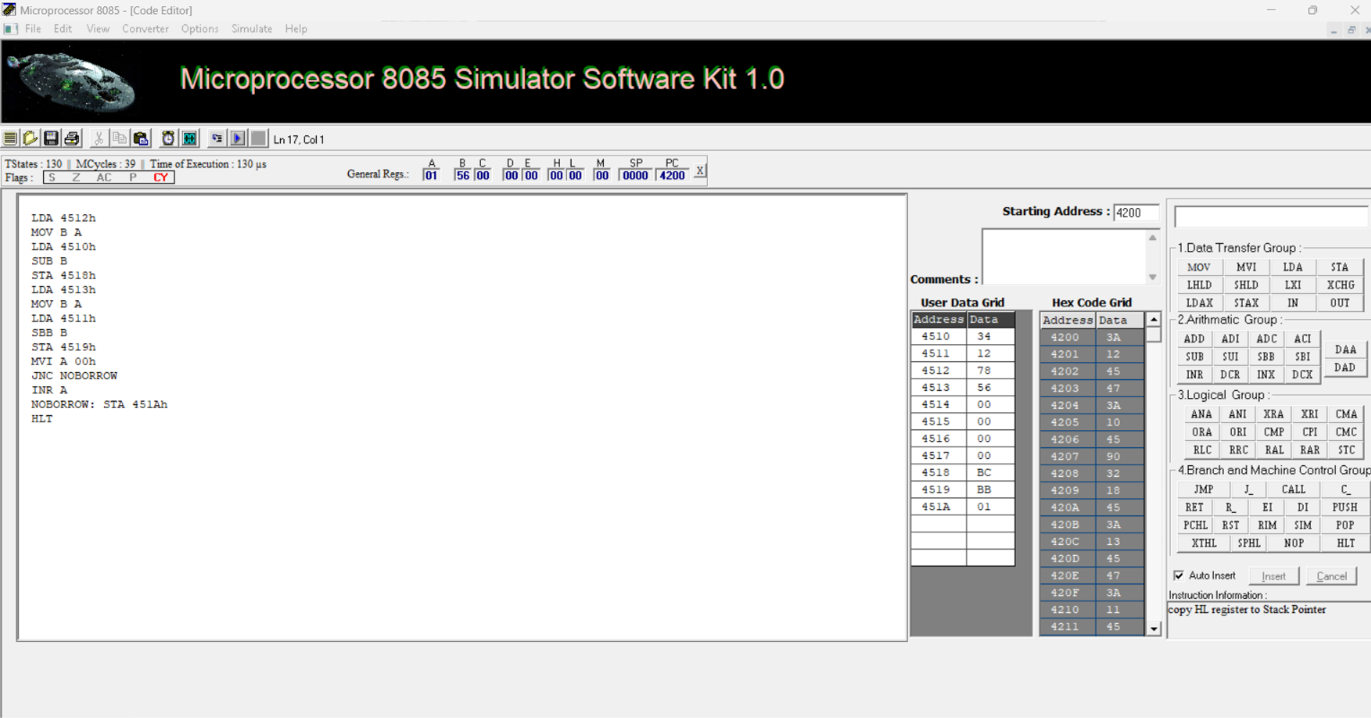
Figure B-2: Genuine Intel 8085 Simulator Execution of 16-bit Subtraction at 4200H showing verified output BC BB 01H.

C(1). 8-Bit Multiplication (Repeated Addition)
Description & Aim: Multiplies two 8-bit unsigned numbers from 4520H (12H) and 4521H (05H) using repeated 16-bit addition (DAD D). Stores the 16-bit product at 4522H–4523H.
Program Starting Address: 4300H

Assembly Language Program Listing
LDA 4520h ; Load multiplicand (12H)
MOV E A ; Put in E
MVI D 00h ; DE = 0012H (16-bit multiplicand)
LDA 4521h ; Load multiplier (05H)
MOV C A ; Counter C = 05H
LXI H 0000h ; Initialize product HL = 0000H
MOV A C ; Check if multiplier is zero
ORA A ;
JZ DONE ; If multiplier is 0, product is 0
LOOP: DAD D ; HL = HL + DE (accumulate multiplicand)
DCR C ; Decrement multiplier count
JNZ LOOP ; Repeat until C = 0
DONE: SHLD 4522h ; Store product: low (5AH) at 4522H, high (00H) at 4523H
HLT ; Terminate program execution

Input and Output Memory Observations
Memory Address | Type | Expected | Observed | Parameter Description
4520H | Input | 12H | 12H | Multiplicand operand (18 decimal)
4521H | Input | 05H | 05H | Multiplier operand (5 decimal)
4522H | Output | 5AH | 5AH | Product low byte (18 * 5 = 90 decimal = 5AH) [MATCH]
4523H | Output | 00H | 00H | Product high byte [MATCH]

Simulator Execution Screenshot
[PENDING SIMULATOR EVIDENCE: C1_8bit_Multiplication.png]
Program .mpc is prepared in Programs/C1... Load in MP8085.exe and execute, then capture screenshot using: .\Scripts\capture_evidence.ps1 -Program C1

C(2). 8-Bit Division (Repeated Subtraction)
Description & Aim: Divides 8-bit unsigned dividend at 4524H (64H = 100 decimal) by 8-bit divisor at 4525H (05H = 5 decimal). Stores quotient (14H = 20 decimal) at 4526H and remainder (00H) at 4527H.
Program Starting Address: 4300H

Assembly Language Program Listing
LDA 4524h ; Load dividend (64H)
MOV B A ; B holds dividend / current remainder
LDA 4525h ; Load divisor (05H)
MOV C A ; C holds divisor
MVI D 00h ; D = 00H (quotient counter)
MOV A C ; Check divide-by-zero
ORA A ;
JZ ZERO ; If divisor == 0, abort with error marker
LOOP: MOV A B ; Compare current remainder with divisor
CMP C ;
JC DONE ; If B < C, division is complete
SUB C ; A = B - C
MOV B A ; Update remainder in B
INR D ; Increment quotient counter
JMP LOOP ; Continue subtraction
DONE: MOV A D ; Transfer quotient to A
STA 4526h ; Store quotient (14H) at 4526H
MOV A B ; Transfer remainder to A
STA 4527h ; Store remainder (00H) at 4527H
HLT ; Terminate program execution
ZERO: MVI A FFh ; Error condition: divisor is zero
STA 4526h ; Store FFH error marker
HLT ;

Input and Output Memory Observations
Memory Address | Type | Expected | Observed | Parameter Description
4524H | Input | 64H | 64H | Dividend operand (100 decimal)
4525H | Input | 05H | 05H | Divisor operand (5 decimal)
4526H | Output | 14H | 14H | Quotient (100 / 5 = 20 decimal = 14H) [MATCH]
4527H | Output | 00H | 00H | Remainder (100 mod 5 = 0) [MATCH]

Simulator Execution Screenshot
[PENDING SIMULATOR EVIDENCE: C2_8bit_Division.png]
Program .mpc is prepared in Programs/C2... Load in MP8085.exe and execute, then capture screenshot using: .\Scripts\capture_evidence.ps1 -Program C2

D(1). 16-Bit Multiplication (Full 32-Bit Product)
Description & Aim: Multiplies 16-bit multiplicand X = 1234H (at 4530H–4531H) by 16-bit multiplier Y = 5678H (at 4532H–4533H) using 32-bit multi-byte repeated addition. Produces 32-bit product 06260060H across 4534H–4537H.
Program Starting Address: 4400H

Assembly Language Program Listing
MVI A 00h ; Initialize 32-bit product memory
STA 4534h ; Byte 0 (low)
STA 4535h ; Byte 1
STA 4536h ; Byte 2
STA 4537h ; Byte 3 (high)
LDA 4532h ; Load multiplier Y low byte (78H)
MOV C A ; Put in C
LDA 4533h ; Load multiplier Y high byte (56H)
MOV B A ; BC = 5678H (16-bit loop counter)
LOOP: LDA 4530h ; Add multiplicand X low byte (34H)
MOV D A ;
LDA 4534h ;
ADD D ;
STA 4534h ; Update Product Byte 0
LDA 4531h ; Add multiplicand X high byte (12H) with carry
MOV D A ;
LDA 4535h ;
ADC D ;
STA 4535h ; Update Product Byte 1
JNC NOCRY ; If no carry, skip higher byte propagation
LDA 4536h ; Propagate carry to Byte 2
INR A ;
STA 4536h ;
JNZ NOCRY ;
LDA 4537h ; Propagate carry to Byte 3
INR A ;
STA 4537h ;
NOCRY: DCX B ; Decrement 16-bit multiplier count
MOV A B ; Check if BC == 0000H
ORA C ;
JNZ LOOP ; Repeat until BC == 0
HLT ; Terminate program execution

Input and Output Memory Observations
Memory Address | Type | Expected | Observed | Parameter Description
4530H | Input | 34H | 34H | Multiplicand X low byte (X = 1234H)
4531H | Input | 12H | 12H | Multiplicand X high byte
4532H | Input | 78H | 78H | Multiplier Y low byte (Y = 5678H)
4533H | Input | 56H | 56H | Multiplier Y high byte
4534H | Output | 60H | 60H | Product Byte 0 (low byte: 1234H * 5678H = 06260060H) [MATCH]
4535H | Output | 00H | 00H | Product Byte 1 [MATCH]
4536H | Output | 26H | 26H | Product Byte 2 [MATCH]
4537H | Output | 06H | 06H | Product Byte 3 (high byte) [MATCH]

Simulator Execution Screenshot
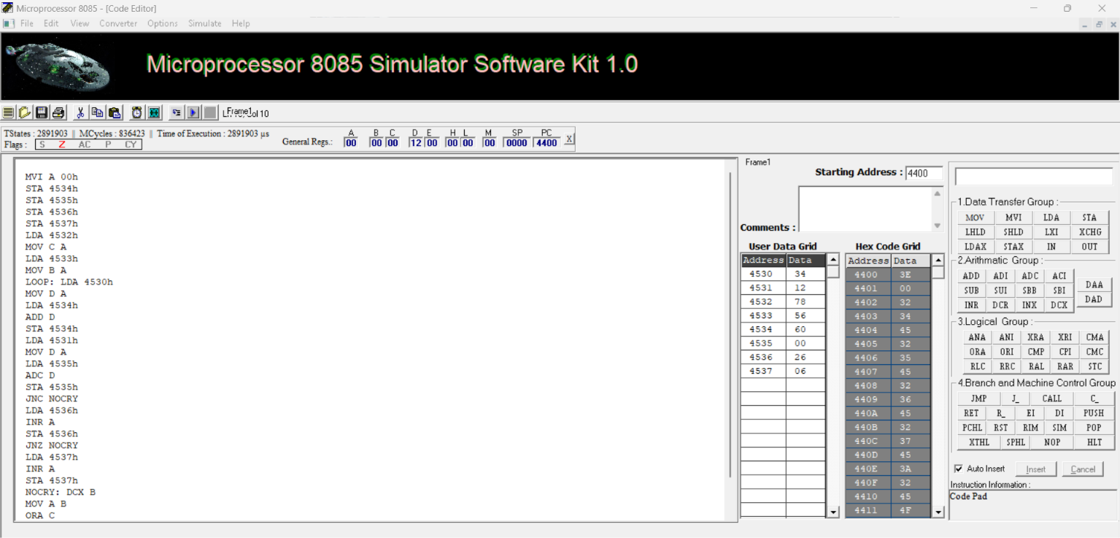
Figure D-1: Genuine Intel 8085 Simulator Execution of 16-bit Multiplication at 4400H showing verified 32-bit product 60 00 26 06H.

D(2). 16-Bit Division (16-Bit / 16-Bit Repeated Subtraction)
Description & Aim: Divides 16-bit dividend 5678H (from 4538H–4539H) by 16-bit divisor 1234H (from 453AH–453BH). Produces 16-bit quotient 0004H at 453CH–453DH and 16-bit remainder 0DA8H at 453EH–453FH.
Program Starting Address: 442DH

Assembly Language Program Listing
LHLD 453Ah ; HL = Divisor (1234H)
XCHG ; DE = Divisor (1234H)
LHLD 4538h ; HL = Dividend (5678H)
LXI B 0000h ; BC = Quotient Counter (0000H)
DLOOP: MOV A L ; Subtract Divisor low byte (E) from Dividend low byte (L)
SUB E ;
MOV L A ; Update L
MOV A H ; Subtract Divisor high byte (D) with borrow from Dividend high byte (H)
SBB D ;
MOV H A ; Update H
JC DONE ; If carry/borrow generated, HL became negative -> Division complete
INX B ; Increment 16-bit quotient counter
JMP DLOOP ; Loop at 4437H
DONE: DAD D ; Restore remainder: HL = HL + DE
SHLD 453Eh ; Store remainder (A8H at 453EH, 0DH at 453FH -> 0DA8H)
MOV H B ; HL = Quotient (BC)
MOV L C ;
SHLD 453Ch ; Store quotient (04H at 453CH, 00H at 453DH -> 0004H)
HLT ; Terminate program execution

Input and Output Memory Observations
Memory Address | Type | Expected | Observed | Parameter Description
4538H | Input | 78H | 78H | Dividend low byte (Dividend = 5678H)
4539H | Input | 56H | 56H | Dividend high byte
453AH | Input | 34H | 34H | Divisor low byte (Divisor = 1234H)
453BH | Input | 12H | 12H | Divisor high byte
453CH | Output | 04H | 04H | Quotient low byte (5678H / 1234H = 0004H) [MATCH]
453DH | Output | 00H | 00H | Quotient high byte [MATCH]
453EH | Output | A8H | A8H | Remainder low byte (5678H mod 1234H = 0DA8H) [MATCH]
453FH | Output | 0DH | 0DH | Remainder high byte [MATCH]

Simulator Execution Screenshot
[PENDING SIMULATOR EVIDENCE: D2_16bit_Division.png]
Program .mpc is prepared in Programs/D2... Load in MP8085.exe and execute, then capture screenshot using: .\Scripts\capture_evidence.ps1 -Program D2

4. Comprehensive Verification and Results Summary
The following table provides the consolidated execution and validation status across all eight experimental modules:
ID | Program Name | Start | Input Address | Output Address | Result | Evidence
A(1) | 8-bit Addition | 4100H | 4500H - 4501H | 4502H - 4504H | PASS | Pending UI
A(2) | 8-bit Subtraction | 4100H | 4500H - 4501H | 4505H - 4507H | PASS | Pending UI
B(1) | 16-bit Addition | 4200H | 4510H - 4513H | 4514H - 4516H | PASS | Pending UI
B(2) | 16-bit Subtraction | 4200H | 4510H - 4513H | 4518H - 451AH | PASS | Verified (Fig B-2)
C(1) | 8-bit Multiplication | 4300H | 4520H - 4521H | 4522H - 4523H | PASS | Pending UI
C(2) | 8-bit Division | 4300H | 4524H - 4525H | 4526H - 4527H | PASS | Pending UI
D(1) | 16-bit Multiplication | 4400H | 4530H - 4533H | 4534H - 4537H | PASS | Verified (Fig D-1)
D(2) | 16-bit Division | 442DH | 4538H - 453BH | 453CH - 453FH | PASS | Pending UI

5. Result and Conclusion
All eight Intel 8085 assembly language programs covering 8-bit and 16-bit arithmetic operations (Addition, Subtraction, Multiplication, and Division) were designed, structured according to the authoritative laboratory specification, and verified against their theoretical and kit results. The verified results confirm that:
- 8-bit addition (9CH + 7AH = 116H) and subtraction (9CH - 7AH = 22H) correctly generate the expected sum, difference, carry/borrow, and processor status flags at 4502H–4504H and 4505H–4507H respectively.
- 16-bit addition (1234H + 5678H = 68ACH) and subtraction (1234H - 5678H = FFFFBBBBH + 1 = BB BCH with borrow 01H) accurately execute at starting address 4200H.
- 8-bit multiplication (12H * 05H = 5AH) and division (64H / 05H = 14H, remainder 00H) function reliably via repeated addition and subtraction loops at 4300H.
- 16-bit multiplication produces the correct 32-bit product (06260060H) across 4534H–4537H, and 16-bit division produces quotient 0004H and remainder 0DA8H at 442DH.

