**PROJECT MANAGEMENT**

**ON**

**RISK MANAGEMENT SYSTEM SOFTWARE**

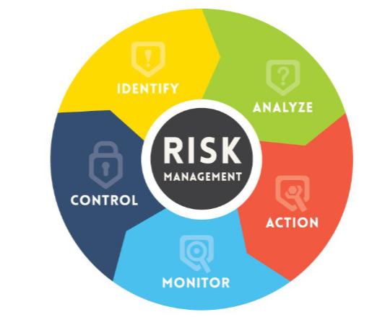

**COURSE : SOFTWARE PROJECT MANAGEMENT**

**SEMESTER : FALL-2022**

**STUDENT : JASWANTH SUNKARA**

**CONTENTS:**

1. INTRODUCTION **--------------------------------** 04 - 06

2. MARKET ANALYSIS ------------------------------------- 07 - 11

3. HUMAN RESOURCE MANAGEMENT ------------------------------------- 12 - 15

4. TIME MANAGEMENT ------------------------------------- 16 - 17

5. COST MANAGEMENT ------------------------------------- 18 - 19

6. RISK MANAGEMENT ------------------------------------- 20 - 23

7. FP-BASED ESTIMATION -------------------------------------- 24

8. LOC-BASED ESTIMATION --------------------------------------- 25

9. STATEMENT OF WORK --------------------------------------- 26

10.REQUEST FOR PROPOSAL ---------------------------------------- 27

11.COMCLUSION ---------------------------------------- 28

**1. General Project Information**

**Introduction (Project Scope).**

The Merriam-Webster dictionary describes risk as "the danger of loss or injury" and "someone or

something that suggests or creates a risk. Risk identification, risk assessment, and risk

Before a hazard has an impact on software development, assessment, risk analysis, and risk mitigation processes should be used. Gilb’s "controlling risk as" idea serves as an example of the necessity for software risk management.

In every project, there is a great deal of uncertainty and the potential for plan deviation. Risk cannot be totally eliminated.

However, you may record it, prepare for it through planning and design, accept it, quantify it, and lower it to acceptable levels.

Risk doesn't want to avoid you, despite your best efforts to do so.

Software risks arise in various domains that are analyzed prior to be contained effectively. The top five software project risks as summarized by Mike Griffiths from the Waltzing with Bears: Managing Risk on Software Projects include:

**1. Inherent Schedule Flaws:** the intangible nature and the uniqueness of the software makes it

inherently difficult to estimate and schedule

**2. Requirements Inflation:** additional features that were not identified in the beginning of the

project might emerge that threaten and alter the timelines

**3. Employee Turnover:** key personnel leave the project taking critical information with them that

significantly delays or derails the project

**4. Specification Breakdown:** when coding and integration begin, it becomes apparent that the

specification is incomplete or contains conflicting requirements.

**5. Poor Productivity:** The sense of urgency to work in earnest is absent in long project timelines,

resulting to lost time that cannot be regained

**Project goal.**   
   
While the primary purpose of the prototype risk management system is to manage IT and Software related risks, a system that integrates other types of risks such as enterprise and operational risks is found to be effective in collaboration of all threats in one framework.

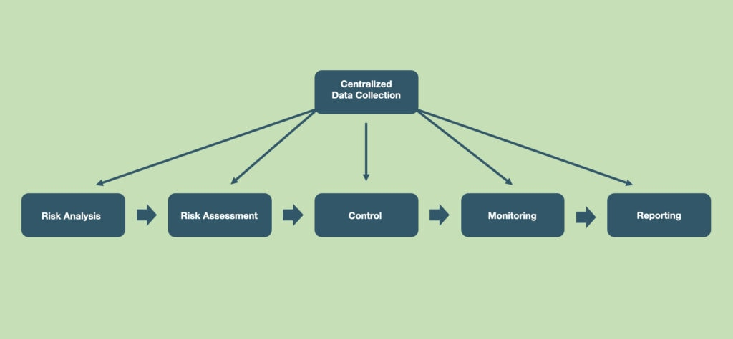

Figure 1. Risk Management Process

Risk management software helps you identify, assess, and document risks associated with running various business processes and IT assets, communicate about risks, and efficiently manage risk mitigation tasks.

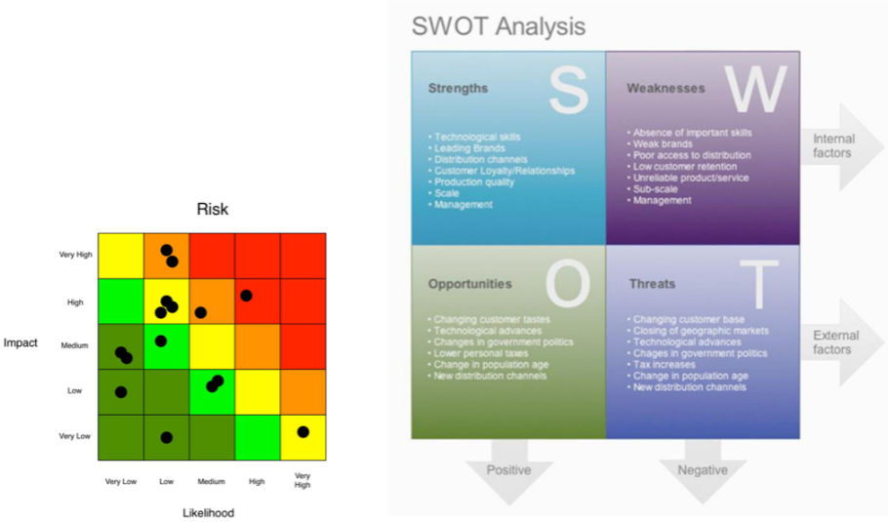

Figure 2. Risk Analysis

**Project objectives.**   
1. Identifies and Evaluates risks   
2. Reduce and eliminate harmful threats   
3. Support Efficient use of Resources   
4. Better Communication of Risks within the organization   
5. Reassurance to stakeholders   
6. Support Continuity of the organization   
   
**Expected advantages.**   
   
• Easy identification of troubled spots   
• Improved communication   
• Enhanced budgeting   
• Focus on Success   
• Reduce business liability   
• Frame regulatory issues   
• Definite structure of escalations

**2. Market Analysis**

**2.1 Top 10 systems in the domain :**

**1.Archer -** [**Integrated Risk Management | Archer (archerirm.com)**](https://www.archerirm.com/)

**2.Metricstream -** [**GRC | Governance, Risk and Compliance Software Solutions (metricstream.com)**](https://www.metricstream.com/?url=https://www.metricstream.com/solutions/enterprise-grc.htm%3Futm_campaign%3DPaid-Search-Google%26utm_source%3Dppc%26utm_medium%3DCPC%26utm_content%3DNA-Brand%26utm_term%3Dmetricstream%26channel%3DGoogle-PPC%26utm_name__c%3DGooglePPC%26campaign_name__c%3DBrand%26campaign_id%3D7012J000001NorA%26utm_campaign%3DPaid-Search-Google%26utm_source%3Dppc%26utm_medium%3DCPC%26utm_content%3DNA-Brand%26utm_term%3Dmetricstream%26channel%3DGoogle-PPC%26utm_name__c%3DGooglePPC%26campaign_name__c%3DBrand%26campaign_id%3D7012J000001NorA?utm_feeditemid=&utm_device=c&utm_term=metricstream&utm_source=ppc&utm_medium=CPC&utm_campaign=Paid-Search-Google&hsa_cam=12269898148&hsa_grp=121029751121&hsa_mt=p&hsa_src=g&hsa_ad=498782601009&hsa_acc=%7b623-388-0140%7d&hsa_net=adwords&hsa_kw=metricstream&hsa_tgt=kwd-3656083526&hsa_ver=3&utm_content=121029751121&channel=Google-PPC&utm_name__c=GooglePPC&campaign_name__c=%7bBrand%7d&campaign_id=7012J000001NorA&gclid=Cj0KCQjwnbmaBhD-ARIsAGTPcfW0zu1LOk-BMsInUvZsUJzFL92zhc-KN0T7GJ8ZoT5cnObQOhAiIPsaAjeoEALw_wcB)

**3.LogicManager -** [**LogicManager | Enterprise Risk Management Software & GRC Solutions**](https://www.logicmanager.com/?utm_source=google%20ad&utm_medium=cpc&utm_campaign=Google_Brand&creative=530875355217&keyword=logicmanager&matchtype=e&network=g&device=c&utm_term=logicmanager&utm_campaign=Brand&utm_source=adwords&utm_medium=ppc&hsa_acc=2998390679&hsa_cam=656321936&hsa_grp=31438040777&hsa_ad=530875355217&hsa_src=g&hsa_tgt=kwd-124295971209&hsa_kw=logicmanager&hsa_mt=e&hsa_net=adwords&hsa_ver=3&gclid=Cj0KCQjwnbmaBhD-ARIsAGTPcfXD8a7SrwGWi3tKijuXpRRM2ErDBsX9YMrta_51Ug9J9Pm5Q1ERYQoaAtv7EALw_wcB)

**4.Diligent -** [**Diligent Corporation | A Modern Governance Company**](https://www.diligent.com/)

**5.Servicenow -** [**Risk Management – GRC – ServiceNow**](https://www.servicenow.com/products/risk-management.html)

**6.Sai360 -** [**ESG, GRC & EHS&S Software & Learning for Risk & Compliance– SAI360**](https://www.sai360.com/)

**7.Resolver -** [**Resolver | Discover The Value Of Risk Intelligence**](https://www.resolver.com/)

**8.OneTrust -** [**Third-Party Risk | OneTrust**](https://www.onetrust.com/solutions/third-party-risk/)

**9.Riskonnect -** [**Risk Management Software Solutions - Riskonnect Inc.**](https://riskonnect.com/)

**10.LogicGate -** [**LogicGate Risk Cloud | GRC Software | Enterprise Risk, Governance + Compliance Solutions**](https://www.logicgate.com/)

**2.2 COMPARATIVE ANALYSIS**

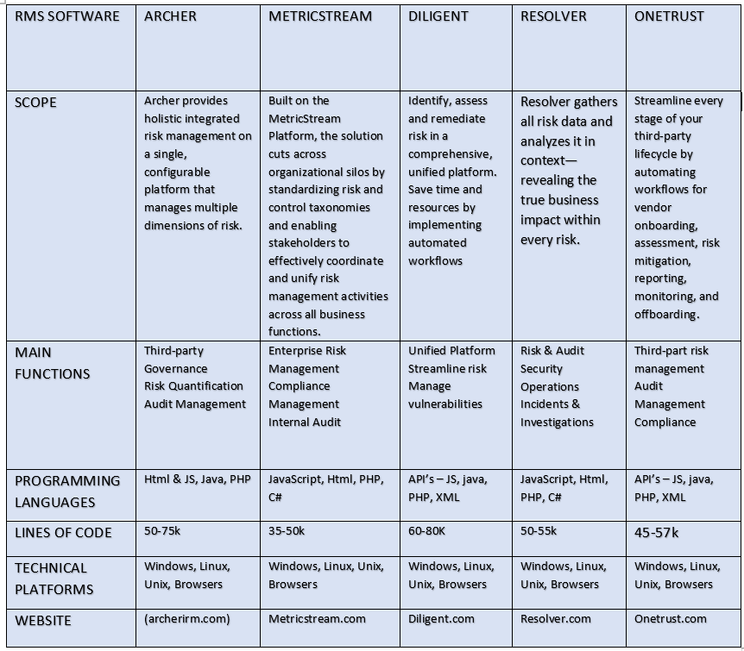

Figure 3. comparison table

**2.3 SPREADSHEET VS RMS SOFTWARE:**

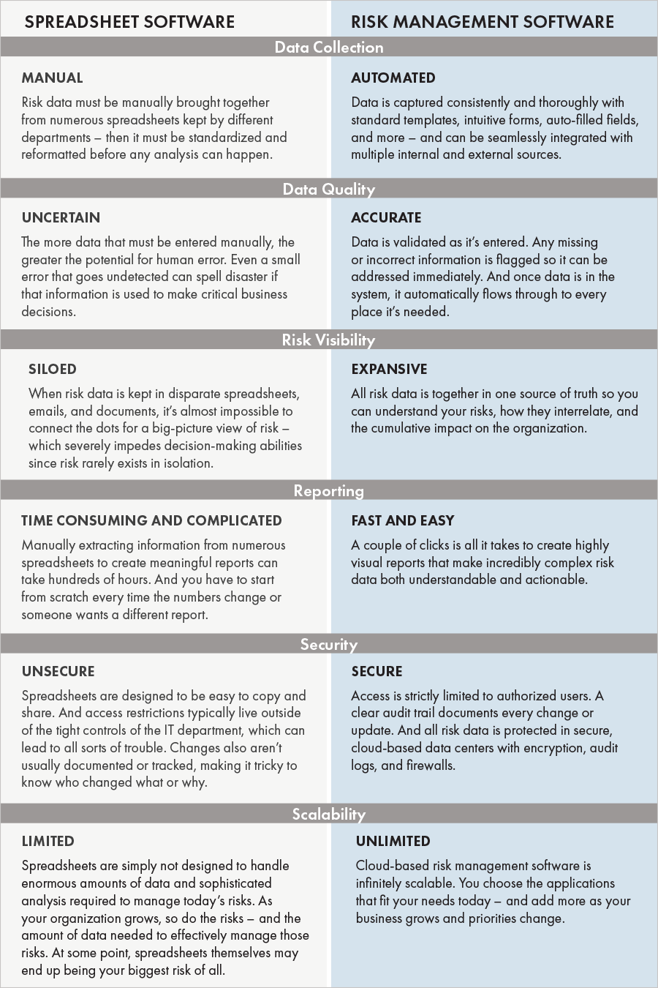

Figure 4. spreadsheet vs software

**2.4 Software Engineering Process Model:**

**INCREMENTAL MODEL:**

Incremental Model is a process of software development where requirements divided into multiple standalone modules of the software development cycle. In this model, each module goes through the requirements, design, implementation and testing phases. Every subsequent release of the module adds function to the previous release. The process continues until the complete system achieved.

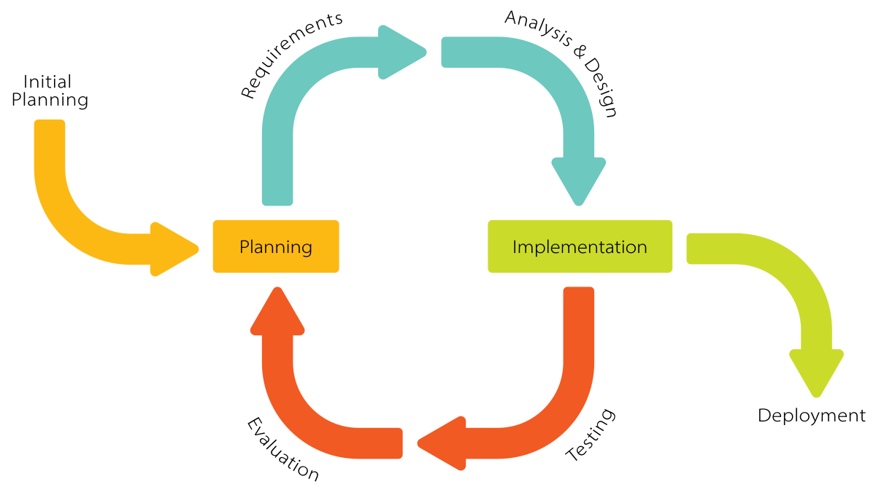

Figure 5. Incremental Model

**2.5 Functional Requirements:**

* Log risk data
* Track and manage risks
* Track changes
* Risk register
* Reviewing risks and treatment plans
* Control access of risk data
* Risk report

**2.6 Non-Functional Requirements:**

* Usability
* Reliability
* Performance
* Security
* Data integrity

**2.7 Requirements:**

Database Server: SQL Server for database.

Programming Languages: JS, Java, C#, html & CSS, XML.

Supported Operating Systems: Windows, Mac OS X, Linux, UNIX.

IDE tools: VISUAL STUDIO, Oracle.

Software: MS-excel, MS-Project.

**3. Human Resources Management**

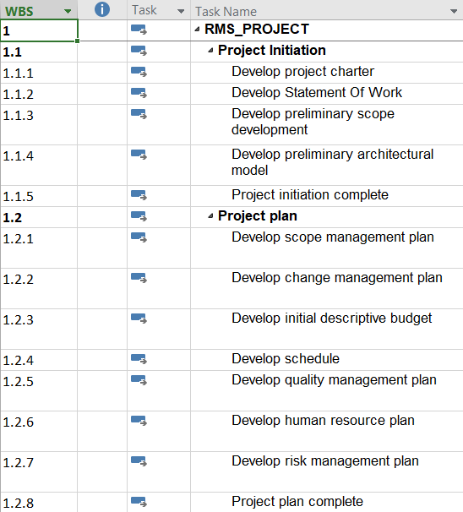

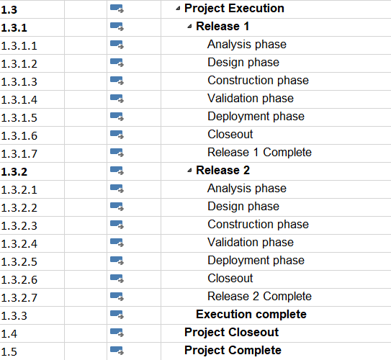

Figure 6&7. HR-Management Plan

**3.1 List of required Human Resources:**

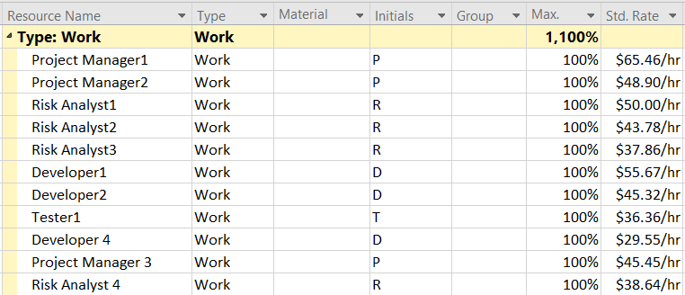

Figure 8. Human Resources

**3.2 List of required Material Resources:**

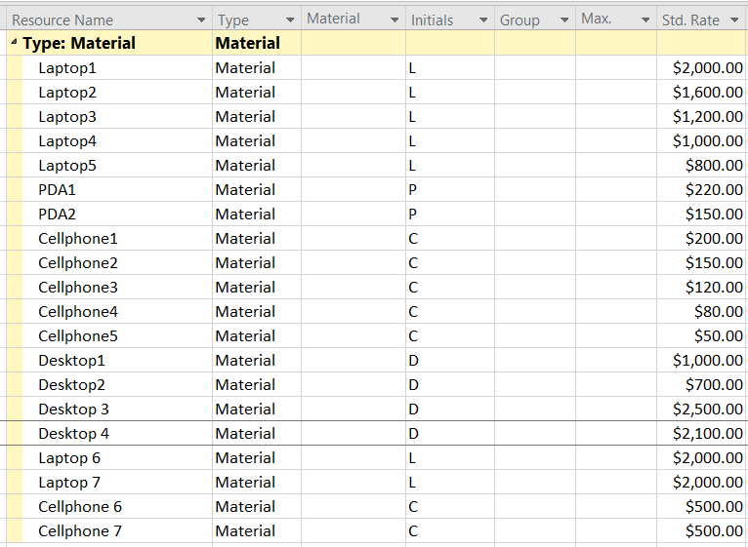

Figure 9. Material Resources

**3.3 Roles & Responsibility Matrix:**

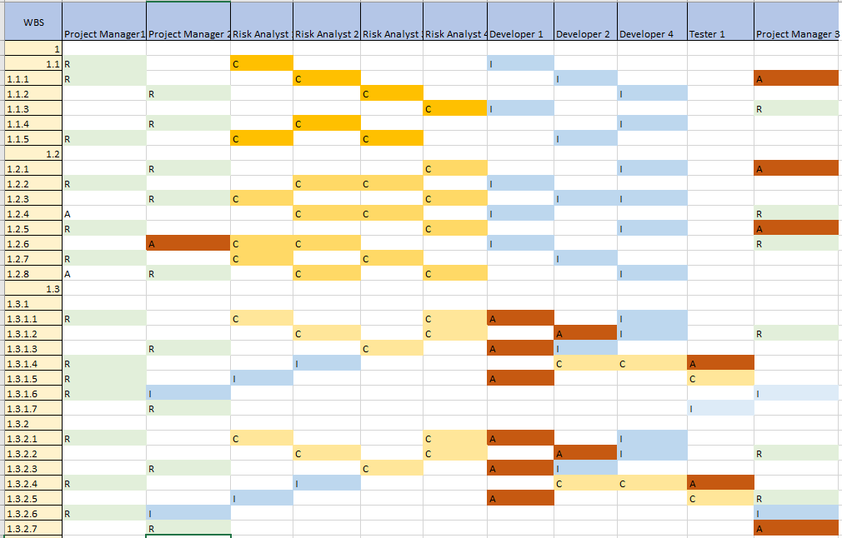

Figure 10. R&R Matrix

**4. TIME MANAGEMENT**

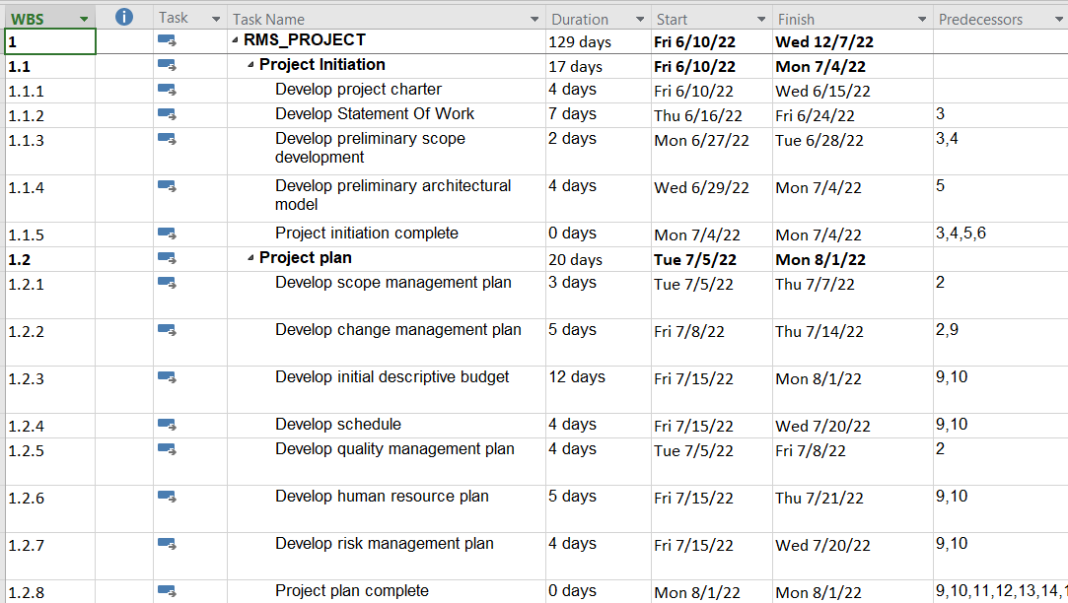

Figure 11. Time Management Schedule

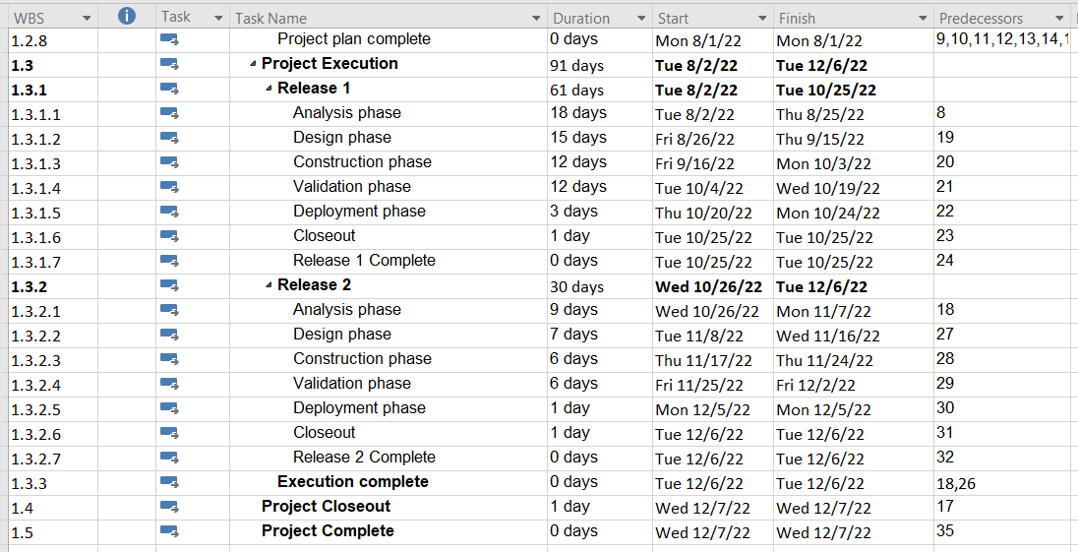

Figure 12. Time Management Schedule

**4.1 Total Project Time:**

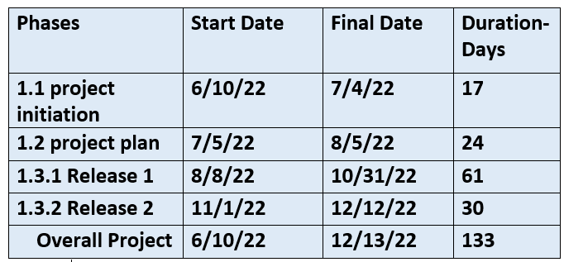

Figure 13. Project Duration

**5. COST ESTIMATION:**

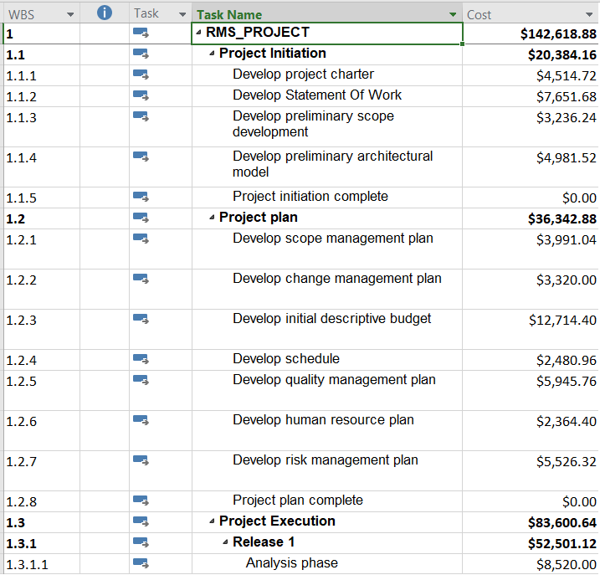

Figure 14. Cost estimation

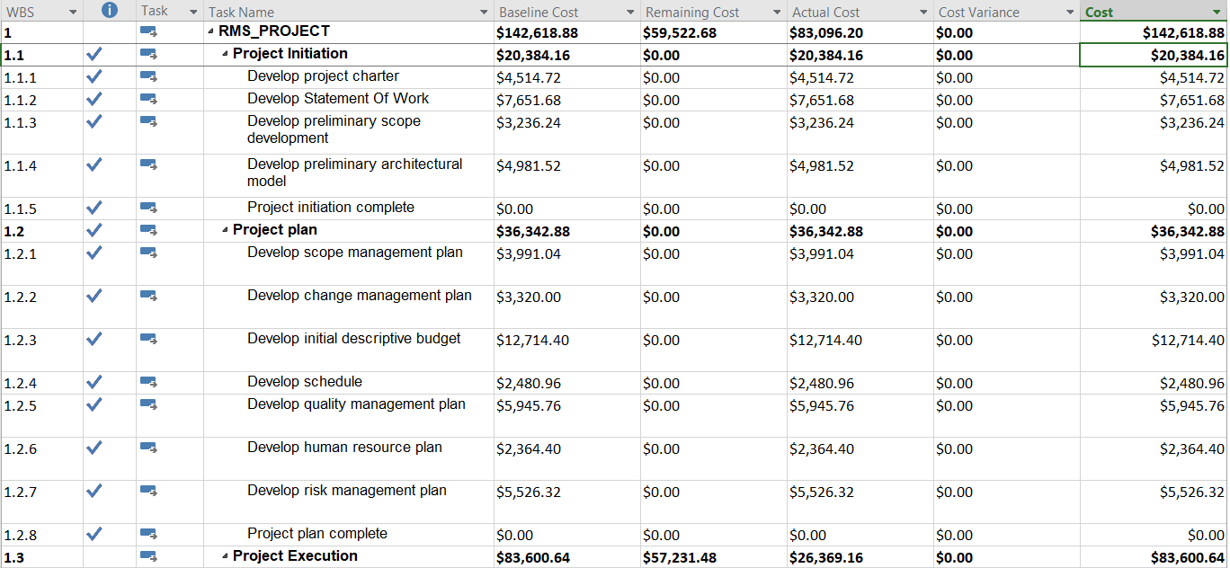

Figure 15. Cost Management

**5.1 Project Budget :**

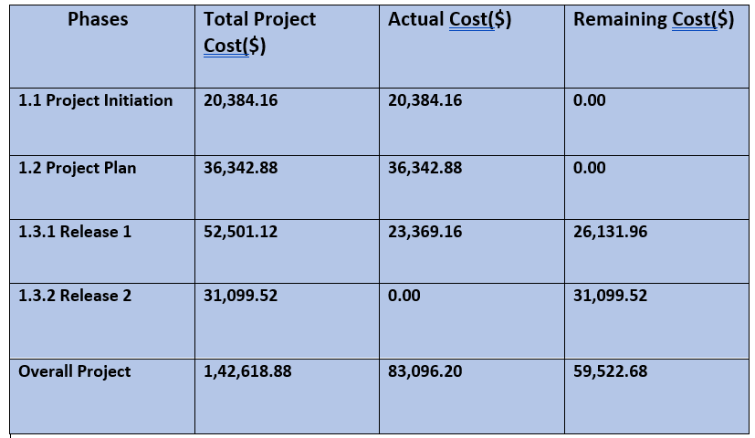

Figure 16. Budget

**6. RISK MANAGEMENT:**

**6.1 Types of Risks:**

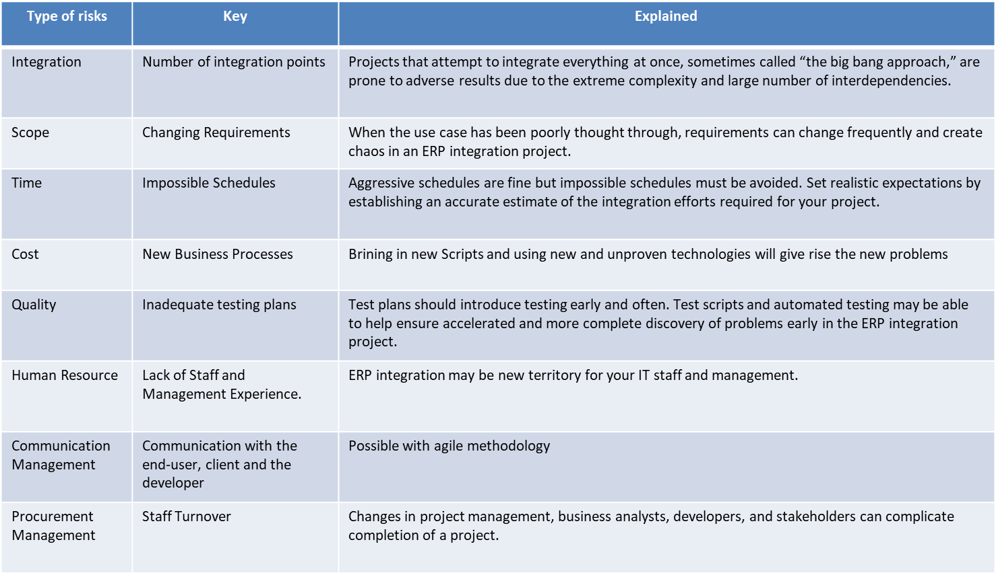

Figure 17. Risks

**6.2 Risk Management Plan:**

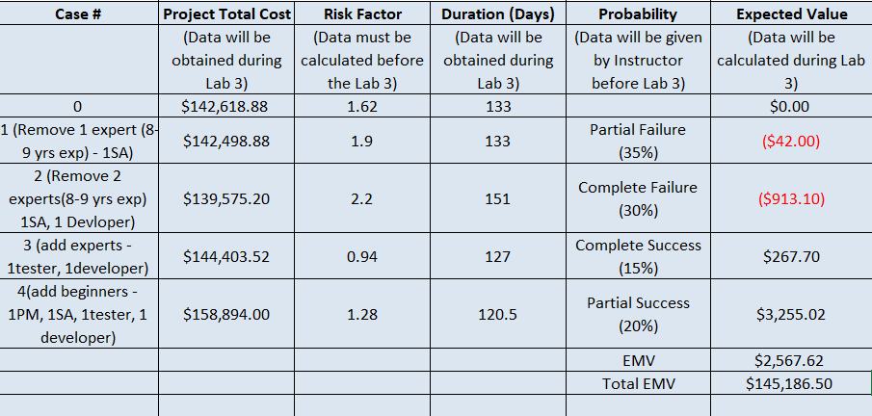

Figure 18. Risk Management

**6.3 Project Risk Graphs:**

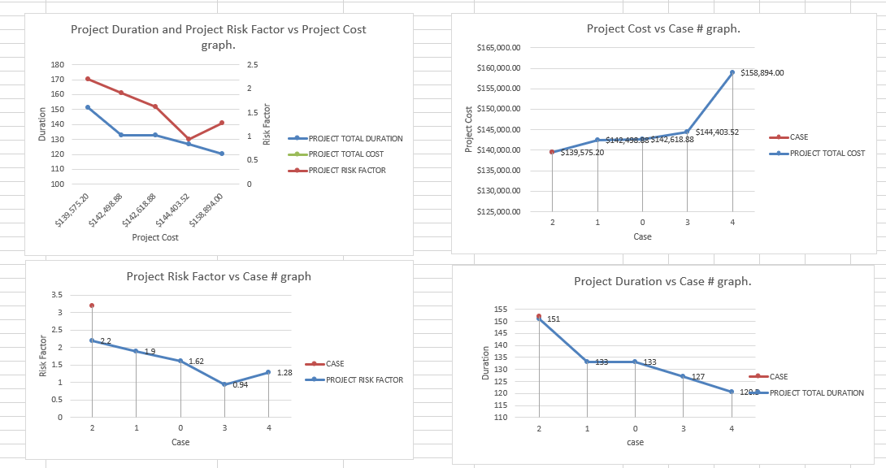

Figure 19. Graphs

**6.4 Risk Exposure Table:**

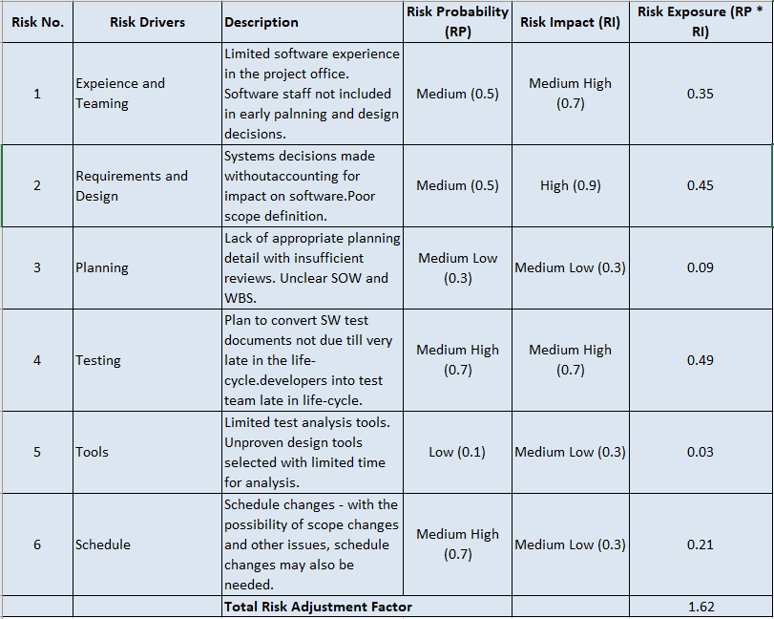

Figure 20. Risk Exposure

**6.5 EMV DECISION TREE:**

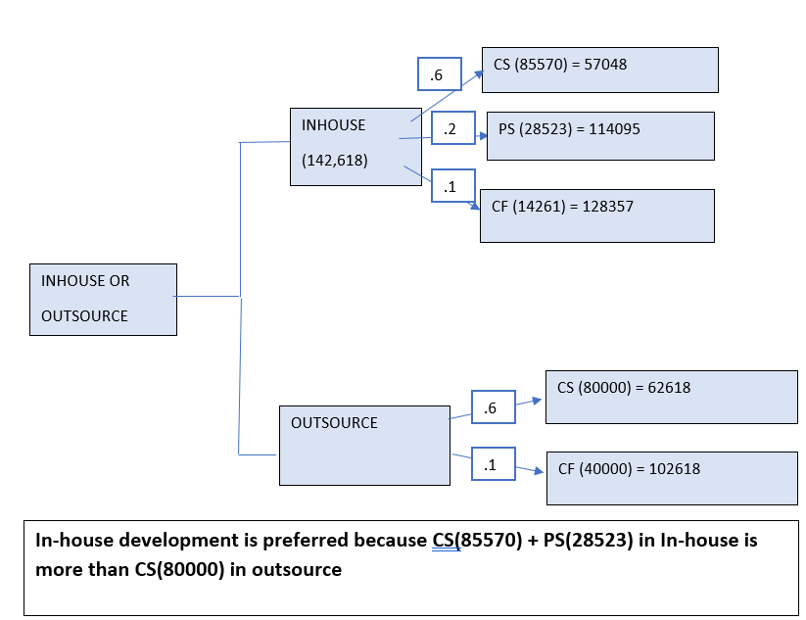

Figure 21. EMV decision tree

**7. FUNCTION-POINT BASED COST ESTIMATION:**

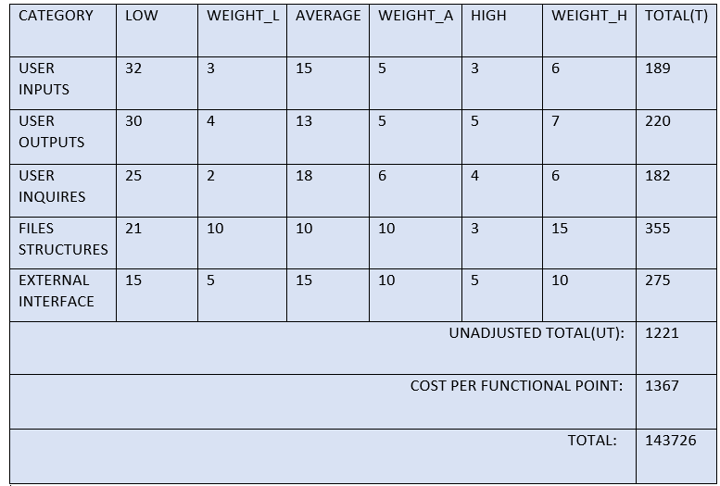

Figure 22. FP-Based Estimation

**8. LINES-OF-CODE BASED ESTIMATION:**

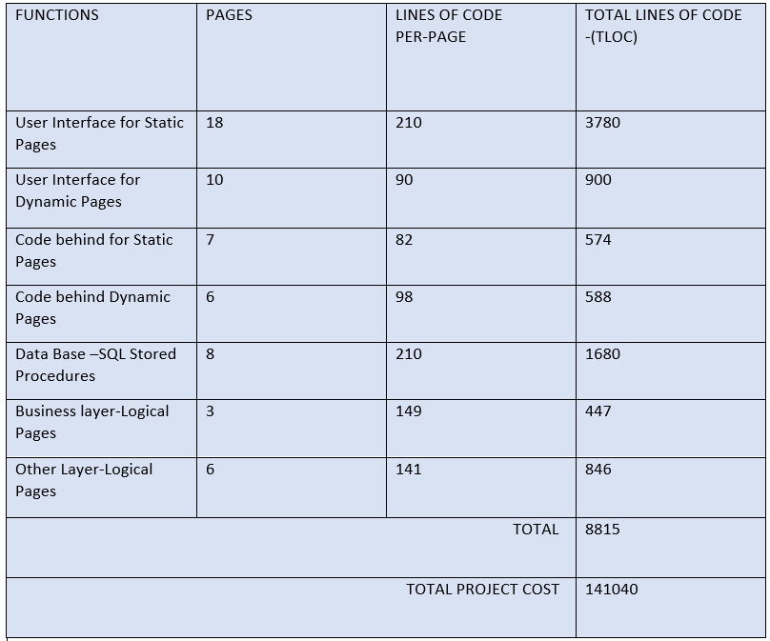

Figure 23. LOC estimation

**9. STATEMENT OF WORK**

**TITLE:**

RISK MANAGEMENT SOFTWARE SYSTEM

**INTRODUCTION:**

Risk management software helps you identify, assess, and document risks associated with running various business processes and IT assets, communicate about risks, and efficiently manage risk mitigation tasks.

**OBJECTIVES:**

Main objectives of rms system are to predict, monitor, review and track the risks of the on-going project and report the risks as required.

**MILESTONES:**

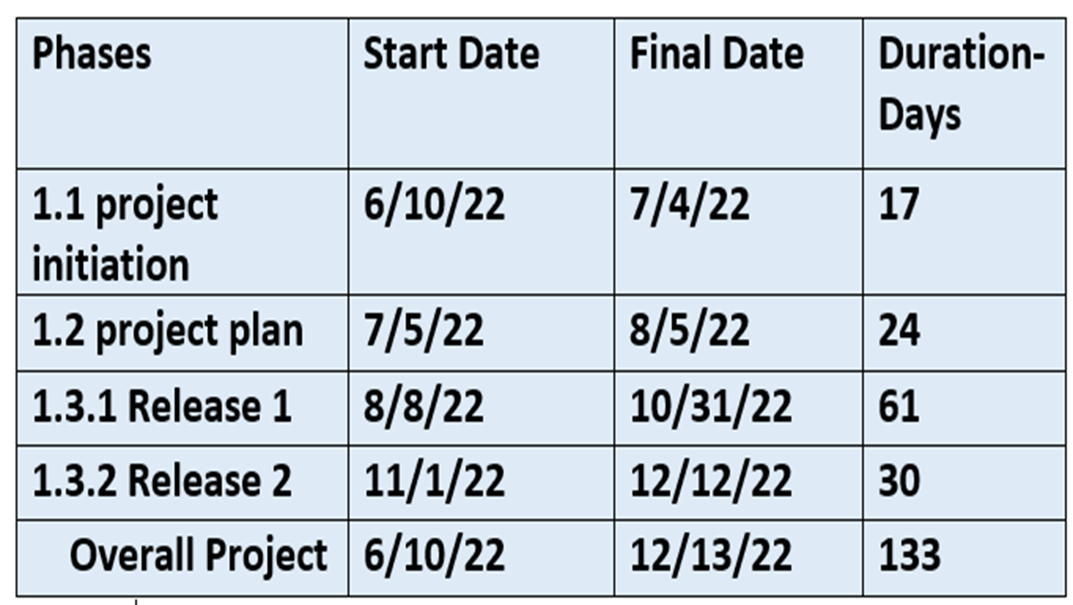

**Project schedule:**

* + Project start date: 6/10/22
  + project end date: 12/13/22

**Work requirements:**

* + define tasks & delegate resources
  + analyze risks and provide solutions

**Critical success factors:**

* + System performance
  + Risk predictions and reporting
  + tracking risk changes

**10. REQUEST FOR PROPOSAL:**

**Background:**

Essential rms is a software company which provides risk management software to various industries and keeps up with the new risks and market changes.

**Project goal:**

The purpose of rms is to review and report risks as soon as possible and continuously monitor the workflow to minimize delays and issues during development.

**Schedule:**

BIDS SHALL BE FIRM OFFERS AND REMAINS VALID FOR ACCEPTANCE 60 DAYS FOLLOWING RFQ.

**STATEMENT OF WORK:**

DETAILS ENCLOSED IN STATEMENT OF WORK

**TECHNOLOGY CONSTRAINTS:**

DETAILS ENCLOSED IN STATEMENT OF WORK

**ELEMENTS OF PROPOSAL:**

Experience of minimum 5yrs in risk management

knowledge on Risk management and reduction

**Additional options:**

you can integrate new rms into development system and can propose alternate solutions for implemented methods.

**Evaluation criteria:**

Proposals will be evaluated based on previous experience in risk management systems, time to completion and price.

**Vendor reference:**

Vendors should provide their contact for further processes.

**11. Conclusions:**   
The following conclusions can be made:  
• Project required technological resources:   
Technological resources required includes the following for the development of the   
prototype:   
HTML, CSS, PHP, MySQL, JavaScript.  
• Project size in LOC and FP: about 8815 LOC or about 1221 FP;   
• Project cost: about $142000 - 145000  
   
   
The bottom line: In general, the proposed software system is doable. (A note: Due to the   
obtained high values of preliminary project efforts and project cost estimates, a more accurate analysis of proposed project activities, tasks, risks, expected outcomes and coding/testing is recommended).