**Jaswanth PULI**

Welcome to my personal profile page!

  
[google link](https://www.google.co.in/) [Projects](https://www.instagram.com/accounts/login/?hl=en) [Contact](https://www.facebook.com/)

I am a web developer with a passion for creating intuitive and user-friendly websites.

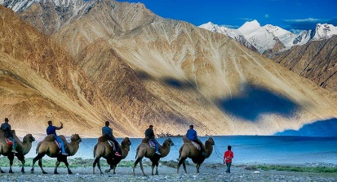

**Projects**

Project 1 : Description of the project.

Project 2 : Description of the project.

**Contact**

Feel free to reach out to me through the following channels:

Contact:john.doe@example.com  
  
© 2024 John Doe