**Inferences based on EDA from Customers, Products and Transactions Data**

1.Spread of Customers across various regions

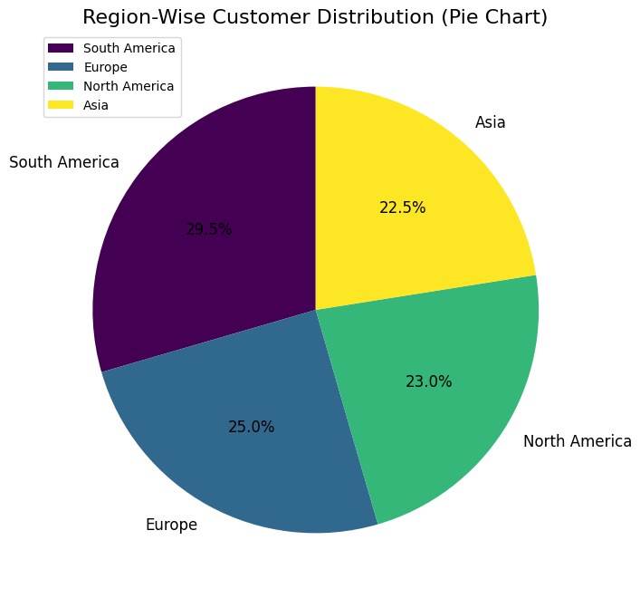

We can observe that customers are spread across 4 different regions i.e South America(29.5%), Europe(25%), North America(23%) and Asia(22.5%). Customers from south America are greater than the average customers.

2.Trends in sales of products

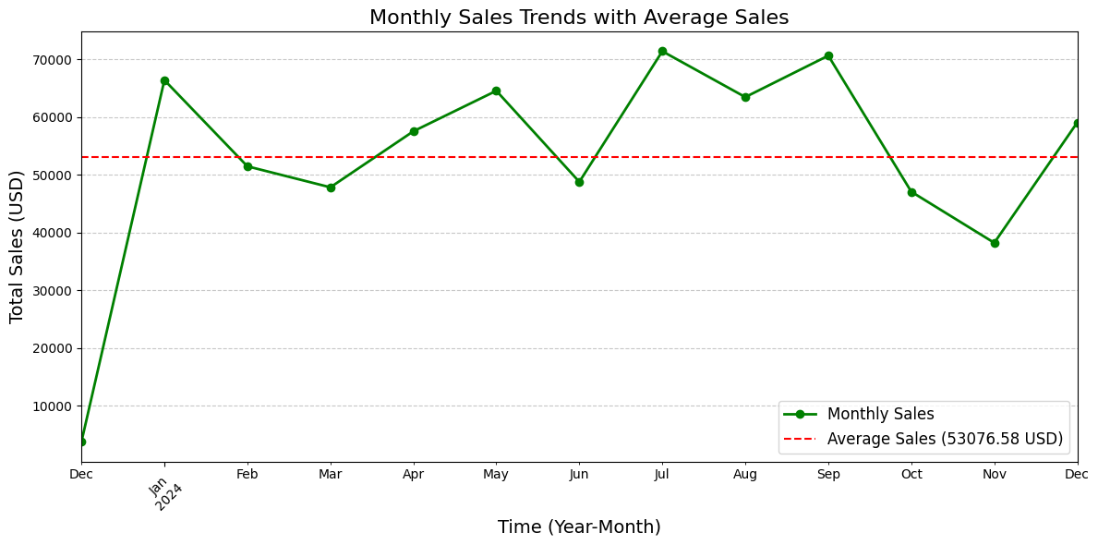

The monthly sales in rainy season ie July, August and September are high. And the South America region has highest sales in these months and “Active wear Smart Watch” the most bought product in this time.

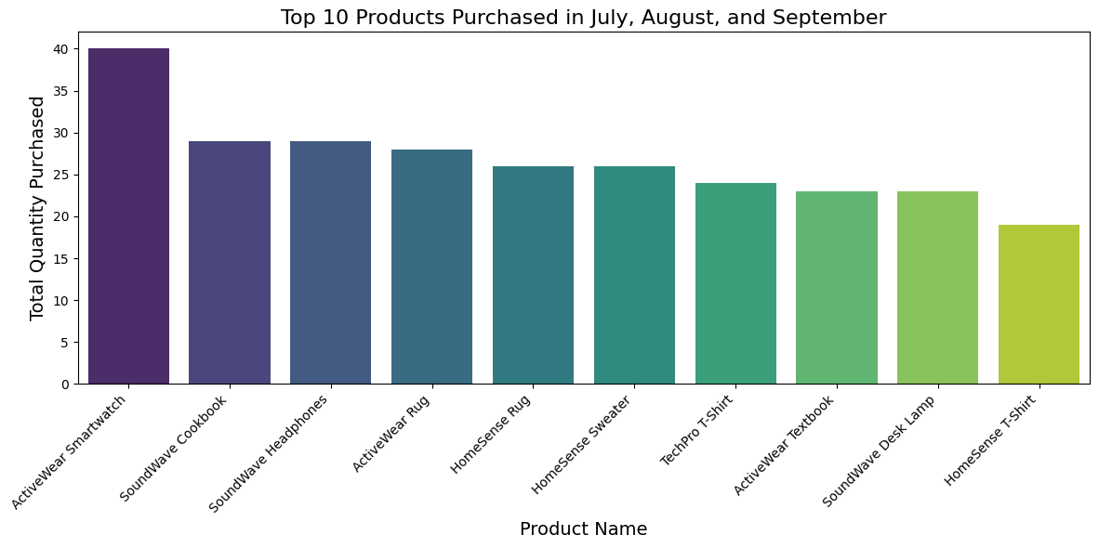

And we can also see Clothing products are widely present in the top-10 products bought in this period.

3.Customer sign-up’s trends

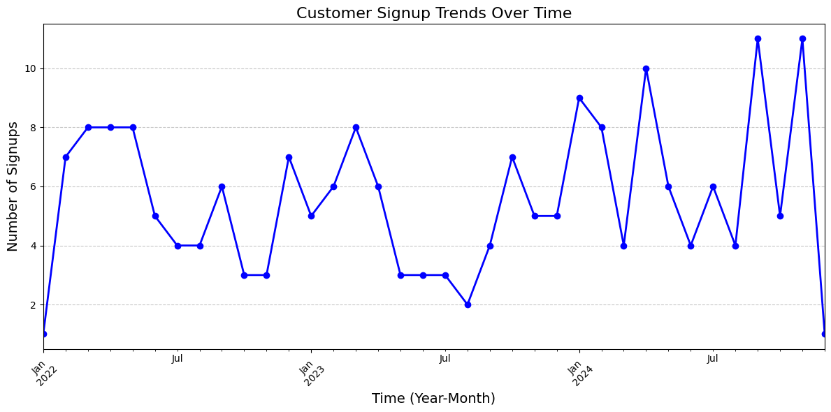

There were highest sign-up’s in September 2024 and November 2024 which is Q4 of the year 2024.

4.Top products by sales volume

Electronic products are the highest bought by volume , especially products like Activewear smartwatch, SoundWave Headphones and Homesense Desk Lamp are the Top-3 frequently bought items.

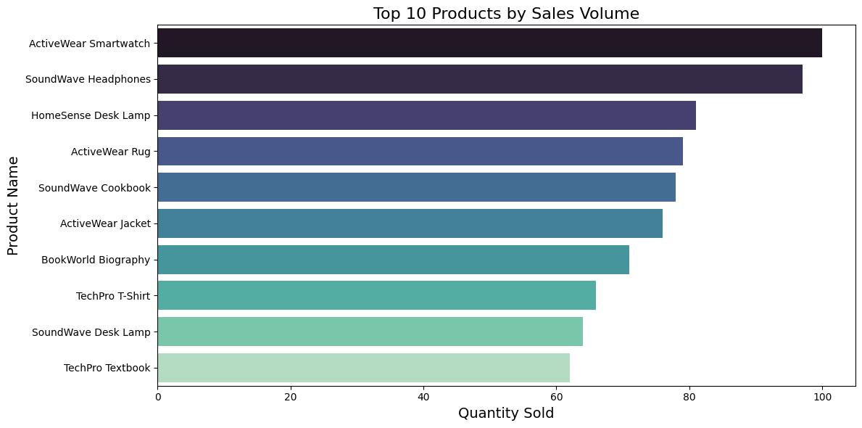

5.Region wise Sales analysis

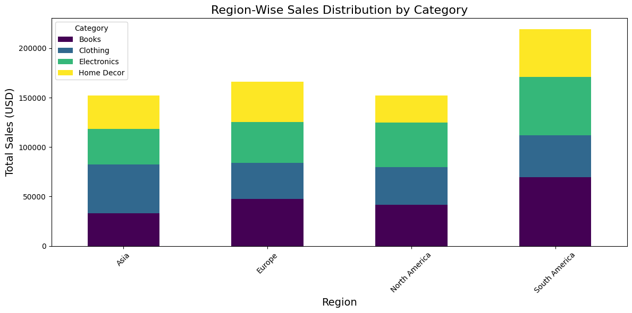

In every region Electronics have the great share of sales , and then in regions like South America and Europe Books have the second major share ,in Asia Clothing products is had the great share of sales.