ADVANCED ALGORITHMS
Project#2
Image compression using SVD
&
Dimensionality reduction using PCA

By
Srinivasa Rao Katta
Jaswanth Datt Meka
Sandeep Kumar banka()

Professor
Dr. Zhong-Hui Duan

Academic Integrity Pledge

Program: - Image compression using SVD and Dimensionality reduction using PCA

Programmer: - Srinivasa Rao Katta, Jaswanth Datt Meka, Sandeep Kumar Banka

Academic Integrity Pledge

- All source code and documentation used in my program is either my original work, or was derived, by me, from the source code published in the text book for this course or presented in class. Any source code in this project that is derived from code published elsewhere is documented as such so the original author receives due credit.

- I have not used source code obtained from another student, or any other unauthorized source, either modified or unmodified. I have not helped another student write their program by providing a printed or electronic copy of my solution.

- I have not discussed coding details about this project with anyone other than my instructor. I understand that I may discuss the concepts of this program with other students, and that another student may help me debug my program. However, the responsibility to write each program belongs solely to the program's author.

- I have violated neither the spirit nor letter of these restrictions.

Srinivasa Rao Katta
Jaswanth Datt Meka
Sandeep Kumar Banka

Signature of Programmer Date: 03/31/2014
INDEX

1 | Introduction |  |  |  | 4
2 | Singular Value Decomposition |  |  |  | 5
3 | Implementation |  |  |  | 6
4 | Test Cases |  |  |  | 6
5 | Graph |  |  |  | 9
6 | References |  |  |  | 9

- Introduction
The main objective of this project is to compress the image using SVD with rank approximation and reducing the dimensions of data set to view the data in low dimensional space.
- Singular Value decomposition
Any m by n matrix A of rank r can be factorized in the form of 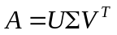where the columns of V are orthogonal eigenvectors of A^{T}A and the columns of U are orthogonal eigenvectors of AA^{T} .
The singular matrix 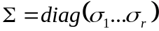 where 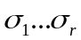are the singular values which are square roots of the eigen values of AA^{T} .
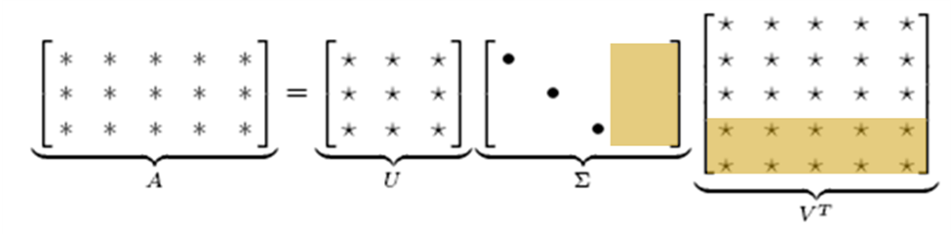
The lower rank of matrix can be used to eliminate the eigen values in S matrix and corresponding columns of U and V.
Steps followed for Image Compression:
- Step1: Converted the ASCII image into Binary
- Step2: Stored the U ,V and singular values in binary format after eliminating the singular values using rank approximation
- Comparing the sizes of images obtained in step1 and 2 using the ROC
Rate of Compression (ROC)=(Original Image size-Approx Image Size)/ Original Image size
- Getting the original Image back from step 1 and approximated image from step2
2.2) Theoretical Analysis
- Since we are storing the input pgm image into binary file, ideally the file size should be N bytes where N=rows*columns of the image.
- 2 bytes for each value present in U and V and the singular values are stored as characters.

2.3) Experimental result (Storage)
Rate of Compression=(Size of Original Image-Size of lower_ranked image)/Size of image(org)
Each of the Image is give input with low rank approximation. As the lower rank of approximation increases, the compression rate actually decreases. Consider Image “dumbu” of size 60 x 66(readings can be seen in the table below).For low rank approximation size of 5, the size is 3960.The compression rate is (15987-1304)/15987=91.84%. We can observe that as image approximation or lower rank increases, compression rate of the image decreases.
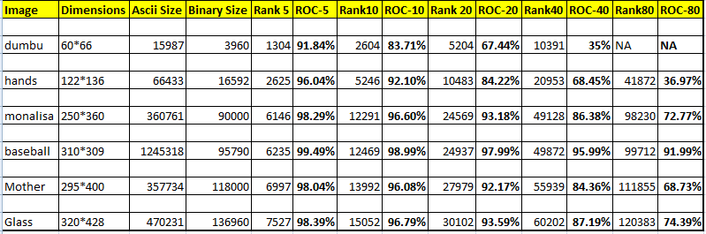
2.4) Test Results (Images with rank)
TEST CASE-1

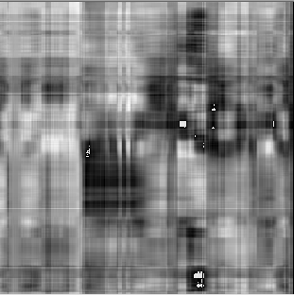
Rank 5
Original Image

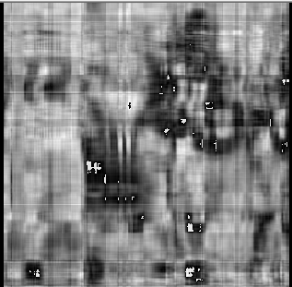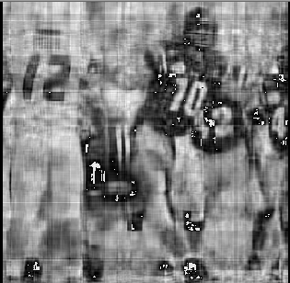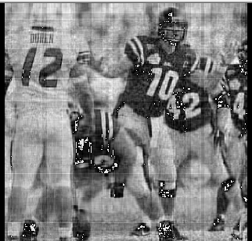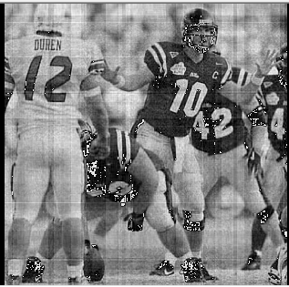
Rank 80
Rank 40
Rank 10
Rank 20

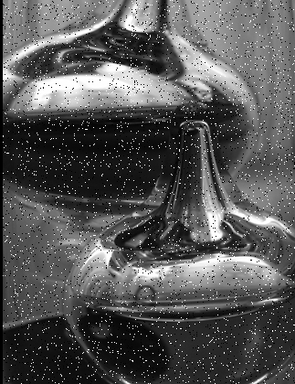
Rank-20
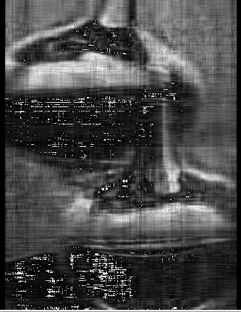
Rank-40
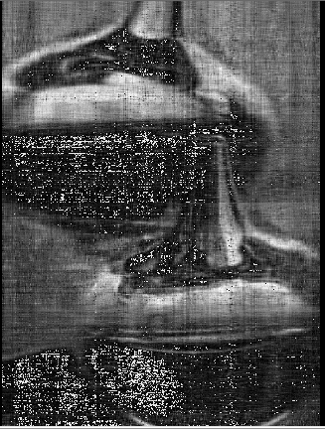
Rank-80
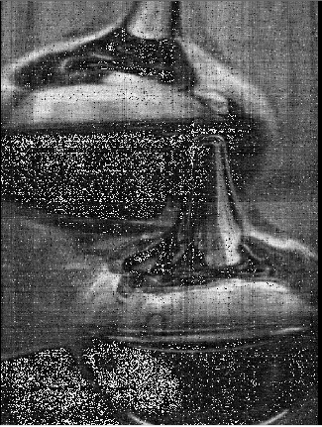
Rank-200

2.5) Implementation Difficulties
1) Storing the decimal numbers
2) Loss of precision values resulting in Zero’s for the whole image and no values are stored

- Principal Component Analysis
- Principal Component Analysis (PCA) is a dimension-reduction tool that can be used to reduce a large set of variables to a small set that still contains most of the information in the large set.
- Principal component analysis (PCA) is a mathematical procedure that transforms a number of (possibly) correlated variables into a (smaller) number of uncorrelated variables called principal components.
- The first principal component accounts for as much of the variability in the data as possible, and each succeeding component accounts for as much of the remaining variability as possible.
- PCA simply performs a coordinate rotation that aligns the transformed axes with the directions of maximum variance.
- PCA can help find underlying structure of the data. It selects a rotation such that most of the variability within the data set is represented in the first few dimensions of the rotated data.
- PCA tries to find a lower dimensional surface so the sum of squares onto that surface is minimized.
- PCA tries to find the surface which has the minimum projection error.
PCA Algorithm Description:
Reducing data from n-dimensional to k-dimensional (n>k)
1) Compute the Co-Variance matrix (C) for the given data matrix X (m samples and n-dimensions)
- Replace each x_{j}^{i} with x_{j} – μ_{j} (determine the mean of each feature set, and then for each feature subtract the mean from the value)
- Calculate [n x n] matrix C=1/(m-1) B^{T}*B
2) Compute the eigen vectors for matrix C
3) U matrix (eigen vectors) is also an [n x n] matrix and the corresponding eigen values are λ₁, λ₂, λ₃ ….. λ_{n}
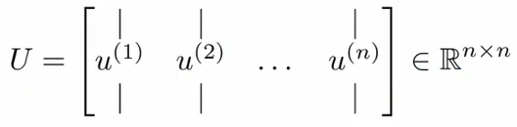
Proportion of variance captured in the direction of first eigen vector (u⁽¹⁾) is given by

λ₁/( λ₁+ λ₂+ …..+ λ_{n})
4) To reduce a system from n-dimensions to k-dimensions
- Take the first k-vectors from U (first k columns)
5) Process to change X (n dimensional) to Z (k dimensional)
- Take first k columns of the U matrix to form U_{reduce} n x k matrix
- Calculate Z as follows
  - Z = (U_{reduce})^{T} * X
6) After finding the Z matrix , we can plot the data into k dimensional space.

Applications of PCA:
1) Visualization of data in low dimensional space.
2) Data Compression
**PCA throws away some data without knowing what the values it's losing
- Probably fine if we're keeping most of the data
- But it will cause problem if we're throwing away some crucial data,
- So we have to go to like 95-99% variance retained
Dimensionality Reduction using PCA:
We have taken a dataset which contains attributes of houses like price, lot-size, house size, number of bed rooms and bathrooms. We can view the data in the mentioned 5 dimensions. But it is very difficult to pick the subset of houses which are having the common features.
We are using Principal Component Analysis (PCA) to reduce the dimensionality of the given dataset. We have used an EXCEL add-in (XLSTAT) to generate the PCA with 2 dimensions.
Below shown is our dataset which is having more than 400 samples.
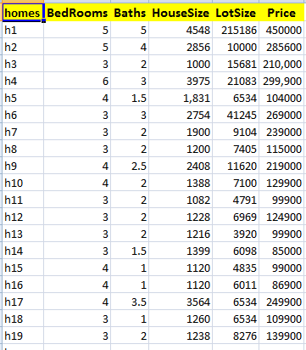
The Co-relation matrix for the dataset is
Co-relation(x,y)=Co-variance (x,y)/std dev(x)* std dev(y)
Variables | BedRooms | Baths | HouseSize | LotSize | Price
BedRooms | 1 | 0.465 | 0.605 | 0.256 | 0.457
Baths | 0.465 | 1 | 0.791 | 0.445 | 0.757
HouseSize | 0.605 | 0.791 | 1 | 0.444 | 0.765
LotSize | 0.256 | 0.445 | 0.444 | 1 | 0.554
Price | 0.457 | 0.757 | 0.765 | 0.554 | 1
The Eigen values for the Co-relation matrix are
 | PC1 | PC2 | PC3 | PC4 | PC5
Eigenvalue | 3.272 | 0.776 | 0.538 | 0.231 | 0.184
Variability (%) | 65.439 | 15.510 | 10.761 | 4.614 | 3.676
Cumulative % | 65.439 | 80.949 | 91.710 | 96.324 | 100.000
From the above table we can say that 65.44% of variance of given data is present in the direction of eigen vector of the eigen value 3.272, so we can consider this vector as our first principal component. In the same way 80.1% of the variance can be explained by the 2 eigen vectors of eigen values 3.272 and 0.776.So we are taking the 2 principal components to explain the given data.

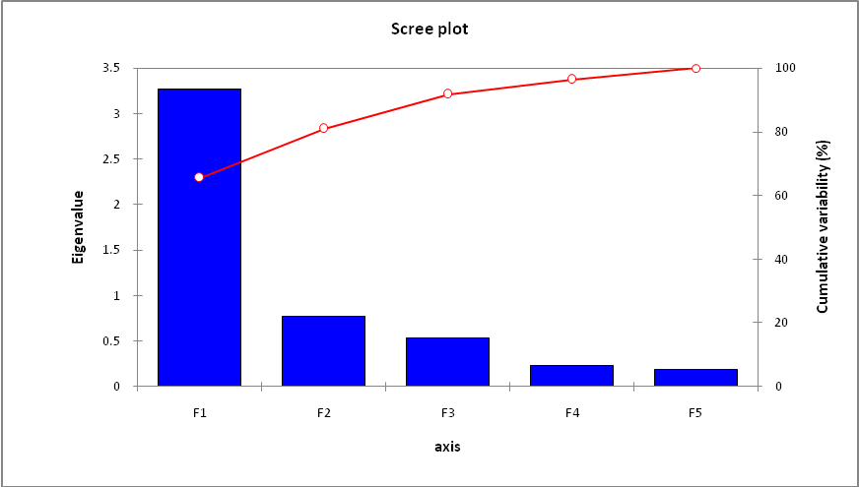

Eigen vector (U) for the corresponding Eigen values
 | u1 |  | u2 |  | u3 | u4 | u5
BedRooms | 0.373 |  | -0.645 |  | 0.630 | 0.026 | -0.218
Baths | 0.486 |  | -0.016 |  | -0.449 | -0.570 | -0.487
HouseSize | 0.504 |  | -0.173 |  | -0.188 | -0.115 | 0.817
LotSize | 0.356 |  | 0.728 |  | 0.555 | -0.183 | 0.036
Price | 0.493 |  | 0.154 |  | -0.243 | 0.792 | -0.216
Contribution of the variables (%)
 |  | PC1 |  | PC2 | PC3 | PC4 | PC5
BedRooms |  | 13.909 |  | 41.577 | 39.690 | 0.068 | 4.755
Baths |  | 23.622 |  | 0.025 | 20.137 | 32.504 | 23.712
HouseSize |  | 25.434 |  | 2.981 | 3.525 | 1.329 | 66.731
LotSize |  | 12.683 |  | 53.060 | 30.763 | 3.366 | 0.127
Price |  | 24.351 |  | 2.357 | 5.884 | 62.733 | 4.674

The representation of data in 2-D space using PCA. Highlighted are the subsets of homes which are having common features in terms of attributes.
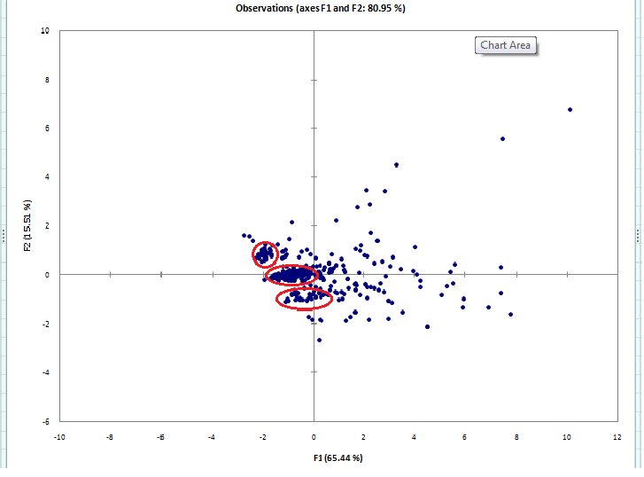
Implementation Difficulties for PCA:
1) Finding the tool to implement PCA.
2) Implementation of PCA for data compression.

References:
1)http://www.holehouse.org/mlclass/14_Dimensionality_Reduction.html
2) http://en.wikipedia.org/wiki/Singular_value_decomposition
3) http://www.ling.ohio-state.edu/~kbaker/pubs/Singular_Value_Decomposition_Tutorial.pdf

