Step-1: Import java Class and jama.jar file
Step-2:Compile the java class

Module1: Give 1 as input and .pgm file

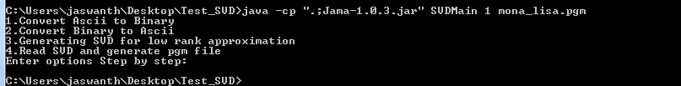
Module 2: Giving 2 as input generate pgm file from bytes.

Module 3:Generate file giving Header.txt and SVD.txt and rank

Module 4:Give pgm file as input to generate the SVD

