ALGORITHMS
Project 3
Seam Carving Algorithm

By
Jaswanth Datt Meka (jm212)

Professor
Dr. Zhong-Hui Duan

Academic Integrity Pledge

Program: Seam Carving Algorithm

Programmer: - Jaswanth Datt Meka

Academic Integrity Pledge

- All source code and documentation used in my program is either my original work, or was derived, by me, from the source code published in the text book for this course or presented in class. Any source code in this project that is derived from code published elsewhere is documented as such so the original author receives due credit.

- I have not used source code obtained from another student, or any other unauthorized source, either modified or unmodified. I have not helped another student write their program by providing a printed or electronic copy of my solution.

- I have not discussed coding details about this project with anyone other than my instructor. I understand that I may discuss the concepts of this program with other students, and that another student may help me debug my program. However, the responsibility to write each program belongs solely to the program's author.

- I have violated neither the spirit nor letter of these restrictions.

Signature of Programmer Date: 11/12/2014
Jaswanth Datt Meka
INDEX

Introduction | 4
Algorithm | 4
Time Complexity | 4
Implementation process | 5
Observations | 8
Test Cases | 10
Implementation Difficulties | 11
Conclusion | 13
References | 13

Seam Carving
- Introduction
Seam carving (also known as image retargeting, content-aware image resizing, content-aware scaling, liquid resizing, or liquid rescaling), is an algorithm for image resizing, developed by Shai Avidan, of Mitsubishi Electric Research Laboratories(MERL), and Ariel Shamir, of the Interdisciplinary Center and MERL^{[1]}. It functions by establishing a number of seams (paths of least importance) in an image and automatically removes seams to reduce image size or inserts seams to extend it. Seam carving also allows manually defining areas in which pixels may not be modified, and features the ability to remove whole objects from photographs^{[1]}.

- Algorithm:
- Read the image as input and store all pixel values.
- Compute Energy Matrix.
- Compute Cumulative Minimum Energy.
- Finding the minimum in bottom row for vertical seam and Rightmost column for horizontal seam.
- Trace the path with min cumulative energy which is the seam to be removed.
- Repeat the same, till the number of seams required to be removed are specified are completed and image is processed.

- Complexity Analysis : Seam carving
Energy Matrix: Read all pixels from .pgm image takes O(n) (summation of top/right/left/bottom pixel values) but the space complexity is O(m*n) where m-number of rows n-no of columns
Cumulative Energy Matrix: Calculating minimum cumulative energy takes O(n) time since we are to find the minimum of three elements.
Finding the bottom minimum: The time complexity is O(n) for finding the minimum in a row.
Finding Seam(Vertical/Horizontal) : Finding seam(vertical) involves backtracking through all the possible pixel values with less cumulative minimum energy. This takes O(n²) time complexity.
Removing element in ArrayList: After finding the seam ,we remove the element in the vertical seam. It takes O(1) time to remove an element from an arrayList.
Based on all the time taken for all the process, we can say that the time complexity of seam carving implemented in this form takes O(n²) .
Since we need to process every element pixel to calculate energy ,cumulative minimum energy and seam, the space complexity is O(n²).

- Implementation Process and Method Used
Part-1: Energy of Pixels
- All the pixels are read into using the scanner and stored in a 2D array.
- The energy of each pixel is calculated using the formula
e(i,j) = |v(i,j)-v(i-1,j)|+ |v(i,j)-v(i+1,j)|+ |v(i,j)-v(i,j-1)|+ |v(i,j)-v(i,j+1)|
- The energy is stored in a 2D array.
30 | 120 | 196
215 | 198 | 180
135 | 4 | 172
Fig 4.1.a Pixel Array

275 | 244 | 92
282 | 307 | 42
286 | 627 | 256
Fig 4.1.b Energy_2D array

Cumulative energy
- Now the cumulative minimum energy is calculated from the energy matrix.
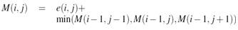
- We identify the minimum value in a row and then start looking at the preceding three elements and find the minimum of those elements.
- We begin with by identifying the least element in the bottom row to figure out the vertical seam. Similarly for the horizontal seam, we begin with the minimum element in the rightmost column in the cumulative 2D array.
Least element in the rightmost column. horizontal seam starts from here.
275 | 244 | 92 | 123
536 | 399 | 123 | 273
238  Least element in the bottom row. Vertical seam starts from here. | 236 | 1177 | 3527
283 | 438 | 3247 | 3478
289 | 383 | 839 | 374
Fig:4.2 Identifying starting point of a seam
- We then remove the pixel in the .pgm file corresponding to the minimum pixel.

210 | 365 | 255 | 255 | 255 | -999
555 | 710 | 765 | 765 | 510 | -999
830 | 1055 | 1475 | 1275 | 765 | -999
1135 | 1045 | 1565 | 1275 | 1020 | -999
1270 | 1455 | 1555 | 1275 | 1020 | -999
1425 | 1925 | 1530 | 1020 | -999 | 765
1535 | 1790 | 1020 | -999 | 765 | 765
Fig 4.3: 2D Array after identifying vertical seam based on Cumulative array 2D

- After removing the pixel from the pixel array, we adjust the elements accordingly.
- A 2D array is created after identifying the minimum seam like in fig 4.2.
- The minimum path is replace with -999 to distinguish it later while iterating.
- We now iterate the above 2D array and remove all the corresponding elements in 2D pixel array where element value is -999.(this signifies the minimum path in that row).
Converting the 2D array to ArrayList<ArrayList<Integer>>
- To dynamically delete the elements from the vertical or horizontal seam
ArrayList<ArrayList<Integer>> completer_struc=new ArrayList<ArrayList<Integer>>();

for(int i=0;i<columns;i++)
{
ArrayList<Integer> inner_ele=new ArrayList<Integer>();
for(int j=0;j<rows;j++)
{
inner_ele.add(array_2D[j][i]);
}
completer_struc.add(inner_ele);
}

Consider the following pixel array after identifying vertical seam which has to be removed Pixel array 2D
30 | 120 | 196
215 | 198 | 180
135 | 4 | 172
210 | 138 | 252
41 | 192 | 53
35 | 123 | 124
5 | 100 | 132
110 | 46 | 203
Fig 4.4 Pixel array with vertical seam to be removed
- To remove the vertical seam we convert it to ArrayList<ArrayList>>
The above array is converted to

0
1
30 196
215 198 180
135 172
120
198
2
4

3
210 252
138
4
41 53
192
5
35 124
123
6
5 132
100
7
110 203
46
- This ArrayList structure is then converted to 2D array and written back to the .pgm file.
Horizontal Seam
- The same processes are followed for horizontal seam with certain change in arguments. No new methods have been created for horizontal seam.
- Instead of calculating the minimum element of rightmost in last column,we have transformed the cumulative2D array, which then effectively becomes a problem like the vertical seam.
- All the vertical seam methods are applied on this cumulative array 2D.
- But while writing elements back to the .pgm file, we invert the 2D array back to its original form.

- Observations
Original Image size in bytes vs Processed Image size in bytes

Note: I have considered pepper.pgm file to analyze the bytes reduced
Original Image( bytes) | Processed Image(bytes) (V,H)
293,830 (256 X 256) | 227,564 (1,0)
 | 223,774 (5,0)
 | 219,149 (10,0)
 | 210,583 (20 ,0)
 | 192,675 (40,0)
 | 175,143(60,0)
 | 157,473 (80,0)
 | 139,614 (100 0)
 | 113,087 (130 0)
 | 95,177 (150 0)
 | 50,558 (200 0)
Here only Vertical seams are applied

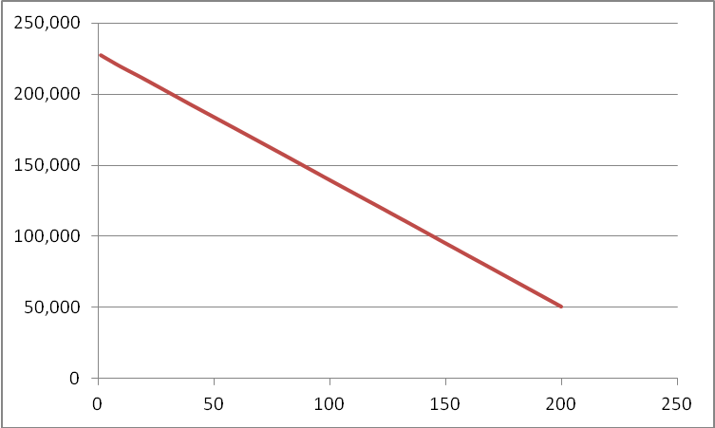
No of seams
Size in bytes

From the above observations, we can clearly say that as the number of seams increases the size of image required to store reduces drastically. The no of seams and size are inversely proportional.
Original Image | Processed Image
61,122 ( 165 X 112) | 52,956 (10 10)
 | 45,241 (20 20)
 | 24,823 (50 50)
 | 13,976 (70 70)
 | 2,802 (100 100)

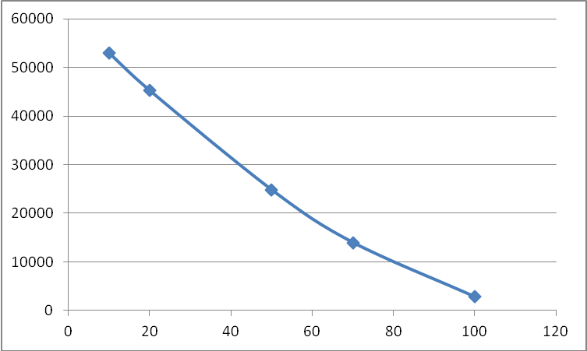
No of seams
Size in bytes
- Test Cases
Image 1: twoBalls.pgm 284 X308

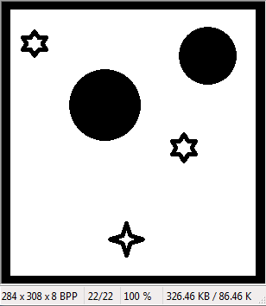
Fig 6.1.a Original Image
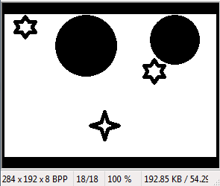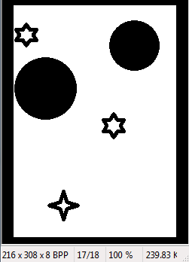
Fig 6.1.b Horizontal Seam (0 116) Fig:6.1.c Vertical Seam (68 0)
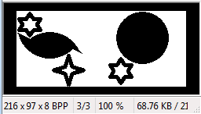
Fig 6.1.d Seam (68,211)

Image 2: Circles.pgm

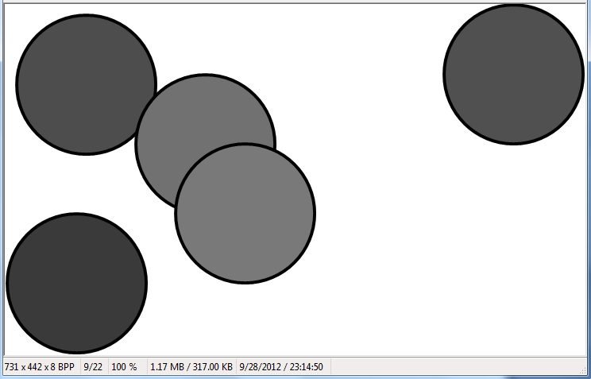
Fig: 6.2.a Original Image (731 X 442)
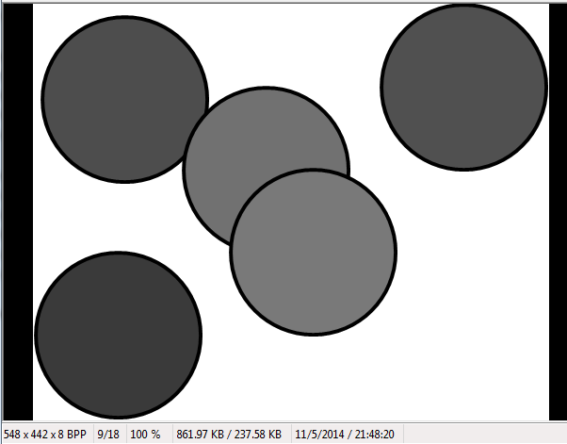
Fig: 6.2.b Vertical Seam (183 0)

Image 3: AkronZips.pgm

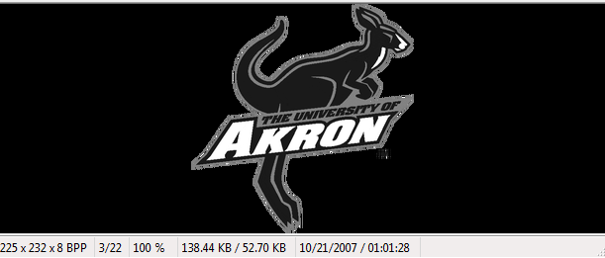
Fig 6.3.a Original Image 225 X 232
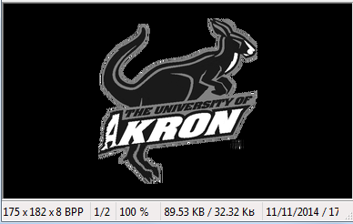
Fig:6.3.b Seams (50 50)

- Implementation Difficulties:
- Finding which path has the lowest cumulative energy and record it for removing vertical seam.
- To dynamically remove the elements on the vertical seam. To implement this I have used ArrayList of ArrayList (ArrayList< ArrayList >).
- Converting the 2D pixels array to ArrayList< ArrayList >
- Converting ArrayList< ArrayList > back to 2D array to be able to write to .pgm file
- Adapting the same methods for horizontal seam removal without witing new methods for horizontal seam.

- Conclusion
From the observations of space requirements, we can say that seam carving serves the purpose, in retaining important information while reducing space requirements for storing it.
- References:
- http://en.wikipedia.org/wiki/Seam_carving
- Dr. Z H Duan class notes on cs.uakron.edu.
- http://www.win.tue.nl/~wstahw/edu/2IV05/seamcarving.pdf

