ALGORITHMS
Project 2
Union Find Algorithm

By
Jaswanth Datt Meka (jm212)

Professor
Dr. Zhong-Hui Duan

Academic Integrity Pledge

Program: Union Find Algorithm

Programmer: - Jaswanth Datt Meka

Academic Integrity Pledge

- All source code and documentation used in my program is either my original work, or was derived, by me, from the source code published in the text book for this course or presented in class. Any source code in this project that is derived from code published elsewhere is documented as such so the original author receives due credit.

- I have not used source code obtained from another student, or any other unauthorized source, either modified or unmodified. I have not helped another student write their program by providing a printed or electronic copy of my solution.

- I have not discussed coding details about this project with anyone other than my instructor. I understand that I may discuss the concepts of this program with other students, and that another student may help me debug my program. However, the responsibility to write each program belongs solely to the program's author.

- I have violated neither the spirit nor letter of these restrictions.

Signature of Programmer Date: 10/27/2014
Jaswanth Datt Meka
INDEX

Introduction | 4
Algorithm | 4
Time Complexity | 5
Implementation process | 5
Observations | 7
Additional | 9
Implementation Difficulties | 10
Conclusion | 11
References | 11

Union Find Algorithm
- Introduction
Union Find Algorithm
Union Find is an algorithm which uses a disjoint-set data structure to find the number of clusters. It has many applications in Social Networking (interactions), Electricity flow (conduction) ,Water Flow(porous) etc.

Union is used to merge two smaller subsets and form a bigger subset. For efficiency it is always suggestible to merge smaller one’s into larger one’s.
Find is used to search for the element for its root.

- Algorithm:
- union( A, B ) - merge A's set with B's set
- find( A ) - finds what set A belongs to

Union:
func union( var setA, var setB )
var rootA = find( setA ), rootB = find( setB )
if ( rootA is equal to rootB )
return
else
set rootB as rootA's parent
end func

Union Code
static int[] union(int a, int b, int whole_arry[]) {
int root1 = find(a, whole_arry); // Find root for a
int root2 = find(b, whole_arry); // Find root for b
if (root1 > root2) {
whole_arry[root1] = root2;

} else {
whole_arry[root2] = root1;
}
return whole_arry;
}

Find:
func find( var element )
while ( element is not the root )
element = element's parent
return element
end func

Find Code:
static int find(int curr, int whole_arry[]) {

if (whole_arry[curr] != curr) {

curr = whole_arry[curr];
}
return curr;
}

- Complexity Analysis : Union Find
isConnected(args1,args2) method is used for checking the connectivity in adjacent cells. It take a 2D array as input and for iterating it requires O(n²) time.
Int [] Union() union algorithm takes array2D_to_1D array .It takes n numbers and compares the roots and merges them. At max, the merged tree structure takes O(logn) time.
Find() Algorithm traces the root of an element. To trace the root of an element in tree structure takes O(1) * height of tree .
Percolates() takes O(n²) because we check the connectivity from top row to last row in a 2D array takes O(n²) time.

- Implementation Process and Method Used
Part-1: Finding Percolation Rate
- We give percolation probability, board size and no of runs as input.
p - percolation probability; n - # of runs; s – board size;
- We assign random values between 0 and 1 to each cell.
- We check if cell random value is greater than percolation probability is assumed as OPEN site and other as BLOCKED site.
Percolation rate=No of cases percolated/Total number of runs.
Part-2: File as input
- Several test cases are run with 1-meaning open site and 0-meaning blocked site.
- All input is taken into a 2D matrix and given as input to isConnected(arr2d) as arguments.
- isConnected() method checks for all cases where in it is connected to neighbours.The sequence of iteration is Top/Left/Right/Bottom.
- Collections of 0 is also considered as a cluster.

Path Compression to get a Flat tree
- Union operation merges two trees, the smaller one into the larger one.
- Find operation gives us the root of the tree. Even after applying we do not get an optimal tree. The size of tree is very big. We need a flat tree.
- We further apply path compression on the tree, to obtain a flat tree.

for (int i = 0; i < (lines_row * lines_column); i++) {
if (!(whole_arry[i] == i) && whole_arry[i] < i)
whole_arry[i] = whole_arry[whole_arry[i]];
}

Consider the following tree

200
60
40
10
50
70

Fig 2.a Original tree after Union Find Algorithm
200

60
40
10
50
70

Fig 2.b Flat tree after Path compression.
After applying path compression, all the child nodes that are attached to nodes with same parents in a group are attached to their root parents.

- Observations
Plotting of Board size vs Running time of percolation

Note: Test case files given in project pdf
Size(X Y) | Number of clusters(0 &1 included)
Testcase1- 200 X 200 | 5465
Testcase2- 100 X 100 | 1423
Testcase3 – 20 X 20 | 70

Compilation of test runs (Percolation Probability Vs Percolation rate)
Percolation Probability | Percolation Rate
0.1 | 0
0.2 | 0.03
0.25 | 0
0.3 | 0
0.4 | 0
0.5 | 0
0.52 | 0
0.53 | 0
0.54 | 0
0.55 | 0
0.56 | 0
0.57 | 0.2
0.58 | 0.1
0.59 | 0.4
0.6 | 0.5
0.65 | 0.6
0.7 | 0.67
0.8 | 0.9
1 | 0.98
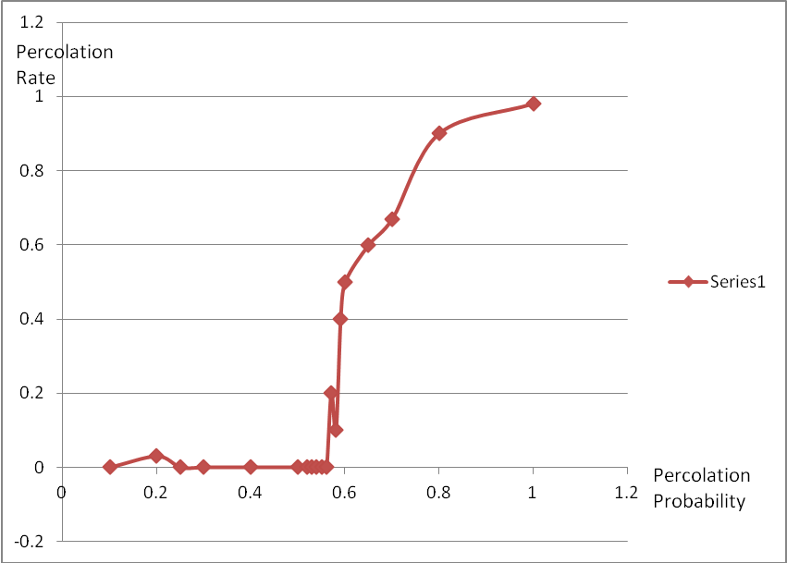
Fig: 5.a
Note: Board Size and number of runs constant @ 100

Board Size vs. Percolation Rate

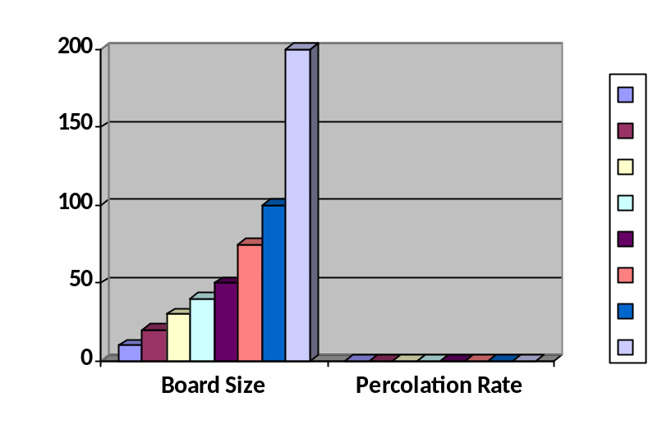
Board Size | Percolation Rate
10 | 0.42
20 | 0.31
30 | 0.37
40 | 0.32
50 | 0.24
75 | 0.15
100 | 0.11
200 | 0.02
Fig 5.b
Note : No of runs 100,Perc prob=0.54

- Additional-PPM Images
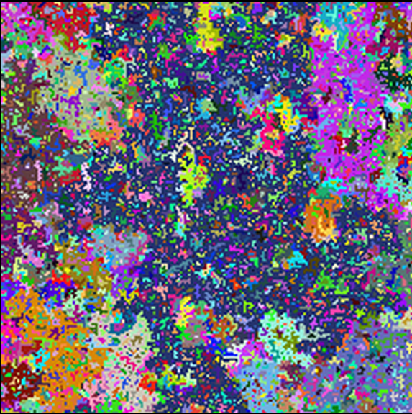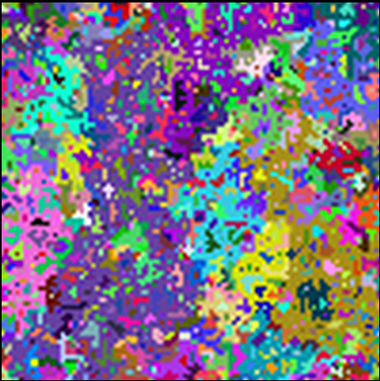
4.a 200 X 200 PPM Image 4.b 100 X 100 PPM Image


4. c 20 X 20 PPM Image

PPM images needed to be written in format of RGB values for every pixel of data. Figures a,b,c above show the percolation of their respective images.

- Implementation Difficulties:
- To write an isConnected() Method ,which finds if an element is connected or not according to certain priority of Top/Right/Bottom/Left
- Implementation of find( ) to check all connected elements of a same root.
- Finding out if maze can be percolated by checking connectivity between top row & last row elements.
- Drawing PPM images.PPM shows color images ,therefore each element has to be converted to RGB value format like 255 255 0 for a pixel value
Following is the implementation:
TreeSet<Integer> keyS = new TreeSet<Integer>();
keyS = new TreeSet<Integer>(cluster_count.keySet());
int key = 0;
for (int i = 0; i < cluster_total; i++) {
key = keyS.pollFirst();
int R = rnd.nextInt(255);
int G = rnd.nextInt(255);
int B = rnd.nextInt(255);
String s = R + " " + G + " " + B + " ";
ppm.put(key, s);
}

- Conclusion
From the observations recorded, we can verify that claim that after 0.56 there is an increase in the percolation rate. Also we can infer from Fig 5.b , there is no dependence on size of board and percolation rate. It purely depends on percolation probability.
- References:
- Dr. Z H Duan class notes on cs.uakron.edu.
- Algorithms book by Robert Sedgwick
- https://www.cs.princeton.edu/courses/archive/fall10/cos226/assignments/percolation.html
- https://www.youtube.com/watch?v=gcmjC-OcWpI

