Xzc,. d



**Placement Empowerment Program**

***Cloud Computing and DevOps Centre***

***Host a Static Website Locally: Set Up a Local Server Apache and Host a Simple HTML page with the content you want.***

# Name: Department: ADS

JASWANTH SARAVANAN

Introduction :

In this POC, we will learn how to host a static website locally using the Apache HTTP Server. This process involves setting up a local web server, configuring it correctly, and hosting a simple HTML page.

Objective :

The goal of this project is to

1. Set up a local web server usingApache.

2. Configure the server to host static files.

3. Create and host a simple HTML page displaying your name

Step-by-Step Overview;

Step 1:

Search for "XAMPP" on Google and click the first link to access the official website.

Step 2 :

Click on the Download Option.

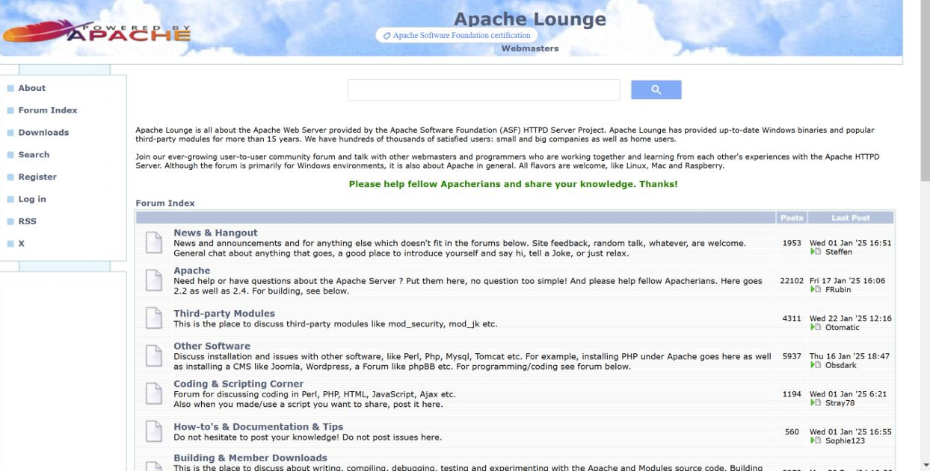

Step 3 :

Click on the link "Apache 2.4.62-240904 Win64" to download .

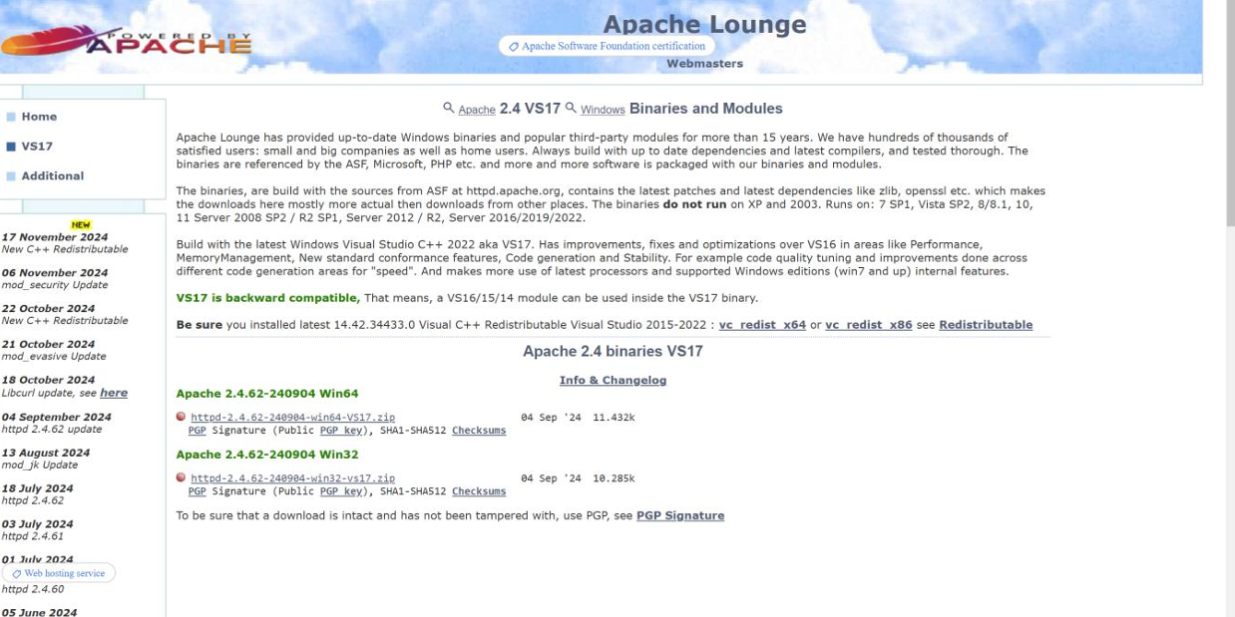

Step 4:

Use the Simple HTML code to display the content that what you want.

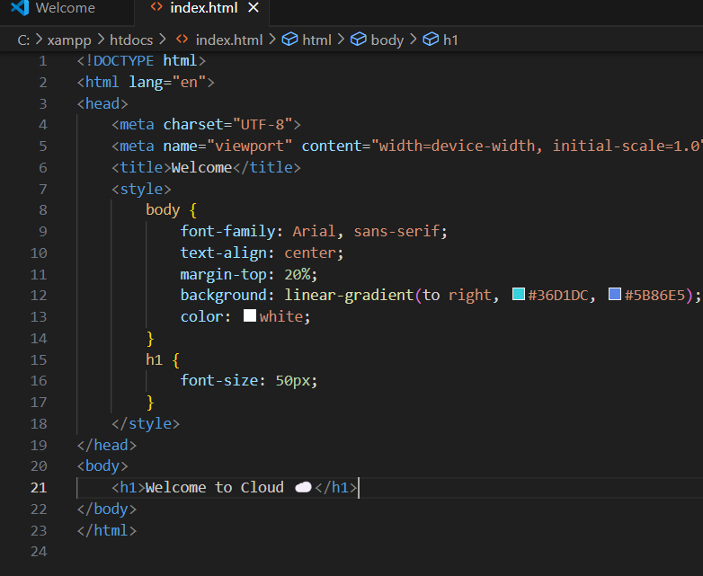

Step 5:

Save the code in “XAMPP” in the folder ‘htdocs’ with the file name should save as file_name.html.

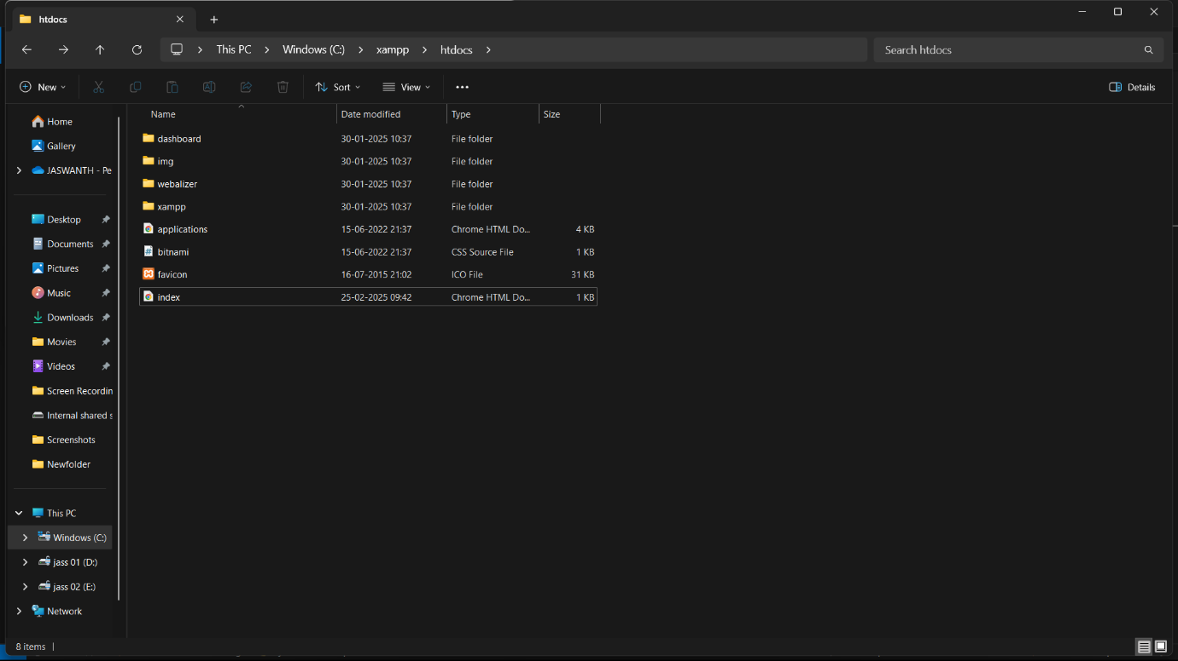

Step 6:

In this step , start the Appache after saving the file .

Step 7:

Type Localhost in Chrome url , then the content that will get display on the screen.

Outcome:

By completing this POC, we will:

1. Successfully configure and run an Apache server locally.

2. Host a static HTML website that displays your name.

3. Understand the basics of web server configuration and file hosting