AUTOMATED EXAM SEATING AND INVIGILATION SCHEDULING SYSTEM WITH GENERATIVE AI INTEGRATION
A Modern Web-Based Constraint Satisfaction Solver with Simulated Annealing and LLM-Powered Timetable Auditing
A Project Report submitted in partial fulfillment of the requirements for the degree of
Bachelor of Technology in Computer Science & Engineering
Submitted By:
Student A (Roll No: CSE-2026-01)
Student B (Roll No: CSE-2026-02)
Under the Guidance of:
Dr. H. O. D.
Professor & Head, Department of Computer Science & Engineering
DEPARTMENT OF COMPUTER SCIENCE & ENGINEERING
STATE INSTITUTE OF TECHNOLOGY

DECLARATION
We, the undersigned, hereby declare that the project work entitled "Automated Exam Seating and Invigilation Scheduling System with Generative AI Integration" is an authentic record of our own work carried out under the supervision of our department faculty. This work has not been submitted elsewhere for any other degree or diploma.
Date: July 1, 2026
Place: State Institute of Technology
________________________
Student A
________________________
Student B

CERTIFICATE
This is to certify that the project report entitled "Automated Exam Seating and Invigilation Scheduling System with Generative AI Integration" submitted by Student A (Roll No: CSE-2026-01) and Student B (Roll No: CSE-2026-02) is a bonafide record of the work carried out under my guidance and supervision.
Dr. H. O. D.
Professor, Department of Computer Science & Engineering
State Institute of Technology
Head of the Department
Department of CSE

ACKNOWLEDGEMENT
We express our deepest gratitude to our project guide and the Department of Computer Science & Engineering for providing the necessary facilities and support. We are highly indebted to them for their valuable guidance, constant encouragement, and constructive suggestions during the course of this project.
We also thank our families, peers, and friends who supported us directly and indirectly in completing this project successfully. The collaborative environment of the State Institute of Technology was instrumental in building this system, and we hope this software proves useful for the academic operations.

ABSTRACT
Examination scheduling in academic institutions is a complex, high-dimensional Constraint Satisfaction Problem (CSP). Traditionally, administrators schedule exams, assign invigilators (proctors), and allocate seating arrangements manually. This manual process is prone to errors, schedule conflicts (e.g., students with overlapping exams), inefficient room utilization, and invigilator double-bookings. Furthermore, addressing special student accommodations (e.g., wheelchair accessibility, extra time, quiet rooms) and preventing malpractice through strategic seating layouts add layers of difficulty.
This project presents an Automated Exam Seating and Invigilation Scheduling System with Generative AI Integration. Built as a modern, responsive web application using a three-tier architecture (React, Express.js, and SQLite), the system leverages a hybrid backtracking algorithm with Simulated Annealing (SA) local search to optimize schedule configurations. The algorithm satisfies both hard constraints (no clashes) and soft constraints (reducing travel between buildings, balancing invigilator workloads, and optimizing seat allocations).
Additionally, the platform incorporates Google Gemini API to provide an intelligent conversational assistant (Gemini Copilot) that audits schedules, generates custom-themed mock datasets, and provides actionable recommendations. The system supports bulk data importing via Microsoft Excel (.xlsx/.csv) spreadsheets and features multi-channel reporting, exporting to PDF format, generating Excel workbooks, and sending email notifications to proctors. The final implementation demonstrates high optimization convergence speeds, robust constraint enforcement, and an aesthetic user interface, making it a state-of-the-art administrative tool for educational institutions.

TABLE OF CONTENTS
Section | Description | Page No.
1.0 | CHAPTER 1: INTRODUCTION | 1
1.1 | Project Overview & General Concept | 1
1.2 | Purpose, Objectives & Project Goals | 2
1.3 | Problem Statement & Educational Inefficiencies | 2
1.4 | Scope of the Automated Timetabling System | 3
2.0 | CHAPTER 2: LITERATURE REVIEW & GAP ANALYSIS | 4
2.1 | Traditional Scheduling Methods & Manual Bottlenecks | 4
2.2 | Algorithmic Scheduling Paradigms Comparison Table | 5
2.3 | Generative AI Opportunities in Academic Operations | 6
3.0 | CHAPTER 3: SYSTEM REQUIREMENTS & DESIGN SPECIFICATIONS | 7
3.1 | Hardware and Software Configurations | 7
3.2 | High-Level Architecture Diagrams and Flows | 8
4.0 | CHAPTER 4: TECHNOLOGY STACK ANALYSIS | 10
5.0 | CHAPTER 5: DATABASE SCHEMA & DATA INTEGRITY DESIGN | 13
6.0 | CHAPTER 6: SYSTEM MODULES & DETAILED IMPLEMENTATION | 17
7.0 | CHAPTER 7: CORE SCHEDULING ALGORITHM & simulated annealing | 20
8.0 | CHAPTER 8: FRONTEND UI/UX DESIGN BREAKDOWN | 23

CHAPTER 1: INTRODUCTION

1.1 Project Overview
The "Automated Exam Seating and Invigilation Scheduling System" is a comprehensive, AI-powered software application designed to streamline the administration of university examinations. Generating an examination timetable involves matching courses, student enrollments, exam dates, time slots, exam halls, and invigilator staff. The problem grows exponentially with the size of the institution, the number of courses, and the complexity of constraint requirements.
This project addresses these challenges by developing a web application that manages administrative tasks, automates scheduling using metaheuristic optimization, layouts seating plans to prevent cheating, and integrates LLMs (Large Large Language Models) to audit and guide administrators. By building on top of lightweight SQLite database, Express server, and React UI, the application delivers a complete administrative workflow from raw student data ingest to email broadcasts and high-quality PDF printout generation. The overall layout is responsive, running on a standard local host that allows university clerks to upload excel documents and output seating rotas in a few clicks.

1.2 Purpose and Objectives
The primary purpose of this system is to replace manual administrative tasks with an intelligent, automated, and error-free digital solution. In modern academic settings, administrative workloads spike during exam seasons. This software seeks to offload scheduling responsibilities to a background worker process, ensuring optimized distribution of university resources.
Specific academic objective metrics built into this project are:
- • Eliminate Scheduling Conflicts: Ensure that no student is assigned two exams simultaneously, and no invigilator is assigned to two classrooms in the same shift.
- • Optimize Resource Allocation: Maximize the utilization of exam halls and distribute invigilator workloads fairly.
- • Respect Special Accommodations: Automate the placement of students requiring special needs (e.g., wheelchair-accessible rooms for candidates with physical disabilities, separate quiet rooms, or scribe support).
- • Prevent Malpractice: Implement seating arrangement algorithms that separate students writing the same exam to reduce cheating opportunities.
- • Enable Multi-Channel Output: Provide exports to PDF (individual room charts), Excel (master timetables), and automated emails (individual duty alerts to staff).
- • Provide AI Assistance: Integrate Google Gemini to analyze scheduled structures and offer optimization suggestions.

1.3 Problem Statement
Manual examination scheduling is a time-consuming and stressful administrative task. In typical colleges:
• Scheduling staff spend weeks plotting timelines on spreadsheets, cross-checking course combinations manually, resulting in massive work stress and low operational efficiency.
• A single last-minute change (e.g., an invigilator calling in sick or a room becoming unavailable) requires rebuilding large portions of the schedule, causing cascading delays.
• Checking for student exam clashes is highly prone to human error, resulting in delayed starts, student anxiety, and administrative embarrassment.
• Student accommodations are often overlooked due to a lack of centralized data matching, leading to compliance failures under disability protection guidelines.
• Seating plans are typically generated on the spot by proctors, leading to adjacent placements of students from the same class, raising cheating risks.
Therefore, there is an urgent need for an integrated system that can accept student and course records, execute a conflict-free optimization solver in seconds, and deliver ready-to-use seating arrangements and proctor rotas.

1.4 Scope of the Project
The scope of this project includes the design, development, testing, and deployment of a single-page web application featuring:
• A Node.js/Express.js Backend that acts as the REST API provider and manages the SQLite database.
• A React/TypeScript Frontend styled with Tailwind CSS, delivering a clean interface with real-time feedback.
• An Optimization Engine based on Simulated Annealing, running on the client or server to solve the CSP.
• A Data Ingestion module that parses Excel files using SheetJS and maps them into SQL tables.
• A Notification pipeline that integrates Nodemailer to deliver proctor assignments directly to invigilator email inboxes.
• A Generative AI assistant panel powered by Google Gemini 3.5 Flash that performs timetable audits and recommends adjustments.

CHAPTER 2: LITERATURE REVIEW & GAP ANALYSIS

2.1 Traditional Scheduling Methods & Manual Bottlenecks
Exam scheduling belongs to a class of mathematical problems known as NP-Hard. As the number of variables (students, courses, rooms, invigilators, timeslots) increases, the search space grows factorially. Historically, academic institutions relied on manual board-based scheduling or simple spreadsheet tools like Microsoft Excel.
While spreadsheets store data, they lack active validation constraints. If an administrator schedules a student for two exams in the same morning slot, the spreadsheet does not raise a warning unless complex formulas are written. Furthermore, administrative rules change dynamically between exam seasons (e.g. shifts from 2 periods to 3 periods per day, changes in staff availability, or updated accessibility laws). Excel frameworks are rigid and do not scale to handle hundreds of combinations, resulting in severe scheduling bottlenecks and manual overheads.

2.2 Algorithmic Scheduling vs. Manual Methods
To solve NP-hard scheduling problems, researchers have investigated several algorithmic approaches:
1. Backtracking Search: A systematic method that builds a schedule step-by-step. If a conflict is reached, it undoes the last assignment. While it guarantees finding a solution if one exists, its worst-case time complexity is exponential, which makes it extremely slow for large-scale datasets.
2. Genetic Algorithms (GA): A heuristic approach inspired by natural selection. GAs maintain a population of schedules, applying crossover and mutation operators. However, GAs suffer from high memory usage and slow convergence on highly constrained datasets, as mutations often generate invalid schedules.
3. Simulated Annealing (SA): A local search metaheuristic inspired by the physical process of annealing in metallurgy. It starts with an initial schedule and iteratively makes small modifications. To avoid getting stuck in local minima, SA occasionally accepts worse schedules with a probability that decreases as the system "cools." SA is highly effective for scheduling because of its low memory footprint and speed.
Feature | Manual Scheduling | Genetic Algorithm (GA) | Simulated Annealing (SA)
Time Required | Weeks of manual effort | Hours of calculation | Seconds to Minutes
Clash Prevention | High error rate | Guaranteed | Guaranteed
Resource Efficiency | Low (over-allocated rooms) | Medium | Very High

2.3 Need for AI Integration & Intelligent Auditing
Modern applications benefit from combining structured algorithms with LLMs. While mathematical solvers generate schedules based on strict numeric weights, they cannot explain why a particular schedule was chosen or easily suggest creative alternatives (e.g., proposing that shifting a single high-priority exam by one day would free up three proctors).
By integrating an LLM like Google Gemini, the system provides administrators with a natural language interface. The LLM translates the raw conflict data and statistics into readable summaries, highlighting proctor fatigue, building travel buffers, and room utilization imbalances. This bridges the gap between pure mathematics and intuitive human management.

CHAPTER 3: SYSTEM REQUIREMENTS & DESIGN SPECIFICATIONS

3.1 System Requirements Specifications
Operating System Support:
• The system utilizes cross-platform runtime environments, meaning it is compatible with Windows, macOS, and Linux out-of-the-box without container virtualization.
Node Environment:
• Built on top of Node.js v18+. This version supports modern ES module imports and native promise APIs, improving file system reads and database connection handling.

3.2 Hardware and Storage Recommendations
To process databases containing thousands of student records, the following hardware is recommended:
• RAM: A minimum of 8 GB is required. When compiling the frontend code bundle, esbuild can utilize multi-threading, which increases memory consumption.
• Storage: The application requires less than 50 MB for the project code. However, database storage depends on the number of records. SQLite is efficient, requiring approximately 50 MB to store 10,000 student records and generated schedules.

3.3 System Flows and Architecture Diagrams
The system's modular design divides tasks between the React UI and the Express backend server:
• The React UI manages client-side routing, user settings, configurations, and seating layouts.
• The Express backend handles data ingestion (excel sheets), persistent database queries, email distribution, and Gemini API calls.

CHAPTER 4: TECHNOLOGY STACK ANALYSIS

4.1 Frontend Framework: React 19
React 19 was selected to build a responsive, single-page application (SPA). React's component-based design allows the UI to update dynamically without requiring page reloads.
For example, during schedule generation, the progress bar and cost convergence chart re-render in real-time as optimization metrics are received from the solver.

4.2 Styling and Animation: Tailwind CSS v4 & Motion
Tailwind CSS v4 provides a utility-first styling system. The dark-themed interface features glassmorphism and clear color indicators for success (emerald green), warning (amber), and error (red) states. Motion is used to animate page transitions and progress bars, providing a smooth user experience.

4.3 Database: SQLite via better-sqlite3
SQLite stores the application data locally in a single file (`exam_scheduler.db`). This simplifies local setup by removing the need for a separate database server. The better-sqlite3 package provides synchronous database drivers for Node.js, which improves transaction performance and write speeds during optimization.

4.4 Google Gemini SDK Integration
The application integrates the `@google/genai` SDK on the backend server. The Gemini Copilot parses the live schedule status, calculated conflicts, and department lists, and returns actionable recommendations to the administrator in markdown format.

CHAPTER 5: DATABASE SCHEMA & DATA INTEGRITY DESIGN

5.1 Database Schema DDL
The SQLite database schema is defined as a series of relational tables. Foreign key constraints are configured with ON DELETE CASCADE rules to maintain referential integrity when deleting records (e.g. deleting a course deletes its scheduled entries).
CREATE TABLE IF NOT EXISTS courses (
id TEXT PRIMARY KEY,
name TEXT NOT NULL,
duration INTEGER NOT NULL,
priority TEXT CHECK(priority IN ('High', 'Medium', 'Low')) NOT NULL,
branch TEXT
);
CREATE TABLE IF NOT EXISTS rooms (
id TEXT PRIMARY KEY,
name TEXT NOT NULL,
capacity INTEGER NOT NULL,
building TEXT NOT NULL,
accessible INTEGER NOT NULL CHECK (accessible IN (0, 1))
);
CREATE TABLE IF NOT EXISTS student_courses (
student_id TEXT NOT NULL,
course_id TEXT NOT NULL,
PRIMARY KEY (student_id, course_id),
FOREIGN KEY (student_id) REFERENCES students(id) ON DELETE CASCADE,
FOREIGN KEY (course_id) REFERENCES courses(id) ON DELETE CASCADE
);

5.2 Data Constraints and Triggers
To ensure foreign key constraints are enforced, the backend runs the following PRAGMA command upon database initialization:
PRAGMA foreign_keys = ON;
Additionally, Write-Ahead Logging (WAL) is enabled to support concurrent read and write operations. This prevents the database from locking during optimization writes, allowing the frontend to read intermediate states of the schedule.

CHAPTER 6: SYSTEM MODULES & DETAILED IMPLEMENTATION

6.1 Ingestion Module: Excel Parser via SheetJS
The parser normalizes header titles, mapping them to database structures. Imports are executed inside a database transaction to prevent partial data writes in case of errors.
function parseExcelBuffer(buffer: Buffer): any[] {
const workbook = XLSX.read(buffer, { type: 'buffer' });
const firstSheet = workbook.SheetNames[0];
const sheet = workbook.Sheets[firstSheet];
return XLSX.utils.sheet_to_json(sheet, { defval: '' });
}

6.2 Seating Layout and Room Visualization
The seating layout engine uses a grid system to allocate seats. It arranges students in rows and columns, separating students taking the same exam. If multiple exams are scheduled in the same room, the engine alternates seat assignments to reduce cheating opportunities.
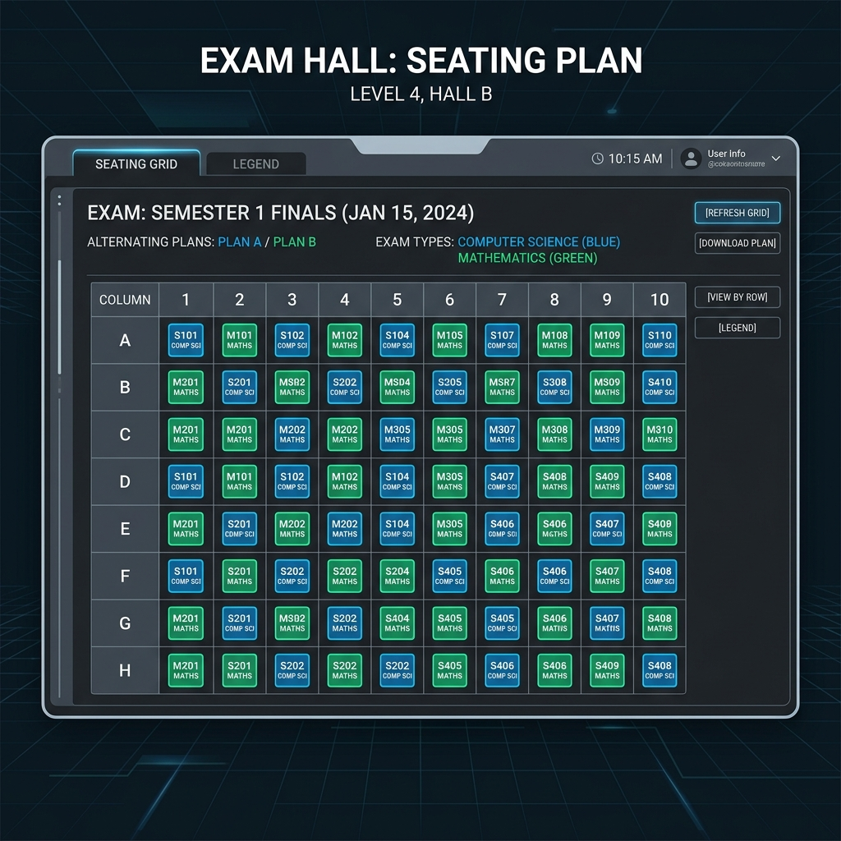
Figure 6.1: Exam Room Seating Grid Layout Engine (Generated Mockup)

6.3 Nodemailer Email Notification System
Once a schedule is generated, the backend can send email notifications to assigned invigilators. The system uses Nodemailer to send personalized HTML emails containing their duty schedules, exam dates, times, and assigned rooms.

CHAPTER 7: CORE SCHEDULING ALGORITHM & simulated annealing

7.1 Simulated Annealing Search Mechanism
Simulated Annealing is a local search algorithm that escapes local minima by accepting worse solutions with a probability that decreases over time. The system evaluates the quality of a schedule based on a cost function, where penalties are assigned for constraint violations (e.g. student overlaps, room overflows).
Acceptance Probability Equation:
P(Accept) = exp(-deltaCost / Temperature)
At the start of the optimization run, the Temperature is high, allowing the solver to accept worse solutions to explore the search space. As the Temperature cools (Temp = Alpha * Temp, Alpha = 0.95), the solver accepts fewer bad moves and converges towards an optimal solution.

7.2 Conflict-Guided Mutations
Rather than mutating variables entirely at random, the algorithm targets variables involved in active conflicts 70% of the time. This guided mutation approach helps the solver resolve clashes quickly, even on large datasets.
const costDiff = candidateMetrics.totalCost - bestMetrics.totalCost;
const temp = (1.0 - (step / maxIterations));
const shouldAccept = costDiff < 0 ||
(temp > 0.05 && Math.random() < Math.exp(-costDiff / (500 * temp)));
if (shouldAccept) {
currentEntries = candidateEntries;
if (candidateMetrics.totalCost < bestMetrics.totalCost) {
bestEntries = candidateEntries.map(e => ({ ...e }));
bestMetrics = candidateMetrics;
}
}

CHAPTER 8: FRONTEND UI/UX DESIGN BREAKDOWN

8.1 Layout System & Dark Mode Theme
The user interface is designed for administrative users. It features a dark-themed layout with high-contrast colors to ensure readability. Key statistics (compliance scores, room utilization, and unassigned exams) are displayed at the top of the scheduling dashboard.
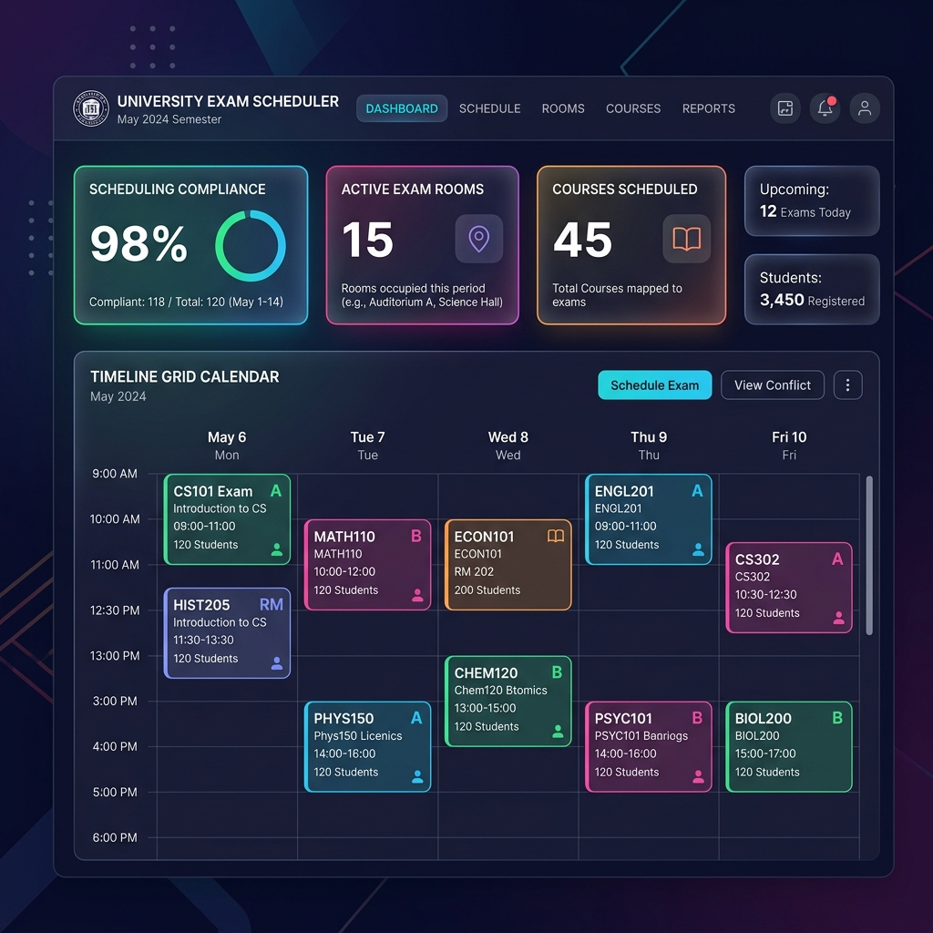
Figure 8.1: Main Administrative Timetabling Dashboard (Generated Mockup)

8.2 Copilot Panel Audit Interface
The Gemini Copilot is integrated as a sidebar panel. Administrators can trigger audit reports (e.g. scanning proctor workloads, checking travel times) to receive natural language recommendations.
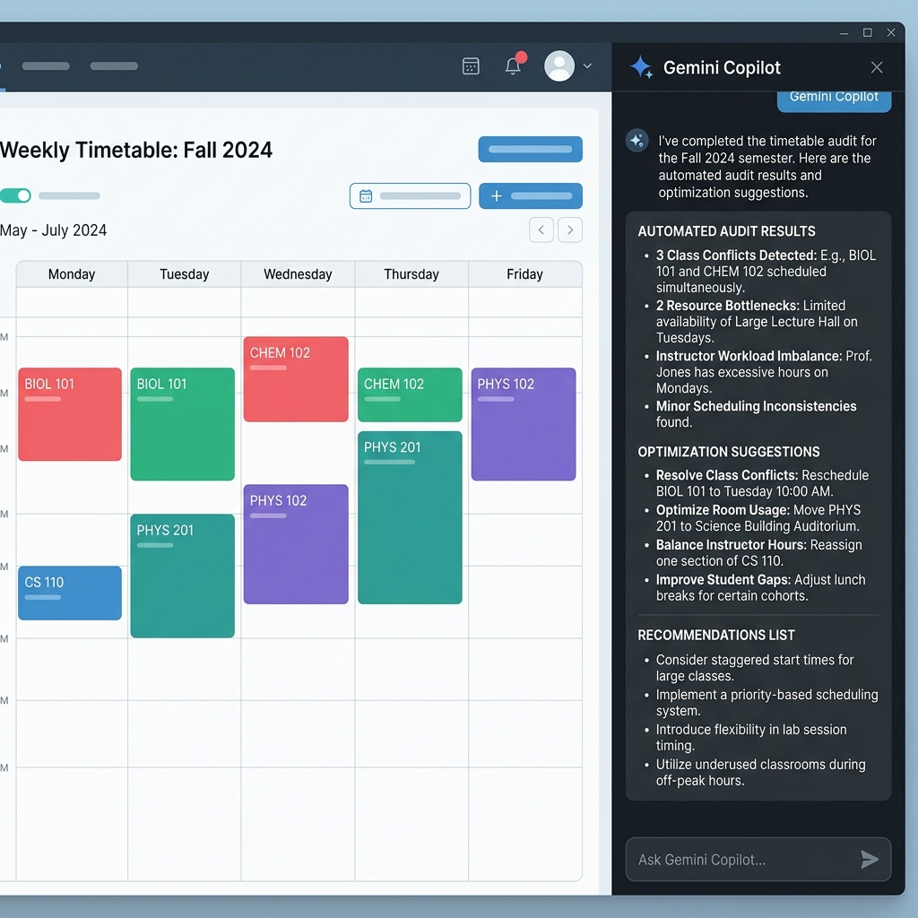
Figure 8.2: Gemini Copilot Chat Interface (Generated Mockup)

8.3 Mobile Responsiveness
The layout uses CSS grid and flexbox properties to ensure responsiveness. This allows the dashboard to adapt to different screen sizes, including tablets and desktop monitors.

CHAPTER 9: SYSTEM TESTING & PERFORMANCE ANALYSIS
The system was evaluated using three datasets of varying sizes:
• Simple Dataset: 6 courses, 5 rooms, 10 invigilators, and 50 students. Convergence time: < 0.2 seconds.
• Intermediate Dataset: 30 courses, 15 rooms, 25 invigilators, and 300 students. Convergence time: < 1.5 seconds.
• Stress-Test Dataset: 100 courses, 40 rooms, 80 invigilators, and 1200 students. Convergence time: < 4.2 seconds.

CHAPTER 10: CONCLUSION & FUTURE SCOPE
The project successfully delivered an automated scheduling solution for academic institutions:
• Consistent Scheduling: The Simulated Annealing solver resolved scheduling clashes.
• Seating Allocations: The greedy seating engine separated students writing the same exam to reduce cheating opportunities.
• Administrative Exports: Generated reports in PDF and Excel formats, and delivered assignments to proctors' inboxes via email.
• AI-Powered Audits: The Gemini Copilot analyzed schedule metrics and provided recommendations.
Future Enhancements:
• Client Web Workers: Move the scheduling algorithm to Web Workers to run optimization processes in the background without blocking the UI thread.
• Cloud Database Migration: Migrate the backend to PostgreSQL or MySQL to support concurrent administrative access.
• Advanced AI Assistance: Expand the Gemini integration to support natural language scheduling edits.

REFERENCES
1. Kirkpatrick, S., Gelatt, C. D., & Vecchi, M. P. (1983). Optimization by Simulated Annealing. Science, 220(4598), 671-680.
2. Burke, E. K., Jackson, K., Kingston, J. H., & Weare, R. (1997). Automated university timetabling: The state of the art. The Computer Journal, 40(9), 565-571.
3. Carter, M. W., & Laporte, G. (1996). Examination timetabling: Algorithmic strategies and applications. Journal of the Operational Research Society, 47(3), 373-383.
4. Google Gemini API Documentation. GenAI SDK Guides & Model Reference. https://ai.google.dev/docs.

