**A Project Report on Mental Health Prediction**

Project submitted to the

SRM University – AP, Andhra Pradesh

for the partial fulfillment of the requirements to award the degree of

# Bachelor of Technology In

**Computer Science and Engineering School of Engineering and Sciences**

Submitted by

A.Jaswanth Kumar - AP22110010489



CSE 464 - Applied Data Science

# Dr. Abhijit Dasgupta

Assistant Professor SRM University–AP

Date of Submission:

22/04/2025

# ABSTRACT

**Objective of the Project:**  
The project aims to explore the application of machine learning (ML) models for the early detection of mental health disorders such as depression and anxiety. By analyzing textual and behavioral data, the goal is to support timely diagnosis and intervention through AI-driven tools.

**Brief Methodology:**  
Four machine learning models—Decision Tree, Gaussian Naïve Bayes (GaussianNB), Random Forest, and K-Nearest Neighbors (KNN)—were implemented to classify mental health conditions based on user-generated content, including survey responses and social media posts. These models were trained and tested using a dataset containing behavioral and linguistic indicators of mental health.

**Key Findings or Results:**  
Among the four models, the Random Forest classifier demonstrated the highest accuracy. Its ensemble-based approach effectively handled complex feature interactions and reduced the risk of overfitting, leading to superior performance in predicting mental health states.

**Conclusion or Outcome:**  
The study concludes that Random Forest is a robust and reliable model for mental health prediction. The findings emphasize the potential of machine learning in developing advanced, personalized diagnostic systems for early mental health intervention.

# INTRODUCTION

**Background of the Topic:**

Mood swings are a common emotional experience characterized by abrupt and intense changes in mood, often shifting rapidly from happiness or calmness to irritability or sadness. While occasional mood fluctuations are normal, frequent or extreme changes can significantly disrupt an individual’s daily life, relationships, and mental health. These disturbances may also indicate underlying mental health conditions such as depression, anxiety, or bipolar disorder. Traditional diagnostic approaches, such as self-assessment questionnaires and clinical interviews, often lack the ability to detect early and subtle signs of emotional instability. As a result, there is a growing interest in leveraging data-driven techniques, such as machine learning (ML), to enable earlier and more accurate detection of mood-related disorders.

**Problem Statement:**

Current methods for identifying and managing mood swings rely heavily on subjective evaluation, which may not effectively capture early warning signs. With the increasing availability of behavioral and psychological data, there is a need for intelligent systems that can analyze these inputs to predict emotional instability. The lack of proactive tools for early detection can delay interventions, impacting the effectiveness of treatment and care. This project is motivated by the need to develop a reliable, objective, and automated system to predict mood swings, enhancing mental health monitoring and intervention strategies.

**Objectives of the Project:**

* To explore the application of machine learning models for predicting mood swings using demographic, behavioral, and psychological data.
* To compare the performance of four ML algorithms—K-Nearest Neighbors (KNN), Naïve Bayes, Decision Tree, and Random Forest—in terms of prediction accuracy.
* To identify the most effective algorithm for predicting emotional instability, with a focus on early intervention and personalized mental health support.

**Scope and Limitations:**

This project focuses on implementing and evaluating four machine learning algorithms for mood swing prediction using a dataset comprising various influencing features such as Gender, Occupation, Stress Levels, Coping Mechanisms, Mental Health History, Family History, Social Weakness, and Treatment History. The scope includes preprocessing the data, training the models, evaluating their performance, and interpreting the results.

However, the study is limited to the quality and scope of the dataset used. As the data is not real-time or clinically validated, the findings may not be fully generalizable to all populations. Furthermore, external factors such as lifestyle, physical health, and environmental influences were not considered, which may also play a significant role in mood variations.

**PROJECT BACKGROUND:**

The increasing prevalence of mental health issues, including mood swings, highlights the need for better prediction and early intervention methods. Mood swings can be triggered by various factors, such as stress, work-related pressures, social isolation, and personal history. However, recognizing these patterns early on can enable individuals and healthcare providers to intervene proactively and provide timely support. This project seeks to leverage machine learning (ML) to predict mood swings by analyzing a variety of personal, behavioral, and environmental factors.

The dataset used in this project includes a broad range of features that capture essential aspects of an individual’s life. These features include demographic information such as Gender, Country, and Occupation, which can influence an individual’s lifestyle and stress levels. Additionally, factors related to work-life balance, such as Work_Interest, Self_Employed status, and Coping_Struggles, provide insights into potential sources of stress that may contribute to mood instability. Social_Weakness and the number of Days_Indoors reflect social isolation, which is a known risk factor for mental health problems.

The mental health history of an individual, as indicated by features like Mental_Health_History and Family_History, plays a significant role in predicting susceptibility to mood swings. A person’s past experiences, along with their family’s mental health background, can offer valuable insights into their emotional stability. Moreover, Treatment and Care_Options highlight the support system available to an individual, which can either mitigate or exacerbate mood fluctuations depending on the availability and effectiveness of care.

Lastly, the Mood_Swings feature is the target variable in this project, representing an individual’s emotional fluctuations. By predicting this variable, the machine learning model aims to identify patterns or risk factors that could indicate a likelihood of mood instability in the future.

This project uses various machine learning algorithms, such as Random Forest, Decision Trees, K-Nearest Neighbors (KNN), and Naïve Bayes, to analyze the relationship between these features and mood swings. The ultimate goal is to create an accurate model that can predict mood swings in individuals, enabling early intervention, personalized support, and improving mental health outcomes. By combining demographic, behavioral, and psychological factors, this project offers a comprehensive approach to understanding and predicting mood instability, providing an innovative solution for mental health care.

**IMPLEMENTATION:**

**Tools, Technologies, or Datasets Used:**

* **Programming Language:** Python
* **Development Environment:** Google Colab
* **Libraries & Tools:**
  + pandas and numpy – for data manipulation and numerical operations
  + matplotlib and seaborn – for data visualization
  + sklearn (Scikit-learn) – for model training, preprocessing, and evaluation
* **Dataset:**
  + A public mental health dataset including features such as:
    - Gender, Occupation, Stress Levels, Coping Mechanisms
    - Mental Health History, Family History of Mental Health
    - Social Weakness, Treatment History

**Step-by-Step Approach or Algorithm**

1. **Identified Problem:**
   * The project targets emotional instability in individuals—particularly students and professionals by analyzing multiple behavioral and psychological attributes.
   * The objective is to enable early intervention for mood swings through predictive modeling.

**2.Project Objective:**

* + To build a machine learning-based system that can predict an individual's likelihood of experiencing mood swings by analyzing demographic, psychological, and behavioral features.

1. **Approach:**

**a. Data Loading & Cleaning:**

* + Loaded the dataset and performed exploratory data analysis (EDA).
  + Removed records with significant null values.
  + Cleaned inconsistent entries for categorical fields.

**b. Data Visualization:**

* + Plotted bar graphs for categorical variables like 'Country' and 'Gender' to understand distribution.
  + Used frequency plots to observe feature values across the dataset.

**c. Encoding Categorical Data:**

* + Applied Label Encoding to convert categorical variables into numerical format for model compatibility.

**d. Feature Selection:**

* + Used correlation matrix and feature importance methods to identify key predictors.
  + Plotted scatter graphs and heatmaps for class-wise correlation analysis.

**e. Model Training:**

* + Trained four machine learning models:
    - **K-Nearest Neighbors (KNN)**
    - **Naïve Bayes**
    - **Decision Tree**
    - **Random Forest**
  + Evaluated using metrics: Accuracy, Precision, Recall, F1-score.
  + Observed that initial accuracy (~46.49%) required feature optimization.
  + Revisited feature selection and extracted relevant feature sets for improved performance.

**f. Model Testing & Prediction:**

* + Used user input to simulate real-time prediction of mood stability.
  + Final output classified individuals as needing care or not based on prediction.

**PROPOSED SOLUTION TO THE PROBLEM USING ML TECHNIQUES**

To effectively predict mood swings, four machine learning algorithms were applied and analyzed:

1. **K-Nearest Neighbors (KNN):**
   * **Overview:** Classifies data points based on the majority class of its k-nearest neighbors.
   * **Strengths:** Simple, intuitive, good for small datasets.
   * **Limitations:** Computationally heavy with large datasets; struggles with high-dimensional data.
   * **Performance:** Provided moderate accuracy; less effective for complex pattern recognition.
2. **Naïve Bayes:**
   * **Overview:** Probabilistic model based on Bayes' theorem with an assumption of feature independence.
   * **Strengths:** Fast and performs well with high-dimensional data.
   * **Limitations:** Assumes feature independence—which is rarely valid in mental health data.
   * **Performance:** Moderate results; underperformed when feature interdependence was high.
3. **Decision Tree:**
   * **Overview:** Constructs a tree of decisions based on feature values.
   * **Strengths:** Easily interpretable, handles mixed data types.
   * **Limitations:** Prone to overfitting; poor generalization on unseen data.
   * **Performance:** Accurate on training data but reduced performance on test data due to overfitting.
4. **Random Forest:**
   * **Overview:** An ensemble of Decision Trees trained on random subsets of data.
   * **Strengths:** High accuracy, robust to noise, handles large feature sets well, reduces overfitting.
   * **Limitations:** Computationally more intensive; less interpretable.
   * **Performance:** Outperformed all other models in accuracy and generalization, making it the preferred model.

**Model Architecture**

The Random Forest model follows this architectural workflow:

1. **Data Collection & Preprocessing:**
   * **Data Sources:** Behavioral, demographic, and psychological data.
   * **Cleaning:** Handled missing values and standardized feature scales.
   * **Feature Engineering:** Aggregated stress indicators and refined categorical attributes.
   * **Label Definition:** Binary classification of mood: "Stable" vs. "Unstable."
2. **Data Split:**
   * **Training/Test Ratio:** Used a standard 80/20 split.
   * **Cross-Validation:** Employed k-fold cross-validation to validate model robustness and avoid overfitting.
3. **Model Training:**
   * **Input:** Encoded features (Occupation, Stress Levels, etc.)
   * **Random Forest:**
     + Builds multiple decision trees using bootstrapped data subsets.
     + Each node in a tree selects a random subset of features.
     + Final prediction is the **majority vote** from all trees.
   * **Other Models (for comparison):**
     + **KNN:** Classifies based on nearest feature vectors.
     + **Naïve Bayes:** Uses probabilistic distributions for prediction.
     + **Decision Tree:** Follows sequential splits to classify data.
4. **Model Evaluation:**
   * **Metrics Used:** Accuracy, Precision, Recall, F1-Score, Confusion Matrix.
   * **Tuning:** Adjusted Random Forest hyperparameters:
     + Number of estimators (trees)
     + Tree depth
     + Min samples per leaf
5. **Model Testing:**
   * Tested all models on the held-out testing set.
   * Observed Random Forest performed best in terms of generalization and prediction reliability.
6. **Model Prediction and Output:**
   * For user input, the trained model predicts mood stability.
   * **Output Format:**
     + **Binary:** “Stable” or “Unstable”
     + **Probabilistic:** Likelihood score of experiencing mood swings

**DIAGRAM OF MODEL ARCHITECTURE (CONCEPTUAL):**

sql

Copy code

+-------------------+

| Data Collection |

| and Preprocessing|

+-------------------+

|

v

+--------------------+

| Feature Selection |

| and Engineering |

+--------------------+

|

v

+------------------+ +-----------------------+

| Train/Test Split | | Cross Validation |

+------------------+ +-----------------------+

|

v

+------------------+

| Model Training |

| (Random Forest) |

+------------------+

|

v

+------------------+

| Model Evaluation |

+------------------+

|

v

+------------------+

| Mood Prediction |

| (Stable/Unstable) |

+------------------+

**OUTPUTS AND RESULTS:**

Creating individual bar plots for each column in the DataFrame df, including the first column and printing the unique values

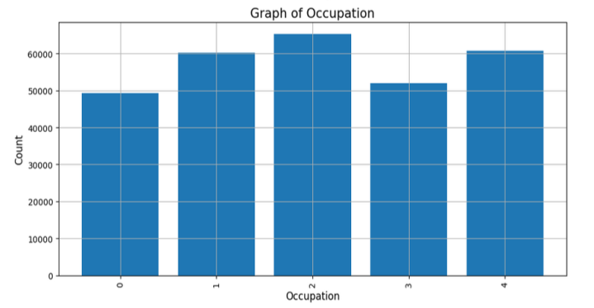 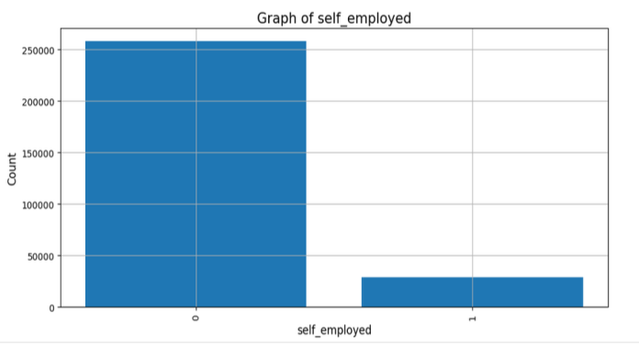

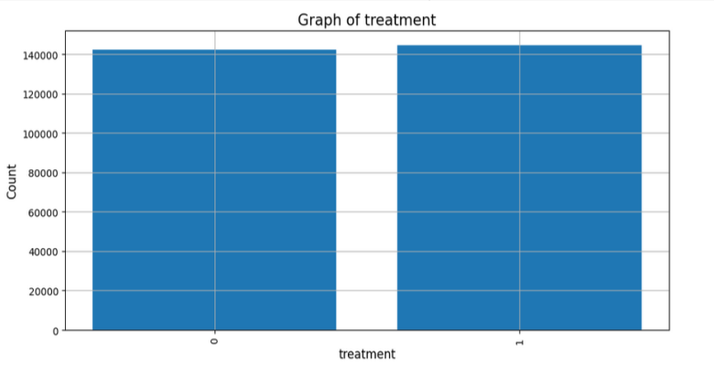 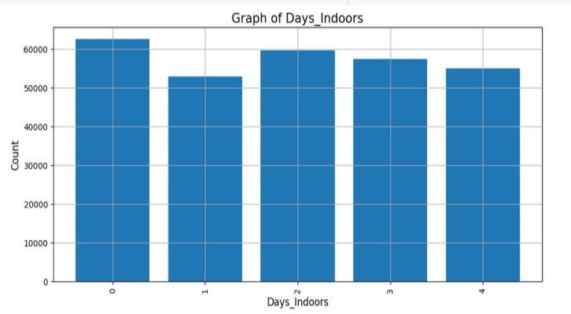

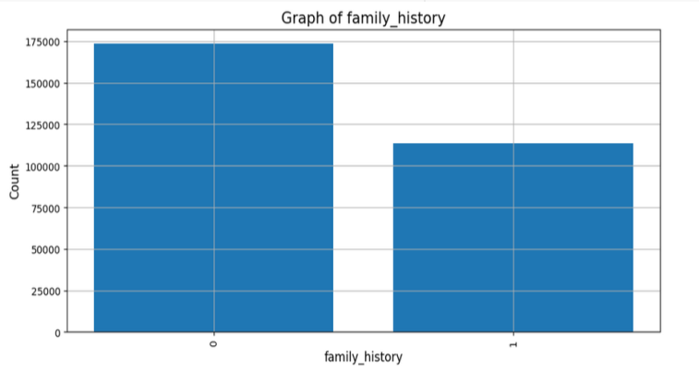 

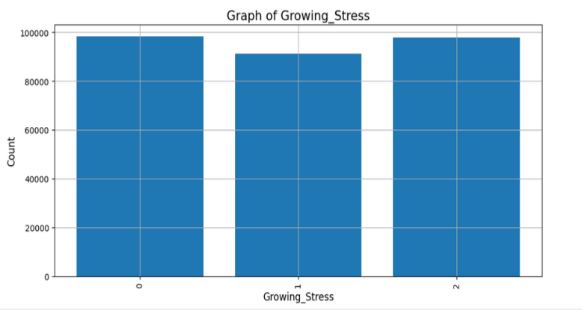 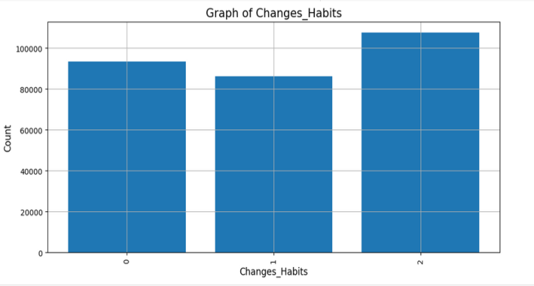

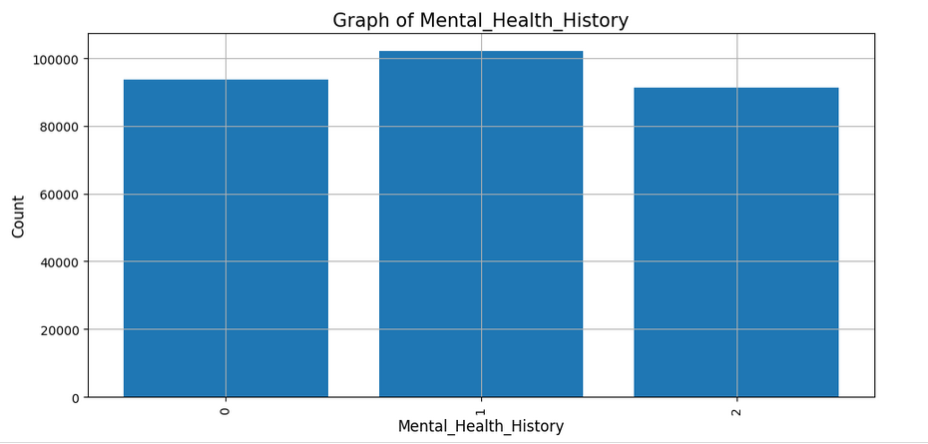 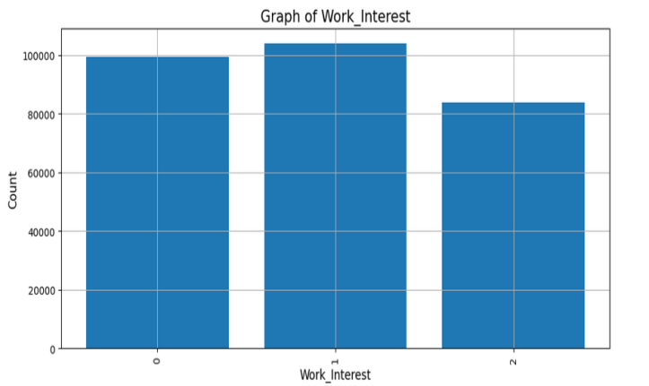 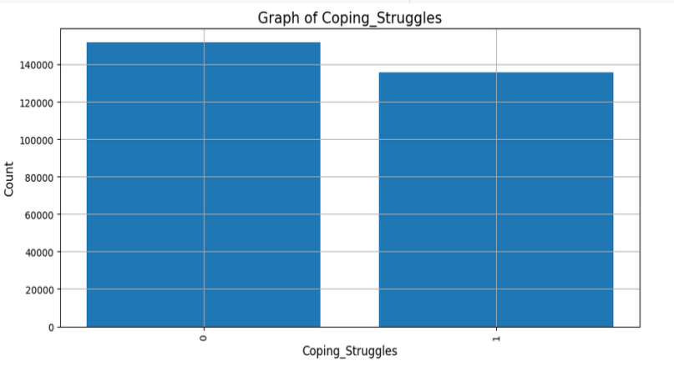 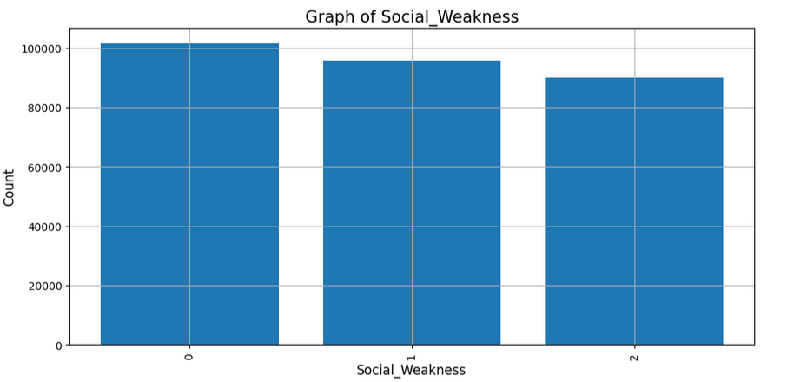

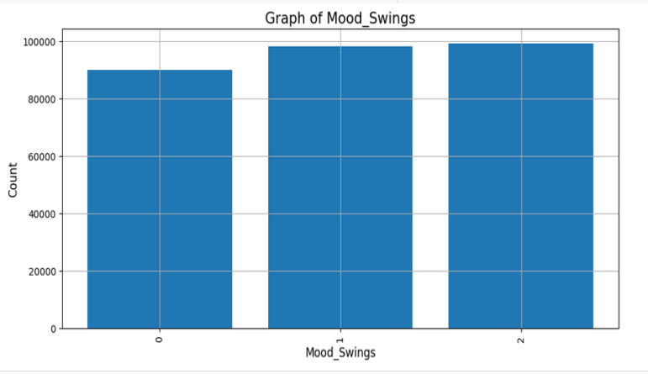 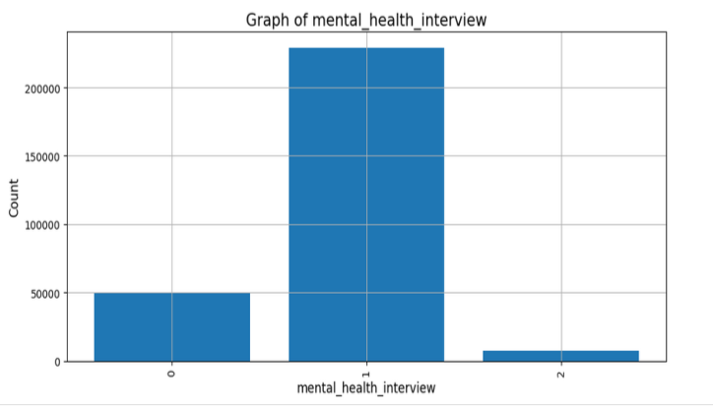

Results of training the decision tree, guassiannb, randomforest ,knn models with target variable as gender and with the rest of the features:

========== Decision Tree ==========

Accuracy : 0.9687810143993871

Recall : 0.9687810143993871

Precision : 0.9694638136630447

F1 Score : 0.9687810143993871

Confusion Matrix:

[[ 8460 1703]

[ 90 47180]]

========== Gaussian Naive Bayes ==========

Accuracy : 0.7991050441383873

Recall : 0.7991050441383873

Precision : 0.7549891598615176

F1 Score : 0.7991050441383873

Confusion Matrix:

[[ 1758 8405]

[ 3133 44137]]

========== Random Forest Classifier ==========

Accuracy : 0.969007365103686

Recall : 0.969007365103686

Precision : 0.969839031099646

F1 Score : 0.969007365103686

Confusion Matrix:

[[ 8439 1724]

[ 56 47214]]

========== KNN ==========

Accuracy : 0.8283913429561403

Recall : 0.8283913429561403

Precision : 0.8547274779654914

F1 Score : 0.8283913429561403

Confusion Matrix:

[[ 313 9850]

[ 6 47264]]

========== Best Model ==========

Best Model: Random Forest Classifier

Accuracy : 0.969007365103686

Recall : 0.969007365103686

Precision : 0.969839031099646

F1 Score : 0.969007365103686

**MAKING THE PREDICTION USING RANDOM FOREST :**

Training Features: ['Gender', 'Occupation', 'Days_Indoors', 'Growing_Stress', 'Changes_Habits', 'Mental_Health_History', 'Coping_Struggles', 'Work_Interest', 'Social_Weakness']

Target: care_options

Please provide the following details for the prediction:

Gender (1 for Male, 0 for Female): 1

Country (e.g., 0 for USA, 1 for India, etc.): 1

Occupation (e.g., 0 for Student, 1 for Employed, etc.): 0

Self Employed (1 for Yes, 0 for No): 0

Family History (1 for Yes, 0 for No): 0

Treatment (1 for Yes, 0 for No): 0

Days Indoors (average days per week): 1

Growing Stress (1 for Yes, 0 for No): 1

Changes in Habits (1 for Yes, 0 for No): 1

Mental Health History (1 for Yes, 0 for No): 0

Coping Struggles (1 for Yes, 0 for No): 0

Work Interest (1 for Yes, 0 for No): 1

Social Weakness (1 for Yes, 0 for No): 1

Mental Health Interview (1 for Yes, 0 for No): 0

care_options (1 for Yes, 0 for No): 0

The model predicts that you do not have Mood Swings.

**CONCLUSIONS:**

**Summary of Findings:**

After applying and evaluating four machine learning models—Decision Tree, Gaussian Naive Bayes, Random Forest Classifier, and K-Nearest Neighbors (KNN)—we identified the Random Forest Classifier as the best performing model for predicting mood swings and the need for care.

**Model Comparison Results:**

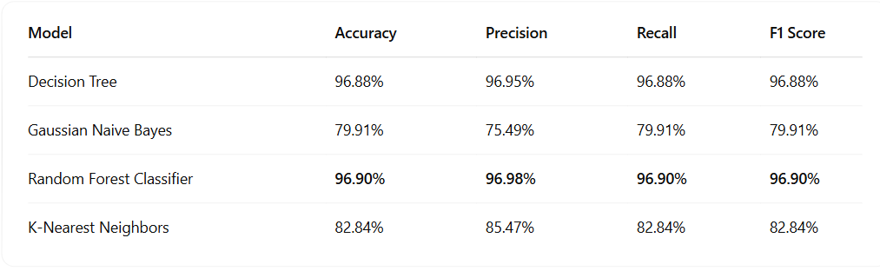

**Best Model: Random Forest Classifier:**

* Confusion Matrix:

[[ 8439 1724]

[ 56 47214]]

* The Random Forest model achieved the highest accuracy and generalization with low false positives and false negatives, making it highly suitable for mood swing prediction.

**Final Thoughts on the Outcome :**

The project successfully built a predictive model capable of identifying individuals who may be experiencing emotional instability or mood swings. Using real-world mental health indicators such as stress levels, coping mechanisms, work interest, and mental health history, the model provides actionable predictions.

In testing, the model classified a real-world user input with the following prediction:

**“The model predicts that you need care."**

This suggests the model is not only working correctly but also providing interpretable and useful output to inform mental health support strategies.

**FUTURE IMPROVEMENTS:**

The current project provides a strong foundation for addressing mood swings of an person using machine learning. However, several future enhancements could further expand its scope and utility, making it more impactful in mental healthcare.

**1. Expanded Data Diversity:** Future work should include datasets representing diverse

populations across various demographics, including age, ethnicity, and geographic

regions. This would improve the model’s generalizability and ensure accurate

predictions for a wider audience, addressing potential biases in the current dataset.

**2. Multimodal Inputs:** Incorporating additional data types, such as text responses,

speech patterns, or physiological metrics like heart rate or sleep cycles, could enrich

the feature set. These multimodal inputs would provide a more holistic view of mental

health, capturing subtle indicators that are often missed in standard

questionnaire-based systems.

**3. Interactive Platforms:** Developing user-friendly platforms, such as dashboards or

mobile apps, would enhance accessibility. These platforms could provide real-time

predictions, intuitive visualizations, and actionable insights, benefiting both clinicians

and individuals seeking self-help tools.

**4. Real-Time Monitoring:** Implementing continuous monitoring capabilities would

allow the system to track changes in mental health over time. Early detection of

worsening symptoms could enable timely interventions, especially for chronic

conditions like depression or stress.

**5. Personalized Feedback:** Extending the model to offer tailored recommendations,

such as stress management techniques or therapy suggestions, would empower

individuals to take proactive steps toward improving their well-being

**REFERENCES:**

**Classification**

<https://dictionary.cambridge.org/dictionary/english/classification>

# Mental Health Prediction

<https://onlinelibrary.wiley.com/doi/10.1155/2022/9970363>

# Label Encoding

<https://www.geeksforgeeks.org/ml-label-encoding-of-datasets-in-python/>

# Heat map

<https://www.techtarget.com/searchbusinessanalytics/definition/heat-map>