EX.No:11

Date:20.09.2020

Reg NO:1518102016

Aim:

Write a Python program to find the greatest common divisor (gcd) of two integers using recursion.

Program:

def gcd(a,b):

if(b==0):

return a

else:

return gcd(b,a%b)

a=int(input("Enter first number:"))

b=int(input("Enter second number:"))

GCD=gcd(a,b)

print("GCD is:")

print(GCD)

LINK:

http://103.53.53.18/mod/vpl/forms/submissionview.php?id=326&userid=1643

Ouput:

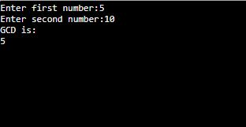

Result:

 Python program is Written to find the greatest common divisor (gcd) of two integers using recursion.