REGNO:1518102016

DATE:19.11.2020

EX NO:10

Aim:

Write a Python function that accepts a string and calculate the number of upper case letters and lower case letters

Program:

def string_test(s):

d={"UPPER_CASE":0,"LOWER_CASE":0}

for c in s:

if c.isupper():

d["UPPER_CASE"]+=1

elif c.islower():

d["LOWER_CASE"]+=1

else:

pass

print("No.of Upper Case characters:",d["UPPER_CASE"])

print("No.of Lower case Characters:",d["LOWER_CASE"])

s=input()

string_test(s)

Link: http://103.53.53.18/mod/vpl/forms/submissionview.php?id=325&userid=1643

Output:

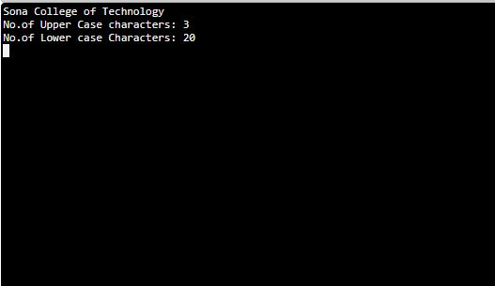

Result:

Thus Python code is written that accepts a string and calculate the number of upper case letters and lower case letters and the output is verified