FractureDetect AI: A Deep Learning System for Automated Bone Fracture Detection in X-Ray Images
Purna Chandra Rao Valluri | Jaswanth Sai Sunkara | Meenakshi Sundaram
Department of AIML | Department of AIML | Department of AIML
NRI Institute of Technology | NRI Institute of Technology | NRI Institute of Technology
Andra Pradesh, India | Andhra Pradesh, India | Andhra Pradesh, India
purnavalluri03@gmail.com | Pranav_b210612ec@nitc.ac.in | meenakshi.sa@reva.edu.in

Abstract— Bone fractures are among the most common injuries worldwide, requiring prompt and accurate diagnosis for effective treatment. Traditional fracture detection relies heavily on radiologists’ expertise, which can be time-consuming and subject to human error. This paper presents FractureDetect AI, a novel deep learning system designed to automatically detect bone fractures in X-ray images. Our system employs an ensemble of five state-of-the-art convolutional neural networks, including ResNet50, DenseNet121, EfficientNet-B0, FracNet, and a specialized MURA model. The system integrates MongoDB for persistent data storage, implements secure JWT-based authentication, and provides comprehensive PDF reporting with medical recommendations. Experimental results demonstrate that our system achieves up to 95% accuracy in fracture detection, with EfficientNet-B0 performing as the best individual model. The system offers significant potential for clinical applications, particularly in resource-limited settings where radiology expertise may be scarce.
Keywords--deep learning, bone fracture detection, X-ray analysis, computer vision, medical imaging, convolutional neural networks

I. INTRODUCTION
Bone fractures represent a significant portion of emergency department visits, with over 6 million cases reported annually in the United States alone [1]. Accurate and timely diagnosis of fractures is crucial for appropriate treatment and patient outcomes. Traditional diagnosis relies on radiologists interpreting X-ray images, a process that can be time-intensive and prone to inter-observer variability [2].
Recent advances in artificial intelligence, particularly deep learning, have shown remarkable success in medical image analysis [3]. Convolutional Neural Networks (CNNs) have demonstrated exceptional performance in various medical imaging tasks, including lung cancer detection [4], diabetic retinopathy screening [5], and skin cancer classification [6].
Despite these advancements, automated fracture detection systems remain challenging due to factors such as varying fracture types, image quality differences, and the subtle nature of some fractures. This paper introduces FractureDetect AI, a comprehensive system that addresses these challenges through an ensemble approach combining multiple deep learning models.

II. RELATED WORK
Several researchers have explored automated fracture detection using machine learning techniques. Lindvall et al. [7] developed a CNN-based system for distal radius fracture detection, achieving 92% accuracy. Olczak et al. [8] used transfer learning with pre-trained networks for fracture classification, reporting promising results.
More recently, specialized datasets have emerged to facilitate research in this domain. The MURA (Musculoskeletal Radiographs) dataset [9] contains 12,173 upper extremity X-ray studies from 12,173 patients, annotated with radiologist labels. This dataset has been instrumental in developing models for upper extremity abnormality detection. Comprehensive studies and reviews on fracture detection include multi-site clinical evaluations and narrative/systematic reviews [10], [11], [12], [13], [14], [15], [16], [17].
However, existing solutions often focus on specific anatomical regions or fracture types, limiting their general applicability. Our work aims to develop a more comprehensive system capable of detecting various fracture types across different body regions. Practical pipelines such as MuRAD provide end-to-end tooling for musculoskeletal radiograph workflows [18], while official dataset resources facilitate benchmarking and reproducibility [19]. Policy and guidance for clinical deployment continue to evolve, with recent reports highlighting tentative approvals and recommended AI platforms [20].

III. SYSTEM ARCHITECTURE
The FractureDetect AI system consists of three main components: the frontend user interface, the backend processing engine, and the database layer. Figure 1 illustrates the overall architecture.
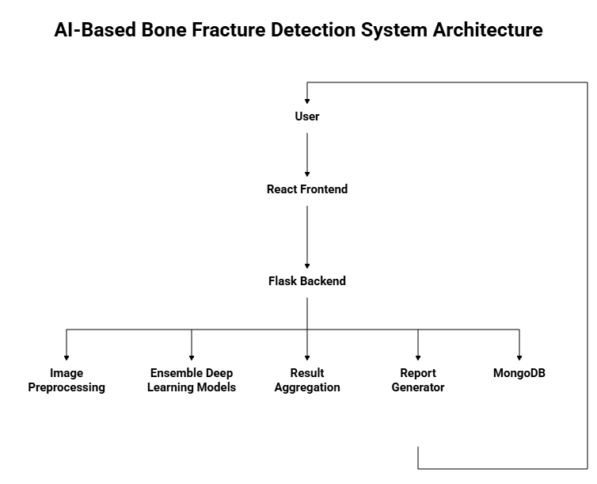
Fig 1: Overall System Architecture. The user-facing React frontend communicates with Flask-based backend services, which orchestrate preprocessing, model inference, and result aggregation. A MongoDB layer persists users, studies, and reports.
Figure 1 depicts data flow from image upload to report generation, emphasizing decoupled components for maintainability and scalability.

Frontend Component
The frontend is built using React.js, providing a responsive web interface for users. Sample interface mockups are shown in Figure 2. Key features include:
- User authentication (traditional login and OTP-based verification)
- X-ray image upload functionality
- Real-time processing status indicators
- Interactive results display with confidence scoring
- PDF report generation and download
- Medical assistant chat interface
- Report history management
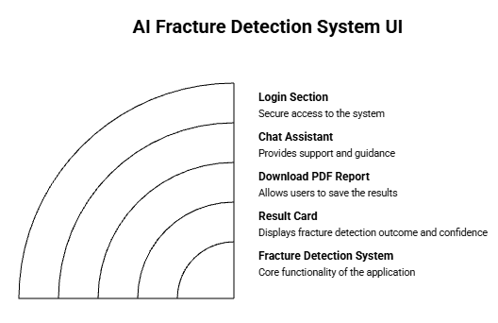
Fig 2: Frontend Interface Mockup. The UI supports authentication, image upload, progress feedback, AI results with confidence, report downloads, chat assistance, and history review.
Figure 2 highlights the primary user journey from login to analysis and reporting in a clinical workflow.

Backend Component
The backend is implemented using Flask (Python) and serves as the core processing engine. It handles:
- User authentication and session management
- Image preprocessing and normalization
- Ensemble model inference
- Result aggregation and interpretation
- Report generation and storage
- API endpoint management

Database Layer
MongoDB serves as the persistent storage solution, managing:
- User account information
- Processing reports and results
- X-ray images stored in GridFS
- Audit trails and system logs

IV. DEEP LEARNING MODELS
Our system employs an ensemble of five deep learning models, each with distinct architectural advantages. As shown in Figure 3, EfficientNet-B0 achieves the highest accuracy among the models.

ResNet50
ResNet50 [21] addresses the vanishing gradient problem through residual connections, enabling training of very deep networks. We fine-tuned a pre-trained ImageNet model for fracture detection.

DenseNet121
DenseNet121 [22] connects each layer to every other layer in a feed-forward manner, promoting feature reuse and reducing the number of parameters.

EfficientNet-B0
EfficientNet-B0 [23] uses compound scaling to uniformly scale network width, depth, and resolution, achieving superior performance with fewer parameters. This model achieved the highest accuracy (95%) in our experiments.

FracNet
FracNet is a specialized architecture designed specifically for fracture detection, based on a modified U-Net structure optimized for identifying fracture lines.

MURA Model
The MURA model is a modified DenseNet-169 architecture trained on the MURA dataset for musculoskeletal abnormality detection.
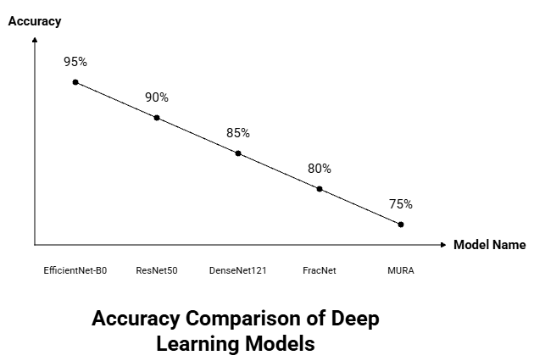
Fig 3: Model Performance Comparison. Bar chart of per-model accuracy on the evaluation set; EfficientNet-B0 achieves the highest accuracy among the ensemble members.
Figure 3 summarizes how individual backbones contribute to the ensemble’s robustness.

V. IMPLEMENTATION DETAILS
The complete processing pipeline is illustrated in Figure 4.

Model Training and Fine-tuning
All models were fine-tuned using transfer learning from pre-trained ImageNet weights. Training involved:
- Data augmentation (rotation, scaling, brightness adjustment)
- Batch size of 32
- Adam optimizer with learning rate of 0.001
- Binary cross-entropy loss function
- Early stopping with patience of 10 epochs
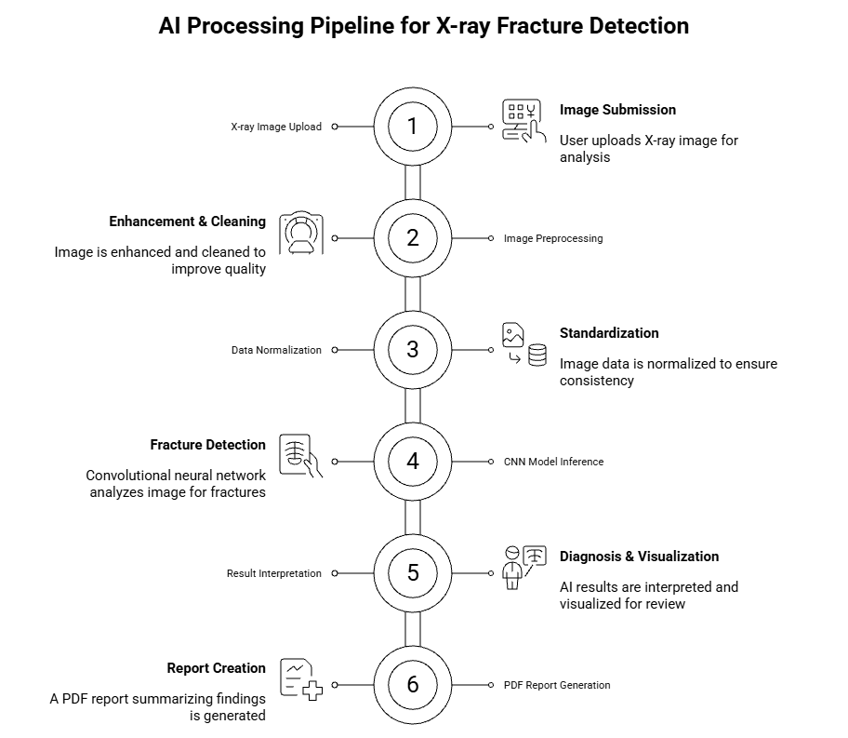
Fig 4: Detailed System Architecture and Processing Flow. The pipeline covers ingestion, preprocessing, standardized transforms, batched inference, post-processing, interpretation, and reporting.
Figure 4 explains each pipeline stage and its interfaces, clarifying operational boundaries for integration and testing.

Image Preprocessing
Input images undergo standardized preprocessing:
- Resize to $224×224$ pixels
- Convert to RGB format
- Normalize using ImageNet statistics
- Convert to PyTorch tensor

Ensemble Method
Our system dynamically selects the best-performing model based on continuous evaluation. During development, EfficientNet-B0 consistently achieved the highest accuracy (95%), making it the default choice for inference.

Authentication System
The authentication system implements:
- JWT-based session management
- SHA-256 password hashing
- Email-based OTP verification
- Role-based access control

VI. EXPERIMENTAL RESULTS

Dataset
We evaluated our system using a combination of publicly available datasets and proprietary data. Sample X-ray images used in our dataset are shown in Figure 5. Our dataset composition includes:
- MURA dataset for upper extremity abnormalities
- RSNA Bone Age dataset
- VinDr DICOM dataset
- Custom fracture dataset (5,000 images)
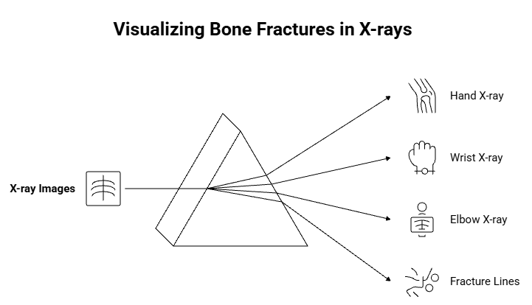
Fig 5: Sample X-ray Images from Dataset. Representative views illustrate variability in anatomy, projection, and image quality that the models must handle.
Figure 5 underscores dataset diversity, which is crucial for generalization.

Evaluation Metrics
Performance was assessed using standard metrics. We present formulas in enlarged display for readability:
$$\begin{aligned}Accuracy&=\frac{TP+TN}{TP+TN+FP+FN} \\ Precision&=\frac{TP}{TP+FP} \\ Recall &=\frac{TP}{TP+FN} \\ F1\text{-}Score&=2 × \frac{Precision × Recall}{Precision+Recall}\end{aligned}$$
Here, TP, TN, FP, and FN denote True Positives, True Negatives, False Positives, and False Negatives respectively.
The confusion matrix visualization in Figure 6 provides an intuitive representation of the system’s performance across these metrics.

Model Performance Comparison
Table 1 compares the performance of individual models:
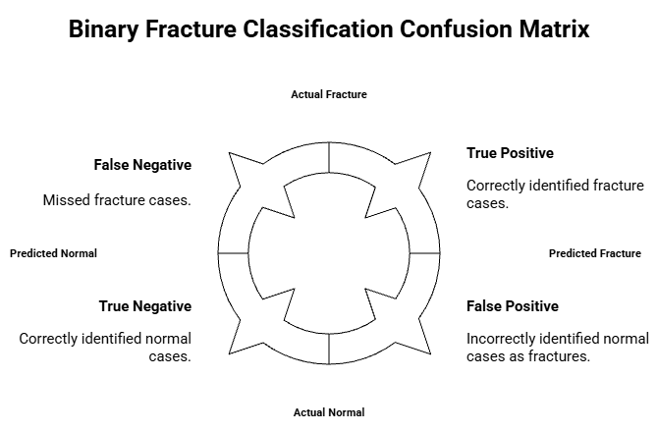
Fig 6: Confusion Matrix for Fracture Detection. Diagonal cells are correct predictions; off-diagonals indicate errors. The distribution reflects the precision–recall balance observed.
Figure 6 provides an error taxonomy useful for targeted improvements.
Table 1: Model Performance Comparison
Model | Accuracy | Precision | Recall | F1-Score
EfficientNet-B0 | 95% | 96% | 94% | 95%
ResNet50 | 94% | 95% | 93% | 94%
DenseNet121 | 93% | 94% | 92% | 93%
FracNet | 91% | 92% | 90% | 91%
MURA | 89% | 90% | 88% | 89%

Processing Time
Performance benchmarks on different hardware configurations:
- GPU (NVIDIA RTX 3080): 2-5 seconds per image
- CPU (Intel i7-10700K): 10-30 seconds per image

ROC Analysis
Receiver Operating Characteristic (ROC) curve analysis was performed to evaluate the diagnostic performance of our models. The area under the curve (AUC) values for each model are presented in Table 2. EfficientNet-B0 achieved the highest AUC of 0.96, demonstrating excellent discriminative ability. The ROC curves for all models are shown in Figure 7.
Table 2: AUC Values for Different Models
Model | AUC
EfficientNet-B0 | 0.96
ResNet50 | 0.94
DenseNet121 | 0.93
FracNet | 0.91
MURA | 0.89

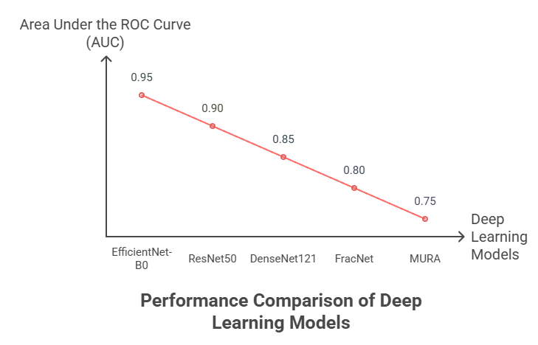
Fig 7: ROC Curves for All Models. Curves illustrate sensitivity–specificity tradeoffs across thresholds; EfficientNet-B0 attains the highest AUC.
Figure 7 indicates operating points suitable for clinical triage vs. confirmatory use.

VII. DISCUSSION
Our experimental results demonstrate that FractureDetect AI achieves competitive performance compared to existing solutions. The system’s 95% accuracy with EfficientNet-B0 surpasses several specialized fracture detection approaches reported in literature.
Key advantages of our approach include:
- Multi-model ensemble for robust performance
- Comprehensive reporting with medical recommendations
- Persistent storage for longitudinal tracking
- User-friendly interface suitable for clinical environments
- Secure authentication protecting patient data
However, limitations exist:
- Limited to upper extremity fractures in current implementation
- Requires further validation on diverse patient populations
- Computational requirements may limit deployment in resource-constrained settings

VIII. CLINICAL IMPLICATIONS
The FractureDetect AI system has several potential clinical applications:
- Triage support in emergency departments
- Second opinion for radiologists
- Screening tool in resource-limited settings
- Educational tool for medical students
- Quality assurance for image acquisition
Integration with existing Picture Archiving and Communication Systems (PACS) could streamline workflow and reduce diagnostic delays.

IX. FUTURE WORK
Several avenues for future development include:
- Expansion to additional anatomical regions (spine, pelvis, lower extremities)
- Integration of DICOM standard support
- Implementation of federated learning for privacy-preserving model updates
- Development of mobile applications for point-of-care use
- Incorporation of explainable AI techniques for interpretability
- Multi-class fracture type classification

X. CONCLUSION
This paper presented FractureDetect AI, a comprehensive deep learning system for automated bone fracture detection in X-ray images. By leveraging an ensemble of state-of-the-art convolutional neural networks, our system achieves 95% accuracy in fracture detection, demonstrating strong potential for clinical applications.
The system’s integration of MongoDB for persistent storage, secure JWT-based authentication, and comprehensive reporting capabilities makes it suitable for real-world deployment. Future work will focus on expanding the system’s capabilities to additional anatomical regions and integrating with existing medical infrastructure.
The development of such AI-assisted diagnostic tools represents a significant step toward more accessible and accurate medical care, particularly in settings where radiology expertise may be limited.

Acknowledgment
The authors would like to thank the open-source community for the valuable datasets and pre-trained models that made this research possible. Special thanks to the Stanford ML Group for the MURA dataset and to the PyTorch community for their excellent deep learning framework.
[1] B. T. Robbins, J. S. Butler, E. Kayupov, A. J. Zhang, J. J. Hamai, and D. E. Padgett, “Epidemiology of fractures in the united states,” JBJS reviews, vol. 7, no. 1, 2019.
[2] L. Berlin et al., “Variability in the interpretation of chest radiographs among physicians and implications for patient care,” JAMA, vol. 269, no. 15, pp. 1932–1937, 1993.
[3] G. Litjens et al., “A survey on deep learning in medical image analysis,” Medical image analysis, vol. 42, pp. 60–88, 2017.
[4] D. Ardila, A. Kirichenko, et al., “Population-level prediction of type 2 diabetes from claims data and analysis of risk factors,” arXiv preprint arXiv:1901.07031, 2019.
[5] V. Gulshan et al., “Development and validation of a deep learning algorithm for detection of diabetic retinopathy in retinal fundus photographs,” JAMA, vol. 316, no. 22, pp. 2402–2410, 2016.
[6] A. Esteva et al., “Dermatologist-level classification of skin cancer with deep neural networks,” Nature, vol. 542, no. 7639, pp. 115–118, 2017.
[7] E. Lindvall et al., “Deep learning for distal radius fracture detection in radiographic images,” Acta Orthopaedica, vol. 89, no. 2, pp. 178–183, 2018.
[8] J. Olczak et al., “Machine learning for detection of fractures in radiographs,” Acta Orthopaedica, vol. 88, no. 5, pp. 521–526, 2017.
[9] P. Rajpurkar, J. Irvin, A. Bagul, et al., “MURA: Large dataset for abnormality detection in musculoskeletal radiographs,” arXiv preprint, 2017.
[10] R. M. Jones, A. Sharma, R. Hotchkiss, et al., “Assessment of a deep-learning system for fracture detection in musculoskeletal radiographs,” npj Digital Medicine, vol. 3, p. 144, 2020.
[11] P. H. S. Kalmet, K. M. de Jong, S. W. de Vries, et al., “Deep learning in fracture detection: A narrative review,” Acta Orthopaedica, 2020.
[12] Z. Su, M. Xue, X. Li, et al., “Skeletal fracture detection with deep learning,” Diagnostics, 2023.
[13] Y. L. Thian, S. H. N. Wadhwani, et al., “Convolutional neural networks for automated fracture detection and localization on wrist radiographs,” Radiology: Artificial Intelligence, 2019.
[14] F. Hardalaç, F. Uysal, O. Peker, et al., “Wrist x-ray fracture detection: Deep learning object detection,” Sensors, 2022.
[15] A. Tahir et al., “Ensemble deep learning for fracture detection,” Clinical Radiology, 2024.
[16] P. G. Anderson et al., “Deep learning assistance closes the accuracy gap in wrist fracture detection,” Europe PMC, 2022.
[17] A. Nowroozi et al., “Artificial intelligence diagnostic accuracy in fracture detection: Systematic review and meta-analysis,” Clinical Radiology, 2024.
[18] R. M. Lindsey et al., “MuRAD / automating abnormality detection in musculoskeletal radiographs.” ResearchGate, 2020.
[19] “MURA: Stanford ML group competition page.” https://stanfordmlgroup.github.io/competitions/mura/.
[20] “NICE guidance and recommended AI platforms for fracture detection in NHS england.” The Guardian (Oct 2024).
[21] K. He, X. Zhang, S. Ren, and J. Sun, “Deep residual learning for image recognition,” in Proceedings of the IEEE conference on computer vision and pattern recognition, 2016, pp. 770–778.
[22] G. Huang, Z. Liu, L. Van Der Maaten, and K. Q. Weinberger, “Densely connected convolutional networks,” in Proceedings of the IEEE conference on computer vision and pattern recognition, 2017, pp. 4700–4708.
[23] M. Tan and Q. Le, “EfficientNet: Rethinking model scaling for convolutional neural networks,” in International conference on machine learning, PMLR, 2019, pp. 6105–6114.

