**Portfolio Optimization and Backtesting Report**

**My approach**

The first thing was, I created an API key from Alpha Vantage to enable financial data retrieval. This report outlines the design, construction, and evaluation of a quantitative portfolio optimization strategy. The project aimed to build a robust and diversified equity portfolio using carefully selected financial indicators, primarily **Momentum** and **Volatility**, and allocate weights through **Risk Parity Optimization**. Backtesting was performed over a two-year period with monthly rebalancing and a lookback period of 6 months realistic transaction costs with transaction cost of 0.001.

**Introduction to my strategy**

The objective of this project is to design a portfolio that balances returns with risk through systematic stock selection and dynamic allocation. The core idea is to ensure that each asset in the portfolio contributes equally to overall portfolio risk—a concept known as **Risk Parity**. This approach considers equal contribution of risks by each stock in the portfolio and ensures diversification not just in asset weights, but in risk exposure.

**Portfolio Construction**

**Stock Universe**

A large universe of blue-chip and tech stocks were selected to ensure diversity. The complete stock list includes: AAPL, MSFT, GOOG, AMZN, META, ORCL, IBM, TSLA, NVDA, INTC, JPM, V, PG, CSCO, UNH, HD, BAC, WMT, MA, CRM, ABBV, XOM, AVGO, CVX, LLY, GILD, NEE, TMO, VZ, KO, MRK, PEP, DHR, MCD, ACN, LIN, CMCSA, NKE, TXN, RTX, AMT, HON, UPS, LOW, ADP, CAT, INTU, MS, AMD

**Stock Selection**

Out of this universe, the top 10 stocks were selected based on a scoring function combining two parameters:

* **Momentum**: Percentage return over the last 6 months (126 trading days).
* **Volatility**: Standard deviation of daily returns over the past 6 months.

Each metric was **normalized**, and the sum of the normalized scores determined the final rank of each stock.

The combined score = normalized momentum – normalized volatility. As, higher the momentum the better the return and lower the volatility the more stable the stock is.

**Rationale Behind Stock Selection**

* **Momentum** is used because of the assumption that stocks which have performed well recently often continue to perform well in the near future (momentum effect). For example, if a stock does well in the 12th month of backtesting it is supposed to do good in the next i.e, 13th month as well.
* **Volatility** is used inversely as a risk filter. Lower volatility is often associated with more stable returns. As volatility has crucial
* Combining the two can give us stocks that are both **performing well and stable**, offering a practical trade-off between risk and return.

**Parameter Selection and Financial Reasoning**

**Momentum**

* **Financial Theory**: Based on the idea of behavorial biases and delayed overreaction.
* **Calculation**: 6 months price return.
* Stocks with recent strong performance are likely to keep up the trend due to investor sentiment and fund flow continuation. The idea was the stock that gives good returns at the end of the lookback period is expected to maintain good returns a month (frequency taken) later also.

**Volatility**

* **Financial Theory**: Risk is typically represented by standard deviation of returns.
* **Calculation**: 6 months rolling standard deviation(volatility) of daily returns.
* Stable stocks are often less prone to large losses. This helps filter out highly unstable assets. Lower the volatility the more stable the stocks.

**Risk Parity Optimization**

* **Mathematical Objective**: Allocate weights such that each asset contributes equally to portfolio variance. That is, we want the stocks to contribute equally to the final risk. This method is good for a **low risk, medium returns investor** to which I feel the most relatable. This is a major reason for my usage of this Optimization method for this task. Portfolios built with risk parity often achieve **higher Sharpe Ratios** by reducing overexposure to high-volatility assets and increasing allocation to stable ones.
* Risk Parity was chosen for its ability to **balance risk intelligently**, reduce drawdowns, and provide **consistently stable returns**, making it an ideal fit for a robust and realistic portfolio allocation strategy.

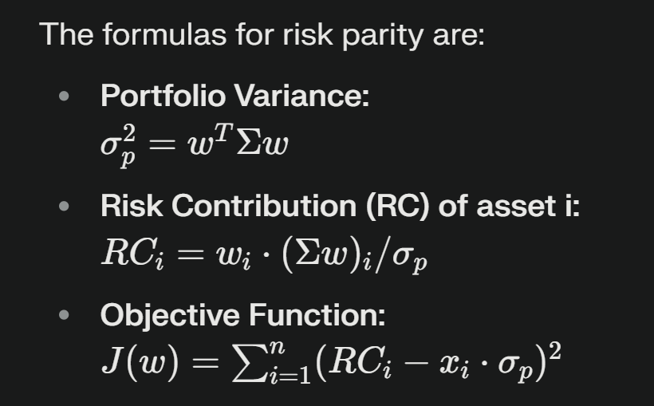

Equal risk contribution ensures diversification in **risk space**, which can be more meaningful than diversification in capital allocation. Plus, equal weightage of stocks wont contribute equally toward risks due to varying volatilities and momentum of stocks from time to time.

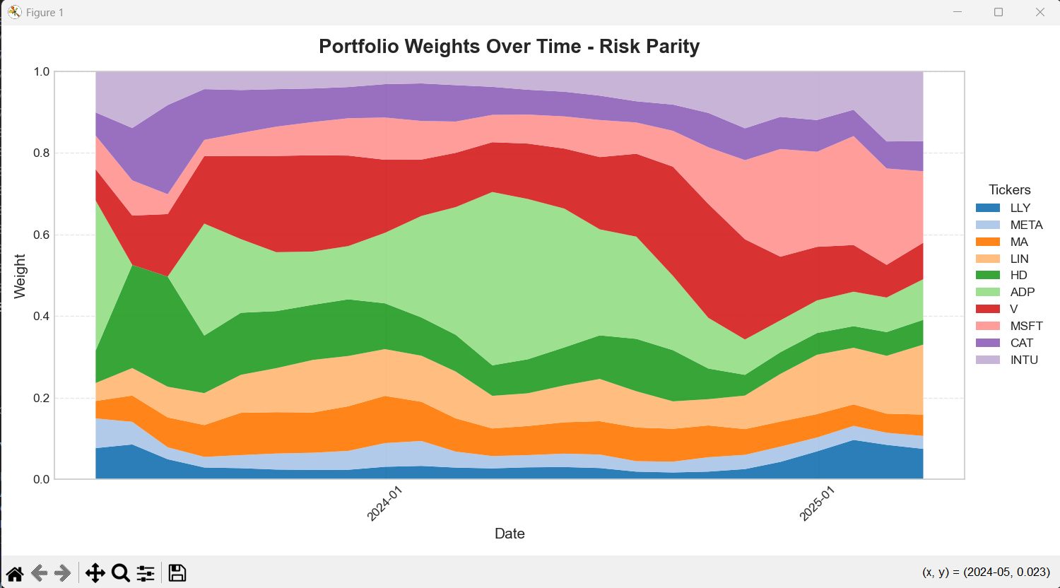

**Backtesting Methodology**

**Data Source**

* **Provider**: Alpha Vantage (via API key) and yfinance as a fallback.
* **Data Range**: 2 years from current time of daily price data.
* **Tickers**: Top 10 stocks selected dynamically based on scoring.

**Rebalancing**

* **Frequency**: Monthly (ME).
* **Prints the rebalanced data of every month based on historical data**.
* **Process**: On each rebalancing date, the last 252 trading days were used as the lookback window for optimization.

**Transaction Costs**

* **Assumption**: 0.1% per side as standard transaction cost rate for each trade.
* After optimization, the weights were penalized for changes from the previous weights to reflect real-world slippage.

**Avoiding Look-ahead Bias by:**

* At each rebalance, only past data was used to calculate momentum, volatility, and covariance matrix.

**Performance Evaluation**

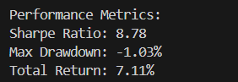

Sharpe Ratio

* Definition: Measures the risk-adjusted return—how much excess return you earn for each unit of risk taken.
* Result: 8.78, which indicates exceptionally strong performance with very high return relative to portfolio volatility. A Sharpe Ratio above 3 is considered excellent; 8.78 reflects highly consistent and efficient risk-taking.

Max Drawdown

* Definition: The maximum observed loss from a peak to a trough during the backtest, showing the worst-case downside.
* Result: -1.03%, meaning the portfolio only declined slightly at its worst point. This indicates very low downside risk and high portfolio stability.

Total Return

* Definition: The overall percentage gain over the backtesting period.
* Result: 7.11%, meaning every $1 invested became $1.0711 by the end of the backtest. This return is solid, especially considering the low drawdown and high Sharpe **Ratio.**

**Limitations and Potential Improvements**

**Limitations**

* Only two parameters used (momentum and volatility).
* Risk parity assumes covariance matrix is stable, which may not hold in turbulent markets.

**Improvements**

* Including additional factors like **liquidity**, **fundamental indicators** (P/E, ROE), or **macroeconomic variables**.
* Trying other optimization techniques like **MSRP** or **Minimum Variance.**