Creation Workshop

UV DLP Slicing and Control Software

User Manual and Quick Config

Version 0.1 Alpha pre-release
02/21/13 by PacManFan

Since this is a pre-alpha release intended for initial testers, I’m not going to have a complete user manual ready. This is more of a quick-start guide on getting models sliced and exported as images.

General notes:
This is a pre-alpha release, I have verified the slicing and export functionality fairly well; however, I’m still in the process of constructing my own UV DLP 3d printer. I make absolutely no guaranties on the suitability of driving your machine with this control software.

Changing the view
You can use the mouse to move the view. Holding the left mouse button will cause the viewpoint to orbit around the model. Holding the right mouse button and moving up or down will move the viewpoint towards/away from the model.

Setting up a basic machine printer configuration
Click the View->Machine Properties menu item to bring up the machine configuration.
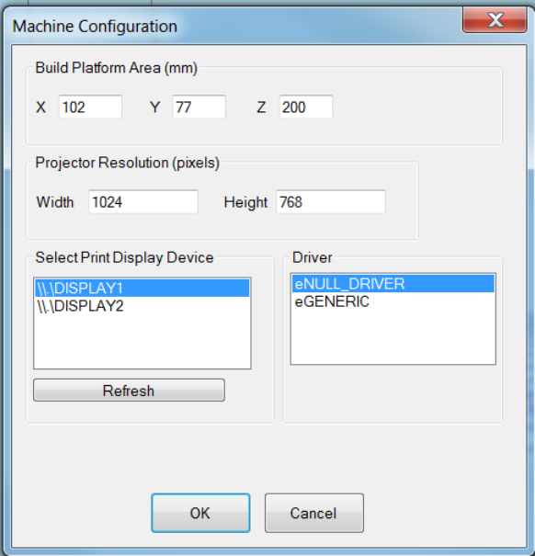
Under the build platform area:
The X and Y sizes correspond to the projected image size on the bottom of your resin build tray. Note that this may or may not be the actual size of your build tray- It’s probably smaller.
The Z Size corresponds to the ZAxis length. This length is the distance from the down position where the build arm is touching the top of the resin build tray to the uppermost point where the ZAxis triggers your limit switch.

Select Print Display Device
In this section you can select which attached monitor (projector) will be used to display the images. Clicking on a monitor will set the appropriate detected monitor resolution in the Projector resolution fields. This also determines the size (and aspect ratio) of generated image slices. Make sure to correctly set this to the resolution of your DLP projector.
Note – I have determined that automatically detecting the resolution does not always work on Linux based systems, you may have to manually type the know projector resolution.
There are 2 offered print drivers by default. The eNULL_DRIVER is the driver I have been using for testing while NOT connected to a machine. It is a simple null driver that simulates the printers responses. If you’re feeling adventurous, you can use the eGENERIC driver to connect to a live machine

Configuring Slicing Options
You can view the current slicing options under the “View->Slicing Options” menu item.
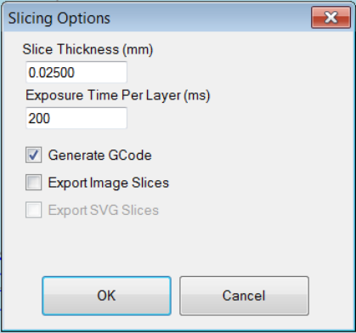
Most of this is self-explanatory. The slice thickness can be changed, as well as the per-layer exposure time. Leave the “Generate G-Code” checkbox check. You can optionally export individual images, although they are not required for the model build, they are generated on-the-fly.

Loading a model
Use either the load model icon or the load model menu option to load a binary STL file. Note – initial ASCII STL model support is implemented, however I’ve had some issues with certain ASCII STL files causing the app to crash or hang on import.
Now the model is loaded, click the “Place on Platform” button to center the model and place it on the platform. You can optionally scale the model by entering in a scale value and clicking the “Scale” button.

Slicing a model
Now that your machine and slicing options have been configured, you can slice a model by clicking the slice icon from the toolbar.
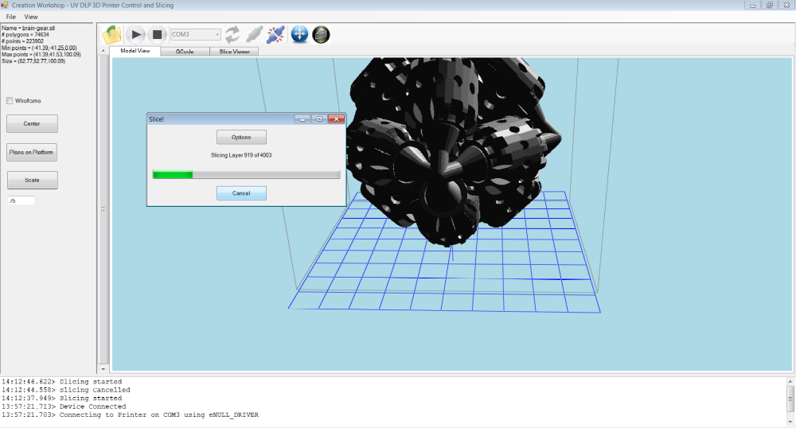

You can cancel the slicing process after slicing is started by clicking the “Cancel” button.
Viewing Slices
Now that the model is sliced, you can examine the generated image slices in the “Slice Viewer” tab, located under the toolbar. Click on the tab and use the scrollbar on the right to move through the individual slices.
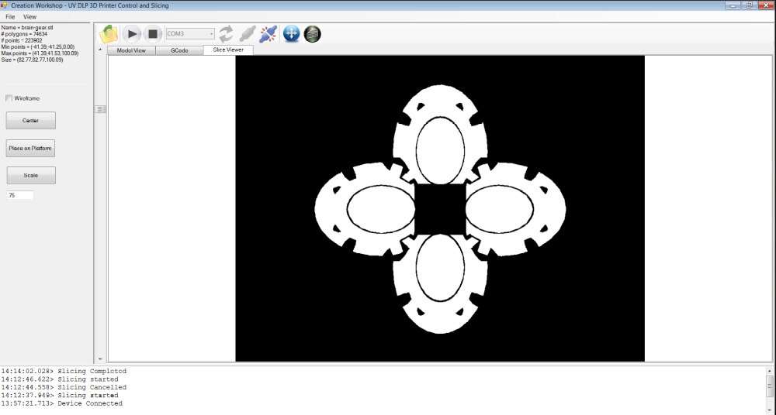
You can also view the 3d-slices by checking the “wireframe” checkbox and using the scrollbar to see the highlighted red slice outline.
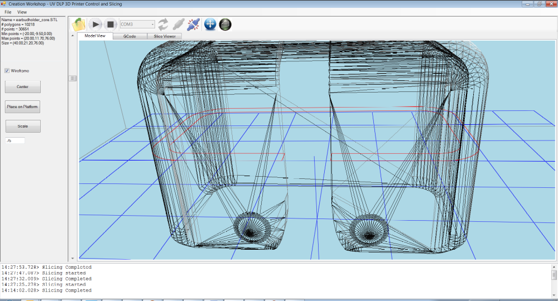

The Build Process
In order to build the model, you need to be connected to a machine (obviously). For testing purposes and to get an idea of what the build process does, use the null driver in your machine configuration, select any com port, and click the “Connect” button on the toolbar. Once you have sliced a model and connected to a machine, you can click the “Start Build” button to start the build process. If you have a secondary monitor (or projector) connected to your system, a full-screen window will appear that displays the individual image slices. If you are using only a single monitor, this screen will appear over your primary display (probably not what you want)
How the build process works
This program uses information from the sliced model, along with generated GCode to control both the printer hardware and projector simultaneously. Special comment lines are generated inside the GCode file that tells the build manager to perform special action:
G1 Z0.00000 F100 (Move Z axis to position)
(<Slice> 0 )
(<Delay> 500)
G1 Z0.02500 F100 (Move Z axis to position)
(<Slice> 1 )
(<Delay> 500)
G1 Z0.05000 F100 (Move Z axis to position)

You might recognize the G1 as a movement command. The (<Slice> 0 ) line tells the build Manager to display slice 0, and the (<Delay> 500) line tells the Build Manager to pause for 500 milliseconds. Much of this is still experimental. I will probably need to insert an additional delay after the move command to allow the ZAxis time to travel to the next position before displaying the next image slice. The next G1 movement command will not be sent to the machine until AFTER the slice and delay commands have executed. This differs from most GCode build systems that will send as many commands as possible to the device.

Use of GCode:
When the machine configuration is set up, 4 GCode files are created in a sub-directory of the same name:
start.gcode
preslice.gcode
postslice.gcode
end.gcode

The contents of the start.gcode file are inserted at the beginning of the generated gcode file. Likewise, the end.gcode is inserted at the end of file for any shut down commands. The preslice.gcode is inserted immediately before each G1 movement command, and the postslice.gcode is inserted immediately after the G1 command. You can modify the contents of these files to suit your machines individual needs.
If you make changes to any of these files, the changes won’t take effect until after you restart the application and re-slice the model.

Manual Control
After the machine is connected, you can manually job the z position up or down by using the manual printer control display.
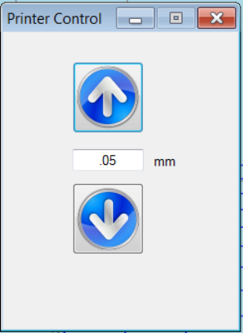

Future Efforts:

Final Words:
This project has taken quite a bit of time and effort. I would love to see this application become a part of the community tools for printer control. Please take the time to report any bugs, give any constructive feedback and design recommendations to:
Pacmanfan321@gmail.com
If you appreciate this program, please also consider donating to me via @ www.paypal.com !

