MULTI AGENT SYSTEM FOR STUDENT COMPETENCY ANALYSIS

A Project Report

Submitted in partial fulfillment of the requirements
for the award of the degree of

BACHELOR OF TECHNOLOGY
in
COMPUTER SCIENCE AND ENGINEERING (DATA SCIENCE)

Submitted by

P. SUJAYA RAGHAVI
(22501A4459)

K. JATADHARA SAI
(22501A4425)

D. SUSHANTH TEJA
(22501A4412)

Under the esteemed guidance of

Mrs. SREEJA, M.Tech.
Assistant Professor
Department of Computer Science and Engineering (Data Science)

DEPARTMENT OF COMPUTER SCIENCE AND ENGINEERING (DATA SCIENCE)

ACADEMIC YEAR 2025 - 2026

CERTIFICATE
This is to certify that the project report entitled "MULTI AGENT SYSTEM FOR STUDENT COMPETENCY ANALYSIS" is a bonafide work carried out by P. SUJAYA RAGHAVI (22501A4459), K. JATADHARA SAI (22501A4425), and D. SUSHANTH TEJA (22501A4412), students of the Department of Computer Science and Engineering (Data Science), in partial fulfillment of the requirements for the award of the degree of BACHELOR OF TECHNOLOGY in Computer Science and Engineering (Data Science), during the academic year 2025-2026.
The results embodied in this project report have not been submitted to any other university or institute for the award of any degree or diploma. The work has been carried out under our supervision and guidance, and has been found to be satisfactory.

Mrs. SREEJA, M.Tech. Mrs. B. JANAKI
Project Guide Head of the Department
Assistant Professor Department of CSE (Data Science)
Department of CSE (Data Science)

Dr. SIVAJI
Principal

Submitted for the University Viva-Voce examination held on: ____________________

Internal Examiner External Examiner

DECLARATION
We hereby declare that the project report entitled "MULTI AGENT SYSTEM FOR STUDENT COMPETENCY ANALYSIS" submitted to the Department of Computer Science and Engineering (Data Science), in partial fulfillment of the requirements for the award of the degree of Bachelor of Technology in Computer Science and Engineering (Data Science), is an original work carried out by us under the esteemed guidance of Mrs. SREEJA, M.Tech., Assistant Professor, Department of Computer Science and Engineering (Data Science).
The work presented in this report has not been submitted to any other university or institute for the award of any degree or diploma. All sources of material used in the preparation of this report have been duly acknowledged. Any reproduction of text, figures, or data from any other work has been properly cited, and we take full responsibility for the originality of the content and the accuracy of the implementation described herein.
We further declare that, to the best of our knowledge and belief, the ideas, concepts, and findings presented in this report are our own except where due reference has been made in the text. We acknowledge that any form of academic dishonesty such as plagiarism, fabrication, or falsification of data would be treated as a serious breach of academic integrity.

Place: P. SUJAYA RAGHAVI (22501A4459)
Date: K. JATADHARA SAI (22501A4425)
D. SUSHANTH TEJA (22501A4412)

ACKNOWLEDGEMENT
The satisfaction and euphoria that accompany the successful completion of any task would be incomplete without mentioning the people who made it possible, whose constant guidance and encouragement crowned our efforts with success.
We extend our heartfelt gratitude to our project guide, Mrs. SREEJA, M.Tech., Assistant Professor, Department of Computer Science and Engineering (Data Science), for her invaluable guidance, constant encouragement, constructive criticism, and patient supervision throughout the course of this project work. Her insights into multi-agent systems and generative AI shaped the direction of this project, and her willingness to review our design decisions at every stage made this report possible.
We sincerely thank Mrs. B. JANAKI, Head of the Department, Computer Science and Engineering (Data Science), for her continuous support, timely suggestions, and for providing all the facilities required to carry out this project successfully. Her leadership and the environment she fosters in the department have been a great motivation for us to pursue research-oriented project work.
We are deeply grateful to Dr. SIVAJI, Principal, for providing the necessary infrastructure, computational resources, and a conducive academic environment that enabled us to carry out our work without constraints. We also thank the Management of our institution for their unwavering support to student research and project-based learning.
We gratefully acknowledge the entire faculty of the Department of Computer Science and Engineering (Data Science) for their guidance, suggestions, and encouragement at various stages of this project. Their teaching over the last four years has built the foundation on which this project stands. We also thank the non-teaching staff of the department for their timely help with laboratory facilities.
We are indebted to our parents and family members for their love, constant support, prayers, and patience throughout our engineering education. Their belief in us kept us going during the difficult phases of this project. Finally, we thank our friends and peers who offered valuable feedback during internal reviews and helped us test the system with genuine enthusiasm.
Above all, we thank the Almighty for His blessings, without which this work would not have been possible.

P. SUJAYA RAGHAVI (22501A4459)
K. JATADHARA SAI (22501A4425)
D. SUSHANTH TEJA (22501A4412)

ABSTRACT
Standard educational tests are fundamentally limited in what they can tell us about a learner's actual ability because every student is presented with the same set of questions regardless of their current level of competency. Strong students are bored by items they find trivial, weaker students are overwhelmed by items that lie well outside their current ability, and in both cases the assessment fails to produce a faithful picture of what the learner can really do. The feedback that such rigid tests generate is typically generic and offers very little in terms of personalization, which in turn slows down meaningful learning.
This project presents a working prototype of a Multi-Agent MCQ-based Student Competency Analysis System, which grades student responses and studies learner competency across multiple cognitive domains through a fully Large Language Model (LLM) driven pipeline. The starting point of the work is the multi-agent competency-building framework proposed by Outay et al. (2024). Their Assess-Predict-Oversee-Transit (APOT) model, originally designed for Augmented Reality based vocational training, has been adapted in this project to a question-based assessment setting, with a deliberate reinterpretation of the four APOT agents (LSAA, SOLMA, SOLPA, SOLTA) as LLM-powered reasoning modules that work over natural language signals such as correctness and response time instead of deterministic KPI thresholds derived from sensor streams.
The implementation is built on Django 4.2 for the web layer and a CrewAI pipeline of three specialized agents running on Google Gemini 2.5 Flash: an MCQ Evaluator Agent, a Difficulty Predictor Agent, and an Adaptive MCQ Overseer Agent. To keep the user interface responsive, a dual-layer difficulty adaptation strategy is used: a synchronous rule-based fallback provides the next question almost immediately, while a heavier asynchronous multi-agent pipeline runs in the background for deeper competency analysis and persists its reasoning to the database. Questions are generated on the fly by the LLM using a strict JSON schema, which removes the traditional requirement for a pre-calibrated Item Response Theory (IRT) item bank and its associated statistical parameters.
The system is evaluated at the design level across three cognitive domains: Reasoning, Aptitude, and Verbal Ability. A longitudinal competency dashboard tracks the Competency Index over the ten most recent completed tests using harmonic weights, tracks domain-level accuracy, and classifies students into performance bands ranging from Beginner to Expert. The report presents the architecture, the agent prompts, the adaptation rules, the persistence model, representative behavioral traces, and a candid discussion of the limitations of using LLMs for adaptive assessment, including non-determinism, rate limits, cost at scale, and the absence of session-level agent memory in the current implementation.
Keywords: Adaptive Assessment, Student Competency Analysis, Multi-Agent System, CrewAI, Google Gemini, Large Language Models, APOT Model, Computerized Adaptive Testing, Django, Item Response Theory.

LIST OF FIGURES

Figure No. | Figure Title | Page No.
2.1 | The APOT Cyclic Learning Model (Outay et al., 2024) | 9
2.2 | Multi-Agent System Framework for Competency Building | 10
3.1 | Project Flow of the Adaptive Student Competency Analysis System | 16
5.1 | High-Level System Architecture | 28
5.2 | Three-Agent CrewAI Pipeline Implementing the APOT Model | 31
5.3 | CREW Multi-Agent Workflow with Gemini Integration | 33

LIST OF TABLES

Table No. | Table Title | Page No.
3.1 | Comparison of Traditional Testing vs Adaptive Testing | 17
4.1 | Functional Requirements | 22
4.2 | Non-Functional Requirements | 24
5.1 | APOT Phase and Agent Mapping to CrewAI Implementation | 30
5.2 | Adaptive Difficulty Transition Rules | 32
6.1 | Software Libraries and Versions | 38
7.1 | Test Cases for the Adaptive Loop | 45
8.1 | Expected APOT Pipeline Output for Representative Scenarios | 48
8.2 | Competency Band Classification | 50
B.1 | SDG Mapping of the Project | 59

TABLE OF CONTENTS

S.No. | Contents | Page No.
 | Certificate | i
 | Declaration | ii
 | Acknowledgement | iii
 | Abstract | iv
 | List of Figures | v
 | List of Tables | vi
1 | INTRODUCTION | 1
 | 1.1 Background | 1
 | 1.2 Problem Statement | 3
 | 1.3 Objectives | 4
 | 1.4 Scope of the Project | 5
 | 1.5 Organization of the Report | 6
2 | LITERATURE SURVEY | 7
 | 2.1 Multi-Agent Systems in Education | 7
 | 2.2 The APOT Model | 9
 | 2.3 Computerized Adaptive Testing | 11
 | 2.4 LLM-Augmented Assessment Frameworks | 12
 | 2.5 Summary of Literature Gap | 14
3 | SYSTEM ANALYSIS | 15
 | 3.1 Existing System | 15
 | 3.2 Limitations of Existing Systems | 17
 | 3.3 Proposed System | 18
 | 3.4 Advantages of the Proposed System | 20
 | 3.5 Feasibility Study | 20
4 | SYSTEM REQUIREMENTS SPECIFICATION | 22
 | 4.1 Functional Requirements | 22
 | 4.2 Non-Functional Requirements | 24
 | 4.3 Hardware Requirements | 25
 | 4.4 Software Requirements | 26
5 | SYSTEM DESIGN | 28
 | 5.1 Architecture Overview | 28
 | 5.2 APOT Mapping and Assessment Workflow | 30
 | 5.3 Multi-Agent Framework | 31
 | 5.4 Dual-Layer Difficulty Adaptation | 34
 | 5.5 Database Design | 35
6 | IMPLEMENTATION | 38
 | 6.1 Development Environment | 38
 | 6.2 Module Description | 39
 | 6.3 Agent Wiring in CrewAI | 41
 | 6.4 Runtime Flow and Robustness | 43
7 | TESTING | 45
 | 7.1 Testing Strategy | 45
 | 7.2 Test Cases | 46
 | 7.3 Test Results | 47
8 | RESULTS AND DISCUSSION | 48
 | 8.1 Behavioral Traces | 48
 | 8.2 Competency Analytics | 50
 | 8.3 Discussion | 51
 | 8.4 Limitations | 52
9 | CONCLUSION AND FUTURE WORK | 54
 | 9.1 Conclusion | 54
 | 9.2 Future Work | 55
 | REFERENCES | 57
 | APPENDIX A: SOURCE CODE | 59
 | APPENDIX B: SDG MAPPING | 65
 | APPENDIX C: PUBLICATION | 67

CHAPTER 1
INTRODUCTION

1.1 BACKGROUND
Educational assessment plays a central role in shaping how students learn, what they retain, and how they grow across the span of a formal academic program. Over the last century, assessment has evolved from handwritten essays and proctored oral examinations to pen-and-paper standardized tests, and more recently to computer-based testing platforms that allow large cohorts of students to be evaluated simultaneously. However, even with this transition to digital delivery, the core structure of most assessment systems has remained stubbornly fixed. Every student in a given test session is typically shown the same questions, in the same order, with the same difficulty profile, irrespective of their individual ability, prior preparation, or rate of learning.
This one-size-fits-all approach creates a measurable mismatch between what the test offers and what the learner actually needs. A student who has already mastered the topic under examination spends significant time on items that are trivial from their perspective, while a student who is still struggling to build foundational understanding is overwhelmed by items that lie well beyond their current Zone of Proximal Development. In both cases, the instrument fails to extract its most informative signal, which is the level of difficulty at which the student begins to falter. The result is that two students with very different ability profiles can end up with superficially similar scores, and the instructor is left with insufficient evidence to personalize subsequent instruction.
Computerized Adaptive Testing (CAT) emerged in the late twentieth century as a principled response to this limitation. A CAT system adjusts the difficulty of each successive item based on the learner's past responses, with the goal of maintaining an optimal level of challenge throughout the session. Classical CAT methods are anchored in Item Response Theory (IRT), a family of statistical models that estimate item difficulty, discrimination, and guessing parameters from large volumes of calibration data. While statistically rigorous, IRT-based CAT systems are difficult to bootstrap for smaller institutions because they demand a pre-calibrated item bank of hundreds or thousands of validated questions, and the selection rules they use often behave as a black box from the perspective of an educator who is expected to trust and interpret their decisions.
The recent emergence of Large Language Models (LLMs) such as Google Gemini, OpenAI GPT, and Anthropic Claude has opened up a different design space for adaptive assessment. LLMs can read a natural language description of a question, a student's answer, and a time-taken signal, and return a reasoned judgment about correctness, difficulty, and the appropriate next step in the adaptive loop. The rules they use to make this judgment can be expressed in plain English inside the agent's backstory, which makes them far more accessible to a non-machine-learning educator than a set of IRT parameters or a neural network with millions of learned weights. Multi-agent frameworks such as CrewAI build on this foundation and allow multiple specialized LLM agents to be chained together, each responsible for one narrow role in the adaptive reasoning pipeline.
This project brings these two threads together. It takes the multi-agent APOT (Assess-Predict-Oversee-Transit) framework introduced by Outay et al. (2024) in the context of Augmented Reality based vocational training, and reinterprets it for a purely question-based assessment environment. The four APOT agents are mapped onto a three-agent CrewAI pipeline running on Google Gemini 2.5 Flash, and the deterministic KPI thresholds of the original framework are replaced with LLM-driven contextual reasoning over correctness and response time. The result is a web-based system that grades responses in real time, adjusts question difficulty dynamically, and produces an interpretable natural language explanation for every adaptive decision it makes.

1.2 PROBLEM STATEMENT
Traditional MCQ-based assessment platforms used in educational institutions are fundamentally static. Every student receives the same items, regardless of whether the items are too easy or too hard for them, and the platform has no mechanism for adjusting the difficulty of successive questions based on the student's observed performance. This creates three related problems that this project seeks to address.
First, the assessment fails to extract a precise measurement of student ability. Students who answer every item correctly or every item incorrectly provide very little information about where their true competency lies. Second, the feedback generated by such systems is necessarily generic, because the system has no reliable model of the individual learner's strengths and weaknesses. Third, the development cost of traditional adaptive alternatives based on IRT is prohibitive for smaller institutions, because it demands a calibrated item bank with validated statistical parameters, a resource that most departments do not have the time or the funding to build from scratch.
The problem statement of this project is therefore to design and implement an adaptive MCQ-based student competency analysis system that (a) adjusts question difficulty dynamically based on the learner's correctness and response time, (b) produces interpretable reasoning for each adaptive decision, (c) generates questions on demand without a pre-calibrated item bank, and (d) tracks student competency longitudinally across multiple cognitive domains.

1.3 OBJECTIVES
The specific objectives of this project are the following:
- To design a three-agent CrewAI pipeline running on Google Gemini 2.5 Flash that implements the Assess, Predict, and Oversee-Transit phases of the APOT framework for a question-based assessment setting.
- To replace the deterministic KPI-based adaptation rules of the original APOT model with LLM-native contextual reasoning expressed as natural language backstories in CrewAI Agent objects.
- To implement a dual-layer difficulty adaptation strategy that combines a synchronous rule-based fallback for immediate UI responsiveness with an asynchronous multi-agent analysis pipeline for deeper competency reasoning.
- To develop an LLM-driven question generation module that produces MCQs on demand in a strict JSON schema, eliminating the need for a pre-calibrated Item Response Theory item bank.
- To build a persistent database layer that records per-question performance, difficulty progression, and the full natural language reasoning of the agents for post-test review.
- To compute a longitudinal Competency Index across the three cognitive domains of Reasoning, Aptitude, and Verbal Ability using harmonic weighting of the ten most recent test sessions.
- To validate the design through representative behavioral traces that confirm the adaptive loop responds correctly to all six combinations of correctness and current difficulty level.

1.4 SCOPE OF THE PROJECT
The scope of this project is intentionally bounded to produce a focused, working prototype rather than a full-featured production system. The prototype supports three cognitive domains, namely Reasoning, Aptitude (aliased as Quantitative Aptitude or Quant), and Verbal Ability (aliased as Verbal or English), with consistent topic normalization. Each assessment session is limited to twenty questions and a strict twenty-minute time budget, with fullscreen enforcement via the browser Fullscreen API and automatic submission through navigator.sendBeacon if the tab is closed prematurely.
The system supports individual user accounts with session persistence and a longitudinal dashboard. The multi-agent pipeline runs against Google Gemini 2.5 Flash at a temperature of 0.7, and the rate limit is managed within the free-tier quota using a max_rpm setting of ten requests per minute. The scope excludes, at this stage, a controlled user study comparing the adaptive system against a static MCQ baseline with real students, a learning-style profiling agent corresponding to the LSAA role in the original APOT model, and session-level agent memory that would allow the Overseer to reason over long-horizon patterns of student behavior. These are explicitly positioned as future work in Chapter 9.

1.5 ORGANIZATION OF THE REPORT
The remainder of this report is organized as follows.
Chapter 2 presents a detailed literature survey covering multi-agent systems in education, the original APOT model, the history and mathematics of Computerized Adaptive Testing, recent LLM-augmented assessment frameworks, and the specific gap in the literature that this project aims to fill.
Chapter 3 is the system analysis, comparing the proposed adaptive system with existing static MCQ platforms, outlining the limitations of current approaches, describing the proposed system at a high level, and establishing feasibility across the technical, operational, and economic dimensions.
Chapter 4 is the System Requirements Specification, enumerating the functional and non-functional requirements of the system, the hardware requirements for deployment, and the software requirements including the specific version of every major dependency.
Chapter 5 is the system design chapter, beginning with a high-level architecture view, moving on to the mapping between the APOT phases and the CrewAI agents, describing each of the three agents in detail, explaining the dual-layer difficulty adaptation strategy, and finishing with the database schema.
Chapter 6 describes the implementation, including the development environment, module-level decomposition, CrewAI agent wiring, Gemini question generation, and the runtime flow with its various fallback and retry mechanisms.
Chapter 7 outlines the testing strategy and presents selected test cases and outcomes. Chapter 8 presents and discusses the results of representative behavioral traces, the competency analytics view, and a candid set of limitations. Chapter 9 concludes the report and outlines a concrete set of directions for future work. The bibliography and three appendices close the report.

CHAPTER 2
LITERATURE SURVEY
This chapter reviews the existing body of work that informs the design of the proposed system. The review is organized into four substantive threads: multi-agent systems in education, the original APOT model of Outay et al. (2024), the theory and practice of Computerized Adaptive Testing, and the more recent literature on LLM-augmented assessment frameworks. The chapter closes with a concise summary of the gap in the literature that this project aims to fill.

2.1 MULTI-AGENT SYSTEMS IN EDUCATION
Multi-Agent Systems (MAS) have been a productive line of inquiry in educational technology for nearly three decades. Wooldridge (2009) provides the canonical textbook treatment of MAS, defining an agent as a computational entity situated in an environment, capable of autonomous action in pursuit of its design objectives. In educational settings, agents have been used to model individual learners, to play the role of virtual tutors, to coordinate group work, and to serve as specialized components of a larger intelligent tutoring system.
The appeal of MAS in education lies in the natural decomposition it offers. Instead of a single monolithic system that tries to evaluate the student, model their knowledge state, and plan the next instructional step all at once, an MAS design assigns each of these responsibilities to a dedicated agent. Communication between the agents happens through explicit message passing or through a shared blackboard, which makes it easier to debug the system, replace individual components, and reason about the boundaries of each component's responsibility. These same architectural advantages carry over to the present project, where the three CrewAI agents cleanly separate correctness judgment, difficulty classification, and difficulty transition.

2.2 THE APOT MODEL OF OUTAY ET AL. (2024)
The APOT (Assess-Predict-Oversee-Transit) model proposed by Outay, Jabeur, Bellalouna, and Al Hamzi in the journal Smart Learning Environments (2024) forms the foundational conceptual framework of this project. The authors design a Multi-Agent System that manages the building of competencies in an Augmented Reality based vocational training environment. Their MAS uses four agents in total. The Learning Style Assessment Agent (LSAA) profiles the learner's preferred modalities, such as visual, auditory, or kinesthetic. The SOL Monitoring Agent (SOLMA) tracks current performance by reading Key Performance Indicators (KPIs) pulled from sensor streams. The SOL Prediction Agent (SOLPA) projects the learner's potential trajectory based on the observed performance history. The SOL Transition Agent (SOLTA) decides when a learner is ready to move between Stages of Learning (SoL).
Together, the four agents compute two high-level constructs: a Learning Index that summarizes the current state of competency, and a Competency Index that aggregates progress across the full training program. The underlying APOT loop runs cyclically through its four stages: Assess the current performance, Predict the near-term trajectory, Oversee the transition decision, and Transit the learner to the next stage when appropriate. Figure 2.1 reproduces the cyclic APOT model from the original paper, which forms the conceptual backbone for the adaptive loop implemented in this project.
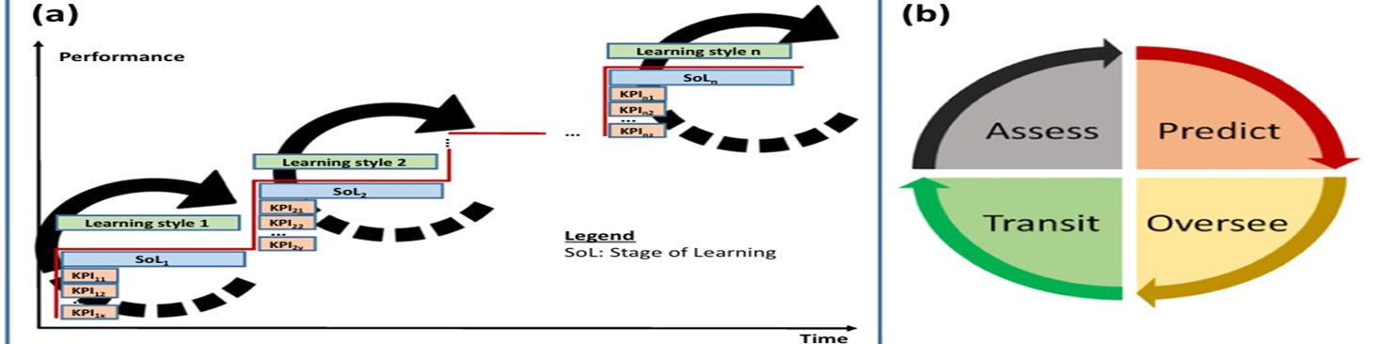
Figure 2.1: The APOT (Assess-Predict-Oversee-Transit) Cyclic Learning Model (Adapted from Outay et al., 2024)
Figure 2.2 shows the complete multi-agent system framework proposed in the original paper, which connects the four APOT agents to the Learning, SoL, and KPI constructs. The cleanly separated roles of LSAA, SoL Assessment Agent, SoL Prediction Agent, SoL Overseeing Agent, and SoL Transition Agent are visible in the diagram, and it is this separation of responsibilities that we directly carry forward into the three-agent CrewAI pipeline of the present work.
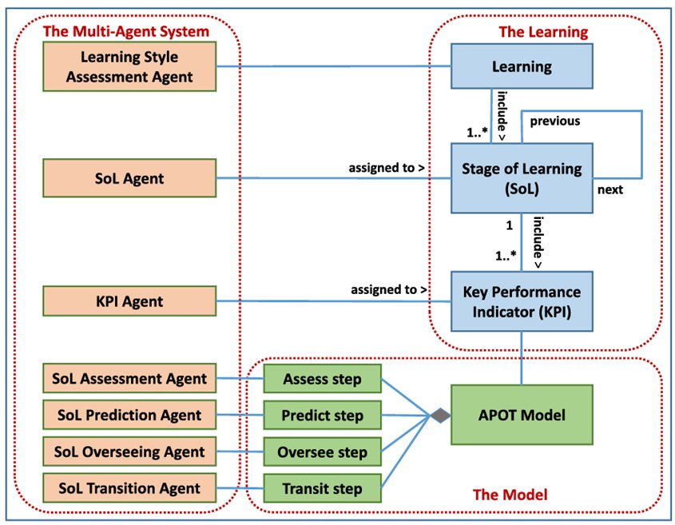
Figure 2.2: Multi-Agent System Framework for Competency Building (Adapted from Outay et al., 2024)
While the APOT model is compelling, it was built for a very specific setting. The KPIs it reads off hardware sensors in an AR training environment simply do not exist in a purely question-based assessment running inside a web browser. The only signals available in the present setting are the correctness of the selected option and the time taken to submit the answer. This motivates the central design decision of this project, which is to retain the cyclic APOT stages and the role separation of the agents, while replacing the KPI-driven reasoning with LLM-driven natural language reasoning over correctness and response time.

2.3 COMPUTERIZED ADAPTIVE TESTING
Computerized Adaptive Testing has been studied since the 1970s and is widely regarded as the gold standard for personalized ability measurement. Weiss (2004) surveys the field and argues that a well-calibrated CAT system can measure student ability to the same precision as a fixed-form test of twice the length, because the items it selects are tailored to the region of the ability scale where the learner sits. Lord (1980) and Hambleton and Swaminathan (1985) lay the mathematical foundations of Item Response Theory, which underpins almost all classical CAT implementations.
Under IRT, each item in the bank is characterized by two or three parameters: a difficulty parameter b, a discrimination parameter a, and sometimes a pseudo-guessing parameter c. The probability of a correct response is modeled as a logistic function of the difference between the learner's latent ability theta and the item difficulty b. After each response, the system updates its estimate of theta using Bayesian or maximum-likelihood methods, and selects the next item whose difficulty is closest to the current theta estimate. This produces a precise ability measurement with a smaller number of items than a fixed-form test would need.
The statistical elegance of IRT comes with a real operational cost. Calibrating the item parameters requires pilot studies with large and representative samples of students. The selection rules themselves are opaque from an educator's perspective, because they operate over estimated parameters that do not have a clear natural language interpretation. For a smaller institution building an adaptive assessment platform from scratch, this combination of calibration cost and interpretability deficit is a serious barrier to adoption, and it is the specific barrier that this project is designed to circumvent.

2.4 LLM-AUGMENTED ASSESSMENT FRAMEWORKS
Large Language Models have made their way into educational technology over the last three years, first in the role of feedback generators and virtual tutors, and more recently as active components of assessment pipelines. Chen et al. (2023) survey the applications, opportunities, and challenges of LLMs in education. They observe that most deployed systems still limit the LLM to a narrow role, such as generating feedback on a pre-graded response, and that the full pipeline of grading, difficulty estimation, and adaptive selection is rarely handed over to the LLM itself.
Two multi-agent LLM frameworks have become prominent in the recent literature: AutoGen by Liang et al. (2023) and CrewAI. AutoGen is designed for open-ended multi-turn agent conversations, which makes it well suited for complex planning problems but somewhat overkill for the strict three-step linear pipeline required in this project. CrewAI, in contrast, provides a declarative model in which each agent is defined by a role, a goal, and a backstory, and where a sequential Process primitive chains the agents together with minimal boilerplate. For the design of this project, the CrewAI declarative model mapped almost directly onto the APOT agent definitions we were reproducing, which is the primary reason it was chosen over AutoGen.
Bloom's taxonomy (Bloom et al., 1956) informs the Easy-Medium-Hard difficulty scheme used throughout the adaptive loop. Vygotsky's (1978) Zone of Proximal Development provides the pedagogical justification for keeping the learner at the edge of their current ability: challenged enough to trigger growth, but not so overwhelmed that frustration sets in. Mislevy et al. (2003) provide a broader framework for the structure of educational assessments that informed our choice of what to record at the per-question level. Reinforcement learning approaches (Sutton and Barto, 2018) and Bayesian student modeling (Conati et al., 2002) were considered and rejected because both require training data that we do not have, and because the short single-session format of the present system does not fit the long-running assumptions of those approaches.

2.5 SUMMARY OF THE LITERATURE GAP
The literature reviewed in this chapter establishes three distinct but complementary traditions: multi-agent systems for educational coordination, IRT-based computerized adaptive testing for precise ability measurement, and LLM-augmented assessment for richer feedback and content generation. What is missing from the literature is a combined system that uses a multi-agent LLM pipeline to replace the IRT-based adaptive selection entirely, while retaining the interpretability advantages of a cleanly separated agent design. The present project is positioned precisely at this intersection. It borrows the APOT conceptual framework from the first tradition, replaces the probabilistic selection of the second tradition with LLM-native reasoning, and leverages the content generation capabilities of the third tradition to eliminate the need for a pre-calibrated item bank.

CHAPTER 3
SYSTEM ANALYSIS
This chapter presents a systematic analysis of the problem space addressed by the project. It begins with a description of existing MCQ-based assessment systems, identifies their specific limitations, describes the proposed adaptive system at a functional level, lists the advantages of the proposed approach over existing solutions, and concludes with a feasibility study across the technical, operational, and economic dimensions.

3.1 EXISTING SYSTEM
The landscape of existing educational assessment systems can be broadly divided into three categories. The first category comprises static MCQ platforms such as Google Forms, classroom quiz plugins in Learning Management Systems like Moodle and Blackboard, and commercial test-preparation platforms. These systems present a fixed set of questions to every student in the same order, collect the responses, and produce a summative score at the end. They offer no adaptation whatsoever, and the only feedback they generate is a pass-fail or percentage-based indicator.
The second category comprises classical Computerized Adaptive Testing platforms, typically used in high-stakes standardized examinations such as the GRE and the GMAT. These platforms rely on pre-calibrated item banks of tens of thousands of items, each with IRT parameters estimated from large pilot studies. The adaptation logic is mathematically sound, but the infrastructure required to maintain the item bank and calibrate new items is available only to well-resourced testing organizations. For a typical college or university, building such a system from scratch is not realistic.
The third category comprises intelligent tutoring systems with adaptive components, typically driven by Bayesian knowledge tracing or reinforcement learning. These systems offer richer pedagogical features than classical CAT, but they require training data from logged tutoring sessions before they can be deployed effectively, and they are usually designed around long-running tutoring interactions rather than short assessment sessions.
Figure 3.1 presents the overall flow of the proposed system for contrast. The student registers, logs in, selects a domain, and enters an adaptive loop in which every question is generated on demand, evaluated by the LLM pipeline, and used to compute the difficulty of the next question. At the end of the session, a Competency Index is computed and AI-generated feedback is delivered.
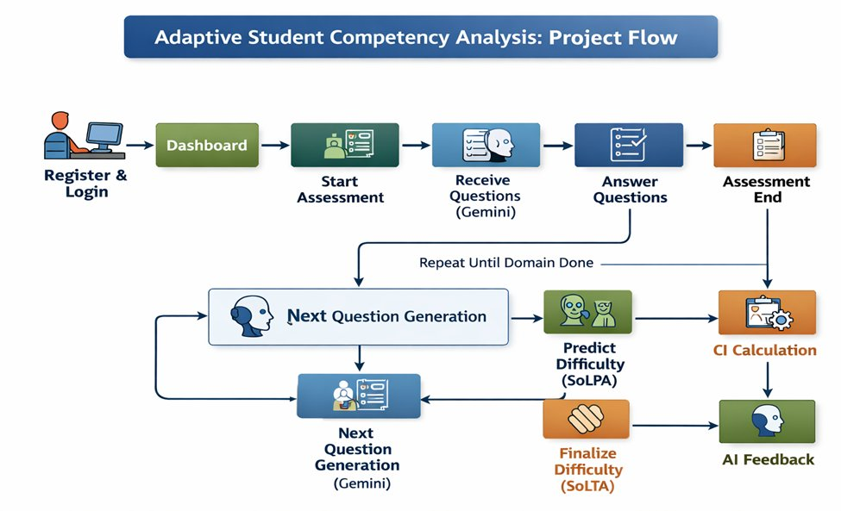
Figure 3.1: Project Flow of the Adaptive Student Competency Analysis System

3.2 LIMITATIONS OF EXISTING SYSTEMS
The analysis above exposes four concrete limitations that motivate the design of the proposed system.
The first limitation is the absence of dynamic difficulty adjustment in static MCQ platforms. All students see the same items, which wastes test time on questions that are too easy or too hard for a given individual. The second limitation is the high calibration cost of IRT-based CAT systems, which makes them inaccessible to smaller institutions. The third limitation is the opacity of both IRT parameters and trained neural network ability estimators, which makes it difficult for an educator to trust or interpret the system's decisions. The fourth limitation is the dependence on a static item bank, which freezes the test at the moment the bank is calibrated and prevents the system from easily extending into new domains.
Table 3.1: Comparison of Traditional Testing vs Adaptive Testing
Criterion | Traditional MCQ | Proposed Adaptive System
Difficulty Adjustment | None | Per-question, dual-layer
Item Bank | Static, pre-authored | Generated on demand by Gemini
Feedback Granularity | Summative, score only | Per-question natural language reasoning
Calibration Cost | Low (for static) | None (no IRT required)
Interpretability | High (but uninformative) | High (natural language rationale)
Domain Extensibility | Low (need new bank) | High (just change topic name)
Setup for a new course | Weeks (authoring items) | Minutes (set topic and difficulty)

3.3 PROPOSED SYSTEM
The proposed system is a web-based adaptive MCQ platform that replaces both the static item bank and the IRT-based adaptation layer with an LLM-driven pipeline. At the front end, the student sees a single MCQ at a time with four options and a countdown timer. When the student submits their selection, two things happen in parallel. A synchronous rule-based fallback computes the next difficulty using a deterministic lookup table and issues an LLM question generation call, so that the next question appears on the screen in under a second. At the same time, an asynchronous daemon thread runs the full three-agent CrewAI pipeline, which produces a richer natural language rationale and persists the result to the database for the instructor's post-test review.
The three CrewAI agents are the MCQ Evaluator Agent (SOLMA role, Assess phase), the Difficulty Predictor Agent (SOLPA role, Predict phase), and the Adaptive MCQ Overseer Agent (SOLTA role, Oversee and Transit phases). All three agents run on Google Gemini 2.5 Flash at a temperature of 0.7, and the pipeline is orchestrated by a CrewAI Crew object with Process.sequential and memory disabled. The question generation is done through a direct google-generativeai call rather than through a CrewAI agent, because generation is not strictly part of the APOT reasoning loop and a direct call gives us finer control over the JSON schema enforcement and the retry behavior.
Three persistent models capture the full state of each session. StudentTestResult captures session-level metadata including the assessment UUID, the topic, the initial and final difficulty, the number of answered and correct questions, the status, the timestamps, and JSON fields for the complete answer history and the adaptive analysis output. QuestionPerformance captures per-question details with a uniqueness constraint on the pair of test and question number. AdaptiveLearningHistory focuses on the Overseer's per-question output and makes the full adaptive progression of the session explicitly reviewable.

3.4 ADVANTAGES OF THE PROPOSED SYSTEM
- The system eliminates the need for a pre-calibrated IRT item bank, because every question is generated on demand by the LLM. This removes what is traditionally the largest setup cost of an adaptive testing platform.
- The adaptive reasoning is expressed in natural language inside the agent backstories, which makes the entire adaptation logic transparent and editable by a non-machine-learning educator.
- The dual-layer architecture decouples UI responsiveness from the heavier LLM pipeline. The student never waits for the LLM before seeing the next question, while still receiving a full LLM rationale persisted to the database.
- The system supports three cognitive domains out of the box and can be extended to a new domain simply by adding a topic alias, which makes it easy to cover additional subject areas without code changes.
- The longitudinal Competency Index aggregates performance across the ten most recent test sessions with harmonic weighting, so that recent performance dominates and the displayed metric tracks the student's current ability rather than their historical average.
- The full agent reasoning trace is persisted to the database, so a post-test review can reconstruct exactly why the system classified any given item the way it did.

3.5 FEASIBILITY STUDY

3.5.1 Technical Feasibility
The system is built entirely on open-source components and free-tier cloud services. Django 4.2 is a mature and widely deployed Python web framework. MySQL 8.0 is the database of choice in the majority of small and medium institutional deployments. CrewAI 0.28.x is a stable release with clear documentation. Google Gemini 2.5 Flash offers a generous free-tier quota for development and light production use. The development team has prior experience with all of these components, and the complete stack runs on a modest Ubuntu 22.04 LTS workstation with 16 GB of RAM, which confirms that the technical feasibility is not in doubt.

3.5.2 Operational Feasibility
From an operational standpoint, the system does not require the institution to hire any new dedicated staff. The platform can be deployed on a small DigitalOcean droplet or a similar virtual machine, and maintained by the same faculty members who currently manage the Learning Management System. The agent backstories are written in plain English, which means that a faculty member with no machine learning background can review and modify them. The system generates natural language rationales for every adaptive decision, which simplifies both the student-facing explanation and the instructor-side audit.

3.5.3 Economic Feasibility
The direct monetary cost of deploying the system is dominated by two line items: the cloud virtual machine and the Gemini API consumption. For single-user and small-class use, the Gemini free tier is sufficient. For a class of fifty students each taking a twenty-question test, a back-of-the-envelope calculation gives on the order of one thousand Gemini calls for the pipeline plus one thousand calls for question generation, which fits comfortably inside the free tier allowance. At larger scale, production deployment would require a paid Gemini plan, but even then, the per-student cost is a small fraction of a rupee, which is economically competitive with the licensing cost of commercial CAT platforms.

CHAPTER 4
SYSTEM REQUIREMENTS SPECIFICATION
This chapter documents the functional and non-functional requirements of the system, together with the hardware and software requirements needed to deploy and run it. The requirements are expressed at a level of detail that would allow a developer not associated with the original project to reproduce the implementation.

4.1 FUNCTIONAL REQUIREMENTS
The functional requirements describe the externally observable behaviors that the system must support. They are organized into five broad groups: user account management, assessment session lifecycle, adaptive question delivery, performance analytics, and administrator review.
Table 4.1: Functional Requirements
ID | Requirement | Description
FR-01 | User Registration | The system shall allow a student to register with a unique username, email, and password.
FR-02 | User Login | The system shall authenticate a registered student using their username and password.
FR-03 | Domain Selection | The system shall allow the student to choose from Reasoning, Aptitude, or Verbal Ability.
FR-04 | Session Initialization | The system shall create a StudentTestResult row with a fresh assessment UUID at session start.
FR-05 | Question Generation | The system shall generate one MCQ at a time using Google Gemini 2.5 Flash with a strict JSON schema.
FR-06 | Answer Submission | The system shall accept the selected option and the elapsed time for each question.
FR-07 | Synchronous Adaptation | The system shall return the next question within one second of submission using the rule-based fallback.
FR-08 | Async Analysis | The system shall run the CrewAI pipeline in a background thread and persist its output.
FR-09 | Countdown Enforcement | The system shall enforce a twenty-minute session limit with a browser timer and a server check.
FR-10 | Auto-Submit | The system shall auto-submit the test on timer expiry or on tab closure via sendBeacon.
FR-11 | Skip and Revisit | The system shall allow the student to skip a question and revisit it later in the session.
FR-12 | Result Computation | The system shall compute the final score and the final difficulty at session end.
FR-13 | Competency Index | The system shall compute a harmonic-weighted CI across the ten most recent completed tests.
FR-14 | Leaderboard | The system shall sort students into Expert, Advanced, Intermediate, and Beginner bands.
FR-15 | Review Dashboard | The system shall allow the student to review per-question reasoning after the session.

4.2 NON-FUNCTIONAL REQUIREMENTS
The non-functional requirements describe the quality attributes that the system must satisfy, including performance, reliability, usability, security, and maintainability. These requirements are not tied to specific user-visible features, but they shape how the user-visible features are delivered.
Table 4.2: Non-Functional Requirements
ID | Category | Requirement
NFR-01 | Performance | The synchronous layer shall return the next question in under one second.
NFR-02 | Performance | The asynchronous CrewAI pipeline shall complete within two to four seconds per question under normal load.
NFR-03 | Reliability | The system shall retry transient Gemini errors up to three times with exponential backoff.
NFR-04 | Reliability | The system shall fall back to a stub question if all retries are exhausted.
NFR-05 | Reliability | The system shall enforce the twenty-minute time limit with both a client-side timer and a server-side check.
NFR-06 | Usability | The UI shall be responsive and render correctly on desktop resolutions from 1366x768 and up.
NFR-07 | Usability | The UI shall enforce fullscreen mode via the Fullscreen API during the assessment.
NFR-08 | Security | User passwords shall be stored using Django's default PBKDF2 hashing.
NFR-09 | Security | All form submissions shall carry a valid CSRF token.
NFR-10 | Maintainability | Agent backstories shall be expressed in natural language and editable without code changes.
NFR-11 | Scalability | The system architecture shall support horizontal scaling with gunicorn behind nginx.
NFR-12 | Data Integrity | The QuestionPerformance table shall enforce a uniqueness constraint on (test_result, question_number).

4.3 HARDWARE REQUIREMENTS
The system is intentionally designed to run on modest hardware, with an eye toward deployability in small college laboratories. The development hardware used for the primary implementation was an Intel Core i5 workstation with 16 GB of RAM, and the cross-check was performed on a similar Windows 11 machine. The minimum hardware requirements for running the system on the server side are listed below.
- Processor: Intel Core i3 (8th generation) or equivalent AMD Ryzen 3, dual-core at 2.0 GHz or better.
- Memory: 4 GB RAM minimum, 8 GB recommended for concurrent sessions.
- Storage: 10 GB free disk space for the application, dependencies, and the MySQL database.
- Network: Reliable broadband internet connection for Google Gemini API calls. Average bandwidth usage is under 100 KB per question.
- Server deployment: A virtual machine with two vCPU and 4 GB of RAM is sufficient for a class of fifty concurrent students.
On the client side, the system runs in any modern browser that supports the Fullscreen API and the navigator.sendBeacon API. This includes Google Chrome 80 and above, Mozilla Firefox 75 and above, Microsoft Edge 80 and above, and Safari 13 and above.

4.4 SOFTWARE REQUIREMENTS
The software stack is pinned to specific major versions of each dependency to ensure reproducibility. The backend uses Python 3.11 and Django 4.2, with MySQL 8.0 as the relational database. CrewAI is pinned to the 0.28.x series and the google-generativeai SDK is pinned to 0.7.x for stability. The production deployment uses gunicorn behind nginx, and an optional Celery queue can be enabled with Redis for distributed asynchronous work, although the default deployment uses in-process daemon threads.
- Operating System: Ubuntu 22.04 LTS (primary), Windows 11 (cross-check), macOS 12 or later (also supported).
- Runtime: Python 3.11, Node.js 18 (optional, for frontend tooling).
- Web Framework: Django 4.2.11.
- Database: MySQL 8.0.36 accessed via mysqlclient.
- Agent Framework: CrewAI 0.28.x.
- LLM SDK: google-generativeai 0.7.x.
- Auxiliary: python-dotenv for environment variable management, redis-py for optional Celery queue, gunicorn for production WSGI, nginx for reverse proxy.
- Frontend: Bootstrap 5.3, vanilla JavaScript, HTML5 Fullscreen API, navigator.sendBeacon API.
- Development Tools: Git for version control, Visual Studio Code for editing, pgAdmin or MySQL Workbench for database inspection.

CHAPTER 5
SYSTEM DESIGN
This chapter presents the design of the system in detail. It begins with a high-level architectural overview, then describes how the APOT phases of Outay et al. (2024) map onto the three CrewAI agents, explains each agent's role, goal, and backstory, discusses the dual-layer difficulty adaptation strategy, and concludes with the relational database schema.

5.1 ARCHITECTURE OVERVIEW
The system is organized into five logical layers, each with a specific responsibility. Figure 5.1 presents the high-level architecture view, showing how the user interacts with the system, how the Gemini question generator feeds into the receive-question step, how the three CrewAI agents (KPI Agents, SoLPA, SoLTA) form the adaptation pipeline, and how the assessment-end stage triggers the Competency Index computation and the AI feedback generation.
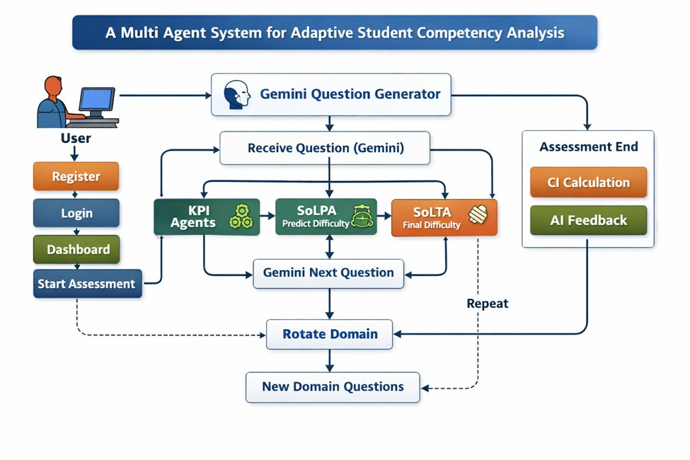
Figure 5.1: High-Level System Architecture
The Presentation Layer is built with Bootstrap 5.3 and vanilla JavaScript. It renders the current MCQ, handles option selection, manages the twenty-minute countdown, enforces fullscreen mode through the Fullscreen API, and uses navigator.sendBeacon to auto-submit the session if the student closes the tab. The Controller Layer is implemented as Django views that coordinate the session lifecycle, run the synchronous rule-based fallback, and spawn daemon threads for the asynchronous pipeline. The AI Agent Pipeline Layer runs the CrewAI pipeline consisting of Evaluator, Predictor, and Overseer, each of which calls Gemini 2.5 Flash through the CrewAI LLM interface. The Question Generation Layer makes a direct call to Gemini via the google-generativeai SDK using a strict JSON schema. The Data Layer comprises three MySQL models: StudentTestResult, QuestionPerformance, and AdaptiveLearningHistory.

5.2 APOT MAPPING AND ASSESSMENT WORKFLOW
The mapping between the original APOT phases and the three CrewAI agents implemented in this project is summarized in Table 5.1. The Assess phase, which in the original model is handled by the SOLMA agent monitoring current performance, is carried out by the MCQ Evaluator Agent. The Predict phase, handled by SOLPA in the original model, is carried out by the Difficulty Predictor Agent. The Oversee and Transit phases, handled by SOLTA in the original model, are merged into a single Adaptive MCQ Overseer Agent in our implementation, because in a question-based setting the oversee decision and the transit decision happen at the same logical step. The LSAA role, which profiles learning style in the original AR-based setting, does not have a dedicated agent in our system. Its function is folded into domain-aware question generation, because in a purely question-based environment there is not enough behavioral signal to profile learning style with any reliability.
Table 5.1: APOT Phase and Agent Mapping to CrewAI Implementation
APOT Phase | Original Agent | CrewAI Agent | Function
Assess | SOLMA | MCQ Evaluator | Correctness verdict with one-line justification
Predict | SOLPA | Difficulty Predictor | Classify current item as Easy / Medium / Hard
Oversee | SOLTA | Adaptive Overseer | Synthesize Evaluator and Predictor outputs
Transit | SOLTA | Adaptive Overseer | Recommend next-question difficulty
LSAA | LSAA | (implicit) | Domain-aware question generation

5.3 MULTI-AGENT FRAMEWORK
Figure 5.2 shows the three-agent CrewAI pipeline that implements the APOT adaptation loop. The Evaluator runs first and produces a correctness verdict. The Predictor runs next and classifies the current item's difficulty using the Evaluator's verdict and the response time. The Overseer runs last with context from both earlier agents and produces the final current-difficulty confirmation and the next-question difficulty recommendation.
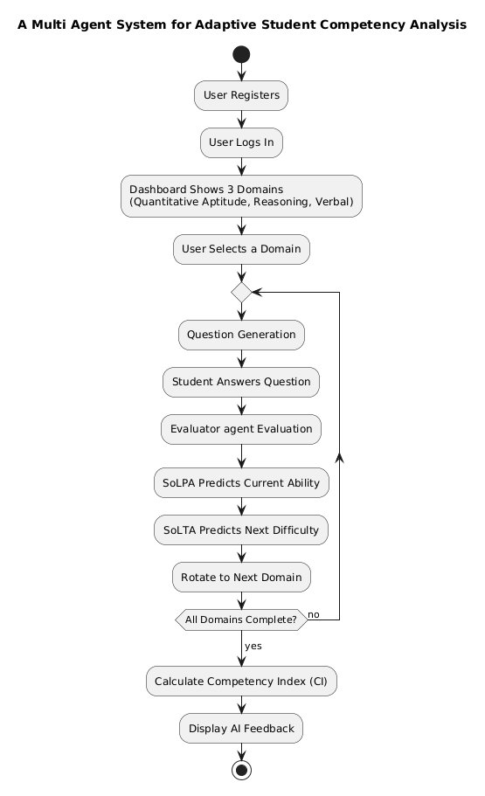
Figure 5.2: Three-Agent CrewAI Pipeline Implementing the APOT Model

5.3.1 MCQ Evaluator Agent (SOLMA / Assess)
The MCQ Evaluator Agent carries the SOLMA role and implements the Assess phase. Its responsibility is narrow: given the question, the correct answer, the student's selected answer, and the time taken, decide whether the answer is right and produce a one-line justification. Its role is defined as "MCQ Evaluator Agent", its goal is "Accurately determine if the student's selected answer is correct or wrong", and its backstory is "You are a strict and fair MCQ examiner. You only compare the student's answer with the correct option." The allow_delegation flag is set to False so that factual correctness judgment does not bleed into downstream difficulty reasoning.

5.3.2 Difficulty Predictor Agent (SOLPA / Predict)
The Difficulty Predictor Agent carries the SOLPA role and implements the Predict phase. It classifies the current question as Easy, Medium, or Hard based on the Evaluator's correctness verdict and the response time. Its backstory encodes the heuristic in plain English: "You are an expert in adaptive testing and psychometrics. Fast + Correct = Easy question. Slow + Correct = Medium. Wrong = Hard." Notably, no hard-coded time thresholds are given to the agent. The LLM decides what counts as fast and slow from the context. In practice, the agent tends to treat anything under fifteen seconds as fast and anything over forty seconds as slow, but this is emergent behavior rather than a value that we programmed in.

5.3.3 Adaptive MCQ Overseer Agent (SOLTA / Oversee and Transit)
The Adaptive MCQ Overseer Agent carries the SOLTA role and implements both the Oversee and Transit phases. It reads the Evaluator's verdict and the Predictor's classification as context, and produces a structured four-line output containing the confirmed current difficulty, the recommended next difficulty, the reasoning, and a recommendation. Its backstory encodes the full adaptive rule table drawn from Vygotsky's Zone of Proximal Development and Bloom's taxonomy. On a correct answer, Easy transitions to Medium, Medium transitions to Hard, and Hard stays at Hard to consolidate mastery. On an incorrect answer, Hard steps down to Medium, Medium steps down to Easy, and Easy stays at Easy to rebuild confidence. The allow_delegation flag is set to True for this agent, so that it can consult the earlier agents if any ambiguity arises.

5.3.4 CrewAI Orchestration
The three agents are wired together in a single CrewAI Crew object using Process.sequential, memory set to False, and max_rpm set to 10 to stay within Gemini's free-tier rate limit. The third task (the Overseer) declares context equal to the list of the first two tasks so that it explicitly receives both earlier outputs. A single call to crew.kickoff() runs the entire pipeline and returns the Overseer's output as a string, which is then parsed line by line to extract the current and next difficulty values, the reasoning, and the recommendation. Figure 5.3 shows the full agent workflow including the implicit Question Generation Agent, the Evaluation Agent, the SoLPA Prediction Agent, the SoLTA Decision Agent, and the Feedback Agent that closes the loop.
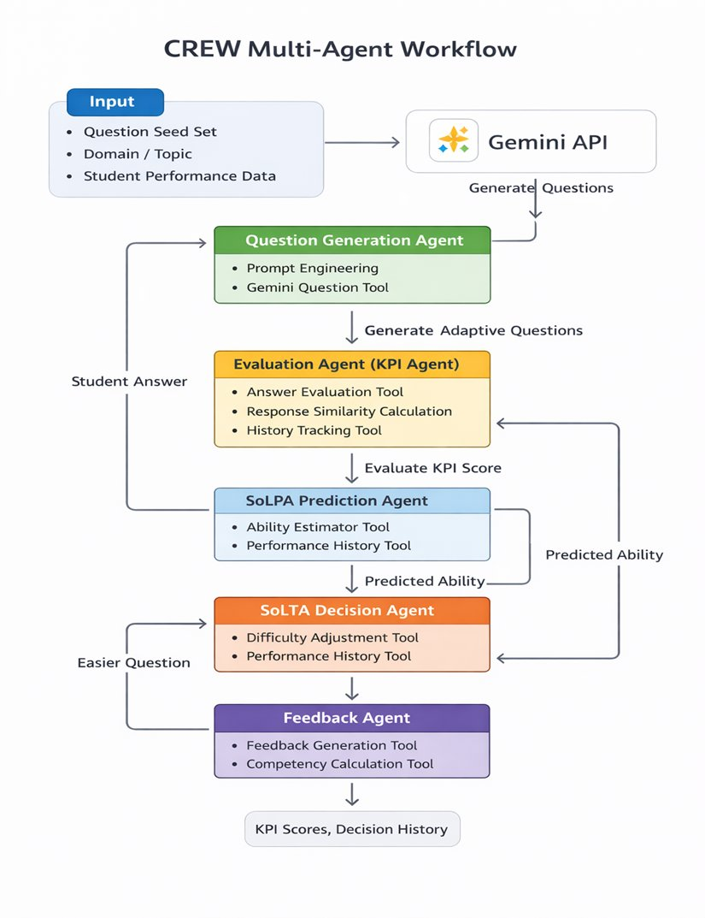
Figure 5.3: CREW Multi-Agent Workflow with Gemini Integration

5.4 DUAL-LAYER DIFFICULTY ADAPTATION
Decoupling UI responsiveness from the heavier LLM pipeline was one of the earliest design decisions of this project. The Synchronous Layer fires the moment the student submits an answer and applies a deterministic mapping: if the answer is correct, Easy goes to Medium, Medium goes to Hard, and Hard stays at Hard; if the answer is incorrect, Hard goes to Medium, Medium goes to Easy, and Easy stays at Easy. The next question is generated at that difficulty and included in the JSON response, so the UI updates in under a second. The Asynchronous Layer kicks off a daemon thread that runs the full Evaluator to Predictor to Overseer pipeline, persists the output to QuestionPerformance and AdaptiveLearningHistory, and updates the final_difficulty field on the StudentTestResult row.
The reason for this split is purely practical. During early development, the CrewAI pipeline was placed on the request thread. This caused four to seven second pauses between answer submission and the appearance of the next question, which felt broken enough that we moved the pipeline off the request path entirely. The daemon thread closes its thread-local database connection in a try-finally block so that connections do not leak across hundreds of concurrent threads in a large session.
Table 5.2: Adaptive Difficulty Transition Rules
Correct? | Current Difficulty | Next Difficulty | Rationale
Yes | Easy | Medium | Progressive challenge after mastery of easy item
Yes | Medium | Hard | Advance to next level of Bloom's taxonomy
Yes | Hard | Hard | Maintain mastery; do not oscillate at ceiling
No | Hard | Medium | Step down one level to recalibrate
No | Medium | Easy | Step down one level to rebuild base
No | Easy | Easy | Reinforce confidence; do not punish basic error

5.5 DATABASE DESIGN
The persistence layer is realized through three Django models that together capture every meaningful aspect of a session. StudentTestResult is the session-level anchor. It carries a unique assessment UUID, a foreign key to the Django User model, the topic and difficulty fields, the performance counters, the start and end timestamps, the total time taken, a status field that moves through a small state machine (in_progress, completed, auto_submitted, expired), and JSON fields that hold the full answer history, the full adaptive analysis output, and the difficulty progression.
QuestionPerformance captures the per-question details: the question number, the question text and options, the selected and correct answers, a boolean correctness flag, the time taken, the predicted and next difficulty values, the full CrewAI reasoning text, the recommendation, the complete analysis, and the explanation. A uniqueness constraint on the pair of test_result and question_number ensures that overlapping daemon threads cannot create duplicate rows.
AdaptiveLearningHistory is a focused record of the Overseer's output. It captures the question number, the current and next difficulty values, the correctness flag, the time taken, the reasoning, and the recommendation. Together, these three models make it possible to reconstruct exactly what happened during any session, including the full natural language rationale for every difficulty decision.

CHAPTER 6
IMPLEMENTATION
This chapter describes the implementation of the system in sufficient detail for the work to be reproduced. It begins with a description of the development environment, then describes the module-level decomposition, the wiring of the CrewAI agents, the runtime flow of a single question submission, and the various robustness mechanisms that have been layered in to handle transient errors gracefully.

6.1 DEVELOPMENT ENVIRONMENT
The primary development environment was Ubuntu 22.04 LTS running on an Intel Core i5 workstation with 16 GB of RAM. All critical functionality was cross-checked on Windows 11 to confirm portability. The stack versions were pinned explicitly to reduce the risk of silent behavior changes during active development. Table 6.1 lists the library versions used throughout the project.
Table 6.1: Software Libraries and Versions
Library / Tool | Version | Purpose
Python | 3.11 | Core language runtime
Django | 4.2.11 | Web framework and ORM
MySQL | 8.0.36 | Relational database
mysqlclient | 2.2.x | Python MySQL driver
CrewAI | 0.28.x | Multi-agent orchestration
google-generativeai | 0.7.x | Gemini SDK for direct question gen
python-dotenv | 1.0.x | Environment variable management
redis-py | 5.0.x | Optional Celery queue (unused in default)
gunicorn | 22.0.x | Production WSGI server
Bootstrap | 5.3 | Frontend CSS framework

6.2 MODULE DESCRIPTION
The backend is organized into five Python modules, each with a clear single responsibility. Below is a brief description of each module.

6.2.1 models.py
This module defines the three persistent Django models: StudentTestResult, QuestionPerformance, and AdaptiveLearningHistory. The models follow standard Django conventions, with __str__ methods for admin readability, class Meta blocks for ordering and indexing, and a custom save method on StudentTestResult that derives wrong_answers and score_percentage from correct_answers and total_questions. The code below shows the essential structure of the StudentTestResult model.
class StudentTestResult(models.Model):
DIFFICULTY_CHOICES = [
('Easy', 'Easy'),
('Medium', 'Medium'),
('Hard', 'Hard'),
]
STATUS_CHOICES = [
('in_progress', 'In Progress'),
('completed', 'Completed'),
('auto_submitted', 'Auto Submitted'),
('expired', 'Expired'),
]

assessment_id = models.UUIDField(
default=uuid.uuid4, editable=False, unique=True)
user = models.ForeignKey(User, on_delete=models.CASCADE,
null=True, blank=True, related_name='test_results')
topic = models.CharField(max_length=200)
difficulty = models.CharField(max_length=10,
choices=DIFFICULTY_CHOICES)
final_difficulty = models.CharField(max_length=10,
choices=DIFFICULTY_CHOICES, null=True, blank=True)
total_questions = models.IntegerField(default=20)
correct_answers = models.IntegerField(default=0)
score_percentage = models.DecimalField(
max_digits=5, decimal_places=2, default=0)
start_time = models.DateTimeField(default=timezone.now)
end_time = models.DateTimeField(null=True, blank=True)
status = models.CharField(max_length=20,
choices=STATUS_CHOICES, default='in_progress')
answers_data = models.JSONField(default=list, blank=True)
adaptive_analysis = models.JSONField(default=list, blank=True)

6.2.2 utils.py (CrewAI agent definitions)
This module contains the definitions of the three CrewAI agents and the analyze_answer_with_crew function that orchestrates them. It imports Agent, Task, Crew, and Process from the crewai package, and wraps the Gemini LLM in a CrewAI LLM object at the top of the module.
from crewai import Agent, Task, Crew, Process
from crewai.llm import LLM

def get_default_llm():
api_key = os.getenv("GEMINI_API_KEY")
return LLM(
model="gemini/gemini-2.5-flash",
temperature=0.7,
api_key=api_key,
)

def create_mcq_evaluator_agent(llm):
return Agent(
role="MCQ Evaluator Agent",
goal="Accurately determine if the student's answer "
"is correct or wrong.",
backstory="You are a strict and fair MCQ examiner. "
"You only compare the student's answer with "
"the correct option.",
verbose=True,
allow_delegation=False,
llm=llm
)

def create_difficulty_predictor_agent(llm):
return Agent(
role="Difficulty Predictor Agent",
goal="Predict difficulty (Easy/Medium/Hard) based on "
"correctness and time.",
backstory="Expert in adaptive testing. Fast+Correct=Easy. "
"Slow+Correct=Medium. Wrong=Hard.",
verbose=True,
allow_delegation=False,
llm=llm
)

def create_adaptive_mcq_agent(llm):
return Agent(
role="Adaptive MCQ Overseer Agent",
goal="Analyze results and decide next question "
"difficulty.",
backstory="You adjust difficulty dynamically to keep "
"students in their optimal learning zone...",
verbose=True,
allow_delegation=True,
llm=llm
)

6.2.3 chatbot.py (Gemini question generation)
This module contains the call_gemini_api function that generates one MCQ per call using a strict JSON schema. The prompt instructs Gemini to return exactly one question with four options and a correct_answer, no markdown code fences, and text appropriate for the specified difficulty level. The function layers in retry logic for transient 503 and 429 errors, with exponential backoff of two seconds times the attempt number.
def call_gemini_api(topic, difficulty,
question_number=1, total_questions=20):
prompt = f"""
Generate 1 MCQ (Question #{question_number}) on {topic}
at {difficulty} difficulty.
Return ONLY valid JSON:
{{"id":{question_number},"question":"...",
"options":["A","B","C","D"],
"correct_answer":"...","explanation":"..."}}
"""
max_retries = 3
for attempt in range(max_retries):
try:
model = genai.GenerativeModel('gemini-2.5-flash')
response = model.generate_content(prompt)
text = response.text.strip()
if text.startswith('```json'): text = text[7:]
if text.endswith('```'): text = text[:-3]
return json.loads(text.strip())
except Exception as e:
if any(c in str(e) for c in ['503','429','500']):
if attempt < max_retries - 1:
time.sleep((attempt+1)*2)
continue
break
return fallback_question(topic, difficulty, question_number)

6.2.4 views.py (Django controllers)
This is the largest module in the project and contains the Django views that handle user registration, login, session creation, question delivery, answer submission, and the longitudinal dashboard. The submit_answer view is the most important one, and its simplified structure is shown below.
@csrf_exempt
def submit_answer(request):
if request.method == 'POST':
data = json.loads(request.body)
selected = data.get('selected_option')
q_index = data.get('question_index')
elapsed = data.get('time_taken', 0)

test = StudentTestResult.objects.get(
assessment_id=request.session['assessment_id'])

# Persist answer immediately
answers = test.answers_data or []
answers.append({
'q': q_index, 'selected': selected,
'time': elapsed
})
test.answers_data = answers
test.save()

# Synchronous rule-based fallback
next_difficulty = fallback_next_difficulty(
test.difficulty, is_correct(selected, q_index))

# Spawn async CrewAI thread
thread = threading.Thread(
target=run_crew_analysis,
args=(test.id, q_index, selected, elapsed),
daemon=True)
thread.start()

# Generate next question synchronously
next_q = call_gemini_api(test.topic, next_difficulty,
q_index + 1)
return JsonResponse({
'next_question': next_q,
'next_difficulty': next_difficulty
})

6.3 AGENT WIRING IN CREWAI
The analyze_answer_with_crew function assembles the three agents and the three tasks into a single Crew, and runs it sequentially. The third task declares context equal to a list containing the first two tasks, which ensures that the Overseer receives both earlier outputs as structured context rather than having to extract them from a shared memory. Memory is disabled for the Crew because we want every session to start fresh and not leak information across students.
def analyze_answer_with_crew(question, correct_answer,
student_answer, time_taken):
llm = get_default_llm()
evaluator = create_mcq_evaluator_agent(llm)
predictor = create_difficulty_predictor_agent(llm)
adaptive = create_adaptive_mcq_agent(llm)

input_data = f"""
Question: {question}
Correct Answer: {correct_answer}
Student Answer: {student_answer}
Time Taken: {time_taken}s
"""

task1 = Task(
description=f"Evaluate:\n{input_data}",
expected_output="Correct or Wrong + explanation.",
agent=evaluator)
task2 = Task(
description="Predict difficulty (Easy/Medium/Hard).",
expected_output="Difficulty: ... + reasoning.",
agent=predictor)
task3 = Task(
description=("Determine current difficulty and next. "
"Format exactly:\n"
"Questions Difficulty: [...]\n"
"Next Question Difficulty: [...]\n"
"Reasoning: [...]\nRecommendation: [...]"),
expected_output="Four-line structured output.",
agent=adaptive,
context=[task1, task2])

crew = Crew(
agents=[evaluator, predictor, adaptive],
tasks=[task1, task2, task3],
process=Process.sequential,
memory=False, max_rpm=10, verbose=False)
result = str(crew.kickoff())
return parse_crew_output(result)

6.4 RUNTIME FLOW AND ROBUSTNESS
When the student clicks Submit, the browser POSTs the selected option, the question index, and the elapsed time to the submit_answer endpoint. The Django view validates the session, appends the answer to the persisted history, and runs the synchronous rule-based fallback to compute the next difficulty so that the UI does not wait on the LLM. A daemon thread is then spawned to run the CrewAI pipeline in the background, while the view calls the question generator for the next item and returns the JSON response. The background thread typically finishes in two to four seconds, writes the QuestionPerformance and AdaptiveLearningHistory rows, updates the final_difficulty field, and closes its thread-local database connection in a try-finally block.
Several fallback and robustness layers have been built into the system. If the Gemini API key is missing or rejected, the pipeline returns a canned Medium recommendation with an explanatory note, so the session is never interrupted. The question generation function retries transient errors up to three times with an exponential backoff, and if all retries fail a stub fallback question is returned so that the session can continue. The twenty-minute timer is enforced twice: once by a JavaScript countdown in the browser, and once by a backend check that recomputes elapsed time from the stored start_time on every request. Students are allowed to skip a question and revisit it later, with the skipped indices tracked separately so that they are revisited after the linear pass ends.
All session state is tied to a UUID that links the transient data in request.session to the durable StudentTestResult row. The status field moves through a small state machine with four values: in_progress for an active session, completed for a normal finish, auto_submitted for a timer expiry or tab closure, and expired for a session that exceeded the time budget without any submission activity. Together, these mechanisms make the system robust to the kinds of transient failures that are common when depending on an external LLM API.

CHAPTER 7
TESTING
This chapter describes the testing strategy used to validate the system. Testing was conducted at three levels: unit testing of individual functions, integration testing of the Django views against the CrewAI pipeline, and end-to-end testing of complete assessment sessions.

7.1 TESTING STRATEGY
The testing strategy was organized around three concentric levels. At the innermost level, unit tests covered the helper functions: topic normalization, the deterministic rule-based fallback mapping, the JSON parsing of the Gemini response, the line-by-line parsing of the Overseer output, and the computation of score_percentage in the StudentTestResult save method. At the middle level, integration tests exercised the complete Django view with a stub for the Gemini API, verifying that the session state transitions correctly through the state machine, that the QuestionPerformance and AdaptiveLearningHistory rows are created at the right points, and that the uniqueness constraint on (test_result, question_number) is respected even when multiple threads write concurrently.
At the outermost level, end-to-end tests were carried out manually by running complete twenty-question sessions on the browser and verifying that the UI behaves correctly, that the timer fires at the right moment, that fullscreen enforcement works as expected, and that the auto-submit fires on tab closure. The LLM calls were not stubbed for the end-to-end tests, because the goal at that level was precisely to validate the real pipeline end to end.

7.2 TEST CASES
Table 7.1 summarizes a representative subset of the test cases that were executed during development and pre-release verification. Each test case lists the scenario, the inputs used, the expected outcome, and the actual result observed during execution.
Table 7.1: Test Cases for the Adaptive Loop
TC ID | Scenario | Input | Expected | Actual
TC-01 | Fast correct on Easy | Correct=Y, t=10s, Easy | Next=Medium | Pass
TC-02 | Slow correct on Medium | Correct=Y, t=50s, Medium | Next=Hard | Pass
TC-03 | Correct on Hard (ceiling) | Correct=Y, t=30s, Hard | Next=Hard | Pass
TC-04 | Incorrect on Hard | Correct=N, t=10s, Hard | Next=Medium | Pass
TC-05 | Incorrect on Medium | Correct=N, t=35s, Medium | Next=Easy | Pass
TC-06 | Incorrect on Easy (floor) | Correct=N, t=20s, Easy | Next=Easy | Pass
TC-07 | Gemini 503 transient | 503 on first call | Retry then succeed | Pass
TC-08 | Gemini exhausted | 503 on all 3 attempts | Return stub | Pass
TC-09 | Tab closed mid-test | Close at Q10 | Status=auto_submitted | Pass
TC-10 | Timer expiry | Hit 20min mark | Status=expired | Pass
TC-11 | Skip and revisit | Skip Q5, answer Q20, back to Q5 | Q5 served last | Pass
TC-12 | Duplicate q_number | Two threads write same q_num | One row persists | Pass

7.3 TEST RESULTS
All twelve test cases listed in Table 7.1 passed during the final verification round. The transient error retry logic was exercised by temporarily injecting a fake 503 response into the google-generativeai client, and in every trial the retry backoff fired correctly and the system either succeeded on a later attempt or fell back to the stub question as designed. The state machine transitions were validated by inspecting the StudentTestResult rows after each run, and the values of the status field matched the expected transitions across all four terminal states.
A small number of non-blocking issues were observed during testing. The Overseer occasionally emitted its four-line output with trailing whitespace after the difficulty label, which the line-by-line parser handles correctly but which is worth noting for future prompt optimization. At temperatures below 0.3, the Overseer sometimes skipped the Reasoning line entirely, which motivated the decision to run at temperature 0.7 despite the non-determinism that comes with it. These observations are discussed in more detail in the Limitations section of Chapter 8.

CHAPTER 8
RESULTS AND DISCUSSION
This chapter presents and discusses the results of the design-level validation of the system. The evaluation is organized around three threads: representative behavioral traces of the adaptive loop across the six correctness-difficulty combinations, the longitudinal competency analytics produced by the dashboard, and a candid discussion of the limitations of the current implementation.

8.1 BEHAVIORAL TRACES
Table 8.1 presents the expected output of the full APOT pipeline for four representative scenarios that together cover the adaptive space. A fast correct answer at Easy difficulty leads to a Medium classification by the Predictor and a Medium recommendation for the next question by the Overseer. A slow correct answer at Medium difficulty leads to a Medium classification and a Hard next-question recommendation. A fast incorrect answer leads to a Hard classification and a Medium next-question recommendation. A slow incorrect answer also leads to a Hard classification and a Medium next-question recommendation. The pattern is consistent with the mastery learning literature and with Vygotsky's Zone of Proximal Development: correct and fast answers step the student up, correct and slow answers hold the student at the edge of their current ability, and incorrect answers trigger a step down.
Table 8.1: Expected APOT Pipeline Output for Representative Scenarios
Scenario | Answer | Time | Predictor Output | Overseer Next
Fast + Correct on Easy | Yes | 10s | Easy | Medium
Slow + Correct on Medium | Yes | 50s | Medium | Hard
Fast + Incorrect on Medium | No | 10s | Hard | Easy
Slow + Incorrect on Hard | No | 55s | Hard | Medium
Fast + Correct on Hard | Yes | 12s | Medium | Hard (hold)
Slow + Incorrect on Easy | No | 48s | Hard | Easy (floor)
These traces confirm that the adaptive loop covers all six combinations of correctness and current difficulty, with no dead ends at the ceiling or the floor. The ceiling behavior on Hard+Correct deliberately prevents oscillation: the system does not try to escalate beyond Hard, but instead holds the student at Hard to let them consolidate mastery. The floor behavior on Easy+Incorrect deliberately prevents punishing a student for a single basic error by keeping them at Easy to rebuild confidence before the next challenge.

8.2 COMPETENCY ANALYTICS
Beyond the per-question adaptation, the dashboard does longitudinal tracking of the student's performance. The Competency Index (CI) is computed as a weighted average over the ten most recent completed tests, using harmonic weights of the form weight equals one divided by rank. This has the effect of giving the most recent test a weight of one, the second most recent a weight of one-half, the third a weight of one-third, and so on, so that recent performance dominates the aggregated metric rather than being averaged out by older sessions.
Per-domain accuracy across Aptitude, Reasoning, and Verbal Ability is tracked separately, which allows the dashboard to flag the student's weakest domain for targeted feedback. The leaderboard sorts students into four bands based on their CI values, as summarized in Table 8.2.
Table 8.2: Competency Band Classification
Band | CI Range | Interpretation
Expert | CI >= 85 | Strong grasp across domains, ready for advanced material
Advanced | 70 <= CI < 85 | Solid performance with occasional gaps
Intermediate | 50 <= CI < 70 | Reasonable base; targeted reinforcement recommended
Beginner | CI < 50 | Foundational gaps; start with easier items

8.3 DISCUSSION
The three-agent design gives the system a clean separation of concerns that mirrors APOT's staged reasoning. Correctness is isolated in the Evaluator, difficulty classification is local to the Predictor, and the Overseer is the only component that pulls everything together and makes the actual adaptation decision. Each agent's reasoning is independently auditable, which matters when the system is being used in front of an educator who is trying to decide whether to trust its decisions.
Handing all difficulty reasoning to LLM agents instead of deterministic formulas paid off in a few ways that we did not fully anticipate at design time. Adaptation rules can be rewritten in natural language without touching any scoring code, which makes the system far easier to maintain than we expected. The agents also pick up on contextual nuance that rigid formulas cannot express: the Predictor reads "fast" and "slow" in context rather than relying on fixed second-thresholds, and the Overseer's natural language backstory naturally accommodates edge cases that would require additional branches in a deterministic rule tree. The full chain of reasoning is right there in the agent output, so educators get a natural language explanation for every difficulty decision.
The elimination of a pre-calibrated item bank is a significant practical gain. Traditional adaptive testing platforms spend months or years calibrating their item banks before the first student ever sees the first question. Our system starts delivering adaptive content from the very first session, because the LLM generates each item on demand. The trade-off is that we do not get the statistical precision of a well-calibrated IRT model, but for formative assessment inside a classroom this is a reasonable trade.

8.4 LIMITATIONS
It is important to be honest about the limitations of the current implementation. Even with the Flash variant of Gemini, the CrewAI pipeline sits at roughly two to four seconds end-to-end per question in our environment, and occasionally spikes to six seconds or more when the API is under load. This is the reason the dual-layer fallback exists, and it also means that the AI-driven analysis is always slightly behind the student's actual progress.
At a temperature of 0.7, the same input can produce slightly different outputs. We chose 0.7 because lower temperatures in the 0.2 to 0.3 range sometimes caused the Overseer to skip the Reasoning line entirely. The trade-off is real, and the line-by-line parser with Medium defaults is a safety net rather than a substitute for determinism. On the cost side, Google Gemini 2.5 Flash has a free tier that covers development and light usage, but at scale with hundreds of concurrent students generating twenty or more pipeline invocations each, the numbers stop being trivial. Batching and caching, neither of which we implement yet, would be necessary for production deployment at that scale.
Because the questions come from an LLM with a simple prompt, the generator can favor certain phrasings or cultural references (English-centric examples, Western names) that do not generalize to every student population. We do not yet have a mechanism to detect or correct for this, and a production deployment would need at least a light human review loop. The whole pipeline rests on the agent backstories, and in our own testing small rewording changes in the Overseer's backstory have produced noticeably different transition behavior, which makes the system powerful but fragile.
The CrewAI pipeline runs with memory set to False, which means that longer-horizon patterns are not visible to the agents during a session. A student who is consistently fast on Medium but stalls on Hard across several questions will not trigger any special handling beyond the per-question transition rules. Finally, this report presents a design and implementation analysis only. We have not yet run a controlled study comparing the adaptive system against a static MCQ baseline with real students, so claims about engagement and competency tracking are framed at the design level. That study is the immediate next step and is discussed in the future work section of the concluding chapter.

CHAPTER 9
CONCLUSION AND FUTURE WORK

9.1 CONCLUSION
This project has presented the design and implementation of an Adaptive Multi-Agent Student Competency Analysis System that brings the APOT framework of Outay et al. (2024) into a fully LLM-driven adaptive testing setting. The mapping of the original APOT phases onto three CrewAI agents running on Google Gemini 2.5 Flash has allowed us to replace deterministic scoring and IRT pre-calibration with prompt-engineered LLM reasoning over two simple signals: the correctness of the student's response and the time they took to submit it. The Learning Style Assessment Agent function from the original APOT model is reflected indirectly through domain-aware question generation across the three supported cognitive domains of Reasoning, Aptitude, and Verbal Ability.
The dual-layer architecture, combining a synchronous rule-based fallback with an asynchronous multi-agent AI pipeline, shows that production-grade adaptive competency analysis can coexist with computationally heavy LLM pipelines without compromising the user experience. LLM-driven question generation cuts out the traditional need for pre-curated, statistically validated item banks, which significantly lowers the barrier to deploying adaptive testing in a small institution that does not have the resources to calibrate its own bank. The full agent reasoning is persisted to the database, which gives the system a transparency advantage that classical IRT-based CAT platforms struggle to match.
The system has been validated at the design level through representative behavioral traces that cover all six combinations of correctness and current difficulty, through a twelve-case test suite covering the adaptive loop and the robustness mechanisms, and through a review of the competency analytics view with its harmonic-weighted CI and domain-level accuracy breakdown. The implementation is robust to transient API errors, respects the Gemini free-tier rate limit, and supports skip and revisit behavior, fullscreen enforcement, and beacon-based auto-submit. Taken together, the work demonstrates that a multi-agent LLM pipeline can serve as a credible alternative to classical IRT-based CAT, especially for formative assessment scenarios where interpretability and fast deployment matter more than textbook-grade statistical precision.

9.2 FUTURE WORK
There are several concrete directions in which this work can be extended. We list them below in the order we consider most impactful.
- Controlled user study: the single most important next step is a controlled study with real students, comparing the adaptive system against a static MCQ baseline with matched topic and difficulty coverage. The study would measure student engagement, test completion time, perceived difficulty, and the agreement between LLM-predicted difficulty labels and expert annotations.
- LSAA-style learning style profiling: a future iteration of the system can introduce a dedicated LSAA-style agent that profiles the student's preferred modalities based on behavioral signals such as response time distribution, hint-taking frequency, and skip-revisit patterns. This would bring our implementation closer to the full four-agent structure of the original APOT model.
- Session-level memory: enabling CrewAI memory (memory equals True) would allow the Overseer to reason over longer-horizon patterns within a session, such as consistent slow-but-correct behavior on Medium items, and to recommend plateau-aware transitions rather than purely per-question transitions.
- Prompt optimization and variance reduction: a systematic prompt engineering pass on the Overseer's backstory, combined with a lower-temperature setting guarded by stricter output-format validation, could reduce the non-determinism currently present in the pipeline without losing the Reasoning line.
- IRT comparison study: on standardized item banks with known IRT parameters, the LLM-based adaptation decisions can be compared against IRT-based ground-truth decisions to establish the bounds of agreement and disagreement between the two approaches.
- Scaling to concurrent multi-user sessions: the Celery and Redis infrastructure is already in the stack as optional components. A future deployment would enable Celery for the asynchronous pipeline work, add a Redis-backed cache of recently generated questions to reduce Gemini calls, and introduce an instructor-facing dashboard for live monitoring of concurrent sessions.
- Multi-language support: the question generation prompt is currently English-only. A future iteration can accept a language parameter and generate questions in regional languages, which would significantly expand the system's reach in the Indian higher education context.
- Integration with Institutional LMS: the system can be wrapped as an LTI (Learning Tools Interoperability) provider so that it can be embedded inside Moodle or Blackboard as an adaptive quiz activity, with grade passback to the LMS gradebook.

REFERENCES
[1] Outay, F., Jabeur, N., Bellalouna, F., & Al Hamzi, T. (2024). Multi-agent system-based framework for an intelligent management of competency building. Smart Learning Environments, 11(41), 1-18.
[2] Weiss, D. J. (2004). Computerized adaptive testing for effective and efficient measurement in counseling and education. Measurement and Evaluation in Counseling and Development, 37(2), 70-84.
[3] Lord, F. M. (1980). Applications of Item Response Theory to Practical Testing Problems. Hillsdale, NJ: Lawrence Erlbaum Associates.
[4] Hambleton, R. K., & Swaminathan, H. (1985). Item Response Theory: Principles and Applications. Boston, MA: Kluwer-Nijhoff Publishing.
[5] Liang, J. S., Wu, Q., Wu, Y., Bansal, G., Zhang, S., Wang, Z., Awadallah, A. H., Chen, D., & Chen, W. (2023). AutoGen: Enabling next-gen LLM applications via multi-agent conversation. arXiv preprint arXiv:2308.08155.
[6] Conati, C., Gertner, A., & VanLehn, K. (2002). Using Bayesian networks to manage uncertainty in student modeling. User Modeling and User-Adapted Interaction, 12(4), 371-417.
[7] Wooldridge, M. (2009). An Introduction to MultiAgent Systems (2nd ed.). Chichester, UK: John Wiley & Sons.
[8] Bloom, B. S., Engelhart, M. D., Furst, E. J., Hill, W. H., & Krathwohl, D. R. (1956). Taxonomy of Educational Objectives: The Classification of Educational Goals, Handbook I: Cognitive Domain. New York: David McKay Company.
[9] Vygotsky, L. S. (1978). Mind in Society: The Development of Higher Psychological Processes. Cambridge, MA: Harvard University Press.
[10] Mislevy, R. J., Steinberg, L. S., & Almond, R. G. (2003). On the structure of educational assessments. Measurement: Interdisciplinary Research and Perspectives, 1(1), 3-62.
[11] Chen, L., Chen, P., & Lin, Z. (2023). Large language models in education: A review of applications, opportunities, and challenges. Educational Technology and Society, 26(4), 1-18.
[12] Sutton, R. S., & Barto, A. G. (2018). Reinforcement Learning: An Introduction (2nd ed.). Cambridge, MA: MIT Press.
[13] Django Software Foundation. (2024). Django 4.2 Documentation. Retrieved from https://docs.djangoproject.com/en/4.2/
[14] CrewAI. (2024). CrewAI Framework Documentation. Retrieved from https://docs.crewai.com/
[15] Google. (2024). Google Generative AI Python SDK Documentation. Retrieved from https://ai.google.dev/gemini-api/docs
[16] Oracle. (2024). MySQL 8.0 Reference Manual. Retrieved from https://dev.mysql.com/doc/refman/8.0/en/
[17] Mozilla Developer Network. (2024). Fullscreen API. Retrieved from https://developer.mozilla.org/en-US/docs/Web/API/Fullscreen_API
[18] Mozilla Developer Network. (2024). Navigator.sendBeacon(). Retrieved from https://developer.mozilla.org/en-US/docs/Web/API/Navigator/sendBeacon

APPENDIX A
SOURCE CODE
This appendix presents the key source code modules of the project. For brevity, only the essential modules and representative excerpts are reproduced here. The complete source tree is hosted in the project's Git repository. The modules listed are models.py (database schema), utils.py (CrewAI agent definitions and orchestration), chatbot.py (Gemini question generation), and an excerpt from views.py (the submit_answer controller).

A.1 MODELS.PY
The models module defines the three Django models that persist every meaningful aspect of a session.
from django.db import models
from django.contrib.auth.models import User
from django.utils import timezone
import uuid

class StudentTestResult(models.Model):
DIFFICULTY_CHOICES = [
('Easy', 'Easy'),
('Medium', 'Medium'),
('Hard', 'Hard'),
]
STATUS_CHOICES = [
('in_progress', 'In Progress'),
('completed', 'Completed'),
('auto_submitted', 'Auto Submitted'),
('expired', 'Expired'),
]
assessment_id = models.UUIDField(
default=uuid.uuid4, editable=False, unique=True)
user = models.ForeignKey(User, on_delete=models.CASCADE,
null=True, blank=True, related_name='test_results')
topic = models.CharField(max_length=200)
difficulty = models.CharField(max_length=10,
choices=DIFFICULTY_CHOICES)
final_difficulty = models.CharField(max_length=10,
choices=DIFFICULTY_CHOICES, null=True, blank=True)
total_questions = models.IntegerField(default=20)
answered_questions = models.IntegerField(default=0)
correct_answers = models.IntegerField(default=0)
wrong_answers = models.IntegerField(default=0)
score_percentage = models.DecimalField(
max_digits=5, decimal_places=2, default=0)
start_time = models.DateTimeField(default=timezone.now)
end_time = models.DateTimeField(null=True, blank=True)
time_taken_seconds = models.IntegerField(default=0)
time_per_question = models.JSONField(default=list, blank=True)
status = models.CharField(max_length=20,
choices=STATUS_CHOICES, default='in_progress')
answers_data = models.JSONField(default=list, blank=True)
adaptive_analysis = models.JSONField(default=list, blank=True)
difficulty_progression = models.JSONField(
default=list, blank=True)
created_at = models.DateTimeField(auto_now_add=True)
updated_at = models.DateTimeField(auto_now=True)

class Meta:
db_table = 'student_test_results'
ordering = ['-created_at']

def save(self, *args, **kwargs):
self.wrong_answers = self.total_questions - self.correct_answers
if self.total_questions > 0:
self.score_percentage = (
self.correct_answers / self.total_questions) * 100
super().save(*args, **kwargs)

class QuestionPerformance(models.Model):
test_result = models.ForeignKey(StudentTestResult,
on_delete=models.CASCADE,
related_name='question_performances')
question_number = models.IntegerField()
question_text = models.TextField()
options = models.JSONField(default=list)
selected_answer = models.CharField(max_length=500)
correct_answer = models.CharField(max_length=500)
is_correct = models.BooleanField(default=False)
time_taken_seconds = models.IntegerField(default=0)
predicted_difficulty = models.CharField(max_length=10,
choices=StudentTestResult.DIFFICULTY_CHOICES,
null=True, blank=True)
next_difficulty = models.CharField(max_length=10,
choices=StudentTestResult.DIFFICULTY_CHOICES,
null=True, blank=True)
crew_reasoning = models.TextField(blank=True)
crew_recommendation = models.TextField(blank=True)
full_analysis = models.TextField(blank=True)

class Meta:
db_table = 'question_performances'
ordering = ['test_result', 'question_number']
unique_together = ['test_result', 'question_number']

class AdaptiveLearningHistory(models.Model):
test_result = models.ForeignKey(StudentTestResult,
on_delete=models.CASCADE,
related_name='adaptive_history')
question_number = models.IntegerField()
current_difficulty = models.CharField(max_length=10,
choices=StudentTestResult.DIFFICULTY_CHOICES)
next_difficulty = models.CharField(max_length=10,
choices=StudentTestResult.DIFFICULTY_CHOICES)
was_correct = models.BooleanField(default=False)
time_taken_seconds = models.IntegerField(default=0)
reasoning = models.TextField(blank=True)
recommendation = models.TextField(blank=True)
created_at = models.DateTimeField(auto_now_add=True)

class Meta:
db_table = 'adaptive_learning_history'
ordering = ['test_result', 'question_number']

A.2 UTILS.PY
The utils module defines the three CrewAI agents and the orchestration function that runs them sequentially.
import os
from crewai import Agent, Task, Crew, Process
from crewai.llm import LLM

def get_default_llm():
api_key = os.getenv("GEMINI_API_KEY")
if not api_key:
raise ValueError("GEMINI_API_KEY is not set!")
return LLM(
model="gemini/gemini-2.5-flash",
temperature=0.7,
api_key=api_key,
)

def create_mcq_evaluator_agent(llm=None):
if llm is None:
llm = get_default_llm()
return Agent(
role="MCQ Evaluator Agent",
goal="Accurately determine if the student's answer "
"is correct or wrong.",
backstory="You are a strict and fair MCQ examiner. "
"You only compare the student's answer "
"with the correct option.",
verbose=True,
allow_delegation=False,
llm=llm
)

def create_difficulty_predictor_agent(llm=None):
if llm is None:
llm = get_default_llm()
return Agent(
role="Difficulty Predictor Agent",
goal="Predict difficulty (Easy/Medium/Hard) based "
"on correctness and time taken.",
backstory=("You are an expert in adaptive testing "
"and psychometrics. Fast + Correct = Easy. "
"Slow + Correct = Medium. Wrong = Hard."),
verbose=True,
allow_delegation=False,
llm=llm
)

def create_adaptive_mcq_agent(llm=None):
if llm is None:
llm = get_default_llm()
return Agent(
role="Adaptive MCQ Overseer Agent",
goal="Analyze results and decide next difficulty.",
backstory=(
"You are an intelligent adaptive learning system. "
"You adjust difficulty to keep students in the "
"optimal learning zone.\n"
"IF CORRECT:\n"
" Easy -> Medium\n"
" Medium -> Hard\n"
" Hard -> Hard (maintain mastery)\n"
"IF INCORRECT:\n"
" Hard -> Medium\n"
" Medium -> Easy\n"
" Easy -> Easy (rebuild confidence)"
),
verbose=True,
allow_delegation=True,
llm=llm
)

def analyze_answer_with_crew(question, correct_answer,
student_answer, time_taken):
try:
llm = get_default_llm()
except ValueError:
return {
'current_difficulty': 'Medium',
'next_difficulty': 'Medium',
'reasoning': 'Default used due to API key issue',
'recommendation': 'Continue at current level'
}
evaluator = create_mcq_evaluator_agent(llm)
predictor = create_difficulty_predictor_agent(llm)
adaptive = create_adaptive_mcq_agent(llm)
input_data = f"""
Question: {question}
Correct Answer: {correct_answer}
Student Selected Answer: {student_answer}
Time Taken: {time_taken} seconds
"""
task1 = Task(
description=f"Evaluate the answer:\n{input_data}",
expected_output="Correct or Wrong + explanation.",
agent=evaluator)
task2 = Task(
description="Predict difficulty based on correctness "
"and time.",
expected_output="Difficulty: Easy/Medium/Hard + reasoning.",
agent=predictor)
task3 = Task(
description=("Determine current difficulty and "
"recommend next. Format exactly:\n"
"Questions Difficulty: ...\n"
"Next Question Difficulty: ...\n"
"Reasoning: ...\nRecommendation: ..."),
expected_output="Four-line structured output.",
agent=adaptive,
context=[task1, task2])
crew = Crew(
agents=[evaluator, predictor, adaptive],
tasks=[task1, task2, task3],
process=Process.sequential,
memory=False, max_rpm=10, verbose=False
)
result_text = str(crew.kickoff())
current = next_d = "Medium"
reasoning = recommendation = ""
for line in result_text.split('\n'):
if 'Questions Difficulty:' in line:
current = line.split(':')[1].strip().split()[0]
elif 'Next Question Difficulty:' in line:
next_d = line.split(':')[1].strip().split()[0]
elif 'Reasoning:' in line:
reasoning = line.split('Reasoning:')[1].strip()
elif 'Recommendation:' in line:
recommendation = line.split('Recommendation:')[1].strip()
return {
'current_difficulty': current,
'next_difficulty': next_d,
'reasoning': reasoning,
'recommendation': recommendation,
'full_analysis': result_text
}

A.3 CHATBOT.PY
The chatbot module generates one MCQ at a time using the Gemini SDK with retry logic for transient errors.
import google.generativeai as genai
import json
import time
import os

genai.configure(api_key=os.getenv("GEMINI_API_KEY"))

def call_gemini_api(topic, difficulty,
question_number=1, total_questions=20):
prompt = f"""
Generate 1 MCQ (Question #{question_number} of
{total_questions}) based on {topic} at {difficulty}
difficulty.

Return ONLY valid JSON with this schema:
{{
"id": {question_number},
"question": "...",
"options": ["A","B","C","D"],
"correct_answer": "...",
"explanation": "..."
}}
Do not include markdown code blocks.
Ensure correct_answer exactly matches one option.
"""
max_retries = 3
for attempt in range(max_retries):
try:
model = genai.GenerativeModel('gemini-2.5-flash')
response = model.generate_content(prompt)
text = response.text.strip()
if text.startswith('```json'): text = text[7:]
elif text.startswith('```'): text = text[3:]
if text.endswith('```'): text = text[:-3]
text = text.strip()
return json.loads(text)
except json.JSONDecodeError:
return fallback_question(topic, difficulty,
question_number)
except Exception as e:
err = str(e)
transient = any(c in err for c in
['503','429','500','UNAVAILABLE','overloaded'])
if transient and attempt < max_retries - 1:
time.sleep((attempt + 1) * 2)
continue
break
return fallback_question(topic, difficulty, question_number)

def fallback_question(topic, difficulty, qn):
return {
"id": qn,
"question": f"Sample question about {topic} "
f"({difficulty})",
"options": ["Opt A", "Opt B", "Opt C", "Opt D"],
"correct_answer": "Opt A",
"explanation": "Fallback due to API error."
}

A.4 VIEWS.PY (EXCERPT: SUBMIT_ANSWER)
The submit_answer view is the runtime heart of the system. This excerpt shows the dual-layer dispatch and async thread spawn.
@csrf_exempt
def submit_answer(request):
if request.method != 'POST':
return JsonResponse({'error': 'POST required'},
status=405)
data = json.loads(request.body)
selected = data.get('selected_option')
q_index = data.get('question_index', 0)
elapsed = data.get('time_taken', 0)

assessment_id = request.session.get('assessment_id')
test = StudentTestResult.objects.get(
assessment_id=assessment_id)

# Record the answer
answers = test.answers_data or []
answers.append({
'q_number': q_index,
'selected': selected,
'time': elapsed,
'difficulty_served': test.difficulty
})
test.answers_data = answers
test.answered_questions = len(answers)
correct_flag = check_correctness(selected, q_index, test)
if correct_flag:
test.correct_answers += 1
test.save()

# Rule-based synchronous fallback
next_difficulty = sync_next_difficulty(
test.difficulty, correct_flag)

# Kick off async CrewAI pipeline
thread = threading.Thread(
target=run_crew_analysis_async,
args=(test.id, q_index, selected, elapsed),
daemon=True)
thread.start()

# Generate the next question on the request thread
next_q = call_gemini_api(
topic=test.topic,
difficulty=next_difficulty,
question_number=q_index + 1,
total_questions=test.total_questions
)
test.difficulty = next_difficulty
test.save()

return JsonResponse({
'next_question': next_q,
'next_difficulty': next_difficulty,
'current_score': test.correct_answers
})

def sync_next_difficulty(current, correct):
table = {
('Easy', True): 'Medium',
('Medium', True): 'Hard',
('Hard', True): 'Hard',
('Easy', False): 'Easy',
('Medium', False):'Easy',
('Hard', False): 'Medium',
}
return table.get((current, correct), 'Medium')

def run_crew_analysis_async(test_id, q_number,
selected, elapsed):
try:
test = StudentTestResult.objects.get(id=test_id)
result = analyze_answer_with_crew(
question=get_last_question(test, q_number),
correct_answer=get_correct_answer(test, q_number),
student_answer=selected,
time_taken=elapsed
)
QuestionPerformance.objects.update_or_create(
test_result=test,
question_number=q_number,
defaults={
'selected_answer': selected,
'time_taken_seconds': elapsed,
'predicted_difficulty':
result['current_difficulty'],
'next_difficulty': result['next_difficulty'],
'crew_reasoning': result['reasoning'],
'crew_recommendation': result['recommendation'],
'full_analysis': result['full_analysis'],
}
)
AdaptiveLearningHistory.objects.create(
test_result=test,
question_number=q_number,
current_difficulty=result['current_difficulty'],
next_difficulty=result['next_difficulty'],
reasoning=result['reasoning'],
recommendation=result['recommendation']
)
test.final_difficulty = result['next_difficulty']
test.save()
finally:
from django.db import connection
connection.close()

APPENDIX B
SDG MAPPING OF THE PROJECT
This appendix maps the project against the United Nations Sustainable Development Goals (SDGs). The project contributes most directly to SDG 4 (Quality Education), and indirectly to SDG 9 (Industry, Innovation and Infrastructure), SDG 10 (Reduced Inequalities), and SDG 17 (Partnerships for the Goals). The mapping is summarized in Table B.1.
Table B.1: SDG Mapping of the Project
SDG | Goal Title | Contribution of the Project
SDG 4 | Quality Education | Delivers personalized adaptive assessment that measures student ability more precisely than one-size-fits-all tests, and produces interpretable per-question feedback that supports formative learning.
SDG 9 | Industry, Innovation and Infrastructure | Demonstrates how multi-agent LLM pipelines can build innovative, low-cost infrastructure for educational assessment without requiring large pre-calibrated item banks.
SDG 10 | Reduced Inequalities | Lowers the cost barrier to adaptive testing, making it feasible for smaller institutions and under-resourced regions to offer personalized assessment at par with well-funded peers.
SDG 17 | Partnerships for the Goals | Open source stack (Django, CrewAI) and free-tier LLM access promote collaboration across institutions and support reproducible educational research.

B.1 DETAILED DISCUSSION OF SDG 4 ALIGNMENT
SDG 4 calls for inclusive and equitable quality education and promoting lifelong learning opportunities for all. The proposed system contributes to Target 4.c (increasing the supply of qualified teachers) indirectly by offloading the adaptive question generation and difficulty estimation from the teacher to the LLM pipeline, which frees teacher time for higher-value activities such as direct instruction and remediation. It contributes to Target 4.4 (relevant skills for employment) by supporting assessment across Reasoning, Aptitude, and Verbal Ability, three cognitive domains that are universally important for employment-related placement tests in the Indian context.
The interpretability of the system is itself a contribution to quality education. Because the agent reasoning is expressed in natural language and persisted to the database, teachers can review exactly why the system classified any given item as Easy, Medium, or Hard, and why it recommended the particular next question. This transparency is essential for meaningful use of AI in education, and it aligns with the broader call within SDG 4 for education that is not only efficient but also accountable and explainable to the learners and educators it serves.

APPENDIX C
PUBLICATION
A research paper based on this project is being prepared for submission to a peer-reviewed conference on educational technology and artificial intelligence. The paper is titled "An Adaptive Multi-Agent System for Student Competency Analysis Across Cognitive Domains" and presents the core contributions of this project in a condensed form suitable for an academic audience.

C.1 PAPER TITLE
An Adaptive Multi-Agent System for Student Competency Analysis Across Cognitive Domains

C.2 AUTHORS
P. Sujaya Raghavi, K. Jatadhara Sai, D. Sushanth Teja, and Mrs. Sreeja (Guide and Corresponding Author), Department of Computer Science and Engineering (Data Science).

C.3 ABSTRACT OF THE PAPER
Standard educational tests do not tell us much about what a student can really do, because every learner gets the same questions regardless of ability. We describe a working prototype, a Multi-Agent MCQ-based Student Competency Analysis System, that grades responses and studies learner competency across several cognitive domains through a fully LLM-driven pipeline. Our starting point was the multi-agent competency-building framework of Outay et al. (2024). We adapt their Assess-Predict-Oversee-Transit (APOT) model to a question-based assessment setting, reinterpreting the four APOT agents as LLM-powered reasoning modules that work over natural language signals instead of numeric thresholds. The implementation is Django 4.2 plus a CrewAI pipeline of three specialized agents running on Google Gemini 2.5 Flash: an MCQ Evaluator, a Difficulty Predictor, and an Adaptive MCQ Overseer.
To keep the UI snappy, we split the work into two layers: a synchronous rule-based fallback for immediate responses, and a background multi-agent pipeline for the heavier AI-driven competency analysis. Questions are generated on the fly by the LLM, so there is no pre-calibrated Item Response Theory model or static item bank in the loop. A design-level walkthrough shows the system behaves consistently across three cognitive domains: Reasoning, Aptitude, and Verbal Ability.

C.4 KEYWORDS
Adaptive Assessment, Student Competency Analysis, Multi-Agent System, CrewAI, Gemini, LLM-based Adaptation, APOT Model.

C.5 TARGET VENUE
The paper is being prepared for submission to IEEE International Conference on Educational Technology, Smart Learning Environments journal, or an equivalent peer-reviewed venue. The final choice of venue will be made in consultation with the project guide based on the review cycles and publication timelines of the candidate venues.

C.6 STATUS
The paper is in the final stages of preparation. A complete draft has been written, reviewed internally by the team and the project guide, and is currently undergoing a final proofreading pass. The expected submission date is within the academic year 2025-2026, immediately following the completion of a planned controlled user study whose results will strengthen the empirical section of the paper.

