Washington State University

School of Electrical Engineering and Computer Science

Fall 2020

CptS 440/540 Artificial Intelligence

**Homework 8**

Due: October 29, 2020 (11:59pm pacific time)

**General Instructions**: Put your answers to the following problems into a PDF document and submit as an attachment under Content → Homework 8 for the course CptS 440 Pullman (all sections of CptS 440 and 540 are merged under the CptS 440 Pullman section) on the Blackboard Learn system by the above deadline. Note that you may submit multiple times, but we will only grade the most recent entry submitted before the deadline.

1. Construct a Bayesian network (showing all nodes, links, and conditional probability tables) that is consistent with the below full joint probability distribution below over four Boolean random variables (Party, Sleep, Study, Pass) and consistent with the following three conditions. Round each probability in the conditional probability tables to the nearest tenth.
   * Sleep is conditionally independent of Study given Party.
   * Study is conditionally independent of Sleep given Party.
   * Pass is conditionally independent of Party given Sleep and Study.

|  |  |  |  |  |
| --- | --- | --- | --- | --- |
| **Party** | **Sleep** | **Study** | **Pass** | **Probability** |
| true | true | true | true | 0.0216 |
| true | true | true | false | 0.0024 |
| true | true | false | true | 0.0224 |
| true | true | false | false | 0.0336 |
| true | false | true | true | 0.0216 |
| true | false | true | false | 0.0144 |
| true | false | false | true | 0.0084 |
| true | false | false | false | 0.0756 |
| false | true | true | true | 0.3024 |
| false | true | true | false | 0.0336 |
| false | true | false | true | 0.0896 |
| false | true | false | false | 0.1344 |
| false | false | true | true | 0.0864 |
| false | false | true | false | 0.0576 |
| false | false | false | true | 0.0096 |
| false | false | false | false | 0.0864 |

Party

|  |
| --- |
| P(Pr) |
| .2 |

|  |  |
| --- | --- |
| Pr | P(Sl) |
| t | .1 |
| f | .6 |

|  |  |
| --- | --- |
| Pr | P(St) |
| t | .1 |
| f | .5 |

Study Sleep

Pass

|  |  |  |
| --- | --- | --- |
| Sl | St | P(Pa) |
| t | t | .3 |
| t | f | .1 |
| f | t | .1 |
| f | f | 0 |

1. Compute the probabilities below based on the following Bayesian network. Show your work.

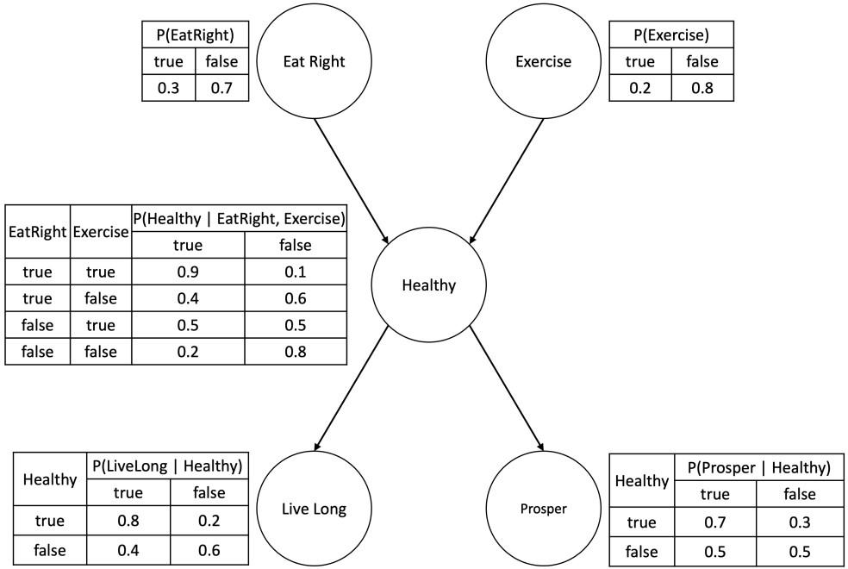

* 1. P(EatRight=true, Exercise=true, Healthy=true, LiveLong=true, Prosper=true)?

0.3 * 0.2 * 0.9 * 0.8 * 0.7 = **0.03024**

* 1. P(Healthy=true | Exercise=false)?

P(H,E) = (0.4+0.2)/2 = 0.3

P(H,E)/P(E) = 0.3/0.8 = **0.375**

* 1. P(LiveLong=true | EatRight=true, Exercise=true)?

(0.3* 0.2 * .9 *.8) + (0.3 * 0.2 *.1 * .4) = 0.0432 + 0.0024 = **0.0456**

* 1. P(EatRight=true | LiveLong=true, Prosper=true)?

=α**P**(ER, LL, P)

$$=α\sum_{EX}{ }\sum_{H}{P(ER, LL, P, H, EX)P(LL|H)P(P|H)}$$

$$=α\sum_{EX}{ }\sum_{H}{P\left(ER\right)P(EX)P(H|ER, EX)P(LL|H) P(P|H)}$$

$$=αP(ER)\sum_{EX}{P(EX) }\sum_{H}{P(H|ER, EX)P(LL|H) P(P|H)}$$

$=α[P(ER)\{P\left(EX\right)[P\left(H | ER,EX\right)P\left(LL | H\right)P\left(P | H\right)+P\left(¬H | ER,EX\right)P\left(LL | ¬H\right)P\left(P | ¬H\right)$] +

$$P\left(¬EX\right)\left[P\left(H | ER,¬EX\right)P\left(LL | H\right)P\left(P | H\right)\right] +P\left(¬H | ER,¬EX\right)P\left(LL | ¬H\right)P\left(P | ¬H\right)]\}$$

=0.3(0.2(0.9*0.8*0.7 + 0.1*0.4*0.3)+0.8(0.4*0.8*0.7 + 0.6*0.4*0.5))= $α$ 0.11352

=0.11352/((1.2/2) *(1.2/2) **)=** 0.11352/0.36 = **0.315**

* 1. **P**(Prosper | EatRight=false, Exercise=false)?

=α**P**(P, $¬$ ER, $¬$ EX)

=α<P(P, $¬$ ER, $¬$ EX), P($¬$ P, $¬$ ER, $¬$ EX)>

α < 0.7*0.8*0.2*0.7 + 0.7*0.8*0.8*0.5, 0.7*0.8*0.2*0.3 + 0.7*0.8*0.8*0.5>

= α <0.3024, 0.2576>

**=<0.54, 0.46>**

1. What would be the most likely sample from applying direct sampling to the Bayesian network in Problem 2? What is this sample’s probability?

P(EatRight=False, Exercise=False, healthy=False, LiveLong=False, prosper=False)

0.7 * 0.8 * 0.8 * 0.6 * 0.5 = **0.1344**

P(EatRight=False, Exercise=False, healthy=False, LiveLong=False, prosper=True)

0.7 * 0.8 * 0.8 * 0.6 * 0.5 = **0.1344**

1. *CptS 540 Students Only*. Consider the Bayesian network below, where each of the five random variables have a domain of 4 values. What is the minimum number of probabilities needed to completely describe the full joint probability distribution for this scenario? Justify your answer.

