**广州大学华软软件学院**

**毕业论文（设计）**







**课题名称 基于微信小程序的程序员交流社区的设计与实现**

**学 院 广州大学华软软件学院**

**系 别 软件工程系**

**专 业 信息工程**

**班 级 17级信息工程五班**

**姓 名 朱镇涛**

**学 号 1740128409**

**指导老师 黄辉**

**日 期 2021年4月10日**

摘要 随着互联网行业的发展，大众获取信息的途径也随着增加。而微信小程序的发布，毋庸置疑的为用户提供了又一种获取信息的途径。

交流社区系统分为微信小程序端、后台管理端、服务端、用户桌面端四个部分。系统提供了两种作品的形式：话题和文章，话题的设计是为了实现用户提出问题，每个话题下可包含零到多篇文章；

微信小程序端采用的是uni-app框架进行设计，包含浏览、搜索、编辑、评论、信息收集、个人信息管理、作品管理、用户关注管理和反馈等9个模块的功能。

后台管理端采用的是Electron + Vue.Js + Bootstrap技术开发，包含统计信息查询、个人信息管理、管理员管理、创建新的管理员、用户管理、编辑、反馈处理、浏览文章、添加标签和发布通知等10个模块的功能。

服务器使用SpringBoot + MyBatis + Mysql + Redis + Lucene等框架进行开发，为前端提供API，为持久化服务、文本审核和搜索等提供技术支持

用户桌面端采用的是Electron + Vue.Js + Bootstrap技术开发，包含修改个人信息和编辑的功能，因为微信小程序端编辑文本的不便利性，所以开发桌面端为用户提供良好的编辑体验

关键词：论坛；微信小程序；SpringBoot；ElectronJS

**ABSTRACT** With the development of the Internet industry, the public access to information is also increasing. The release of Wechat app undoubtedly provides users with another way to obtain information.

BBS is divided into 4 parts: Wechat mini program, background management system, service and desktop app for user.The system providers two forms of expression: the topic and the article. The topic is designed for users to ask questions, and each topic can contain zero to more articles.

Wechat mini program system is designed with uni-app framework, which includes nine modules including browsing, searching, editing, commenting, information collection, personal information management, works management, user followed management and feedback.

Back-end Management system is designed with Electron + Vue.Js + Bootstrap, whice includes ten modules including statistical information query, personal information management, administrator management, create a new administrator account, user management, editing, handling feedback, browsing articles, add new label and publish notification.

Server system is design with frameworks of SpringBoot + MyBatis + Mysql + Redis + Lucene, support the API for the front-end system; provide technical support for persistence services, text auditing and search.

Desktop App is designed with Electron + Vue.js + Bootstrap, includes personal information management and editing; because Wechat mini program can't provide editing function perfectly, therefore, the development of desktop application provides users with a good editing experience

**KEYWORDS** BBS; Wechat Mini Program; SpringBoot; ElectronJS

# 1 绪 论

## 研究背景及意义

* + 1. 研究背景

近年来越来越多的应用都推出了基于本身应用的小程序，微信小程序、抖音小程序和百度小程序等都是基于各自平台的小程序，而作为其中的龙头微信小程序，借助其庞大的用户群体和月活跃用户量将近十亿的优势，微信小程序的使用率和曝光度也是日益增长，在这种趋势下，许多的厂商都将自己的应用移植到了微信小程序平台。程序作为一款不同于Desktop端和Application端的新的应用类型，借助于微信累积的海量用户，更适合用于连接线下的用户。对于中小企业，微信小程序的开发成本会比开发Android和IOS低，也更容易开发和维护。

* + 1. 研究意义

交流社区是在网络上提供交流的手段。交流社区早已经从原本的娱乐和交流的工具转换成了新型的媒体。而基于微信小程序的交流社区可以使得人们更加便捷的获取到信息，但是目前在微信微信小程序上的程序员交流社区的体验并没有使用App的体验好，其中的原因是大部分的公司只是将微信小程序当作为自己App端引流的一个媒介，将庞大的微信用户量转换为自己的用户量，所以它们的交流社区小程序能够承载的功能并不多，所以开发一款纯粹的基于微信小程序的程序员交流社区不仅可以为用户提供良好的体验也还可以让我们的用户量增长。

* 1. 论文主要研究内容

本设计主要研究小程序提升用户的使用体验感以及提供更快捷的信息获取和处理的功能。

在此基础上在小程序和后台上提供趋向轻量级和模块化的设计。话题和文章的模型的设计将会为用户提供两种不同的浏览体验；使用云服务让系统处理的效率更加的迅速和安全，还为用户的浏览效果有更好的体验；为提高用户的编辑体验提供基于桌面的编辑器应用。在管理端为管理员提供高效的用户管理、管理员管理、系统管理和文章管理等功能。设计并提供。

* 1. 本章小结

本章讲述了本课题的设计背景和设计意义，简单的阐述了研究的内容

# 2 系统需求分析

## 系统需求分析可以在系统设计和开发的时候提供一份指南，所以灵活、简介和全面的需求分析可以让系统设计和开发得心应手。接下来要对系统功能模块、系统用例进行详细的分析。

## 2.1 系统功能分析

程序员交流社区的设计书大体要求是用户登陆注册、用户个人信息管理、浏览、编辑、评论、内容推送、搜索、关注和管理、个人作品管理。下面对这些要求分析出所需的功能。

### 2.1.1 微信小程序端需求分析

1. 登录

用户通过openid从后台获取用户信息，没有就进行注册。

1. 注册

用户通过openid进行注册。

1. 浏览

用户可以进行浏览首页的分类列表、文章详情、话题详情、用户关注列表、粉丝列表、用户收藏文章列表、个人文章列表、个人话题列表和用户信息等功能。

1. 搜索

用户输入关键词或者根据热度榜进行搜索文章和话题。

1. 评论

用户对文章进行评论或者对评论进行评论回复。

1. 文章和话题管理

用户可以进行点赞文章、收藏文章、删除个人文章和删除个人话题等功能。

1. 关注用户

用户关注其他的用户。

1. 个人信息管理

用户对自己的信息进行修改，包括手机号、性别、专业和动态等

1. 反馈

用户对系统的Bug、不足和意见进行编辑反馈给管理员处理。

1. 编辑话题

用户编辑话题。

1. 编辑文章

用户编辑文章。

1. 回复话题

用户对话题进行回复。

1. 系统通知管理

用户进入系统时会显示系统的通知，用户可以对其进行浏览和处理。

1. 生成报告

用户可以查看近一个月的报告。

1. 记录用户使用数据

小程序会记录用户的App使用情况和文章浏览数据等数据

1. 个人标签管理

用户可以对自己的标签进行管理

### 2.1.2 用户桌面端需求分析

1.登录

用户在微信小程序将自己的账号绑定手机号之后，就可以在桌面端使用手机号进行验证登录。

1. 编辑文章

用户编辑文章

1. 编辑话题

用户编辑话题

### 2.1.1 管理端需求分析

1.登录

管理员使用手机号或邮箱进行登录管理端

1. 报表统计

管理员查看系统的使用数据、浏览数据和用户数据等信息组成的报告，并可以下载保存。

1. 个人信息管理

管理员可以修改的个人信息，其中包括手机、邮箱、头像和动态等内容。

1. 管理员管理

管理员可以对其他管理员进行权限管理、删除管理员和创建新的管理员账号等功能。

1. 用户管理

管理员可以对用户进行管理。

1. 编辑话题

管理员以“官方账号”的名义编辑话题。

1. 编辑文章

管理员以“官方账号”的名义编辑文章。

1. 文章浏览

管理员浏览系统内的所有文章。

1. 通知

管理员为其他管理员或用户编写通知。

1. 标签管理

管理员对系统的标签进行管理。

1. 反馈处理

管理员可以对用户的反馈进行处理。

### 2.2.1 系统用例图

用例图可以划分为两个用例图：用户用例图和管理员用例图

用户用例图包含10个用例，其中包括登录、注册、浏览、编辑、搜索、反馈、个人信息管理、用户数据、个人标签管理、系统通知管理。其中用例图如下图。

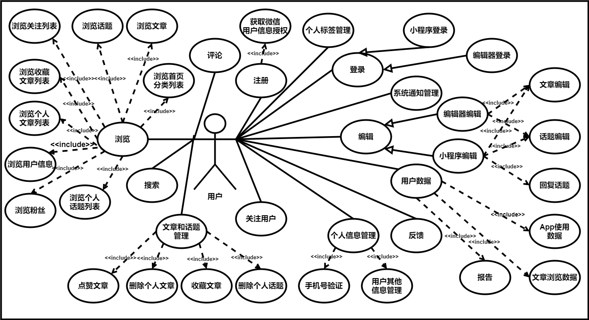

图 1用户用例图

管理员用例图包含10个用例，其中包括登录、个人信息管理、报表统计、用户管理、管理员管理、反馈处理、编辑、文章浏览、标签管理和通知。其中用例图如下图。

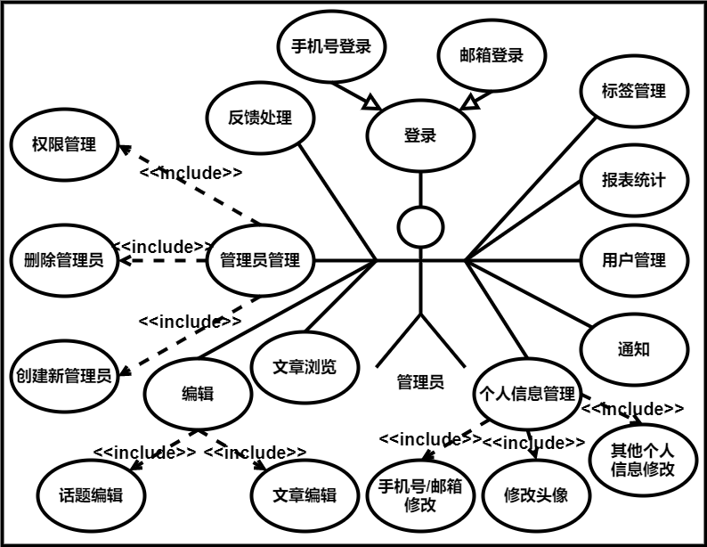

图 2 管理员用例图

### 2.2.2 用%3CmxGraphModel%3E%3Croot%3E%3CmxCell%20id%3D%220%22%2F%3E%3CmxCell%20id%3D%221%22%20parent%3D%220%22%2F%3E%3CmxCell%20id%3D%222%22%20value%3D%22%22%20style%3D%22rounded%3D0%3BwhiteSpace%3Dwrap%3Bhtml%3D1%3B%22%20vertex%3D%221%22%20parent%3D%221%22%3E%3CmxGeometry%20x%3D%22-800%22%20y%3D%221240%22%20width%3D%221520%22%20height%3D%22840%22%20as%3D%22geometry%22%2F%3E%3C%2FmxCell%3E%3CmxCell%20id%3D%223%22%20value%3D%22%22%20style%3D%22endArrow%3Dnone%3Bhtml%3D1%3BentryX%3D0.5%3BentryY%3D1%3BentryDx%3D0%3BentryDy%3D0%3BexitX%3D0.5%3BexitY%3D0%3BexitDx%3D0%3BexitDy%3D0%3BexitPerimeter%3D0%3B%22%20edge%3D%221%22%20target%3D%225%22%20parent%3D%221%22%3E%3CmxGeometry%20width%3D%2250%22%20height%3D%2250%22%20relative%3D%221%22%20as%3D%22geometry%22%3E%3CmxPoint%20x%3D%22-50.000000000000455%22%20y%3D%221580%22%20as%3D%22sourcePoint%22%2F%3E%3CmxPoint%20x%3D%22-40%22%20y%3D%221520%22%20as%3D%22targetPoint%22%2F%3E%3C%2FmxGeometry%3E%3C%2FmxCell%3E%3CmxCell%20id%3D%224%22%20value%3D%22%26amp%3Blt%3B%26amp%3Blt%3Binclude%26amp%3Bgt%3B%26amp%3Bgt%3B%22%20style%3D%22html%3D1%3BverticalAlign%3Dbottom%3BlabelBackgroundColor%3Dnone%3BendArrow%3Dopen%3BendFill%3D0%3Bdashed%3D1%3BentryX%3D0.5%3BentryY%3D1%3BentryDx%3D0%3BentryDy%3D0%3BexitX%3D0.5%3BexitY%3D0%3BexitDx%3D0%3BexitDy%3D0%3B%22%20edge%3D%221%22%20source%3D%225%22%20target%3D%227%22%20parent%3D%221%22%3E%3CmxGeometry%20x%3D%22-0.5%22%20width%3D%22160%22%20relative%3D%221%22%20as%3D%22geometry%22%3E%3CmxPoint%20x%3D%22-40%22%20y%3D%221460%22%20as%3D%22sourcePoint%22%2F%3E%3CmxPoint%20x%3D%22-40%22%20y%3D%221420%22%20as%3D%22targetPoint%22%2F%3E%3CmxPoint%20as%3D%22offset%22%2F%3E%3C%2FmxGeometry%3E%3C%2FmxCell%3E%3CmxCell%20id%3D%225%22%20value%3D%22%E6%B3%A8%E5%86%8C%22%20style%3D%22ellipse%3BwhiteSpace%3Dwrap%3Bhtml%3D1%3BfontSize%3D16%3B%22%20vertex%3D%221%22%20parent%3D%221%22%3E%3CmxGeometry%20x%3D%22-110%22%20y%3D%221440%22%20width%3D%22120%22%20height%3D%2280%22%20as%3D%22geometry%22%2F%3E%3C%2FmxCell%3E%3CmxCell%20id%3D%226%22%20value%3D%22%E7%99%BB%E5%BD%95%22%20style%3D%22ellipse%3BwhiteSpace%3Dwrap%3Bhtml%3D1%3BfontSize%3D16%3B%22%20vertex%3D%221%22%20parent%3D%221%22%3E%3CmxGeometry%20x%3D%22150%22%20y%3D%221370%22%20width%3D%22120%22%20height%3D%2280%22%20as%3D%22geometry%22%2F%3E%3C%2FmxCell%3E%3CmxCell%20id%3D%227%22%20value%3D%22%E8%8E%B7%E5%8F%96%E5%BE%AE%E4%BF%A1%26lt%3Bbr%20style%3D%26quot%3Bfont-size%3A%2016px%3B%26quot%3B%26gt%3B%E7%94%A8%E6%88%B7%E4%BF%A1%E6%81%AF%E6%8E%88%E6%9D%83%22%20style%3D%22ellipse%3BwhiteSpace%3Dwrap%3Bhtml%3D1%3BfontSize%3D16%3B%22%20vertex%3D%221%22%20parent%3D%221%22%3E%3CmxGeometry%20x%3D%22-110%22%20y%3D%221280%22%20width%3D%22120%22%20height%3D%2280%22%20as%3D%22geometry%22%2F%3E%3C%2FmxCell%3E%3CmxCell%20id%3D%228%22%20value%3D%22%22%20style%3D%22endArrow%3Dnone%3Bhtml%3D1%3BentryX%3D0%3BentryY%3D0.5%3BentryDx%3D0%3BentryDy%3D0%3BexitX%3D1%3BexitY%3D0.3333333333333333%3BexitDx%3D0%3BexitDy%3D0%3BexitPerimeter%3D0%3B%22%20edge%3D%221%22%20source%3D%2213%22%20target%3D%226%22%20parent%3D%221%22%3E%3CmxGeometry%20width%3D%2250%22%20height%3D%2250%22%20relative%3D%221%22%20as%3D%22geometry%22%3E%3CmxPoint%20x%3D%229.999999999999545%22%20y%3D%221480%22%20as%3D%22sourcePoint%22%2F%3E%3CmxPoint%20x%3D%22-20%22%20y%3D%221400%22%20as%3D%22targetPoint%22%2F%3E%3C%2FmxGeometry%3E%3C%2FmxCell%3E%3CmxCell%20id%3D%229%22%20value%3D%22%E5%B0%8F%E7%A8%8B%E5%BA%8F%E7%99%BB%E5%BD%95%22%20style%3D%22ellipse%3BwhiteSpace%3Dwrap%3Bhtml%3D1%3BfontSize%3D16%3B%22%20vertex%3D%221%22%20parent%3D%221%22%3E%3CmxGeometry%20x%3D%2230%22%20y%3D%221260%22%20width%3D%22120%22%20height%3D%2280%22%20as%3D%22geometry%22%2F%3E%3C%2FmxCell%3E%3CmxCell%20id%3D%2210%22%20value%3D%22%E7%BC%96%E8%BE%91%E5%99%A8%E7%99%BB%E5%BD%95%22%20style%3D%22ellipse%3BwhiteSpace%3Dwrap%3Bhtml%3D1%3BfontSize%3D16%3B%22%20vertex%3D%221%22%20parent%3D%221%22%3E%3CmxGeometry%20x%3D%22250%22%20y%3D%221260%22%20width%3D%22120%22%20height%3D%2280%22%20as%3D%22geometry%22%2F%3E%3C%2FmxCell%3E%3CmxCell%20id%3D%2211%22%20value%3D%22%22%20style%3D%22edgeStyle%3Dnone%3Bhtml%3D1%3BendSize%3D12%3BendArrow%3Dblock%3BendFill%3D0%3BfontSize%3D16%3BexitX%3D0.5%3BexitY%3D1%3BexitDx%3D0%3BexitDy%3D0%3BentryX%3D0%3BentryY%3D0%3BentryDx%3D0%3BentryDy%3D0%3B%22%20edge%3D%221%22%20source%3D%229%22%20target%3D%226%22%20parent%3D%221%22%3E%3CmxGeometry%20width%3D%22160%22%20relative%3D%221%22%20as%3D%22geometry%22%3E%3CmxPoint%20x%3D%22320%22%20y%3D%221290%22%20as%3D%22sourcePoint%22%2F%3E%3CmxPoint%20x%3D%22282.42640687119274%22%20y%3D%221341.7157287525383%22%20as%3D%22targetPoint%22%2F%3E%3C%2FmxGeometry%3E%3C%2FmxCell%3E%3CmxCell%20id%3D%2212%22%20value%3D%22%22%20style%3D%22edgeStyle%3Dnone%3Bhtml%3D1%3BendSize%3D12%3BendArrow%3Dblock%3BendFill%3D0%3BfontSize%3D16%3BexitX%3D0.5%3BexitY%3D1%3BexitDx%3D0%3BexitDy%3D0%3BentryX%3D1%3BentryY%3D0%3BentryDx%3D0%3BentryDy%3D0%3B%22%20edge%3D%221%22%20source%3D%2210%22%20target%3D%226%22%20parent%3D%221%22%3E%3CmxGeometry%20width%3D%22160%22%20relative%3D%221%22%20as%3D%22geometry%22%3E%3CmxPoint%20x%3D%22380%22%20y%3D%221430%22%20as%3D%22sourcePoint%22%2F%3E%3CmxPoint%20x%3D%22282.42640687119274%22%20y%3D%221461.7157287525383%22%20as%3D%22targetPoint%22%2F%3E%3C%2FmxGeometry%3E%3C%2FmxCell%3E%3CmxCell%20id%3D%2213%22%20value%3D%22%E7%94%A8%E6%88%B7%22%20style%3D%22shape%3DumlActor%3BverticalLabelPosition%3Dbottom%3BverticalAlign%3Dtop%3Bhtml%3D1%3BoutlineConnect%3D0%3B%22%20vertex%3D%221%22%20parent%3D%221%22%3E%3CmxGeometry%20x%3D%22-100%22%20y%3D%221580%22%20width%3D%22100%22%20height%3D%22180%22%20as%3D%22geometry%22%2F%3E%3C%2FmxCell%3E%3CmxCell%20id%3D%2214%22%20value%3D%22%E6%B5%8F%E8%A7%88%22%20style%3D%22ellipse%3BwhiteSpace%3Dwrap%3Bhtml%3D1%3BfontSize%3D16%3B%22%20vertex%3D%221%22%20parent%3D%221%22%3E%3CmxGeometry%20x%3D%22-520%22%20y%3D%221600%22%20width%3D%22120%22%20height%3D%2280%22%20as%3D%22geometry%22%2F%3E%3C%2FmxCell%3E%3CmxCell%20id%3D%2215%22%20value%3D%22%22%20style%3D%22endArrow%3Dnone%3Bhtml%3D1%3BentryX%3D0%3BentryY%3D0.3333333333333333%3BentryDx%3D0%3BentryDy%3D0%3BexitX%3D1%3BexitY%3D0.5%3BexitDx%3D0%3BexitDy%3D0%3BentryPerimeter%3D0%3B%22%20edge%3D%221%22%20source%3D%2214%22%20target%3D%2213%22%20parent%3D%221%22%3E%3CmxGeometry%20width%3D%2250%22%20height%3D%2250%22%20relative%3D%221%22%20as%3D%22geometry%22%3E%3CmxPoint%20x%3D%2220%22%20y%3D%221570.0000000000005%22%20as%3D%22sourcePoint%22%2F%3E%3CmxPoint%20x%3D%22-100%22%20y%3D%221720.0000000000005%22%20as%3D%22targetPoint%22%2F%3E%3C%2FmxGeometry%3E%3C%2FmxCell%3E%3CmxCell%20id%3D%2216%22%20value%3D%22%E6%B5%8F%E8%A7%88%E9%A6%96%E9%A1%B5%26lt%3Bbr%26gt%3B%E5%88%86%E7%B1%BB%E5%88%97%E8%A1%A8%22%20style%3D%22ellipse%3BwhiteSpace%3Dwrap%3Bhtml%3D1%3BfontSize%3D16%3B%22%20vertex%3D%221%22%20parent%3D%221%22%3E%3CmxGeometry%20x%3D%22-280%22%20y%3D%221480%22%20width%3D%22120%22%20height%3D%2280%22%20as%3D%22geometry%22%2F%3E%3C%2FmxCell%3E%3CmxCell%20id%3D%2217%22%20value%3D%22%E6%B5%8F%E8%A7%88%E6%96%87%E7%AB%A0%22%20style%3D%22ellipse%3BwhiteSpace%3Dwrap%3Bhtml%3D1%3BfontSize%3D16%3B%22%20vertex%3D%221%22%20parent%3D%221%22%3E%3CmxGeometry%20x%3D%22-440%22%20y%3D%221480%22%20width%3D%22120%22%20height%3D%2280%22%20as%3D%22geometry%22%2F%3E%3C%2FmxCell%3E%3CmxCell%20id%3D%2218%22%20value%3D%22%E6%B5%8F%E8%A7%88%E8%AF%9D%E9%A2%98%22%20style%3D%22ellipse%3BwhiteSpace%3Dwrap%3Bhtml%3D1%3BfontSize%3D16%3B%22%20vertex%3D%221%22%20parent%3D%221%22%3E%3CmxGeometry%20x%3D%22-600%22%20y%3D%221480%22%20width%3D%22120%22%20height%3D%2280%22%20as%3D%22geometry%22%2F%3E%3C%2FmxCell%3E%3CmxCell%20id%3D%2219%22%20value%3D%22%E6%B5%8F%E8%A7%88%E5%85%B3%E6%B3%A8%E5%88%97%E8%A1%A8%22%20style%3D%22ellipse%3BwhiteSpace%3Dwrap%3Bhtml%3D1%3BfontSize%3D16%3B%22%20vertex%3D%221%22%20parent%3D%221%22%3E%3CmxGeometry%20x%3D%22-760%22%20y%3D%221480%22%20width%3D%22120%22%20height%3D%2280%22%20as%3D%22geometry%22%2F%3E%3C%2FmxCell%3E%3CmxCell%20id%3D%2220%22%20value%3D%22%E6%B5%8F%E8%A7%88%E7%B2%89%E4%B8%9D%22%20style%3D%22ellipse%3BwhiteSpace%3Dwrap%3Bhtml%3D1%3BfontSize%3D16%3B%22%20vertex%3D%221%22%20parent%3D%221%22%3E%3CmxGeometry%20x%3D%22-440%22%20y%3D%221720%22%20width%3D%22120%22%20height%3D%2280%22%20as%3D%22geometry%22%2F%3E%3C%2FmxCell%3E%3CmxCell%20id%3D%2221%22%20value%3D%22%E6%B5%8F%E8%A7%88%E4%B8%AA%E4%BA%BA%26lt%3Bbr%26gt%3B%E8%AF%9D%E9%A2%98%E5%88%97%E8%A1%A8%22%20style%3D%22ellipse%3BwhiteSpace%3Dwrap%3Bhtml%3D1%3BfontSize%3D16%3B%22%20vertex%3D%221%22%20parent%3D%221%22%3E%3CmxGeometry%20x%3D%22-280%22%20y%3D%221720%22%20width%3D%22120%22%20height%3D%2280%22%20as%3D%22geometry%22%2F%3E%3C%2FmxCell%3E%3CmxCell%20id%3D%2222%22%20value%3D%22%E6%B5%8F%E8%A7%88%E4%B8%AA%E4%BA%BA%26lt%3Bbr%26gt%3B%E6%96%87%E7%AB%A0%E5%88%97%E8%A1%A8%22%20style%3D%22ellipse%3BwhiteSpace%3Dwrap%3Bhtml%3D1%3BfontSize%3D16%3B%22%20vertex%3D%221%22%20parent%3D%221%22%3E%3CmxGeometry%20x%3D%22-760%22%20y%3D%221720%22%20width%3D%22120%22%20height%3D%2280%22%20as%3D%22geometry%22%2F%3E%3C%2FmxCell%3E%3CmxCell%20id%3D%2223%22%20value%3D%22%E6%B5%8F%E8%A7%88%E6%94%B6%E8%97%8F%26lt%3Bbr%26gt%3B%E6%96%87%E7%AB%A0%E5%88%97%E8%A1%A8%22%20style%3D%22ellipse%3BwhiteSpace%3Dwrap%3Bhtml%3D1%3BfontSize%3D16%3B%22%20vertex%3D%221%22%20parent%3D%221%22%3E%3CmxGeometry%20x%3D%22-760%22%20y%3D%221600%22%20width%3D%22120%22%20height%3D%2280%22%20as%3D%22geometry%22%2F%3E%3C%2FmxCell%3E%3CmxCell%20id%3D%2224%22%20value%3D%22%E6%B5%8F%E8%A7%88%E7%94%A8%E6%88%B7%E4%BF%A1%E6%81%AF%22%20style%3D%22ellipse%3BwhiteSpace%3Dwrap%3Bhtml%3D1%3BfontSize%3D16%3B%22%20vertex%3D%221%22%20parent%3D%221%22%3E%3CmxGeometry%20x%3D%22-600%22%20y%3D%221720%22%20width%3D%22120%22%20height%3D%2280%22%20as%3D%22geometry%22%2F%3E%3C%2FmxCell%3E%3CmxCell%20id%3D%2225%22%20value%3D%22%26amp%3Blt%3B%26amp%3Blt%3Binclude%26amp%3Bgt%3B%26amp%3Bgt%3B%22%20style%3D%22html%3D1%3BverticalAlign%3Dbottom%3BlabelBackgroundColor%3Dnone%3BendArrow%3Dopen%3BendFill%3D0%3Bdashed%3D1%3BexitX%3D1%3BexitY%3D0%3BexitDx%3D0%3BexitDy%3D0%3BentryX%3D0%3BentryY%3D1%3BentryDx%3D0%3BentryDy%3D0%3B%22%20edge%3D%221%22%20source%3D%2214%22%20target%3D%2216%22%20parent%3D%221%22%3E%3CmxGeometry%20x%3D%220.0653%22%20y%3D%22-13%22%20width%3D%22160%22%20relative%3D%221%22%20as%3D%22geometry%22%3E%3CmxPoint%20x%3D%22-40%22%20y%3D%221450.0000000000005%22%20as%3D%22sourcePoint%22%2F%3E%3CmxPoint%20x%3D%22-280%22%20y%3D%221450%22%20as%3D%22targetPoint%22%2F%3E%3CmxPoint%20as%3D%22offset%22%2F%3E%3C%2FmxGeometry%3E%3C%2FmxCell%3E%3CmxCell%20id%3D%2226%22%20value%3D%22%26amp%3Blt%3B%26amp%3Blt%3Binclude%26amp%3Bgt%3B%26amp%3Bgt%3B%22%20style%3D%22html%3D1%3BverticalAlign%3Dbottom%3BlabelBackgroundColor%3Dnone%3BendArrow%3Dopen%3BendFill%3D0%3Bdashed%3D1%3BexitX%3D0.5%3BexitY%3D0%3BexitDx%3D0%3BexitDy%3D0%3BentryX%3D0.5%3BentryY%3D1%3BentryDx%3D0%3BentryDy%3D0%3B%22%20edge%3D%221%22%20source%3D%2214%22%20target%3D%2218%22%20parent%3D%221%22%3E%3CmxGeometry%20width%3D%22160%22%20relative%3D%221%22%20as%3D%22geometry%22%3E%3CmxPoint%20x%3D%22-407.57359312880726%22%20y%3D%221621.7157287525383%22%20as%3D%22sourcePoint%22%2F%3E%3CmxPoint%20x%3D%22-252.42640687119274%22%20y%3D%221558.2842712474621%22%20as%3D%22targetPoint%22%2F%3E%3CmxPoint%20as%3D%22offset%22%2F%3E%3C%2FmxGeometry%3E%3C%2FmxCell%3E%3CmxCell%20id%3D%2227%22%20value%3D%22%26amp%3Blt%3B%26amp%3Blt%3Binclude%26amp%3Bgt%3B%26amp%3Bgt%3B%22%20style%3D%22html%3D1%3BverticalAlign%3Dbottom%3BlabelBackgroundColor%3Dnone%3BendArrow%3Dopen%3BendFill%3D0%3Bdashed%3D1%3BexitX%3D0.5%3BexitY%3D0%3BexitDx%3D0%3BexitDy%3D0%3BentryX%3D0.5%3BentryY%3D1%3BentryDx%3D0%3BentryDy%3D0%3B%22%20edge%3D%221%22%20source%3D%2214%22%20target%3D%2217%22%20parent%3D%221%22%3E%3CmxGeometry%20x%3D%220.0653%22%20y%3D%22-13%22%20width%3D%22160%22%20relative%3D%221%22%20as%3D%22geometry%22%3E%3CmxPoint%20x%3D%22-450%22%20y%3D%221610%22%20as%3D%22sourcePoint%22%2F%3E%3CmxPoint%20x%3D%22-530%22%20y%3D%221570%22%20as%3D%22targetPoint%22%2F%3E%3CmxPoint%20as%3D%22offset%22%2F%3E%3C%2FmxGeometry%3E%3C%2FmxCell%3E%3CmxCell%20id%3D%2228%22%20value%3D%22%26amp%3Blt%3B%26amp%3Blt%3Binclude%26amp%3Bgt%3B%26amp%3Bgt%3B%22%20style%3D%22html%3D1%3BverticalAlign%3Dbottom%3BlabelBackgroundColor%3Dnone%3BendArrow%3Dopen%3BendFill%3D0%3Bdashed%3D1%3BexitX%3D0.5%3BexitY%3D1%3BexitDx%3D0%3BexitDy%3D0%3BentryX%3D0.5%3BentryY%3D0%3BentryDx%3D0%3BentryDy%3D0%3B%22%20edge%3D%221%22%20source%3D%2214%22%20target%3D%2224%22%20parent%3D%221%22%3E%3CmxGeometry%20width%3D%22160%22%20relative%3D%221%22%20as%3D%22geometry%22%3E%3CmxPoint%20x%3D%22-450%22%20y%3D%221610%22%20as%3D%22sourcePoint%22%2F%3E%3CmxPoint%20x%3D%22-530%22%20y%3D%221570%22%20as%3D%22targetPoint%22%2F%3E%3CmxPoint%20as%3D%22offset%22%2F%3E%3C%2FmxGeometry%3E%3C%2FmxCell%3E%3CmxCell%20id%3D%2229%22%20value%3D%22%26amp%3Blt%3B%26amp%3Blt%3Binclude%26amp%3Bgt%3B%26amp%3Bgt%3B%22%20style%3D%22html%3D1%3BverticalAlign%3Dbottom%3BlabelBackgroundColor%3Dnone%3BendArrow%3Dopen%3BendFill%3D0%3Bdashed%3D1%3BexitX%3D0.5%3BexitY%3D1%3BexitDx%3D0%3BexitDy%3D0%3BentryX%3D0.5%3BentryY%3D0%3BentryDx%3D0%3BentryDy%3D0%3B%22%20edge%3D%221%22%20source%3D%2214%22%20target%3D%2220%22%20parent%3D%221%22%3E%3CmxGeometry%20width%3D%22160%22%20relative%3D%221%22%20as%3D%22geometry%22%3E%3CmxPoint%20x%3D%22-440%22%20y%3D%221620%22%20as%3D%22sourcePoint%22%2F%3E%3CmxPoint%20x%3D%22-520%22%20y%3D%221580%22%20as%3D%22targetPoint%22%2F%3E%3CmxPoint%20as%3D%22offset%22%2F%3E%3C%2FmxGeometry%3E%3C%2FmxCell%3E%3CmxCell%20id%3D%2230%22%20value%3D%22%26amp%3Blt%3B%26amp%3Blt%3Binclude%26amp%3Bgt%3B%26amp%3Bgt%3B%22%20style%3D%22html%3D1%3BverticalAlign%3Dbottom%3BlabelBackgroundColor%3Dnone%3BendArrow%3Dopen%3BendFill%3D0%3Bdashed%3D1%3BexitX%3D1%3BexitY%3D1%3BexitDx%3D0%3BexitDy%3D0%3BentryX%3D0%3BentryY%3D0%3BentryDx%3D0%3BentryDy%3D0%3B%22%20edge%3D%221%22%20source%3D%2214%22%20target%3D%2221%22%20parent%3D%221%22%3E%3CmxGeometry%20width%3D%22160%22%20relative%3D%221%22%20as%3D%22geometry%22%3E%3CmxPoint%20x%3D%22-430%22%20y%3D%221630%22%20as%3D%22sourcePoint%22%2F%3E%3CmxPoint%20x%3D%22-510%22%20y%3D%221590%22%20as%3D%22targetPoint%22%2F%3E%3CmxPoint%20as%3D%22offset%22%2F%3E%3C%2FmxGeometry%3E%3C%2FmxCell%3E%3CmxCell%20id%3D%2231%22%20value%3D%22%26amp%3Blt%3B%26amp%3Blt%3Binclude%26amp%3Bgt%3B%26amp%3Bgt%3B%22%20style%3D%22html%3D1%3BverticalAlign%3Dbottom%3BlabelBackgroundColor%3Dnone%3BendArrow%3Dopen%3BendFill%3D0%3Bdashed%3D1%3BexitX%3D0%3BexitY%3D1%3BexitDx%3D0%3BexitDy%3D0%3BentryX%3D1%3BentryY%3D0%3BentryDx%3D0%3BentryDy%3D0%3B%22%20edge%3D%221%22%20source%3D%2214%22%20target%3D%2222%22%20parent%3D%221%22%3E%3CmxGeometry%20width%3D%22160%22%20relative%3D%221%22%20as%3D%22geometry%22%3E%3CmxPoint%20x%3D%22-420%22%20y%3D%221640%22%20as%3D%22sourcePoint%22%2F%3E%3CmxPoint%20x%3D%22-500%22%20y%3D%221600%22%20as%3D%22targetPoint%22%2F%3E%3CmxPoint%20as%3D%22offset%22%2F%3E%3C%2FmxGeometry%3E%3C%2FmxCell%3E%3CmxCell%20id%3D%2232%22%20value%3D%22%26amp%3Blt%3B%26amp%3Blt%3Binclude%26amp%3Bgt%3B%26amp%3Bgt%3B%22%20style%3D%22html%3D1%3BverticalAlign%3Dbottom%3BlabelBackgroundColor%3Dnone%3BendArrow%3Dopen%3BendFill%3D0%3Bdashed%3D1%3BexitX%3D0%3BexitY%3D0.5%3BexitDx%3D0%3BexitDy%3D0%3BentryX%3D1%3BentryY%3D0.5%3BentryDx%3D0%3BentryDy%3D0%3B%22%20edge%3D%221%22%20source%3D%2214%22%20target%3D%2223%22%20parent%3D%221%22%3E%3CmxGeometry%20width%3D%22160%22%20relative%3D%221%22%20as%3D%22geometry%22%3E%3CmxPoint%20x%3D%22-410%22%20y%3D%221650%22%20as%3D%22sourcePoint%22%2F%3E%3CmxPoint%20x%3D%22-490%22%20y%3D%221610%22%20as%3D%22targetPoint%22%2F%3E%3CmxPoint%20as%3D%22offset%22%2F%3E%3C%2FmxGeometry%3E%3C%2FmxCell%3E%3CmxCell%20id%3D%2233%22%20value%3D%22%26amp%3Blt%3B%26amp%3Blt%3Binclude%26amp%3Bgt%3B%26amp%3Bgt%3B%22%20style%3D%22html%3D1%3BverticalAlign%3Dbottom%3BlabelBackgroundColor%3Dnone%3BendArrow%3Dopen%3BendFill%3D0%3Bdashed%3D1%3BexitX%3D0%3BexitY%3D0%3BexitDx%3D0%3BexitDy%3D0%3BentryX%3D1%3BentryY%3D1%3BentryDx%3D0%3BentryDy%3D0%3B%22%20edge%3D%221%22%20source%3D%2214%22%20target%3D%2219%22%20parent%3D%221%22%3E%3CmxGeometry%20width%3D%22160%22%20relative%3D%221%22%20as%3D%22geometry%22%3E%3CmxPoint%20x%3D%22-400%22%20y%3D%221660%22%20as%3D%22sourcePoint%22%2F%3E%3CmxPoint%20x%3D%22-480%22%20y%3D%221620%22%20as%3D%22targetPoint%22%2F%3E%3CmxPoint%20as%3D%22offset%22%2F%3E%3C%2FmxGeometry%3E%3C%2FmxCell%3E%3CmxCell%20id%3D%2234%22%20value%3D%22%E6%90%9C%E7%B4%A2%22%20style%3D%22ellipse%3BwhiteSpace%3Dwrap%3Bhtml%3D1%3BfontSize%3D16%3B%22%20vertex%3D%221%22%20parent%3D%221%22%3E%3CmxGeometry%20x%3D%22-240%22%20y%3D%221840%22%20width%3D%22120%22%20height%3D%2280%22%20as%3D%22geometry%22%2F%3E%3C%2FmxCell%3E%3CmxCell%20id%3D%2235%22%20value%3D%22%22%20style%3D%22endArrow%3Dnone%3Bhtml%3D1%3BentryX%3D0%3BentryY%3D0.3333333333333333%3BentryDx%3D0%3BentryDy%3D0%3BexitX%3D0.5%3BexitY%3D0%3BexitDx%3D0%3BexitDy%3D0%3BentryPerimeter%3D0%3B%22%20edge%3D%221%22%20source%3D%2234%22%20target%3D%2213%22%20parent%3D%221%22%3E%3CmxGeometry%20width%3D%2250%22%20height%3D%2250%22%20relative%3D%221%22%20as%3D%22geometry%22%3E%3CmxPoint%20x%3D%22-390%22%20y%3D%221650%22%20as%3D%22sourcePoint%22%2F%3E%3CmxPoint%20x%3D%22-90%22%20y%3D%221650%22%20as%3D%22targetPoint%22%2F%3E%3C%2FmxGeometry%3E%3C%2FmxCell%3E%3CmxCell%20id%3D%2236%22%20value%3D%22%E8%AF%84%E8%AE%BA%22%20style%3D%22ellipse%3BwhiteSpace%3Dwrap%3Bhtml%3D1%3BfontSize%3D16%3B%22%20vertex%3D%221%22%20parent%3D%221%22%3E%3CmxGeometry%20x%3D%22-240%22%20y%3D%221360%22%20width%3D%22120%22%20height%3D%2280%22%20as%3D%22geometry%22%2F%3E%3C%2FmxCell%3E%3CmxCell%20id%3D%2237%22%20value%3D%22%22%20style%3D%22endArrow%3Dnone%3Bhtml%3D1%3BexitX%3D0.5%3BexitY%3D1%3BexitDx%3D0%3BexitDy%3D0%3B%22%20edge%3D%221%22%20source%3D%2236%22%20parent%3D%221%22%3E%3CmxGeometry%20width%3D%2250%22%20height%3D%2250%22%20relative%3D%221%22%20as%3D%22geometry%22%3E%3CmxPoint%20x%3D%22-390%22%20y%3D%221650%22%20as%3D%22sourcePoint%22%2F%3E%3CmxPoint%20x%3D%22-100%22%20y%3D%221640%22%20as%3D%22targetPoint%22%2F%3E%3C%2FmxGeometry%3E%3C%2FmxCell%3E%3CmxCell%20id%3D%2238%22%20value%3D%22%E7%BC%96%E8%BE%91%22%20style%3D%22ellipse%3BwhiteSpace%3Dwrap%3Bhtml%3D1%3BfontSize%3D16%3B%22%20vertex%3D%221%22%20parent%3D%221%22%3E%3CmxGeometry%20x%3D%22160%22%20y%3D%221600%22%20width%3D%22120%22%20height%3D%2280%22%20as%3D%22geometry%22%2F%3E%3C%2FmxCell%3E%3CmxCell%20id%3D%2239%22%20value%3D%22%22%20style%3D%22endArrow%3Dnone%3Bhtml%3D1%3BentryX%3D0%3BentryY%3D0.5%3BentryDx%3D0%3BentryDy%3D0%3BexitX%3D1%3BexitY%3D0.3333333333333333%3BexitDx%3D0%3BexitDy%3D0%3BexitPerimeter%3D0%3B%22%20edge%3D%221%22%20source%3D%2213%22%20target%3D%2238%22%20parent%3D%221%22%3E%3CmxGeometry%20width%3D%2250%22%20height%3D%2250%22%20relative%3D%221%22%20as%3D%22geometry%22%3E%3CmxPoint%20x%3D%2210%22%20y%3D%221650%22%20as%3D%22sourcePoint%22%2F%3E%3CmxPoint%20x%3D%22170%22%20y%3D%221490%22%20as%3D%22targetPoint%22%2F%3E%3C%2FmxGeometry%3E%3C%2FmxCell%3E%3CmxCell%20id%3D%2240%22%20value%3D%22%E7%BC%96%E8%BE%91%E5%99%A8%E7%BC%96%E8%BE%91%22%20style%3D%22ellipse%3BwhiteSpace%3Dwrap%3Bhtml%3D1%3BfontSize%3D16%3B%22%20vertex%3D%221%22%20parent%3D%221%22%3E%3CmxGeometry%20x%3D%22320%22%20y%3D%221520%22%20width%3D%22120%22%20height%3D%2280%22%20as%3D%22geometry%22%2F%3E%3C%2FmxCell%3E%3CmxCell%20id%3D%2241%22%20value%3D%22%E5%B0%8F%E7%A8%8B%E5%BA%8F%E7%BC%96%E8%BE%91%22%20style%3D%22ellipse%3BwhiteSpace%3Dwrap%3Bhtml%3D1%3BfontSize%3D16%3B%22%20vertex%3D%221%22%20parent%3D%221%22%3E%3CmxGeometry%20x%3D%22320%22%20y%3D%221680%22%20width%3D%22120%22%20height%3D%2280%22%20as%3D%22geometry%22%2F%3E%3C%2FmxCell%3E%3CmxCell%20id%3D%2242%22%20value%3D%22%22%20style%3D%22edgeStyle%3Dnone%3Bhtml%3D1%3BendSize%3D12%3BendArrow%3Dblock%3BendFill%3D0%3BfontSize%3D16%3BexitX%3D0%3BexitY%3D0.5%3BexitDx%3D0%3BexitDy%3D0%3BentryX%3D1%3BentryY%3D0%3BentryDx%3D0%3BentryDy%3D0%3B%22%20edge%3D%221%22%20source%3D%2240%22%20target%3D%2238%22%20parent%3D%221%22%3E%3CmxGeometry%20width%3D%22160%22%20relative%3D%221%22%20as%3D%22geometry%22%3E%3CmxPoint%20x%3D%22310%22%20y%3D%221370%22%20as%3D%22sourcePoint%22%2F%3E%3CmxPoint%20x%3D%22272.42640687119274%22%20y%3D%221461.7157287525379%22%20as%3D%22targetPoint%22%2F%3E%3C%2FmxGeometry%3E%3C%2FmxCell%3E%3CmxCell%20id%3D%2243%22%20value%3D%22%22%20style%3D%22edgeStyle%3Dnone%3Bhtml%3D1%3BendSize%3D12%3BendArrow%3Dblock%3BendFill%3D0%3BfontSize%3D16%3BexitX%3D0%3BexitY%3D0.5%3BexitDx%3D0%3BexitDy%3D0%3BentryX%3D1%3BentryY%3D1%3BentryDx%3D0%3BentryDy%3D0%3B%22%20edge%3D%221%22%20source%3D%2241%22%20target%3D%2238%22%20parent%3D%221%22%3E%3CmxGeometry%20width%3D%22160%22%20relative%3D%221%22%20as%3D%22geometry%22%3E%3CmxPoint%20x%3D%22150%22%20y%3D%221370%22%20as%3D%22sourcePoint%22%2F%3E%3CmxPoint%20x%3D%22187.57359312880726%22%20y%3D%221461.7157287525379%22%20as%3D%22targetPoint%22%2F%3E%3C%2FmxGeometry%3E%3C%2FmxCell%3E%3CmxCell%20id%3D%2244%22%20value%3D%22%E6%96%87%E7%AB%A0%E7%BC%96%E8%BE%91%22%20style%3D%22ellipse%3BwhiteSpace%3Dwrap%3Bhtml%3D1%3BfontSize%3D16%3B%22%20vertex%3D%221%22%20parent%3D%221%22%3E%3CmxGeometry%20x%3D%22520%22%20y%3D%221440%22%20width%3D%22120%22%20height%3D%2280%22%20as%3D%22geometry%22%2F%3E%3C%2FmxCell%3E%3CmxCell%20id%3D%2245%22%20value%3D%22%E8%AF%9D%E9%A2%98%E7%BC%96%E8%BE%91%22%20style%3D%22ellipse%3BwhiteSpace%3Dwrap%3Bhtml%3D1%3BfontSize%3D16%3B%22%20vertex%3D%221%22%20parent%3D%221%22%3E%3CmxGeometry%20x%3D%22520%22%20y%3D%221600%22%20width%3D%22120%22%20height%3D%2280%22%20as%3D%22geometry%22%2F%3E%3C%2FmxCell%3E%3CmxCell%20id%3D%2246%22%20value%3D%22%E5%9B%9E%E5%A4%8D%E8%AF%9D%E9%A2%98%22%20style%3D%22ellipse%3BwhiteSpace%3Dwrap%3Bhtml%3D1%3BfontSize%3D16%3B%22%20vertex%3D%221%22%20parent%3D%221%22%3E%3CmxGeometry%20x%3D%22520%22%20y%3D%221760%22%20width%3D%22120%22%20height%3D%2280%22%20as%3D%22geometry%22%2F%3E%3C%2FmxCell%3E%3CmxCell%20id%3D%2247%22%20value%3D%22%26amp%3Blt%3B%26amp%3Blt%3Binclude%26amp%3Bgt%3B%26amp%3Bgt%3B%22%20style%3D%22html%3D1%3BverticalAlign%3Dbottom%3BlabelBackgroundColor%3Dnone%3BendArrow%3Dopen%3BendFill%3D0%3Bdashed%3D1%3BentryX%3D0%3BentryY%3D0.5%3BentryDx%3D0%3BentryDy%3D0%3BexitX%3D1%3BexitY%3D0.5%3BexitDx%3D0%3BexitDy%3D0%3B%22%20edge%3D%221%22%20source%3D%2240%22%20target%3D%2244%22%20parent%3D%221%22%3E%3CmxGeometry%20x%3D%22-0.5%22%20width%3D%22160%22%20relative%3D%221%22%20as%3D%22geometry%22%3E%3CmxPoint%20x%3D%22-40%22%20y%3D%221450%22%20as%3D%22sourcePoint%22%2F%3E%3CmxPoint%20x%3D%22-40%22%20y%3D%221370%22%20as%3D%22targetPoint%22%2F%3E%3CmxPoint%20as%3D%22offset%22%2F%3E%3C%2FmxGeometry%3E%3C%2FmxCell%3E%3CmxCell%20id%3D%2248%22%20value%3D%22%26amp%3Blt%3B%26amp%3Blt%3Binclude%26amp%3Bgt%3B%26amp%3Bgt%3B%22%20style%3D%22html%3D1%3BverticalAlign%3Dbottom%3BlabelBackgroundColor%3Dnone%3BendArrow%3Dopen%3BendFill%3D0%3Bdashed%3D1%3BentryX%3D0%3BentryY%3D0.5%3BentryDx%3D0%3BentryDy%3D0%3BexitX%3D1%3BexitY%3D0.5%3BexitDx%3D0%3BexitDy%3D0%3B%22%20edge%3D%221%22%20source%3D%2240%22%20target%3D%2245%22%20parent%3D%221%22%3E%3CmxGeometry%20x%3D%22-0.5%22%20width%3D%22160%22%20relative%3D%221%22%20as%3D%22geometry%22%3E%3CmxPoint%20x%3D%22450%22%20y%3D%221570%22%20as%3D%22sourcePoint%22%2F%3E%3CmxPoint%20x%3D%22530%22%20y%3D%221490%22%20as%3D%22targetPoint%22%2F%3E%3CmxPoint%20as%3D%22offset%22%2F%3E%3C%2FmxGeometry%3E%3C%2FmxCell%3E%3CmxCell%20id%3D%2249%22%20value%3D%22%26amp%3Blt%3B%26amp%3Blt%3Binclude%26amp%3Bgt%3B%26amp%3Bgt%3B%22%20style%3D%22html%3D1%3BverticalAlign%3Dbottom%3BlabelBackgroundColor%3Dnone%3BendArrow%3Dopen%3BendFill%3D0%3Bdashed%3D1%3BentryX%3D0%3BentryY%3D0.5%3BentryDx%3D0%3BentryDy%3D0%3BexitX%3D1%3BexitY%3D0.5%3BexitDx%3D0%3BexitDy%3D0%3B%22%20edge%3D%221%22%20source%3D%2241%22%20target%3D%2244%22%20parent%3D%221%22%3E%3CmxGeometry%20x%3D%22-0.5%22%20width%3D%22160%22%20relative%3D%221%22%20as%3D%22geometry%22%3E%3CmxPoint%20x%3D%22460%22%20y%3D%221580%22%20as%3D%22sourcePoint%22%2F%3E%3CmxPoint%20x%3D%22540%22%20y%3D%221500%22%20as%3D%22targetPoint%22%2F%3E%3CmxPoint%20as%3D%22offset%22%2F%3E%3C%2FmxGeometry%3E%3C%2FmxCell%3E%3CmxCell%20id%3D%2250%22%20value%3D%22%26amp%3Blt%3B%26amp%3Blt%3Binclude%26amp%3Bgt%3B%26amp%3Bgt%3B%22%20style%3D%22html%3D1%3BverticalAlign%3Dbottom%3BlabelBackgroundColor%3Dnone%3BendArrow%3Dopen%3BendFill%3D0%3Bdashed%3D1%3BentryX%3D0%3BentryY%3D0.5%3BentryDx%3D0%3BentryDy%3D0%3BexitX%3D1%3BexitY%3D0.5%3BexitDx%3D0%3BexitDy%3D0%3B%22%20edge%3D%221%22%20source%3D%2241%22%20target%3D%2245%22%20parent%3D%221%22%3E%3CmxGeometry%20x%3D%22-0.5%22%20width%3D%22160%22%20relative%3D%221%22%20as%3D%22geometry%22%3E%3CmxPoint%20x%3D%22470%22%20y%3D%221590%22%20as%3D%22sourcePoint%22%2F%3E%3CmxPoint%20x%3D%22550%22%20y%3D%221510%22%20as%3D%22targetPoint%22%2F%3E%3CmxPoint%20as%3D%22offset%22%2F%3E%3C%2FmxGeometry%3E%3C%2FmxCell%3E%3CmxCell%20id%3D%2251%22%20value%3D%22%26amp%3Blt%3B%26amp%3Blt%3Binclude%26amp%3Bgt%3B%26amp%3Bgt%3B%22%20style%3D%22html%3D1%3BverticalAlign%3Dbottom%3BlabelBackgroundColor%3Dnone%3BendArrow%3Dopen%3BendFill%3D0%3Bdashed%3D1%3BentryX%3D0%3BentryY%3D0.5%3BentryDx%3D0%3BentryDy%3D0%3B%22%20edge%3D%221%22%20target%3D%2246%22%20parent%3D%221%22%3E%3CmxGeometry%20x%3D%22-0.5%22%20width%3D%22160%22%20relative%3D%221%22%20as%3D%22geometry%22%3E%3CmxPoint%20x%3D%22440%22%20y%3D%221720%22%20as%3D%22sourcePoint%22%2F%3E%3CmxPoint%20x%3D%22560%22%20y%3D%221520%22%20as%3D%22targetPoint%22%2F%3E%3CmxPoint%20as%3D%22offset%22%2F%3E%3C%2FmxGeometry%3E%3C%2FmxCell%3E%3CmxCell%20id%3D%2252%22%20value%3D%22%E7%94%A8%E6%88%B7%E6%95%B0%E6%8D%AE%22%20style%3D%22ellipse%3BwhiteSpace%3Dwrap%3Bhtml%3D1%3BfontSize%3D16%3B%22%20vertex%3D%221%22%20parent%3D%221%22%3E%3CmxGeometry%20x%3D%22240%22%20y%3D%221840%22%20width%3D%22120%22%20height%3D%2280%22%20as%3D%22geometry%22%2F%3E%3C%2FmxCell%3E%3CmxCell%20id%3D%2253%22%20value%3D%22%22%20style%3D%22endArrow%3Dnone%3Bhtml%3D1%3BentryX%3D0%3BentryY%3D0%3BentryDx%3D0%3BentryDy%3D0%3BexitX%3D1%3BexitY%3D0.3333333333333333%3BexitDx%3D0%3BexitDy%3D0%3BexitPerimeter%3D0%3B%22%20edge%3D%221%22%20source%3D%2213%22%20target%3D%2252%22%20parent%3D%221%22%3E%3CmxGeometry%20width%3D%2250%22%20height%3D%2250%22%20relative%3D%221%22%20as%3D%22geometry%22%3E%3CmxPoint%20x%3D%2210%22%20y%3D%221650%22%20as%3D%22sourcePoint%22%2F%3E%3CmxPoint%20x%3D%22170%22%20y%3D%221650%22%20as%3D%22targetPoint%22%2F%3E%3C%2FmxGeometry%3E%3C%2FmxCell%3E%3CmxCell%20id%3D%2254%22%20value%3D%22%E5%8F%8D%E9%A6%88%22%20style%3D%22ellipse%3BwhiteSpace%3Dwrap%3Bhtml%3D1%3BfontSize%3D16%3B%22%20vertex%3D%221%22%20parent%3D%221%22%3E%3CmxGeometry%20x%3D%2280%22%20y%3D%221840%22%20width%3D%22120%22%20height%3D%2280%22%20as%3D%22geometry%22%2F%3E%3C%2FmxCell%3E%3CmxCell%20id%3D%2255%22%20value%3D%22%E4%B8%AA%E4%BA%BA%E4%BF%A1%E6%81%AF%E7%AE%A1%E7%90%86%22%20style%3D%22ellipse%3BwhiteSpace%3Dwrap%3Bhtml%3D1%3BfontSize%3D16%3B%22%20vertex%3D%221%22%20parent%3D%221%22%3E%3CmxGeometry%20x%3D%22-80%22%20y%3D%221840%22%20width%3D%22120%22%20height%3D%2280%22%20as%3D%22geometry%22%2F%3E%3C%2FmxCell%3E%3CmxCell%20id%3D%2256%22%20value%3D%22%22%20style%3D%22endArrow%3Dnone%3Bhtml%3D1%3BexitX%3D0.5%3BexitY%3D0%3BexitDx%3D0%3BexitDy%3D0%3B%22%20edge%3D%221%22%20source%3D%2254%22%20parent%3D%221%22%3E%3CmxGeometry%20width%3D%2250%22%20height%3D%2250%22%20relative%3D%221%22%20as%3D%22geometry%22%3E%3CmxPoint%20x%3D%22-170%22%20y%3D%221850%22%20as%3D%22sourcePoint%22%2F%3E%3CmxPoint%20y%3D%221640%22%20as%3D%22targetPoint%22%2F%3E%3C%2FmxGeometry%3E%3C%2FmxCell%3E%3CmxCell%20id%3D%2257%22%20value%3D%22%22%20style%3D%22endArrow%3Dnone%3Bhtml%3D1%3BexitX%3D0.5%3BexitY%3D0%3BexitDx%3D0%3BexitDy%3D0%3BentryX%3D1%3BentryY%3D1%3BentryDx%3D0%3BentryDy%3D0%3BentryPerimeter%3D0%3B%22%20edge%3D%221%22%20source%3D%2255%22%20target%3D%2213%22%20parent%3D%221%22%3E%3CmxGeometry%20width%3D%2250%22%20height%3D%2250%22%20relative%3D%221%22%20as%3D%22geometry%22%3E%3CmxPoint%20x%3D%22-160%22%20y%3D%221860%22%20as%3D%22sourcePoint%22%2F%3E%3CmxPoint%20x%3D%22-80%22%20y%3D%221660%22%20as%3D%22targetPoint%22%2F%3E%3C%2FmxGeometry%3E%3C%2FmxCell%3E%3CmxCell%20id%3D%2258%22%20value%3D%22App%E4%BD%BF%E7%94%A8%26lt%3Bbr%26gt%3B%E6%95%B0%E6%8D%AE%22%20style%3D%22ellipse%3BwhiteSpace%3Dwrap%3Bhtml%3D1%3BfontSize%3D16%3B%22%20vertex%3D%221%22%20parent%3D%221%22%3E%3CmxGeometry%20x%3D%22440%22%20y%3D%221880%22%20width%3D%22120%22%20height%3D%2280%22%20as%3D%22geometry%22%2F%3E%3C%2FmxCell%3E%3CmxCell%20id%3D%2259%22%20value%3D%22%E6%96%87%E7%AB%A0%E6%B5%8F%E8%A7%88%E6%95%B0%E6%8D%AE%22%20style%3D%22ellipse%3BwhiteSpace%3Dwrap%3Bhtml%3D1%3BfontSize%3D16%3B%22%20vertex%3D%221%22%20parent%3D%221%22%3E%3CmxGeometry%20x%3D%22320%22%20y%3D%221960%22%20width%3D%22120%22%20height%3D%2280%22%20as%3D%22geometry%22%2F%3E%3C%2FmxCell%3E%3CmxCell%20id%3D%2260%22%20value%3D%22%E6%8A%A5%E5%91%8A%22%20style%3D%22ellipse%3BwhiteSpace%3Dwrap%3Bhtml%3D1%3BfontSize%3D16%3B%22%20vertex%3D%221%22%20parent%3D%221%22%3E%3CmxGeometry%20x%3D%22160%22%20y%3D%221960%22%20width%3D%22120%22%20height%3D%2280%22%20as%3D%22geometry%22%2F%3E%3C%2FmxCell%3E%3CmxCell%20id%3D%2261%22%20value%3D%22%E6%89%8B%E6%9C%BA%E5%8F%B7%E9%AA%8C%E8%AF%81%22%20style%3D%22ellipse%3BwhiteSpace%3Dwrap%3Bhtml%3D1%3BfontSize%3D16%3B%22%20vertex%3D%221%22%20parent%3D%221%22%3E%3CmxGeometry%20x%3D%22-160%22%20y%3D%221960%22%20width%3D%22120%22%20height%3D%2280%22%20as%3D%22geometry%22%2F%3E%3C%2FmxCell%3E%3CmxCell%20id%3D%2262%22%20value%3D%22%E7%94%A8%E6%88%B7%E5%85%B6%E4%BB%96%26lt%3Bbr%26gt%3B%E4%BF%A1%E6%81%AF%E7%AE%A1%E7%90%86%22%20style%3D%22ellipse%3BwhiteSpace%3Dwrap%3Bhtml%3D1%3BfontSize%3D16%3B%22%20vertex%3D%221%22%20parent%3D%221%22%3E%3CmxGeometry%20y%3D%221960%22%20width%3D%22120%22%20height%3D%2280%22%20as%3D%22geometry%22%2F%3E%3C%2FmxCell%3E%3CmxCell%20id%3D%2263%22%20value%3D%22%26amp%3Blt%3B%26amp%3Blt%3Binclude%26amp%3Bgt%3B%26amp%3Bgt%3B%22%20style%3D%22html%3D1%3BverticalAlign%3Dbottom%3BlabelBackgroundColor%3Dnone%3BendArrow%3Dopen%3BendFill%3D0%3Bdashed%3D1%3BentryX%3D0%3BentryY%3D0.5%3BentryDx%3D0%3BentryDy%3D0%3BexitX%3D1%3BexitY%3D0.5%3BexitDx%3D0%3BexitDy%3D0%3B%22%20edge%3D%221%22%20source%3D%2252%22%20target%3D%2258%22%20parent%3D%221%22%3E%3CmxGeometry%20width%3D%22160%22%20relative%3D%221%22%20as%3D%22geometry%22%3E%3CmxPoint%20x%3D%22450%22%20y%3D%221730%22%20as%3D%22sourcePoint%22%2F%3E%3CmxPoint%20x%3D%22530%22%20y%3D%221810%22%20as%3D%22targetPoint%22%2F%3E%3CmxPoint%20as%3D%22offset%22%2F%3E%3C%2FmxGeometry%3E%3C%2FmxCell%3E%3CmxCell%20id%3D%2264%22%20value%3D%22%26amp%3Blt%3B%26amp%3Blt%3Binclude%26amp%3Bgt%3B%26amp%3Bgt%3B%22%20style%3D%22html%3D1%3BverticalAlign%3Dbottom%3BlabelBackgroundColor%3Dnone%3BendArrow%3Dopen%3BendFill%3D0%3Bdashed%3D1%3BentryX%3D0.5%3BentryY%3D0%3BentryDx%3D0%3BentryDy%3D0%3BexitX%3D1%3BexitY%3D1%3BexitDx%3D0%3BexitDy%3D0%3B%22%20edge%3D%221%22%20source%3D%2252%22%20target%3D%2259%22%20parent%3D%221%22%3E%3CmxGeometry%20x%3D%22-0.1272%22%20y%3D%221%22%20width%3D%22160%22%20relative%3D%221%22%20as%3D%22geometry%22%3E%3CmxPoint%20x%3D%22460%22%20y%3D%221740%22%20as%3D%22sourcePoint%22%2F%3E%3CmxPoint%20x%3D%22540%22%20y%3D%221820%22%20as%3D%22targetPoint%22%2F%3E%3CmxPoint%20as%3D%22offset%22%2F%3E%3C%2FmxGeometry%3E%3C%2FmxCell%3E%3CmxCell%20id%3D%2265%22%20value%3D%22%26amp%3Blt%3B%26amp%3Blt%3Binclude%26amp%3Bgt%3B%26amp%3Bgt%3B%22%20style%3D%22html%3D1%3BverticalAlign%3Dbottom%3BlabelBackgroundColor%3Dnone%3BendArrow%3Dopen%3BendFill%3D0%3Bdashed%3D1%3BentryX%3D0.5%3BentryY%3D0%3BentryDx%3D0%3BentryDy%3D0%3BexitX%3D0%3BexitY%3D1%3BexitDx%3D0%3BexitDy%3D0%3B%22%20edge%3D%221%22%20source%3D%2252%22%20target%3D%2260%22%20parent%3D%221%22%3E%3CmxGeometry%20x%3D%22-0.1272%22%20y%3D%22-1%22%20width%3D%22160%22%20relative%3D%221%22%20as%3D%22geometry%22%3E%3CmxPoint%20x%3D%22352.42640687119274%22%20y%3D%221918.2842712474621%22%20as%3D%22sourcePoint%22%2F%3E%3CmxPoint%20x%3D%22390%22%20y%3D%221970%22%20as%3D%22targetPoint%22%2F%3E%3CmxPoint%20as%3D%22offset%22%2F%3E%3C%2FmxGeometry%3E%3C%2FmxCell%3E%3CmxCell%20id%3D%2266%22%20value%3D%22%26amp%3Blt%3B%26amp%3Blt%3Binclude%26amp%3Bgt%3B%26amp%3Bgt%3B%22%20style%3D%22html%3D1%3BverticalAlign%3Dbottom%3BlabelBackgroundColor%3Dnone%3BendArrow%3Dopen%3BendFill%3D0%3Bdashed%3D1%3BentryX%3D0.5%3BentryY%3D0%3BentryDx%3D0%3BentryDy%3D0%3BexitX%3D1%3BexitY%3D1%3BexitDx%3D0%3BexitDy%3D0%3B%22%20edge%3D%221%22%20source%3D%2255%22%20target%3D%2262%22%20parent%3D%221%22%3E%3CmxGeometry%20x%3D%22-0.1272%22%20y%3D%22-1%22%20width%3D%22160%22%20relative%3D%221%22%20as%3D%22geometry%22%3E%3CmxPoint%20x%3D%22267.57359312880726%22%20y%3D%221918.2842712474612%22%20as%3D%22sourcePoint%22%2F%3E%3CmxPoint%20x%3D%22230%22%20y%3D%221970%22%20as%3D%22targetPoint%22%2F%3E%3CmxPoint%20as%3D%22offset%22%2F%3E%3C%2FmxGeometry%3E%3C%2FmxCell%3E%3CmxCell%20id%3D%2267%22%20value%3D%22%26amp%3Blt%3B%26amp%3Blt%3Binclude%26amp%3Bgt%3B%26amp%3Bgt%3B%22%20style%3D%22html%3D1%3BverticalAlign%3Dbottom%3BlabelBackgroundColor%3Dnone%3BendArrow%3Dopen%3BendFill%3D0%3Bdashed%3D1%3BentryX%3D0.5%3BentryY%3D0%3BentryDx%3D0%3BentryDy%3D0%3BexitX%3D0%3BexitY%3D1%3BexitDx%3D0%3BexitDy%3D0%3B%22%20edge%3D%221%22%20source%3D%2255%22%20target%3D%2261%22%20parent%3D%221%22%3E%3CmxGeometry%20x%3D%22-0.1272%22%20y%3D%22-1%22%20width%3D%22160%22%20relative%3D%221%22%20as%3D%22geometry%22%3E%3CmxPoint%20x%3D%2232.42640687119274%22%20y%3D%221918.2842712474621%22%20as%3D%22sourcePoint%22%2F%3E%3CmxPoint%20x%3D%2270%22%20y%3D%221970%22%20as%3D%22targetPoint%22%2F%3E%3CmxPoint%20as%3D%22offset%22%2F%3E%3C%2FmxGeometry%3E%3C%2FmxCell%3E%3CmxCell%20id%3D%2268%22%20value%3D%22%E4%B8%AA%E4%BA%BA%E6%A0%87%E7%AD%BE%E7%AE%A1%E7%90%86%22%20style%3D%22ellipse%3BwhiteSpace%3Dwrap%3Bhtml%3D1%3BfontSize%3D16%3B%22%20vertex%3D%221%22%20parent%3D%221%22%3E%3CmxGeometry%20y%3D%221370%22%20width%3D%22120%22%20height%3D%2280%22%20as%3D%22geometry%22%2F%3E%3C%2FmxCell%3E%3CmxCell%20id%3D%2269%22%20value%3D%22%22%20style%3D%22endArrow%3Dnone%3Bhtml%3D1%3BentryX%3D0.5%3BentryY%3D1%3BentryDx%3D0%3BentryDy%3D0%3BexitX%3D1%3BexitY%3D0.3333333333333333%3BexitDx%3D0%3BexitDy%3D0%3BexitPerimeter%3D0%3B%22%20edge%3D%221%22%20source%3D%2213%22%20target%3D%2268%22%20parent%3D%221%22%3E%3CmxGeometry%20width%3D%2250%22%20height%3D%2250%22%20relative%3D%221%22%20as%3D%22geometry%22%3E%3CmxPoint%20x%3D%2210%22%20y%3D%221650%22%20as%3D%22sourcePoint%22%2F%3E%3CmxPoint%20x%3D%22170%22%20y%3D%221490%22%20as%3D%22targetPoint%22%2F%3E%3C%2FmxGeometry%3E%3C%2FmxCell%3E%3CmxCell%20id%3D%2270%22%20value%3D%22%E7%B3%BB%E7%BB%9F%E9%80%9A%E7%9F%A5%E7%AE%A1%E7%90%86%22%20style%3D%22ellipse%3BwhiteSpace%3Dwrap%3Bhtml%3D1%3BfontSize%3D16%3B%22%20vertex%3D%221%22%20parent%3D%221%22%3E%3CmxGeometry%20x%3D%22150%22%20y%3D%221480%22%20width%3D%22120%22%20height%3D%2280%22%20as%3D%22geometry%22%2F%3E%3C%2FmxCell%3E%3CmxCell%20id%3D%2271%22%20value%3D%22%22%20style%3D%22endArrow%3Dnone%3Bhtml%3D1%3BentryX%3D0%3BentryY%3D0.5%3BentryDx%3D0%3BentryDy%3D0%3B%22%20edge%3D%221%22%20target%3D%2270%22%20parent%3D%221%22%3E%3CmxGeometry%20width%3D%2250%22%20height%3D%2250%22%20relative%3D%221%22%20as%3D%22geometry%22%3E%3CmxPoint%20y%3D%221640%22%20as%3D%22sourcePoint%22%2F%3E%3CmxPoint%20x%3D%22160%22%20y%3D%221420%22%20as%3D%22targetPoint%22%2F%3E%3C%2FmxGeometry%3E%3C%2FmxCell%3E%3C%2Froot%3E%3C%2FmxGraphModel%3E%3CmxGraphModel%3E%3Croot%3E%3CmxCell%20id%3D%220%22%2F%3E%3CmxCell%20id%3D%221%22%20parent%3D%220%22%2F%3E%3CmxCell%20id%3D%222%22%20value%3D%22%22%20style%3D%22rounded%3D0%3BwhiteSpace%3Dwrap%3Bhtml%3D1%3B%22%20vertex%3D%221%22%20parent%3D%221%22%3E%3CmxGeometry%20x%3D%22-800%22%20y%3D%221240%22%20width%3D%221520%22%20height%3D%22840%22%20as%3D%22geometry%22%2F%3E%3C%2FmxCell%3E%3CmxCell%20id%3D%223%22%20value%3D%22%22%20style%3D%22endArrow%3Dnone%3Bhtml%3D1%3BentryX%3D0.5%3BentryY%3D1%3BentryDx%3D0%3BentryDy%3D0%3BexitX%3D0.5%3BexitY%3D0%3BexitDx%3D0%3BexitDy%3D0%3BexitPerimeter%3D0%3B%22%20edge%3D%221%22%20target%3D%225%22%20parent%3D%221%22%3E%3CmxGeometry%20width%3D%2250%22%20height%3D%2250%22%20relative%3D%221%22%20as%3D%22geometry%22%3E%3CmxPoint%20x%3D%22-50.000000000000455%22%20y%3D%221580%22%20as%3D%22sourcePoint%22%2F%3E%3CmxPoint%20x%3D%22-40%22%20y%3D%221520%22%20as%3D%22targetPoint%22%2F%3E%3C%2FmxGeometry%3E%3C%2FmxCell%3E%3CmxCell%20id%3D%224%22%20value%3D%22%26amp%3Blt%3B%26amp%3Blt%3Binclude%26amp%3Bgt%3B%26amp%3Bgt%3B%22%20style%3D%22html%3D1%3BverticalAlign%3Dbottom%3BlabelBackgroundColor%3Dnone%3BendArrow%3Dopen%3BendFill%3D0%3Bdashed%3D1%3BentryX%3D0.5%3BentryY%3D1%3BentryDx%3D0%3BentryDy%3D0%3BexitX%3D0.5%3BexitY%3D0%3BexitDx%3D0%3BexitDy%3D0%3B%22%20edge%3D%221%22%20source%3D%225%22%20target%3D%227%22%20parent%3D%221%22%3E%3CmxGeometry%20x%3D%22-0.5%22%20width%3D%22160%22%20relative%3D%221%22%20as%3D%22geometry%22%3E%3CmxPoint%20x%3D%22-40%22%20y%3D%221460%22%20as%3D%22sourcePoint%22%2F%3E%3CmxPoint%20x%3D%22-40%22%20y%3D%221420%22%20as%3D%22targetPoint%22%2F%3E%3CmxPoint%20as%3D%22offset%22%2F%3E%3C%2FmxGeometry%3E%3C%2FmxCell%3E%3CmxCell%20id%3D%225%22%20value%3D%22%E6%B3%A8%E5%86%8C%22%20style%3D%22ellipse%3BwhiteSpace%3Dwrap%3Bhtml%3D1%3BfontSize%3D16%3B%22%20vertex%3D%221%22%20parent%3D%221%22%3E%3CmxGeometry%20x%3D%22-110%22%20y%3D%221440%22%20width%3D%22120%22%20height%3D%2280%22%20as%3D%22geometry%22%2F%3E%3C%2FmxCell%3E%3CmxCell%20id%3D%226%22%20value%3D%22%E7%99%BB%E5%BD%95%22%20style%3D%22ellipse%3BwhiteSpace%3Dwrap%3Bhtml%3D1%3BfontSize%3D16%3B%22%20vertex%3D%221%22%20parent%3D%221%22%3E%3CmxGeometry%20x%3D%22150%22%20y%3D%221370%22%20width%3D%22120%22%20height%3D%2280%22%20as%3D%22geometry%22%2F%3E%3C%2FmxCell%3E%3CmxCell%20id%3D%227%22%20value%3D%22%E8%8E%B7%E5%8F%96%E5%BE%AE%E4%BF%A1%26lt%3Bbr%20style%3D%26quot%3Bfont-size%3A%2016px%3B%26quot%3B%26gt%3B%E7%94%A8%E6%88%B7%E4%BF%A1%E6%81%AF%E6%8E%88%E6%9D%83%22%20style%3D%22ellipse%3BwhiteSpace%3Dwrap%3Bhtml%3D1%3BfontSize%3D16%3B%22%20vertex%3D%221%22%20parent%3D%221%22%3E%3CmxGeometry%20x%3D%22-110%22%20y%3D%221280%22%20width%3D%22120%22%20height%3D%2280%22%20as%3D%22geometry%22%2F%3E%3C%2FmxCell%3E%3CmxCell%20id%3D%228%22%20value%3D%22%22%20style%3D%22endArrow%3Dnone%3Bhtml%3D1%3BentryX%3D0%3BentryY%3D0.5%3BentryDx%3D0%3BentryDy%3D0%3BexitX%3D1%3BexitY%3D0.3333333333333333%3BexitDx%3D0%3BexitDy%3D0%3BexitPerimeter%3D0%3B%22%20edge%3D%221%22%20source%3D%2213%22%20target%3D%226%22%20parent%3D%221%22%3E%3CmxGeometry%20width%3D%2250%22%20height%3D%2250%22%20relative%3D%221%22%20as%3D%22geometry%22%3E%3CmxPoint%20x%3D%229.999999999999545%22%20y%3D%221480%22%20as%3D%22sourcePoint%22%2F%3E%3CmxPoint%20x%3D%22-20%22%20y%3D%221400%22%20as%3D%22targetPoint%22%2F%3E%3C%2FmxGeometry%3E%3C%2FmxCell%3E%3CmxCell%20id%3D%229%22%20value%3D%22%E5%B0%8F%E7%A8%8B%E5%BA%8F%E7%99%BB%E5%BD%95%22%20style%3D%22ellipse%3BwhiteSpace%3Dwrap%3Bhtml%3D1%3BfontSize%3D16%3B%22%20vertex%3D%221%22%20parent%3D%221%22%3E%3CmxGeometry%20x%3D%2230%22%20y%3D%221260%22%20width%3D%22120%22%20height%3D%2280%22%20as%3D%22geometry%22%2F%3E%3C%2FmxCell%3E%3CmxCell%20id%3D%2210%22%20value%3D%22%E7%BC%96%E8%BE%91%E5%99%A8%E7%99%BB%E5%BD%95%22%20style%3D%22ellipse%3BwhiteSpace%3Dwrap%3Bhtml%3D1%3BfontSize%3D16%3B%22%20vertex%3D%221%22%20parent%3D%221%22%3E%3CmxGeometry%20x%3D%22250%22%20y%3D%221260%22%20width%3D%22120%22%20height%3D%2280%22%20as%3D%22geometry%22%2F%3E%3C%2FmxCell%3E%3CmxCell%20id%3D%2211%22%20value%3D%22%22%20style%3D%22edgeStyle%3Dnone%3Bhtml%3D1%3BendSize%3D12%3BendArrow%3Dblock%3BendFill%3D0%3BfontSize%3D16%3BexitX%3D0.5%3BexitY%3D1%3BexitDx%3D0%3BexitDy%3D0%3BentryX%3D0%3BentryY%3D0%3BentryDx%3D0%3BentryDy%3D0%3B%22%20edge%3D%221%22%20source%3D%229%22%20target%3D%226%22%20parent%3D%221%22%3E%3CmxGeometry%20width%3D%22160%22%20relative%3D%221%22%20as%3D%22geometry%22%3E%3CmxPoint%20x%3D%22320%22%20y%3D%221290%22%20as%3D%22sourcePoint%22%2F%3E%3CmxPoint%20x%3D%22282.42640687119274%22%20y%3D%221341.7157287525383%22%20as%3D%22targetPoint%22%2F%3E%3C%2FmxGeometry%3E%3C%2FmxCell%3E%3CmxCell%20id%3D%2212%22%20value%3D%22%22%20style%3D%22edgeStyle%3Dnone%3Bhtml%3D1%3BendSize%3D12%3BendArrow%3Dblock%3BendFill%3D0%3BfontSize%3D16%3BexitX%3D0.5%3BexitY%3D1%3BexitDx%3D0%3BexitDy%3D0%3BentryX%3D1%3BentryY%3D0%3BentryDx%3D0%3BentryDy%3D0%3B%22%20edge%3D%221%22%20source%3D%2210%22%20target%3D%226%22%20parent%3D%221%22%3E%3CmxGeometry%20width%3D%22160%22%20relative%3D%221%22%20as%3D%22geometry%22%3E%3CmxPoint%20x%3D%22380%22%20y%3D%221430%22%20as%3D%22sourcePoint%22%2F%3E%3CmxPoint%20x%3D%22282.42640687119274%22%20y%3D%221461.7157287525383%22%20as%3D%22targetPoint%22%2F%3E%3C%2FmxGeometry%3E%3C%2FmxCell%3E%3CmxCell%20id%3D%2213%22%20value%3D%22%E7%94%A8%E6%88%B7%22%20style%3D%22shape%3DumlActor%3BverticalLabelPosition%3Dbottom%3BverticalAlign%3Dtop%3Bhtml%3D1%3BoutlineConnect%3D0%3B%22%20vertex%3D%221%22%20parent%3D%221%22%3E%3CmxGeometry%20x%3D%22-100%22%20y%3D%221580%22%20width%3D%22100%22%20height%3D%22180%22%20as%3D%22geometry%22%2F%3E%3C%2FmxCell%3E%3CmxCell%20id%3D%2214%22%20value%3D%22%E6%B5%8F%E8%A7%88%22%20style%3D%22ellipse%3BwhiteSpace%3Dwrap%3Bhtml%3D1%3BfontSize%3D16%3B%22%20vertex%3D%221%22%20parent%3D%221%22%3E%3CmxGeometry%20x%3D%22-520%22%20y%3D%221600%22%20width%3D%22120%22%20height%3D%2280%22%20as%3D%22geometry%22%2F%3E%3C%2FmxCell%3E%3CmxCell%20id%3D%2215%22%20value%3D%22%22%20style%3D%22endArrow%3Dnone%3Bhtml%3D1%3BentryX%3D0%3BentryY%3D0.3333333333333333%3BentryDx%3D0%3BentryDy%3D0%3BexitX%3D1%3BexitY%3D0.5%3BexitDx%3D0%3BexitDy%3D0%3BentryPerimeter%3D0%3B%22%20edge%3D%221%22%20source%3D%2214%22%20target%3D%2213%22%20parent%3D%221%22%3E%3CmxGeometry%20width%3D%2250%22%20height%3D%2250%22%20relative%3D%221%22%20as%3D%22geometry%22%3E%3CmxPoint%20x%3D%2220%22%20y%3D%221570.0000000000005%22%20as%3D%22sourcePoint%22%2F%3E%3CmxPoint%20x%3D%22-100%22%20y%3D%221720.0000000000005%22%20as%3D%22targetPoint%22%2F%3E%3C%2FmxGeometry%3E%3C%2FmxCell%3E%3CmxCell%20id%3D%2216%22%20value%3D%22%E6%B5%8F%E8%A7%88%E9%A6%96%E9%A1%B5%26lt%3Bbr%26gt%3B%E5%88%86%E7%B1%BB%E5%88%97%E8%A1%A8%22%20style%3D%22ellipse%3BwhiteSpace%3Dwrap%3Bhtml%3D1%3BfontSize%3D16%3B%22%20vertex%3D%221%22%20parent%3D%221%22%3E%3CmxGeometry%20x%3D%22-280%22%20y%3D%221480%22%20width%3D%22120%22%20height%3D%2280%22%20as%3D%22geometry%22%2F%3E%3C%2FmxCell%3E%3CmxCell%20id%3D%2217%22%20value%3D%22%E6%B5%8F%E8%A7%88%E6%96%87%E7%AB%A0%22%20style%3D%22ellipse%3BwhiteSpace%3Dwrap%3Bhtml%3D1%3BfontSize%3D16%3B%22%20vertex%3D%221%22%20parent%3D%221%22%3E%3CmxGeometry%20x%3D%22-440%22%20y%3D%221480%22%20width%3D%22120%22%20height%3D%2280%22%20as%3D%22geometry%22%2F%3E%3C%2FmxCell%3E%3CmxCell%20id%3D%2218%22%20value%3D%22%E6%B5%8F%E8%A7%88%E8%AF%9D%E9%A2%98%22%20style%3D%22ellipse%3BwhiteSpace%3Dwrap%3Bhtml%3D1%3BfontSize%3D16%3B%22%20vertex%3D%221%22%20parent%3D%221%22%3E%3CmxGeometry%20x%3D%22-600%22%20y%3D%221480%22%20width%3D%22120%22%20height%3D%2280%22%20as%3D%22geometry%22%2F%3E%3C%2FmxCell%3E%3CmxCell%20id%3D%2219%22%20value%3D%22%E6%B5%8F%E8%A7%88%E5%85%B3%E6%B3%A8%E5%88%97%E8%A1%A8%22%20style%3D%22ellipse%3BwhiteSpace%3Dwrap%3Bhtml%3D1%3BfontSize%3D16%3B%22%20vertex%3D%221%22%20parent%3D%221%22%3E%3CmxGeometry%20x%3D%22-760%22%20y%3D%221480%22%20width%3D%22120%22%20height%3D%2280%22%20as%3D%22geometry%22%2F%3E%3C%2FmxCell%3E%3CmxCell%20id%3D%2220%22%20value%3D%22%E6%B5%8F%E8%A7%88%E7%B2%89%E4%B8%9D%22%20style%3D%22ellipse%3BwhiteSpace%3Dwrap%3Bhtml%3D1%3BfontSize%3D16%3B%22%20vertex%3D%221%22%20parent%3D%221%22%3E%3CmxGeometry%20x%3D%22-440%22%20y%3D%221720%22%20width%3D%22120%22%20height%3D%2280%22%20as%3D%22geometry%22%2F%3E%3C%2FmxCell%3E%3CmxCell%20id%3D%2221%22%20value%3D%22%E6%B5%8F%E8%A7%88%E4%B8%AA%E4%BA%BA%26lt%3Bbr%26gt%3B%E8%AF%9D%E9%A2%98%E5%88%97%E8%A1%A8%22%20style%3D%22ellipse%3BwhiteSpace%3Dwrap%3Bhtml%3D1%3BfontSize%3D16%3B%22%20vertex%3D%221%22%20parent%3D%221%22%3E%3CmxGeometry%20x%3D%22-280%22%20y%3D%221720%22%20width%3D%22120%22%20height%3D%2280%22%20as%3D%22geometry%22%2F%3E%3C%2FmxCell%3E%3CmxCell%20id%3D%2222%22%20value%3D%22%E6%B5%8F%E8%A7%88%E4%B8%AA%E4%BA%BA%26lt%3Bbr%26gt%3B%E6%96%87%E7%AB%A0%E5%88%97%E8%A1%A8%22%20style%3D%22ellipse%3BwhiteSpace%3Dwrap%3Bhtml%3D1%3BfontSize%3D16%3B%22%20vertex%3D%221%22%20parent%3D%221%22%3E%3CmxGeometry%20x%3D%22-760%22%20y%3D%221720%22%20width%3D%22120%22%20height%3D%2280%22%20as%3D%22geometry%22%2F%3E%3C%2FmxCell%3E%3CmxCell%20id%3D%2223%22%20value%3D%22%E6%B5%8F%E8%A7%88%E6%94%B6%E8%97%8F%26lt%3Bbr%26gt%3B%E6%96%87%E7%AB%A0%E5%88%97%E8%A1%A8%22%20style%3D%22ellipse%3BwhiteSpace%3Dwrap%3Bhtml%3D1%3BfontSize%3D16%3B%22%20vertex%3D%221%22%20parent%3D%221%22%3E%3CmxGeometry%20x%3D%22-760%22%20y%3D%221600%22%20width%3D%22120%22%20height%3D%2280%22%20as%3D%22geometry%22%2F%3E%3C%2FmxCell%3E%3CmxCell%20id%3D%2224%22%20value%3D%22%E6%B5%8F%E8%A7%88%E7%94%A8%E6%88%B7%E4%BF%A1%E6%81%AF%22%20style%3D%22ellipse%3BwhiteSpace%3Dwrap%3Bhtml%3D1%3BfontSize%3D16%3B%22%20vertex%3D%221%22%20parent%3D%221%22%3E%3CmxGeometry%20x%3D%22-600%22%20y%3D%221720%22%20width%3D%22120%22%20height%3D%2280%22%20as%3D%22geometry%22%2F%3E%3C%2FmxCell%3E%3CmxCell%20id%3D%2225%22%20value%3D%22%26amp%3Blt%3B%26amp%3Blt%3Binclude%26amp%3Bgt%3B%26amp%3Bgt%3B%22%20style%3D%22html%3D1%3BverticalAlign%3Dbottom%3BlabelBackgroundColor%3Dnone%3BendArrow%3Dopen%3BendFill%3D0%3Bdashed%3D1%3BexitX%3D1%3BexitY%3D0%3BexitDx%3D0%3BexitDy%3D0%3BentryX%3D0%3BentryY%3D1%3BentryDx%3D0%3BentryDy%3D0%3B%22%20edge%3D%221%22%20source%3D%2214%22%20target%3D%2216%22%20parent%3D%221%22%3E%3CmxGeometry%20x%3D%220.0653%22%20y%3D%22-13%22%20width%3D%22160%22%20relative%3D%221%22%20as%3D%22geometry%22%3E%3CmxPoint%20x%3D%22-40%22%20y%3D%221450.0000000000005%22%20as%3D%22sourcePoint%22%2F%3E%3CmxPoint%20x%3D%22-280%22%20y%3D%221450%22%20as%3D%22targetPoint%22%2F%3E%3CmxPoint%20as%3D%22offset%22%2F%3E%3C%2FmxGeometry%3E%3C%2FmxCell%3E%3CmxCell%20id%3D%2226%22%20value%3D%22%26amp%3Blt%3B%26amp%3Blt%3Binclude%26amp%3Bgt%3B%26amp%3Bgt%3B%22%20style%3D%22html%3D1%3BverticalAlign%3Dbottom%3BlabelBackgroundColor%3Dnone%3BendArrow%3Dopen%3BendFill%3D0%3Bdashed%3D1%3BexitX%3D0.5%3BexitY%3D0%3BexitDx%3D0%3BexitDy%3D0%3BentryX%3D0.5%3BentryY%3D1%3BentryDx%3D0%3BentryDy%3D0%3B%22%20edge%3D%221%22%20source%3D%2214%22%20target%3D%2218%22%20parent%3D%221%22%3E%3CmxGeometry%20width%3D%22160%22%20relative%3D%221%22%20as%3D%22geometry%22%3E%3CmxPoint%20x%3D%22-407.57359312880726%22%20y%3D%221621.7157287525383%22%20as%3D%22sourcePoint%22%2F%3E%3CmxPoint%20x%3D%22-252.42640687119274%22%20y%3D%221558.2842712474621%22%20as%3D%22targetPoint%22%2F%3E%3CmxPoint%20as%3D%22offset%22%2F%3E%3C%2FmxGeometry%3E%3C%2FmxCell%3E%3CmxCell%20id%3D%2227%22%20value%3D%22%26amp%3Blt%3B%26amp%3Blt%3Binclude%26amp%3Bgt%3B%26amp%3Bgt%3B%22%20style%3D%22html%3D1%3BverticalAlign%3Dbottom%3BlabelBackgroundColor%3Dnone%3BendArrow%3Dopen%3BendFill%3D0%3Bdashed%3D1%3BexitX%3D0.5%3BexitY%3D0%3BexitDx%3D0%3BexitDy%3D0%3BentryX%3D0.5%3BentryY%3D1%3BentryDx%3D0%3BentryDy%3D0%3B%22%20edge%3D%221%22%20source%3D%2214%22%20target%3D%2217%22%20parent%3D%221%22%3E%3CmxGeometry%20x%3D%220.0653%22%20y%3D%22-13%22%20width%3D%22160%22%20relative%3D%221%22%20as%3D%22geometry%22%3E%3CmxPoint%20x%3D%22-450%22%20y%3D%221610%22%20as%3D%22sourcePoint%22%2F%3E%3CmxPoint%20x%3D%22-530%22%20y%3D%221570%22%20as%3D%22targetPoint%22%2F%3E%3CmxPoint%20as%3D%22offset%22%2F%3E%3C%2FmxGeometry%3E%3C%2FmxCell%3E%3CmxCell%20id%3D%2228%22%20value%3D%22%26amp%3Blt%3B%26amp%3Blt%3Binclude%26amp%3Bgt%3B%26amp%3Bgt%3B%22%20style%3D%22html%3D1%3BverticalAlign%3Dbottom%3BlabelBackgroundColor%3Dnone%3BendArrow%3Dopen%3BendFill%3D0%3Bdashed%3D1%3BexitX%3D0.5%3BexitY%3D1%3BexitDx%3D0%3BexitDy%3D0%3BentryX%3D0.5%3BentryY%3D0%3BentryDx%3D0%3BentryDy%3D0%3B%22%20edge%3D%221%22%20source%3D%2214%22%20target%3D%2224%22%20parent%3D%221%22%3E%3CmxGeometry%20width%3D%22160%22%20relative%3D%221%22%20as%3D%22geometry%22%3E%3CmxPoint%20x%3D%22-450%22%20y%3D%221610%22%20as%3D%22sourcePoint%22%2F%3E%3CmxPoint%20x%3D%22-530%22%20y%3D%221570%22%20as%3D%22targetPoint%22%2F%3E%3CmxPoint%20as%3D%22offset%22%2F%3E%3C%2FmxGeometry%3E%3C%2FmxCell%3E%3CmxCell%20id%3D%2229%22%20value%3D%22%26amp%3Blt%3B%26amp%3Blt%3Binclude%26amp%3Bgt%3B%26amp%3Bgt%3B%22%20style%3D%22html%3D1%3BverticalAlign%3Dbottom%3BlabelBackgroundColor%3Dnone%3BendArrow%3Dopen%3BendFill%3D0%3Bdashed%3D1%3BexitX%3D0.5%3BexitY%3D1%3BexitDx%3D0%3BexitDy%3D0%3BentryX%3D0.5%3BentryY%3D0%3BentryDx%3D0%3BentryDy%3D0%3B%22%20edge%3D%221%22%20source%3D%2214%22%20target%3D%2220%22%20parent%3D%221%22%3E%3CmxGeometry%20width%3D%22160%22%20relative%3D%221%22%20as%3D%22geometry%22%3E%3CmxPoint%20x%3D%22-440%22%20y%3D%221620%22%20as%3D%22sourcePoint%22%2F%3E%3CmxPoint%20x%3D%22-520%22%20y%3D%221580%22%20as%3D%22targetPoint%22%2F%3E%3CmxPoint%20as%3D%22offset%22%2F%3E%3C%2FmxGeometry%3E%3C%2FmxCell%3E%3CmxCell%20id%3D%2230%22%20value%3D%22%26amp%3Blt%3B%26amp%3Blt%3Binclude%26amp%3Bgt%3B%26amp%3Bgt%3B%22%20style%3D%22html%3D1%3BverticalAlign%3Dbottom%3BlabelBackgroundColor%3Dnone%3BendArrow%3Dopen%3BendFill%3D0%3Bdashed%3D1%3BexitX%3D1%3BexitY%3D1%3BexitDx%3D0%3BexitDy%3D0%3BentryX%3D0%3BentryY%3D0%3BentryDx%3D0%3BentryDy%3D0%3B%22%20edge%3D%221%22%20source%3D%2214%22%20target%3D%2221%22%20parent%3D%221%22%3E%3CmxGeometry%20width%3D%22160%22%20relative%3D%221%22%20as%3D%22geometry%22%3E%3CmxPoint%20x%3D%22-430%22%20y%3D%221630%22%20as%3D%22sourcePoint%22%2F%3E%3CmxPoint%20x%3D%22-510%22%20y%3D%221590%22%20as%3D%22targetPoint%22%2F%3E%3CmxPoint%20as%3D%22offset%22%2F%3E%3C%2FmxGeometry%3E%3C%2FmxCell%3E%3CmxCell%20id%3D%2231%22%20value%3D%22%26amp%3Blt%3B%26amp%3Blt%3Binclude%26amp%3Bgt%3B%26amp%3Bgt%3B%22%20style%3D%22html%3D1%3BverticalAlign%3Dbottom%3BlabelBackgroundColor%3Dnone%3BendArrow%3Dopen%3BendFill%3D0%3Bdashed%3D1%3BexitX%3D0%3BexitY%3D1%3BexitDx%3D0%3BexitDy%3D0%3BentryX%3D1%3BentryY%3D0%3BentryDx%3D0%3BentryDy%3D0%3B%22%20edge%3D%221%22%20source%3D%2214%22%20target%3D%2222%22%20parent%3D%221%22%3E%3CmxGeometry%20width%3D%22160%22%20relative%3D%221%22%20as%3D%22geometry%22%3E%3CmxPoint%20x%3D%22-420%22%20y%3D%221640%22%20as%3D%22sourcePoint%22%2F%3E%3CmxPoint%20x%3D%22-500%22%20y%3D%221600%22%20as%3D%22targetPoint%22%2F%3E%3CmxPoint%20as%3D%22offset%22%2F%3E%3C%2FmxGeometry%3E%3C%2FmxCell%3E%3CmxCell%20id%3D%2232%22%20value%3D%22%26amp%3Blt%3B%26amp%3Blt%3Binclude%26amp%3Bgt%3B%26amp%3Bgt%3B%22%20style%3D%22html%3D1%3BverticalAlign%3Dbottom%3BlabelBackgroundColor%3Dnone%3BendArrow%3Dopen%3BendFill%3D0%3Bdashed%3D1%3BexitX%3D0%3BexitY%3D0.5%3BexitDx%3D0%3BexitDy%3D0%3BentryX%3D1%3BentryY%3D0.5%3BentryDx%3D0%3BentryDy%3D0%3B%22%20edge%3D%221%22%20source%3D%2214%22%20target%3D%2223%22%20parent%3D%221%22%3E%3CmxGeometry%20width%3D%22160%22%20relative%3D%221%22%20as%3D%22geometry%22%3E%3CmxPoint%20x%3D%22-410%22%20y%3D%221650%22%20as%3D%22sourcePoint%22%2F%3E%3CmxPoint%20x%3D%22-490%22%20y%3D%221610%22%20as%3D%22targetPoint%22%2F%3E%3CmxPoint%20as%3D%22offset%22%2F%3E%3C%2FmxGeometry%3E%3C%2FmxCell%3E%3CmxCell%20id%3D%2233%22%20value%3D%22%26amp%3Blt%3B%26amp%3Blt%3Binclude%26amp%3Bgt%3B%26amp%3Bgt%3B%22%20style%3D%22html%3D1%3BverticalAlign%3Dbottom%3BlabelBackgroundColor%3Dnone%3BendArrow%3Dopen%3BendFill%3D0%3Bdashed%3D1%3BexitX%3D0%3BexitY%3D0%3BexitDx%3D0%3BexitDy%3D0%3BentryX%3D1%3BentryY%3D1%3BentryDx%3D0%3BentryDy%3D0%3B%22%20edge%3D%221%22%20source%3D%2214%22%20target%3D%2219%22%20parent%3D%221%22%3E%3CmxGeometry%20width%3D%22160%22%20relative%3D%221%22%20as%3D%22geometry%22%3E%3CmxPoint%20x%3D%22-400%22%20y%3D%221660%22%20as%3D%22sourcePoint%22%2F%3E%3CmxPoint%20x%3D%22-480%22%20y%3D%221620%22%20as%3D%22targetPoint%22%2F%3E%3CmxPoint%20as%3D%22offset%22%2F%3E%3C%2FmxGeometry%3E%3C%2FmxCell%3E%3CmxCell%20id%3D%2234%22%20value%3D%22%E6%90%9C%E7%B4%A2%22%20style%3D%22ellipse%3BwhiteSpace%3Dwrap%3Bhtml%3D1%3BfontSize%3D16%3B%22%20vertex%3D%221%22%20parent%3D%221%22%3E%3CmxGeometry%20x%3D%22-240%22%20y%3D%221840%22%20width%3D%22120%22%20height%3D%2280%22%20as%3D%22geometry%22%2F%3E%3C%2FmxCell%3E%3CmxCell%20id%3D%2235%22%20value%3D%22%22%20style%3D%22endArrow%3Dnone%3Bhtml%3D1%3BentryX%3D0%3BentryY%3D0.3333333333333333%3BentryDx%3D0%3BentryDy%3D0%3BexitX%3D0.5%3BexitY%3D0%3BexitDx%3D0%3BexitDy%3D0%3BentryPerimeter%3D0%3B%22%20edge%3D%221%22%20source%3D%2234%22%20target%3D%2213%22%20parent%3D%221%22%3E%3CmxGeometry%20width%3D%2250%22%20height%3D%2250%22%20relative%3D%221%22%20as%3D%22geometry%22%3E%3CmxPoint%20x%3D%22-390%22%20y%3D%221650%22%20as%3D%22sourcePoint%22%2F%3E%3CmxPoint%20x%3D%22-90%22%20y%3D%221650%22%20as%3D%22targetPoint%22%2F%3E%3C%2FmxGeometry%3E%3C%2FmxCell%3E%3CmxCell%20id%3D%2236%22%20value%3D%22%E8%AF%84%E8%AE%BA%22%20style%3D%22ellipse%3BwhiteSpace%3Dwrap%3Bhtml%3D1%3BfontSize%3D16%3B%22%20vertex%3D%221%22%20parent%3D%221%22%3E%3CmxGeometry%20x%3D%22-240%22%20y%3D%221360%22%20width%3D%22120%22%20height%3D%2280%22%20as%3D%22geometry%22%2F%3E%3C%2FmxCell%3E%3CmxCell%20id%3D%2237%22%20value%3D%22%22%20style%3D%22endArrow%3Dnone%3Bhtml%3D1%3BexitX%3D0.5%3BexitY%3D1%3BexitDx%3D0%3BexitDy%3D0%3B%22%20edge%3D%221%22%20source%3D%2236%22%20parent%3D%221%22%3E%3CmxGeometry%20width%3D%2250%22%20height%3D%2250%22%20relative%3D%221%22%20as%3D%22geometry%22%3E%3CmxPoint%20x%3D%22-390%22%20y%3D%221650%22%20as%3D%22sourcePoint%22%2F%3E%3CmxPoint%20x%3D%22-100%22%20y%3D%221640%22%20as%3D%22targetPoint%22%2F%3E%3C%2FmxGeometry%3E%3C%2FmxCell%3E%3CmxCell%20id%3D%2238%22%20value%3D%22%E7%BC%96%E8%BE%91%22%20style%3D%22ellipse%3BwhiteSpace%3Dwrap%3Bhtml%3D1%3BfontSize%3D16%3B%22%20vertex%3D%221%22%20parent%3D%221%22%3E%3CmxGeometry%20x%3D%22160%22%20y%3D%221600%22%20width%3D%22120%22%20height%3D%2280%22%20as%3D%22geometry%22%2F%3E%3C%2FmxCell%3E%3CmxCell%20id%3D%2239%22%20value%3D%22%22%20style%3D%22endArrow%3Dnone%3Bhtml%3D1%3BentryX%3D0%3BentryY%3D0.5%3BentryDx%3D0%3BentryDy%3D0%3BexitX%3D1%3BexitY%3D0.3333333333333333%3BexitDx%3D0%3BexitDy%3D0%3BexitPerimeter%3D0%3B%22%20edge%3D%221%22%20source%3D%2213%22%20target%3D%2238%22%20parent%3D%221%22%3E%3CmxGeometry%20width%3D%2250%22%20height%3D%2250%22%20relative%3D%221%22%20as%3D%22geometry%22%3E%3CmxPoint%20x%3D%2210%22%20y%3D%221650%22%20as%3D%22sourcePoint%22%2F%3E%3CmxPoint%20x%3D%22170%22%20y%3D%221490%22%20as%3D%22targetPoint%22%2F%3E%3C%2FmxGeometry%3E%3C%2FmxCell%3E%3CmxCell%20id%3D%2240%22%20value%3D%22%E7%BC%96%E8%BE%91%E5%99%A8%E7%BC%96%E8%BE%91%22%20style%3D%22ellipse%3BwhiteSpace%3Dwrap%3Bhtml%3D1%3BfontSize%3D16%3B%22%20vertex%3D%221%22%20parent%3D%221%22%3E%3CmxGeometry%20x%3D%22320%22%20y%3D%221520%22%20width%3D%22120%22%20height%3D%2280%22%20as%3D%22geometry%22%2F%3E%3C%2FmxCell%3E%3CmxCell%20id%3D%2241%22%20value%3D%22%E5%B0%8F%E7%A8%8B%E5%BA%8F%E7%BC%96%E8%BE%91%22%20style%3D%22ellipse%3BwhiteSpace%3Dwrap%3Bhtml%3D1%3BfontSize%3D16%3B%22%20vertex%3D%221%22%20parent%3D%221%22%3E%3CmxGeometry%20x%3D%22320%22%20y%3D%221680%22%20width%3D%22120%22%20height%3D%2280%22%20as%3D%22geometry%22%2F%3E%3C%2FmxCell%3E%3CmxCell%20id%3D%2242%22%20value%3D%22%22%20style%3D%22edgeStyle%3Dnone%3Bhtml%3D1%3BendSize%3D12%3BendArrow%3Dblock%3BendFill%3D0%3BfontSize%3D16%3BexitX%3D0%3BexitY%3D0.5%3BexitDx%3D0%3BexitDy%3D0%3BentryX%3D1%3BentryY%3D0%3BentryDx%3D0%3BentryDy%3D0%3B%22%20edge%3D%221%22%20source%3D%2240%22%20target%3D%2238%22%20parent%3D%221%22%3E%3CmxGeometry%20width%3D%22160%22%20relative%3D%221%22%20as%3D%22geometry%22%3E%3CmxPoint%20x%3D%22310%22%20y%3D%221370%22%20as%3D%22sourcePoint%22%2F%3E%3CmxPoint%20x%3D%22272.42640687119274%22%20y%3D%221461.7157287525379%22%20as%3D%22targetPoint%22%2F%3E%3C%2FmxGeometry%3E%3C%2FmxCell%3E%3CmxCell%20id%3D%2243%22%20value%3D%22%22%20style%3D%22edgeStyle%3Dnone%3Bhtml%3D1%3BendSize%3D12%3BendArrow%3Dblock%3BendFill%3D0%3BfontSize%3D16%3BexitX%3D0%3BexitY%3D0.5%3BexitDx%3D0%3BexitDy%3D0%3BentryX%3D1%3BentryY%3D1%3BentryDx%3D0%3BentryDy%3D0%3B%22%20edge%3D%221%22%20source%3D%2241%22%20target%3D%2238%22%20parent%3D%221%22%3E%3CmxGeometry%20width%3D%22160%22%20relative%3D%221%22%20as%3D%22geometry%22%3E%3CmxPoint%20x%3D%22150%22%20y%3D%221370%22%20as%3D%22sourcePoint%22%2F%3E%3CmxPoint%20x%3D%22187.57359312880726%22%20y%3D%221461.7157287525379%22%20as%3D%22targetPoint%22%2F%3E%3C%2FmxGeometry%3E%3C%2FmxCell%3E%3CmxCell%20id%3D%2244%22%20value%3D%22%E6%96%87%E7%AB%A0%E7%BC%96%E8%BE%91%22%20style%3D%22ellipse%3BwhiteSpace%3Dwrap%3Bhtml%3D1%3BfontSize%3D16%3B%22%20vertex%3D%221%22%20parent%3D%221%22%3E%3CmxGeometry%20x%3D%22520%22%20y%3D%221440%22%20width%3D%22120%22%20height%3D%2280%22%20as%3D%22geometry%22%2F%3E%3C%2FmxCell%3E%3CmxCell%20id%3D%2245%22%20value%3D%22%E8%AF%9D%E9%A2%98%E7%BC%96%E8%BE%91%22%20style%3D%22ellipse%3BwhiteSpace%3Dwrap%3Bhtml%3D1%3BfontSize%3D16%3B%22%20vertex%3D%221%22%20parent%3D%221%22%3E%3CmxGeometry%20x%3D%22520%22%20y%3D%221600%22%20width%3D%22120%22%20height%3D%2280%22%20as%3D%22geometry%22%2F%3E%3C%2FmxCell%3E%3CmxCell%20id%3D%2246%22%20value%3D%22%E5%9B%9E%E5%A4%8D%E8%AF%9D%E9%A2%98%22%20style%3D%22ellipse%3BwhiteSpace%3Dwrap%3Bhtml%3D1%3BfontSize%3D16%3B%22%20vertex%3D%221%22%20parent%3D%221%22%3E%3CmxGeometry%20x%3D%22520%22%20y%3D%221760%22%20width%3D%22120%22%20height%3D%2280%22%20as%3D%22geometry%22%2F%3E%3C%2FmxCell%3E%3CmxCell%20id%3D%2247%22%20value%3D%22%26amp%3Blt%3B%26amp%3Blt%3Binclude%26amp%3Bgt%3B%26amp%3Bgt%3B%22%20style%3D%22html%3D1%3BverticalAlign%3Dbottom%3BlabelBackgroundColor%3Dnone%3BendArrow%3Dopen%3BendFill%3D0%3Bdashed%3D1%3BentryX%3D0%3BentryY%3D0.5%3BentryDx%3D0%3BentryDy%3D0%3BexitX%3D1%3BexitY%3D0.5%3BexitDx%3D0%3BexitDy%3D0%3B%22%20edge%3D%221%22%20source%3D%2240%22%20target%3D%2244%22%20parent%3D%221%22%3E%3CmxGeometry%20x%3D%22-0.5%22%20width%3D%22160%22%20relative%3D%221%22%20as%3D%22geometry%22%3E%3CmxPoint%20x%3D%22-40%22%20y%3D%221450%22%20as%3D%22sourcePoint%22%2F%3E%3CmxPoint%20x%3D%22-40%22%20y%3D%221370%22%20as%3D%22targetPoint%22%2F%3E%3CmxPoint%20as%3D%22offset%22%2F%3E%3C%2FmxGeometry%3E%3C%2FmxCell%3E%3CmxCell%20id%3D%2248%22%20value%3D%22%26amp%3Blt%3B%26amp%3Blt%3Binclude%26amp%3Bgt%3B%26amp%3Bgt%3B%22%20style%3D%22html%3D1%3BverticalAlign%3Dbottom%3BlabelBackgroundColor%3Dnone%3BendArrow%3Dopen%3BendFill%3D0%3Bdashed%3D1%3BentryX%3D0%3BentryY%3D0.5%3BentryDx%3D0%3BentryDy%3D0%3BexitX%3D1%3BexitY%3D0.5%3BexitDx%3D0%3BexitDy%3D0%3B%22%20edge%3D%221%22%20source%3D%2240%22%20target%3D%2245%22%20parent%3D%221%22%3E%3CmxGeometry%20x%3D%22-0.5%22%20width%3D%22160%22%20relative%3D%221%22%20as%3D%22geometry%22%3E%3CmxPoint%20x%3D%22450%22%20y%3D%221570%22%20as%3D%22sourcePoint%22%2F%3E%3CmxPoint%20x%3D%22530%22%20y%3D%221490%22%20as%3D%22targetPoint%22%2F%3E%3CmxPoint%20as%3D%22offset%22%2F%3E%3C%2FmxGeometry%3E%3C%2FmxCell%3E%3CmxCell%20id%3D%2249%22%20value%3D%22%26amp%3Blt%3B%26amp%3Blt%3Binclude%26amp%3Bgt%3B%26amp%3Bgt%3B%22%20style%3D%22html%3D1%3BverticalAlign%3Dbottom%3BlabelBackgroundColor%3Dnone%3BendArrow%3Dopen%3BendFill%3D0%3Bdashed%3D1%3BentryX%3D0%3BentryY%3D0.5%3BentryDx%3D0%3BentryDy%3D0%3BexitX%3D1%3BexitY%3D0.5%3BexitDx%3D0%3BexitDy%3D0%3B%22%20edge%3D%221%22%20source%3D%2241%22%20target%3D%2244%22%20parent%3D%221%22%3E%3CmxGeometry%20x%3D%22-0.5%22%20width%3D%22160%22%20relative%3D%221%22%20as%3D%22geometry%22%3E%3CmxPoint%20x%3D%22460%22%20y%3D%221580%22%20as%3D%22sourcePoint%22%2F%3E%3CmxPoint%20x%3D%22540%22%20y%3D%221500%22%20as%3D%22targetPoint%22%2F%3E%3CmxPoint%20as%3D%22offset%22%2F%3E%3C%2FmxGeometry%3E%3C%2FmxCell%3E%3CmxCell%20id%3D%2250%22%20value%3D%22%26amp%3Blt%3B%26amp%3Blt%3Binclude%26amp%3Bgt%3B%26amp%3Bgt%3B%22%20style%3D%22html%3D1%3BverticalAlign%3Dbottom%3BlabelBackgroundColor%3Dnone%3BendArrow%3Dopen%3BendFill%3D0%3Bdashed%3D1%3BentryX%3D0%3BentryY%3D0.5%3BentryDx%3D0%3BentryDy%3D0%3BexitX%3D1%3BexitY%3D0.5%3BexitDx%3D0%3BexitDy%3D0%3B%22%20edge%3D%221%22%20source%3D%2241%22%20target%3D%2245%22%20parent%3D%221%22%3E%3CmxGeometry%20x%3D%22-0.5%22%20width%3D%22160%22%20relative%3D%221%22%20as%3D%22geometry%22%3E%3CmxPoint%20x%3D%22470%22%20y%3D%221590%22%20as%3D%22sourcePoint%22%2F%3E%3CmxPoint%20x%3D%22550%22%20y%3D%221510%22%20as%3D%22targetPoint%22%2F%3E%3CmxPoint%20as%3D%22offset%22%2F%3E%3C%2FmxGeometry%3E%3C%2FmxCell%3E%3CmxCell%20id%3D%2251%22%20value%3D%22%26amp%3Blt%3B%26amp%3Blt%3Binclude%26amp%3Bgt%3B%26amp%3Bgt%3B%22%20style%3D%22html%3D1%3BverticalAlign%3Dbottom%3BlabelBackgroundColor%3Dnone%3BendArrow%3Dopen%3BendFill%3D0%3Bdashed%3D1%3BentryX%3D0%3BentryY%3D0.5%3BentryDx%3D0%3BentryDy%3D0%3B%22%20edge%3D%221%22%20target%3D%2246%22%20parent%3D%221%22%3E%3CmxGeometry%20x%3D%22-0.5%22%20width%3D%22160%22%20relative%3D%221%22%20as%3D%22geometry%22%3E%3CmxPoint%20x%3D%22440%22%20y%3D%221720%22%20as%3D%22sourcePoint%22%2F%3E%3CmxPoint%20x%3D%22560%22%20y%3D%221520%22%20as%3D%22targetPoint%22%2F%3E%3CmxPoint%20as%3D%22offset%22%2F%3E%3C%2FmxGeometry%3E%3C%2FmxCell%3E%3CmxCell%20id%3D%2252%22%20value%3D%22%E7%94%A8%E6%88%B7%E6%95%B0%E6%8D%AE%22%20style%3D%22ellipse%3BwhiteSpace%3Dwrap%3Bhtml%3D1%3BfontSize%3D16%3B%22%20vertex%3D%221%22%20parent%3D%221%22%3E%3CmxGeometry%20x%3D%22240%22%20y%3D%221840%22%20width%3D%22120%22%20height%3D%2280%22%20as%3D%22geometry%22%2F%3E%3C%2FmxCell%3E%3CmxCell%20id%3D%2253%22%20value%3D%22%22%20style%3D%22endArrow%3Dnone%3Bhtml%3D1%3BentryX%3D0%3BentryY%3D0%3BentryDx%3D0%3BentryDy%3D0%3BexitX%3D1%3BexitY%3D0.3333333333333333%3BexitDx%3D0%3BexitDy%3D0%3BexitPerimeter%3D0%3B%22%20edge%3D%221%22%20source%3D%2213%22%20target%3D%2252%22%20parent%3D%221%22%3E%3CmxGeometry%20width%3D%2250%22%20height%3D%2250%22%20relative%3D%221%22%20as%3D%22geometry%22%3E%3CmxPoint%20x%3D%2210%22%20y%3D%221650%22%20as%3D%22sourcePoint%22%2F%3E%3CmxPoint%20x%3D%22170%22%20y%3D%221650%22%20as%3D%22targetPoint%22%2F%3E%3C%2FmxGeometry%3E%3C%2FmxCell%3E%3CmxCell%20id%3D%2254%22%20value%3D%22%E5%8F%8D%E9%A6%88%22%20style%3D%22ellipse%3BwhiteSpace%3Dwrap%3Bhtml%3D1%3BfontSize%3D16%3B%22%20vertex%3D%221%22%20parent%3D%221%22%3E%3CmxGeometry%20x%3D%2280%22%20y%3D%221840%22%20width%3D%22120%22%20height%3D%2280%22%20as%3D%22geometry%22%2F%3E%3C%2FmxCell%3E%3CmxCell%20id%3D%2255%22%20value%3D%22%E4%B8%AA%E4%BA%BA%E4%BF%A1%E6%81%AF%E7%AE%A1%E7%90%86%22%20style%3D%22ellipse%3BwhiteSpace%3Dwrap%3Bhtml%3D1%3BfontSize%3D16%3B%22%20vertex%3D%221%22%20parent%3D%221%22%3E%3CmxGeometry%20x%3D%22-80%22%20y%3D%221840%22%20width%3D%22120%22%20height%3D%2280%22%20as%3D%22geometry%22%2F%3E%3C%2FmxCell%3E%3CmxCell%20id%3D%2256%22%20value%3D%22%22%20style%3D%22endArrow%3Dnone%3Bhtml%3D1%3BexitX%3D0.5%3BexitY%3D0%3BexitDx%3D0%3BexitDy%3D0%3B%22%20edge%3D%221%22%20source%3D%2254%22%20parent%3D%221%22%3E%3CmxGeometry%20width%3D%2250%22%20height%3D%2250%22%20relative%3D%221%22%20as%3D%22geometry%22%3E%3CmxPoint%20x%3D%22-170%22%20y%3D%221850%22%20as%3D%22sourcePoint%22%2F%3E%3CmxPoint%20y%3D%221640%22%20as%3D%22targetPoint%22%2F%3E%3C%2FmxGeometry%3E%3C%2FmxCell%3E%3CmxCell%20id%3D%2257%22%20value%3D%22%22%20style%3D%22endArrow%3Dnone%3Bhtml%3D1%3BexitX%3D0.5%3BexitY%3D0%3BexitDx%3D0%3BexitDy%3D0%3BentryX%3D1%3BentryY%3D1%3BentryDx%3D0%3BentryDy%3D0%3BentryPerimeter%3D0%3B%22%20edge%3D%221%22%20source%3D%2255%22%20target%3D%2213%22%20parent%3D%221%22%3E%3CmxGeometry%20width%3D%2250%22%20height%3D%2250%22%20relative%3D%221%22%20as%3D%22geometry%22%3E%3CmxPoint%20x%3D%22-160%22%20y%3D%221860%22%20as%3D%22sourcePoint%22%2F%3E%3CmxPoint%20x%3D%22-80%22%20y%3D%221660%22%20as%3D%22targetPoint%22%2F%3E%3C%2FmxGeometry%3E%3C%2FmxCell%3E%3CmxCell%20id%3D%2258%22%20value%3D%22App%E4%BD%BF%E7%94%A8%26lt%3Bbr%26gt%3B%E6%95%B0%E6%8D%AE%22%20style%3D%22ellipse%3BwhiteSpace%3Dwrap%3Bhtml%3D1%3BfontSize%3D16%3B%22%20vertex%3D%221%22%20parent%3D%221%22%3E%3CmxGeometry%20x%3D%22440%22%20y%3D%221880%22%20width%3D%22120%22%20height%3D%2280%22%20as%3D%22geometry%22%2F%3E%3C%2FmxCell%3E%3CmxCell%20id%3D%2259%22%20value%3D%22%E6%96%87%E7%AB%A0%E6%B5%8F%E8%A7%88%E6%95%B0%E6%8D%AE%22%20style%3D%22ellipse%3BwhiteSpace%3Dwrap%3Bhtml%3D1%3BfontSize%3D16%3B%22%20vertex%3D%221%22%20parent%3D%221%22%3E%3CmxGeometry%20x%3D%22320%22%20y%3D%221960%22%20width%3D%22120%22%20height%3D%2280%22%20as%3D%22geometry%22%2F%3E%3C%2FmxCell%3E%3CmxCell%20id%3D%2260%22%20value%3D%22%E6%8A%A5%E5%91%8A%22%20style%3D%22ellipse%3BwhiteSpace%3Dwrap%3Bhtml%3D1%3BfontSize%3D16%3B%22%20vertex%3D%221%22%20parent%3D%221%22%3E%3CmxGeometry%20x%3D%22160%22%20y%3D%221960%22%20width%3D%22120%22%20height%3D%2280%22%20as%3D%22geometry%22%2F%3E%3C%2FmxCell%3E%3CmxCell%20id%3D%2261%22%20value%3D%22%E6%89%8B%E6%9C%BA%E5%8F%B7%E9%AA%8C%E8%AF%81%22%20style%3D%22ellipse%3BwhiteSpace%3Dwrap%3Bhtml%3D1%3BfontSize%3D16%3B%22%20vertex%3D%221%22%20parent%3D%221%22%3E%3CmxGeometry%20x%3D%22-160%22%20y%3D%221960%22%20width%3D%22120%22%20height%3D%2280%22%20as%3D%22geometry%22%2F%3E%3C%2FmxCell%3E%3CmxCell%20id%3D%2262%22%20value%3D%22%E7%94%A8%E6%88%B7%E5%85%B6%E4%BB%96%26lt%3Bbr%26gt%3B%E4%BF%A1%E6%81%AF%E7%AE%A1%E7%90%86%22%20style%3D%22ellipse%3BwhiteSpace%3Dwrap%3Bhtml%3D1%3BfontSize%3D16%3B%22%20vertex%3D%221%22%20parent%3D%221%22%3E%3CmxGeometry%20y%3D%221960%22%20width%3D%22120%22%20height%3D%2280%22%20as%3D%22geometry%22%2F%3E%3C%2FmxCell%3E%3CmxCell%20id%3D%2263%22%20value%3D%22%26amp%3Blt%3B%26amp%3Blt%3Binclude%26amp%3Bgt%3B%26amp%3Bgt%3B%22%20style%3D%22html%3D1%3BverticalAlign%3Dbottom%3BlabelBackgroundColor%3Dnone%3BendArrow%3Dopen%3BendFill%3D0%3Bdashed%3D1%3BentryX%3D0%3BentryY%3D0.5%3BentryDx%3D0%3BentryDy%3D0%3BexitX%3D1%3BexitY%3D0.5%3BexitDx%3D0%3BexitDy%3D0%3B%22%20edge%3D%221%22%20source%3D%2252%22%20target%3D%2258%22%20parent%3D%221%22%3E%3CmxGeometry%20width%3D%22160%22%20relative%3D%221%22%20as%3D%22geometry%22%3E%3CmxPoint%20x%3D%22450%22%20y%3D%221730%22%20as%3D%22sourcePoint%22%2F%3E%3CmxPoint%20x%3D%22530%22%20y%3D%221810%22%20as%3D%22targetPoint%22%2F%3E%3CmxPoint%20as%3D%22offset%22%2F%3E%3C%2FmxGeometry%3E%3C%2FmxCell%3E%3CmxCell%20id%3D%2264%22%20value%3D%22%26amp%3Blt%3B%26amp%3Blt%3Binclude%26amp%3Bgt%3B%26amp%3Bgt%3B%22%20style%3D%22html%3D1%3BverticalAlign%3Dbottom%3BlabelBackgroundColor%3Dnone%3BendArrow%3Dopen%3BendFill%3D0%3Bdashed%3D1%3BentryX%3D0.5%3BentryY%3D0%3BentryDx%3D0%3BentryDy%3D0%3BexitX%3D1%3BexitY%3D1%3BexitDx%3D0%3BexitDy%3D0%3B%22%20edge%3D%221%22%20source%3D%2252%22%20target%3D%2259%22%20parent%3D%221%22%3E%3CmxGeometry%20x%3D%22-0.1272%22%20y%3D%221%22%20width%3D%22160%22%20relative%3D%221%22%20as%3D%22geometry%22%3E%3CmxPoint%20x%3D%22460%22%20y%3D%221740%22%20as%3D%22sourcePoint%22%2F%3E%3CmxPoint%20x%3D%22540%22%20y%3D%221820%22%20as%3D%22targetPoint%22%2F%3E%3CmxPoint%20as%3D%22offset%22%2F%3E%3C%2FmxGeometry%3E%3C%2FmxCell%3E%3CmxCell%20id%3D%2265%22%20value%3D%22%26amp%3Blt%3B%26amp%3Blt%3Binclude%26amp%3Bgt%3B%26amp%3Bgt%3B%22%20style%3D%22html%3D1%3BverticalAlign%3Dbottom%3BlabelBackgroundColor%3Dnone%3BendArrow%3Dopen%3BendFill%3D0%3Bdashed%3D1%3BentryX%3D0.5%3BentryY%3D0%3BentryDx%3D0%3BentryDy%3D0%3BexitX%3D0%3BexitY%3D1%3BexitDx%3D0%3BexitDy%3D0%3B%22%20edge%3D%221%22%20source%3D%2252%22%20target%3D%2260%22%20parent%3D%221%22%3E%3CmxGeometry%20x%3D%22-0.1272%22%20y%3D%22-1%22%20width%3D%22160%22%20relative%3D%221%22%20as%3D%22geometry%22%3E%3CmxPoint%20x%3D%22352.42640687119274%22%20y%3D%221918.2842712474621%22%20as%3D%22sourcePoint%22%2F%3E%3CmxPoint%20x%3D%22390%22%20y%3D%221970%22%20as%3D%22targetPoint%22%2F%3E%3CmxPoint%20as%3D%22offset%22%2F%3E%3C%2FmxGeometry%3E%3C%2FmxCell%3E%3CmxCell%20id%3D%2266%22%20value%3D%22%26amp%3Blt%3B%26amp%3Blt%3Binclude%26amp%3Bgt%3B%26amp%3Bgt%3B%22%20style%3D%22html%3D1%3BverticalAlign%3Dbottom%3BlabelBackgroundColor%3Dnone%3BendArrow%3Dopen%3BendFill%3D0%3Bdashed%3D1%3BentryX%3D0.5%3BentryY%3D0%3BentryDx%3D0%3BentryDy%3D0%3BexitX%3D1%3BexitY%3D1%3BexitDx%3D0%3BexitDy%3D0%3B%22%20edge%3D%221%22%20source%3D%2255%22%20target%3D%2262%22%20parent%3D%221%22%3E%3CmxGeometry%20x%3D%22-0.1272%22%20y%3D%22-1%22%20width%3D%22160%22%20relative%3D%221%22%20as%3D%22geometry%22%3E%3CmxPoint%20x%3D%22267.57359312880726%22%20y%3D%221918.2842712474612%22%20as%3D%22sourcePoint%22%2F%3E%3CmxPoint%20x%3D%22230%22%20y%3D%221970%22%20as%3D%22targetPoint%22%2F%3E%3CmxPoint%20as%3D%22offset%22%2F%3E%3C%2FmxGeometry%3E%3C%2FmxCell%3E%3CmxCell%20id%3D%2267%22%20value%3D%22%26amp%3Blt%3B%26amp%3Blt%3Binclude%26amp%3Bgt%3B%26amp%3Bgt%3B%22%20style%3D%22html%3D1%3BverticalAlign%3Dbottom%3BlabelBackgroundColor%3Dnone%3BendArrow%3Dopen%3BendFill%3D0%3Bdashed%3D1%3BentryX%3D0.5%3BentryY%3D0%3BentryDx%3D0%3BentryDy%3D0%3BexitX%3D0%3BexitY%3D1%3BexitDx%3D0%3BexitDy%3D0%3B%22%20edge%3D%221%22%20source%3D%2255%22%20target%3D%2261%22%20parent%3D%221%22%3E%3CmxGeometry%20x%3D%22-0.1272%22%20y%3D%22-1%22%20width%3D%22160%22%20relative%3D%221%22%20as%3D%22geometry%22%3E%3CmxPoint%20x%3D%2232.42640687119274%22%20y%3D%221918.2842712474621%22%20as%3D%22sourcePoint%22%2F%3E%3CmxPoint%20x%3D%2270%22%20y%3D%221970%22%20as%3D%22targetPoint%22%2F%3E%3CmxPoint%20as%3D%22offset%22%2F%3E%3C%2FmxGeometry%3E%3C%2FmxCell%3E%3CmxCell%20id%3D%2268%22%20value%3D%22%E4%B8%AA%E4%BA%BA%E6%A0%87%E7%AD%BE%E7%AE%A1%E7%90%86%22%20style%3D%22ellipse%3BwhiteSpace%3Dwrap%3Bhtml%3D1%3BfontSize%3D16%3B%22%20vertex%3D%221%22%20parent%3D%221%22%3E%3CmxGeometry%20y%3D%221370%22%20width%3D%22120%22%20height%3D%2280%22%20as%3D%22geometry%22%2F%3E%3C%2FmxCell%3E%3CmxCell%20id%3D%2269%22%20value%3D%22%22%20style%3D%22endArrow%3Dnone%3Bhtml%3D1%3BentryX%3D0.5%3BentryY%3D1%3BentryDx%3D0%3BentryDy%3D0%3BexitX%3D1%3BexitY%3D0.3333333333333333%3BexitDx%3D0%3BexitDy%3D0%3BexitPerimeter%3D0%3B%22%20edge%3D%221%22%20source%3D%2213%22%20target%3D%2268%22%20parent%3D%221%22%3E%3CmxGeometry%20width%3D%2250%22%20height%3D%2250%22%20relative%3D%221%22%20as%3D%22geometry%22%3E%3CmxPoint%20x%3D%2210%22%20y%3D%221650%22%20as%3D%22sourcePoint%22%2F%3E%3CmxPoint%20x%3D%22170%22%20y%3D%221490%22%20as%3D%22targetPoint%22%2F%3E%3C%2FmxGeometry%3E%3C%2FmxCell%3E%3CmxCell%20id%3D%2270%22%20value%3D%22%E7%B3%BB%E7%BB%9F%E9%80%9A%E7%9F%A5%E7%AE%A1%E7%90%86%22%20style%3D%22ellipse%3BwhiteSpace%3Dwrap%3Bhtml%3D1%3BfontSize%3D16%3B%22%20vertex%3D%221%22%20parent%3D%221%22%3E%3CmxGeometry%20x%3D%22150%22%20y%3D%221480%22%20width%3D%22120%22%20height%3D%2280%22%20as%3D%22geometry%22%2F%3E%3C%2FmxCell%3E%3CmxCell%20id%3D%2271%22%20value%3D%22%22%20style%3D%22endArrow%3Dnone%3Bhtml%3D1%3BentryX%3D0%3BentryY%3D0.5%3BentryDx%3D0%3BentryDy%3D0%3B%22%20edge%3D%221%22%20target%3D%2270%22%20parent%3D%221%22%3E%3CmxGeometry%20width%3D%2250%22%20height%3D%2250%22%20relative%3D%221%22%20as%3D%22geometry%22%3E%3CmxPoint%20y%3D%221640%22%20as%3D%22sourcePoint%22%2F%3E%3CmxPoint%20x%3D%22160%22%20y%3D%221420%22%20as%3D%22targetPoint%22%2F%3E%3C%2FmxGeometry%3E%3C%2FmxCell%3E%3C%2Froot%3E%3C%2FmxGraphModel%3E%3CmxGraphModel%3E%3Croot%3E%3CmxCell%20id%3D%220%22%2F%3E%3CmxCell%20id%3D%221%22%20parent%3D%220%22%2F%3E%3CmxCell%20id%3D%222%22%20value%3D%22%22%20style%3D%22rounded%3D0%3BwhiteSpace%3Dwrap%3Bhtml%3D1%3B%22%20vertex%3D%221%22%20parent%3D%221%22%3E%3CmxGeometry%20x%3D%22-800%22%20y%3D%221240%22%20width%3D%221520%22%20height%3D%22840%22%20as%3D%22geometry%22%2F%3E%3C%2FmxCell%3E%3CmxCell%20id%3D%223%22%20value%3D%22%22%20style%3D%22endArrow%3Dnone%3Bhtml%3D1%3BentryX%3D0.5%3BentryY%3D1%3BentryDx%3D0%3BentryDy%3D0%3BexitX%3D0.5%3BexitY%3D0%3BexitDx%3D0%3BexitDy%3D0%3BexitPerimeter%3D0%3B%22%20edge%3D%221%22%20target%3D%225%22%20parent%3D%221%22%3E%3CmxGeometry%20width%3D%2250%22%20height%3D%2250%22%20relative%3D%221%22%20as%3D%22geometry%22%3E%3CmxPoint%20x%3D%22-50.000000000000455%22%20y%3D%221580%22%20as%3D%22sourcePoint%22%2F%3E%3CmxPoint%20x%3D%22-40%22%20y%3D%221520%22%20as%3D%22targetPoint%22%2F%3E%3C%2FmxGeometry%3E%3C%2FmxCell%3E%3CmxCell%20id%3D%224%22%20value%3D%22%26amp%3Blt%3B%26amp%3Blt%3Binclude%26amp%3Bgt%3B%26amp%3Bgt%3B%22%20style%3D%22html%3D1%3BverticalAlign%3Dbottom%3BlabelBackgroundColor%3Dnone%3BendArrow%3Dopen%3BendFill%3D0%3Bdashed%3D1%3BentryX%3D0.5%3BentryY%3D1%3BentryDx%3D0%3BentryDy%3D0%3BexitX%3D0.5%3BexitY%3D0%3BexitDx%3D0%3BexitDy%3D0%3B%22%20edge%3D%221%22%20source%3D%225%22%20target%3D%227%22%20parent%3D%221%22%3E%3CmxGeometry%20x%3D%22-0.5%22%20width%3D%22160%22%20relative%3D%221%22%20as%3D%22geometry%22%3E%3CmxPoint%20x%3D%22-40%22%20y%3D%221460%22%20as%3D%22sourcePoint%22%2F%3E%3CmxPoint%20x%3D%22-40%22%20y%3D%221420%22%20as%3D%22targetPoint%22%2F%3E%3CmxPoint%20as%3D%22offset%22%2F%3E%3C%2FmxGeometry%3E%3C%2FmxCell%3E%3CmxCell%20id%3D%225%22%20value%3D%22%E6%B3%A8%E5%86%8C%22%20style%3D%22ellipse%3BwhiteSpace%3Dwrap%3Bhtml%3D1%3BfontSize%3D16%3B%22%20vertex%3D%221%22%20parent%3D%221%22%3E%3CmxGeometry%20x%3D%22-110%22%20y%3D%221440%22%20width%3D%22120%22%20height%3D%2280%22%20as%3D%22geometry%22%2F%3E%3C%2FmxCell%3E%3CmxCell%20id%3D%226%22%20value%3D%22%E7%99%BB%E5%BD%95%22%20style%3D%22ellipse%3BwhiteSpace%3Dwrap%3Bhtml%3D1%3BfontSize%3D16%3B%22%20vertex%3D%221%22%20parent%3D%221%22%3E%3CmxGeometry%20x%3D%22150%22%20y%3D%221370%22%20width%3D%22120%22%20height%3D%2280%22%20as%3D%22geometry%22%2F%3E%3C%2FmxCell%3E%3CmxCell%20id%3D%227%22%20value%3D%22%E8%8E%B7%E5%8F%96%E5%BE%AE%E4%BF%A1%26lt%3Bbr%20style%3D%26quot%3Bfont-size%3A%2016px%3B%26quot%3B%26gt%3B%E7%94%A8%E6%88%B7%E4%BF%A1%E6%81%AF%E6%8E%88%E6%9D%83%22%20style%3D%22ellipse%3BwhiteSpace%3Dwrap%3Bhtml%3D1%3BfontSize%3D16%3B%22%20vertex%3D%221%22%20parent%3D%221%22%3E%3CmxGeometry%20x%3D%22-110%22%20y%3D%221280%22%20width%3D%22120%22%20height%3D%2280%22%20as%3D%22geometry%22%2F%3E%3C%2FmxCell%3E%3CmxCell%20id%3D%228%22%20value%3D%22%22%20style%3D%22endArrow%3Dnone%3Bhtml%3D1%3BentryX%3D0%3BentryY%3D0.5%3BentryDx%3D0%3BentryDy%3D0%3BexitX%3D1%3BexitY%3D0.3333333333333333%3BexitDx%3D0%3BexitDy%3D0%3BexitPerimeter%3D0%3B%22%20edge%3D%221%22%20source%3D%2213%22%20target%3D%226%22%20parent%3D%221%22%3E%3CmxGeometry%20width%3D%2250%22%20height%3D%2250%22%20relative%3D%221%22%20as%3D%22geometry%22%3E%3CmxPoint%20x%3D%229.999999999999545%22%20y%3D%221480%22%20as%3D%22sourcePoint%22%2F%3E%3CmxPoint%20x%3D%22-20%22%20y%3D%221400%22%20as%3D%22targetPoint%22%2F%3E%3C%2FmxGeometry%3E%3C%2FmxCell%3E%3CmxCell%20id%3D%229%22%20value%3D%22%E5%B0%8F%E7%A8%8B%E5%BA%8F%E7%99%BB%E5%BD%95%22%20style%3D%22ellipse%3BwhiteSpace%3Dwrap%3Bhtml%3D1%3BfontSize%3D16%3B%22%20vertex%3D%221%22%20parent%3D%221%22%3E%3CmxGeometry%20x%3D%2230%22%20y%3D%221260%22%20width%3D%22120%22%20height%3D%2280%22%20as%3D%22geometry%22%2F%3E%3C%2FmxCell%3E%3CmxCell%20id%3D%2210%22%20value%3D%22%E7%BC%96%E8%BE%91%E5%99%A8%E7%99%BB%E5%BD%95%22%20style%3D%22ellipse%3BwhiteSpace%3Dwrap%3Bhtml%3D1%3BfontSize%3D16%3B%22%20vertex%3D%221%22%20parent%3D%221%22%3E%3CmxGeometry%20x%3D%22250%22%20y%3D%221260%22%20width%3D%22120%22%20height%3D%2280%22%20as%3D%22geometry%22%2F%3E%3C%2FmxCell%3E%3CmxCell%20id%3D%2211%22%20value%3D%22%22%20style%3D%22edgeStyle%3Dnone%3Bhtml%3D1%3BendSize%3D12%3BendArrow%3Dblock%3BendFill%3D0%3BfontSize%3D16%3BexitX%3D0.5%3BexitY%3D1%3BexitDx%3D0%3BexitDy%3D0%3BentryX%3D0%3BentryY%3D0%3BentryDx%3D0%3BentryDy%3D0%3B%22%20edge%3D%221%22%20source%3D%229%22%20target%3D%226%22%20parent%3D%221%22%3E%3CmxGeometry%20width%3D%22160%22%20relative%3D%221%22%20as%3D%22geometry%22%3E%3CmxPoint%20x%3D%22320%22%20y%3D%221290%22%20as%3D%22sourcePoint%22%2F%3E%3CmxPoint%20x%3D%22282.42640687119274%22%20y%3D%221341.7157287525383%22%20as%3D%22targetPoint%22%2F%3E%3C%2FmxGeometry%3E%3C%2FmxCell%3E%3CmxCell%20id%3D%2212%22%20value%3D%22%22%20style%3D%22edgeStyle%3Dnone%3Bhtml%3D1%3BendSize%3D12%3BendArrow%3Dblock%3BendFill%3D0%3BfontSize%3D16%3BexitX%3D0.5%3BexitY%3D1%3BexitDx%3D0%3BexitDy%3D0%3BentryX%3D1%3BentryY%3D0%3BentryDx%3D0%3BentryDy%3D0%3B%22%20edge%3D%221%22%20source%3D%2210%22%20target%3D%226%22%20parent%3D%221%22%3E%3CmxGeometry%20width%3D%22160%22%20relative%3D%221%22%20as%3D%22geometry%22%3E%3CmxPoint%20x%3D%22380%22%20y%3D%221430%22%20as%3D%22sourcePoint%22%2F%3E%3CmxPoint%20x%3D%22282.42640687119274%22%20y%3D%221461.7157287525383%22%20as%3D%22targetPoint%22%2F%3E%3C%2FmxGeometry%3E%3C%2FmxCell%3E%3CmxCell%20id%3D%2213%22%20value%3D%22%E7%94%A8%E6%88%B7%22%20style%3D%22shape%3DumlActor%3BverticalLabelPosition%3Dbottom%3BverticalAlign%3Dtop%3Bhtml%3D1%3BoutlineConnect%3D0%3B%22%20vertex%3D%221%22%20parent%3D%221%22%3E%3CmxGeometry%20x%3D%22-100%22%20y%3D%221580%22%20width%3D%22100%22%20height%3D%22180%22%20as%3D%22geometry%22%2F%3E%3C%2FmxCell%3E%3CmxCell%20id%3D%2214%22%20value%3D%22%E6%B5%8F%E8%A7%88%22%20style%3D%22ellipse%3BwhiteSpace%3Dwrap%3Bhtml%3D1%3BfontSize%3D16%3B%22%20vertex%3D%221%22%20parent%3D%221%22%3E%3CmxGeometry%20x%3D%22-520%22%20y%3D%221600%22%20width%3D%22120%22%20height%3D%2280%22%20as%3D%22geometry%22%2F%3E%3C%2FmxCell%3E%3CmxCell%20id%3D%2215%22%20value%3D%22%22%20style%3D%22endArrow%3Dnone%3Bhtml%3D1%3BentryX%3D0%3BentryY%3D0.3333333333333333%3BentryDx%3D0%3BentryDy%3D0%3BexitX%3D1%3BexitY%3D0.5%3BexitDx%3D0%3BexitDy%3D0%3BentryPerimeter%3D0%3B%22%20edge%3D%221%22%20source%3D%2214%22%20target%3D%2213%22%20parent%3D%221%22%3E%3CmxGeometry%20width%3D%2250%22%20height%3D%2250%22%20relative%3D%221%22%20as%3D%22geometry%22%3E%3CmxPoint%20x%3D%2220%22%20y%3D%221570.0000000000005%22%20as%3D%22sourcePoint%22%2F%3E%3CmxPoint%20x%3D%22-100%22%20y%3D%221720.0000000000005%22%20as%3D%22targetPoint%22%2F%3E%3C%2FmxGeometry%3E%3C%2FmxCell%3E%3CmxCell%20id%3D%2216%22%20value%3D%22%E6%B5%8F%E8%A7%88%E9%A6%96%E9%A1%B5%26lt%3Bbr%26gt%3B%E5%88%86%E7%B1%BB%E5%88%97%E8%A1%A8%22%20style%3D%22ellipse%3BwhiteSpace%3Dwrap%3Bhtml%3D1%3BfontSize%3D16%3B%22%20vertex%3D%221%22%20parent%3D%221%22%3E%3CmxGeometry%20x%3D%22-280%22%20y%3D%221480%22%20width%3D%22120%22%20height%3D%2280%22%20as%3D%22geometry%22%2F%3E%3C%2FmxCell%3E%3CmxCell%20id%3D%2217%22%20value%3D%22%E6%B5%8F%E8%A7%88%E6%96%87%E7%AB%A0%22%20style%3D%22ellipse%3BwhiteSpace%3Dwrap%3Bhtml%3D1%3BfontSize%3D16%3B%22%20vertex%3D%221%22%20parent%3D%221%22%3E%3CmxGeometry%20x%3D%22-440%22%20y%3D%221480%22%20width%3D%22120%22%20height%3D%2280%22%20as%3D%22geometry%22%2F%3E%3C%2FmxCell%3E%3CmxCell%20id%3D%2218%22%20value%3D%22%E6%B5%8F%E8%A7%88%E8%AF%9D%E9%A2%98%22%20style%3D%22ellipse%3BwhiteSpace%3Dwrap%3Bhtml%3D1%3BfontSize%3D16%3B%22%20vertex%3D%221%22%20parent%3D%221%22%3E%3CmxGeometry%20x%3D%22-600%22%20y%3D%221480%22%20width%3D%22120%22%20height%3D%2280%22%20as%3D%22geometry%22%2F%3E%3C%2FmxCell%3E%3CmxCell%20id%3D%2219%22%20value%3D%22%E6%B5%8F%E8%A7%88%E5%85%B3%E6%B3%A8%E5%88%97%E8%A1%A8%22%20style%3D%22ellipse%3BwhiteSpace%3Dwrap%3Bhtml%3D1%3BfontSize%3D16%3B%22%20vertex%3D%221%22%20parent%3D%221%22%3E%3CmxGeometry%20x%3D%22-760%22%20y%3D%221480%22%20width%3D%22120%22%20height%3D%2280%22%20as%3D%22geometry%22%2F%3E%3C%2FmxCell%3E%3CmxCell%20id%3D%2220%22%20value%3D%22%E6%B5%8F%E8%A7%88%E7%B2%89%E4%B8%9D%22%20style%3D%22ellipse%3BwhiteSpace%3Dwrap%3Bhtml%3D1%3BfontSize%3D16%3B%22%20vertex%3D%221%22%20parent%3D%221%22%3E%3CmxGeometry%20x%3D%22-440%22%20y%3D%221720%22%20width%3D%22120%22%20height%3D%2280%22%20as%3D%22geometry%22%2F%3E%3C%2FmxCell%3E%3CmxCell%20id%3D%2221%22%20value%3D%22%E6%B5%8F%E8%A7%88%E4%B8%AA%E4%BA%BA%26lt%3Bbr%26gt%3B%E8%AF%9D%E9%A2%98%E5%88%97%E8%A1%A8%22%20style%3D%22ellipse%3BwhiteSpace%3Dwrap%3Bhtml%3D1%3BfontSize%3D16%3B%22%20vertex%3D%221%22%20parent%3D%221%22%3E%3CmxGeometry%20x%3D%22-280%22%20y%3D%221720%22%20width%3D%22120%22%20height%3D%2280%22%20as%3D%22geometry%22%2F%3E%3C%2FmxCell%3E%3CmxCell%20id%3D%2222%22%20value%3D%22%E6%B5%8F%E8%A7%88%E4%B8%AA%E4%BA%BA%26lt%3Bbr%26gt%3B%E6%96%87%E7%AB%A0%E5%88%97%E8%A1%A8%22%20style%3D%22ellipse%3BwhiteSpace%3Dwrap%3Bhtml%3D1%3BfontSize%3D16%3B%22%20vertex%3D%221%22%20parent%3D%221%22%3E%3CmxGeometry%20x%3D%22-760%22%20y%3D%221720%22%20width%3D%22120%22%20height%3D%2280%22%20as%3D%22geometry%22%2F%3E%3C%2FmxCell%3E%3CmxCell%20id%3D%2223%22%20value%3D%22%E6%B5%8F%E8%A7%88%E6%94%B6%E8%97%8F%26lt%3Bbr%26gt%3B%E6%96%87%E7%AB%A0%E5%88%97%E8%A1%A8%22%20style%3D%22ellipse%3BwhiteSpace%3Dwrap%3Bhtml%3D1%3BfontSize%3D16%3B%22%20vertex%3D%221%22%20parent%3D%221%22%3E%3CmxGeometry%20x%3D%22-760%22%20y%3D%221600%22%20width%3D%22120%22%20height%3D%2280%22%20as%3D%22geometry%22%2F%3E%3C%2FmxCell%3E%3CmxCell%20id%3D%2224%22%20value%3D%22%E6%B5%8F%E8%A7%88%E7%94%A8%E6%88%B7%E4%BF%A1%E6%81%AF%22%20style%3D%22ellipse%3BwhiteSpace%3Dwrap%3Bhtml%3D1%3BfontSize%3D16%3B%22%20vertex%3D%221%22%20parent%3D%221%22%3E%3CmxGeometry%20x%3D%22-600%22%20y%3D%221720%22%20width%3D%22120%22%20height%3D%2280%22%20as%3D%22geometry%22%2F%3E%3C%2FmxCell%3E%3CmxCell%20id%3D%2225%22%20value%3D%22%26amp%3Blt%3B%26amp%3Blt%3Binclude%26amp%3Bgt%3B%26amp%3Bgt%3B%22%20style%3D%22html%3D1%3BverticalAlign%3Dbottom%3BlabelBackgroundColor%3Dnone%3BendArrow%3Dopen%3BendFill%3D0%3Bdashed%3D1%3BexitX%3D1%3BexitY%3D0%3BexitDx%3D0%3BexitDy%3D0%3BentryX%3D0%3BentryY%3D1%3BentryDx%3D0%3BentryDy%3D0%3B%22%20edge%3D%221%22%20source%3D%2214%22%20target%3D%2216%22%20parent%3D%221%22%3E%3CmxGeometry%20x%3D%220.0653%22%20y%3D%22-13%22%20width%3D%22160%22%20relative%3D%221%22%20as%3D%22geometry%22%3E%3CmxPoint%20x%3D%22-40%22%20y%3D%221450.0000000000005%22%20as%3D%22sourcePoint%22%2F%3E%3CmxPoint%20x%3D%22-280%22%20y%3D%221450%22%20as%3D%22targetPoint%22%2F%3E%3CmxPoint%20as%3D%22offset%22%2F%3E%3C%2FmxGeometry%3E%3C%2FmxCell%3E%3CmxCell%20id%3D%2226%22%20value%3D%22%26amp%3Blt%3B%26amp%3Blt%3Binclude%26amp%3Bgt%3B%26amp%3Bgt%3B%22%20style%3D%22html%3D1%3BverticalAlign%3Dbottom%3BlabelBackgroundColor%3Dnone%3BendArrow%3Dopen%3BendFill%3D0%3Bdashed%3D1%3BexitX%3D0.5%3BexitY%3D0%3BexitDx%3D0%3BexitDy%3D0%3BentryX%3D0.5%3BentryY%3D1%3BentryDx%3D0%3BentryDy%3D0%3B%22%20edge%3D%221%22%20source%3D%2214%22%20target%3D%2218%22%20parent%3D%221%22%3E%3CmxGeometry%20width%3D%22160%22%20relative%3D%221%22%20as%3D%22geometry%22%3E%3CmxPoint%20x%3D%22-407.57359312880726%22%20y%3D%221621.7157287525383%22%20as%3D%22sourcePoint%22%2F%3E%3CmxPoint%20x%3D%22-252.42640687119274%22%20y%3D%221558.2842712474621%22%20as%3D%22targetPoint%22%2F%3E%3CmxPoint%20as%3D%22offset%22%2F%3E%3C%2FmxGeometry%3E%3C%2FmxCell%3E%3CmxCell%20id%3D%2227%22%20value%3D%22%26amp%3Blt%3B%26amp%3Blt%3Binclude%26amp%3Bgt%3B%26amp%3Bgt%3B%22%20style%3D%22html%3D1%3BverticalAlign%3Dbottom%3BlabelBackgroundColor%3Dnone%3BendArrow%3Dopen%3BendFill%3D0%3Bdashed%3D1%3BexitX%3D0.5%3BexitY%3D0%3BexitDx%3D0%3BexitDy%3D0%3BentryX%3D0.5%3BentryY%3D1%3BentryDx%3D0%3BentryDy%3D0%3B%22%20edge%3D%221%22%20source%3D%2214%22%20target%3D%2217%22%20parent%3D%221%22%3E%3CmxGeometry%20x%3D%220.0653%22%20y%3D%22-13%22%20width%3D%22160%22%20relative%3D%221%22%20as%3D%22geometry%22%3E%3CmxPoint%20x%3D%22-450%22%20y%3D%221610%22%20as%3D%22sourcePoint%22%2F%3E%3CmxPoint%20x%3D%22-530%22%20y%3D%221570%22%20as%3D%22targetPoint%22%2F%3E%3CmxPoint%20as%3D%22offset%22%2F%3E%3C%2FmxGeometry%3E%3C%2FmxCell%3E%3CmxCell%20id%3D%2228%22%20value%3D%22%26amp%3Blt%3B%26amp%3Blt%3Binclude%26amp%3Bgt%3B%26amp%3Bgt%3B%22%20style%3D%22html%3D1%3BverticalAlign%3Dbottom%3BlabelBackgroundColor%3Dnone%3BendArrow%3Dopen%3BendFill%3D0%3Bdashed%3D1%3BexitX%3D0.5%3BexitY%3D1%3BexitDx%3D0%3BexitDy%3D0%3BentryX%3D0.5%3BentryY%3D0%3BentryDx%3D0%3BentryDy%3D0%3B%22%20edge%3D%221%22%20source%3D%2214%22%20target%3D%2224%22%20parent%3D%221%22%3E%3CmxGeometry%20width%3D%22160%22%20relative%3D%221%22%20as%3D%22geometry%22%3E%3CmxPoint%20x%3D%22-450%22%20y%3D%221610%22%20as%3D%22sourcePoint%22%2F%3E%3CmxPoint%20x%3D%22-530%22%20y%3D%221570%22%20as%3D%22targetPoint%22%2F%3E%3CmxPoint%20as%3D%22offset%22%2F%3E%3C%2FmxGeometry%3E%3C%2FmxCell%3E%3CmxCell%20id%3D%2229%22%20value%3D%22%26amp%3Blt%3B%26amp%3Blt%3Binclude%26amp%3Bgt%3B%26amp%3Bgt%3B%22%20style%3D%22html%3D1%3BverticalAlign%3Dbottom%3BlabelBackgroundColor%3Dnone%3BendArrow%3Dopen%3BendFill%3D0%3Bdashed%3D1%3BexitX%3D0.5%3BexitY%3D1%3BexitDx%3D0%3BexitDy%3D0%3BentryX%3D0.5%3BentryY%3D0%3BentryDx%3D0%3BentryDy%3D0%3B%22%20edge%3D%221%22%20source%3D%2214%22%20target%3D%2220%22%20parent%3D%221%22%3E%3CmxGeometry%20width%3D%22160%22%20relative%3D%221%22%20as%3D%22geometry%22%3E%3CmxPoint%20x%3D%22-440%22%20y%3D%221620%22%20as%3D%22sourcePoint%22%2F%3E%3CmxPoint%20x%3D%22-520%22%20y%3D%221580%22%20as%3D%22targetPoint%22%2F%3E%3CmxPoint%20as%3D%22offset%22%2F%3E%3C%2FmxGeometry%3E%3C%2FmxCell%3E%3CmxCell%20id%3D%2230%22%20value%3D%22%26amp%3Blt%3B%26amp%3Blt%3Binclude%26amp%3Bgt%3B%26amp%3Bgt%3B%22%20style%3D%22html%3D1%3BverticalAlign%3Dbottom%3BlabelBackgroundColor%3Dnone%3BendArrow%3Dopen%3BendFill%3D0%3Bdashed%3D1%3BexitX%3D1%3BexitY%3D1%3BexitDx%3D0%3BexitDy%3D0%3BentryX%3D0%3BentryY%3D0%3BentryDx%3D0%3BentryDy%3D0%3B%22%20edge%3D%221%22%20source%3D%2214%22%20target%3D%2221%22%20parent%3D%221%22%3E%3CmxGeometry%20width%3D%22160%22%20relative%3D%221%22%20as%3D%22geometry%22%3E%3CmxPoint%20x%3D%22-430%22%20y%3D%221630%22%20as%3D%22sourcePoint%22%2F%3E%3CmxPoint%20x%3D%22-510%22%20y%3D%221590%22%20as%3D%22targetPoint%22%2F%3E%3CmxPoint%20as%3D%22offset%22%2F%3E%3C%2FmxGeometry%3E%3C%2FmxCell%3E%3CmxCell%20id%3D%2231%22%20value%3D%22%26amp%3Blt%3B%26amp%3Blt%3Binclude%26amp%3Bgt%3B%26amp%3Bgt%3B%22%20style%3D%22html%3D1%3BverticalAlign%3Dbottom%3BlabelBackgroundColor%3Dnone%3BendArrow%3Dopen%3BendFill%3D0%3Bdashed%3D1%3BexitX%3D0%3BexitY%3D1%3BexitDx%3D0%3BexitDy%3D0%3BentryX%3D1%3BentryY%3D0%3BentryDx%3D0%3BentryDy%3D0%3B%22%20edge%3D%221%22%20source%3D%2214%22%20target%3D%2222%22%20parent%3D%221%22%3E%3CmxGeometry%20width%3D%22160%22%20relative%3D%221%22%20as%3D%22geometry%22%3E%3CmxPoint%20x%3D%22-420%22%20y%3D%221640%22%20as%3D%22sourcePoint%22%2F%3E%3CmxPoint%20x%3D%22-500%22%20y%3D%221600%22%20as%3D%22targetPoint%22%2F%3E%3CmxPoint%20as%3D%22offset%22%2F%3E%3C%2FmxGeometry%3E%3C%2FmxCell%3E%3CmxCell%20id%3D%2232%22%20value%3D%22%26amp%3Blt%3B%26amp%3Blt%3Binclude%26amp%3Bgt%3B%26amp%3Bgt%3B%22%20style%3D%22html%3D1%3BverticalAlign%3Dbottom%3BlabelBackgroundColor%3Dnone%3BendArrow%3Dopen%3BendFill%3D0%3Bdashed%3D1%3BexitX%3D0%3BexitY%3D0.5%3BexitDx%3D0%3BexitDy%3D0%3BentryX%3D1%3BentryY%3D0.5%3BentryDx%3D0%3BentryDy%3D0%3B%22%20edge%3D%221%22%20source%3D%2214%22%20target%3D%2223%22%20parent%3D%221%22%3E%3CmxGeometry%20width%3D%22160%22%20relative%3D%221%22%20as%3D%22geometry%22%3E%3CmxPoint%20x%3D%22-410%22%20y%3D%221650%22%20as%3D%22sourcePoint%22%2F%3E%3CmxPoint%20x%3D%22-490%22%20y%3D%221610%22%20as%3D%22targetPoint%22%2F%3E%3CmxPoint%20as%3D%22offset%22%2F%3E%3C%2FmxGeometry%3E%3C%2FmxCell%3E%3CmxCell%20id%3D%2233%22%20value%3D%22%26amp%3Blt%3B%26amp%3Blt%3Binclude%26amp%3Bgt%3B%26amp%3Bgt%3B%22%20style%3D%22html%3D1%3BverticalAlign%3Dbottom%3BlabelBackgroundColor%3Dnone%3BendArrow%3Dopen%3BendFill%3D0%3Bdashed%3D1%3BexitX%3D0%3BexitY%3D0%3BexitDx%3D0%3BexitDy%3D0%3BentryX%3D1%3BentryY%3D1%3BentryDx%3D0%3BentryDy%3D0%3B%22%20edge%3D%221%22%20source%3D%2214%22%20target%3D%2219%22%20parent%3D%221%22%3E%3CmxGeometry%20width%3D%22160%22%20relative%3D%221%22%20as%3D%22geometry%22%3E%3CmxPoint%20x%3D%22-400%22%20y%3D%221660%22%20as%3D%22sourcePoint%22%2F%3E%3CmxPoint%20x%3D%22-480%22%20y%3D%221620%22%20as%3D%22targetPoint%22%2F%3E%3CmxPoint%20as%3D%22offset%22%2F%3E%3C%2FmxGeometry%3E%3C%2FmxCell%3E%3CmxCell%20id%3D%2234%22%20value%3D%22%E6%90%9C%E7%B4%A2%22%20style%3D%22ellipse%3BwhiteSpace%3Dwrap%3Bhtml%3D1%3BfontSize%3D16%3B%22%20vertex%3D%221%22%20parent%3D%221%22%3E%3CmxGeometry%20x%3D%22-240%22%20y%3D%221840%22%20width%3D%22120%22%20height%3D%2280%22%20as%3D%22geometry%22%2F%3E%3C%2FmxCell%3E%3CmxCell%20id%3D%2235%22%20value%3D%22%22%20style%3D%22endArrow%3Dnone%3Bhtml%3D1%3BentryX%3D0%3BentryY%3D0.3333333333333333%3BentryDx%3D0%3BentryDy%3D0%3BexitX%3D0.5%3BexitY%3D0%3BexitDx%3D0%3BexitDy%3D0%3BentryPerimeter%3D0%3B%22%20edge%3D%221%22%20source%3D%2234%22%20target%3D%2213%22%20parent%3D%221%22%3E%3CmxGeometry%20width%3D%2250%22%20height%3D%2250%22%20relative%3D%221%22%20as%3D%22geometry%22%3E%3CmxPoint%20x%3D%22-390%22%20y%3D%221650%22%20as%3D%22sourcePoint%22%2F%3E%3CmxPoint%20x%3D%22-90%22%20y%3D%221650%22%20as%3D%22targetPoint%22%2F%3E%3C%2FmxGeometry%3E%3C%2FmxCell%3E%3CmxCell%20id%3D%2236%22%20value%3D%22%E8%AF%84%E8%AE%BA%22%20style%3D%22ellipse%3BwhiteSpace%3Dwrap%3Bhtml%3D1%3BfontSize%3D16%3B%22%20vertex%3D%221%22%20parent%3D%221%22%3E%3CmxGeometry%20x%3D%22-240%22%20y%3D%221360%22%20width%3D%22120%22%20height%3D%2280%22%20as%3D%22geometry%22%2F%3E%3C%2FmxCell%3E%3CmxCell%20id%3D%2237%22%20value%3D%22%22%20style%3D%22endArrow%3Dnone%3Bhtml%3D1%3BexitX%3D0.5%3BexitY%3D1%3BexitDx%3D0%3BexitDy%3D0%3B%22%20edge%3D%221%22%20source%3D%2236%22%20parent%3D%221%22%3E%3CmxGeometry%20width%3D%2250%22%20height%3D%2250%22%20relative%3D%221%22%20as%3D%22geometry%22%3E%3CmxPoint%20x%3D%22-390%22%20y%3D%221650%22%20as%3D%22sourcePoint%22%2F%3E%3CmxPoint%20x%3D%22-100%22%20y%3D%221640%22%20as%3D%22targetPoint%22%2F%3E%3C%2FmxGeometry%3E%3C%2FmxCell%3E%3CmxCell%20id%3D%2238%22%20value%3D%22%E7%BC%96%E8%BE%91%22%20style%3D%22ellipse%3BwhiteSpace%3Dwrap%3Bhtml%3D1%3BfontSize%3D16%3B%22%20vertex%3D%221%22%20parent%3D%221%22%3E%3CmxGeometry%20x%3D%22160%22%20y%3D%221600%22%20width%3D%22120%22%20height%3D%2280%22%20as%3D%22geometry%22%2F%3E%3C%2FmxCell%3E%3CmxCell%20id%3D%2239%22%20value%3D%22%22%20style%3D%22endArrow%3Dnone%3Bhtml%3D1%3BentryX%3D0%3BentryY%3D0.5%3BentryDx%3D0%3BentryDy%3D0%3BexitX%3D1%3BexitY%3D0.3333333333333333%3BexitDx%3D0%3BexitDy%3D0%3BexitPerimeter%3D0%3B%22%20edge%3D%221%22%20source%3D%2213%22%20target%3D%2238%22%20parent%3D%221%22%3E%3CmxGeometry%20width%3D%2250%22%20height%3D%2250%22%20relative%3D%221%22%20as%3D%22geometry%22%3E%3CmxPoint%20x%3D%2210%22%20y%3D%221650%22%20as%3D%22sourcePoint%22%2F%3E%3CmxPoint%20x%3D%22170%22%20y%3D%221490%22%20as%3D%22targetPoint%22%2F%3E%3C%2FmxGeometry%3E%3C%2FmxCell%3E%3CmxCell%20id%3D%2240%22%20value%3D%22%E7%BC%96%E8%BE%91%E5%99%A8%E7%BC%96%E8%BE%91%22%20style%3D%22ellipse%3BwhiteSpace%3Dwrap%3Bhtml%3D1%3BfontSize%3D16%3B%22%20vertex%3D%221%22%20parent%3D%221%22%3E%3CmxGeometry%20x%3D%22320%22%20y%3D%221520%22%20width%3D%22120%22%20height%3D%2280%22%20as%3D%22geometry%22%2F%3E%3C%2FmxCell%3E%3CmxCell%20id%3D%2241%22%20value%3D%22%E5%B0%8F%E7%A8%8B%E5%BA%8F%E7%BC%96%E8%BE%91%22%20style%3D%22ellipse%3BwhiteSpace%3Dwrap%3Bhtml%3D1%3BfontSize%3D16%3B%22%20vertex%3D%221%22%20parent%3D%221%22%3E%3CmxGeometry%20x%3D%22320%22%20y%3D%221680%22%20width%3D%22120%22%20height%3D%2280%22%20as%3D%22geometry%22%2F%3E%3C%2FmxCell%3E%3CmxCell%20id%3D%2242%22%20value%3D%22%22%20style%3D%22edgeStyle%3Dnone%3Bhtml%3D1%3BendSize%3D12%3BendArrow%3Dblock%3BendFill%3D0%3BfontSize%3D16%3BexitX%3D0%3BexitY%3D0.5%3BexitDx%3D0%3BexitDy%3D0%3BentryX%3D1%3BentryY%3D0%3BentryDx%3D0%3BentryDy%3D0%3B%22%20edge%3D%221%22%20source%3D%2240%22%20target%3D%2238%22%20parent%3D%221%22%3E%3CmxGeometry%20width%3D%22160%22%20relative%3D%221%22%20as%3D%22geometry%22%3E%3CmxPoint%20x%3D%22310%22%20y%3D%221370%22%20as%3D%22sourcePoint%22%2F%3E%3CmxPoint%20x%3D%22272.42640687119274%22%20y%3D%221461.7157287525379%22%20as%3D%22targetPoint%22%2F%3E%3C%2FmxGeometry%3E%3C%2FmxCell%3E%3CmxCell%20id%3D%2243%22%20value%3D%22%22%20style%3D%22edgeStyle%3Dnone%3Bhtml%3D1%3BendSize%3D12%3BendArrow%3Dblock%3BendFill%3D0%3BfontSize%3D16%3BexitX%3D0%3BexitY%3D0.5%3BexitDx%3D0%3BexitDy%3D0%3BentryX%3D1%3BentryY%3D1%3BentryDx%3D0%3BentryDy%3D0%3B%22%20edge%3D%221%22%20source%3D%2241%22%20target%3D%2238%22%20parent%3D%221%22%3E%3CmxGeometry%20width%3D%22160%22%20relative%3D%221%22%20as%3D%22geometry%22%3E%3CmxPoint%20x%3D%22150%22%20y%3D%221370%22%20as%3D%22sourcePoint%22%2F%3E%3CmxPoint%20x%3D%22187.57359312880726%22%20y%3D%221461.7157287525379%22%20as%3D%22targetPoint%22%2F%3E%3C%2FmxGeometry%3E%3C%2FmxCell%3E%3CmxCell%20id%3D%2244%22%20value%3D%22%E6%96%87%E7%AB%A0%E7%BC%96%E8%BE%91%22%20style%3D%22ellipse%3BwhiteSpace%3Dwrap%3Bhtml%3D1%3BfontSize%3D16%3B%22%20vertex%3D%221%22%20parent%3D%221%22%3E%3CmxGeometry%20x%3D%22520%22%20y%3D%221440%22%20width%3D%22120%22%20height%3D%2280%22%20as%3D%22geometry%22%2F%3E%3C%2FmxCell%3E%3CmxCell%20id%3D%2245%22%20value%3D%22%E8%AF%9D%E9%A2%98%E7%BC%96%E8%BE%91%22%20style%3D%22ellipse%3BwhiteSpace%3Dwrap%3Bhtml%3D1%3BfontSize%3D16%3B%22%20vertex%3D%221%22%20parent%3D%221%22%3E%3CmxGeometry%20x%3D%22520%22%20y%3D%221600%22%20width%3D%22120%22%20height%3D%2280%22%20as%3D%22geometry%22%2F%3E%3C%2FmxCell%3E%3CmxCell%20id%3D%2246%22%20value%3D%22%E5%9B%9E%E5%A4%8D%E8%AF%9D%E9%A2%98%22%20style%3D%22ellipse%3BwhiteSpace%3Dwrap%3Bhtml%3D1%3BfontSize%3D16%3B%22%20vertex%3D%221%22%20parent%3D%221%22%3E%3CmxGeometry%20x%3D%22520%22%20y%3D%221760%22%20width%3D%22120%22%20height%3D%2280%22%20as%3D%22geometry%22%2F%3E%3C%2FmxCell%3E%3CmxCell%20id%3D%2247%22%20value%3D%22%26amp%3Blt%3B%26amp%3Blt%3Binclude%26amp%3Bgt%3B%26amp%3Bgt%3B%22%20style%3D%22html%3D1%3BverticalAlign%3Dbottom%3BlabelBackgroundColor%3Dnone%3BendArrow%3Dopen%3BendFill%3D0%3Bdashed%3D1%3BentryX%3D0%3BentryY%3D0.5%3BentryDx%3D0%3BentryDy%3D0%3BexitX%3D1%3BexitY%3D0.5%3BexitDx%3D0%3BexitDy%3D0%3B%22%20edge%3D%221%22%20source%3D%2240%22%20target%3D%2244%22%20parent%3D%221%22%3E%3CmxGeometry%20x%3D%22-0.5%22%20width%3D%22160%22%20relative%3D%221%22%20as%3D%22geometry%22%3E%3CmxPoint%20x%3D%22-40%22%20y%3D%221450%22%20as%3D%22sourcePoint%22%2F%3E%3CmxPoint%20x%3D%22-40%22%20y%3D%221370%22%20as%3D%22targetPoint%22%2F%3E%3CmxPoint%20as%3D%22offset%22%2F%3E%3C%2FmxGeometry%3E%3C%2FmxCell%3E%3CmxCell%20id%3D%2248%22%20value%3D%22%26amp%3Blt%3B%26amp%3Blt%3Binclude%26amp%3Bgt%3B%26amp%3Bgt%3B%22%20style%3D%22html%3D1%3BverticalAlign%3Dbottom%3BlabelBackgroundColor%3Dnone%3BendArrow%3Dopen%3BendFill%3D0%3Bdashed%3D1%3BentryX%3D0%3BentryY%3D0.5%3BentryDx%3D0%3BentryDy%3D0%3BexitX%3D1%3BexitY%3D0.5%3BexitDx%3D0%3BexitDy%3D0%3B%22%20edge%3D%221%22%20source%3D%2240%22%20target%3D%2245%22%20parent%3D%221%22%3E%3CmxGeometry%20x%3D%22-0.5%22%20width%3D%22160%22%20relative%3D%221%22%20as%3D%22geometry%22%3E%3CmxPoint%20x%3D%22450%22%20y%3D%221570%22%20as%3D%22sourcePoint%22%2F%3E%3CmxPoint%20x%3D%22530%22%20y%3D%221490%22%20as%3D%22targetPoint%22%2F%3E%3CmxPoint%20as%3D%22offset%22%2F%3E%3C%2FmxGeometry%3E%3C%2FmxCell%3E%3CmxCell%20id%3D%2249%22%20value%3D%22%26amp%3Blt%3B%26amp%3Blt%3Binclude%26amp%3Bgt%3B%26amp%3Bgt%3B%22%20style%3D%22html%3D1%3BverticalAlign%3Dbottom%3BlabelBackgroundColor%3Dnone%3BendArrow%3Dopen%3BendFill%3D0%3Bdashed%3D1%3BentryX%3D0%3BentryY%3D0.5%3BentryDx%3D0%3BentryDy%3D0%3BexitX%3D1%3BexitY%3D0.5%3BexitDx%3D0%3BexitDy%3D0%3B%22%20edge%3D%221%22%20source%3D%2241%22%20target%3D%2244%22%20parent%3D%221%22%3E%3CmxGeometry%20x%3D%22-0.5%22%20width%3D%22160%22%20relative%3D%221%22%20as%3D%22geometry%22%3E%3CmxPoint%20x%3D%22460%22%20y%3D%221580%22%20as%3D%22sourcePoint%22%2F%3E%3CmxPoint%20x%3D%22540%22%20y%3D%221500%22%20as%3D%22targetPoint%22%2F%3E%3CmxPoint%20as%3D%22offset%22%2F%3E%3C%2FmxGeometry%3E%3C%2FmxCell%3E%3CmxCell%20id%3D%2250%22%20value%3D%22%26amp%3Blt%3B%26amp%3Blt%3Binclude%26amp%3Bgt%3B%26amp%3Bgt%3B%22%20style%3D%22html%3D1%3BverticalAlign%3Dbottom%3BlabelBackgroundColor%3Dnone%3BendArrow%3Dopen%3BendFill%3D0%3Bdashed%3D1%3BentryX%3D0%3BentryY%3D0.5%3BentryDx%3D0%3BentryDy%3D0%3BexitX%3D1%3BexitY%3D0.5%3BexitDx%3D0%3BexitDy%3D0%3B%22%20edge%3D%221%22%20source%3D%2241%22%20target%3D%2245%22%20parent%3D%221%22%3E%3CmxGeometry%20x%3D%22-0.5%22%20width%3D%22160%22%20relative%3D%221%22%20as%3D%22geometry%22%3E%3CmxPoint%20x%3D%22470%22%20y%3D%221590%22%20as%3D%22sourcePoint%22%2F%3E%3CmxPoint%20x%3D%22550%22%20y%3D%221510%22%20as%3D%22targetPoint%22%2F%3E%3CmxPoint%20as%3D%22offset%22%2F%3E%3C%2FmxGeometry%3E%3C%2FmxCell%3E%3CmxCell%20id%3D%2251%22%20value%3D%22%26amp%3Blt%3B%26amp%3Blt%3Binclude%26amp%3Bgt%3B%26amp%3Bgt%3B%22%20style%3D%22html%3D1%3BverticalAlign%3Dbottom%3BlabelBackgroundColor%3Dnone%3BendArrow%3Dopen%3BendFill%3D0%3Bdashed%3D1%3BentryX%3D0%3BentryY%3D0.5%3BentryDx%3D0%3BentryDy%3D0%3B%22%20edge%3D%221%22%20target%3D%2246%22%20parent%3D%221%22%3E%3CmxGeometry%20x%3D%22-0.5%22%20width%3D%22160%22%20relative%3D%221%22%20as%3D%22geometry%22%3E%3CmxPoint%20x%3D%22440%22%20y%3D%221720%22%20as%3D%22sourcePoint%22%2F%3E%3CmxPoint%20x%3D%22560%22%20y%3D%221520%22%20as%3D%22targetPoint%22%2F%3E%3CmxPoint%20as%3D%22offset%22%2F%3E%3C%2FmxGeometry%3E%3C%2FmxCell%3E%3CmxCell%20id%3D%2252%22%20value%3D%22%E7%94%A8%E6%88%B7%E6%95%B0%E6%8D%AE%22%20style%3D%22ellipse%3BwhiteSpace%3Dwrap%3Bhtml%3D1%3BfontSize%3D16%3B%22%20vertex%3D%221%22%20parent%3D%221%22%3E%3CmxGeometry%20x%3D%22240%22%20y%3D%221840%22%20width%3D%22120%22%20height%3D%2280%22%20as%3D%22geometry%22%2F%3E%3C%2FmxCell%3E%3CmxCell%20id%3D%2253%22%20value%3D%22%22%20style%3D%22endArrow%3Dnone%3Bhtml%3D1%3BentryX%3D0%3BentryY%3D0%3BentryDx%3D0%3BentryDy%3D0%3BexitX%3D1%3BexitY%3D0.3333333333333333%3BexitDx%3D0%3BexitDy%3D0%3BexitPerimeter%3D0%3B%22%20edge%3D%221%22%20source%3D%2213%22%20target%3D%2252%22%20parent%3D%221%22%3E%3CmxGeometry%20width%3D%2250%22%20height%3D%2250%22%20relative%3D%221%22%20as%3D%22geometry%22%3E%3CmxPoint%20x%3D%2210%22%20y%3D%221650%22%20as%3D%22sourcePoint%22%2F%3E%3CmxPoint%20x%3D%22170%22%20y%3D%221650%22%20as%3D%22targetPoint%22%2F%3E%3C%2FmxGeometry%3E%3C%2FmxCell%3E%3CmxCell%20id%3D%2254%22%20value%3D%22%E5%8F%8D%E9%A6%88%22%20style%3D%22ellipse%3BwhiteSpace%3Dwrap%3Bhtml%3D1%3BfontSize%3D16%3B%22%20vertex%3D%221%22%20parent%3D%221%22%3E%3CmxGeometry%20x%3D%2280%22%20y%3D%221840%22%20width%3D%22120%22%20height%3D%2280%22%20as%3D%22geometry%22%2F%3E%3C%2FmxCell%3E%3CmxCell%20id%3D%2255%22%20value%3D%22%E4%B8%AA%E4%BA%BA%E4%BF%A1%E6%81%AF%E7%AE%A1%E7%90%86%22%20style%3D%22ellipse%3BwhiteSpace%3Dwrap%3Bhtml%3D1%3BfontSize%3D16%3B%22%20vertex%3D%221%22%20parent%3D%221%22%3E%3CmxGeometry%20x%3D%22-80%22%20y%3D%221840%22%20width%3D%22120%22%20height%3D%2280%22%20as%3D%22geometry%22%2F%3E%3C%2FmxCell%3E%3CmxCell%20id%3D%2256%22%20value%3D%22%22%20style%3D%22endArrow%3Dnone%3Bhtml%3D1%3BexitX%3D0.5%3BexitY%3D0%3BexitDx%3D0%3BexitDy%3D0%3B%22%20edge%3D%221%22%20source%3D%2254%22%20parent%3D%221%22%3E%3CmxGeometry%20width%3D%2250%22%20height%3D%2250%22%20relative%3D%221%22%20as%3D%22geometry%22%3E%3CmxPoint%20x%3D%22-170%22%20y%3D%221850%22%20as%3D%22sourcePoint%22%2F%3E%3CmxPoint%20y%3D%221640%22%20as%3D%22targetPoint%22%2F%3E%3C%2FmxGeometry%3E%3C%2FmxCell%3E%3CmxCell%20id%3D%2257%22%20value%3D%22%22%20style%3D%22endArrow%3Dnone%3Bhtml%3D1%3BexitX%3D0.5%3BexitY%3D0%3BexitDx%3D0%3BexitDy%3D0%3BentryX%3D1%3BentryY%3D1%3BentryDx%3D0%3BentryDy%3D0%3BentryPerimeter%3D0%3B%22%20edge%3D%221%22%20source%3D%2255%22%20target%3D%2213%22%20parent%3D%221%22%3E%3CmxGeometry%20width%3D%2250%22%20height%3D%2250%22%20relative%3D%221%22%20as%3D%22geometry%22%3E%3CmxPoint%20x%3D%22-160%22%20y%3D%221860%22%20as%3D%22sourcePoint%22%2F%3E%3CmxPoint%20x%3D%22-80%22%20y%3D%221660%22%20as%3D%22targetPoint%22%2F%3E%3C%2FmxGeometry%3E%3C%2FmxCell%3E%3CmxCell%20id%3D%2258%22%20value%3D%22App%E4%BD%BF%E7%94%A8%26lt%3Bbr%26gt%3B%E6%95%B0%E6%8D%AE%22%20style%3D%22ellipse%3BwhiteSpace%3Dwrap%3Bhtml%3D1%3BfontSize%3D16%3B%22%20vertex%3D%221%22%20parent%3D%221%22%3E%3CmxGeometry%20x%3D%22440%22%20y%3D%221880%22%20width%3D%22120%22%20height%3D%2280%22%20as%3D%22geometry%22%2F%3E%3C%2FmxCell%3E%3CmxCell%20id%3D%2259%22%20value%3D%22%E6%96%87%E7%AB%A0%E6%B5%8F%E8%A7%88%E6%95%B0%E6%8D%AE%22%20style%3D%22ellipse%3BwhiteSpace%3Dwrap%3Bhtml%3D1%3BfontSize%3D16%3B%22%20vertex%3D%221%22%20parent%3D%221%22%3E%3CmxGeometry%20x%3D%22320%22%20y%3D%221960%22%20width%3D%22120%22%20height%3D%2280%22%20as%3D%22geometry%22%2F%3E%3C%2FmxCell%3E%3CmxCell%20id%3D%2260%22%20value%3D%22%E6%8A%A5%E5%91%8A%22%20style%3D%22ellipse%3BwhiteSpace%3Dwrap%3Bhtml%3D1%3BfontSize%3D16%3B%22%20vertex%3D%221%22%20parent%3D%221%22%3E%3CmxGeometry%20x%3D%22160%22%20y%3D%221960%22%20width%3D%22120%22%20height%3D%2280%22%20as%3D%22geometry%22%2F%3E%3C%2FmxCell%3E%3CmxCell%20id%3D%2261%22%20value%3D%22%E6%89%8B%E6%9C%BA%E5%8F%B7%E9%AA%8C%E8%AF%81%22%20style%3D%22ellipse%3BwhiteSpace%3Dwrap%3Bhtml%3D1%3BfontSize%3D16%3B%22%20vertex%3D%221%22%20parent%3D%221%22%3E%3CmxGeometry%20x%3D%22-160%22%20y%3D%221960%22%20width%3D%22120%22%20height%3D%2280%22%20as%3D%22geometry%22%2F%3E%3C%2FmxCell%3E%3CmxCell%20id%3D%2262%22%20value%3D%22%E7%94%A8%E6%88%B7%E5%85%B6%E4%BB%96%26lt%3Bbr%26gt%3B%E4%BF%A1%E6%81%AF%E7%AE%A1%E7%90%86%22%20style%3D%22ellipse%3BwhiteSpace%3Dwrap%3Bhtml%3D1%3BfontSize%3D16%3B%22%20vertex%3D%221%22%20parent%3D%221%22%3E%3CmxGeometry%20y%3D%221960%22%20width%3D%22120%22%20height%3D%2280%22%20as%3D%22geometry%22%2F%3E%3C%2FmxCell%3E%3CmxCell%20id%3D%2263%22%20value%3D%22%26amp%3Blt%3B%26amp%3Blt%3Binclude%26amp%3Bgt%3B%26amp%3Bgt%3B%22%20style%3D%22html%3D1%3BverticalAlign%3Dbottom%3BlabelBackgroundColor%3Dnone%3BendArrow%3Dopen%3BendFill%3D0%3Bdashed%3D1%3BentryX%3D0%3BentryY%3D0.5%3BentryDx%3D0%3BentryDy%3D0%3BexitX%3D1%3BexitY%3D0.5%3BexitDx%3D0%3BexitDy%3D0%3B%22%20edge%3D%221%22%20source%3D%2252%22%20target%3D%2258%22%20parent%3D%221%22%3E%3CmxGeometry%20width%3D%22160%22%20relative%3D%221%22%20as%3D%22geometry%22%3E%3CmxPoint%20x%3D%22450%22%20y%3D%221730%22%20as%3D%22sourcePoint%22%2F%3E%3CmxPoint%20x%3D%22530%22%20y%3D%221810%22%20as%3D%22targetPoint%22%2F%3E%3CmxPoint%20as%3D%22offset%22%2F%3E%3C%2FmxGeometry%3E%3C%2FmxCell%3E%3CmxCell%20id%3D%2264%22%20value%3D%22%26amp%3Blt%3B%26amp%3Blt%3Binclude%26amp%3Bgt%3B%26amp%3Bgt%3B%22%20style%3D%22html%3D1%3BverticalAlign%3Dbottom%3BlabelBackgroundColor%3Dnone%3BendArrow%3Dopen%3BendFill%3D0%3Bdashed%3D1%3BentryX%3D0.5%3BentryY%3D0%3BentryDx%3D0%3BentryDy%3D0%3BexitX%3D1%3BexitY%3D1%3BexitDx%3D0%3BexitDy%3D0%3B%22%20edge%3D%221%22%20source%3D%2252%22%20target%3D%2259%22%20parent%3D%221%22%3E%3CmxGeometry%20x%3D%22-0.1272%22%20y%3D%221%22%20width%3D%22160%22%20relative%3D%221%22%20as%3D%22geometry%22%3E%3CmxPoint%20x%3D%22460%22%20y%3D%221740%22%20as%3D%22sourcePoint%22%2F%3E%3CmxPoint%20x%3D%22540%22%20y%3D%221820%22%20as%3D%22targetPoint%22%2F%3E%3CmxPoint%20as%3D%22offset%22%2F%3E%3C%2FmxGeometry%3E%3C%2FmxCell%3E%3CmxCell%20id%3D%2265%22%20value%3D%22%26amp%3Blt%3B%26amp%3Blt%3Binclude%26amp%3Bgt%3B%26amp%3Bgt%3B%22%20style%3D%22html%3D1%3BverticalAlign%3Dbottom%3BlabelBackgroundColor%3Dnone%3BendArrow%3Dopen%3BendFill%3D0%3Bdashed%3D1%3BentryX%3D0.5%3BentryY%3D0%3BentryDx%3D0%3BentryDy%3D0%3BexitX%3D0%3BexitY%3D1%3BexitDx%3D0%3BexitDy%3D0%3B%22%20edge%3D%221%22%20source%3D%2252%22%20target%3D%2260%22%20parent%3D%221%22%3E%3CmxGeometry%20x%3D%22-0.1272%22%20y%3D%22-1%22%20width%3D%22160%22%20relative%3D%221%22%20as%3D%22geometry%22%3E%3CmxPoint%20x%3D%22352.42640687119274%22%20y%3D%221918.2842712474621%22%20as%3D%22sourcePoint%22%2F%3E%3CmxPoint%20x%3D%22390%22%20y%3D%221970%22%20as%3D%22targetPoint%22%2F%3E%3CmxPoint%20as%3D%22offset%22%2F%3E%3C%2FmxGeometry%3E%3C%2FmxCell%3E%3CmxCell%20id%3D%2266%22%20value%3D%22%26amp%3Blt%3B%26amp%3Blt%3Binclude%26amp%3Bgt%3B%26amp%3Bgt%3B%22%20style%3D%22html%3D1%3BverticalAlign%3Dbottom%3BlabelBackgroundColor%3Dnone%3BendArrow%3Dopen%3BendFill%3D0%3Bdashed%3D1%3BentryX%3D0.5%3BentryY%3D0%3BentryDx%3D0%3BentryDy%3D0%3BexitX%3D1%3BexitY%3D1%3BexitDx%3D0%3BexitDy%3D0%3B%22%20edge%3D%221%22%20source%3D%2255%22%20target%3D%2262%22%20parent%3D%221%22%3E%3CmxGeometry%20x%3D%22-0.1272%22%20y%3D%22-1%22%20width%3D%22160%22%20relative%3D%221%22%20as%3D%22geometry%22%3E%3CmxPoint%20x%3D%22267.57359312880726%22%20y%3D%221918.2842712474612%22%20as%3D%22sourcePoint%22%2F%3E%3CmxPoint%20x%3D%22230%22%20y%3D%221970%22%20as%3D%22targetPoint%22%2F%3E%3CmxPoint%20as%3D%22offset%22%2F%3E%3C%2FmxGeometry%3E%3C%2FmxCell%3E%3CmxCell%20id%3D%2267%22%20value%3D%22%26amp%3Blt%3B%26amp%3Blt%3Binclude%26amp%3Bgt%3B%26amp%3Bgt%3B%22%20style%3D%22html%3D1%3BverticalAlign%3Dbottom%3BlabelBackgroundColor%3Dnone%3BendArrow%3Dopen%3BendFill%3D0%3Bdashed%3D1%3BentryX%3D0.5%3BentryY%3D0%3BentryDx%3D0%3BentryDy%3D0%3BexitX%3D0%3BexitY%3D1%3BexitDx%3D0%3BexitDy%3D0%3B%22%20edge%3D%221%22%20source%3D%2255%22%20target%3D%2261%22%20parent%3D%221%22%3E%3CmxGeometry%20x%3D%22-0.1272%22%20y%3D%22-1%22%20width%3D%22160%22%20relative%3D%221%22%20as%3D%22geometry%22%3E%3CmxPoint%20x%3D%2232.42640687119274%22%20y%3D%221918.2842712474621%22%20as%3D%22sourcePoint%22%2F%3E%3CmxPoint%20x%3D%2270%22%20y%3D%221970%22%20as%3D%22targetPoint%22%2F%3E%3CmxPoint%20as%3D%22offset%22%2F%3E%3C%2FmxGeometry%3E%3C%2FmxCell%3E%3CmxCell%20id%3D%2268%22%20value%3D%22%E4%B8%AA%E4%BA%BA%E6%A0%87%E7%AD%BE%E7%AE%A1%E7%90%86%22%20style%3D%22ellipse%3BwhiteSpace%3Dwrap%3Bhtml%3D1%3BfontSize%3D16%3B%22%20vertex%3D%221%22%20parent%3D%221%22%3E%3CmxGeometry%20y%3D%221370%22%20width%3D%22120%22%20height%3D%2280%22%20as%3D%22geometry%22%2F%3E%3C%2FmxCell%3E%3CmxCell%20id%3D%2269%22%20value%3D%22%22%20style%3D%22endArrow%3Dnone%3Bhtml%3D1%3BentryX%3D0.5%3BentryY%3D1%3BentryDx%3D0%3BentryDy%3D0%3BexitX%3D1%3BexitY%3D0.3333333333333333%3BexitDx%3D0%3BexitDy%3D0%3BexitPerimeter%3D0%3B%22%20edge%3D%221%22%20source%3D%2213%22%20target%3D%2268%22%20parent%3D%221%22%3E%3CmxGeometry%20width%3D%2250%22%20height%3D%2250%22%20relative%3D%221%22%20as%3D%22geometry%22%3E%3CmxPoint%20x%3D%2210%22%20y%3D%221650%22%20as%3D%22sourcePoint%22%2F%3E%3CmxPoint%20x%3D%22170%22%20y%3D%221490%22%20as%3D%22targetPoint%22%2F%3E%3C%2FmxGeometry%3E%3C%2FmxCell%3E%3CmxCell%20id%3D%2270%22%20value%3D%22%E7%B3%BB%E7%BB%9F%E9%80%9A%E7%9F%A5%E7%AE%A1%E7%90%86%22%20style%3D%22ellipse%3BwhiteSpace%3Dwrap%3Bhtml%3D1%3BfontSize%3D16%3B%22%20vertex%3D%221%22%20parent%3D%221%22%3E%3CmxGeometry%20x%3D%22150%22%20y%3D%221480%22%20width%3D%22120%22%20height%3D%2280%22%20as%3D%22geometry%22%2F%3E%3C%2FmxCell%3E%3CmxCell%20id%3D%2271%22%20value%3D%22%22%20style%3D%22endArrow%3Dnone%3Bhtml%3D1%3BentryX%3D0%3BentryY%3D0.5%3BentryDx%3D0%3BentryDy%3D0%3B%22%20edge%3D%221%22%20target%3D%2270%22%20parent%3D%221%22%3E%3CmxGeometry%20width%3D%2250%22%20height%3D%2250%22%20relative%3D%221%22%20as%3D%22geometry%22%3E%3CmxPoint%20y%3D%221640%22%20as%3D%22sourcePoint%22%2F%3E%3CmxPoint%20x%3D%22160%22%20y%3D%221420%22%20as%3D%22targetPoint%22%2F%3E%3C%2FmxGeometry%3E%3C%2FmxCell%3E%3C%2Froot%3E%3C%2FmxGraphModel%3E例规约

用户登录注册微信小程序是通过用户的openid进行登录和注册到交流社区，详细约束如表2-1所示。

表 2-1用户登录注册微信小程序用例规约

|  |  |  |
| --- | --- | --- |
| 用例名称 | 用户登录注册微信小程序 | |
| 主要参与者 | 用户 | |
| 用例描述 | 用户获得微信openid进行登录或者注册 | |
| 前置条件 | 获取微信用户信息的授权 | |
| 后置条件 | 系统进入用户模式 | |
| 正常事件流 | 用户动作 | 系统响应 |
| 1. 点击登录按钮。 | 1. 小程序根据wx.login()得到code，请求获取openid。 2. 后台判断该openid是否存在数据库中，不存在就进入3.a。 3. 后台将用户信息传给小程序。 4. 小程序进入用户模式，用例结束。 |
| 其他事件流 | 无 | |
| 异常事件流 | 用户动作 | 系统响应 |
| 3.a 用户授权获取用户信息进行注册 | 3.a 小程序调用wx.getUserInfo()获取用户信息，并传给后台存入服务器 |

用户登录桌面端是通过用户输入手机号获取验证码进行验证登录，详细约束如表2-2

表 2-2 用户登录桌面端

|  |  |  |
| --- | --- | --- |
| 用例名称 | 用户登录桌面端 | |
| 主要参与者 | 用户 | |
| 用例描述 | 用户输入手机号获取验证码登录 | |
| 前置条件 | 用户进入桌面端 | |
| 后置条件 | 程序进入首页 | |
| 正常事件流 | 用户动作 | 系统响应 |
| 1.输入手机号确认  5.用户接收验证码  6.输入验证码并确认 | 2.携带手机号请求短信服务  3.接收阿里短信服务返回的验证码  4.将手机号和验证码存入redis数据库并设置TTL  7.后台判断redis中的验证码和用户输入的是否相同  8.程序进入首页，用例结束 |
| 其他事件流 | 无 | |
| 异常事件流 | 用户动作 | 系统响应 |
|  | 7.a 验证码不正确，提示用户验证码不正确  7.b 验证码过期，提示用户重新获取验证码 |

浏览首页分类列表是用户进入程序和进入首页时程序显示按照标签分类的文章和话题列表，详细约束如表2-3。

表 2-3 用户浏览首页分类列表

|  |  |  |
| --- | --- | --- |
| 用例名称 | 用户浏览首页分类列表 | |
| 主要参与者 | 用户 | |
| 用例描述 | 用户按照不同标签浏览文章和话题列表 | |
| 前置条件 | 进入首页 | |
| 后置条件 | 无 | |
| 正常事件流 | 用户动作 | 系统响应 |
| 1.用户进入首页  3.用户选择标签  5.用户浏览，用例结束 | 2.小程序请求后台，获取推荐类型的文章和话题渲染到首页界面  4.小程序请求后台获取用户选择标签类型的文章和话题渲染到界面 |
| 其他事件流 | 用户动作 | 系统响应 |
| 3.a 用户选择关注列表，而用户没有登录 | 3.a 小程序提示用户前往登录 |
| 异常事件流 | 无 | |

用户浏览文章是用户在首页、作者信息页面、收藏列表、个人文章列表时点击特定的文章触发，详细约束如下表2-4所示

表 2-4 用户浏览文章

|  |  |  |
| --- | --- | --- |
| 用例名称 | 用户浏览文章 | |
| 主要参与者 | 用户 | |
| 用例描述 | 用户浏览文章 | |
| 前置条件 | 用户进入文章详情页面 | |
| 后置条件 | 用户退出文章详情页面 | |
| 正常事件流 | 用户动作 | 系统响应 |
| 1.用户点击进入文章详情页面  6.用户浏览  7.用户退出详情页面，用例结束 | 2.小程序请求后台，获取文章的详情信息和文章的评论  3.小程序获取到数据渲染到界面  4.小程序用文章的内容链接请求OSS服务器获取到文章的文本渲染到界面  5.小程序设置定时器 |
| 其他事件流 | 用户动作 | 系统响应 |
| 6.a 用户浏览超过3秒 | 6.a1 小程序将本篇文章浏览量加一  6.a2 小程序请求后台将数据库中的浏览量也加一  6.a3 小程序将浏览的数据存入缓存中 |
| 异常事件流 | 无 | |

用户浏览话题是在首页、作者信息页面和个人话题列表时点击特定的文话题触发，详细约束如表2-5所示。

表 2-5 用户浏览话题

|  |  |  |
| --- | --- | --- |
| 用例名称 | 用户浏览话题 | |
| 主要参与者 | 用户 | |
| 用例描述 | 用户浏览话题 | |
| 前置条件 | 用户进入话题详情页面 | |
| 后置条件 | 用户退出话题详情页面 | |
| 正常事件流 | 用户动作 | 系统响应 |
| 1.用户点击进入话题详情页面  6.用户浏览  7.用户退出话题详情页面，用例结束 | 2.小程序请求后台，获取话题详情。  3.小程序将话题详情渲染到页面  4.小程序请求后台，获取话题下的文章详细和文章对应的评论。  5.小程序将文章渲染到页面 |
| 其他事件流 | 无 | |
| 异常事件流 | 用户动作 | 系统响应 |
|  | 5a.数据库没有文章，就提示用户没有文章。 |

用户浏览关注列表是用户在“我的”界面点击“关注”获取用户关注的作者列表，详细约束如表2-6所示。

表 2-6 用户浏览关注列表

|  |  |  |
| --- | --- | --- |
| 用例名称 | 用户浏览关注列表 | |
| 主要参与者 | 用户 | |
| 用例描述 | 用户对自己关注的用户进行浏览 | |
| 前置条件 | 1. 已登录 2. 进入“关注用户”界面 | |
| 后置条件 | 退出“关注用户”界面 | |
| 正常事件流 | 用户动作 | 系统响应 |
| 1. 进入“关注用户”界面   4.用户退出界面，用例结束 | 2.小程序请求后台获取用户的关注数据  3.小程序将数据渲染到界面 |
| 其他事件流 | 用户动作 | 系统响应 |
| 4.a 用户进入用户信息详情界面 | 4.a 系统请求该用户的信息并渲染 |
| 异常事件流 | 用户动作 | 系统响应 |
|  | 3.a 用户还没有关注的用户，显示没有数据 |

用户浏览粉丝列表是用户在“我的”界面点击“粉丝”获取用户的粉丝列表，

详细约束如表2-7所示。

表 2-7 用户浏览粉丝列表

|  |  |  |
| --- | --- | --- |
| 用例名称 | 用户浏览粉丝列表 | |
| 主要参与者 | 用户 | |
| 用例描述 | 用户对关注自己的用户进行浏览 | |
| 前置条件 | 1. 已登录 2. 进入“粉丝”界面 | |
| 后置条件 | 退出“粉丝”界面 | |
| 正常事件流 | 用户动作 | 系统响应 |
| 1.进入“粉丝”界面  4.用户退出界面，用例结束 | 2.小程序请求后台获取用户的粉丝数据  3.小程序将数据渲染到界面 |
| 其他事件流 | 用户动作 | 系统响应 |
| 4.a 用户进入用户信息详情界面 | 4.a 系统请求该用户并渲染 |
| 异常事件流 | 用户动作 | 系统响应 |
|  | 3.a 用户还没有粉丝，显示没有数据 |

用户浏览收藏文章列表是用户在“我的”界面点击“收藏文章”获取用户的收藏文章列表，详细约束如表2-8所示。

表 2-8 用户浏览收藏文章

|  |  |  |
| --- | --- | --- |
| 用例名称 | 用户浏览收藏文章 | |
| 主要参与者 | 用户 | |
| 用例描述 | 用户对自己收藏过的文章进行浏览 | |
| 前置条件 | 1. 已登录 2. 进入“收藏文章”界面 | |
| 后置条件 | 退出“收藏文章”界面 | |
| 正常事件流 | 用户动作 | 系统响应 |
| 1.进入“收藏文章”界面  4.用户退出界面，用例结束 | 2.小程序请求后台获取用户的收藏的文章数据  3.小程序将数据渲染到界面 |
| 其他事件流 | 用户动作 | 系统响应 |
| 4.a 用户进入文章信息详情界面 | 4.a 系统请求该文章内容并渲染 |
| 异常事件流 | 用户动作 | 系统响应 |
|  | 3.a 用户还没有收藏过，显示没有数据 |

用户浏览个人文章列表是用户在“我的”界面点击“个人文章”获取用户的个人文章列表，详细约束如表2-9所示。

表 2-9 用户浏览个人文章

|  |  |  |
| --- | --- | --- |
| 用例名称 | 用户浏览个人文章 | |
| 主要参与者 | 用户 | |
| 用例描述 | 用户对自己编辑文章或者回复话题时编写的文章进行浏览 | |
| 前置条件 | 1.已登录  2.进入“个人文章”界面 | |
| 后置条件 | 退出“个人文章”界面 | |
| 正常事件流 | 用户动作 | 系统响应 |
| 1.进入“个人文章”界面  4.用户退出界面，用例结束 | 2.小程序请求后台获取用户个人的文章数据  3.小程序将数据渲染到界面 |
| 其他事件流 | 用户动作 | 系统响应 |
| 4.a 用户进入文章信息详情界面 | 4.a 系统请求该文章内容并渲染 |
| 异常事件流 | 用户动作 | 系统响应 |
|  | 3.a 用户还没有编写过文章，显示没有数据 |

用户浏览个人话题列表是用户在“我的”界面点击“个人话题”获取用户的个人话题列表，详细约束如表2-10所示。

表 2-10 用户浏览个人话题

|  |  |  |
| --- | --- | --- |
| 用例名称 | 用户浏览个人话题 | |
| 主要参与者 | 用户 | |
| 用例描述 | 用户对自己编写过的话题进行浏览 | |
| 前置条件 | 1.已登录  2.进入“个人话题”界面 | |
| 后置条件 | 退出“个人话题”界面 | |
| 正常事件流 | 用户动作 | 系统响应 |
| 1.进入“个人话题”界面  4.用户退出界面，用例结束 | 2.小程序请求后台获取用户的个人的话题数据  3.小程序将数据渲染到界面 |
| 其他事件流 | 用户动作 | 系统响应 |
| 4.a 用户进入话题信息详情界面 | 4.a 系统请求该话题内容并渲染 |
| 异常事件流 | 用户动作 | 系统响应 |
|  | 3.a 用户编写过话题，显示没有数据 |

用户浏览用户信息是用户在文章详情界面、话题详情界面、评论区、用户列表等点击进入用户信息详情界面获取用户的个人信息，详细约束如表2-11所示。

表 2-11 用户浏览用户信息

|  |  |  |
| --- | --- | --- |
| 用例名称 | 用户浏览用户信息 | |
| 主要参与者 | 用户 | |
| 用例描述 | 用户查看系统内用户的基本信息 | |
| 前置条件 | 进入用户信息详情界面 | |
| 后置条件 | 退出界面 | |
| 正常事件流 | 用户动作 | 系统响应 |
| 1.进入用户信息详情界面  6.用户退出界面，用例结束 | 2.小程序请求后台获取用户的基本信息  3.小程序将用户信息渲染到页面  4.小程序请求后台获取用户的文章和话题列表  5. 小程序将文章和话题列表渲染到页面 |
| 其他事件流 | 用户动作 | 系统响应 |
| 6.a 用户进入文章信息详情界面  6.b 用户进入话题详情姐买你 | 6.a 系统请求该文章内容并渲染  6.b 系统请求该话题内容并渲染 |
| 异常事件流 | 用户动作 | 系统响应 |
|  | 4.a 用户没有编辑过话题和文章，显示没有数据 |

用户搜索是用户在“搜索界面输入关键词或者点击热度榜，后台将文章和话题按照权重降序显示给用户，详细约束如表2-12所示。

表 2-12 用户搜索

|  |  |  |
| --- | --- | --- |
| 用例名称 | 用户搜索 | |
| 主要参与者 | 用户 | |
| 用例描述 | 用户根据用户输入或热度榜的点击获取话题和文章信息 | |
| 前置条件 | 用户进入搜索页面 | |
| 后置条件 | 小程序显示搜索出的数据 | |
| 正常事件流 | 用户动作 | 系统响应 |
| 1.进入“收藏文章”界面  2.用户输入关键词 | 3.小程序将关键词传给后台  4.后台搜索lucene索引，按照权重获取文章和话题的ID  5.后台按照搜索出来的ID从数据库获取文章和话题的详情  6.小程序将数据渲染到界面，用例结束 |
| 其他事件流 | 用户动作 | 系统响应 |
| 2.a 用户点击热度榜 |  |
| 异常事件流 | 用户动作 | 系统响应 |
|  | 4.a lucene索引未搜索到，直接使用数据库模糊查询 |

用户评论是用户在浏览文章时可以回复评论，可以回复文章也可以回复用户的评论，详细约束如表2-13所示。

表 2-13 用户评论

|  |  |  |
| --- | --- | --- |
| 用例名称 | 用户评论 | |
| 主要参与者 | 用户 | |
| 用例描述 | 用户对文章或其他评论进行评论 | |
| 前置条件 | 1. 进入文章详情页面 2. 已登录 | |
| 后置条件 | 小程序将用户的评论渲染到界面 | |
| 正常事件流 | 用户动作 | 系统响应 |
| 1.进入文章详情页面  2.用户点击评论  3.用户输入评论内容  4.发送 | 5.小程序判断是否为子评论  6.小程序将被评论的id和评论的内容传递给后台  7.后台将数据存入数据库  8.小程序将用户的评论渲染到界面，用例结束 |
| 其他事件流 | 用户动作 | 系统响应 |
| 4.a 用户输入的内容为空 | 4.a 小程序提示评论不能为空  6.a 评论不是子评论，小程序将文章id和评论内容传递给后台 |
| 异常事件流 | 无 | |

用户手机号验证是用户在“个人信息”界面更新或添加自己的手机号，详细约束如表2-14所示。

表 2-14 用户手机号验证

|  |  |  |
| --- | --- | --- |
| 用例名称 | 用户手机号验证 | |
| 主要参与者 | 用户 | |
| 用例描述 | 用户更新或添加手机号 | |
| 前置条件 | 1. 已登录 2. 进入“个人信息”界面 | |
| 后置条件 | 手机号验证成功 | |
| 正常事件流 | 用户动作 | 系统响应 |
| 1.输入手机号  2.确认  7.用户获取验证码  8.用户输入验证码  9.确认 | 3.小程序将手机号传递给后台  4.后台携带手机号和验证码请求阿里短信服务  5.阿里短信服务将验证码发给用户  6.后台将手机和验证存入redis中  10.小程序将手机号和验证码传递给后台  11.后台将传过来的验证码和redis比较  12.用户验证码成功，用例结束 |
| 其他事件流 | 用户动作 | 系统响应 |
| 2.a 手机号输入为空  2.b 输入手机号格式不正确  9.a 验证码输入为空  9.b 输入验证码格式不正确  9.c 提交验证码时已过期 | 2.a 提示用户输入手机号为空  2.b 提示用户输入手机号格式错误  9.a 提示用户输入验证码为空  9.b 提示用户输入验证码格式错误  9.c 提示用户验证码已过期，重新获取 |
| 异常事件流 | 用户动作 | 系统响应 |
|  | 11.a 验证码不正确，小程序提示用户验证码错误  11.b 验证码过期，小程序提示用户验证码已过期，重新获取 |

用户其他信息管理是用户在“个人信息”界面更新或添加手机号之外的信息修，详细约束如表2-15所示。

表 2-15 用户其他信息管理

|  |  |  |
| --- | --- | --- |
| 用例名称 | 用户其他信息管理 | |
| 主要参与者 | 用户 | |
| 用例描述 | 用户修改个人信息界面除了手机号之外的信息 | |
| 前置条件 | 1. 已登录 2. 进入“个人信息”界面 | |
| 后置条件 | 用户信息修改成功 | |
| 正常事件流 | 用户动作 | 系统响应 |
| 1.点击修改  2.输入修改的内容  3.确认 | 4.小程序将修改的内容传递给后台  5.后台将创建存入数据库中  6.小程序提示用户修改成功，用例结束 |
| 其他事件流 | 用户动作 | 系统响应 |
| 3.a 输入的内容为空 | 3.a 提示用户输入内容不能为空 |
| 异常事件流 | 无 | |

用户反馈是用户在“我的”界面点击“反馈”界面对本系统的一些建议、Bug或赞扬进行编写，让管理员去处理这个反馈，详细约束如表2-16所示。

表 2-16 用户反馈

|  |  |  |
| --- | --- | --- |
| 用例名称 | 用户反馈 | |
| 主要参与者 | 用户 | |
| 用例描述 | 用户对系统的Bug、对系统的建议和赞扬的反馈编写 | |
| 前置条件 | 1. 已登录 2. 进入“反馈”页面 | |
| 后置条件 | 返回到“我的”界面 | |
| 正常事件流 | 用户动作 | 系统响应 |
| 1.进入“反馈”界面  2.选择反馈的类型  3.填写反馈的内容  4.选择反馈的图片  5.确认 | 6.小程序将图片存入OSS服务器  7.小程序将数据传递给后台  8.后台将数据存入数据库  9.小程序提示用户反馈成功  10.小程序跳转回“我的”界面，用例结束 |
| 其他事件流 | 用户动作 | 系统响应 |
| 5.a 用户没有选择类型  5.b 用户输入的内容为空  5.c 用户没有选择图片 | 5.a 提示用户选择类型  5.b 提示用户输入的内容不能为空  5.c 跳过事件6 |
| 异常事件流 | 用户动作 | 系统响应 |
| 6.a 用户重新提交 | 6.a 图片存入OSS失败，提示用户存入OSS失败 |

用户个人标签管理是用户在“标签管理”界面增加或者移除自己喜欢的标签，确认修改之后，程序会去重新请求后台获取首页分类列表，详细约束如表2-17所示。

表 2-17 用户个人标签管理

|  |  |  |
| --- | --- | --- |
| 用例名称 | 用户个人标签管理 | |
| 主要参与者 | 用户 | |
| 用例描述 | 用户对自己标签列表进行修改 | |
| 前置条件 | 1. 已登录 2. 进入“标签管理”界面 | |
| 后置条件 | 返回到首页 | |
| 正常事件流 | 用户动作 | 系统响应 |
| 1.用户进入“标签管理”界面  2.用户点击编辑  3.用户向个人标签添加或删除标签  4.确认 | 5.小程序将修改过数据传递给后台  6.后台将数据更新到数据库  7.小程序将更新之后的标签列表存入缓存  8.小程序按照更新之后的标签列表重新请求首页分类列表  9.返回到首页，用例结束 |
| 其他事件流 | 用户动作 | 系统响应 |
|  | 4.a 修改的数据和修改之前的数据系统，直接跳至事件9 |
| 异常事件流 | 无 | |

系统通知管理是在用户进入小程序的时候，系统会将最新的一条通知显示给用户，让用户处理，详细约束如表2-18所示。

表 2-18 系统通知管理

|  |  |  |
| --- | --- | --- |
| 用例名称 | 系统通知管理 | |
| 主要参与者 | 用户 | |
| 用例描述 | 用户浏览和处理系统通知 | |
| 前置条件 | 用户进入小程序 | |
| 后置条件 | 进入首页 | |
| 正常事件流 | 用户动作 | 系统响应 |
| 1.用户进入小程序  5.用户浏览  6.用户点击确认 | 2.小程序请求后台获取系统通知  3.小程序检查缓存中是否有系统通知的ID  4.小程序缓存没有ID，显示系统通知  7.小程序将系统通知的ID存入缓存  8.进入首页，用例结束 |
| 其他事件流 | 用户动作 | 系统响应 |
| 6.a 用户点击取消 | 3.a 小程序缓存有ID，跳至事件8  6.a 跳转事件8 |
| 异常事件流 | 无 | |

App使用数据是系统在用户进入小程序的时候存入缓存一个时间戳，在用户退出小程序是将这个缓存拿出来处理分析传输给后台存入数据库，为用户模型添加数据，详细约束如表2-19所示。

表 2-19 App使用数据

|  |  |  |
| --- | --- | --- |
| 用例名称 | App使用数据 | |
| 主要参与者 | 用户 | |
| 用例描述 | 系统将用户的App使用数据存入后台 | |
| 前置条件 | 用户进入小程序 | |
| 后置条件 | 使用数据存入后台数据库 | |
| 正常事件流 | 用户动作 | 系统响应 |
| 1.用户进入小程序  3.用户退出小程序 | 2.小程序将当时的时间戳存入缓存  4.小程序获取缓存计算使用数据  5.小程序将使用数据和用户openid传递给后台存入数据库，用例结束 |
| 其他事件流 | 用户动作 | 系统响应 |
|  | 5.a 用户没有登录；小程序将使用数据传递给后台并将数据存入数据库，用例结束 |
| 异常事件流 | 无 | |

文章浏览数据是系统在用户浏览文章和浏览话题下的文章时，当文章的内容链接中文本渲染完成时，存入一个时间戳，当用户退出浏览时，将用户存入缓存，当用户退出小程序，小程序将数据进行处理分析和App使用数据一起发送给后台存入数据库，为用户模型添加数据，详细约束如表2-20所示。

表 2-20 文章浏览数据

|  |  |  |
| --- | --- | --- |
| 用例名称 | 文章浏览数据 | |
| 主要参与者 | 用户 | |
| 用例描述 | 用户浏览文章时系统会记录数据，在退出应用时分析梳理传递给后台 | |
| 前置条件 | 用户浏览文章 | |
| 后置条件 | 用户退出小程序 | |
| 正常事件流 | 用户动作 | 系统响应 |
| 1.用户浏览文章  3.用户退出浏览  5.用户退出小程序 | 2.小程序将记录当时的时间戳  4.小程序计算使用数据并存入缓存  6.小程序将文章浏览数据和用户openid传递给后台存入数据库，用例结束 |
| 其他事件流 | 无 | |
| 异常事件流 | 用户动作 | 系统响应 |
|  | 4.a 用户浏览事件小于3秒；使用数据不存入缓存 |

用户查看报告是系统将用户近一个月来的所有浏览和使用信息分析并展示给用户，详细约束如表2-21所示。

表 2-21 用户查看报告

|  |  |  |
| --- | --- | --- |
| 用例名称 | 用户查看报告 | |
| 主要参与者 | 用户 | |
| 用例描述 | 用户查看近一个月来的所有浏览和使用信息的分析 | |
| 前置条件 | 1. 已登录 2. 进入“报告”界面 | |
| 后置条件 | 退出“报告”界面 | |
| 正常事件流 | 用户动作 | 系统响应 |
| 1.用户进入“报告”界面  5.用户退出“报告”界面 | 2.小程序请求用户的报告数据  3.分析数据  4.小程序将数据渲染到界面 |
| 其他事件流 | 无 | |
| 异常事件流 | 用户动作 | 系统响应 |
|  | 3.a 没有数据，显示没有数据 |

用户编写文章是用户使用小程序或桌面端的编辑文章功能进行编辑，详细约束如表2-22所示。

表 2-22 用户编辑文章

|  |  |  |
| --- | --- | --- |
| 用例名称 | 用户编辑文章 | |
| 主要参与者 | 用户 | |
| 用例描述 | 用户在小程序或桌面端编辑文章 | |
| 前置条件 | 1. 已登录 2. 进入文章编辑界面 | |
| 后置条件 | 提交文章 | |
| 正常事件流 | 用户动作 | 系统响应 |
| 1.用户进行编辑界面  2.用户编辑内容  3.插入图片  5.点击提交  6.选择文章类型 | 4.小程序/桌面端把图片存入OSS，并将链接输出在输入框  7.小程序/桌面端将将文章内容存入OSS  8.小程序/桌面端将数据传递给后台存入数据，用例结束 |
| 其他事件流 | 用户动作 | 系统响应 |
| 3.a 用户不插入图片，跳转到事件5  5.a 用户没有编辑标题  5.b 用户的文章内容为空 | 5.a 小程序/桌面端提示用户输入标题  5.b 小程序/桌面端提示内容不能为空 |
| 异常事件流 | 用户动作 | 系统响应 |
| 4.a 用户重新插入图片 | 4.a 图片存入OSS失败，提示用户存入OSS失败 |

用户编写话题是用户使用小程序或桌面端的编辑话题功能进行编辑，详细约束如表2-23所示。

表 2-23 用户编辑话题

|  |  |  |
| --- | --- | --- |
| 用例名称 | 用户编辑话题 | |
| 主要参与者 | 用户 | |
| 用例描述 | 用户在小程序或桌面端编辑话题 | |
| 前置条件 | 1. 已登录 2. 进入话题编辑界面 | |
| 后置条件 | 提交文章 | |
| 正常事件流 | 用户动作 | 系统响应 |
| 1.用户进入话题编辑界面  2.用户编辑内容  3.插入图片  4.点击提交  5.选择话题类型 | 6.小程序/桌面端把图片存入OSS  7.小程序/桌面端将数据传递给后台存入数据，用例结束 |
| 其他事件流 | 用户动作 | 系统响应 |
| 3.a 用户不插入图片，跳转到事件4  4.a 用户没有编辑标题  4.b 用户的话题内容为空 | 4.a 小程序/桌面端提示用户输入标题  4.b 小程序/桌面端提示内容不能为空 |
| 异常事件流 | 用户动作 | 系统响应 |
| 6.a 用户提交 | 6.a 图片存入OSS失败，提示用户存入OSS失败 |

用户回复话题是用户在小程序的“回复话题”模块或“话题详情”模块点击编辑对指定文章进行编辑，详细约束如表2-24所示。

表 2-24 用户回复话题

|  |  |  |
| --- | --- | --- |
| 用例名称 | 用户回复话题 | |
| 主要参与者 | 用户 | |
| 用例描述 | 用户在小程序回复话题 | |
| 前置条件 | 1. 已登录 2. 回复特定话题 | |
| 后置条件 | 3.提交回复 | |
| 正常事件流 | 用户动作 | 系统响应 |
| 1.进入话题界面  2.点击回复话题  4.输入内容  5.插入图片  7.提交 | 3.跳转到回复话题界面  6.把图片存入OSS  8.小程序将内容存入OSS  9.小程序将数据传递给后台存入数据库，用例结束 |
| 其他事件流 | 用户动作 | 系统响应 |
| 1.a 进入“回复话题”界面  5.a 用户没有选择图片，跳转至步骤7  7.a 没有输入标题  7.b 输入的内容为空 | 7.a 小程序提示输入标题  7.b 小程序提示内容不能为空 |
| 异常事件流 | 用户动作 | 系统响应 |
| 6.a 用户重新插入图片  8.a 用户重新提交 | 6.a 图片存入OSS失败  8.a 内容存入OSS失败 |

用户点赞文章是用户在文章页面为文章点赞，详细约束如表2-25所示。

表 2-25 用户点赞文章

|  |  |  |
| --- | --- | --- |
| 用例名称 | 用户点赞文章 | |
| 主要参与者 | 用户 | |
| 用例描述 | 用户为文章点赞 | |
| 前置条件 | 1. 已登录 2. 进入文章界面 3. 文章未被点赞 | |
| 后置条件 | 点赞成功 | |
| 正常事件流 | 用户动作 | 系统响应 |
| 1.用户进入文章界面  2.用户点赞文章 | 3.小程序将文章ID和用户ID请求后台接口  4.小程序提示用户点赞成功，用例结束 |
| 其他事件流 | 无 | |
| 异常事件流 | 用户动作 | 系统响应 |
|  | 2.a 用户已经点赞过；小程序提示用户已经点赞，用例结束 |

用户收藏文章是用户在文章野蛮为文章收藏，详细约束如表2-26所示。

表 2-26 用户收藏文章

|  |  |  |
| --- | --- | --- |
| 用例名称 | 用户收藏文章 | |
| 主要参与者 | 用户 | |
| 用例描述 | 用户对文章收藏 | |
| 前置条件 | 1. 已登录 2. 进入文章界面 | |
| 后置条件 | 收藏成功 | |
| 正常事件流 | 用户动作 | 系统响应 |
| 1.用户进入文章界面  2.用户收藏文章 | 3.小程序将文章ID和用户ID请求后台接口  4.小程序提示用户收藏成功 |
| 其他事件流 | 用户动作 | 系统响应 |
|  | 4.a 用户已经收藏过；小程序提示用户取消收藏成功 |
| 异常事件流 | 无 | |

用户删除个人文章是用户在“个人文章”界面对文章进行删除，详细约束如表2-27所示。

表 2-27 用户删除个人文章

|  |  |  |
| --- | --- | --- |
| 用例名称 | 用户删除个人文章 | |
| 主要参与者 | 用户 | |
| 用例描述 | 用户对自己编写的文章进行删除 | |
| 前置条件 | 1. 已登录 2. 进入个人文章界面 | |
| 后置条件 | 删除成功 | |
| 正常事件流 | 用户动作 | 系统响应 |
| 1.用户进入个人文章界面  2.用户选择删除的文章  4.用户确认 | 3.小程序提示是否删除  4.小程序请求后台删除文章  5.小程序提示用户删除成功，用例结束 |
| 其他事件流 | 用户动作 | 系统响应 |
| 4.a用户取消，用例结束 |  |
| 异常事件流 | 用户动作 | 系统响应 |
|  | 2.a 用户没有编辑过文章，用例结束 |

用户删除个人话题是用户在“个人话题”界面对话题进行删除，详细约束如表2-28所示。

表 2-28 用户删除个人话题

|  |  |  |
| --- | --- | --- |
| 用例名称 | 用户删除个人话题 | |
| 主要参与者 | 用户 | |
| 用例描述 | 用户对自己编写的话题进行删除 | |
| 前置条件 | 1. 已登录 2. 进入个人话题界面 | |
| 后置条件 | 删除成功 | |
| 正常事件流 | 用户动作 | 系统响应 |
| 1.用户进入个人话题界面  2.用户选择删除的话题  4.用户确认 | 3.小程序提示是否删除  4.小程序请求后台删除话题  6.后台将话题删除  7.后台将话题下的文章进行删除  8.小程序提示用户删除成功，用例结束 |
| 其他事件流 | 用户动作 | 系统响应 |
| 4.a用户取消，用例结束 |  |
| 异常事件流 | 用户动作 | 系统响应 |
|  | 2.a 用户没有编辑过话题，用例结束  7.a 话题下没有文章，跳至事件8 |

用户关注用户是用户对其他用户进行关注，详细约束如表2-29所示。

表 2-29 用户关注用户

|  |  |  |
| --- | --- | --- |
| 用例名称 | 用户关注用户 | |
| 主要参与者 | 用户 | |
| 用例描述 | 用户对其他用户进行关注 | |
| 前置条件 | 已登录 | |
| 后置条件 | 关注成功 | |
| 正常事件流 | 用户动作 | 系统响应 |
| 1.用户点击关注作者按钮 | 2.小程序请求后台关注作者  3.系统提示用户关注成功  4.首页分类列表的关注列表重新请求文章和话题，用例结束 |
| 其他事件流 | 用户动作 | 系统响应 |
|  | 3.a 用户已关注作者；小程序提示用户取消成功 |
| 异常事件流 | 无 | |

管理员登录是管理员登录管理端，详细约束如表2-30所示。

表 2-30 管理员登录

|  |  |  |
| --- | --- | --- |
| 用例名称 | 管理员登录 | |
| 主要参与者 | 管理员 | |
| 用例描述 | 管理员通过邮箱或者手机号登录 | |
| 前置条件 | 打开管理端 | |
| 后置条件 | 进入首页 | |
| 正常事件流 | 用户动作 | 系统响应 |
| 1.打开管理端  2.管理员输入邮箱  3.管理员输入密码  4.点击确认 | 5.管理端把账号和密码传递给后台  6.验证成功  7.后台把个人信息传递给管理端  8.管理端将个人信息存入缓存  9.进入首页，用例结束 |
| 其他事件流 | 用户动作 | 系统响应 |
| 2.a 管理员输入手机号  4.a 输入账号为空  4.b 输入密码为空 | 4.a 提示管理员输入账号不能为空  4.b 提示管理员输入密码不能为空 |
| 异常事件流 | 用户动作 | 系统响应 |
|  | 6.a 验证失败，管理端提示登录失败，用例结束 |

管理员报表统计是管理员浏览整个系统的使用情况，详细约束如表2-31所示。

表 2-31 管理员报表统计

|  |  |  |
| --- | --- | --- |
| 用例名称 | 管理员报表统计 | |
| 主要参与者 | 管理员 | |
| 用例描述 | 管理员查看系统生成的报表数据 | |
| 前置条件 | 进入首页 | |
| 后置条件 | 退出首页 | |
| 正常事件流 | 用户动作 | 系统响应 |
| 1.进入首页  5.下载报表  6.退出首页，用例结束 | 2.管理端从后台获取数据  3.管理端分析数据  4.管理端渲染数据 |
| 其他事件流 | 用户动作 | 系统响应 |
| 5.a 管理员不下载报表，跳转事件6 |  |
| 异常事件流 | 用户动作 | 系统响应 |
|  | 2.a 后台没有数据，跳至事件6 |

管理员手机号/邮箱修改是管理员对账号的手机或邮箱进行修改，详细约束如表2-32所示。

表 2-32 管理员手机号/邮箱修改

|  |  |  |
| --- | --- | --- |
| 用例名称 | 管理员手机号/邮箱修改 | |
| 主要参与者 | 管理员 | |
| 用例描述 | 管理员对自己的手机号或邮箱进行修改 | |
| 前置条件 | 进入个人信息界面 | |
| 后置条件 | 返回登录界面 | |
| 正常事件流 | 用户动作 | 系统响应 |
| 1.管理员点击修改  2.管理员输入手机号  3.提交 | 4.后台验证数据  5.验证成功  6.管理端更新缓存  7.返回登录界面，用例结束 |
| 其他事件流 | 用户动作 | 系统响应 |
| 2.a 管理员输入邮箱  3.a 管理员输入的手机号/邮箱为控股 | 3.a 管理端提示管理员输入不能为空 |
| 异常事件流 | 用户动作 | 系统响应 |
|  | 5.a 验证失败，管理端提示手机号/邮箱已存在 |

管理员修改头像是管理员对比自己的头像进行修改，详细约束如表2-33所示。

表 2-33 管理员修改头像

|  |  |  |
| --- | --- | --- |
| 用例名称 | 管理员修改头像 | |
| 主要参与者 | 管理员 | |
| 用例描述 | 管理员修改头像 | |
| 前置条件 | 进入个人信息界面 | |
| 后置条件 | 头像更新成功 | |
| 正常事件流 | 用户动作 | 系统响应 |
| 1.进入个人信息界面  2.点击修改头像  3.选择头像 | 4.管理端将头像存入OSS  5.管理端更新缓存中的个人信息  6.头像更新成功，用例结束 |
| 其他事件流 | 无 | |
| 异常事件流 | 用户动作 | 系统响应 |
| 4.a 重新选择头像 | 4.a 存入OSS失败，提示重新选择 |

管理员其他信息修改是管理员修改除了手机号、邮箱或头像之外的个人信息，详细约束如表2-34所示。

表 2-34 管理员其他信息修改

|  |  |  |
| --- | --- | --- |
| 用例名称 | 管理员其他信息修改 | |
| 主要参与者 | 管理员 | |
| 用例描述 | 管理员修改除了手机号、邮箱或头像之外的个人信息 | |
| 前置条件 | 进入个人信息界面 | |
| 后置条件 | 修改数据成功 | |
| 正常事件流 | 用户动作 | 系统响应 |
| 1.进入个人信息界面  2.点击修改  3.输入内容  4.提交 | 5.管理端将数据传递给后台  6.后台更新数据库  7.修改数据成功，用例结束 |
| 其他事件流 | 用户动作 | 系统响应 |
| 4.a 输入修改的内容为空 | 4.a 管理端提示输入不能为空 |
| 异常事件流 | 无 | |

管理员权限管理是管理员对比自己权限低的管理员进行权限控制，详细约束如表2-35所示。

表 2-35 管理员权限管理

|  |  |  |
| --- | --- | --- |
| 用例名称 | 管理员权限管理 | |
| 主要参与者 | 管理员 | |
| 用例描述 | 管理员对比自己权限低的管理员进行权限控制 | |
| 前置条件 | 进入管理员列表 | |
| 后置条件 | 退出管理员列表 | |
| 正常事件流 | 用户动作 | 系统响应 |
| 1.进入管理列表  3.点击管理按钮  5.修改管理员的权限  6.提交  8.退出管理员列表，用例结束 | 2.管理端获取管理员列表  4.显示管理员的个人信息  7.后台更新管理器的权限 |
| 其他事件流 | 用户动作 | 系统响应 |
| 5.a 管理器的权限等级低于选择的管理员的权限等级，不能修改 |  |
| 异常事件流 | 用户动作 | 系统响应 |
| 6.a 修改的权限没有变化 | 6.a 不请求服务器进行修改 |

管理员删除管理员是管理员删除比自己权限低的管理员，详细约束如表2-36示。

表 2-36 管理员删除管理员

|  |  |  |
| --- | --- | --- |
| 用例名称 | 管理员删除管理员 | |
| 主要参与者 | 管理员 | |
| 用例描述 | 管理员删除比自己权限低的管理员 | |
| 前置条件 | 进入管理员列表 | |
| 后置条件 | 退出管理员列表 | |
| 正常事件流 | 用户动作 | 系统响应 |
| 1.进入管理员列表  2.点击删除  4.确认  5.退出管理员列表，用例结束 | 3.管理端提示是否删除  5.管理端请求后台删除管理员 |
| 其他事件流 | 用户动作 | 系统响应 |
| 4.a 取消 |  |
| 异常事件流 | 无 | |

管理员创建新管理员是由管理员创建新的管理员，详细约束如表2-37所示。

表 2-37 管理员创建新管理员

|  |  |  |
| --- | --- | --- |
| 用例名称 | 管理员创建新管理员 | |
| 主要参与者 | 管理员 | |
| 用例描述 | 管理员创建新的管理员并设置权限 | |
| 前置条件 | 进入创建管理员界面 | |
| 后置条件 | 创建成功 | |
| 正常事件流 | 用户动作 | 系统响应 |
| 1.进入创建管理员界面  2.选择管理员权限  3.填写管理员昵称  4.填写管理员邮箱  5.填写管理员密码  6.填写确认密码  7.提交 | 8.管理端将数据传递给后台  9.后台检查邮箱的唯一性  10.创建成功，用例结束 |
| 其他事件流 | 用户动作 | 系统响应 |
| 7.a 选择的权限高于当前管理员的权限  7.b 填写的昵称为空  7.c 填写的邮箱为空  7.d 填写的密码为空  7.e 填写的确认密码为空  7.f 输入的两个密码不一样 | 7.a 提示重新选择权限  7.b 提示填写的昵称不能为空  7.c 提示填写的邮箱不能为空  7.d 提示填写的密码不能为空  7.e 提示填写的确认密码不能为空  7.f 提示两个密码不一样 |
| 异常事件流 | 用户动作 | 系统响应 |
|  | 9.a 后台数据库已经存在邮箱 |

管理员话题编辑是管理员在管理端以“官方账号”的名义创建话题，详细约束如表2-38所示。

表 2-38 管理员话题编辑

|  |  |  |
| --- | --- | --- |
| 用例名称 | 管理员话题编辑 | |
| 主要参与者 | 管理员 | |
| 用例描述 | 管理员在管理端以“官方账号”的名义创建话题 | |
| 前置条件 | 进入话题编辑界面 | |
| 后置条件 | 话题添加成功 | |
| 正常事件流 | 用户动作 | 系统响应 |
| 1.进入话题编辑界面  2.填写内容  3.填写标题  4.选择标签  5.选择图片  6.提交 | 7.管理端将图片存入OSS  8.管理端将数据传递给后台存入数据库  9.话题添加成功，用例结束 |
| 其他事件流 | 用户动作 | 系统响应 |
| 5.a 不选择图片，跳至事件6  6.a 输入的内容为空  6.b 输入的标题为空  6.c 输入的标签为空 | 6.a 提示内容不能为空  6.b 提示标题不能为空  6.c 提示标签不能为空 |
| 异常事件流 | 用户动作 | 系统响应 |
| 7.a 用户重新提交 | 7.a 图片存入OSS失败，提示管理员重新提交 |

管理员文章编辑是管理员在管理端以“官方帐号”的名义编辑文章，详细约束如表2-39所示。

表 2-39 管理员文章编辑

|  |  |  |
| --- | --- | --- |
| 用例名称 | 管理员文章编辑 | |
| 主要参与者 | 管理员 | |
| 用例描述 | 管理员在管理端以“官方帐号”的名义编辑文章 | |
| 前置条件 | 进入文章编辑界面 | |
| 后置条件 | 文章编辑成功 | |
| 正常事件流 | 用户动作 | 系统响应 |
| 1.进入话题编辑界面  2.填写内容  3.填写标题  4.选择标签  5.插入图片  7.提交 | 6.管理端将图片存入OSS  8.管理端将数据传递给后台存入数据库  9.文章添加成功，用例结束 |
| 其他事件流 | 用户动作 | 系统响应 |
| 5.a 不插入图片，跳至事件7  7.a 输入的内容为空  7.b 输入的标题为空  7.c 输入的标签为空 | 7.a 提示内容不能为空  7.b 提示标题不能为空  7.c 提示标签不能为空 |
| 异常事件流 | 用户动作 | 系统响应 |
| 6.a 用户重新插入图片 | 6.a 图片存入OSS失败，提示管理员重新插入图片 |

管理员文章浏览是管理员在管理端系统内所有的文章进行浏览，详细约束如表2-40所示。

表 2-40 管理员文章浏览

|  |  |  |
| --- | --- | --- |
| 用例名称 | 管理员文章浏览 | |
| 主要参与者 | 管理员 | |
| 用例描述 | 管理员在管理端系统内所有的文章进行浏览 | |
| 前置条件 | 进入文章浏览界面 | |
| 后置条件 | 退出文章浏览界面 | |
| 正常事件流 | 用户动作 | 系统响应 |
| 1.进入文章浏览界面  6.点击下一篇，跳至事件1  7.退出文章浏览界面，用例结束 | 2.管理端获取后台的文章详情  3.管理端渲染文章详情  4.通过详情的链接请求文本内容  5.管理端渲染文章文本内容 |
| 其他事件流 | 用户动作 | 系统响应 |
| 6.a 不点击下一篇，跳至事件7 |  |
| 异常事件流 | 无 | |

管理员反馈处理是管理员在管理端对用户的反馈进行处理，详细约束如表2-41所示。

表 2-41 管理员反馈处理

|  |  |  |
| --- | --- | --- |
| 用例名称 | 管理员反馈处理 | |
| 主要参与者 | 管理员 | |
| 用例描述 | 管理员在管理端对用户的反馈进行处理 | |
| 前置条件 | 进入反馈界面 | |
| 后置条件 | 处理反馈成功 | |
| 正常事件流 | 用户动作 | 系统响应 |
| 1.进入反馈界面  2.点击要处理的反馈类型  4.点击“属实”按钮 | 3.管理端请求获取对应类型的反馈列表  5.后台将反馈的用户的积分增加  6.后台更新处理状态  7.管理端显示处理成功，用例结束 |
| 其他事件流 | 用户动作 | 系统响应 |
| 4.a 点击“无效反馈”按钮，跳至事件6 |  |
| 异常事件流 | 无 | |

管理员用户管理是管理员对用户进行浏览管理，详细约束如表2-42所示。

表 2-42 管理员用户管理

|  |  |  |
| --- | --- | --- |
| 用例名称 | 管理员用户管理 | |
| 主要参与者 | 管理员 | |
| 用例描述 | 管理员对用户进行浏览管理 | |
| 前置条件 | 进入用户管理界面 | |
| 后置条件 | 退出用户管理界面 | |
| 正常事件流 | 用户动作 | 系统响应 |
| 1.进入用户管理界面  4.退出用户管理界面 | 2.管理端请求后台获取用户列表  3.管理端渲染数据 |
| 其他事件流 | 无 | |
| 异常事件流 | 无 | |

管理员通知是管理员编写通知给其他管理员或用户，详细约束如表2-43所示。

表 2-43 管理员通知

|  |  |  |
| --- | --- | --- |
| 用例名称 | 管理员通知 | |
| 主要参与者 | 管理员 | |
| 用例描述 | 管理员编写通知给其他管理员或用户 | |
| 前置条件 | 进入通知编辑界面 | |
| 后置条件 | 编辑成功 | |
| 正常事件流 | 用户动作 | 系统响应 |
| 1.进入通知编辑界面  2.选择通知的对象  3.填写通知的内容  4.提交 | 5.管理端将数据传递给后台存入数据库  6.管理端提示编辑成功，用例结束 |
| 其他事件流 | 用户动作 | 系统响应 |
| 4.a 未选择通知的对象  4.b 填写的内容未空 | 4.a 提示选择通知的对象  4.b 提示填写的内容不能为空 |
| 异常事件流 | 无 | |

管理员标签管理是管理员添加交流社区的标签，详细约束如表2-44所示。

表 2-44 管理员标签管理

|  |  |  |
| --- | --- | --- |
| 用例名称 | 管理员标签管理 | |
| 主要参与者 | 管理员 | |
| 用例描述 | 管理员添加交流社区的标签 | |
| 前置条件 | 进入标签管理页面 | |
| 后置条件 | 添加成功 | |
| 正常事件流 | 用户动作 | 系统响应 |
| 1.进入标签管理界面  2.编写标签  3.提交 | 4.管理端将数据传递给后台添加  5.管理端提示添加成功，用例结束 |
| 其他事件流 | 用户动作 | 系统响应 |
| 3.a 输入的标签为空  3.b 输入的标签已存在 | 3.a 提示输入的标签不能为空  3.b 提示输入的标签已存在 |
| 异常事件流 | 无 | |

## 2.3 本章小结

本章讲述了需求的设计、系统的用例图和各个功能的用例规约。用户桌面端的功能实现和微信小程序端基本一致，提供桌面端是为了用户能有更好的编辑体验。

%3CmxGraphModel%3E%3Croot%3E%3CmxCell%20id%3D%220%22%2F%3E%3CmxCell%20id%3D%221%22%20parent%3D%220%22%2F%3E%3CmxCell%20id%3D%222%22%20value%3D%22%22%20style%3D%22rounded%3D0%3BwhiteSpace%3Dwrap%3Bhtml%3D1%3BfontSize%3D18%3BfontStyle%3D1%3BstrokeWidth%3D4%3B%22%20vertex%3D%221%22%20parent%3D%221%22%3E%3CmxGeometry%20x%3D%22-800%22%20y%3D%221200%22%20width%3D%22790%22%20height%3D%22610%22%20as%3D%22geometry%22%2F%3E%3C%2FmxCell%3E%3CmxCell%20id%3D%223%22%20value%3D%22%22%20style%3D%22endArrow%3Dnone%3Bhtml%3D1%3BentryX%3D0.5%3BentryY%3D1%3BentryDx%3D0%3BentryDy%3D0%3BexitX%3D0.5%3BexitY%3D0%3BexitDx%3D0%3BexitDy%3D0%3BexitPerimeter%3D0%3BfontSize%3D18%3BfontStyle%3D1%3BstrokeWidth%3D4%3B%22%20edge%3D%221%22%20source%3D%225%22%20target%3D%224%22%20parent%3D%221%22%3E%3CmxGeometry%20width%3D%2250%22%20height%3D%2250%22%20relative%3D%221%22%20as%3D%22geometry%22%3E%3CmxPoint%20x%3D%22-280.00000000000045%22%20y%3D%221430%22%20as%3D%22sourcePoint%22%2F%3E%3CmxPoint%20x%3D%22-270%22%20y%3D%221370%22%20as%3D%22targetPoint%22%2F%3E%3C%2FmxGeometry%3E%3C%2FmxCell%3E%3CmxCell%20id%3D%224%22%20value%3D%22%E7%99%BB%E5%BD%95%22%20style%3D%22ellipse%3BwhiteSpace%3Dwrap%3Bhtml%3D1%3BfontSize%3D18%3BfontStyle%3D1%3BstrokeWidth%3D4%3B%22%20vertex%3D%221%22%20parent%3D%221%22%3E%3CmxGeometry%20x%3D%22-390%22%20y%3D%221310%22%20width%3D%22120%22%20height%3D%2280%22%20as%3D%22geometry%22%2F%3E%3C%2FmxCell%3E%3CmxCell%20id%3D%225%22%20value%3D%22%E7%AE%A1%E7%90%86%E5%91%98%22%20style%3D%22shape%3DumlActor%3BverticalLabelPosition%3Dbottom%3BverticalAlign%3Dtop%3Bhtml%3D1%3BoutlineConnect%3D0%3BfontSize%3D18%3BfontStyle%3D1%3BstrokeWidth%3D4%3B%22%20vertex%3D%221%22%20parent%3D%221%22%3E%3CmxGeometry%20x%3D%22-380%22%20y%3D%221430%22%20width%3D%22100%22%20height%3D%22180%22%20as%3D%22geometry%22%2F%3E%3C%2FmxCell%3E%3CmxCell%20id%3D%226%22%20value%3D%22%E9%82%AE%E7%AE%B1%E7%99%BB%E5%BD%95%22%20style%3D%22ellipse%3BwhiteSpace%3Dwrap%3Bhtml%3D1%3BfontSize%3D18%3BfontStyle%3D1%3BstrokeWidth%3D4%3B%22%20vertex%3D%221%22%20parent%3D%221%22%3E%3CmxGeometry%20x%3D%22-310%22%20y%3D%221220%22%20width%3D%22120%22%20height%3D%2280%22%20as%3D%22geometry%22%2F%3E%3C%2FmxCell%3E%3CmxCell%20id%3D%227%22%20value%3D%22%E6%89%8B%E6%9C%BA%E5%8F%B7%E7%99%BB%E5%BD%95%22%20style%3D%22ellipse%3BwhiteSpace%3Dwrap%3Bhtml%3D1%3BfontSize%3D18%3BfontStyle%3D1%3BstrokeWidth%3D4%3B%22%20vertex%3D%221%22%20parent%3D%221%22%3E%3CmxGeometry%20x%3D%22-490%22%20y%3D%221210%22%20width%3D%22120%22%20height%3D%2280%22%20as%3D%22geometry%22%2F%3E%3C%2FmxCell%3E%3CmxCell%20id%3D%228%22%20value%3D%22%E6%8A%A5%E8%A1%A8%E7%BB%9F%E8%AE%A1%22%20style%3D%22ellipse%3BwhiteSpace%3Dwrap%3Bhtml%3D1%3BfontSize%3D18%3BfontStyle%3D1%3BstrokeWidth%3D4%3B%22%20vertex%3D%221%22%20parent%3D%221%22%3E%3CmxGeometry%20x%3D%22-150%22%20y%3D%221360%22%20width%3D%22120%22%20height%3D%2280%22%20as%3D%22geometry%22%2F%3E%3C%2FmxCell%3E%3CmxCell%20id%3D%229%22%20value%3D%22%E4%B8%AA%E4%BA%BA%E4%BF%A1%E6%81%AF%E7%AE%A1%E7%90%86%22%20style%3D%22ellipse%3BwhiteSpace%3Dwrap%3Bhtml%3D1%3BfontSize%3D18%3BfontStyle%3D1%3BstrokeWidth%3D4%3B%22%20vertex%3D%221%22%20parent%3D%221%22%3E%3CmxGeometry%20x%3D%22-150%22%20y%3D%221260%22%20width%3D%22120%22%20height%3D%2280%22%20as%3D%22geometry%22%2F%3E%3C%2FmxCell%3E%3CmxCell%20id%3D%2210%22%20value%3D%22%E7%AE%A1%E7%90%86%E5%91%98%E7%AE%A1%E7%90%86%22%20style%3D%22ellipse%3BwhiteSpace%3Dwrap%3Bhtml%3D1%3BfontSize%3D18%3BfontStyle%3D1%3BstrokeWidth%3D4%3B%22%20vertex%3D%221%22%20parent%3D%221%22%3E%3CmxGeometry%20x%3D%22-570%22%20y%3D%221450%22%20width%3D%22120%22%20height%3D%2280%22%20as%3D%22geometry%22%2F%3E%3C%2FmxCell%3E%3CmxCell%20id%3D%2211%22%20value%3D%22%E6%9D%83%E9%99%90%E7%AE%A1%E7%90%86%22%20style%3D%22ellipse%3BwhiteSpace%3Dwrap%3Bhtml%3D1%3BfontSize%3D18%3BfontStyle%3D1%3BstrokeWidth%3D4%3B%22%20vertex%3D%221%22%20parent%3D%221%22%3E%3CmxGeometry%20x%3D%22-790%22%20y%3D%221320%22%20width%3D%22120%22%20height%3D%2280%22%20as%3D%22geometry%22%2F%3E%3C%2FmxCell%3E%3CmxCell%20id%3D%2212%22%20value%3D%22%E5%88%9B%E5%BB%BA%E6%96%B0%E7%AE%A1%E7%90%86%E5%91%98%22%20style%3D%22ellipse%3BwhiteSpace%3Dwrap%3Bhtml%3D1%3BfontSize%3D18%3BfontStyle%3D1%3BstrokeWidth%3D4%3B%22%20vertex%3D%221%22%20parent%3D%221%22%3E%3CmxGeometry%20x%3D%22-790%22%20y%3D%221580%22%20width%3D%22120%22%20height%3D%2280%22%20as%3D%22geometry%22%2F%3E%3C%2FmxCell%3E%3CmxCell%20id%3D%2213%22%20value%3D%22%E7%94%A8%E6%88%B7%E7%AE%A1%E7%90%86%22%20style%3D%22ellipse%3BwhiteSpace%3Dwrap%3Bhtml%3D1%3BfontSize%3D18%3BfontStyle%3D1%3BstrokeWidth%3D4%3B%22%20vertex%3D%221%22%20parent%3D%221%22%3E%3CmxGeometry%20x%3D%22-150%22%20y%3D%221450%22%20width%3D%22120%22%20height%3D%2280%22%20as%3D%22geometry%22%2F%3E%3C%2FmxCell%3E%3CmxCell%20id%3D%2214%22%20value%3D%22%E7%BC%96%E8%BE%91%22%20style%3D%22ellipse%3BwhiteSpace%3Dwrap%3Bhtml%3D1%3BfontSize%3D18%3BfontStyle%3D1%3BstrokeWidth%3D4%3B%22%20vertex%3D%221%22%20parent%3D%221%22%3E%3CmxGeometry%20x%3D%22-640%22%20y%3D%221600%22%20width%3D%22120%22%20height%3D%2280%22%20as%3D%22geometry%22%2F%3E%3C%2FmxCell%3E%3CmxCell%20id%3D%2215%22%20value%3D%22%E5%8F%8D%E9%A6%88%E5%A4%84%E7%90%86%22%20style%3D%22ellipse%3BwhiteSpace%3Dwrap%3Bhtml%3D1%3BfontSize%3D18%3BfontStyle%3D1%3BstrokeWidth%3D4%3B%22%20vertex%3D%221%22%20parent%3D%221%22%3E%3CmxGeometry%20x%3D%22-570%22%20y%3D%221290%22%20width%3D%22120%22%20height%3D%2280%22%20as%3D%22geometry%22%2F%3E%3C%2FmxCell%3E%3CmxCell%20id%3D%2216%22%20value%3D%22%E6%96%87%E7%AB%A0%E6%B5%8F%E8%A7%88%22%20style%3D%22ellipse%3BwhiteSpace%3Dwrap%3Bhtml%3D1%3BfontSize%3D18%3BfontStyle%3D1%3BstrokeWidth%3D4%3B%22%20vertex%3D%221%22%20parent%3D%221%22%3E%3CmxGeometry%20x%3D%22-520%22%20y%3D%221570%22%20width%3D%22120%22%20height%3D%2280%22%20as%3D%22geometry%22%2F%3E%3C%2FmxCell%3E%3CmxCell%20id%3D%2217%22%20value%3D%22%E9%80%9A%E7%9F%A5%22%20style%3D%22ellipse%3BwhiteSpace%3Dwrap%3Bhtml%3D1%3BfontSize%3D18%3BfontStyle%3D1%3BstrokeWidth%3D4%3B%22%20vertex%3D%221%22%20parent%3D%221%22%3E%3CmxGeometry%20x%3D%22-150%22%20y%3D%221550%22%20width%3D%22120%22%20height%3D%2280%22%20as%3D%22geometry%22%2F%3E%3C%2FmxCell%3E%3CmxCell%20id%3D%2218%22%20value%3D%22%E6%A0%87%E7%AD%BE%E7%AE%A1%E7%90%86%22%20style%3D%22ellipse%3BwhiteSpace%3Dwrap%3Bhtml%3D1%3BfontSize%3D18%3BfontStyle%3D1%3BstrokeWidth%3D4%3B%22%20vertex%3D%221%22%20parent%3D%221%22%3E%3CmxGeometry%20x%3D%22-270%22%20y%3D%221600%22%20width%3D%22120%22%20height%3D%2280%22%20as%3D%22geometry%22%2F%3E%3C%2FmxCell%3E%3CmxCell%20id%3D%2219%22%20value%3D%22%26amp%3Blt%3B%26amp%3Blt%3Binclude%26amp%3Bgt%3B%26amp%3Bgt%3B%22%20style%3D%22html%3D1%3BverticalAlign%3Dbottom%3BlabelBackgroundColor%3Dnone%3BendArrow%3Dopen%3BendFill%3D0%3Bdashed%3D1%3BstrokeWidth%3D4%3BfontSize%3D20%3BentryX%3D1%3BentryY%3D0.5%3BentryDx%3D0%3BentryDy%3D0%3BexitX%3D0.5%3BexitY%3D0%3BexitDx%3D0%3BexitDy%3D0%3BfontStyle%3D1%22%20edge%3D%221%22%20source%3D%2210%22%20target%3D%2211%22%20parent%3D%221%22%3E%3CmxGeometry%20x%3D%22-0.0293%22%20y%3D%22-1%22%20width%3D%22160%22%20relative%3D%221%22%20as%3D%22geometry%22%3E%3CmxPoint%20x%3D%22-280%22%20y%3D%221520%22%20as%3D%22sourcePoint%22%2F%3E%3CmxPoint%20x%3D%22-120%22%20y%3D%221520%22%20as%3D%22targetPoint%22%2F%3E%3CmxPoint%20x%3D%22-1%22%20as%3D%22offset%22%2F%3E%3C%2FmxGeometry%3E%3C%2FmxCell%3E%3CmxCell%20id%3D%2220%22%20value%3D%22%26amp%3Blt%3B%26amp%3Blt%3Binclude%26amp%3Bgt%3B%26amp%3Bgt%3B%22%20style%3D%22html%3D1%3BverticalAlign%3Dbottom%3BlabelBackgroundColor%3Dnone%3BendArrow%3Dopen%3BendFill%3D0%3Bdashed%3D1%3BstrokeWidth%3D4%3BfontSize%3D20%3BentryX%3D1%3BentryY%3D0.5%3BentryDx%3D0%3BentryDy%3D0%3BexitX%3D0.5%3BexitY%3D1%3BexitDx%3D0%3BexitDy%3D0%3BfontStyle%3D1%22%20edge%3D%221%22%20source%3D%2210%22%20target%3D%2212%22%20parent%3D%221%22%3E%3CmxGeometry%20x%3D%22-0.0293%22%20y%3D%22-1%22%20width%3D%22160%22%20relative%3D%221%22%20as%3D%22geometry%22%3E%3CmxPoint%20x%3D%22-500%22%20y%3D%221460%22%20as%3D%22sourcePoint%22%2F%3E%3CmxPoint%20x%3D%22-670.0000000000273%22%20y%3D%221370%22%20as%3D%22targetPoint%22%2F%3E%3CmxPoint%20x%3D%22-1%22%20as%3D%22offset%22%2F%3E%3C%2FmxGeometry%3E%3C%2FmxCell%3E%3CmxCell%20id%3D%2221%22%20value%3D%22%22%20style%3D%22endArrow%3Dnone%3Bhtml%3D1%3BentryX%3D1%3BentryY%3D1%3BentryDx%3D0%3BentryDy%3D0%3BexitX%3D0%3BexitY%3D0.3333333333333333%3BexitDx%3D0%3BexitDy%3D0%3BexitPerimeter%3D0%3BfontSize%3D18%3BfontStyle%3D1%3BstrokeWidth%3D4%3B%22%20edge%3D%221%22%20source%3D%225%22%20target%3D%2215%22%20parent%3D%221%22%3E%3CmxGeometry%20width%3D%2250%22%20height%3D%2250%22%20relative%3D%221%22%20as%3D%22geometry%22%3E%3CmxPoint%20x%3D%22-270%22%20y%3D%221440%22%20as%3D%22sourcePoint%22%2F%3E%3CmxPoint%20x%3D%22-270%22%20y%3D%221380%22%20as%3D%22targetPoint%22%2F%3E%3C%2FmxGeometry%3E%3C%2FmxCell%3E%3CmxCell%20id%3D%2222%22%20value%3D%22%22%20style%3D%22endArrow%3Dnone%3Bhtml%3D1%3BentryX%3D0%3BentryY%3D0.3333333333333333%3BentryDx%3D0%3BentryDy%3D0%3BexitX%3D1%3BexitY%3D0.5%3BexitDx%3D0%3BexitDy%3D0%3BfontSize%3D18%3BfontStyle%3D1%3BstrokeWidth%3D4%3BentryPerimeter%3D0%3B%22%20edge%3D%221%22%20source%3D%2210%22%20target%3D%225%22%20parent%3D%221%22%3E%3CmxGeometry%20width%3D%2250%22%20height%3D%2250%22%20relative%3D%221%22%20as%3D%22geometry%22%3E%3CmxPoint%20x%3D%22-320%22%20y%3D%221500%22%20as%3D%22sourcePoint%22%2F%3E%3CmxPoint%20x%3D%22-457.57359312884455%22%20y%3D%221368.284271247437%22%20as%3D%22targetPoint%22%2F%3E%3C%2FmxGeometry%3E%3C%2FmxCell%3E%3CmxCell%20id%3D%2223%22%20value%3D%22%22%20style%3D%22endArrow%3Dnone%3Bhtml%3D1%3BentryX%3D0%3BentryY%3D0.5%3BentryDx%3D0%3BentryDy%3D0%3BexitX%3D1%3BexitY%3D0.3333333333333333%3BexitDx%3D0%3BexitDy%3D0%3BfontSize%3D18%3BfontStyle%3D1%3BstrokeWidth%3D4%3BexitPerimeter%3D0%3B%22%20edge%3D%221%22%20source%3D%225%22%20target%3D%228%22%20parent%3D%221%22%3E%3CmxGeometry%20width%3D%2250%22%20height%3D%2250%22%20relative%3D%221%22%20as%3D%22geometry%22%3E%3CmxPoint%20x%3D%22-440.0000000000273%22%20y%3D%221500%22%20as%3D%22sourcePoint%22%2F%3E%3CmxPoint%20x%3D%22-320%22%20y%3D%221500%22%20as%3D%22targetPoint%22%2F%3E%3C%2FmxGeometry%3E%3C%2FmxCell%3E%3CmxCell%20id%3D%2224%22%20value%3D%22%22%20style%3D%22endArrow%3Dnone%3Bhtml%3D1%3BentryX%3D0%3BentryY%3D1%3BentryDx%3D0%3BentryDy%3D0%3BexitX%3D1%3BexitY%3D0.3333333333333333%3BexitDx%3D0%3BexitDy%3D0%3BfontSize%3D18%3BfontStyle%3D1%3BstrokeWidth%3D4%3BexitPerimeter%3D0%3B%22%20edge%3D%221%22%20source%3D%225%22%20target%3D%229%22%20parent%3D%221%22%3E%3CmxGeometry%20width%3D%2250%22%20height%3D%2250%22%20relative%3D%221%22%20as%3D%22geometry%22%3E%3CmxPoint%20x%3D%22-430.0000000000273%22%20y%3D%221510%22%20as%3D%22sourcePoint%22%2F%3E%3CmxPoint%20x%3D%22-310%22%20y%3D%221510%22%20as%3D%22targetPoint%22%2F%3E%3C%2FmxGeometry%3E%3C%2FmxCell%3E%3CmxCell%20id%3D%2225%22%20value%3D%22%22%20style%3D%22endArrow%3Dnone%3Bhtml%3D1%3BentryX%3D0%3BentryY%3D0.3333333333333333%3BentryDx%3D0%3BentryDy%3D0%3BexitX%3D0.5%3BexitY%3D0%3BexitDx%3D0%3BexitDy%3D0%3BfontSize%3D18%3BfontStyle%3D1%3BstrokeWidth%3D4%3BentryPerimeter%3D0%3B%22%20edge%3D%221%22%20source%3D%2214%22%20target%3D%225%22%20parent%3D%221%22%3E%3CmxGeometry%20width%3D%2250%22%20height%3D%2250%22%20relative%3D%221%22%20as%3D%22geometry%22%3E%3CmxPoint%20x%3D%22-420.0000000000273%22%20y%3D%221520%22%20as%3D%22sourcePoint%22%2F%3E%3CmxPoint%20x%3D%22-300%22%20y%3D%221520%22%20as%3D%22targetPoint%22%2F%3E%3C%2FmxGeometry%3E%3C%2FmxCell%3E%3CmxCell%20id%3D%2226%22%20value%3D%22%22%20style%3D%22endArrow%3Dnone%3Bhtml%3D1%3BexitX%3D0.5%3BexitY%3D0%3BexitDx%3D0%3BexitDy%3D0%3BfontSize%3D18%3BfontStyle%3D1%3BstrokeWidth%3D4%3BentryX%3D0%3BentryY%3D0.3333333333333333%3BentryDx%3D0%3BentryDy%3D0%3BentryPerimeter%3D0%3B%22%20edge%3D%221%22%20source%3D%2216%22%20target%3D%225%22%20parent%3D%221%22%3E%3CmxGeometry%20width%3D%2250%22%20height%3D%2250%22%20relative%3D%221%22%20as%3D%22geometry%22%3E%3CmxPoint%20x%3D%22-410.0000000000273%22%20y%3D%221530%22%20as%3D%22sourcePoint%22%2F%3E%3CmxPoint%20x%3D%22-330%22%20y%3D%221490%22%20as%3D%22targetPoint%22%2F%3E%3C%2FmxGeometry%3E%3C%2FmxCell%3E%3CmxCell%20id%3D%2227%22%20value%3D%22%22%20style%3D%22endArrow%3Dnone%3Bhtml%3D1%3BexitX%3D0%3BexitY%3D0.5%3BexitDx%3D0%3BexitDy%3D0%3BfontSize%3D18%3BfontStyle%3D1%3BstrokeWidth%3D4%3BentryX%3D1%3BentryY%3D0.3333333333333333%3BentryDx%3D0%3BentryDy%3D0%3BentryPerimeter%3D0%3B%22%20edge%3D%221%22%20source%3D%2213%22%20target%3D%225%22%20parent%3D%221%22%3E%3CmxGeometry%20width%3D%2250%22%20height%3D%2250%22%20relative%3D%221%22%20as%3D%22geometry%22%3E%3CmxPoint%20x%3D%22-457.57359312881636%22%20y%3D%221771.715728752544%22%20as%3D%22sourcePoint%22%2F%3E%3CmxPoint%20x%3D%22-320%22%20y%3D%221500%22%20as%3D%22targetPoint%22%2F%3E%3C%2FmxGeometry%3E%3C%2FmxCell%3E%3CmxCell%20id%3D%2228%22%20value%3D%22%22%20style%3D%22endArrow%3Dnone%3Bhtml%3D1%3BfontSize%3D18%3BfontStyle%3D1%3BstrokeWidth%3D4%3BentryX%3D1%3BentryY%3D0.3333333333333333%3BentryDx%3D0%3BentryDy%3D0%3BentryPerimeter%3D0%3B%22%20edge%3D%221%22%20source%3D%2217%22%20target%3D%225%22%20parent%3D%221%22%3E%3CmxGeometry%20width%3D%2250%22%20height%3D%2250%22%20relative%3D%221%22%20as%3D%22geometry%22%3E%3CmxPoint%20x%3D%22-447.57359312881636%22%20y%3D%221781.715728752544%22%20as%3D%22sourcePoint%22%2F%3E%3CmxPoint%20x%3D%22-310%22%20y%3D%221510%22%20as%3D%22targetPoint%22%2F%3E%3C%2FmxGeometry%3E%3C%2FmxCell%3E%3CmxCell%20id%3D%2229%22%20value%3D%22%22%20style%3D%22endArrow%3Dnone%3Bhtml%3D1%3BexitX%3D0.5%3BexitY%3D0%3BexitDx%3D0%3BexitDy%3D0%3BfontSize%3D18%3BfontStyle%3D1%3BstrokeWidth%3D4%3BentryX%3D1%3BentryY%3D0.3333333333333333%3BentryDx%3D0%3BentryDy%3D0%3BentryPerimeter%3D0%3B%22%20edge%3D%221%22%20source%3D%2218%22%20target%3D%225%22%20parent%3D%221%22%3E%3CmxGeometry%20width%3D%2250%22%20height%3D%2250%22%20relative%3D%221%22%20as%3D%22geometry%22%3E%3CmxPoint%20x%3D%22-437.57359312881636%22%20y%3D%221791.715728752544%22%20as%3D%22sourcePoint%22%2F%3E%3CmxPoint%20x%3D%22-300%22%20y%3D%221520%22%20as%3D%22targetPoint%22%2F%3E%3C%2FmxGeometry%3E%3C%2FmxCell%3E%3CmxCell%20id%3D%2230%22%20value%3D%22%22%20style%3D%22edgeStyle%3Dnone%3Bhtml%3D1%3BendSize%3D12%3BendArrow%3Dblock%3BendFill%3D0%3BstrokeWidth%3D4%3BfontSize%3D20%3BentryX%3D1%3BentryY%3D0%3BentryDx%3D0%3BentryDy%3D0%3BexitX%3D0.5%3BexitY%3D1%3BexitDx%3D0%3BexitDy%3D0%3B%22%20edge%3D%221%22%20source%3D%226%22%20target%3D%224%22%20parent%3D%221%22%3E%3CmxGeometry%20width%3D%22160%22%20relative%3D%221%22%20as%3D%22geometry%22%3E%3CmxPoint%20x%3D%22-280%22%20y%3D%221260%22%20as%3D%22sourcePoint%22%2F%3E%3CmxPoint%20x%3D%22-120%22%20y%3D%221260%22%20as%3D%22targetPoint%22%2F%3E%3C%2FmxGeometry%3E%3C%2FmxCell%3E%3CmxCell%20id%3D%2231%22%20value%3D%22%22%20style%3D%22edgeStyle%3Dnone%3Bhtml%3D1%3BendSize%3D12%3BendArrow%3Dblock%3BendFill%3D0%3BstrokeWidth%3D4%3BfontSize%3D20%3BentryX%3D0%3BentryY%3D0%3BentryDx%3D0%3BentryDy%3D0%3BexitX%3D0.5%3BexitY%3D1%3BexitDx%3D0%3BexitDy%3D0%3B%22%20edge%3D%221%22%20source%3D%227%22%20target%3D%224%22%20parent%3D%221%22%3E%3CmxGeometry%20width%3D%22160%22%20relative%3D%221%22%20as%3D%22geometry%22%3E%3CmxPoint%20x%3D%22-149.99999999999955%22%20y%3D%221270%22%20as%3D%22sourcePoint%22%2F%3E%3CmxPoint%20x%3D%22-227.57359312880726%22%20y%3D%221311.7157287525388%22%20as%3D%22targetPoint%22%2F%3E%3C%2FmxGeometry%3E%3C%2FmxCell%3E%3CmxCell%20id%3D%2232%22%20value%3D%22%E5%88%A0%E9%99%A4%E7%AE%A1%E7%90%86%E5%91%98%22%20style%3D%22ellipse%3BwhiteSpace%3Dwrap%3Bhtml%3D1%3BfontSize%3D18%3BfontStyle%3D1%3BstrokeWidth%3D4%3B%22%20vertex%3D%221%22%20parent%3D%221%22%3E%3CmxGeometry%20x%3D%22-790%22%20y%3D%221450%22%20width%3D%22120%22%20height%3D%2280%22%20as%3D%22geometry%22%2F%3E%3C%2FmxCell%3E%3CmxCell%20id%3D%2233%22%20value%3D%22%26amp%3Blt%3B%26amp%3Blt%3Binclude%26amp%3Bgt%3B%26amp%3Bgt%3B%22%20style%3D%22html%3D1%3BverticalAlign%3Dbottom%3BlabelBackgroundColor%3Dnone%3BendArrow%3Dopen%3BendFill%3D0%3Bdashed%3D1%3BstrokeWidth%3D4%3BfontSize%3D20%3BentryX%3D1%3BentryY%3D0.5%3BentryDx%3D0%3BentryDy%3D0%3BexitX%3D0%3BexitY%3D0.5%3BexitDx%3D0%3BexitDy%3D0%3BfontStyle%3D1%3B%22%20edge%3D%221%22%20source%3D%2210%22%20target%3D%2232%22%20parent%3D%221%22%3E%3CmxGeometry%20x%3D%22-0.0293%22%20y%3D%22-1%22%20width%3D%22160%22%20relative%3D%221%22%20as%3D%22geometry%22%3E%3CmxPoint%20x%3D%22-500%22%20y%3D%221460%22%20as%3D%22sourcePoint%22%2F%3E%3CmxPoint%20x%3D%22-670.0000000000068%22%20y%3D%221370%22%20as%3D%22targetPoint%22%2F%3E%3CmxPoint%20x%3D%22-1%22%20as%3D%22offset%22%2F%3E%3C%2FmxGeometry%3E%3C%2FmxCell%3E%3CmxCell%20id%3D%2234%22%20value%3D%22%E6%96%87%E7%AB%A0%E7%BC%96%E8%BE%91%22%20style%3D%22ellipse%3BwhiteSpace%3Dwrap%3Bhtml%3D1%3BfontSize%3D18%3BfontStyle%3D1%3BstrokeWidth%3D4%3B%22%20vertex%3D%221%22%20parent%3D%221%22%3E%3CmxGeometry%20x%3D%22-520%22%20y%3D%221714%22%20width%3D%22120%22%20height%3D%2280%22%20as%3D%22geometry%22%2F%3E%3C%2FmxCell%3E%3CmxCell%20id%3D%2235%22%20value%3D%22%E8%AF%9D%E9%A2%98%E7%BC%96%E8%BE%91%22%20style%3D%22ellipse%3BwhiteSpace%3Dwrap%3Bhtml%3D1%3BfontSize%3D18%3BfontStyle%3D1%3BstrokeWidth%3D4%3B%22%20vertex%3D%221%22%20parent%3D%221%22%3E%3CmxGeometry%20x%3D%22-760%22%20y%3D%221714%22%20width%3D%22120%22%20height%3D%2280%22%20as%3D%22geometry%22%2F%3E%3C%2FmxCell%3E%3CmxCell%20id%3D%2236%22%20value%3D%22%26amp%3Blt%3B%26amp%3Blt%3Binclude%26amp%3Bgt%3B%26amp%3Bgt%3B%22%20style%3D%22html%3D1%3BverticalAlign%3Dbottom%3BlabelBackgroundColor%3Dnone%3BendArrow%3Dopen%3BendFill%3D0%3Bdashed%3D1%3BstrokeWidth%3D4%3BfontSize%3D20%3BentryX%3D1%3BentryY%3D0%3BentryDx%3D0%3BentryDy%3D0%3BexitX%3D0.5%3BexitY%3D1%3BexitDx%3D0%3BexitDy%3D0%3BfontStyle%3D1%22%20edge%3D%221%22%20source%3D%2214%22%20target%3D%2235%22%20parent%3D%221%22%3E%3CmxGeometry%20x%3D%220.5993%22%20y%3D%224%22%20width%3D%22160%22%20relative%3D%221%22%20as%3D%22geometry%22%3E%3CmxPoint%20x%3D%22-500%22%20y%3D%221540%22%20as%3D%22sourcePoint%22%2F%3E%3CmxPoint%20x%3D%22-660%22%20y%3D%221630%22%20as%3D%22targetPoint%22%2F%3E%3CmxPoint%20as%3D%22offset%22%2F%3E%3C%2FmxGeometry%3E%3C%2FmxCell%3E%3CmxCell%20id%3D%2237%22%20value%3D%22%26amp%3Blt%3B%26amp%3Blt%3Binclude%26amp%3Bgt%3B%26amp%3Bgt%3B%22%20style%3D%22html%3D1%3BverticalAlign%3Dbottom%3BlabelBackgroundColor%3Dnone%3BendArrow%3Dopen%3BendFill%3D0%3Bdashed%3D1%3BstrokeWidth%3D4%3BfontSize%3D20%3BentryX%3D0%3BentryY%3D0%3BentryDx%3D0%3BentryDy%3D0%3BfontStyle%3D1%22%20edge%3D%221%22%20target%3D%2234%22%20parent%3D%221%22%3E%3CmxGeometry%20x%3D%220.674%22%20y%3D%22-2%22%20width%3D%22160%22%20relative%3D%221%22%20as%3D%22geometry%22%3E%3CmxPoint%20x%3D%22-580%22%20y%3D%221680%22%20as%3D%22sourcePoint%22%2F%3E%3CmxPoint%20x%3D%22-647.5735931288073%22%20y%3D%221735.715728752538%22%20as%3D%22targetPoint%22%2F%3E%3CmxPoint%20as%3D%22offset%22%2F%3E%3C%2FmxGeometry%3E%3C%2FmxCell%3E%3C%2Froot%3E%3C%2FmxGraphModel%3E%3CmxGraphModel%3E%3Croot%3E%3CmxCell%20id%3D%220%22%2F%3E%3CmxCell%20id%3D%221%22%20parent%3D%220%22%2F%3E%3CmxCell%20id%3D%222%22%20value%3D%22%22%20style%3D%22rounded%3D0%3BwhiteSpace%3Dwrap%3Bhtml%3D1%3BfontSize%3D18%3BfontStyle%3D1%3BstrokeWidth%3D4%3B%22%20vertex%3D%221%22%20parent%3D%221%22%3E%3CmxGeometry%20x%3D%22-800%22%20y%3D%221200%22%20width%3D%22790%22%20height%3D%22610%22%20as%3D%22geometry%22%2F%3E%3C%2FmxCell%3E%3CmxCell%20id%3D%223%22%20value%3D%22%22%20style%3D%22endArrow%3Dnone%3Bhtml%3D1%3BentryX%3D0.5%3BentryY%3D1%3BentryDx%3D0%3BentryDy%3D0%3BexitX%3D0.5%3BexitY%3D0%3BexitDx%3D0%3BexitDy%3D0%3BexitPerimeter%3D0%3BfontSize%3D18%3BfontStyle%3D1%3BstrokeWidth%3D4%3B%22%20edge%3D%221%22%20source%3D%225%22%20target%3D%224%22%20parent%3D%221%22%3E%3CmxGeometry%20width%3D%2250%22%20height%3D%2250%22%20relative%3D%221%22%20as%3D%22geometry%22%3E%3CmxPoint%20x%3D%22-280.00000000000045%22%20y%3D%221430%22%20as%3D%22sourcePoint%22%2F%3E%3CmxPoint%20x%3D%22-270%22%20y%3D%221370%22%20as%3D%22targetPoint%22%2F%3E%3C%2FmxGeometry%3E%3C%2FmxCell%3E%3CmxCell%20id%3D%224%22%20value%3D%22%E7%99%BB%E5%BD%95%22%20style%3D%22ellipse%3BwhiteSpace%3Dwrap%3Bhtml%3D1%3BfontSize%3D18%3BfontStyle%3D1%3BstrokeWidth%3D4%3B%22%20vertex%3D%221%22%20parent%3D%221%22%3E%3CmxGeometry%20x%3D%22-390%22%20y%3D%221310%22%20width%3D%22120%22%20height%3D%2280%22%20as%3D%22geometry%22%2F%3E%3C%2FmxCell%3E%3CmxCell%20id%3D%225%22%20value%3D%22%E7%AE%A1%E7%90%86%E5%91%98%22%20style%3D%22shape%3DumlActor%3BverticalLabelPosition%3Dbottom%3BverticalAlign%3Dtop%3Bhtml%3D1%3BoutlineConnect%3D0%3BfontSize%3D18%3BfontStyle%3D1%3BstrokeWidth%3D4%3B%22%20vertex%3D%221%22%20parent%3D%221%22%3E%3CmxGeometry%20x%3D%22-380%22%20y%3D%221430%22%20width%3D%22100%22%20height%3D%22180%22%20as%3D%22geometry%22%2F%3E%3C%2FmxCell%3E%3CmxCell%20id%3D%226%22%20value%3D%22%E9%82%AE%E7%AE%B1%E7%99%BB%E5%BD%95%22%20style%3D%22ellipse%3BwhiteSpace%3Dwrap%3Bhtml%3D1%3BfontSize%3D18%3BfontStyle%3D1%3BstrokeWidth%3D4%3B%22%20vertex%3D%221%22%20parent%3D%221%22%3E%3CmxGeometry%20x%3D%22-310%22%20y%3D%221220%22%20width%3D%22120%22%20height%3D%2280%22%20as%3D%22geometry%22%2F%3E%3C%2FmxCell%3E%3CmxCell%20id%3D%227%22%20value%3D%22%E6%89%8B%E6%9C%BA%E5%8F%B7%E7%99%BB%E5%BD%95%22%20style%3D%22ellipse%3BwhiteSpace%3Dwrap%3Bhtml%3D1%3BfontSize%3D18%3BfontStyle%3D1%3BstrokeWidth%3D4%3B%22%20vertex%3D%221%22%20parent%3D%221%22%3E%3CmxGeometry%20x%3D%22-490%22%20y%3D%221210%22%20width%3D%22120%22%20height%3D%2280%22%20as%3D%22geometry%22%2F%3E%3C%2FmxCell%3E%3CmxCell%20id%3D%228%22%20value%3D%22%E6%8A%A5%E8%A1%A8%E7%BB%9F%E8%AE%A1%22%20style%3D%22ellipse%3BwhiteSpace%3Dwrap%3Bhtml%3D1%3BfontSize%3D18%3BfontStyle%3D1%3BstrokeWidth%3D4%3B%22%20vertex%3D%221%22%20parent%3D%221%22%3E%3CmxGeometry%20x%3D%22-150%22%20y%3D%221360%22%20width%3D%22120%22%20height%3D%2280%22%20as%3D%22geometry%22%2F%3E%3C%2FmxCell%3E%3CmxCell%20id%3D%229%22%20value%3D%22%E4%B8%AA%E4%BA%BA%E4%BF%A1%E6%81%AF%E7%AE%A1%E7%90%86%22%20style%3D%22ellipse%3BwhiteSpace%3Dwrap%3Bhtml%3D1%3BfontSize%3D18%3BfontStyle%3D1%3BstrokeWidth%3D4%3B%22%20vertex%3D%221%22%20parent%3D%221%22%3E%3CmxGeometry%20x%3D%22-150%22%20y%3D%221260%22%20width%3D%22120%22%20height%3D%2280%22%20as%3D%22geometry%22%2F%3E%3C%2FmxCell%3E%3CmxCell%20id%3D%2210%22%20value%3D%22%E7%AE%A1%E7%90%86%E5%91%98%E7%AE%A1%E7%90%86%22%20style%3D%22ellipse%3BwhiteSpace%3Dwrap%3Bhtml%3D1%3BfontSize%3D18%3BfontStyle%3D1%3BstrokeWidth%3D4%3B%22%20vertex%3D%221%22%20parent%3D%221%22%3E%3CmxGeometry%20x%3D%22-570%22%20y%3D%221450%22%20width%3D%22120%22%20height%3D%2280%22%20as%3D%22geometry%22%2F%3E%3C%2FmxCell%3E%3CmxCell%20id%3D%2211%22%20value%3D%22%E6%9D%83%E9%99%90%E7%AE%A1%E7%90%86%22%20style%3D%22ellipse%3BwhiteSpace%3Dwrap%3Bhtml%3D1%3BfontSize%3D18%3BfontStyle%3D1%3BstrokeWidth%3D4%3B%22%20vertex%3D%221%22%20parent%3D%221%22%3E%3CmxGeometry%20x%3D%22-790%22%20y%3D%221320%22%20width%3D%22120%22%20height%3D%2280%22%20as%3D%22geometry%22%2F%3E%3C%2FmxCell%3E%3CmxCell%20id%3D%2212%22%20value%3D%22%E5%88%9B%E5%BB%BA%E6%96%B0%E7%AE%A1%E7%90%86%E5%91%98%22%20style%3D%22ellipse%3BwhiteSpace%3Dwrap%3Bhtml%3D1%3BfontSize%3D18%3BfontStyle%3D1%3BstrokeWidth%3D4%3B%22%20vertex%3D%221%22%20parent%3D%221%22%3E%3CmxGeometry%20x%3D%22-790%22%20y%3D%221580%22%20width%3D%22120%22%20height%3D%2280%22%20as%3D%22geometry%22%2F%3E%3C%2FmxCell%3E%3CmxCell%20id%3D%2213%22%20value%3D%22%E7%94%A8%E6%88%B7%E7%AE%A1%E7%90%86%22%20style%3D%22ellipse%3BwhiteSpace%3Dwrap%3Bhtml%3D1%3BfontSize%3D18%3BfontStyle%3D1%3BstrokeWidth%3D4%3B%22%20vertex%3D%221%22%20parent%3D%221%22%3E%3CmxGeometry%20x%3D%22-150%22%20y%3D%221450%22%20width%3D%22120%22%20height%3D%2280%22%20as%3D%22geometry%22%2F%3E%3C%2FmxCell%3E%3CmxCell%20id%3D%2214%22%20value%3D%22%E7%BC%96%E8%BE%91%22%20style%3D%22ellipse%3BwhiteSpace%3Dwrap%3Bhtml%3D1%3BfontSize%3D18%3BfontStyle%3D1%3BstrokeWidth%3D4%3B%22%20vertex%3D%221%22%20parent%3D%221%22%3E%3CmxGeometry%20x%3D%22-640%22%20y%3D%221600%22%20width%3D%22120%22%20height%3D%2280%22%20as%3D%22geometry%22%2F%3E%3C%2FmxCell%3E%3CmxCell%20id%3D%2215%22%20value%3D%22%E5%8F%8D%E9%A6%88%E5%A4%84%E7%90%86%22%20style%3D%22ellipse%3BwhiteSpace%3Dwrap%3Bhtml%3D1%3BfontSize%3D18%3BfontStyle%3D1%3BstrokeWidth%3D4%3B%22%20vertex%3D%221%22%20parent%3D%221%22%3E%3CmxGeometry%20x%3D%22-570%22%20y%3D%221290%22%20width%3D%22120%22%20height%3D%2280%22%20as%3D%22geometry%22%2F%3E%3C%2FmxCell%3E%3CmxCell%20id%3D%2216%22%20value%3D%22%E6%96%87%E7%AB%A0%E6%B5%8F%E8%A7%88%22%20style%3D%22ellipse%3BwhiteSpace%3Dwrap%3Bhtml%3D1%3BfontSize%3D18%3BfontStyle%3D1%3BstrokeWidth%3D4%3B%22%20vertex%3D%221%22%20parent%3D%221%22%3E%3CmxGeometry%20x%3D%22-520%22%20y%3D%221570%22%20width%3D%22120%22%20height%3D%2280%22%20as%3D%22geometry%22%2F%3E%3C%2FmxCell%3E%3CmxCell%20id%3D%2217%22%20value%3D%22%E9%80%9A%E7%9F%A5%22%20style%3D%22ellipse%3BwhiteSpace%3Dwrap%3Bhtml%3D1%3BfontSize%3D18%3BfontStyle%3D1%3BstrokeWidth%3D4%3B%22%20vertex%3D%221%22%20parent%3D%221%22%3E%3CmxGeometry%20x%3D%22-150%22%20y%3D%221550%22%20width%3D%22120%22%20height%3D%2280%22%20as%3D%22geometry%22%2F%3E%3C%2FmxCell%3E%3CmxCell%20id%3D%2218%22%20value%3D%22%E6%A0%87%E7%AD%BE%E7%AE%A1%E7%90%86%22%20style%3D%22ellipse%3BwhiteSpace%3Dwrap%3Bhtml%3D1%3BfontSize%3D18%3BfontStyle%3D1%3BstrokeWidth%3D4%3B%22%20vertex%3D%221%22%20parent%3D%221%22%3E%3CmxGeometry%20x%3D%22-270%22%20y%3D%221600%22%20width%3D%22120%22%20height%3D%2280%22%20as%3D%22geometry%22%2F%3E%3C%2FmxCell%3E%3CmxCell%20id%3D%2219%22%20value%3D%22%26amp%3Blt%3B%26amp%3Blt%3Binclude%26amp%3Bgt%3B%26amp%3Bgt%3B%22%20style%3D%22html%3D1%3BverticalAlign%3Dbottom%3BlabelBackgroundColor%3Dnone%3BendArrow%3Dopen%3BendFill%3D0%3Bdashed%3D1%3BstrokeWidth%3D4%3BfontSize%3D20%3BentryX%3D1%3BentryY%3D0.5%3BentryDx%3D0%3BentryDy%3D0%3BexitX%3D0.5%3BexitY%3D0%3BexitDx%3D0%3BexitDy%3D0%3BfontStyle%3D1%22%20edge%3D%221%22%20source%3D%2210%22%20target%3D%2211%22%20parent%3D%221%22%3E%3CmxGeometry%20x%3D%22-0.0293%22%20y%3D%22-1%22%20width%3D%22160%22%20relative%3D%221%22%20as%3D%22geometry%22%3E%3CmxPoint%20x%3D%22-280%22%20y%3D%221520%22%20as%3D%22sourcePoint%22%2F%3E%3CmxPoint%20x%3D%22-120%22%20y%3D%221520%22%20as%3D%22targetPoint%22%2F%3E%3CmxPoint%20x%3D%22-1%22%20as%3D%22offset%22%2F%3E%3C%2FmxGeometry%3E%3C%2FmxCell%3E%3CmxCell%20id%3D%2220%22%20value%3D%22%26amp%3Blt%3B%26amp%3Blt%3Binclude%26amp%3Bgt%3B%26amp%3Bgt%3B%22%20style%3D%22html%3D1%3BverticalAlign%3Dbottom%3BlabelBackgroundColor%3Dnone%3BendArrow%3Dopen%3BendFill%3D0%3Bdashed%3D1%3BstrokeWidth%3D4%3BfontSize%3D20%3BentryX%3D1%3BentryY%3D0.5%3BentryDx%3D0%3BentryDy%3D0%3BexitX%3D0.5%3BexitY%3D1%3BexitDx%3D0%3BexitDy%3D0%3BfontStyle%3D1%22%20edge%3D%221%22%20source%3D%2210%22%20target%3D%2212%22%20parent%3D%221%22%3E%3CmxGeometry%20x%3D%22-0.0293%22%20y%3D%22-1%22%20width%3D%22160%22%20relative%3D%221%22%20as%3D%22geometry%22%3E%3CmxPoint%20x%3D%22-500%22%20y%3D%221460%22%20as%3D%22sourcePoint%22%2F%3E%3CmxPoint%20x%3D%22-670.0000000000273%22%20y%3D%221370%22%20as%3D%22targetPoint%22%2F%3E%3CmxPoint%20x%3D%22-1%22%20as%3D%22offset%22%2F%3E%3C%2FmxGeometry%3E%3C%2FmxCell%3E%3CmxCell%20id%3D%2221%22%20value%3D%22%22%20style%3D%22endArrow%3Dnone%3Bhtml%3D1%3BentryX%3D1%3BentryY%3D1%3BentryDx%3D0%3BentryDy%3D0%3BexitX%3D0%3BexitY%3D0.3333333333333333%3BexitDx%3D0%3BexitDy%3D0%3BexitPerimeter%3D0%3BfontSize%3D18%3BfontStyle%3D1%3BstrokeWidth%3D4%3B%22%20edge%3D%221%22%20source%3D%225%22%20target%3D%2215%22%20parent%3D%221%22%3E%3CmxGeometry%20width%3D%2250%22%20height%3D%2250%22%20relative%3D%221%22%20as%3D%22geometry%22%3E%3CmxPoint%20x%3D%22-270%22%20y%3D%221440%22%20as%3D%22sourcePoint%22%2F%3E%3CmxPoint%20x%3D%22-270%22%20y%3D%221380%22%20as%3D%22targetPoint%22%2F%3E%3C%2FmxGeometry%3E%3C%2FmxCell%3E%3CmxCell%20id%3D%2222%22%20value%3D%22%22%20style%3D%22endArrow%3Dnone%3Bhtml%3D1%3BentryX%3D0%3BentryY%3D0.3333333333333333%3BentryDx%3D0%3BentryDy%3D0%3BexitX%3D1%3BexitY%3D0.5%3BexitDx%3D0%3BexitDy%3D0%3BfontSize%3D18%3BfontStyle%3D1%3BstrokeWidth%3D4%3BentryPerimeter%3D0%3B%22%20edge%3D%221%22%20source%3D%2210%22%20target%3D%225%22%20parent%3D%221%22%3E%3CmxGeometry%20width%3D%2250%22%20height%3D%2250%22%20relative%3D%221%22%20as%3D%22geometry%22%3E%3CmxPoint%20x%3D%22-320%22%20y%3D%221500%22%20as%3D%22sourcePoint%22%2F%3E%3CmxPoint%20x%3D%22-457.57359312884455%22%20y%3D%221368.284271247437%22%20as%3D%22targetPoint%22%2F%3E%3C%2FmxGeometry%3E%3C%2FmxCell%3E%3CmxCell%20id%3D%2223%22%20value%3D%22%22%20style%3D%22endArrow%3Dnone%3Bhtml%3D1%3BentryX%3D0%3BentryY%3D0.5%3BentryDx%3D0%3BentryDy%3D0%3BexitX%3D1%3BexitY%3D0.3333333333333333%3BexitDx%3D0%3BexitDy%3D0%3BfontSize%3D18%3BfontStyle%3D1%3BstrokeWidth%3D4%3BexitPerimeter%3D0%3B%22%20edge%3D%221%22%20source%3D%225%22%20target%3D%228%22%20parent%3D%221%22%3E%3CmxGeometry%20width%3D%2250%22%20height%3D%2250%22%20relative%3D%221%22%20as%3D%22geometry%22%3E%3CmxPoint%20x%3D%22-440.0000000000273%22%20y%3D%221500%22%20as%3D%22sourcePoint%22%2F%3E%3CmxPoint%20x%3D%22-320%22%20y%3D%221500%22%20as%3D%22targetPoint%22%2F%3E%3C%2FmxGeometry%3E%3C%2FmxCell%3E%3CmxCell%20id%3D%2224%22%20value%3D%22%22%20style%3D%22endArrow%3Dnone%3Bhtml%3D1%3BentryX%3D0%3BentryY%3D1%3BentryDx%3D0%3BentryDy%3D0%3BexitX%3D1%3BexitY%3D0.3333333333333333%3BexitDx%3D0%3BexitDy%3D0%3BfontSize%3D18%3BfontStyle%3D1%3BstrokeWidth%3D4%3BexitPerimeter%3D0%3B%22%20edge%3D%221%22%20source%3D%225%22%20target%3D%229%22%20parent%3D%221%22%3E%3CmxGeometry%20width%3D%2250%22%20height%3D%2250%22%20relative%3D%221%22%20as%3D%22geometry%22%3E%3CmxPoint%20x%3D%22-430.0000000000273%22%20y%3D%221510%22%20as%3D%22sourcePoint%22%2F%3E%3CmxPoint%20x%3D%22-310%22%20y%3D%221510%22%20as%3D%22targetPoint%22%2F%3E%3C%2FmxGeometry%3E%3C%2FmxCell%3E%3CmxCell%20id%3D%2225%22%20value%3D%22%22%20style%3D%22endArrow%3Dnone%3Bhtml%3D1%3BentryX%3D0%3BentryY%3D0.3333333333333333%3BentryDx%3D0%3BentryDy%3D0%3BexitX%3D0.5%3BexitY%3D0%3BexitDx%3D0%3BexitDy%3D0%3BfontSize%3D18%3BfontStyle%3D1%3BstrokeWidth%3D4%3BentryPerimeter%3D0%3B%22%20edge%3D%221%22%20source%3D%2214%22%20target%3D%225%22%20parent%3D%221%22%3E%3CmxGeometry%20width%3D%2250%22%20height%3D%2250%22%20relative%3D%221%22%20as%3D%22geometry%22%3E%3CmxPoint%20x%3D%22-420.0000000000273%22%20y%3D%221520%22%20as%3D%22sourcePoint%22%2F%3E%3CmxPoint%20x%3D%22-300%22%20y%3D%221520%22%20as%3D%22targetPoint%22%2F%3E%3C%2FmxGeometry%3E%3C%2FmxCell%3E%3CmxCell%20id%3D%2226%22%20value%3D%22%22%20style%3D%22endArrow%3Dnone%3Bhtml%3D1%3BexitX%3D0.5%3BexitY%3D0%3BexitDx%3D0%3BexitDy%3D0%3BfontSize%3D18%3BfontStyle%3D1%3BstrokeWidth%3D4%3BentryX%3D0%3BentryY%3D0.3333333333333333%3BentryDx%3D0%3BentryDy%3D0%3BentryPerimeter%3D0%3B%22%20edge%3D%221%22%20source%3D%2216%22%20target%3D%225%22%20parent%3D%221%22%3E%3CmxGeometry%20width%3D%2250%22%20height%3D%2250%22%20relative%3D%221%22%20as%3D%22geometry%22%3E%3CmxPoint%20x%3D%22-410.0000000000273%22%20y%3D%221530%22%20as%3D%22sourcePoint%22%2F%3E%3CmxPoint%20x%3D%22-330%22%20y%3D%221490%22%20as%3D%22targetPoint%22%2F%3E%3C%2FmxGeometry%3E%3C%2FmxCell%3E%3CmxCell%20id%3D%2227%22%20value%3D%22%22%20style%3D%22endArrow%3Dnone%3Bhtml%3D1%3BexitX%3D0%3BexitY%3D0.5%3BexitDx%3D0%3BexitDy%3D0%3BfontSize%3D18%3BfontStyle%3D1%3BstrokeWidth%3D4%3BentryX%3D1%3BentryY%3D0.3333333333333333%3BentryDx%3D0%3BentryDy%3D0%3BentryPerimeter%3D0%3B%22%20edge%3D%221%22%20source%3D%2213%22%20target%3D%225%22%20parent%3D%221%22%3E%3CmxGeometry%20width%3D%2250%22%20height%3D%2250%22%20relative%3D%221%22%20as%3D%22geometry%22%3E%3CmxPoint%20x%3D%22-457.57359312881636%22%20y%3D%221771.715728752544%22%20as%3D%22sourcePoint%22%2F%3E%3CmxPoint%20x%3D%22-320%22%20y%3D%221500%22%20as%3D%22targetPoint%22%2F%3E%3C%2FmxGeometry%3E%3C%2FmxCell%3E%3CmxCell%20id%3D%2228%22%20value%3D%22%22%20style%3D%22endArrow%3Dnone%3Bhtml%3D1%3BfontSize%3D18%3BfontStyle%3D1%3BstrokeWidth%3D4%3BentryX%3D1%3BentryY%3D0.3333333333333333%3BentryDx%3D0%3BentryDy%3D0%3BentryPerimeter%3D0%3B%22%20edge%3D%221%22%20source%3D%2217%22%20target%3D%225%22%20parent%3D%221%22%3E%3CmxGeometry%20width%3D%2250%22%20height%3D%2250%22%20relative%3D%221%22%20as%3D%22geometry%22%3E%3CmxPoint%20x%3D%22-447.57359312881636%22%20y%3D%221781.715728752544%22%20as%3D%22sourcePoint%22%2F%3E%3CmxPoint%20x%3D%22-310%22%20y%3D%221510%22%20as%3D%22targetPoint%22%2F%3E%3C%2FmxGeometry%3E%3C%2FmxCell%3E%3CmxCell%20id%3D%2229%22%20value%3D%22%22%20style%3D%22endArrow%3Dnone%3Bhtml%3D1%3BexitX%3D0.5%3BexitY%3D0%3BexitDx%3D0%3BexitDy%3D0%3BfontSize%3D18%3BfontStyle%3D1%3BstrokeWidth%3D4%3BentryX%3D1%3BentryY%3D0.3333333333333333%3BentryDx%3D0%3BentryDy%3D0%3BentryPerimeter%3D0%3B%22%20edge%3D%221%22%20source%3D%2218%22%20target%3D%225%22%20parent%3D%221%22%3E%3CmxGeometry%20width%3D%2250%22%20height%3D%2250%22%20relative%3D%221%22%20as%3D%22geometry%22%3E%3CmxPoint%20x%3D%22-437.57359312881636%22%20y%3D%221791.715728752544%22%20as%3D%22sourcePoint%22%2F%3E%3CmxPoint%20x%3D%22-300%22%20y%3D%221520%22%20as%3D%22targetPoint%22%2F%3E%3C%2FmxGeometry%3E%3C%2FmxCell%3E%3CmxCell%20id%3D%2230%22%20value%3D%22%22%20style%3D%22edgeStyle%3Dnone%3Bhtml%3D1%3BendSize%3D12%3BendArrow%3Dblock%3BendFill%3D0%3BstrokeWidth%3D4%3BfontSize%3D20%3BentryX%3D1%3BentryY%3D0%3BentryDx%3D0%3BentryDy%3D0%3BexitX%3D0.5%3BexitY%3D1%3BexitDx%3D0%3BexitDy%3D0%3B%22%20edge%3D%221%22%20source%3D%226%22%20target%3D%224%22%20parent%3D%221%22%3E%3CmxGeometry%20width%3D%22160%22%20relative%3D%221%22%20as%3D%22geometry%22%3E%3CmxPoint%20x%3D%22-280%22%20y%3D%221260%22%20as%3D%22sourcePoint%22%2F%3E%3CmxPoint%20x%3D%22-120%22%20y%3D%221260%22%20as%3D%22targetPoint%22%2F%3E%3C%2FmxGeometry%3E%3C%2FmxCell%3E%3CmxCell%20id%3D%2231%22%20value%3D%22%22%20style%3D%22edgeStyle%3Dnone%3Bhtml%3D1%3BendSize%3D12%3BendArrow%3Dblock%3BendFill%3D0%3BstrokeWidth%3D4%3BfontSize%3D20%3BentryX%3D0%3BentryY%3D0%3BentryDx%3D0%3BentryDy%3D0%3BexitX%3D0.5%3BexitY%3D1%3BexitDx%3D0%3BexitDy%3D0%3B%22%20edge%3D%221%22%20source%3D%227%22%20target%3D%224%22%20parent%3D%221%22%3E%3CmxGeometry%20width%3D%22160%22%20relative%3D%221%22%20as%3D%22geometry%22%3E%3CmxPoint%20x%3D%22-149.99999999999955%22%20y%3D%221270%22%20as%3D%22sourcePoint%22%2F%3E%3CmxPoint%20x%3D%22-227.57359312880726%22%20y%3D%221311.7157287525388%22%20as%3D%22targetPoint%22%2F%3E%3C%2FmxGeometry%3E%3C%2FmxCell%3E%3CmxCell%20id%3D%2232%22%20value%3D%22%E5%88%A0%E9%99%A4%E7%AE%A1%E7%90%86%E5%91%98%22%20style%3D%22ellipse%3BwhiteSpace%3Dwrap%3Bhtml%3D1%3BfontSize%3D18%3BfontStyle%3D1%3BstrokeWidth%3D4%3B%22%20vertex%3D%221%22%20parent%3D%221%22%3E%3CmxGeometry%20x%3D%22-790%22%20y%3D%221450%22%20width%3D%22120%22%20height%3D%2280%22%20as%3D%22geometry%22%2F%3E%3C%2FmxCell%3E%3CmxCell%20id%3D%2233%22%20value%3D%22%26amp%3Blt%3B%26amp%3Blt%3Binclude%26amp%3Bgt%3B%26amp%3Bgt%3B%22%20style%3D%22html%3D1%3BverticalAlign%3Dbottom%3BlabelBackgroundColor%3Dnone%3BendArrow%3Dopen%3BendFill%3D0%3Bdashed%3D1%3BstrokeWidth%3D4%3BfontSize%3D20%3BentryX%3D1%3BentryY%3D0.5%3BentryDx%3D0%3BentryDy%3D0%3BexitX%3D0%3BexitY%3D0.5%3BexitDx%3D0%3BexitDy%3D0%3BfontStyle%3D1%3B%22%20edge%3D%221%22%20source%3D%2210%22%20target%3D%2232%22%20parent%3D%221%22%3E%3CmxGeometry%20x%3D%22-0.0293%22%20y%3D%22-1%22%20width%3D%22160%22%20relative%3D%221%22%20as%3D%22geometry%22%3E%3CmxPoint%20x%3D%22-500%22%20y%3D%221460%22%20as%3D%22sourcePoint%22%2F%3E%3CmxPoint%20x%3D%22-670.0000000000068%22%20y%3D%221370%22%20as%3D%22targetPoint%22%2F%3E%3CmxPoint%20x%3D%22-1%22%20as%3D%22offset%22%2F%3E%3C%2FmxGeometry%3E%3C%2FmxCell%3E%3CmxCell%20id%3D%2234%22%20value%3D%22%E6%96%87%E7%AB%A0%E7%BC%96%E8%BE%91%22%20style%3D%22ellipse%3BwhiteSpace%3Dwrap%3Bhtml%3D1%3BfontSize%3D18%3BfontStyle%3D1%3BstrokeWidth%3D4%3B%22%20vertex%3D%221%22%20parent%3D%221%22%3E%3CmxGeometry%20x%3D%22-520%22%20y%3D%221714%22%20width%3D%22120%22%20height%3D%2280%22%20as%3D%22geometry%22%2F%3E%3C%2FmxCell%3E%3CmxCell%20id%3D%2235%22%20value%3D%22%E8%AF%9D%E9%A2%98%E7%BC%96%E8%BE%91%22%20style%3D%22ellipse%3BwhiteSpace%3Dwrap%3Bhtml%3D1%3BfontSize%3D18%3BfontStyle%3D1%3BstrokeWidth%3D4%3B%22%20vertex%3D%221%22%20parent%3D%221%22%3E%3CmxGeometry%20x%3D%22-760%22%20y%3D%221714%22%20width%3D%22120%22%20height%3D%2280%22%20as%3D%22geometry%22%2F%3E%3C%2FmxCell%3E%3CmxCell%20id%3D%2236%22%20value%3D%22%26amp%3Blt%3B%26amp%3Blt%3Binclude%26amp%3Bgt%3B%26amp%3Bgt%3B%22%20style%3D%22html%3D1%3BverticalAlign%3Dbottom%3BlabelBackgroundColor%3Dnone%3BendArrow%3Dopen%3BendFill%3D0%3Bdashed%3D1%3BstrokeWidth%3D4%3BfontSize%3D20%3BentryX%3D1%3BentryY%3D0%3BentryDx%3D0%3BentryDy%3D0%3BexitX%3D0.5%3BexitY%3D1%3BexitDx%3D0%3BexitDy%3D0%3BfontStyle%3D1%22%20edge%3D%221%22%20source%3D%2214%22%20target%3D%2235%22%20parent%3D%221%22%3E%3CmxGeometry%20x%3D%220.5993%22%20y%3D%224%22%20width%3D%22160%22%20relative%3D%221%22%20as%3D%22geometry%22%3E%3CmxPoint%20x%3D%22-500%22%20y%3D%221540%22%20as%3D%22sourcePoint%22%2F%3E%3CmxPoint%20x%3D%22-660%22%20y%3D%221630%22%20as%3D%22targetPoint%22%2F%3E%3CmxPoint%20as%3D%22offset%22%2F%3E%3C%2FmxGeometry%3E%3C%2FmxCell%3E%3CmxCell%20id%3D%2237%22%20value%3D%22%26amp%3Blt%3B%26amp%3Blt%3Binclude%26amp%3Bgt%3B%26amp%3Bgt%3B%22%20style%3D%22html%3D1%3BverticalAlign%3Dbottom%3BlabelBackgroundColor%3Dnone%3BendArrow%3Dopen%3BendFill%3D0%3Bdashed%3D1%3BstrokeWidth%3D4%3BfontSize%3D20%3BentryX%3D0%3BentryY%3D0%3BentryDx%3D0%3BentryDy%3D0%3BfontStyle%3D1%22%20edge%3D%221%22%20target%3D%2234%22%20parent%3D%221%22%3E%3CmxGeometry%20x%3D%220.674%22%20y%3D%22-2%22%20width%3D%22160%22%20relative%3D%221%22%20as%3D%22geometry%22%3E%3CmxPoint%20x%3D%22-580%22%20y%3D%221680%22%20as%3D%22sourcePoint%22%2F%3E%3CmxPoint%20x%3D%22-647.5735931288073%22%20y%3D%221735.715728752538%22%20as%3D%22targetPoint%22%2F%3E%3CmxPoint%20as%3D%22offset%22%2F%3E%3C%2FmxGeometry%3E%3C%2FmxCell%3E%3C%2Froot%3E%3C%2FmxGraphModel%3E%3CmxGraphModel%3E%3Croot%3E%3CmxCell%20id%3D%220%22%2F%3E%3CmxCell%20id%3D%221%22%20parent%3D%220%22%2F%3E%3CmxCell%20id%3D%222%22%20value%3D%22%22%20style%3D%22rounded%3D0%3BwhiteSpace%3Dwrap%3Bhtml%3D1%3BfontSize%3D18%3BfontStyle%3D1%3BstrokeWidth%3D4%3B%22%20vertex%3D%221%22%20parent%3D%221%22%3E%3CmxGeometry%20x%3D%22-800%22%20y%3D%221200%22%20width%3D%22790%22%20height%3D%22610%22%20as%3D%22geometry%22%2F%3E%3C%2FmxCell%3E%3CmxCell%20id%3D%223%22%20value%3D%22%22%20style%3D%22endArrow%3Dnone%3Bhtml%3D1%3BentryX%3D0.5%3BentryY%3D1%3BentryDx%3D0%3BentryDy%3D0%3BexitX%3D0.5%3BexitY%3D0%3BexitDx%3D0%3BexitDy%3D0%3BexitPerimeter%3D0%3BfontSize%3D18%3BfontStyle%3D1%3BstrokeWidth%3D4%3B%22%20edge%3D%221%22%20source%3D%225%22%20target%3D%224%22%20parent%3D%221%22%3E%3CmxGeometry%20width%3D%2250%22%20height%3D%2250%22%20relative%3D%221%22%20as%3D%22geometry%22%3E%3CmxPoint%20x%3D%22-280.00000000000045%22%20y%3D%221430%22%20as%3D%22sourcePoint%22%2F%3E%3CmxPoint%20x%3D%22-270%22%20y%3D%221370%22%20as%3D%22targetPoint%22%2F%3E%3C%2FmxGeometry%3E%3C%2FmxCell%3E%3CmxCell%20id%3D%224%22%20value%3D%22%E7%99%BB%E5%BD%95%22%20style%3D%22ellipse%3BwhiteSpace%3Dwrap%3Bhtml%3D1%3BfontSize%3D18%3BfontStyle%3D1%3BstrokeWidth%3D4%3B%22%20vertex%3D%221%22%20parent%3D%221%22%3E%3CmxGeometry%20x%3D%22-390%22%20y%3D%221310%22%20width%3D%22120%22%20height%3D%2280%22%20as%3D%22geometry%22%2F%3E%3C%2FmxCell%3E%3CmxCell%20id%3D%225%22%20value%3D%22%E7%AE%A1%E7%90%86%E5%91%98%22%20style%3D%22shape%3DumlActor%3BverticalLabelPosition%3Dbottom%3BverticalAlign%3Dtop%3Bhtml%3D1%3BoutlineConnect%3D0%3BfontSize%3D18%3BfontStyle%3D1%3BstrokeWidth%3D4%3B%22%20vertex%3D%221%22%20parent%3D%221%22%3E%3CmxGeometry%20x%3D%22-380%22%20y%3D%221430%22%20width%3D%22100%22%20height%3D%22180%22%20as%3D%22geometry%22%2F%3E%3C%2FmxCell%3E%3CmxCell%20id%3D%226%22%20value%3D%22%E9%82%AE%E7%AE%B1%E7%99%BB%E5%BD%95%22%20style%3D%22ellipse%3BwhiteSpace%3Dwrap%3Bhtml%3D1%3BfontSize%3D18%3BfontStyle%3D1%3BstrokeWidth%3D4%3B%22%20vertex%3D%221%22%20parent%3D%221%22%3E%3CmxGeometry%20x%3D%22-310%22%20y%3D%221220%22%20width%3D%22120%22%20height%3D%2280%22%20as%3D%22geometry%22%2F%3E%3C%2FmxCell%3E%3CmxCell%20id%3D%227%22%20value%3D%22%E6%89%8B%E6%9C%BA%E5%8F%B7%E7%99%BB%E5%BD%95%22%20style%3D%22ellipse%3BwhiteSpace%3Dwrap%3Bhtml%3D1%3BfontSize%3D18%3BfontStyle%3D1%3BstrokeWidth%3D4%3B%22%20vertex%3D%221%22%20parent%3D%221%22%3E%3CmxGeometry%20x%3D%22-490%22%20y%3D%221210%22%20width%3D%22120%22%20height%3D%2280%22%20as%3D%22geometry%22%2F%3E%3C%2FmxCell%3E%3CmxCell%20id%3D%228%22%20value%3D%22%E6%8A%A5%E8%A1%A8%E7%BB%9F%E8%AE%A1%22%20style%3D%22ellipse%3BwhiteSpace%3Dwrap%3Bhtml%3D1%3BfontSize%3D18%3BfontStyle%3D1%3BstrokeWidth%3D4%3B%22%20vertex%3D%221%22%20parent%3D%221%22%3E%3CmxGeometry%20x%3D%22-150%22%20y%3D%221360%22%20width%3D%22120%22%20height%3D%2280%22%20as%3D%22geometry%22%2F%3E%3C%2FmxCell%3E%3CmxCell%20id%3D%229%22%20value%3D%22%E4%B8%AA%E4%BA%BA%E4%BF%A1%E6%81%AF%E7%AE%A1%E7%90%86%22%20style%3D%22ellipse%3BwhiteSpace%3Dwrap%3Bhtml%3D1%3BfontSize%3D18%3BfontStyle%3D1%3BstrokeWidth%3D4%3B%22%20vertex%3D%221%22%20parent%3D%221%22%3E%3CmxGeometry%20x%3D%22-150%22%20y%3D%221260%22%20width%3D%22120%22%20height%3D%2280%22%20as%3D%22geometry%22%2F%3E%3C%2FmxCell%3E%3CmxCell%20id%3D%2210%22%20value%3D%22%E7%AE%A1%E7%90%86%E5%91%98%E7%AE%A1%E7%90%86%22%20style%3D%22ellipse%3BwhiteSpace%3Dwrap%3Bhtml%3D1%3BfontSize%3D18%3BfontStyle%3D1%3BstrokeWidth%3D4%3B%22%20vertex%3D%221%22%20parent%3D%221%22%3E%3CmxGeometry%20x%3D%22-570%22%20y%3D%221450%22%20width%3D%22120%22%20height%3D%2280%22%20as%3D%22geometry%22%2F%3E%3C%2FmxCell%3E%3CmxCell%20id%3D%2211%22%20value%3D%22%E6%9D%83%E9%99%90%E7%AE%A1%E7%90%86%22%20style%3D%22ellipse%3BwhiteSpace%3Dwrap%3Bhtml%3D1%3BfontSize%3D18%3BfontStyle%3D1%3BstrokeWidth%3D4%3B%22%20vertex%3D%221%22%20parent%3D%221%22%3E%3CmxGeometry%20x%3D%22-790%22%20y%3D%221320%22%20width%3D%22120%22%20height%3D%2280%22%20as%3D%22geometry%22%2F%3E%3C%2FmxCell%3E%3CmxCell%20id%3D%2212%22%20value%3D%22%E5%88%9B%E5%BB%BA%E6%96%B0%E7%AE%A1%E7%90%86%E5%91%98%22%20style%3D%22ellipse%3BwhiteSpace%3Dwrap%3Bhtml%3D1%3BfontSize%3D18%3BfontStyle%3D1%3BstrokeWidth%3D4%3B%22%20vertex%3D%221%22%20parent%3D%221%22%3E%3CmxGeometry%20x%3D%22-790%22%20y%3D%221580%22%20width%3D%22120%22%20height%3D%2280%22%20as%3D%22geometry%22%2F%3E%3C%2FmxCell%3E%3CmxCell%20id%3D%2213%22%20value%3D%22%E7%94%A8%E6%88%B7%E7%AE%A1%E7%90%86%22%20style%3D%22ellipse%3BwhiteSpace%3Dwrap%3Bhtml%3D1%3BfontSize%3D18%3BfontStyle%3D1%3BstrokeWidth%3D4%3B%22%20vertex%3D%221%22%20parent%3D%221%22%3E%3CmxGeometry%20x%3D%22-150%22%20y%3D%221450%22%20width%3D%22120%22%20height%3D%2280%22%20as%3D%22geometry%22%2F%3E%3C%2FmxCell%3E%3CmxCell%20id%3D%2214%22%20value%3D%22%E7%BC%96%E8%BE%91%22%20style%3D%22ellipse%3BwhiteSpace%3Dwrap%3Bhtml%3D1%3BfontSize%3D18%3BfontStyle%3D1%3BstrokeWidth%3D4%3B%22%20vertex%3D%221%22%20parent%3D%221%22%3E%3CmxGeometry%20x%3D%22-640%22%20y%3D%221600%22%20width%3D%22120%22%20height%3D%2280%22%20as%3D%22geometry%22%2F%3E%3C%2FmxCell%3E%3CmxCell%20id%3D%2215%22%20value%3D%22%E5%8F%8D%E9%A6%88%E5%A4%84%E7%90%86%22%20style%3D%22ellipse%3BwhiteSpace%3Dwrap%3Bhtml%3D1%3BfontSize%3D18%3BfontStyle%3D1%3BstrokeWidth%3D4%3B%22%20vertex%3D%221%22%20parent%3D%221%22%3E%3CmxGeometry%20x%3D%22-570%22%20y%3D%221290%22%20width%3D%22120%22%20height%3D%2280%22%20as%3D%22geometry%22%2F%3E%3C%2FmxCell%3E%3CmxCell%20id%3D%2216%22%20value%3D%22%E6%96%87%E7%AB%A0%E6%B5%8F%E8%A7%88%22%20style%3D%22ellipse%3BwhiteSpace%3Dwrap%3Bhtml%3D1%3BfontSize%3D18%3BfontStyle%3D1%3BstrokeWidth%3D4%3B%22%20vertex%3D%221%22%20parent%3D%221%22%3E%3CmxGeometry%20x%3D%22-520%22%20y%3D%221570%22%20width%3D%22120%22%20height%3D%2280%22%20as%3D%22geometry%22%2F%3E%3C%2FmxCell%3E%3CmxCell%20id%3D%2217%22%20value%3D%22%E9%80%9A%E7%9F%A5%22%20style%3D%22ellipse%3BwhiteSpace%3Dwrap%3Bhtml%3D1%3BfontSize%3D18%3BfontStyle%3D1%3BstrokeWidth%3D4%3B%22%20vertex%3D%221%22%20parent%3D%221%22%3E%3CmxGeometry%20x%3D%22-150%22%20y%3D%221550%22%20width%3D%22120%22%20height%3D%2280%22%20as%3D%22geometry%22%2F%3E%3C%2FmxCell%3E%3CmxCell%20id%3D%2218%22%20value%3D%22%E6%A0%87%E7%AD%BE%E7%AE%A1%E7%90%86%22%20style%3D%22ellipse%3BwhiteSpace%3Dwrap%3Bhtml%3D1%3BfontSize%3D18%3BfontStyle%3D1%3BstrokeWidth%3D4%3B%22%20vertex%3D%221%22%20parent%3D%221%22%3E%3CmxGeometry%20x%3D%22-270%22%20y%3D%221600%22%20width%3D%22120%22%20height%3D%2280%22%20as%3D%22geometry%22%2F%3E%3C%2FmxCell%3E%3CmxCell%20id%3D%2219%22%20value%3D%22%26amp%3Blt%3B%26amp%3Blt%3Binclude%26amp%3Bgt%3B%26amp%3Bgt%3B%22%20style%3D%22html%3D1%3BverticalAlign%3Dbottom%3BlabelBackgroundColor%3Dnone%3BendArrow%3Dopen%3BendFill%3D0%3Bdashed%3D1%3BstrokeWidth%3D4%3BfontSize%3D20%3BentryX%3D1%3BentryY%3D0.5%3BentryDx%3D0%3BentryDy%3D0%3BexitX%3D0.5%3BexitY%3D0%3BexitDx%3D0%3BexitDy%3D0%3BfontStyle%3D1%22%20edge%3D%221%22%20source%3D%2210%22%20target%3D%2211%22%20parent%3D%221%22%3E%3CmxGeometry%20x%3D%22-0.0293%22%20y%3D%22-1%22%20width%3D%22160%22%20relative%3D%221%22%20as%3D%22geometry%22%3E%3CmxPoint%20x%3D%22-280%22%20y%3D%221520%22%20as%3D%22sourcePoint%22%2F%3E%3CmxPoint%20x%3D%22-120%22%20y%3D%221520%22%20as%3D%22targetPoint%22%2F%3E%3CmxPoint%20x%3D%22-1%22%20as%3D%22offset%22%2F%3E%3C%2FmxGeometry%3E%3C%2FmxCell%3E%3CmxCell%20id%3D%2220%22%20value%3D%22%26amp%3Blt%3B%26amp%3Blt%3Binclude%26amp%3Bgt%3B%26amp%3Bgt%3B%22%20style%3D%22html%3D1%3BverticalAlign%3Dbottom%3BlabelBackgroundColor%3Dnone%3BendArrow%3Dopen%3BendFill%3D0%3Bdashed%3D1%3BstrokeWidth%3D4%3BfontSize%3D20%3BentryX%3D1%3BentryY%3D0.5%3BentryDx%3D0%3BentryDy%3D0%3BexitX%3D0.5%3BexitY%3D1%3BexitDx%3D0%3BexitDy%3D0%3BfontStyle%3D1%22%20edge%3D%221%22%20source%3D%2210%22%20target%3D%2212%22%20parent%3D%221%22%3E%3CmxGeometry%20x%3D%22-0.0293%22%20y%3D%22-1%22%20width%3D%22160%22%20relative%3D%221%22%20as%3D%22geometry%22%3E%3CmxPoint%20x%3D%22-500%22%20y%3D%221460%22%20as%3D%22sourcePoint%22%2F%3E%3CmxPoint%20x%3D%22-670.0000000000273%22%20y%3D%221370%22%20as%3D%22targetPoint%22%2F%3E%3CmxPoint%20x%3D%22-1%22%20as%3D%22offset%22%2F%3E%3C%2FmxGeometry%3E%3C%2FmxCell%3E%3CmxCell%20id%3D%2221%22%20value%3D%22%22%20style%3D%22endArrow%3Dnone%3Bhtml%3D1%3BentryX%3D1%3BentryY%3D1%3BentryDx%3D0%3BentryDy%3D0%3BexitX%3D0%3BexitY%3D0.3333333333333333%3BexitDx%3D0%3BexitDy%3D0%3BexitPerimeter%3D0%3BfontSize%3D18%3BfontStyle%3D1%3BstrokeWidth%3D4%3B%22%20edge%3D%221%22%20source%3D%225%22%20target%3D%2215%22%20parent%3D%221%22%3E%3CmxGeometry%20width%3D%2250%22%20height%3D%2250%22%20relative%3D%221%22%20as%3D%22geometry%22%3E%3CmxPoint%20x%3D%22-270%22%20y%3D%221440%22%20as%3D%22sourcePoint%22%2F%3E%3CmxPoint%20x%3D%22-270%22%20y%3D%221380%22%20as%3D%22targetPoint%22%2F%3E%3C%2FmxGeometry%3E%3C%2FmxCell%3E%3CmxCell%20id%3D%2222%22%20value%3D%22%22%20style%3D%22endArrow%3Dnone%3Bhtml%3D1%3BentryX%3D0%3BentryY%3D0.3333333333333333%3BentryDx%3D0%3BentryDy%3D0%3BexitX%3D1%3BexitY%3D0.5%3BexitDx%3D0%3BexitDy%3D0%3BfontSize%3D18%3BfontStyle%3D1%3BstrokeWidth%3D4%3BentryPerimeter%3D0%3B%22%20edge%3D%221%22%20source%3D%2210%22%20target%3D%225%22%20parent%3D%221%22%3E%3CmxGeometry%20width%3D%2250%22%20height%3D%2250%22%20relative%3D%221%22%20as%3D%22geometry%22%3E%3CmxPoint%20x%3D%22-320%22%20y%3D%221500%22%20as%3D%22sourcePoint%22%2F%3E%3CmxPoint%20x%3D%22-457.57359312884455%22%20y%3D%221368.284271247437%22%20as%3D%22targetPoint%22%2F%3E%3C%2FmxGeometry%3E%3C%2FmxCell%3E%3CmxCell%20id%3D%2223%22%20value%3D%22%22%20style%3D%22endArrow%3Dnone%3Bhtml%3D1%3BentryX%3D0%3BentryY%3D0.5%3BentryDx%3D0%3BentryDy%3D0%3BexitX%3D1%3BexitY%3D0.3333333333333333%3BexitDx%3D0%3BexitDy%3D0%3BfontSize%3D18%3BfontStyle%3D1%3BstrokeWidth%3D4%3BexitPerimeter%3D0%3B%22%20edge%3D%221%22%20source%3D%225%22%20target%3D%228%22%20parent%3D%221%22%3E%3CmxGeometry%20width%3D%2250%22%20height%3D%2250%22%20relative%3D%221%22%20as%3D%22geometry%22%3E%3CmxPoint%20x%3D%22-440.0000000000273%22%20y%3D%221500%22%20as%3D%22sourcePoint%22%2F%3E%3CmxPoint%20x%3D%22-320%22%20y%3D%221500%22%20as%3D%22targetPoint%22%2F%3E%3C%2FmxGeometry%3E%3C%2FmxCell%3E%3CmxCell%20id%3D%2224%22%20value%3D%22%22%20style%3D%22endArrow%3Dnone%3Bhtml%3D1%3BentryX%3D0%3BentryY%3D1%3BentryDx%3D0%3BentryDy%3D0%3BexitX%3D1%3BexitY%3D0.3333333333333333%3BexitDx%3D0%3BexitDy%3D0%3BfontSize%3D18%3BfontStyle%3D1%3BstrokeWidth%3D4%3BexitPerimeter%3D0%3B%22%20edge%3D%221%22%20source%3D%225%22%20target%3D%229%22%20parent%3D%221%22%3E%3CmxGeometry%20width%3D%2250%22%20height%3D%2250%22%20relative%3D%221%22%20as%3D%22geometry%22%3E%3CmxPoint%20x%3D%22-430.0000000000273%22%20y%3D%221510%22%20as%3D%22sourcePoint%22%2F%3E%3CmxPoint%20x%3D%22-310%22%20y%3D%221510%22%20as%3D%22targetPoint%22%2F%3E%3C%2FmxGeometry%3E%3C%2FmxCell%3E%3CmxCell%20id%3D%2225%22%20value%3D%22%22%20style%3D%22endArrow%3Dnone%3Bhtml%3D1%3BentryX%3D0%3BentryY%3D0.3333333333333333%3BentryDx%3D0%3BentryDy%3D0%3BexitX%3D0.5%3BexitY%3D0%3BexitDx%3D0%3BexitDy%3D0%3BfontSize%3D18%3BfontStyle%3D1%3BstrokeWidth%3D4%3BentryPerimeter%3D0%3B%22%20edge%3D%221%22%20source%3D%2214%22%20target%3D%225%22%20parent%3D%221%22%3E%3CmxGeometry%20width%3D%2250%22%20height%3D%2250%22%20relative%3D%221%22%20as%3D%22geometry%22%3E%3CmxPoint%20x%3D%22-420.0000000000273%22%20y%3D%221520%22%20as%3D%22sourcePoint%22%2F%3E%3CmxPoint%20x%3D%22-300%22%20y%3D%221520%22%20as%3D%22targetPoint%22%2F%3E%3C%2FmxGeometry%3E%3C%2FmxCell%3E%3CmxCell%20id%3D%2226%22%20value%3D%22%22%20style%3D%22endArrow%3Dnone%3Bhtml%3D1%3BexitX%3D0.5%3BexitY%3D0%3BexitDx%3D0%3BexitDy%3D0%3BfontSize%3D18%3BfontStyle%3D1%3BstrokeWidth%3D4%3BentryX%3D0%3BentryY%3D0.3333333333333333%3BentryDx%3D0%3BentryDy%3D0%3BentryPerimeter%3D0%3B%22%20edge%3D%221%22%20source%3D%2216%22%20target%3D%225%22%20parent%3D%221%22%3E%3CmxGeometry%20width%3D%2250%22%20height%3D%2250%22%20relative%3D%221%22%20as%3D%22geometry%22%3E%3CmxPoint%20x%3D%22-410.0000000000273%22%20y%3D%221530%22%20as%3D%22sourcePoint%22%2F%3E%3CmxPoint%20x%3D%22-330%22%20y%3D%221490%22%20as%3D%22targetPoint%22%2F%3E%3C%2FmxGeometry%3E%3C%2FmxCell%3E%3CmxCell%20id%3D%2227%22%20value%3D%22%22%20style%3D%22endArrow%3Dnone%3Bhtml%3D1%3BexitX%3D0%3BexitY%3D0.5%3BexitDx%3D0%3BexitDy%3D0%3BfontSize%3D18%3BfontStyle%3D1%3BstrokeWidth%3D4%3BentryX%3D1%3BentryY%3D0.3333333333333333%3BentryDx%3D0%3BentryDy%3D0%3BentryPerimeter%3D0%3B%22%20edge%3D%221%22%20source%3D%2213%22%20target%3D%225%22%20parent%3D%221%22%3E%3CmxGeometry%20width%3D%2250%22%20height%3D%2250%22%20relative%3D%221%22%20as%3D%22geometry%22%3E%3CmxPoint%20x%3D%22-457.57359312881636%22%20y%3D%221771.715728752544%22%20as%3D%22sourcePoint%22%2F%3E%3CmxPoint%20x%3D%22-320%22%20y%3D%221500%22%20as%3D%22targetPoint%22%2F%3E%3C%2FmxGeometry%3E%3C%2FmxCell%3E%3CmxCell%20id%3D%2228%22%20value%3D%22%22%20style%3D%22endArrow%3Dnone%3Bhtml%3D1%3BfontSize%3D18%3BfontStyle%3D1%3BstrokeWidth%3D4%3BentryX%3D1%3BentryY%3D0.3333333333333333%3BentryDx%3D0%3BentryDy%3D0%3BentryPerimeter%3D0%3B%22%20edge%3D%221%22%20source%3D%2217%22%20target%3D%225%22%20parent%3D%221%22%3E%3CmxGeometry%20width%3D%2250%22%20height%3D%2250%22%20relative%3D%221%22%20as%3D%22geometry%22%3E%3CmxPoint%20x%3D%22-447.57359312881636%22%20y%3D%221781.715728752544%22%20as%3D%22sourcePoint%22%2F%3E%3CmxPoint%20x%3D%22-310%22%20y%3D%221510%22%20as%3D%22targetPoint%22%2F%3E%3C%2FmxGeometry%3E%3C%2FmxCell%3E%3CmxCell%20id%3D%2229%22%20value%3D%22%22%20style%3D%22endArrow%3Dnone%3Bhtml%3D1%3BexitX%3D0.5%3BexitY%3D0%3BexitDx%3D0%3BexitDy%3D0%3BfontSize%3D18%3BfontStyle%3D1%3BstrokeWidth%3D4%3BentryX%3D1%3BentryY%3D0.3333333333333333%3BentryDx%3D0%3BentryDy%3D0%3BentryPerimeter%3D0%3B%22%20edge%3D%221%22%20source%3D%2218%22%20target%3D%225%22%20parent%3D%221%22%3E%3CmxGeometry%20width%3D%2250%22%20height%3D%2250%22%20relative%3D%221%22%20as%3D%22geometry%22%3E%3CmxPoint%20x%3D%22-437.57359312881636%22%20y%3D%221791.715728752544%22%20as%3D%22sourcePoint%22%2F%3E%3CmxPoint%20x%3D%22-300%22%20y%3D%221520%22%20as%3D%22targetPoint%22%2F%3E%3C%2FmxGeometry%3E%3C%2FmxCell%3E%3CmxCell%20id%3D%2230%22%20value%3D%22%22%20style%3D%22edgeStyle%3Dnone%3Bhtml%3D1%3BendSize%3D12%3BendArrow%3Dblock%3BendFill%3D0%3BstrokeWidth%3D4%3BfontSize%3D20%3BentryX%3D1%3BentryY%3D0%3BentryDx%3D0%3BentryDy%3D0%3BexitX%3D0.5%3BexitY%3D1%3BexitDx%3D0%3BexitDy%3D0%3B%22%20edge%3D%221%22%20source%3D%226%22%20target%3D%224%22%20parent%3D%221%22%3E%3CmxGeometry%20width%3D%22160%22%20relative%3D%221%22%20as%3D%22geometry%22%3E%3CmxPoint%20x%3D%22-280%22%20y%3D%221260%22%20as%3D%22sourcePoint%22%2F%3E%3CmxPoint%20x%3D%22-120%22%20y%3D%221260%22%20as%3D%22targetPoint%22%2F%3E%3C%2FmxGeometry%3E%3C%2FmxCell%3E%3CmxCell%20id%3D%2231%22%20value%3D%22%22%20style%3D%22edgeStyle%3Dnone%3Bhtml%3D1%3BendSize%3D12%3BendArrow%3Dblock%3BendFill%3D0%3BstrokeWidth%3D4%3BfontSize%3D20%3BentryX%3D0%3BentryY%3D0%3BentryDx%3D0%3BentryDy%3D0%3BexitX%3D0.5%3BexitY%3D1%3BexitDx%3D0%3BexitDy%3D0%3B%22%20edge%3D%221%22%20source%3D%227%22%20target%3D%224%22%20parent%3D%221%22%3E%3CmxGeometry%20width%3D%22160%22%20relative%3D%221%22%20as%3D%22geometry%22%3E%3CmxPoint%20x%3D%22-149.99999999999955%22%20y%3D%221270%22%20as%3D%22sourcePoint%22%2F%3E%3CmxPoint%20x%3D%22-227.57359312880726%22%20y%3D%221311.7157287525388%22%20as%3D%22targetPoint%22%2F%3E%3C%2FmxGeometry%3E%3C%2FmxCell%3E%3CmxCell%20id%3D%2232%22%20value%3D%22%E5%88%A0%E9%99%A4%E7%AE%A1%E7%90%86%E5%91%98%22%20style%3D%22ellipse%3BwhiteSpace%3Dwrap%3Bhtml%3D1%3BfontSize%3D18%3BfontStyle%3D1%3BstrokeWidth%3D4%3B%22%20vertex%3D%221%22%20parent%3D%221%22%3E%3CmxGeometry%20x%3D%22-790%22%20y%3D%221450%22%20width%3D%22120%22%20height%3D%2280%22%20as%3D%22geometry%22%2F%3E%3C%2FmxCell%3E%3CmxCell%20id%3D%2233%22%20value%3D%22%26amp%3Blt%3B%26amp%3Blt%3Binclude%26amp%3Bgt%3B%26amp%3Bgt%3B%22%20style%3D%22html%3D1%3BverticalAlign%3Dbottom%3BlabelBackgroundColor%3Dnone%3BendArrow%3Dopen%3BendFill%3D0%3Bdashed%3D1%3BstrokeWidth%3D4%3BfontSize%3D20%3BentryX%3D1%3BentryY%3D0.5%3BentryDx%3D0%3BentryDy%3D0%3BexitX%3D0%3BexitY%3D0.5%3BexitDx%3D0%3BexitDy%3D0%3BfontStyle%3D1%3B%22%20edge%3D%221%22%20source%3D%2210%22%20target%3D%2232%22%20parent%3D%221%22%3E%3CmxGeometry%20x%3D%22-0.0293%22%20y%3D%22-1%22%20width%3D%22160%22%20relative%3D%221%22%20as%3D%22geometry%22%3E%3CmxPoint%20x%3D%22-500%22%20y%3D%221460%22%20as%3D%22sourcePoint%22%2F%3E%3CmxPoint%20x%3D%22-670.0000000000068%22%20y%3D%221370%22%20as%3D%22targetPoint%22%2F%3E%3CmxPoint%20x%3D%22-1%22%20as%3D%22offset%22%2F%3E%3C%2FmxGeometry%3E%3C%2FmxCell%3E%3CmxCell%20id%3D%2234%22%20value%3D%22%E6%96%87%E7%AB%A0%E7%BC%96%E8%BE%91%22%20style%3D%22ellipse%3BwhiteSpace%3Dwrap%3Bhtml%3D1%3BfontSize%3D18%3BfontStyle%3D1%3BstrokeWidth%3D4%3B%22%20vertex%3D%221%22%20parent%3D%221%22%3E%3CmxGeometry%20x%3D%22-520%22%20y%3D%221714%22%20width%3D%22120%22%20height%3D%2280%22%20as%3D%22geometry%22%2F%3E%3C%2FmxCell%3E%3CmxCell%20id%3D%2235%22%20value%3D%22%E8%AF%9D%E9%A2%98%E7%BC%96%E8%BE%91%22%20style%3D%22ellipse%3BwhiteSpace%3Dwrap%3Bhtml%3D1%3BfontSize%3D18%3BfontStyle%3D1%3BstrokeWidth%3D4%3B%22%20vertex%3D%221%22%20parent%3D%221%22%3E%3CmxGeometry%20x%3D%22-760%22%20y%3D%221714%22%20width%3D%22120%22%20height%3D%2280%22%20as%3D%22geometry%22%2F%3E%3C%2FmxCell%3E%3CmxCell%20id%3D%2236%22%20value%3D%22%26amp%3Blt%3B%26amp%3Blt%3Binclude%26amp%3Bgt%3B%26amp%3Bgt%3B%22%20style%3D%22html%3D1%3BverticalAlign%3Dbottom%3BlabelBackgroundColor%3Dnone%3BendArrow%3Dopen%3BendFill%3D0%3Bdashed%3D1%3BstrokeWidth%3D4%3BfontSize%3D20%3BentryX%3D1%3BentryY%3D0%3BentryDx%3D0%3BentryDy%3D0%3BexitX%3D0.5%3BexitY%3D1%3BexitDx%3D0%3BexitDy%3D0%3BfontStyle%3D1%22%20edge%3D%221%22%20source%3D%2214%22%20target%3D%2235%22%20parent%3D%221%22%3E%3CmxGeometry%20x%3D%220.5993%22%20y%3D%224%22%20width%3D%22160%22%20relative%3D%221%22%20as%3D%22geometry%22%3E%3CmxPoint%20x%3D%22-500%22%20y%3D%221540%22%20as%3D%22sourcePoint%22%2F%3E%3CmxPoint%20x%3D%22-660%22%20y%3D%221630%22%20as%3D%22targetPoint%22%2F%3E%3CmxPoint%20as%3D%22offset%22%2F%3E%3C%2FmxGeometry%3E%3C%2FmxCell%3E%3CmxCell%20id%3D%2237%22%20value%3D%22%26amp%3Blt%3B%26amp%3Blt%3Binclude%26amp%3Bgt%3B%26amp%3Bgt%3B%22%20style%3D%22html%3D1%3BverticalAlign%3Dbottom%3BlabelBackgroundColor%3Dnone%3BendArrow%3Dopen%3BendFill%3D0%3Bdashed%3D1%3BstrokeWidth%3D4%3BfontSize%3D20%3BentryX%3D0%3BentryY%3D0%3BentryDx%3D0%3BentryDy%3D0%3BfontStyle%3D1%22%20edge%3D%221%22%20target%3D%2234%22%20parent%3D%221%22%3E%3CmxGeometry%20x%3D%220.674%22%20y%3D%22-2%22%20width%3D%22160%22%20relative%3D%221%22%20as%3D%22geometry%22%3E%3CmxPoint%20x%3D%22-580%22%20y%3D%221680%22%20as%3D%22sourcePoint%22%2F%3E%3CmxPoint%20x%3D%22-647.5735931288073%22%20y%3D%221735.715728752538%22%20as%3D%22targetPoint%22%2F%3E%3CmxPoint%20as%3D%22offset%22%2F%3E%3C%2FmxGeometry%3E%3C%2FmxCell%3E%3C%2Froot%3E%3C%2FmxGraphModel%3E%3CmxGraphModel%3E%3Croot%3E%3CmxCell%20id%3D%220%22%2F%3E%3CmxCell%20id%3D%221%22%20parent%3D%220%22%2F%3E%3CmxCell%20id%3D%222%22%20value%3D%22%22%20style%3D%22rounded%3D0%3BwhiteSpace%3Dwrap%3Bhtml%3D1%3BfontSize%3D18%3BfontStyle%3D1%3BstrokeWidth%3D4%3B%22%20vertex%3D%221%22%20parent%3D%221%22%3E%3CmxGeometry%20x%3D%22-800%22%20y%3D%221200%22%20width%3D%22790%22%20height%3D%22610%22%20as%3D%22geometry%22%2F%3E%3C%2FmxCell%3E%3CmxCell%20id%3D%223%22%20value%3D%22%22%20style%3D%22endArrow%3Dnone%3Bhtml%3D1%3BentryX%3D0.5%3BentryY%3D1%3BentryDx%3D0%3BentryDy%3D0%3BexitX%3D0.5%3BexitY%3D0%3BexitDx%3D0%3BexitDy%3D0%3BexitPerimeter%3D0%3BfontSize%3D18%3BfontStyle%3D1%3BstrokeWidth%3D4%3B%22%20edge%3D%221%22%20source%3D%225%22%20target%3D%224%22%20parent%3D%221%22%3E%3CmxGeometry%20width%3D%2250%22%20height%3D%2250%22%20relative%3D%221%22%20as%3D%22geometry%22%3E%3CmxPoint%20x%3D%22-280.00000000000045%22%20y%3D%221430%22%20as%3D%22sourcePoint%22%2F%3E%3CmxPoint%20x%3D%22-270%22%20y%3D%221370%22%20as%3D%22targetPoint%22%2F%3E%3C%2FmxGeometry%3E%3C%2FmxCell%3E%3CmxCell%20id%3D%224%22%20value%3D%22%E7%99%BB%E5%BD%95%22%20style%3D%22ellipse%3BwhiteSpace%3Dwrap%3Bhtml%3D1%3BfontSize%3D18%3BfontStyle%3D1%3BstrokeWidth%3D4%3B%22%20vertex%3D%221%22%20parent%3D%221%22%3E%3CmxGeometry%20x%3D%22-390%22%20y%3D%221310%22%20width%3D%22120%22%20height%3D%2280%22%20as%3D%22geometry%22%2F%3E%3C%2FmxCell%3E%3CmxCell%20id%3D%225%22%20value%3D%22%E7%AE%A1%E7%90%86%E5%91%98%22%20style%3D%22shape%3DumlActor%3BverticalLabelPosition%3Dbottom%3BverticalAlign%3Dtop%3Bhtml%3D1%3BoutlineConnect%3D0%3BfontSize%3D18%3BfontStyle%3D1%3BstrokeWidth%3D4%3B%22%20vertex%3D%221%22%20parent%3D%221%22%3E%3CmxGeometry%20x%3D%22-380%22%20y%3D%221430%22%20width%3D%22100%22%20height%3D%22180%22%20as%3D%22geometry%22%2F%3E%3C%2FmxCell%3E%3CmxCell%20id%3D%226%22%20value%3D%22%E9%82%AE%E7%AE%B1%E7%99%BB%E5%BD%95%22%20style%3D%22ellipse%3BwhiteSpace%3Dwrap%3Bhtml%3D1%3BfontSize%3D18%3BfontStyle%3D1%3BstrokeWidth%3D4%3B%22%20vertex%3D%221%22%20parent%3D%221%22%3E%3CmxGeometry%20x%3D%22-310%22%20y%3D%221220%22%20width%3D%22120%22%20height%3D%2280%22%20as%3D%22geometry%22%2F%3E%3C%2FmxCell%3E%3CmxCell%20id%3D%227%22%20value%3D%22%E6%89%8B%E6%9C%BA%E5%8F%B7%E7%99%BB%E5%BD%95%22%20style%3D%22ellipse%3BwhiteSpace%3Dwrap%3Bhtml%3D1%3BfontSize%3D18%3BfontStyle%3D1%3BstrokeWidth%3D4%3B%22%20vertex%3D%221%22%20parent%3D%221%22%3E%3CmxGeometry%20x%3D%22-490%22%20y%3D%221210%22%20width%3D%22120%22%20height%3D%2280%22%20as%3D%22geometry%22%2F%3E%3C%2FmxCell%3E%3CmxCell%20id%3D%228%22%20value%3D%22%E6%8A%A5%E8%A1%A8%E7%BB%9F%E8%AE%A1%22%20style%3D%22ellipse%3BwhiteSpace%3Dwrap%3Bhtml%3D1%3BfontSize%3D18%3BfontStyle%3D1%3BstrokeWidth%3D4%3B%22%20vertex%3D%221%22%20parent%3D%221%22%3E%3CmxGeometry%20x%3D%22-150%22%20y%3D%221360%22%20width%3D%22120%22%20height%3D%2280%22%20as%3D%22geometry%22%2F%3E%3C%2FmxCell%3E%3CmxCell%20id%3D%229%22%20value%3D%22%E4%B8%AA%E4%BA%BA%E4%BF%A1%E6%81%AF%E7%AE%A1%E7%90%86%22%20style%3D%22ellipse%3BwhiteSpace%3Dwrap%3Bhtml%3D1%3BfontSize%3D18%3BfontStyle%3D1%3BstrokeWidth%3D4%3B%22%20vertex%3D%221%22%20parent%3D%221%22%3E%3CmxGeometry%20x%3D%22-150%22%20y%3D%221260%22%20width%3D%22120%22%20height%3D%2280%22%20as%3D%22geometry%22%2F%3E%3C%2FmxCell%3E%3CmxCell%20id%3D%2210%22%20value%3D%22%E7%AE%A1%E7%90%86%E5%91%98%E7%AE%A1%E7%90%86%22%20style%3D%22ellipse%3BwhiteSpace%3Dwrap%3Bhtml%3D1%3BfontSize%3D18%3BfontStyle%3D1%3BstrokeWidth%3D4%3B%22%20vertex%3D%221%22%20parent%3D%221%22%3E%3CmxGeometry%20x%3D%22-570%22%20y%3D%221450%22%20width%3D%22120%22%20height%3D%2280%22%20as%3D%22geometry%22%2F%3E%3C%2FmxCell%3E%3CmxCell%20id%3D%2211%22%20value%3D%22%E6%9D%83%E9%99%90%E7%AE%A1%E7%90%86%22%20style%3D%22ellipse%3BwhiteSpace%3Dwrap%3Bhtml%3D1%3BfontSize%3D18%3BfontStyle%3D1%3BstrokeWidth%3D4%3B%22%20vertex%3D%221%22%20parent%3D%221%22%3E%3CmxGeometry%20x%3D%22-790%22%20y%3D%221320%22%20width%3D%22120%22%20height%3D%2280%22%20as%3D%22geometry%22%2F%3E%3C%2FmxCell%3E%3CmxCell%20id%3D%2212%22%20value%3D%22%E5%88%9B%E5%BB%BA%E6%96%B0%E7%AE%A1%E7%90%86%E5%91%98%22%20style%3D%22ellipse%3BwhiteSpace%3Dwrap%3Bhtml%3D1%3BfontSize%3D18%3BfontStyle%3D1%3BstrokeWidth%3D4%3B%22%20vertex%3D%221%22%20parent%3D%221%22%3E%3CmxGeometry%20x%3D%22-790%22%20y%3D%221580%22%20width%3D%22120%22%20height%3D%2280%22%20as%3D%22geometry%22%2F%3E%3C%2FmxCell%3E%3CmxCell%20id%3D%2213%22%20value%3D%22%E7%94%A8%E6%88%B7%E7%AE%A1%E7%90%86%22%20style%3D%22ellipse%3BwhiteSpace%3Dwrap%3Bhtml%3D1%3BfontSize%3D18%3BfontStyle%3D1%3BstrokeWidth%3D4%3B%22%20vertex%3D%221%22%20parent%3D%221%22%3E%3CmxGeometry%20x%3D%22-150%22%20y%3D%221450%22%20width%3D%22120%22%20height%3D%2280%22%20as%3D%22geometry%22%2F%3E%3C%2FmxCell%3E%3CmxCell%20id%3D%2214%22%20value%3D%22%E7%BC%96%E8%BE%91%22%20style%3D%22ellipse%3BwhiteSpace%3Dwrap%3Bhtml%3D1%3BfontSize%3D18%3BfontStyle%3D1%3BstrokeWidth%3D4%3B%22%20vertex%3D%221%22%20parent%3D%221%22%3E%3CmxGeometry%20x%3D%22-640%22%20y%3D%221600%22%20width%3D%22120%22%20height%3D%2280%22%20as%3D%22geometry%22%2F%3E%3C%2FmxCell%3E%3CmxCell%20id%3D%2215%22%20value%3D%22%E5%8F%8D%E9%A6%88%E5%A4%84%E7%90%86%22%20style%3D%22ellipse%3BwhiteSpace%3Dwrap%3Bhtml%3D1%3BfontSize%3D18%3BfontStyle%3D1%3BstrokeWidth%3D4%3B%22%20vertex%3D%221%22%20parent%3D%221%22%3E%3CmxGeometry%20x%3D%22-570%22%20y%3D%221290%22%20width%3D%22120%22%20height%3D%2280%22%20as%3D%22geometry%22%2F%3E%3C%2FmxCell%3E%3CmxCell%20id%3D%2216%22%20value%3D%22%E6%96%87%E7%AB%A0%E6%B5%8F%E8%A7%88%22%20style%3D%22ellipse%3BwhiteSpace%3Dwrap%3Bhtml%3D1%3BfontSize%3D18%3BfontStyle%3D1%3BstrokeWidth%3D4%3B%22%20vertex%3D%221%22%20parent%3D%221%22%3E%3CmxGeometry%20x%3D%22-520%22%20y%3D%221570%22%20width%3D%22120%22%20height%3D%2280%22%20as%3D%22geometry%22%2F%3E%3C%2FmxCell%3E%3CmxCell%20id%3D%2217%22%20value%3D%22%E9%80%9A%E7%9F%A5%22%20style%3D%22ellipse%3BwhiteSpace%3Dwrap%3Bhtml%3D1%3BfontSize%3D18%3BfontStyle%3D1%3BstrokeWidth%3D4%3B%22%20vertex%3D%221%22%20parent%3D%221%22%3E%3CmxGeometry%20x%3D%22-150%22%20y%3D%221550%22%20width%3D%22120%22%20height%3D%2280%22%20as%3D%22geometry%22%2F%3E%3C%2FmxCell%3E%3CmxCell%20id%3D%2218%22%20value%3D%22%E6%A0%87%E7%AD%BE%E7%AE%A1%E7%90%86%22%20style%3D%22ellipse%3BwhiteSpace%3Dwrap%3Bhtml%3D1%3BfontSize%3D18%3BfontStyle%3D1%3BstrokeWidth%3D4%3B%22%20vertex%3D%221%22%20parent%3D%221%22%3E%3CmxGeometry%20x%3D%22-270%22%20y%3D%221600%22%20width%3D%22120%22%20height%3D%2280%22%20as%3D%22geometry%22%2F%3E%3C%2FmxCell%3E%3CmxCell%20id%3D%2219%22%20value%3D%22%26amp%3Blt%3B%26amp%3Blt%3Binclude%26amp%3Bgt%3B%26amp%3Bgt%3B%22%20style%3D%22html%3D1%3BverticalAlign%3Dbottom%3BlabelBackgroundColor%3Dnone%3BendArrow%3Dopen%3BendFill%3D0%3Bdashed%3D1%3BstrokeWidth%3D4%3BfontSize%3D20%3BentryX%3D1%3BentryY%3D0.5%3BentryDx%3D0%3BentryDy%3D0%3BexitX%3D0.5%3BexitY%3D0%3BexitDx%3D0%3BexitDy%3D0%3BfontStyle%3D1%22%20edge%3D%221%22%20source%3D%2210%22%20target%3D%2211%22%20parent%3D%221%22%3E%3CmxGeometry%20x%3D%22-0.0293%22%20y%3D%22-1%22%20width%3D%22160%22%20relative%3D%221%22%20as%3D%22geometry%22%3E%3CmxPoint%20x%3D%22-280%22%20y%3D%221520%22%20as%3D%22sourcePoint%22%2F%3E%3CmxPoint%20x%3D%22-120%22%20y%3D%221520%22%20as%3D%22targetPoint%22%2F%3E%3CmxPoint%20x%3D%22-1%22%20as%3D%22offset%22%2F%3E%3C%2FmxGeometry%3E%3C%2FmxCell%3E%3CmxCell%20id%3D%2220%22%20value%3D%22%26amp%3Blt%3B%26amp%3Blt%3Binclude%26amp%3Bgt%3B%26amp%3Bgt%3B%22%20style%3D%22html%3D1%3BverticalAlign%3Dbottom%3BlabelBackgroundColor%3Dnone%3BendArrow%3Dopen%3BendFill%3D0%3Bdashed%3D1%3BstrokeWidth%3D4%3BfontSize%3D20%3BentryX%3D1%3BentryY%3D0.5%3BentryDx%3D0%3BentryDy%3D0%3BexitX%3D0.5%3BexitY%3D1%3BexitDx%3D0%3BexitDy%3D0%3BfontStyle%3D1%22%20edge%3D%221%22%20source%3D%2210%22%20target%3D%2212%22%20parent%3D%221%22%3E%3CmxGeometry%20x%3D%22-0.0293%22%20y%3D%22-1%22%20width%3D%22160%22%20relative%3D%221%22%20as%3D%22geometry%22%3E%3CmxPoint%20x%3D%22-500%22%20y%3D%221460%22%20as%3D%22sourcePoint%22%2F%3E%3CmxPoint%20x%3D%22-670.0000000000273%22%20y%3D%221370%22%20as%3D%22targetPoint%22%2F%3E%3CmxPoint%20x%3D%22-1%22%20as%3D%22offset%22%2F%3E%3C%2FmxGeometry%3E%3C%2FmxCell%3E%3CmxCell%20id%3D%2221%22%20value%3D%22%22%20style%3D%22endArrow%3Dnone%3Bhtml%3D1%3BentryX%3D1%3BentryY%3D1%3BentryDx%3D0%3BentryDy%3D0%3BexitX%3D0%3BexitY%3D0.3333333333333333%3BexitDx%3D0%3BexitDy%3D0%3BexitPerimeter%3D0%3BfontSize%3D18%3BfontStyle%3D1%3BstrokeWidth%3D4%3B%22%20edge%3D%221%22%20source%3D%225%22%20target%3D%2215%22%20parent%3D%221%22%3E%3CmxGeometry%20width%3D%2250%22%20height%3D%2250%22%20relative%3D%221%22%20as%3D%22geometry%22%3E%3CmxPoint%20x%3D%22-270%22%20y%3D%221440%22%20as%3D%22sourcePoint%22%2F%3E%3CmxPoint%20x%3D%22-270%22%20y%3D%221380%22%20as%3D%22targetPoint%22%2F%3E%3C%2FmxGeometry%3E%3C%2FmxCell%3E%3CmxCell%20id%3D%2222%22%20value%3D%22%22%20style%3D%22endArrow%3Dnone%3Bhtml%3D1%3BentryX%3D0%3BentryY%3D0.3333333333333333%3BentryDx%3D0%3BentryDy%3D0%3BexitX%3D1%3BexitY%3D0.5%3BexitDx%3D0%3BexitDy%3D0%3BfontSize%3D18%3BfontStyle%3D1%3BstrokeWidth%3D4%3BentryPerimeter%3D0%3B%22%20edge%3D%221%22%20source%3D%2210%22%20target%3D%225%22%20parent%3D%221%22%3E%3CmxGeometry%20width%3D%2250%22%20height%3D%2250%22%20relative%3D%221%22%20as%3D%22geometry%22%3E%3CmxPoint%20x%3D%22-320%22%20y%3D%221500%22%20as%3D%22sourcePoint%22%2F%3E%3CmxPoint%20x%3D%22-457.57359312884455%22%20y%3D%221368.284271247437%22%20as%3D%22targetPoint%22%2F%3E%3C%2FmxGeometry%3E%3C%2FmxCell%3E%3CmxCell%20id%3D%2223%22%20value%3D%22%22%20style%3D%22endArrow%3Dnone%3Bhtml%3D1%3BentryX%3D0%3BentryY%3D0.5%3BentryDx%3D0%3BentryDy%3D0%3BexitX%3D1%3BexitY%3D0.3333333333333333%3BexitDx%3D0%3BexitDy%3D0%3BfontSize%3D18%3BfontStyle%3D1%3BstrokeWidth%3D4%3BexitPerimeter%3D0%3B%22%20edge%3D%221%22%20source%3D%225%22%20target%3D%228%22%20parent%3D%221%22%3E%3CmxGeometry%20width%3D%2250%22%20height%3D%2250%22%20relative%3D%221%22%20as%3D%22geometry%22%3E%3CmxPoint%20x%3D%22-440.0000000000273%22%20y%3D%221500%22%20as%3D%22sourcePoint%22%2F%3E%3CmxPoint%20x%3D%22-320%22%20y%3D%221500%22%20as%3D%22targetPoint%22%2F%3E%3C%2FmxGeometry%3E%3C%2FmxCell%3E%3CmxCell%20id%3D%2224%22%20value%3D%22%22%20style%3D%22endArrow%3Dnone%3Bhtml%3D1%3BentryX%3D0%3BentryY%3D1%3BentryDx%3D0%3BentryDy%3D0%3BexitX%3D1%3BexitY%3D0.3333333333333333%3BexitDx%3D0%3BexitDy%3D0%3BfontSize%3D18%3BfontStyle%3D1%3BstrokeWidth%3D4%3BexitPerimeter%3D0%3B%22%20edge%3D%221%22%20source%3D%225%22%20target%3D%229%22%20parent%3D%221%22%3E%3CmxGeometry%20width%3D%2250%22%20height%3D%2250%22%20relative%3D%221%22%20as%3D%22geometry%22%3E%3CmxPoint%20x%3D%22-430.0000000000273%22%20y%3D%221510%22%20as%3D%22sourcePoint%22%2F%3E%3CmxPoint%20x%3D%22-310%22%20y%3D%221510%22%20as%3D%22targetPoint%22%2F%3E%3C%2FmxGeometry%3E%3C%2FmxCell%3E%3CmxCell%20id%3D%2225%22%20value%3D%22%22%20style%3D%22endArrow%3Dnone%3Bhtml%3D1%3BentryX%3D0%3BentryY%3D0.3333333333333333%3BentryDx%3D0%3BentryDy%3D0%3BexitX%3D0.5%3BexitY%3D0%3BexitDx%3D0%3BexitDy%3D0%3BfontSize%3D18%3BfontStyle%3D1%3BstrokeWidth%3D4%3BentryPerimeter%3D0%3B%22%20edge%3D%221%22%20source%3D%2214%22%20target%3D%225%22%20parent%3D%221%22%3E%3CmxGeometry%20width%3D%2250%22%20height%3D%2250%22%20relative%3D%221%22%20as%3D%22geometry%22%3E%3CmxPoint%20x%3D%22-420.0000000000273%22%20y%3D%221520%22%20as%3D%22sourcePoint%22%2F%3E%3CmxPoint%20x%3D%22-300%22%20y%3D%221520%22%20as%3D%22targetPoint%22%2F%3E%3C%2FmxGeometry%3E%3C%2FmxCell%3E%3CmxCell%20id%3D%2226%22%20value%3D%22%22%20style%3D%22endArrow%3Dnone%3Bhtml%3D1%3BexitX%3D0.5%3BexitY%3D0%3BexitDx%3D0%3BexitDy%3D0%3BfontSize%3D18%3BfontStyle%3D1%3BstrokeWidth%3D4%3BentryX%3D0%3BentryY%3D0.3333333333333333%3BentryDx%3D0%3BentryDy%3D0%3BentryPerimeter%3D0%3B%22%20edge%3D%221%22%20source%3D%2216%22%20target%3D%225%22%20parent%3D%221%22%3E%3CmxGeometry%20width%3D%2250%22%20height%3D%2250%22%20relative%3D%221%22%20as%3D%22geometry%22%3E%3CmxPoint%20x%3D%22-410.0000000000273%22%20y%3D%221530%22%20as%3D%22sourcePoint%22%2F%3E%3CmxPoint%20x%3D%22-330%22%20y%3D%221490%22%20as%3D%22targetPoint%22%2F%3E%3C%2FmxGeometry%3E%3C%2FmxCell%3E%3CmxCell%20id%3D%2227%22%20value%3D%22%22%20style%3D%22endArrow%3Dnone%3Bhtml%3D1%3BexitX%3D0%3BexitY%3D0.5%3BexitDx%3D0%3BexitDy%3D0%3BfontSize%3D18%3BfontStyle%3D1%3BstrokeWidth%3D4%3BentryX%3D1%3BentryY%3D0.3333333333333333%3BentryDx%3D0%3BentryDy%3D0%3BentryPerimeter%3D0%3B%22%20edge%3D%221%22%20source%3D%2213%22%20target%3D%225%22%20parent%3D%221%22%3E%3CmxGeometry%20width%3D%2250%22%20height%3D%2250%22%20relative%3D%221%22%20as%3D%22geometry%22%3E%3CmxPoint%20x%3D%22-457.57359312881636%22%20y%3D%221771.715728752544%22%20as%3D%22sourcePoint%22%2F%3E%3CmxPoint%20x%3D%22-320%22%20y%3D%221500%22%20as%3D%22targetPoint%22%2F%3E%3C%2FmxGeometry%3E%3C%2FmxCell%3E%3CmxCell%20id%3D%2228%22%20value%3D%22%22%20style%3D%22endArrow%3Dnone%3Bhtml%3D1%3BfontSize%3D18%3BfontStyle%3D1%3BstrokeWidth%3D4%3BentryX%3D1%3BentryY%3D0.3333333333333333%3BentryDx%3D0%3BentryDy%3D0%3BentryPerimeter%3D0%3B%22%20edge%3D%221%22%20source%3D%2217%22%20target%3D%225%22%20parent%3D%221%22%3E%3CmxGeometry%20width%3D%2250%22%20height%3D%2250%22%20relative%3D%221%22%20as%3D%22geometry%22%3E%3CmxPoint%20x%3D%22-447.57359312881636%22%20y%3D%221781.715728752544%22%20as%3D%22sourcePoint%22%2F%3E%3CmxPoint%20x%3D%22-310%22%20y%3D%221510%22%20as%3D%22targetPoint%22%2F%3E%3C%2FmxGeometry%3E%3C%2FmxCell%3E%3CmxCell%20id%3D%2229%22%20value%3D%22%22%20style%3D%22endArrow%3Dnone%3Bhtml%3D1%3BexitX%3D0.5%3BexitY%3D0%3BexitDx%3D0%3BexitDy%3D0%3BfontSize%3D18%3BfontStyle%3D1%3BstrokeWidth%3D4%3BentryX%3D1%3BentryY%3D0.3333333333333333%3BentryDx%3D0%3BentryDy%3D0%3BentryPerimeter%3D0%3B%22%20edge%3D%221%22%20source%3D%2218%22%20target%3D%225%22%20parent%3D%221%22%3E%3CmxGeometry%20width%3D%2250%22%20height%3D%2250%22%20relative%3D%221%22%20as%3D%22geometry%22%3E%3CmxPoint%20x%3D%22-437.57359312881636%22%20y%3D%221791.715728752544%22%20as%3D%22sourcePoint%22%2F%3E%3CmxPoint%20x%3D%22-300%22%20y%3D%221520%22%20as%3D%22targetPoint%22%2F%3E%3C%2FmxGeometry%3E%3C%2FmxCell%3E%3CmxCell%20id%3D%2230%22%20value%3D%22%22%20style%3D%22edgeStyle%3Dnone%3Bhtml%3D1%3BendSize%3D12%3BendArrow%3Dblock%3BendFill%3D0%3BstrokeWidth%3D4%3BfontSize%3D20%3BentryX%3D1%3BentryY%3D0%3BentryDx%3D0%3BentryDy%3D0%3BexitX%3D0.5%3BexitY%3D1%3BexitDx%3D0%3BexitDy%3D0%3B%22%20edge%3D%221%22%20source%3D%226%22%20target%3D%224%22%20parent%3D%221%22%3E%3CmxGeometry%20width%3D%22160%22%20relative%3D%221%22%20as%3D%22geometry%22%3E%3CmxPoint%20x%3D%22-280%22%20y%3D%221260%22%20as%3D%22sourcePoint%22%2F%3E%3CmxPoint%20x%3D%22-120%22%20y%3D%221260%22%20as%3D%22targetPoint%22%2F%3E%3C%2FmxGeometry%3E%3C%2FmxCell%3E%3CmxCell%20id%3D%2231%22%20value%3D%22%22%20style%3D%22edgeStyle%3Dnone%3Bhtml%3D1%3BendSize%3D12%3BendArrow%3Dblock%3BendFill%3D0%3BstrokeWidth%3D4%3BfontSize%3D20%3BentryX%3D0%3BentryY%3D0%3BentryDx%3D0%3BentryDy%3D0%3BexitX%3D0.5%3BexitY%3D1%3BexitDx%3D0%3BexitDy%3D0%3B%22%20edge%3D%221%22%20source%3D%227%22%20target%3D%224%22%20parent%3D%221%22%3E%3CmxGeometry%20width%3D%22160%22%20relative%3D%221%22%20as%3D%22geometry%22%3E%3CmxPoint%20x%3D%22-149.99999999999955%22%20y%3D%221270%22%20as%3D%22sourcePoint%22%2F%3E%3CmxPoint%20x%3D%22-227.57359312880726%22%20y%3D%221311.7157287525388%22%20as%3D%22targetPoint%22%2F%3E%3C%2FmxGeometry%3E%3C%2FmxCell%3E%3CmxCell%20id%3D%2232%22%20value%3D%22%E5%88%A0%E9%99%A4%E7%AE%A1%E7%90%86%E5%91%98%22%20style%3D%22ellipse%3BwhiteSpace%3Dwrap%3Bhtml%3D1%3BfontSize%3D18%3BfontStyle%3D1%3BstrokeWidth%3D4%3B%22%20vertex%3D%221%22%20parent%3D%221%22%3E%3CmxGeometry%20x%3D%22-790%22%20y%3D%221450%22%20width%3D%22120%22%20height%3D%2280%22%20as%3D%22geometry%22%2F%3E%3C%2FmxCell%3E%3CmxCell%20id%3D%2233%22%20value%3D%22%26amp%3Blt%3B%26amp%3Blt%3Binclude%26amp%3Bgt%3B%26amp%3Bgt%3B%22%20style%3D%22html%3D1%3BverticalAlign%3Dbottom%3BlabelBackgroundColor%3Dnone%3BendArrow%3Dopen%3BendFill%3D0%3Bdashed%3D1%3BstrokeWidth%3D4%3BfontSize%3D20%3BentryX%3D1%3BentryY%3D0.5%3BentryDx%3D0%3BentryDy%3D0%3BexitX%3D0%3BexitY%3D0.5%3BexitDx%3D0%3BexitDy%3D0%3BfontStyle%3D1%3B%22%20edge%3D%221%22%20source%3D%2210%22%20target%3D%2232%22%20parent%3D%221%22%3E%3CmxGeometry%20x%3D%22-0.0293%22%20y%3D%22-1%22%20width%3D%22160%22%20relative%3D%221%22%20as%3D%22geometry%22%3E%3CmxPoint%20x%3D%22-500%22%20y%3D%221460%22%20as%3D%22sourcePoint%22%2F%3E%3CmxPoint%20x%3D%22-670.0000000000068%22%20y%3D%221370%22%20as%3D%22targetPoint%22%2F%3E%3CmxPoint%20x%3D%22-1%22%20as%3D%22offset%22%2F%3E%3C%2FmxGeometry%3E%3C%2FmxCell%3E%3CmxCell%20id%3D%2234%22%20value%3D%22%E6%96%87%E7%AB%A0%E7%BC%96%E8%BE%91%22%20style%3D%22ellipse%3BwhiteSpace%3Dwrap%3Bhtml%3D1%3BfontSize%3D18%3BfontStyle%3D1%3BstrokeWidth%3D4%3B%22%20vertex%3D%221%22%20parent%3D%221%22%3E%3CmxGeometry%20x%3D%22-520%22%20y%3D%221714%22%20width%3D%22120%22%20height%3D%2280%22%20as%3D%22geometry%22%2F%3E%3C%2FmxCell%3E%3CmxCell%20id%3D%2235%22%20value%3D%22%E8%AF%9D%E9%A2%98%E7%BC%96%E8%BE%91%22%20style%3D%22ellipse%3BwhiteSpace%3Dwrap%3Bhtml%3D1%3BfontSize%3D18%3BfontStyle%3D1%3BstrokeWidth%3D4%3B%22%20vertex%3D%221%22%20parent%3D%221%22%3E%3CmxGeometry%20x%3D%22-760%22%20y%3D%221714%22%20width%3D%22120%22%20height%3D%2280%22%20as%3D%22geometry%22%2F%3E%3C%2FmxCell%3E%3CmxCell%20id%3D%2236%22%20value%3D%22%26amp%3Blt%3B%26amp%3Blt%3Binclude%26amp%3Bgt%3B%26amp%3Bgt%3B%22%20style%3D%22html%3D1%3BverticalAlign%3Dbottom%3BlabelBackgroundColor%3Dnone%3BendArrow%3Dopen%3BendFill%3D0%3Bdashed%3D1%3BstrokeWidth%3D4%3BfontSize%3D20%3BentryX%3D1%3BentryY%3D0%3BentryDx%3D0%3BentryDy%3D0%3BexitX%3D0.5%3BexitY%3D1%3BexitDx%3D0%3BexitDy%3D0%3BfontStyle%3D1%22%20edge%3D%221%22%20source%3D%2214%22%20target%3D%2235%22%20parent%3D%221%22%3E%3CmxGeometry%20x%3D%220.5993%22%20y%3D%224%22%20width%3D%22160%22%20relative%3D%221%22%20as%3D%22geometry%22%3E%3CmxPoint%20x%3D%22-500%22%20y%3D%221540%22%20as%3D%22sourcePoint%22%2F%3E%3CmxPoint%20x%3D%22-660%22%20y%3D%221630%22%20as%3D%22targetPoint%22%2F%3E%3CmxPoint%20as%3D%22offset%22%2F%3E%3C%2FmxGeometry%3E%3C%2FmxCell%3E%3CmxCell%20id%3D%2237%22%20value%3D%22%26amp%3Blt%3B%26amp%3Blt%3Binclude%26amp%3Bgt%3B%26amp%3Bgt%3B%22%20style%3D%22html%3D1%3BverticalAlign%3Dbottom%3BlabelBackgroundColor%3Dnone%3BendArrow%3Dopen%3BendFill%3D0%3Bdashed%3D1%3BstrokeWidth%3D4%3BfontSize%3D20%3BentryX%3D0%3BentryY%3D0%3BentryDx%3D0%3BentryDy%3D0%3BfontStyle%3D1%22%20edge%3D%221%22%20target%3D%2234%22%20parent%3D%221%22%3E%3CmxGeometry%20x%3D%220.674%22%20y%3D%22-2%22%20width%3D%22160%22%20relative%3D%221%22%20as%3D%22geometry%22%3E%3CmxPoint%20x%3D%22-580%22%20y%3D%221680%22%20as%3D%22sourcePoint%22%2F%3E%3CmxPoint%20x%3D%22-647.5735931288073%22%20y%3D%221735.715728752538%22%20as%3D%22targetPoint%22%2F%3E%3CmxPoint%20as%3D%22offset%22%2F%3E%3C%2FmxGeometry%3E%3C%2FmxCell%3E%3C%2Froot%3E%3C%2FmxGraphModel%3E%3CmxGraphModel%3E%3Croot%3E%3CmxCell%20id%3D%220%22%2F%3E%3CmxCell%20id%3D%221%22%20parent%3D%220%22%2F%3E%3CmxCell%20id%3D%222%22%20value%3D%22%22%20style%3D%22rounded%3D0%3BwhiteSpace%3Dwrap%3Bhtml%3D1%3BfontSize%3D18%3BfontStyle%3D1%3BstrokeWidth%3D4%3B%22%20vertex%3D%221%22%20parent%3D%221%22%3E%3CmxGeometry%20x%3D%22-800%22%20y%3D%221200%22%20width%3D%22790%22%20height%3D%22610%22%20as%3D%22geometry%22%2F%3E%3C%2FmxCell%3E%3CmxCell%20id%3D%223%22%20value%3D%22%22%20style%3D%22endArrow%3Dnone%3Bhtml%3D1%3BentryX%3D0.5%3BentryY%3D1%3BentryDx%3D0%3BentryDy%3D0%3BexitX%3D0.5%3BexitY%3D0%3BexitDx%3D0%3BexitDy%3D0%3BexitPerimeter%3D0%3BfontSize%3D18%3BfontStyle%3D1%3BstrokeWidth%3D4%3B%22%20edge%3D%221%22%20source%3D%225%22%20target%3D%224%22%20parent%3D%221%22%3E%3CmxGeometry%20width%3D%2250%22%20height%3D%2250%22%20relative%3D%221%22%20as%3D%22geometry%22%3E%3CmxPoint%20x%3D%22-280.00000000000045%22%20y%3D%221430%22%20as%3D%22sourcePoint%22%2F%3E%3CmxPoint%20x%3D%22-270%22%20y%3D%221370%22%20as%3D%22targetPoint%22%2F%3E%3C%2FmxGeometry%3E%3C%2FmxCell%3E%3CmxCell%20id%3D%224%22%20value%3D%22%E7%99%BB%E5%BD%95%22%20style%3D%22ellipse%3BwhiteSpace%3Dwrap%3Bhtml%3D1%3BfontSize%3D18%3BfontStyle%3D1%3BstrokeWidth%3D4%3B%22%20vertex%3D%221%22%20parent%3D%221%22%3E%3CmxGeometry%20x%3D%22-390%22%20y%3D%221310%22%20width%3D%22120%22%20height%3D%2280%22%20as%3D%22geometry%22%2F%3E%3C%2FmxCell%3E%3CmxCell%20id%3D%225%22%20value%3D%22%E7%AE%A1%E7%90%86%E5%91%98%22%20style%3D%22shape%3DumlActor%3BverticalLabelPosition%3Dbottom%3BverticalAlign%3Dtop%3Bhtml%3D1%3BoutlineConnect%3D0%3BfontSize%3D18%3BfontStyle%3D1%3BstrokeWidth%3D4%3B%22%20vertex%3D%221%22%20parent%3D%221%22%3E%3CmxGeometry%20x%3D%22-380%22%20y%3D%221430%22%20width%3D%22100%22%20height%3D%22180%22%20as%3D%22geometry%22%2F%3E%3C%2FmxCell%3E%3CmxCell%20id%3D%226%22%20value%3D%22%E9%82%AE%E7%AE%B1%E7%99%BB%E5%BD%95%22%20style%3D%22ellipse%3BwhiteSpace%3Dwrap%3Bhtml%3D1%3BfontSize%3D18%3BfontStyle%3D1%3BstrokeWidth%3D4%3B%22%20vertex%3D%221%22%20parent%3D%221%22%3E%3CmxGeometry%20x%3D%22-310%22%20y%3D%221220%22%20width%3D%22120%22%20height%3D%2280%22%20as%3D%22geometry%22%2F%3E%3C%2FmxCell%3E%3CmxCell%20id%3D%227%22%20value%3D%22%E6%89%8B%E6%9C%BA%E5%8F%B7%E7%99%BB%E5%BD%95%22%20style%3D%22ellipse%3BwhiteSpace%3Dwrap%3Bhtml%3D1%3BfontSize%3D18%3BfontStyle%3D1%3BstrokeWidth%3D4%3B%22%20vertex%3D%221%22%20parent%3D%221%22%3E%3CmxGeometry%20x%3D%22-490%22%20y%3D%221210%22%20width%3D%22120%22%20height%3D%2280%22%20as%3D%22geometry%22%2F%3E%3C%2FmxCell%3E%3CmxCell%20id%3D%228%22%20value%3D%22%E6%8A%A5%E8%A1%A8%E7%BB%9F%E8%AE%A1%22%20style%3D%22ellipse%3BwhiteSpace%3Dwrap%3Bhtml%3D1%3BfontSize%3D18%3BfontStyle%3D1%3BstrokeWidth%3D4%3B%22%20vertex%3D%221%22%20parent%3D%221%22%3E%3CmxGeometry%20x%3D%22-150%22%20y%3D%221360%22%20width%3D%22120%22%20height%3D%2280%22%20as%3D%22geometry%22%2F%3E%3C%2FmxCell%3E%3CmxCell%20id%3D%229%22%20value%3D%22%E4%B8%AA%E4%BA%BA%E4%BF%A1%E6%81%AF%E7%AE%A1%E7%90%86%22%20style%3D%22ellipse%3BwhiteSpace%3Dwrap%3Bhtml%3D1%3BfontSize%3D18%3BfontStyle%3D1%3BstrokeWidth%3D4%3B%22%20vertex%3D%221%22%20parent%3D%221%22%3E%3CmxGeometry%20x%3D%22-150%22%20y%3D%221260%22%20width%3D%22120%22%20height%3D%2280%22%20as%3D%22geometry%22%2F%3E%3C%2FmxCell%3E%3CmxCell%20id%3D%2210%22%20value%3D%22%E7%AE%A1%E7%90%86%E5%91%98%E7%AE%A1%E7%90%86%22%20style%3D%22ellipse%3BwhiteSpace%3Dwrap%3Bhtml%3D1%3BfontSize%3D18%3BfontStyle%3D1%3BstrokeWidth%3D4%3B%22%20vertex%3D%221%22%20parent%3D%221%22%3E%3CmxGeometry%20x%3D%22-570%22%20y%3D%221450%22%20width%3D%22120%22%20height%3D%2280%22%20as%3D%22geometry%22%2F%3E%3C%2FmxCell%3E%3CmxCell%20id%3D%2211%22%20value%3D%22%E6%9D%83%E9%99%90%E7%AE%A1%E7%90%86%22%20style%3D%22ellipse%3BwhiteSpace%3Dwrap%3Bhtml%3D1%3BfontSize%3D18%3BfontStyle%3D1%3BstrokeWidth%3D4%3B%22%20vertex%3D%221%22%20parent%3D%221%22%3E%3CmxGeometry%20x%3D%22-790%22%20y%3D%221320%22%20width%3D%22120%22%20height%3D%2280%22%20as%3D%22geometry%22%2F%3E%3C%2FmxCell%3E%3CmxCell%20id%3D%2212%22%20value%3D%22%E5%88%9B%E5%BB%BA%E6%96%B0%E7%AE%A1%E7%90%86%E5%91%98%22%20style%3D%22ellipse%3BwhiteSpace%3Dwrap%3Bhtml%3D1%3BfontSize%3D18%3BfontStyle%3D1%3BstrokeWidth%3D4%3B%22%20vertex%3D%221%22%20parent%3D%221%22%3E%3CmxGeometry%20x%3D%22-790%22%20y%3D%221580%22%20width%3D%22120%22%20height%3D%2280%22%20as%3D%22geometry%22%2F%3E%3C%2FmxCell%3E%3CmxCell%20id%3D%2213%22%20value%3D%22%E7%94%A8%E6%88%B7%E7%AE%A1%E7%90%86%22%20style%3D%22ellipse%3BwhiteSpace%3Dwrap%3Bhtml%3D1%3BfontSize%3D18%3BfontStyle%3D1%3BstrokeWidth%3D4%3B%22%20vertex%3D%221%22%20parent%3D%221%22%3E%3CmxGeometry%20x%3D%22-150%22%20y%3D%221450%22%20width%3D%22120%22%20height%3D%2280%22%20as%3D%22geometry%22%2F%3E%3C%2FmxCell%3E%3CmxCell%20id%3D%2214%22%20value%3D%22%E7%BC%96%E8%BE%91%22%20style%3D%22ellipse%3BwhiteSpace%3Dwrap%3Bhtml%3D1%3BfontSize%3D18%3BfontStyle%3D1%3BstrokeWidth%3D4%3B%22%20vertex%3D%221%22%20parent%3D%221%22%3E%3CmxGeometry%20x%3D%22-640%22%20y%3D%221600%22%20width%3D%22120%22%20height%3D%2280%22%20as%3D%22geometry%22%2F%3E%3C%2FmxCell%3E%3CmxCell%20id%3D%2215%22%20value%3D%22%E5%8F%8D%E9%A6%88%E5%A4%84%E7%90%86%22%20style%3D%22ellipse%3BwhiteSpace%3Dwrap%3Bhtml%3D1%3BfontSize%3D18%3BfontStyle%3D1%3BstrokeWidth%3D4%3B%22%20vertex%3D%221%22%20parent%3D%221%22%3E%3CmxGeometry%20x%3D%22-570%22%20y%3D%221290%22%20width%3D%22120%22%20height%3D%2280%22%20as%3D%22geometry%22%2F%3E%3C%2FmxCell%3E%3CmxCell%20id%3D%2216%22%20value%3D%22%E6%96%87%E7%AB%A0%E6%B5%8F%E8%A7%88%22%20style%3D%22ellipse%3BwhiteSpace%3Dwrap%3Bhtml%3D1%3BfontSize%3D18%3BfontStyle%3D1%3BstrokeWidth%3D4%3B%22%20vertex%3D%221%22%20parent%3D%221%22%3E%3CmxGeometry%20x%3D%22-520%22%20y%3D%221570%22%20width%3D%22120%22%20height%3D%2280%22%20as%3D%22geometry%22%2F%3E%3C%2FmxCell%3E%3CmxCell%20id%3D%2217%22%20value%3D%22%E9%80%9A%E7%9F%A5%22%20style%3D%22ellipse%3BwhiteSpace%3Dwrap%3Bhtml%3D1%3BfontSize%3D18%3BfontStyle%3D1%3BstrokeWidth%3D4%3B%22%20vertex%3D%221%22%20parent%3D%221%22%3E%3CmxGeometry%20x%3D%22-150%22%20y%3D%221550%22%20width%3D%22120%22%20height%3D%2280%22%20as%3D%22geometry%22%2F%3E%3C%2FmxCell%3E%3CmxCell%20id%3D%2218%22%20value%3D%22%E6%A0%87%E7%AD%BE%E7%AE%A1%E7%90%86%22%20style%3D%22ellipse%3BwhiteSpace%3Dwrap%3Bhtml%3D1%3BfontSize%3D18%3BfontStyle%3D1%3BstrokeWidth%3D4%3B%22%20vertex%3D%221%22%20parent%3D%221%22%3E%3CmxGeometry%20x%3D%22-270%22%20y%3D%221600%22%20width%3D%22120%22%20height%3D%2280%22%20as%3D%22geometry%22%2F%3E%3C%2FmxCell%3E%3CmxCell%20id%3D%2219%22%20value%3D%22%26amp%3Blt%3B%26amp%3Blt%3Binclude%26amp%3Bgt%3B%26amp%3Bgt%3B%22%20style%3D%22html%3D1%3BverticalAlign%3Dbottom%3BlabelBackgroundColor%3Dnone%3BendArrow%3Dopen%3BendFill%3D0%3Bdashed%3D1%3BstrokeWidth%3D4%3BfontSize%3D20%3BentryX%3D1%3BentryY%3D0.5%3BentryDx%3D0%3BentryDy%3D0%3BexitX%3D0.5%3BexitY%3D0%3BexitDx%3D0%3BexitDy%3D0%3BfontStyle%3D1%22%20edge%3D%221%22%20source%3D%2210%22%20target%3D%2211%22%20parent%3D%221%22%3E%3CmxGeometry%20x%3D%22-0.0293%22%20y%3D%22-1%22%20width%3D%22160%22%20relative%3D%221%22%20as%3D%22geometry%22%3E%3CmxPoint%20x%3D%22-280%22%20y%3D%221520%22%20as%3D%22sourcePoint%22%2F%3E%3CmxPoint%20x%3D%22-120%22%20y%3D%221520%22%20as%3D%22targetPoint%22%2F%3E%3CmxPoint%20x%3D%22-1%22%20as%3D%22offset%22%2F%3E%3C%2FmxGeometry%3E%3C%2FmxCell%3E%3CmxCell%20id%3D%2220%22%20value%3D%22%26amp%3Blt%3B%26amp%3Blt%3Binclude%26amp%3Bgt%3B%26amp%3Bgt%3B%22%20style%3D%22html%3D1%3BverticalAlign%3Dbottom%3BlabelBackgroundColor%3Dnone%3BendArrow%3Dopen%3BendFill%3D0%3Bdashed%3D1%3BstrokeWidth%3D4%3BfontSize%3D20%3BentryX%3D1%3BentryY%3D0.5%3BentryDx%3D0%3BentryDy%3D0%3BexitX%3D0.5%3BexitY%3D1%3BexitDx%3D0%3BexitDy%3D0%3BfontStyle%3D1%22%20edge%3D%221%22%20source%3D%2210%22%20target%3D%2212%22%20parent%3D%221%22%3E%3CmxGeometry%20x%3D%22-0.0293%22%20y%3D%22-1%22%20width%3D%22160%22%20relative%3D%221%22%20as%3D%22geometry%22%3E%3CmxPoint%20x%3D%22-500%22%20y%3D%221460%22%20as%3D%22sourcePoint%22%2F%3E%3CmxPoint%20x%3D%22-670.0000000000273%22%20y%3D%221370%22%20as%3D%22targetPoint%22%2F%3E%3CmxPoint%20x%3D%22-1%22%20as%3D%22offset%22%2F%3E%3C%2FmxGeometry%3E%3C%2FmxCell%3E%3CmxCell%20id%3D%2221%22%20value%3D%22%22%20style%3D%22endArrow%3Dnone%3Bhtml%3D1%3BentryX%3D1%3BentryY%3D1%3BentryDx%3D0%3BentryDy%3D0%3BexitX%3D0%3BexitY%3D0.3333333333333333%3BexitDx%3D0%3BexitDy%3D0%3BexitPerimeter%3D0%3BfontSize%3D18%3BfontStyle%3D1%3BstrokeWidth%3D4%3B%22%20edge%3D%221%22%20source%3D%225%22%20target%3D%2215%22%20parent%3D%221%22%3E%3CmxGeometry%20width%3D%2250%22%20height%3D%2250%22%20relative%3D%221%22%20as%3D%22geometry%22%3E%3CmxPoint%20x%3D%22-270%22%20y%3D%221440%22%20as%3D%22sourcePoint%22%2F%3E%3CmxPoint%20x%3D%22-270%22%20y%3D%221380%22%20as%3D%22targetPoint%22%2F%3E%3C%2FmxGeometry%3E%3C%2FmxCell%3E%3CmxCell%20id%3D%2222%22%20value%3D%22%22%20style%3D%22endArrow%3Dnone%3Bhtml%3D1%3BentryX%3D0%3BentryY%3D0.3333333333333333%3BentryDx%3D0%3BentryDy%3D0%3BexitX%3D1%3BexitY%3D0.5%3BexitDx%3D0%3BexitDy%3D0%3BfontSize%3D18%3BfontStyle%3D1%3BstrokeWidth%3D4%3BentryPerimeter%3D0%3B%22%20edge%3D%221%22%20source%3D%2210%22%20target%3D%225%22%20parent%3D%221%22%3E%3CmxGeometry%20width%3D%2250%22%20height%3D%2250%22%20relative%3D%221%22%20as%3D%22geometry%22%3E%3CmxPoint%20x%3D%22-320%22%20y%3D%221500%22%20as%3D%22sourcePoint%22%2F%3E%3CmxPoint%20x%3D%22-457.57359312884455%22%20y%3D%221368.284271247437%22%20as%3D%22targetPoint%22%2F%3E%3C%2FmxGeometry%3E%3C%2FmxCell%3E%3CmxCell%20id%3D%2223%22%20value%3D%22%22%20style%3D%22endArrow%3Dnone%3Bhtml%3D1%3BentryX%3D0%3BentryY%3D0.5%3BentryDx%3D0%3BentryDy%3D0%3BexitX%3D1%3BexitY%3D0.3333333333333333%3BexitDx%3D0%3BexitDy%3D0%3BfontSize%3D18%3BfontStyle%3D1%3BstrokeWidth%3D4%3BexitPerimeter%3D0%3B%22%20edge%3D%221%22%20source%3D%225%22%20target%3D%228%22%20parent%3D%221%22%3E%3CmxGeometry%20width%3D%2250%22%20height%3D%2250%22%20relative%3D%221%22%20as%3D%22geometry%22%3E%3CmxPoint%20x%3D%22-440.0000000000273%22%20y%3D%221500%22%20as%3D%22sourcePoint%22%2F%3E%3CmxPoint%20x%3D%22-320%22%20y%3D%221500%22%20as%3D%22targetPoint%22%2F%3E%3C%2FmxGeometry%3E%3C%2FmxCell%3E%3CmxCell%20id%3D%2224%22%20value%3D%22%22%20style%3D%22endArrow%3Dnone%3Bhtml%3D1%3BentryX%3D0%3BentryY%3D1%3BentryDx%3D0%3BentryDy%3D0%3BexitX%3D1%3BexitY%3D0.3333333333333333%3BexitDx%3D0%3BexitDy%3D0%3BfontSize%3D18%3BfontStyle%3D1%3BstrokeWidth%3D4%3BexitPerimeter%3D0%3B%22%20edge%3D%221%22%20source%3D%225%22%20target%3D%229%22%20parent%3D%221%22%3E%3CmxGeometry%20width%3D%2250%22%20height%3D%2250%22%20relative%3D%221%22%20as%3D%22geometry%22%3E%3CmxPoint%20x%3D%22-430.0000000000273%22%20y%3D%221510%22%20as%3D%22sourcePoint%22%2F%3E%3CmxPoint%20x%3D%22-310%22%20y%3D%221510%22%20as%3D%22targetPoint%22%2F%3E%3C%2FmxGeometry%3E%3C%2FmxCell%3E%3CmxCell%20id%3D%2225%22%20value%3D%22%22%20style%3D%22endArrow%3Dnone%3Bhtml%3D1%3BentryX%3D0%3BentryY%3D0.3333333333333333%3BentryDx%3D0%3BentryDy%3D0%3BexitX%3D0.5%3BexitY%3D0%3BexitDx%3D0%3BexitDy%3D0%3BfontSize%3D18%3BfontStyle%3D1%3BstrokeWidth%3D4%3BentryPerimeter%3D0%3B%22%20edge%3D%221%22%20source%3D%2214%22%20target%3D%225%22%20parent%3D%221%22%3E%3CmxGeometry%20width%3D%2250%22%20height%3D%2250%22%20relative%3D%221%22%20as%3D%22geometry%22%3E%3CmxPoint%20x%3D%22-420.0000000000273%22%20y%3D%221520%22%20as%3D%22sourcePoint%22%2F%3E%3CmxPoint%20x%3D%22-300%22%20y%3D%221520%22%20as%3D%22targetPoint%22%2F%3E%3C%2FmxGeometry%3E%3C%2FmxCell%3E%3CmxCell%20id%3D%2226%22%20value%3D%22%22%20style%3D%22endArrow%3Dnone%3Bhtml%3D1%3BexitX%3D0.5%3BexitY%3D0%3BexitDx%3D0%3BexitDy%3D0%3BfontSize%3D18%3BfontStyle%3D1%3BstrokeWidth%3D4%3BentryX%3D0%3BentryY%3D0.3333333333333333%3BentryDx%3D0%3BentryDy%3D0%3BentryPerimeter%3D0%3B%22%20edge%3D%221%22%20source%3D%2216%22%20target%3D%225%22%20parent%3D%221%22%3E%3CmxGeometry%20width%3D%2250%22%20height%3D%2250%22%20relative%3D%221%22%20as%3D%22geometry%22%3E%3CmxPoint%20x%3D%22-410.0000000000273%22%20y%3D%221530%22%20as%3D%22sourcePoint%22%2F%3E%3CmxPoint%20x%3D%22-330%22%20y%3D%221490%22%20as%3D%22targetPoint%22%2F%3E%3C%2FmxGeometry%3E%3C%2FmxCell%3E%3CmxCell%20id%3D%2227%22%20value%3D%22%22%20style%3D%22endArrow%3Dnone%3Bhtml%3D1%3BexitX%3D0%3BexitY%3D0.5%3BexitDx%3D0%3BexitDy%3D0%3BfontSize%3D18%3BfontStyle%3D1%3BstrokeWidth%3D4%3BentryX%3D1%3BentryY%3D0.3333333333333333%3BentryDx%3D0%3BentryDy%3D0%3BentryPerimeter%3D0%3B%22%20edge%3D%221%22%20source%3D%2213%22%20target%3D%225%22%20parent%3D%221%22%3E%3CmxGeometry%20width%3D%2250%22%20height%3D%2250%22%20relative%3D%221%22%20as%3D%22geometry%22%3E%3CmxPoint%20x%3D%22-457.57359312881636%22%20y%3D%221771.715728752544%22%20as%3D%22sourcePoint%22%2F%3E%3CmxPoint%20x%3D%22-320%22%20y%3D%221500%22%20as%3D%22targetPoint%22%2F%3E%3C%2FmxGeometry%3E%3C%2FmxCell%3E%3CmxCell%20id%3D%2228%22%20value%3D%22%22%20style%3D%22endArrow%3Dnone%3Bhtml%3D1%3BfontSize%3D18%3BfontStyle%3D1%3BstrokeWidth%3D4%3BentryX%3D1%3BentryY%3D0.3333333333333333%3BentryDx%3D0%3BentryDy%3D0%3BentryPerimeter%3D0%3B%22%20edge%3D%221%22%20source%3D%2217%22%20target%3D%225%22%20parent%3D%221%22%3E%3CmxGeometry%20width%3D%2250%22%20height%3D%2250%22%20relative%3D%221%22%20as%3D%22geometry%22%3E%3CmxPoint%20x%3D%22-447.57359312881636%22%20y%3D%221781.715728752544%22%20as%3D%22sourcePoint%22%2F%3E%3CmxPoint%20x%3D%22-310%22%20y%3D%221510%22%20as%3D%22targetPoint%22%2F%3E%3C%2FmxGeometry%3E%3C%2FmxCell%3E%3CmxCell%20id%3D%2229%22%20value%3D%22%22%20style%3D%22endArrow%3Dnone%3Bhtml%3D1%3BexitX%3D0.5%3BexitY%3D0%3BexitDx%3D0%3BexitDy%3D0%3BfontSize%3D18%3BfontStyle%3D1%3BstrokeWidth%3D4%3BentryX%3D1%3BentryY%3D0.3333333333333333%3BentryDx%3D0%3BentryDy%3D0%3BentryPerimeter%3D0%3B%22%20edge%3D%221%22%20source%3D%2218%22%20target%3D%225%22%20parent%3D%221%22%3E%3CmxGeometry%20width%3D%2250%22%20height%3D%2250%22%20relative%3D%221%22%20as%3D%22geometry%22%3E%3CmxPoint%20x%3D%22-437.57359312881636%22%20y%3D%221791.715728752544%22%20as%3D%22sourcePoint%22%2F%3E%3CmxPoint%20x%3D%22-300%22%20y%3D%221520%22%20as%3D%22targetPoint%22%2F%3E%3C%2FmxGeometry%3E%3C%2FmxCell%3E%3CmxCell%20id%3D%2230%22%20value%3D%22%22%20style%3D%22edgeStyle%3Dnone%3Bhtml%3D1%3BendSize%3D12%3BendArrow%3Dblock%3BendFill%3D0%3BstrokeWidth%3D4%3BfontSize%3D20%3BentryX%3D1%3BentryY%3D0%3BentryDx%3D0%3BentryDy%3D0%3BexitX%3D0.5%3BexitY%3D1%3BexitDx%3D0%3BexitDy%3D0%3B%22%20edge%3D%221%22%20source%3D%226%22%20target%3D%224%22%20parent%3D%221%22%3E%3CmxGeometry%20width%3D%22160%22%20relative%3D%221%22%20as%3D%22geometry%22%3E%3CmxPoint%20x%3D%22-280%22%20y%3D%221260%22%20as%3D%22sourcePoint%22%2F%3E%3CmxPoint%20x%3D%22-120%22%20y%3D%221260%22%20as%3D%22targetPoint%22%2F%3E%3C%2FmxGeometry%3E%3C%2FmxCell%3E%3CmxCell%20id%3D%2231%22%20value%3D%22%22%20style%3D%22edgeStyle%3Dnone%3Bhtml%3D1%3BendSize%3D12%3BendArrow%3Dblock%3BendFill%3D0%3BstrokeWidth%3D4%3BfontSize%3D20%3BentryX%3D0%3BentryY%3D0%3BentryDx%3D0%3BentryDy%3D0%3BexitX%3D0.5%3BexitY%3D1%3BexitDx%3D0%3BexitDy%3D0%3B%22%20edge%3D%221%22%20source%3D%227%22%20target%3D%224%22%20parent%3D%221%22%3E%3CmxGeometry%20width%3D%22160%22%20relative%3D%221%22%20as%3D%22geometry%22%3E%3CmxPoint%20x%3D%22-149.99999999999955%22%20y%3D%221270%22%20as%3D%22sourcePoint%22%2F%3E%3CmxPoint%20x%3D%22-227.57359312880726%22%20y%3D%221311.7157287525388%22%20as%3D%22targetPoint%22%2F%3E%3C%2FmxGeometry%3E%3C%2FmxCell%3E%3CmxCell%20id%3D%2232%22%20value%3D%22%E5%88%A0%E9%99%A4%E7%AE%A1%E7%90%86%E5%91%98%22%20style%3D%22ellipse%3BwhiteSpace%3Dwrap%3Bhtml%3D1%3BfontSize%3D18%3BfontStyle%3D1%3BstrokeWidth%3D4%3B%22%20vertex%3D%221%22%20parent%3D%221%22%3E%3CmxGeometry%20x%3D%22-790%22%20y%3D%221450%22%20width%3D%22120%22%20height%3D%2280%22%20as%3D%22geometry%22%2F%3E%3C%2FmxCell%3E%3CmxCell%20id%3D%2233%22%20value%3D%22%26amp%3Blt%3B%26amp%3Blt%3Binclude%26amp%3Bgt%3B%26amp%3Bgt%3B%22%20style%3D%22html%3D1%3BverticalAlign%3Dbottom%3BlabelBackgroundColor%3Dnone%3BendArrow%3Dopen%3BendFill%3D0%3Bdashed%3D1%3BstrokeWidth%3D4%3BfontSize%3D20%3BentryX%3D1%3BentryY%3D0.5%3BentryDx%3D0%3BentryDy%3D0%3BexitX%3D0%3BexitY%3D0.5%3BexitDx%3D0%3BexitDy%3D0%3BfontStyle%3D1%3B%22%20edge%3D%221%22%20source%3D%2210%22%20target%3D%2232%22%20parent%3D%221%22%3E%3CmxGeometry%20x%3D%22-0.0293%22%20y%3D%22-1%22%20width%3D%22160%22%20relative%3D%221%22%20as%3D%22geometry%22%3E%3CmxPoint%20x%3D%22-500%22%20y%3D%221460%22%20as%3D%22sourcePoint%22%2F%3E%3CmxPoint%20x%3D%22-670.0000000000068%22%20y%3D%221370%22%20as%3D%22targetPoint%22%2F%3E%3CmxPoint%20x%3D%22-1%22%20as%3D%22offset%22%2F%3E%3C%2FmxGeometry%3E%3C%2FmxCell%3E%3CmxCell%20id%3D%2234%22%20value%3D%22%E6%96%87%E7%AB%A0%E7%BC%96%E8%BE%91%22%20style%3D%22ellipse%3BwhiteSpace%3Dwrap%3Bhtml%3D1%3BfontSize%3D18%3BfontStyle%3D1%3BstrokeWidth%3D4%3B%22%20vertex%3D%221%22%20parent%3D%221%22%3E%3CmxGeometry%20x%3D%22-520%22%20y%3D%221714%22%20width%3D%22120%22%20height%3D%2280%22%20as%3D%22geometry%22%2F%3E%3C%2FmxCell%3E%3CmxCell%20id%3D%2235%22%20value%3D%22%E8%AF%9D%E9%A2%98%E7%BC%96%E8%BE%91%22%20style%3D%22ellipse%3BwhiteSpace%3Dwrap%3Bhtml%3D1%3BfontSize%3D18%3BfontStyle%3D1%3BstrokeWidth%3D4%3B%22%20vertex%3D%221%22%20parent%3D%221%22%3E%3CmxGeometry%20x%3D%22-760%22%20y%3D%221714%22%20width%3D%22120%22%20height%3D%2280%22%20as%3D%22geometry%22%2F%3E%3C%2FmxCell%3E%3CmxCell%20id%3D%2236%22%20value%3D%22%26amp%3Blt%3B%26amp%3Blt%3Binclude%26amp%3Bgt%3B%26amp%3Bgt%3B%22%20style%3D%22html%3D1%3BverticalAlign%3Dbottom%3BlabelBackgroundColor%3Dnone%3BendArrow%3Dopen%3BendFill%3D0%3Bdashed%3D1%3BstrokeWidth%3D4%3BfontSize%3D20%3BentryX%3D1%3BentryY%3D0%3BentryDx%3D0%3BentryDy%3D0%3BexitX%3D0.5%3BexitY%3D1%3BexitDx%3D0%3BexitDy%3D0%3BfontStyle%3D1%22%20edge%3D%221%22%20source%3D%2214%22%20target%3D%2235%22%20parent%3D%221%22%3E%3CmxGeometry%20x%3D%220.5993%22%20y%3D%224%22%20width%3D%22160%22%20relative%3D%221%22%20as%3D%22geometry%22%3E%3CmxPoint%20x%3D%22-500%22%20y%3D%221540%22%20as%3D%22sourcePoint%22%2F%3E%3CmxPoint%20x%3D%22-660%22%20y%3D%221630%22%20as%3D%22targetPoint%22%2F%3E%3CmxPoint%20as%3D%22offset%22%2F%3E%3C%2FmxGeometry%3E%3C%2FmxCell%3E%3CmxCell%20id%3D%2237%22%20value%3D%22%26amp%3Blt%3B%26amp%3Blt%3Binclude%26amp%3Bgt%3B%26amp%3Bgt%3B%22%20style%3D%22html%3D1%3BverticalAlign%3Dbottom%3BlabelBackgroundColor%3Dnone%3BendArrow%3Dopen%3BendFill%3D0%3Bdashed%3D1%3BstrokeWidth%3D4%3BfontSize%3D20%3BentryX%3D0%3BentryY%3D0%3BentryDx%3D0%3BentryDy%3D0%3BfontStyle%3D1%22%20edge%3D%221%22%20target%3D%2234%22%20parent%3D%221%22%3E%3CmxGeometry%20x%3D%220.674%22%20y%3D%22-2%22%20width%3D%22160%22%20relative%3D%221%22%20as%3D%22geometry%22%3E%3CmxPoint%20x%3D%22-580%22%20y%3D%221680%22%20as%3D%22sourcePoint%22%2F%3E%3CmxPoint%20x%3D%22-647.5735931288073%22%20y%3D%221735.715728752538%22%20as%3D%22targetPoint%22%2F%3E%3CmxPoint%20as%3D%22offset%22%2F%3E%3C%2FmxGeometry%3E%3C%2FmxCell%3E%3C%2Froot%3E%3C%2FmxGraphModel%3

# 3 系统设计

## 3.1 系统的总体设计

接下来本章节将会通过体系结构和功能结构来描述系统的总体设计。

### 3.1.1 系统的体系架构

系统体系架构分为微信小程序端、管理端、用户桌面端和服务端。基于微信小程序的程序员交流社区的系统体系架构图如图3-1所示。

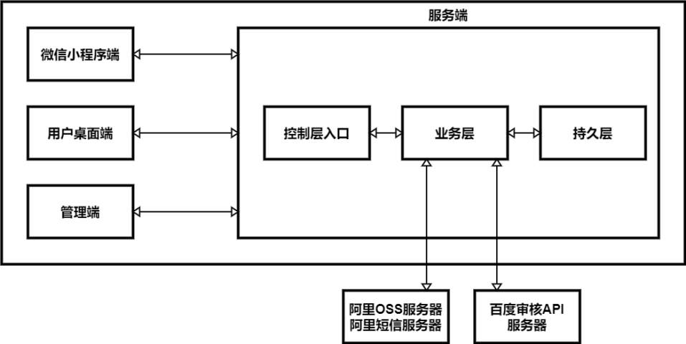

图 3-1系统体系架构图

### 3.1.2 系统的功能结构

在需求分析之后，系统功能一共分为三大部分：微信小程序端、用户桌面端和管理端。

微信小程序端一共分为鉴权管理模块、编辑模块、个人信息管理模块、关注用户模块、浏览模块、文章和话题管理模块、搜索模块、评论模块、反馈模块、系统通知管理模块、个人标签管理模块和用户数据模块等十二个模块。

用户桌面端一共分为用户登录模块和编辑模块两个模块。

管理端一共分为管理员登录模块、报表统计模块、个人信息管理模块、用户管理模块、文章浏览模块、反馈处理模块、通知模块、管理员管理模块、标签管理模块和编辑模块等十个模块。

以下是功能结构图，如图3-2所示。

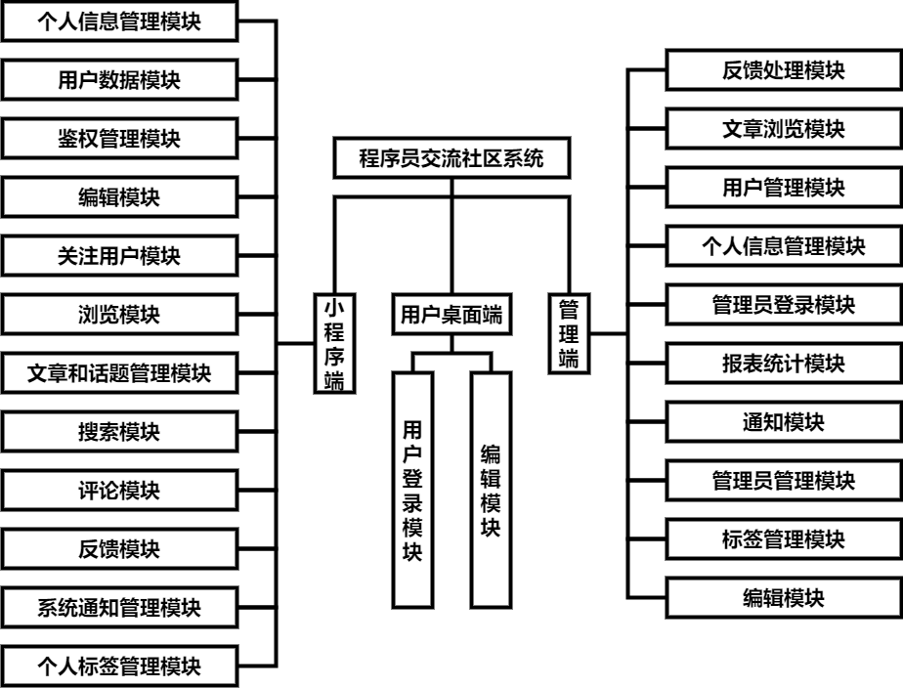

图 3-2功能结构图

## 3.2 系统模块设计

### 3.2.1 微信小程序端

### 3.2.1.1 鉴权管理模块

鉴权管理模块包括：登录、注册和获取用户openid。

鉴权管理流程设计：点击登录按钮之后，小程序去请求用户的openid，然后通过openid去访问服务器接口查询数据库是否存在该openid，如果存在就将用户信息查询并返回给用户；如果不存在，返回失败状态码小程序去获取用户的用户基本信息，然后将用户的基本信息post给服务器存入数据库中，期间使用OSS SDK将用户的头像存入OSS服务器中。以下是登录注册的活动图，如图3-3-1所示

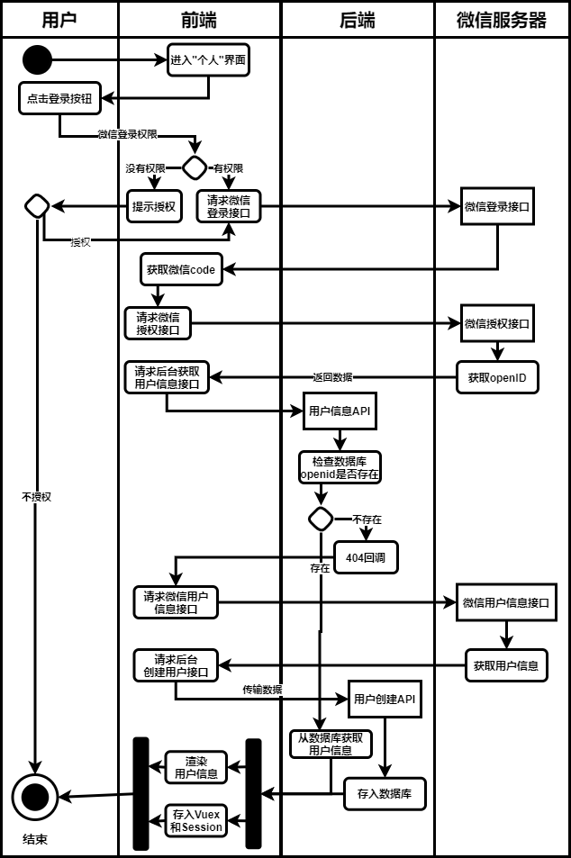

表 3-3-1 用户登录注册活动图

### 3.2.1.2 浏览模块

用户浏览模块包括浏览首页分类列表、浏览文章、浏览话题、浏览关注列表、浏览粉丝列表、浏览收藏文章列表、浏览个人文章列表、浏览个人话题列表和浏览用户信息等九个功能。

1. 浏览首页分类列表

浏览首页分类列表的流程设计：进入小程序之后，系统检查是否是游客状态，如果不是就携带用户的openid去请求后台服务器获得用户的个人标签渲染到界面；如果是，就直接使用系统默认的标签数据；在游客状态下无法查看关注分类列表；用户可以切换进行不同标签类型的文章和话题的浏览。活动图如图3-4-1所示。

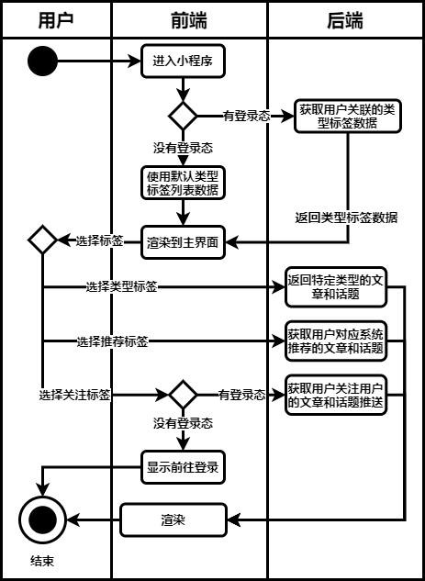

图 3-4-1 用户浏览首页分类列表活动图

1. 浏览文章

浏览文章的流程设计：用户点击特定的文章之后，系统检查是否是游客状态，如果不是游客状态，会将文章的ID和用户的openid发送到服务器，服务器去获取数据库中这篇文章的详情、文章对应的话题和用户与文章的关系，其中关系包括用户对文章的点赞和收藏状态，用户对作者的关注状态；如果是游客状态则指挥将用户的openid发送给服务器去获取文章详情。获取成功之后，小程序会去请求数据中的文章链接获取文本。当获取到了OSS中文本并渲染到页面之后，系统开始计时，当浏览3秒之后，调用服务器接口实现浏览量增加。活动图如图3-5-1所示。

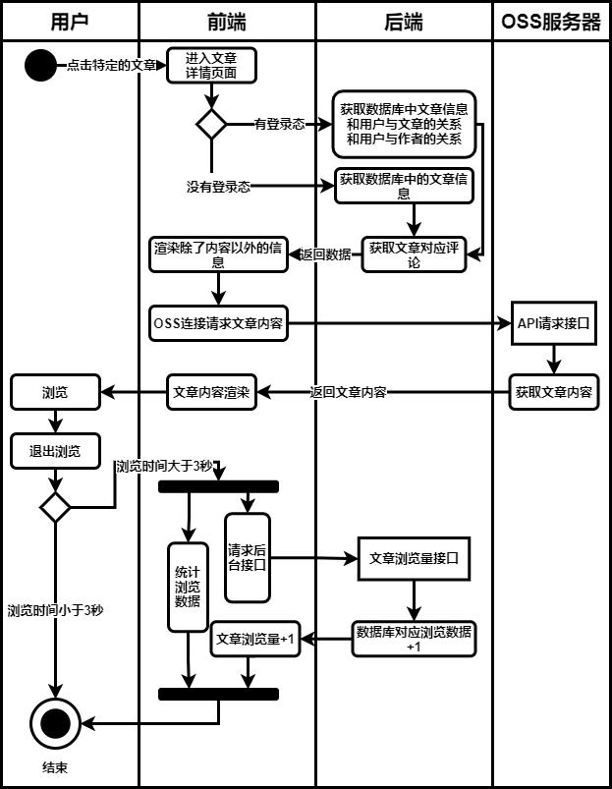

图 3-5-1 浏览文章活动图

1. 浏览话题

浏览话题的流程设计：用户点击话题，系统检查是否登录，登录就将话题ID和用户openid传递给服务器，去请求话题详情；未登录则获取该篇话题的详情，当小程序渲染话题完成之后，小程序通过调用服务器接口去获取该话题下的文章详情。话题下的文章的流程和预览文章的流程一致。活动图如图3-6-1所示。

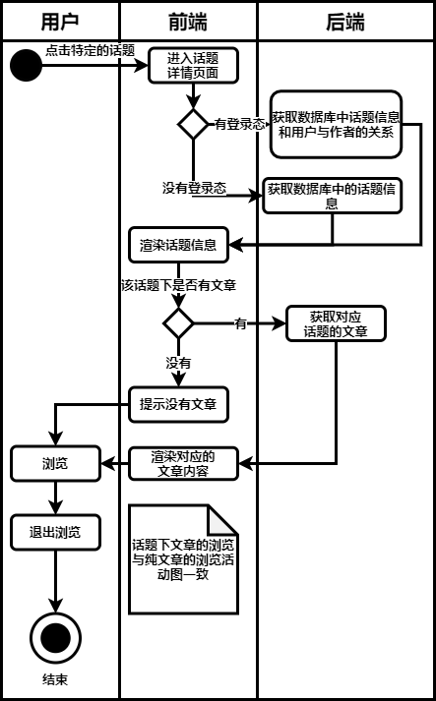

图 3-6-1 浏览话题活动图

1. 浏览关注列表

浏览关注列表的流程设计：用户点击进入“关注用户”界面，微信小程序请求后台获取用户关注的用户的信息列表渲染到界面。活动图如图3-7-1所示。

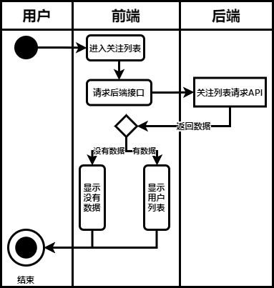

图 3-7-1 浏览关注列表活动图

1. 浏览粉丝列表

浏览粉丝列表的流程设计：用户点击进入“粉丝”界面，微信小程序请求后台获取用户的粉丝的信息列表渲染到界面。活动图如图3-8-1所示。

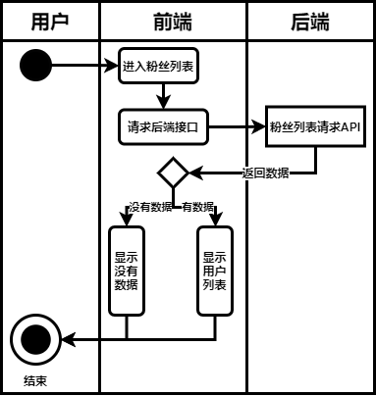

图 3-8-1 浏览粉丝列表活动图

1. 浏览收藏文章列表

浏览收藏文章列表的流程设计：用户点击进入“收藏文章”界面，微信小程序请求后台获取用户收藏的文章列表渲染到界面。活动图如图3-9-1所示。

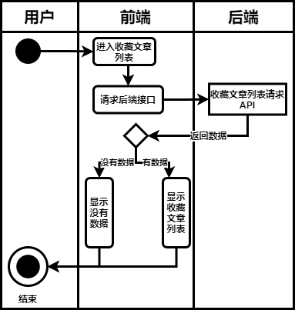

图 3-9-1 浏览收藏文章列表活动图

1. 浏览个人文章列表

浏览个文章列表的流程设计：用户点击进入“个人文章”界面，微信小程序请求后台获取用户编写的文章的列表渲染到界面。活动图如图3-10-1所示。

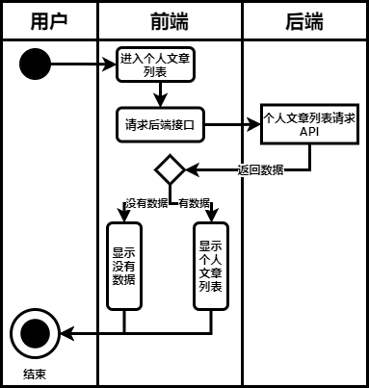

图 3-10-1 浏览个人文章列表活动图

1. 浏览个人话题列表

浏览关注列表的流程设计：用户点击进入“个人话题”界面，微信小程序请求后台获取用户编写的话题的列表渲染到界面。活动图如图3-11-1所示。

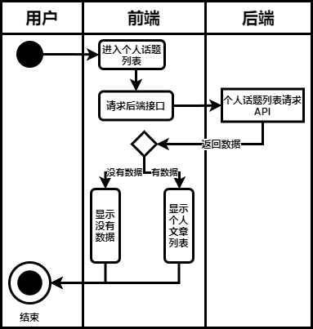

图 3-11-1 浏览个人话题列表活动图

1. 浏览用户信息

浏览用户信息的流程设计：用户点击进入特定用户的“用户信息”界面，微信小程序请求后台获取数据，后台分别获取用户的个人信息和用户编写过的文章和话题渲染到界面上显示。活动图如图3-12-1所示。

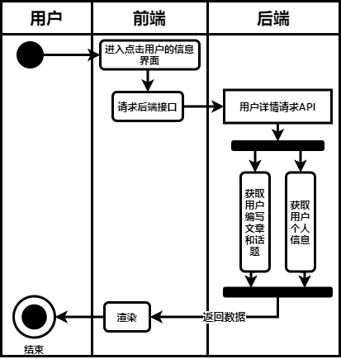

图 3-12-1 浏览用户信息

### 3.2.1.3 编辑模块

用户编辑模块包括编辑文章、编辑话题和回复话题等三个功能。

1. 编辑文章

编辑文章的流程设计：用户进入文章编辑界面，文章的编写格式是使用的Github的Markdown风格来进行编写，用户可以选择插入图片，插入图片之后，小程序会去请求OSS服务器将图片存入OSS，点击提交之后，小程序提示用户选择文章的标签，选择之后；微信小程序将文章的内容存入OSS，将文章内插入的第一张到第三张图片作为文章预览时的图片描述。活动图见3-13-1所示。

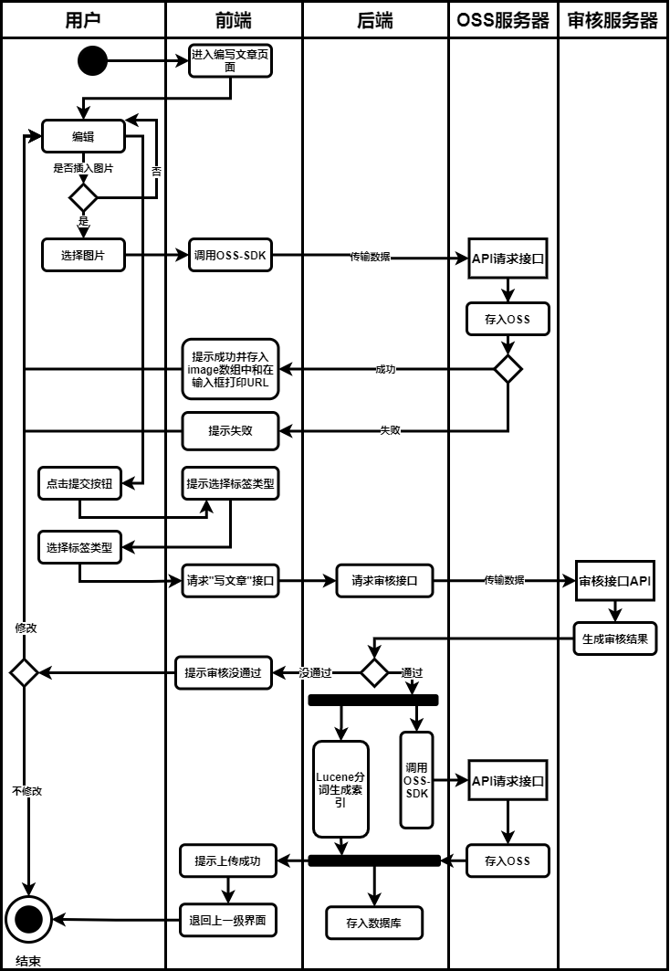

图 3-13-1 编辑文章活动图

1. 编辑话题

编辑话题的流程设计：用户进入话题编辑界面，话题的编写格式是普通的文本渲染，用户可以选择插入图片，插入图片之后，小程序会去请求OSS服务器将图片存入OSS，点击提交之后，小程序提示用户选择话题的标签，选择之后；小程序将话题详情存入后台数据库。活动图见3-14-1所示。

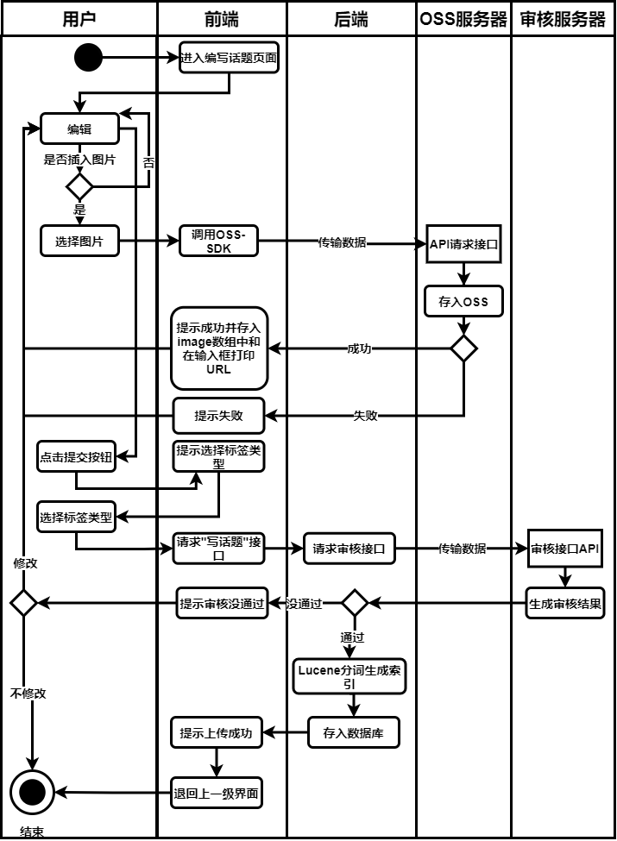

图 3-14-1 编辑话题活动图

1. 回复话题

编辑文章的流程设计：用户进入回复话题界面，风格和编辑文章一致，只是不需要选择标签，而是引用了回复的话题的标签类型。活动图见3-15-1所示。

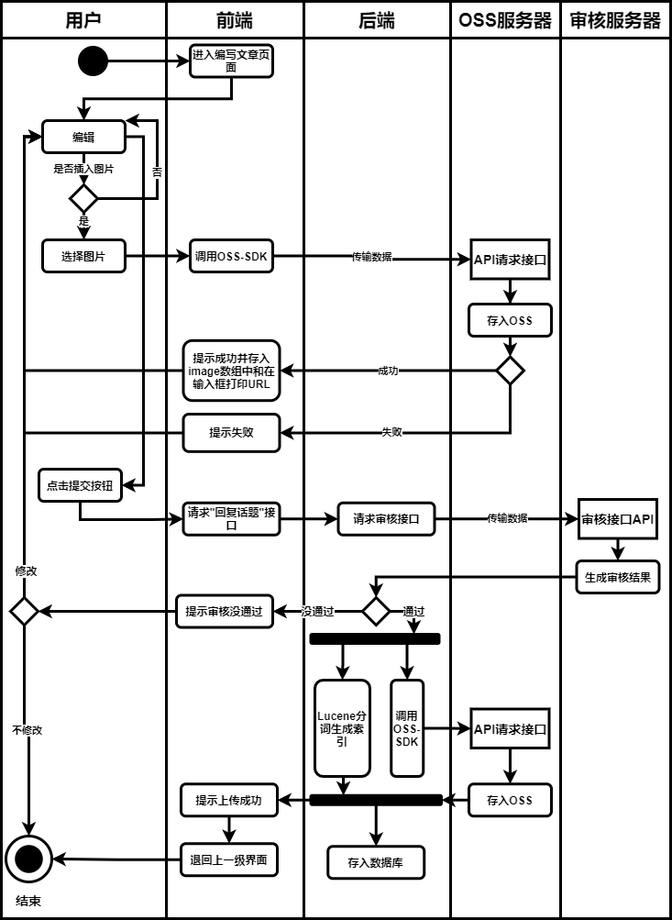

图 3-15-1 回复话题活动图

### 3.2.1.4 文章和话题管理模块

用户文章管理模块包括文章点赞、文章收藏、删除个人文章和删除个人话题

1. 文章点赞

文章点赞的流程设计：用户点赞之后，小程序判断是否登录，未登录提示登录；已登录，小程序判断用户是否已经点赞，已点赞提示已经点赞；未点赞就去请求后台更新或添加数据。活动图如图3-16-1所示。

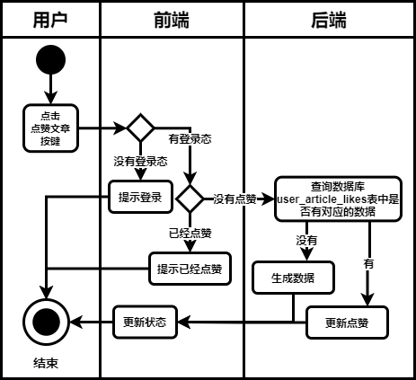

图 3-16-1 文章点赞活动图

1. 文章收藏

文章收藏的流程设计：用户收藏之后，小程序判断是否登录，未登录提示登录；已登录，请求后台更新或添加数据。活动图如图3-16-1所示。

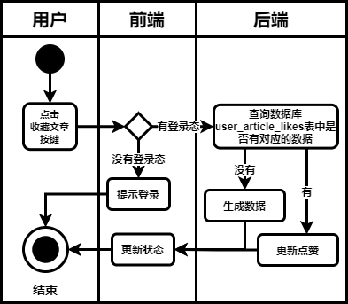

图 3-17-1 文章收藏活动图

1. 删除个人文章

删除个人文章的流程设计：用户点击删除文章，小程序提示确认；确认之后，小程序请求后台删除文章和对应的评论。活动图如图3-18-1所示。

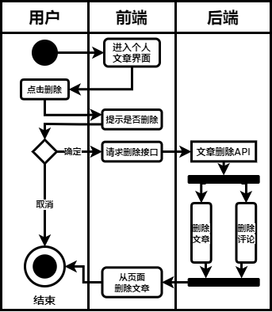

图 3-18-1 删除个人文章活动图

1. 删除个人话题

删除个人话题的流程设计：用户点击删除话题，小程序提示确认；确认之后，小程序请求后台删除话题和对应的文章基对应的评论。活动图如图3-19-1所示。

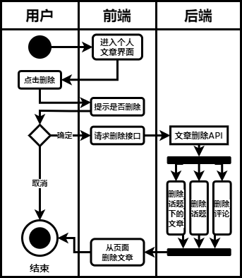

图 3-19-1 删除个人话题活动图

### 3.2.1.5 评论模块

评论模块的流程设计：在登录的情况下可以为文章点赞，包括文章详情界面和话题详情界面下的文章；编写评论之后，小程序会判断是不是子回复，然后将数据传递给后台，成功之后渲染到界面。活动图如图3-20-1所示。

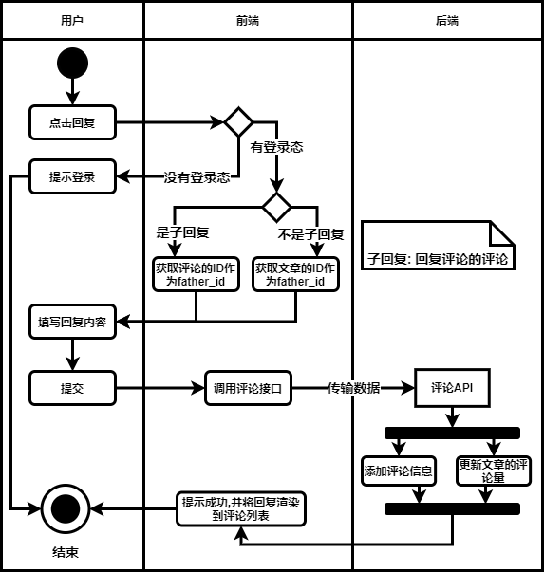

图 3-20-1 评论活动图

### 3.2.1.6 搜索模块

搜索模块的流程设计：用户通过输入关键词、点击热度榜或点击历史记录获取列表，后台搜索lucene中的索引来获取列表，活动图如图3-21-1所示。

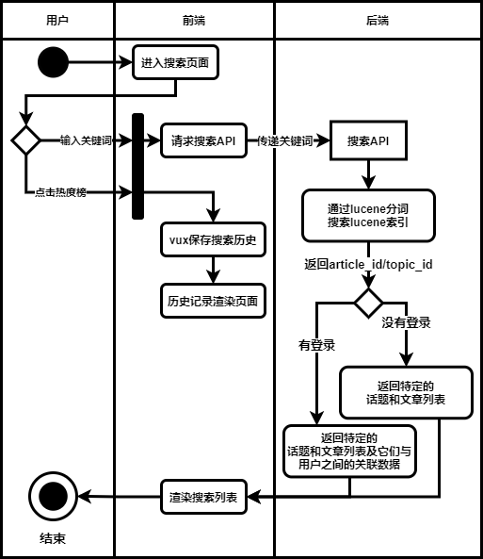

图 3-21-1 搜索模块活动图

### 3.2.1.7 关注用户模块

搜索模块的流程设计：用户点击关注进行关注活动图如图3-22-1所示。

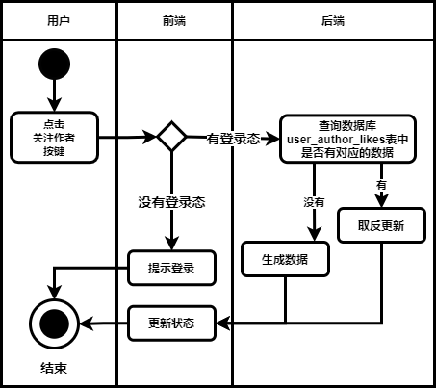

图 3-22-1 关注用户模块活动图

### 3.2.1.8 个人信息管理模块

个人信息管理模块包含手机号验证和其他信息修改

1. 手机号验证

手机号验证流程设计：用户输入手机号确认，小程序请求后台，后台生成验证码请求短信服务器，短信服务器发送短信给用户，后台向redis存入手机号和验证码，用户输入验证码确认，后台判断验证码的准确性。活动图如图3-23-1。

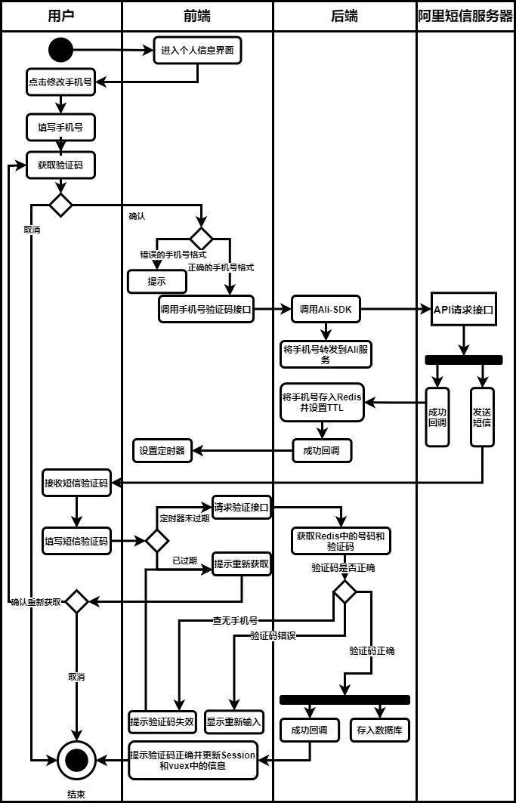

图 3-23-1 手机号验证活动图

1. 其他信息修改

其他信息修改：用户点击修改其他个人信息，活动图见图3-24-1所示

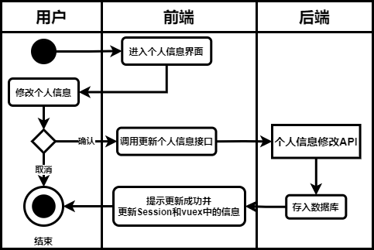

图 3-24-1 其他信息修改活动图

### 3.2.1.9 反馈模块

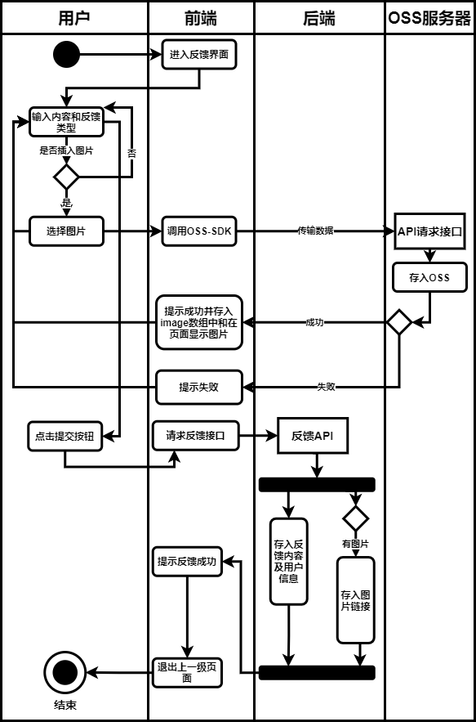

### 3.2.1.10 个人标签管理模块

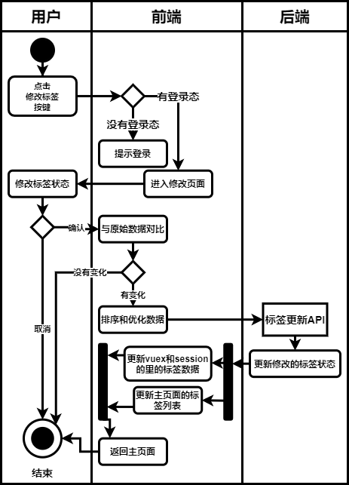

### 3.2.1.11 用户数据模块

用户数据模块包括用户查看报告、App使用数据和文章浏览数据三个功能组成

1. App使用数据

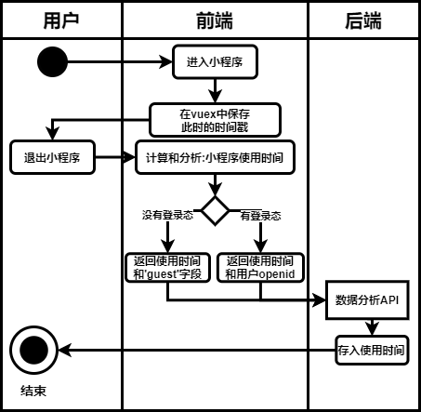

1. 文章浏览数据

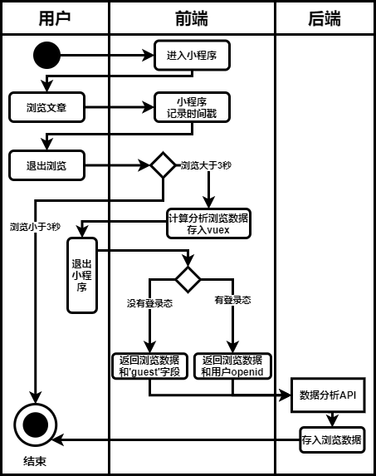

1. 用户查看报告

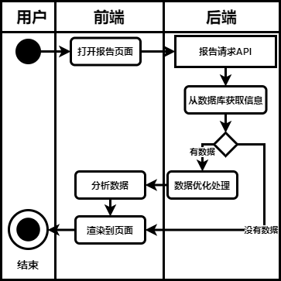

### 3.2.1.12 系统通知管理模块

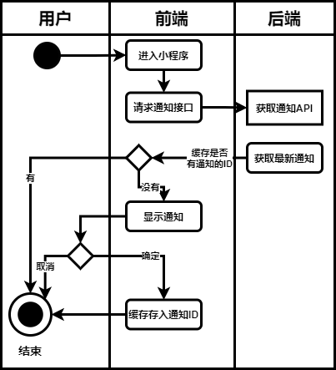

### 3.2.2 用户桌面端

### 3.2.2.1 用户登录模块

L;

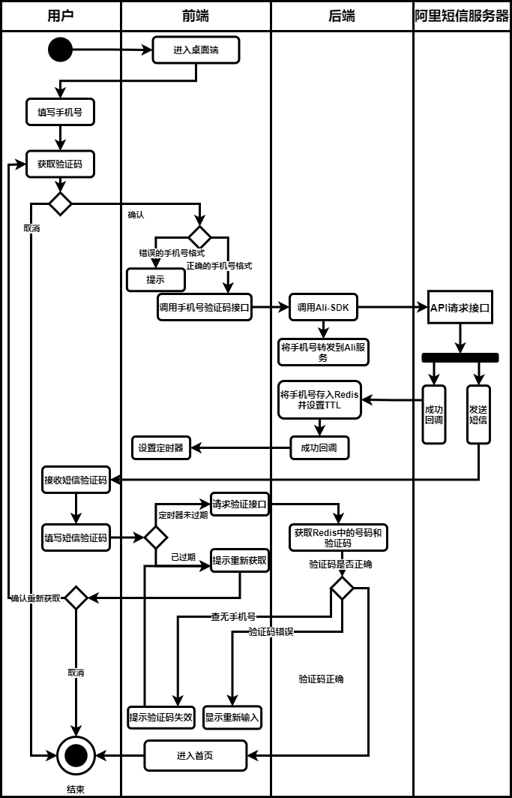

### 3.2.2.2 编辑模块

用户桌面端的编辑模块包括编辑文章和编辑话题，这个两个功能的流程设计与微信小程序端的一致。

### 3.2.3 管理端

### 3.2.3.1 管理员登录管理模块

### 3.2.3.2 报表统计模块

### 3.2.3.3 个人信息管理模块

### 3.2.3.4 用户管理模块

### 3.2.3.5 管理员管理模块

### 3.2.3.6 文章浏览模块

### 3.2.3.7 反馈处理模块

### 3.2.3.8 通知模块

### 3.2.3.9 标签管理模块

### 3.2.3.10 编辑模块

## 3.3数据库设计

数据库设计可以体现系统业务之间运作和存储的关系。数据库设计既要满足业务逻辑，又需要满足数据存放的基本规律，下面将会通过ER图、数据表设计来分析数据库的设计。

### 3.3.1 ER图

用户信息实体保存用户openid和手机号号等个人信息，如下图所示。

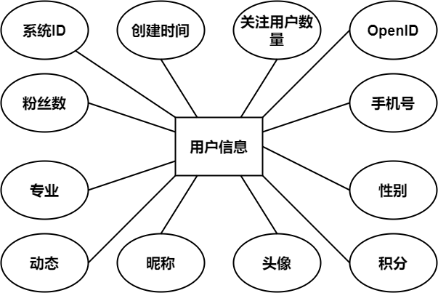

图 4 用户实体ER图

用户与用户关系实体保存的是用户之前的关注关系，如下图所示。

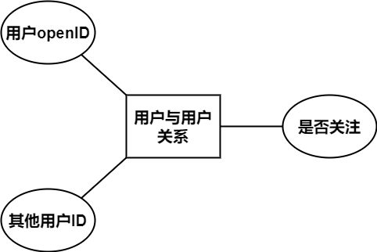

图 5 用户与用户关系ER图

标签实体用来记录系统的标签，如下图所示。

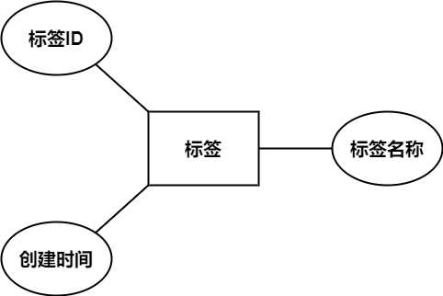

图 6 标签ER图

用户与标签关系实体保存的是用户与各个标签之间的关系，如下图所示。

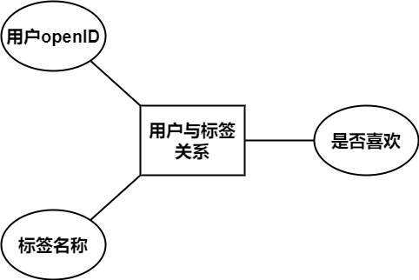

图 7 用户与标签关系ER图

话题和文章预览实体用来保存话题和文章的详细内容，用于预览话题和文章时请求，比如浏览首页列表，搜索列表等预览的查询，如下图所示。

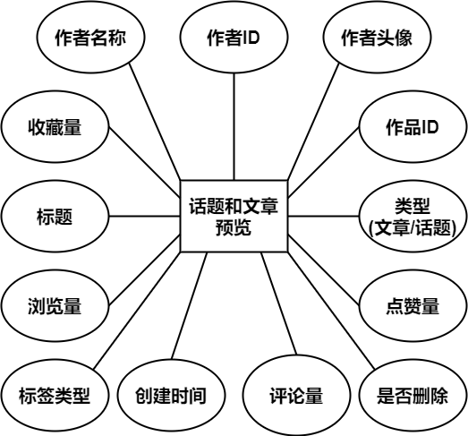

图 8 话题和文章预览ER图

文章实体用来存储的是回复话题的文章和编辑文章的详情数据，ER图与话题与文章预览实体相似，如下图所示。

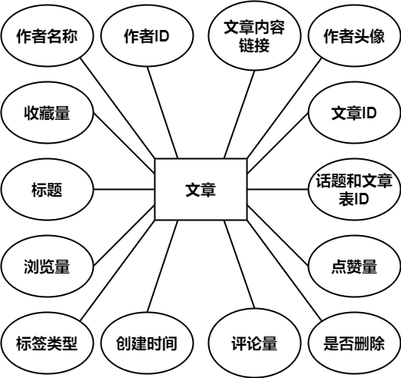

图 9 文章ER图

预览图片实体用来存储话题和文字预览的图片描述，如下图所示。

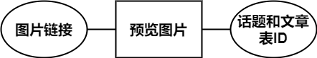

图 10 预览图片ER图

用户与文章关系实体用来储存用户与文章之间的关系，包括点赞和收藏，如下图所示。

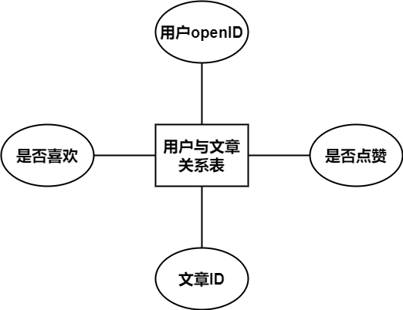

图 11 用户和文章关系ER图

用户评论实体用来存储用户的评论和评论之间的关系，如下图所示。

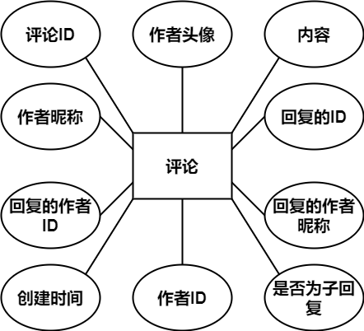

图 12 评论ER图

用户反馈实体用来存储用户的反馈内容，如下图所示。

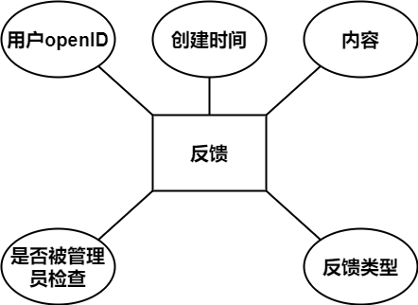

图 13 反馈ER图

用户反馈图片实体用来存储用户的反馈图片，如下图所示。

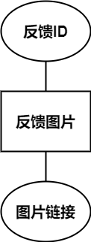

图 14 反馈图片ER图

用户使用时长实体用来存储用户使用小程序的时间，如下图所示。

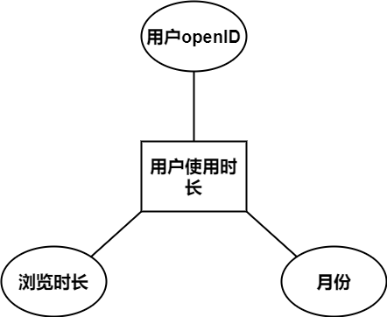

图 15 用户使用时长ER图

用户浏览作者时间记录实体用来存储用户浏览文章时的浏览时间，如下图所示。

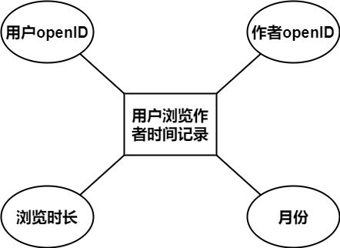

图 16 用户浏览作者时间记录ER图

用户浏览标签时间记录实体用来存储用户浏览文章是的浏览时间，如下图所示。

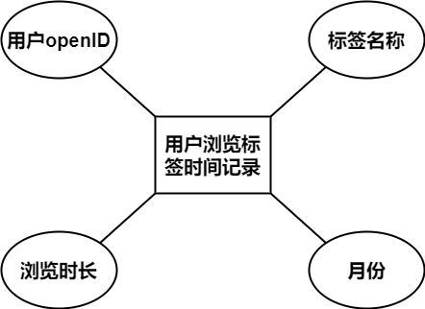

图 17 用户浏览标签时间记录ER图

管理员信息实体用来记录管理员基本信息，如下图所示。

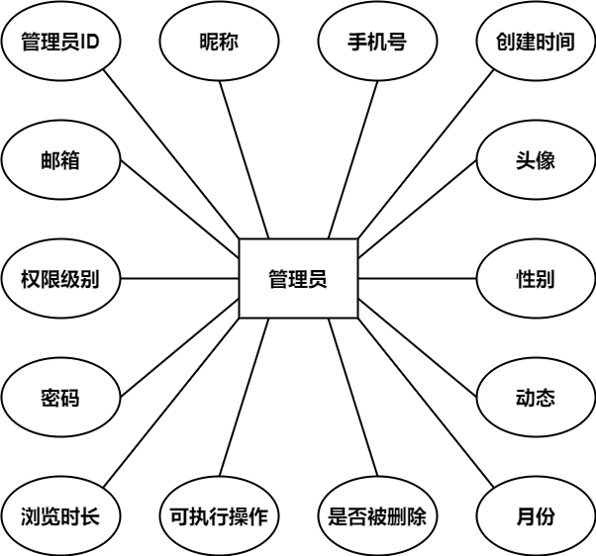

图 18 管理员信息ER图

管理员默认权限实体用来记录各个权限等级的默认权限，如下图所示。

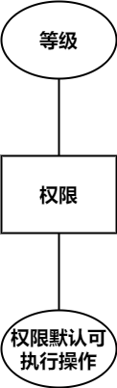

图 19 管理员默认权限ER图

通知实体用来记录系通知的内容及指向，如下图所示。

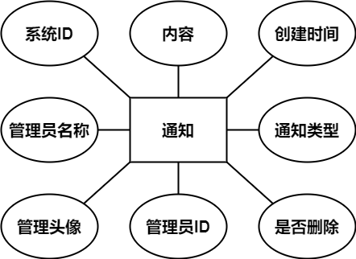

图 20 通知ER图

### 系统ER图，描述了各个表之间的关系，并省略了字段，如下图所示。

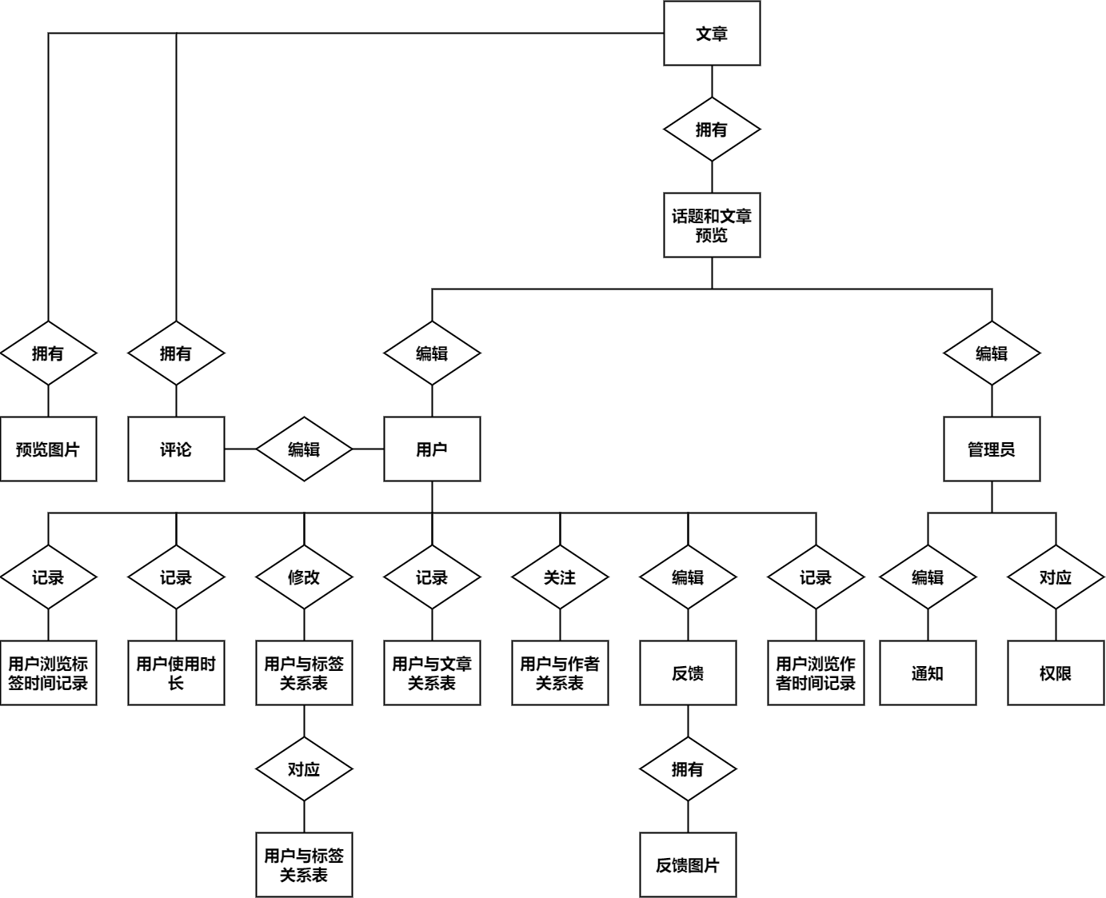

图 21系统ER图

### 3.3.2 系统数据库表设计

经过ER图数据库分析和ER图设计之后，进而进行系统数据库表设计。系统数据表的全部信息如表3-1所示。

表 3-1 系统数据库

|  |  |
| --- | --- |
| **数据表名称** | **数据表的描述** |
| 用户信息表(user) | 存放用户的个人信息 |
| 标签类型表(label) | 存放系统的标签类型 |
| 用户与标签关系表(user_label) | 存放用户与系统标签类型的关系 |
| 用户与用户关系表(user_author_likes) | 存放用户之间的关注关系 |
| 话题和文章预览表(topic_and_article) | 存放话题和文章 |
| 文章列表(article) | 存放文章 |
| 预览图片表(cover) | 存放话题和文章预览的图片描述 |
| 用户与文章的关系表(user_article_likes) | 存放用户与文章之间的点赞和收藏关系 |
| 评论表(comment) | 存放用户的评论 |
| 反馈表(feedback) | 存放用户的反馈内容 |
| 反馈图片表(f_cover) | 存放用户的反馈图片 |
| 通知表(notification) | 存放系统的通知 |
| 用户使用时长表(browse_all) | 存放用户的小程序使用时间 |
| 用户浏览作者时间记录表(browse_author) | 存放用户的作者浏览时间 |
| 用户浏览标签时间记录表(browse_label) | 存放用户的标签浏览时间 |
| 管理员表(admin) | 存放管理员信息 |
| 权限表(admin_role) | 存放管理员权限的默认值 |

### 3.3.3 数据库自定义函数和自定义过程设计

1.创建用户(create_user)

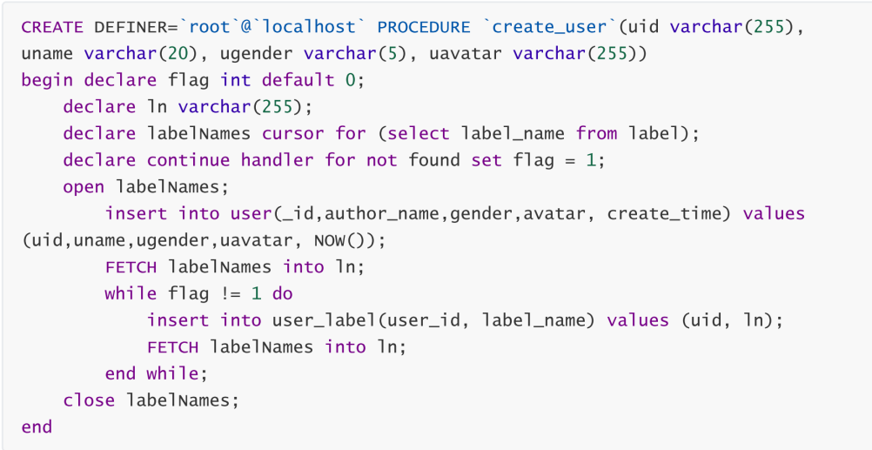

2.编辑话题

3.编辑文章

4.回复话题

### 3.3.4 数据库模型设计

## 3.4 本章小结

# 4 系统设计实现

## 系统的开发环境

操作系统：Windows10、Ubuntu20.04

开发工具：微信开发者工具、IntelliJ IDEA、VS Code、HBuilderX

运行环境：JDK1.8、Mysql8.0、NodeJSv13.13.0

## 4.2 系统各功能模块实现

### 4.2.1 用户管理实现