AutoDine– Smart Restaurant Table-to-Kitchen Coordination Platform with Autonomous Waiter Robot using IoT

Abstract: Traditional restaurant business is mostly reliant on manual processes to acquire orders, dispense food and bill, which often culminate into delays, miscommunication and human mistakes. This paper presents a new framework, AutoDine, a low-cost, Internet of Things-based automation system that will integrate customer communication, kitchen management and autonomous delivery of food into a single system. They consist of three main elements of the architecture: a table unit that handles order placement, a host unit to manage the operations of the kitchen, and an autonomous waiter robot to deliver food. AutoDine uses a simple embedded interface, in contrast to extant solutions which require smartphones or complex user interfaces therefore increasing accessibility and reducing costs of operation. Moreover, the robotic subsystem is based on a time-stamped navigation paradigm which eliminates the need to use intricate localization algorithms. A distributed control architecture supports concurrent communication between the modules that make it up. Empirical assessment proves high system behavior, which is an indication of the low communication latency with an effectiveness of coordination among several tables. The suggested methodology, in turn, provides a scalable low-cost solution to smart automation of restaurants. Keywords: Restaurant Automation, ESP32, Arduino, Autonomous Robot, Embedded Systems, Smart Ordering.

- INTRODUCTION
The speed of development of the Internet of Things (IoT) and embedded systems has greatly changed the existing service industries, the restaurant sector being one of them. Traditional restaurant functions on manual processes to take orders, deliver food, and bill customers and this may create delays, poor communication and erroneous human input which adversely affect efficiency and customer satisfaction.
A number of automation systems based on IoT have been suggested to overcome such difficulties. Karthik et al. [1] and Venkatesh and Prakash [2] proposed smart ordering systems through embedded and wireless technologies to enhance more accurate ordering and less manual intervention. In a comparable manner, Sharma et al. [5], Patel et al. [6], and Rahman et al. [8] have designed IoT solutions that targeted the digital menu systems and automated order management. Parallel to this invention, the robotic waiter systems have been investigated in the automated food delivery. Kumar et al. [10] and Zhang et al. [14] have suggested path-following delivery robots, and Johnson and Wilson [13] have introduced IoT-based autonomous waiter robots. Nevertheless, the majority of current solutions are based on pre-programmed navigation, smartphone interfaces, or consider ordering and delivery as two distinct activities, which makes them less flexible and scalable.
In order to overcome these shortcomings, this paper suggests AutoDine, an all-in-one and affordable restaurant automation solution that combines interaction with clients, kitchen coordination, and autonomous delivery into one system. It uses a low-priced embedded interface, which does not require smart phones or touchscreen gadgets, as well as time-calibrated navigation strategy, which does not have to be complicated in localization methods. Also, there is a distributed finite state machine (FSM)-based architecture which guarantees that all system components operate in a coordinated manner. This unified solution offers a flexible and effective way of automating smart restaurants.

- System Architecture
The AutoDine system is divided into three units for three different functions and each unit has specific role which contribute to finish completing the restaurant workflow as shown in Fig. 1. The table unit role is for customer interaction, the host unit role is to manage kitchen coordination, and the waiter robot unit role is to handle food delivery from kitchen to tables. All three units communicate together through WiFi and Bluetooth to complete restaurant automation loop.
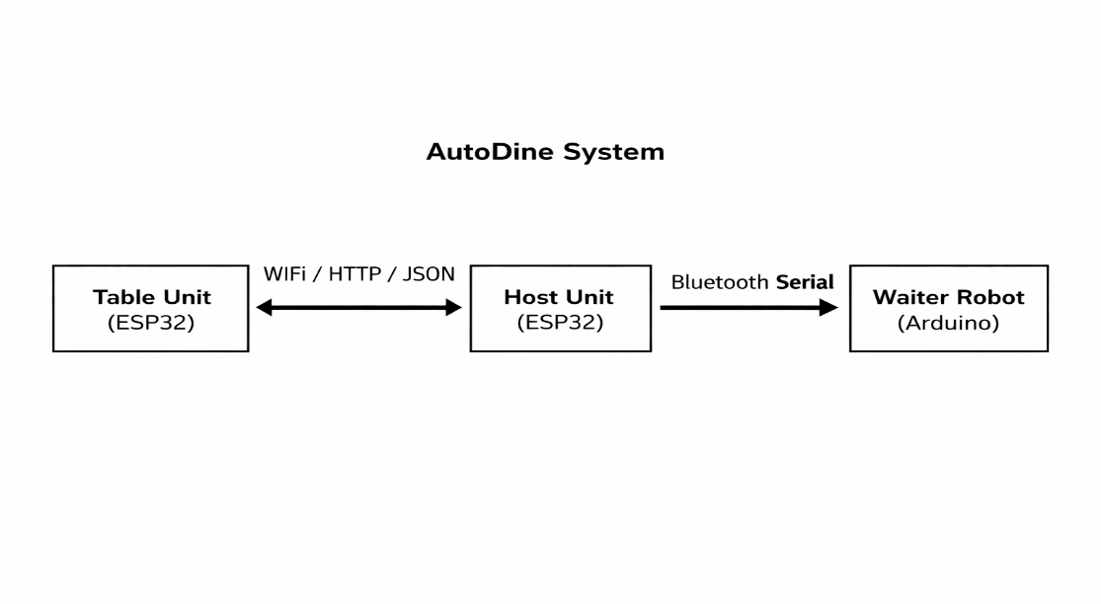
Fig. 1. AutoDine Block Diagram
2.1 Table Unit
The table unit is the unit where customer directly interacts with. We built the table unit using an ESP32 DEV module, a 0.96-inch OLED display, and four push buttons as shown in Fig. 2. For making the prototype the OLED is only 128x64 pixels, so we had designed the UI carefully to fit into display without any information loss or clumsy.
The four push buttons handle everything starting from scrolling through menu, setting desired quantity, confirming selections, sending order, adding more items to cart, request for bill generation, and payment mode selection. Everything works through these four buttons, which keeps the hardware simple and low cost without the need of any touchscreen or smartphone.
The firmware is written in C using the ESP-IDF framework. And the table units ESP32s are connected with the same WiFi from the host ESP32. When the customer presses a button to send the order, the table unit packages all the cart details into a JSON message and sends it to the host using an HTTP request over WiFi. After that, it keeps polling the host every few seconds to check for status updates and reflects them on the OLED in real time. Every table unit is assigned a unique TABLE_ID so the host can track multiple tables independently without any configuration overhead.
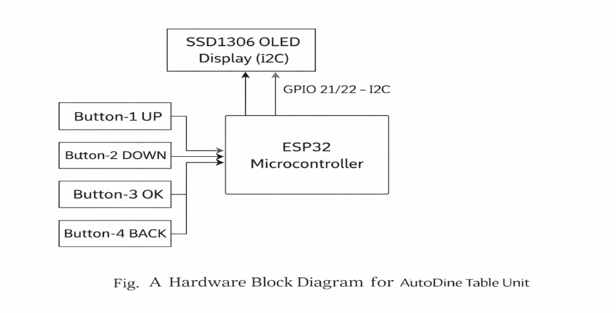
Fig. 2. Table Unit block diagram
2.2 Host Unit
The host unit is placed in the Kitchen. The hardware portion is an ESP32 and a small buzzer as shown in Fig. 3. Its job is to run as server and serves a dashboard for kitchen staff when connected to the same WiFi.
When an order comes in from any table, the buzzer connected to the ESP32 makes a beep sound so the staff knows something has arrived without having to stare at the screen always. The dashboard then shows the order details with accept and decline buttons. Once the staff accepts, the table unit gets the update within seconds. All order status updates, bill generation, and payment tracking are managed here.
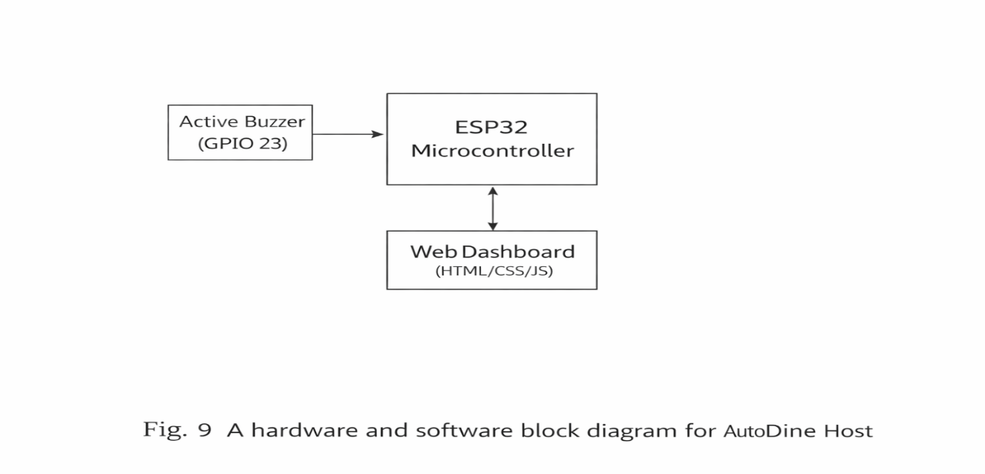
Fig. 3. Host Unit block diagram
2.3 Waiter Robot
The waiter robot is a four-wheel chassis unit built on an Arduino Uno. An Adafruit Motor Shield drives four DC motors for movement as shown in Fig. 4. The robot receives instructions over Bluetooth via HC-05 module from host.
We used time-based navigation instead of encoders or line-following tape. This means we simply calibrated how many milliseconds the robot needs to travel distance based on table’s arrangement from kitchen.
An HC-SR04 ultrasonic sensor is mounted at the front. If something comes within 20 cm, the robot stops and waits. Once the obstacle is cleared it resumes, and the time it was paused till obstacle is cleared, to avoid wrong table delivery. After a 10-second wait at the table, it reverses back to the kitchen on its own.
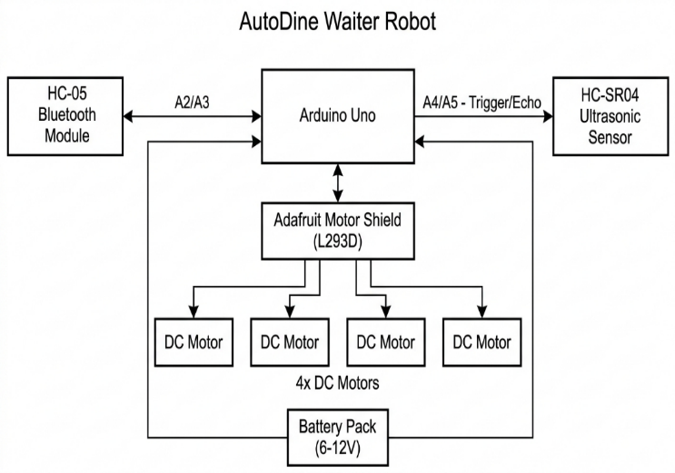
Fig. 4. Waiter Robot block diagram
2.4 State Machines
All these three units are controlled using state machines as represented in Fig. 5, to ensure that the workflow is clean and that no invalid state transition occurs. The table unit has eight different states: Idle, Menu, Quantity, Cart, Waiting, Preparing, Ready, and Billing. The state of each table is tracked by the host from the time the order is received to the time the payment is confirmed. The waiter robot has five different states: Idle, Forward, Obstacle Check, Table Wait, Return, and Idle.
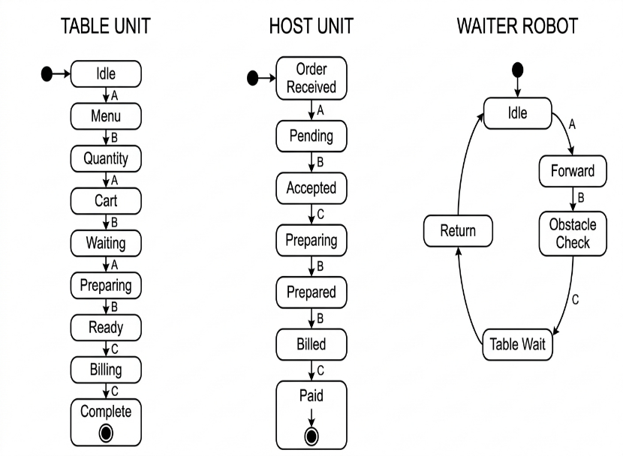
Fig. 5. State Machines for table unit (left), host unit (center), and waiter robot (right)

- Implementation
The whole AutoDine system was assembled in a lab setup as shown in Fig. 6, which is similar mini setup of a real restaurant environment. In the kitchen, the host ESP32, which is connected to a laptop containing the dashboard, is placed at one end. Two table units, named Table-1 and Table-2, are placed at a distance of 100 cm and 150 cm from the kitchen, respectively. Each table is built using a breadboard, containing the ESP32, OLED, and four push buttons. The waiter robot is placed beside the kitchen, awaiting delivery commands via Bluetooth.
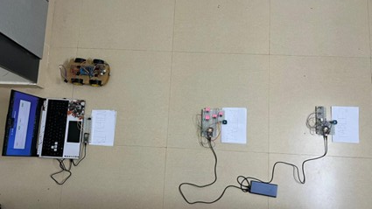
Fig. 6. Complete AutoDine hardware layout
The step-by-step implementation of the complete AutoDine workflow from customer order placement to food delivery and payment is demonstrated in the following steps.
Step 1: System Initialization
AutoDine system is set up with the interconnection of all units to a shared WiFi network. The table units get in idle mode, to be accessed by the user, and the host dashboard is unlocked to monitor the incoming orders.
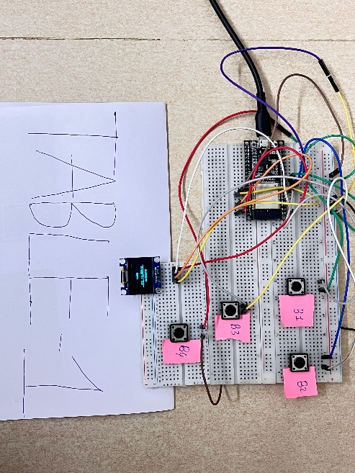
Fig. 7a. Table-1 Setup
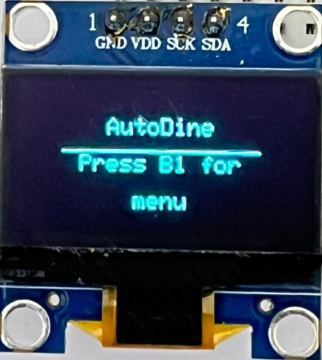
Fig. 7b. Initial OLED screen
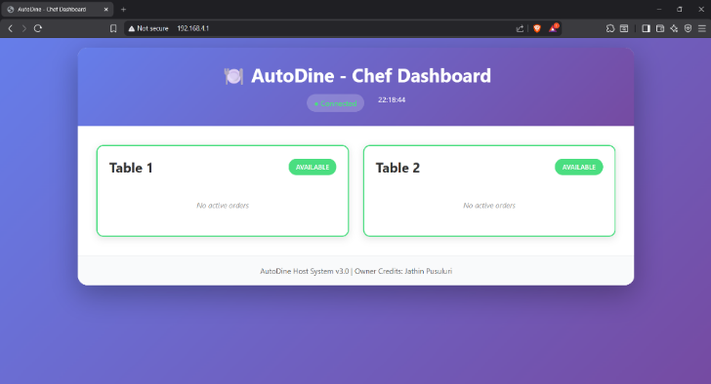
Fig. 7c. Host dashboard initial screen

Step 2: Selecting menu and taking orders.
The customer uses the table unit to navigate through the menu, order things, and define the quantity required using a basic embedded interface.
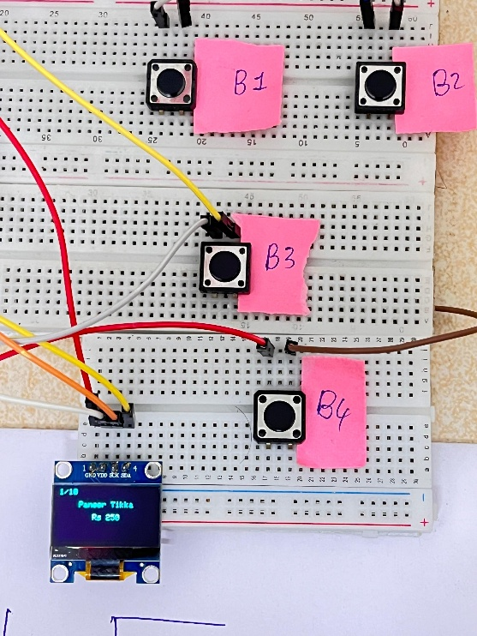Fig. 8a. OLED menu display
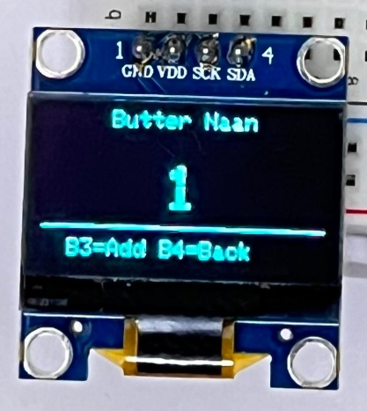
Fig. 8b. Quantity selection screen
Step 3: Confirmation and Submission of order.
After being chosen, they are sent to a cart and sent to the host unit to be processed. The host dashboard shows the order to accept or reject, whereas the table unit shows the order status in real time.
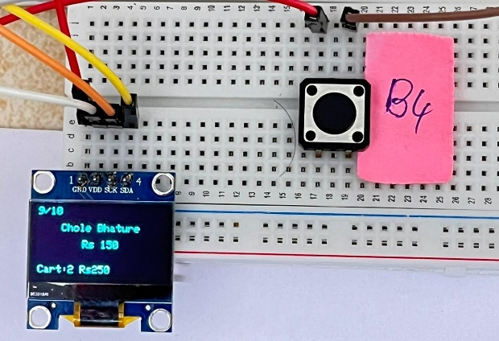
Fig. 9a. OLED screen with ready to send cart 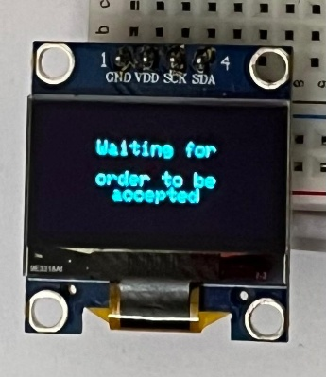
Fig. 9b. OLED Screen showing waiting for Order acceptance
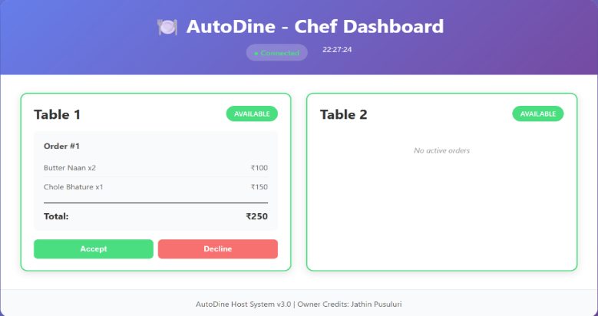
Fig. 9c. Host dashboard with incoming order from table
Step 4: Order Processing
The host unit will enable the kitchen staff to take or reject incoming orders. Accepted orders are sent to the preparation phase and real-time status update is given to the table unit whereas rejected orders lead to system reset to initiate the next discussion.
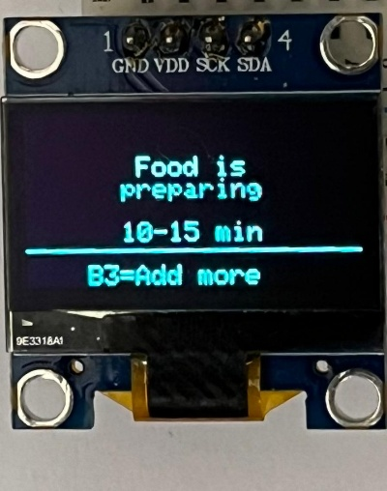
Fig. 10a. OLED screen if order is accepted 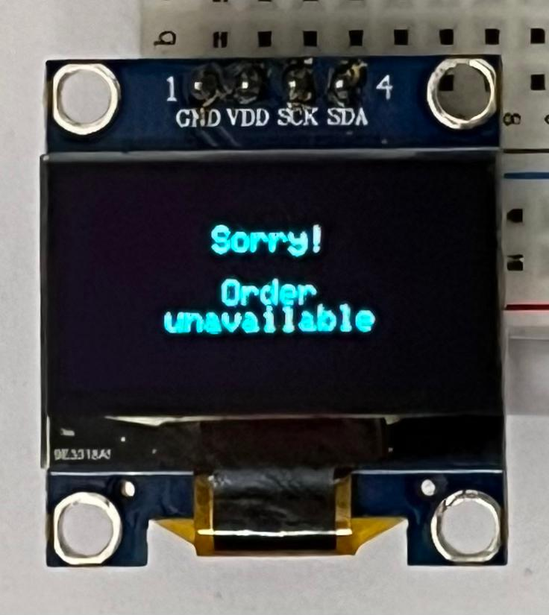
Fig. 10b. OLED screen if order is declined
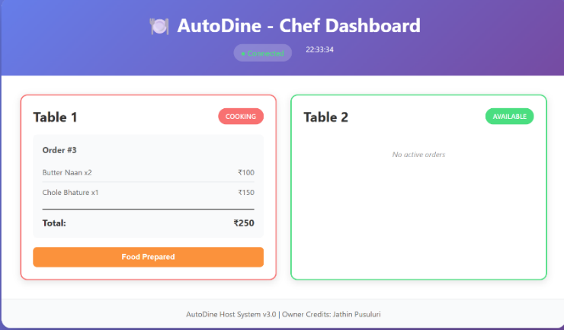
Fig. 10c. Host dashboard when order is in preparation stage
Step 5: Preparation of order and completion of preparation.
Customers can make modifications on their orders during preparation and it is reflected on the host dashboard in real time. Upon completion of the preparation of all items, the system changes the status of the order and informs the table unit about it.
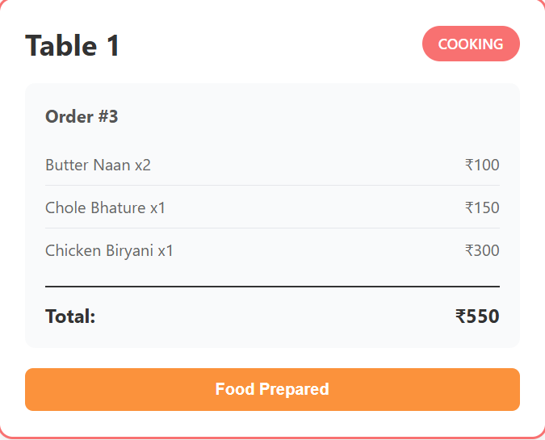
Fig. 11a. Updated dasboard when customers add new items 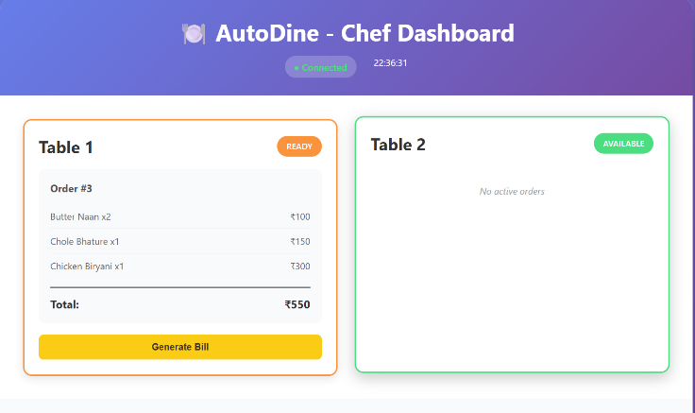
Fig. 11b. Dashboard when chef presses Food prepared button
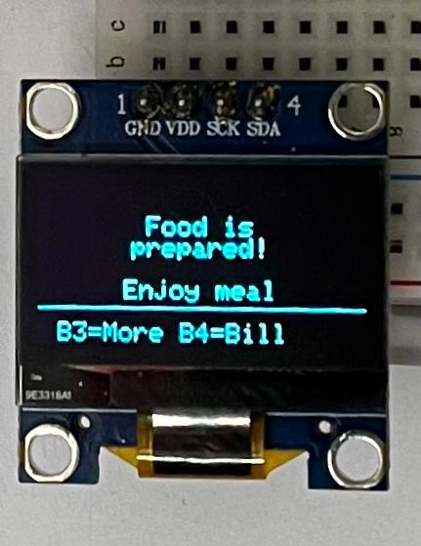
Fig. 11c. OLED when Food is prepared
Step 6: Independent Delivery of Food.
When the food is ready the host unit activates the waiter robot, which then transmits the order to the specific table using the Bluetooth communication mechanism. The robot moves with the help of time-calibrated navigation with obstacle detection, halts when an obstruction is observed, and continues moving after clearing the obstacle. Once it has been delivered, it goes back to its original location to perform the next tasks.
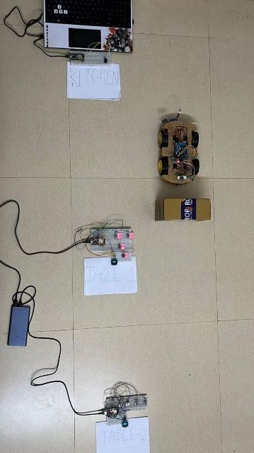
Fig. 12a. Waiter Robot waiting to clear obstacle 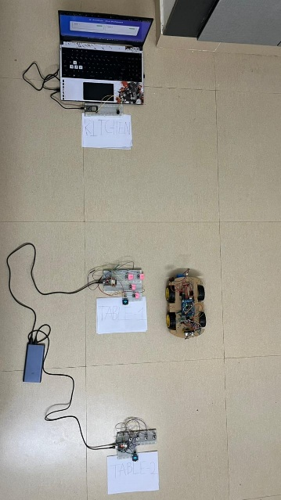
Fig. 12b. Waiter robot at table-1 to deliver the food
Step7:Billingand Payment Selection
After dining, the system generates an itemized bill accessible on both the host dashboard and table unit. The customer is then provided with multiple payment options for completing the transaction.
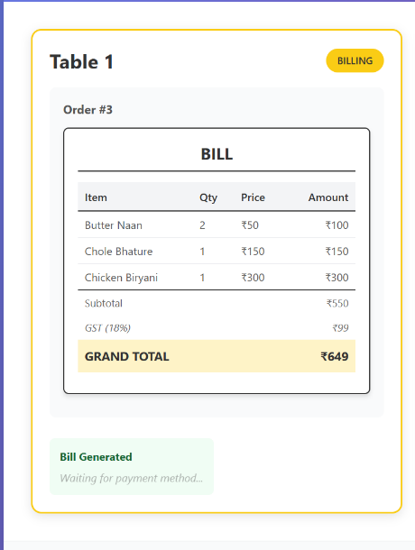
Fig. 13a. Dashboard with generated bill 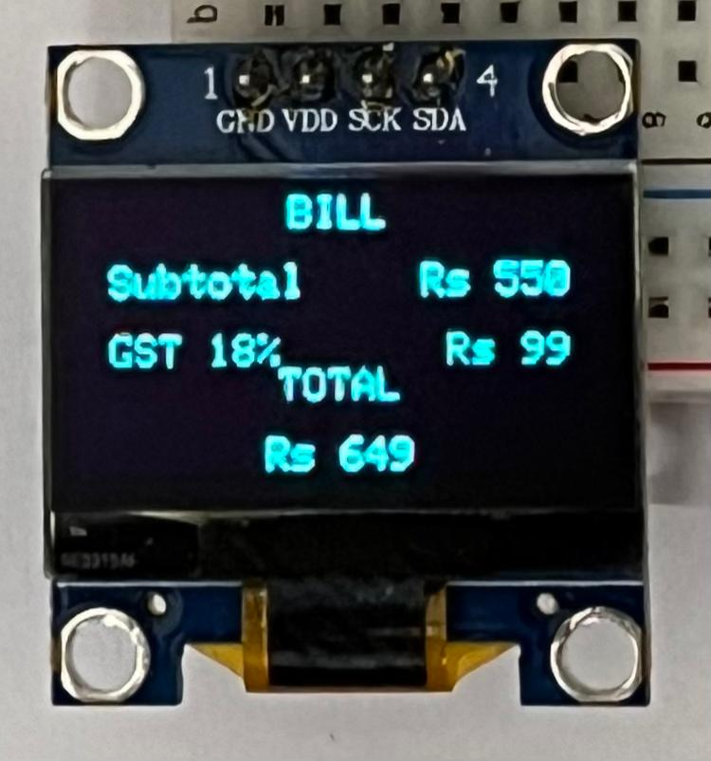
Fig. 13b. OLED with bill screen
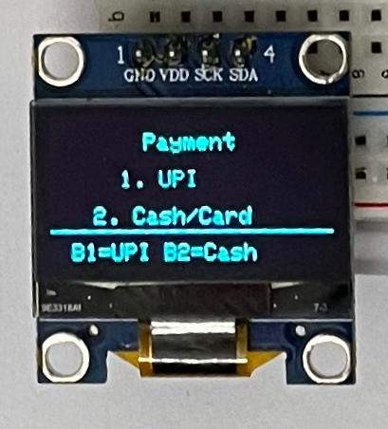
Fig. 13c. Payment method selection on OLED screen
Step 8: Payment Processing
The system supports both digital and offline payment methods. Payment selection is communicated to the host unit in real time, enabling the staff to track and verify transactions efficiently. 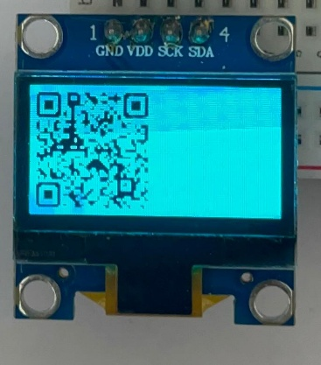
Fig. 14a. Payment QR if customer selects UPI method 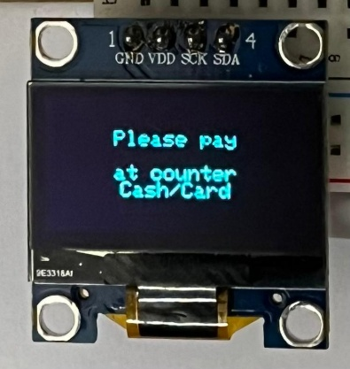
Fig. 14b. If customer selects cash/card
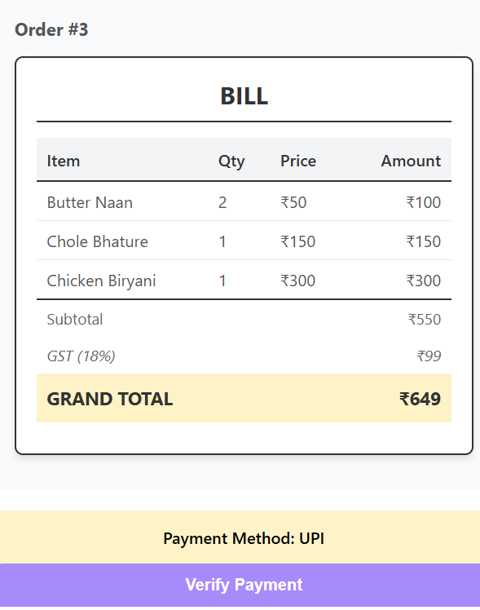
Fig. 14c. Dashboard updates with customer payment method selection
Step 9: Verification of payment and System reset.
Once the payment has been completed, the host unit checks the transaction and changes the system status. It is then brought back to its original condition and the table unit is readied to start the next customer session.
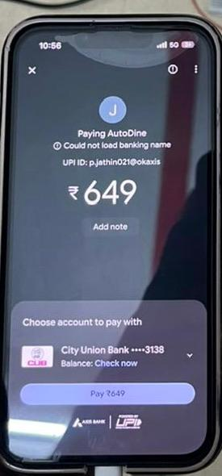Fig. 15a. Mobile screen in payment page 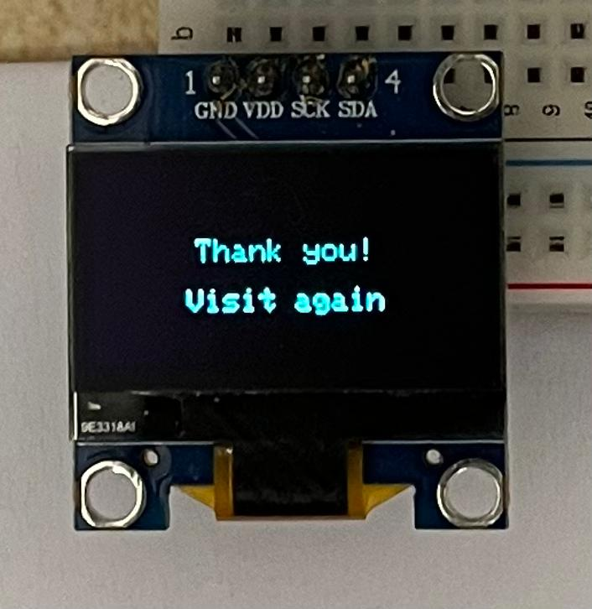
Fig. 15b. OLED showing Thank you page after payment verification
- Result
The AutoDine system was subjected to a set of end-to-end test cycles in a controlled laboratory setting, which was meant to simulate a small-scale restaurant setup, which consisted of two table units and a waiter robot. The evaluation focused on how responsive the system was, how well the orders could be processed and on the quality of autonomous delivery.
The table units were found to be stabile in all of the test iterations responding to user inputs and performing correct state transitions in all stages of operation. The orders typed in through the table units were successfully sent to the host dashboard with an average latency of under two seconds. Live up to date synchronization was noticed between the table units and the host system thus ensuring prompt update of order status.
The host unit was effectively able to handle several orders simultaneously thus preventing any inconsistency or duplication of data. The processing of orders workflow that includes acceptance, preparation updates and billing processes were carried out with reliability in all test scenarios. The invoices that resulted were correct, and they were always depicting the right itemization and price.
The waiter robot was able to perform autonomous delivery activity in most of the experiments. Obstacle-detection mechanism worked as would be expected allowing the robot to stop when it met obstruction and start moving again after clearing the obstruction. A small amount of positional errors were observed in a few cases that could be explained by the conditions of the surface; however, the robot successfully arrived at the specified delivery area in each of the finishes.
Generally, it is a system that has shown consistency and reliability in its entire workflow including order placement, delivery and payment. The system would always go back to its starting position of idle mode after every session thus proving resistance and preparedness to continue with further activities. These results support the effectiveness of the suggested system to achieve coordinated low-latency automation of restaurants.
- Conclusion and Future Scope
5.1 Conclusion
The proposed AutoDine solution is an illustration of end-to-end Internet of Things (IoT)-based restaurant automation solution on low-cost embedded platforms. It provides an order placement, kitchen coordination, autonomous delivery and payment processing within one common architecture.
The architecture is made up of a three-unit design that is made up of table units, a host system, and a waiter robot. It was consistent and reliable in all test situations and guaranteed stable communication and coordination. The state-machine-based controller enabled the predictable system behaviour whereas the order-management mechanism ensured accuracy and duplication was avoided.
Generally, the system validates the practicability of applying the cost-effective and scalable smart restaurant system to small restaurants, food courts, and institutional canteens.
5.2 Future Scope
Although the system is working perfectly as a prototype, there are a few things that can be improved further.
Although the current system of using a small OLED with a button to navigate through the different options is working perfectly as a prototype, it is not the most comfortable experience for the customer. Using a compact touchscreen will make the experience easier for the customer, especially for those who are not used to button-based navigation systems.
Although the current system of using a static QR code on the OLED for the payment method via UPI is working properly as a prototype, it can be improved by using dynamic QR codes that can be linked to the exact bill amount for each session.
Although the current system of displaying the billing details on the dashboard for the restaurant owner is working properly as a prototype, it can be improved by using the host to connect to a cloud platform to store all the order and billing details. This will help the restaurant owner to keep track of the sales made in the restaurant.
References
- S. Karthik, R. Suresh, P. Kumar, and M. Raj, “IoT based smart restaurant management system,” International Journal of Engineering Research and Technology (IJERT), vol. 7, no. 4, pp. 1–5, 2018.
- P. Venkatesh and M. Prakash, “Smart ordering system using embedded systems and wireless communication,” International Journal of Computer Applications (IJCA), vol. 179, no. 12, pp. 15–19, 2019.
- A. R. Al-Ali and M. Q. Shah, “GSM based alert system using microcontroller,” in Proc. IEEE Int. Conf. Embedded Systems, 2020, pp. 45–50.
- M. Conti, A. Dehghantanha, K. Franke, and S. Watson, “Lightweight authentication and session management for IoT systems,” IEEE Internet of Things Journal, vol. 8, no. 6, pp. 4689–4701, 2021.
- A. Sharma, R. Singh, and V. Kumar, “Design and implementation of IoT based smart restaurant,” International Journal of Advanced Engineering and Management (IJAEM), vol. 5, no. 2, pp. 89–95, 2023.
- K. Patel, S. Jain, and N. Mehta, “IoT based restaurant automation system,” International Journal of Research and Technology Innovations (IJRTI), vol. 6, no. 3, pp. 112–118, 2019.
- L. Chen, T. Wang, and H. Liu, “Smart restaurant using e-menu and waiter robot,” International Journal of Creative Research Thoughts (IJCRT), vol. 11, no. 5, pp. 234–241, May 2023.
- M. Rahman, A. Islam, and S. Ahmed, “Automated restaurant system using IoT,” International Journal of Innovative Research in Technology (IJIRT), vol. 8, no. 12, pp. 456–462, 2023.
- Miller, K. Brown, and T. Davis, “Arduino based android application controlled waiter robot,” in Proc. Int. Conf. Robotics and Automation, Charles Darwin University, 2022, pp. 78–84.
- R. Kumar, P. Sharma, and V. Singh, “Virtual path following smart waiter-bot,” International Journal of Creative Research Thoughts (IJCRT), vol. 8, no. 4, pp. 567–574, 2020.
- S. Lee, Y. Park, and J. Kim, “Computerized serving robot,” International Journal of Engineering Research and Technology (IJERT), vol. 11, no. 2, pp. 89–96, Feb. 2023.
- A. Gupta, N. Verma, and R. Agarwal, “A research paper on smart menu ordering system,” International Journal of Progressive Research in Science and Engineering (IJRPR), vol. 5, no. 4, pp. 123–129, 2024.
- T. Johnson and M. Wilson, “An IoT-based autonomous waiter robot,” Revista de Ingeniería, Universidad de Montevideo, vol. 28, no. 1, pp. 45–58, 2024.
- H. Zhang, L. Wang, and C. Chen, “Smart robot for restaurant food delivery,” Mathematical Statistician and Engineering Applications, vol. 72, no. 3, pp. 234–245, 2023.
- D. Anderson, P. Roberts, and S. Thompson, “Restaurant IoT – connected customer experience and management,” Instructables Engineering Projects, Mar. 2025. [Online]. Available:

