Improving the Performance of Long-Term Stock Investments with a Two-Stage LLM Filtering Framework

Abstract
Large language models (LLMs) are increasingly applied to investment strategy, but most existing systems ingest news and financial reports in a single prompt, an approach that can introduce noise and dilute relevant signals. We develop a two-stage sequential filtering framework in which news articles first nominate a candidate stock pool and financial reports then validate and refine that pool into a final portfolio. Across 2,759 matched portfolio runs spanning three OpenAI models, ten filtering configurations, and rolling 12-month evaluation windows, moderate two-stage filtering consistently outperforms an unfiltered single-pass baseline given the same information. For the strongest model, GPT-5.1, the best configuration (twenty candidates narrowed to ten) raised mean ROI from 45.7% to 60.6% without a commensurate increase in risk — annualized volatility 28.1% against 27.8% and maximum drawdown −23.2% against −22.4%, lifting the median Sharpe ratio from 1.34 to 1.70 — and beat the matched baseline in 22 of 27 window comparisons (81.5%; exact 95% CI [61.9, 93.7]). The effect is driven primarily by the size of the initial candidate pool: moderate pools of ten to twenty candidates outperform, while oversized pools degrade performance below the baseline. Filtered portfolios also outperform an equal-weighted portfolio of the eligible universe and random portfolios matched on holding count, whereas the unfiltered baseline does not, indicating selection skill within the sector rather than sector exposure alone. Comparisons against the S&P 500 and sector indices are reported as context; outperformance of the broad index largely reflects the technology-heavy universe. These results indicate that the structural organization of information is a first-class design variable for LLM-based investment systems.
Keywords: large language models, investment strategy, two-stage filtering, portfolio construction, financial news analysis, information structuring

Introduction

Background and Context
Robust financial analysis requires integrating qualitative sentiment—extracted from earnings reports and news sources—with quantitative metrics such as historical price, volume, and risk profiles ((Y. Nie, Y. Kong, X. Dong, J. M. Mulvey, H. V. Poor, Q. Wen, S. Zohren. A survey of large language models for financial applications: progress, prospects and challenges. arXiv, 2024, https://doi.org/10.48550/arXiv.2406.11903.)), ((S. An, Q. Li, J. Lu, D. Yin, X. Sun. FinVerse: an autonomous agent system for versatile financial analysis. arXiv, 2024, https://doi.org/10.48550/arXiv.2406.06379.)). Capitalizing on their natural language understanding capabilities, LLMs are increasingly applied to financial markets to generate directional signals—buy, hold, or sell recommendations—by synthesizing information from news, earnings reports, and regulatory filings ((A. Lopez-Lira, Y. Tang. Can ChatGPT forecast stock price movements? return predictability and large language models. SSRN. 2023, https://doi.org/10.2139/ssrn.4412788.)), ((Y. Xiao, E. Sun, D. Luo, W. Wang. TradingAgents: multi-agents LLM financial trading framework. arXiv, 2024, https://doi.org/10.48550/arXiv.2412.20138.)), ((H. Ding, Y. Li, J. Wang, H. Chen. Large language model agent in financial trading: a survey. arXiv, 2024, https://doi.org/10.48550/arXiv.2408.06361.)).
The bulk of existing LLM-based investment research focuses on short-term trading horizons—high-frequency trading or single-day price prediction ((A. Lopez-Lira, Y. Tang. Can ChatGPT forecast stock price movements? return predictability and large language models. SSRN. 2023, https://doi.org/10.2139/ssrn.4412788.)), ((Y. Xiao, E. Sun, D. Luo, W. Wang. TradingAgents: multi-agents LLM financial trading framework. arXiv, 2024, https://doi.org/10.48550/arXiv.2412.20138.)), ((W. W. Li, H. Kim, M. Cucuringu, T. Ma. Can LLM-based financial investing strategies outperform the market in the long run? arXiv, 2025, https://doi.org/10.48550/arXiv.2505.07078.)). A growing subset of work has begun exploring longer horizons ((W. W. Li, H. Kim, M. Cucuringu, T. Ma. Can LLM-based financial investing strategies outperform the market in the long run? arXiv, 2025, https://doi.org/10.48550/arXiv.2505.07078.)), ((D. Blitz, M. X. Hanauer, T. Hoogteijling, C. Howard. The term structure of machine learning alpha. The Journal of Financial Data Science. Vol. 5, pg. 40–65, 2023, https://doi.org/10.3905/jfds.2023.1.135.)), but this literature remains limited in scope: most studies do not guard against lookahead bias by restricting the model to information available at the simulated investment date, and few target holding periods exceeding one quarter. Long-term investing, by contrast, demands sustained reasoning over extended horizons—a domain traditionally reserved for human analysts who synthesize broad macroeconomic insights, qualitative judgment, and multi-year strategic perspectives ((W. W. Li, H. Kim, M. Cucuringu, T. Ma. Can LLM-based financial investing strategies outperform the market in the long run? arXiv, 2025, https://doi.org/10.48550/arXiv.2505.07078.)). This gap motivates the present work: we investigate whether a structured LLM pipeline can generate reliable investment strategies over 12-month holding periods under a forward-usable protocol: every decision uses only information available at that decision date, with no look-ahead into future data. The models themselves postdate the earliest simulated decision dates, so it is the protocol, not the specific model, that transfers.
Large language models have emerged as transformative tools in finance. Their capacity for summarization ((G. Lu, S. B. Larcher, T. Tran. Hybrid long document summarization using C2F-FAR and ChatGPT: a practical study. arXiv, 2023, https://doi.org/10.48550/arXiv.2306.01169.)), information extraction, and natural language generation suits applications such as market trend monitoring, risk factor identification, and investment decision support ((Y. Nie, Y. Kong, X. Dong, J. M. Mulvey, H. V. Poor, Q. Wen, S. Zohren. A survey of large language models for financial applications: progress, prospects and challenges. arXiv, 2024, https://doi.org/10.48550/arXiv.2406.11903.)), ((S. An, Q. Li, J. Lu, D. Yin, X. Sun. FinVerse: an autonomous agent system for versatile financial analysis. arXiv, 2024, https://doi.org/10.48550/arXiv.2406.06379.)). As LLMs have scaled, their ability to process complex, heterogeneous financial datasets has grown substantially ((Y. Nie, Y. Kong, X. Dong, J. M. Mulvey, H. V. Poor, Q. Wen, S. Zohren. A survey of large language models for financial applications: progress, prospects and challenges. arXiv, 2024, https://doi.org/10.48550/arXiv.2406.11903.)), ((H. Naveed, A. U. Khan, S. Qiu, M. Saqib, S. Anwar, M. Usman, N. Akhtar, N. Barnes, A. Mian. A comprehensive overview of large language models. ACM Transactions on Intelligent Systems and Technology. Vol. 16, no. 5, 2025, https://doi.org/10.1145/3744746.)), but this capability brings interpretability challenges: model opacity makes it difficult to audit whether outputs reflect genuine financial reasoning or spurious correlations from pre-training ((B. Cao, S. Wang, X. Lin, X. Wu, H. Zhang, L. M. Ni, J. Guo. From deep learning to LLMs: a survey of AI in quantitative investment. arXiv, 2025, https://doi.org/10.48550/arXiv.2503.21422.)), ((I. Mirzadeh, K. Alizadeh, H. Shahrokhi, O. Tuzel, S. Bengio, M. Farajtabar. GSM-symbolic: understanding the limitations of mathematical reasoning in large language models. International Conference on Learning Representations (ICLR 2025). 2025, https://openreview.net/forum?id=AjXkRZIvjB.)). Because undetected biases can propagate into consequential financial decisions ((B. Cao, S. Wang, X. Lin, X. Wu, H. Zhang, L. M. Ni, J. Guo. From deep learning to LLMs: a survey of AI in quantitative investment. arXiv, 2025, https://doi.org/10.48550/arXiv.2503.21422.)), ((Y. Zhang, Y. Li, L. Cui, D. Cai, L. Liu, T. Fu, X. Huang, E. Zhao, Y. Zhang, C. Xu, Y. Chen, L. Wang, A. T. Luu, W. Bi, F. Shi, S. Shi. Siren’s song in the AI ocean: a survey on hallucination in large language models. Computational Linguistics. Vol. 51, pg. 1373–1418, 2025, https://doi.org/10.1162/coli.a.16.)), realizing the potential of LLMs in financial analysis depends on clear, principled deployment frameworks ((Y. Nie, Y. Kong, X. Dong, J. M. Mulvey, H. V. Poor, Q. Wen, S. Zohren. A survey of large language models for financial applications: progress, prospects and challenges. arXiv, 2024, https://doi.org/10.48550/arXiv.2406.11903.)), ((I. Okpala, A. Golgoon, A. R. Kannan. Agentic AI systems applied to tasks in financial services: modeling and model risk management crews. arXiv, 2025, https://doi.org/10.48550/arXiv.2502.05439.)).

Large Language Models in Financial Forecasting
Existing research has demonstrated the proficiency of LLMs in synthesizing heterogeneous financial data to extract predictive market signals ((A. Lopez-Lira, Y. Tang. Can ChatGPT forecast stock price movements? return predictability and large language models. SSRN. 2023, https://doi.org/10.2139/ssrn.4412788.)), ((H. Ding, Y. Li, J. Wang, H. Chen. Large language model agent in financial trading: a survey. arXiv, 2024, https://doi.org/10.48550/arXiv.2408.06361.)), ((G. Fatouros, K. Metaxas, J. Soldatos, M. Karathanassis. MarketSenseAI 2.0: enhancing stock analysis through LLM agents. arXiv, 2025, https://doi.org/10.48550/arXiv.2502.00415.)). Studies integrating LLMs with conventional forecasting techniques reported improved predictive accuracy, attributed to the models’ ability to capture nuanced relationships between news sentiment and price movements ((A. Lopez-Lira, Y. Tang. Can ChatGPT forecast stock price movements? return predictability and large language models. SSRN. 2023, https://doi.org/10.2139/ssrn.4412788.)), ((G. Fatouros, K. Metaxas, J. Soldatos, M. Karathanassis. MarketSenseAI 2.0: enhancing stock analysis through LLM agents. arXiv, 2025, https://doi.org/10.48550/arXiv.2502.00415.)), ((J. Cheng, P. Chin. AAPM: large language model agent-based asset pricing models. arXiv, 2024, https://doi.org/10.48550/arXiv.2409.17266.)). A complementary line of work combines document embeddings with LLM-generated representations to construct richer proxies for investor sentiment and macroeconomic conditions ((G. Fatouros, K. Metaxas, J. Soldatos, M. Karathanassis. MarketSenseAI 2.0: enhancing stock analysis through LLM agents. arXiv, 2025, https://doi.org/10.48550/arXiv.2502.00415.)), ((C. Choi, A. Lopez-Lira, Y. Lee, J. Kwon, M. Kim, J. Hwang, M. Ha, C. Kim, J. Ha, S. Yun, J. Kim. Structuring the unstructured: a multi-agent system for extracting and querying financial KPIs and guidance. arXiv, 2025, https://doi.org/10.48550/arXiv.2505.19197.)). By automating the extraction of financially relevant signals from unstructured text, LLMs reduce the manual overhead of information processing and enable more scalable financial modeling pipelines ((G. Fatouros, K. Metaxas, J. Soldatos, M. Karathanassis. MarketSenseAI 2.0: enhancing stock analysis through LLM agents. arXiv, 2025, https://doi.org/10.48550/arXiv.2502.00415.)), ((C. Choi, A. Lopez-Lira, Y. Lee, J. Kwon, M. Kim, J. Hwang, M. Ha, C. Kim, J. Ha, S. Yun, J. Kim. Structuring the unstructured: a multi-agent system for extracting and querying financial KPIs and guidance. arXiv, 2025, https://doi.org/10.48550/arXiv.2505.19197.)).

Multi-Agent LLM Systems for Trading
Beyond single-model deployments, LLMs are increasingly employed as components of multi-agent trading systems, in which specialized agents interact to simulate market dynamics and refine portfolio strategies ((Y. Xiao, E. Sun, D. Luo, W. Wang. TradingAgents: multi-agents LLM financial trading framework. arXiv, 2024, https://doi.org/10.48550/arXiv.2412.20138.)), ((T. Guo, X. Chen, Y. Wang, R. Chang, S. Pei, N. V. Chawla, O. Wiest, X. Zhang. Large language model based multi-agents: a survey of progress and challenges. Proceedings of the 33rd International Joint Conference on Artificial Intelligence (IJCAI 2024), Survey Track. 2024, https://doi.org/10.24963/ijcai.2024/890.)), ((X. Han, N. Wang, S. Che, H. Yang, K. Zhang, S. X. Xu. Enhancing investment analysis: optimizing AI-agent collaboration in financial research. Proceedings of the 5th ACM International Conference on AI in Finance. 2024, https://doi.org/10.1145/3677052.3698645.)), ((C. Zhang, X. Liu, M. Jin, Z. Zhang, L. Li, Z. Wang, W. Hua, D. Shu, S. Zhu, X. Jin, S. Li, M. Du, Y. Zhang. When AI meets finance (StockAgent): large language model-based stock trading in simulated real-world environments. arXiv, 2024, https://doi.org/10.48550/arXiv.2407.18957.)). Such systems incorporate layered memory architectures and role-differentiated agent designs, enabling individual agents to retain relevant historical context and adapt their behavior as market conditions evolve ((Y. Li, Y. Yu, H. Li, Z. Chen, K. Khashanah. TradingGPT: multi-agent system with layered memory and distinct characters for enhanced financial trading performance. arXiv, 2023, https://doi.org/10.48550/arXiv.2309.03736.)), ((Y. Yu, H. Li, Z. Chen, Y. Jiang, Y. Li, D. Zhang, R. Liu, J. W. Suchow, K. Khashanah. FinMem: a performance-enhanced LLM trading agent with layered memory and character design. Proceedings of the AAAI Symposium Series. Vol. 3, pg. 595–597, 2024, https://doi.org/10.1609/aaaiss.v3i1.31290.)). Empirical evidence indicates that multi-agent configurations frequently outperform single-agent baselines, as the diversity of strategies across agents reduces overfitting observed in isolated backtests ((X. Han, N. Wang, S. Che, H. Yang, K. Zhang, S. X. Xu. Enhancing investment analysis: optimizing AI-agent collaboration in financial research. Proceedings of the 5th ACM International Conference on AI in Finance. 2024, https://doi.org/10.1145/3677052.3698645.)), ((T. Guo, H. Shen, J. Huang, Z. Mao, J. Luo, B. Chen, Z. Chen, L. Liu, B. Xia, X. Liu, Y. Ma, M. Zhang. MASS: multi-agent simulation scaling for portfolio construction. arXiv, 2025, https://doi.org/10.48550/arXiv.2505.10278.)). Within these architectures, individual agents are assigned distinct functions—portfolio allocation, risk assessment, and real-time monitoring—enabling a modular division of responsibilities that exploits the natural language flexibility of LLMs ((Y. Xiao, E. Sun, D. Luo, W. Wang. TradingAgents: multi-agents LLM financial trading framework. arXiv, 2024, https://doi.org/10.48550/arXiv.2412.20138.)), ((T. Guo, X. Chen, Y. Wang, R. Chang, S. Pei, N. V. Chawla, O. Wiest, X. Zhang. Large language model based multi-agents: a survey of progress and challenges. Proceedings of the 33rd International Joint Conference on Artificial Intelligence (IJCAI 2024), Survey Track. 2024, https://doi.org/10.24963/ijcai.2024/890.)), ((J. Li, J. Zhang, H. Li, Y. Shen. An agent framework for real-time financial information searching with large language models. arXiv, 2025, https://doi.org/10.48550/arXiv.2502.15684.)). Representative frameworks such as 3S-Trader ((K. Chen, H. Ahmad, D. Goel, C. Szabo. 3S-trader: a multi-LLM framework for adaptive stock scoring, strategy, and selection in portfolio optimization. arXiv, 2025, https://doi.org/10.48550/arXiv.2510.17393.)), AlphaAgents ((T. Zhao, J. Lyu, S. Jones, H. Garber, S. Pasquali, D. Mehta. AlphaAgents: large language model-based multi-agents for equity portfolio constructions. arXiv, 2025, https://doi.org/10.48550/arXiv.2508.11152.)), FinRobot ((T. Zhou, P. Wang, Y. Wu, H. Yang. FinRobot: AI agent for equity research and valuation with large language models. arXiv, 2024, https://doi.org/10.48550/arXiv.2411.08804.)), and tool-augmented multimodal foundation agents ((W. Zhang, L. Zhao, H. Xia, S. Sun, J. Sun, M. Qin, X. Li, Y. Zhao, Y. Zhao, X. Cai, L. Zheng, X. Wang, B. An. A multimodal foundation agent for financial trading: tool-augmented, diversified, and generalist. Proceedings of the 30th ACM SIGKDD Conference on Knowledge Discovery and Data Mining. 2024, https://doi.org/10.1145/3637528.3671801.)) coordinate multiple LLMs to score candidate stocks, construct a portfolio, and iteratively refine strategies from historical performance, though at the cost of considerable system complexity.

Sentiment Analysis and Market Dynamics
LLMs have proven adept at inferring investor sentiment and forecasting market movements by analyzing news articles and social media data ((A. Lopez-Lira, Y. Tang. Can ChatGPT forecast stock price movements? return predictability and large language models. SSRN. 2023, https://doi.org/10.2139/ssrn.4412788.)), ((G. Fatouros, K. Metaxas, J. Soldatos, M. Karathanassis. MarketSenseAI 2.0: enhancing stock analysis through LLM agents. arXiv, 2025, https://doi.org/10.48550/arXiv.2502.00415.)), ((P. C. Tetlock. Giving content to investor sentiment: the role of media in the stock market. The Journal of Finance. Vol. 62, pg. 1139–1168, 2007, https://doi.org/10.1111/j.1540-6261.2007.01232.x.)). By leveraging pre-training on large-scale financial datasets, LLMs can discern specialized terminology and complex rhetorical structures, providing an effective framework for mapping textual information to market price movements ((A. Lopez-Lira, Y. Tang. Can ChatGPT forecast stock price movements? return predictability and large language models. SSRN. 2023, https://doi.org/10.2139/ssrn.4412788.)), ((J. Lee, N. Stevens, S. C. Han, M. Song. A survey of large language models in finance (FinLLMs). Neural Computing and Applications. Vol. 37, pg. 24853–24867, 2025, https://doi.org/10.1007/s00521-024-10495-6.)). Sentiment-augmented models have also been reported to identify early indicators of trend reversals ((A. Lopez-Lira, Y. Tang. Can ChatGPT forecast stock price movements? return predictability and large language models. SSRN. 2023, https://doi.org/10.2139/ssrn.4412788.)), ((P. C. Tetlock. Giving content to investor sentiment: the role of media in the stock market. The Journal of Finance. Vol. 62, pg. 1139–1168, 2007, https://doi.org/10.1111/j.1540-6261.2007.01232.x.)). By processing vast quantities of unstructured data at scale, LLMs enable the development of more agile, information-rich trading strategies that respond to market shifts in real time ((Y. Nie, Y. Kong, X. Dong, J. M. Mulvey, H. V. Poor, Q. Wen, S. Zohren. A survey of large language models for financial applications: progress, prospects and challenges. arXiv, 2024, https://doi.org/10.48550/arXiv.2406.11903.)), ((J. Li, J. Zhang, H. Li, Y. Shen. An agent framework for real-time financial information searching with large language models. arXiv, 2025, https://doi.org/10.48550/arXiv.2502.15684.)). This body of research extends foundational work by demonstrating that media-derived content yields quantifiable sentiment signals that have a direct and measurable impact on equity prices ((A. Lopez-Lira, Y. Tang. Can ChatGPT forecast stock price movements? return predictability and large language models. SSRN. 2023, https://doi.org/10.2139/ssrn.4412788.)), ((P. C. Tetlock. Giving content to investor sentiment: the role of media in the stock market. The Journal of Finance. Vol. 62, pg. 1139–1168, 2007, https://doi.org/10.1111/j.1540-6261.2007.01232.x.)).

Self-Improving and Feedback-Driven Financial LLMs
Beyond static single-pass designs, self-improving and feedback-driven agent systems have produced further gains in automated trading ((Y. Yu, H. Li, Z. Chen, Y. Jiang, Y. Li, D. Zhang, R. Liu, J. W. Suchow, K. Khashanah. FinMem: a performance-enhanced LLM trading agent with layered memory and character design. Proceedings of the AAAI Symposium Series. Vol. 3, pg. 595–597, 2024, https://doi.org/10.1609/aaaiss.v3i1.31290.)), ((S. Wang, H. Yuan, L. M. Ni, J. Guo. QuantAgent: seeking holy grail in trading by self-improving large language model. arXiv, 2024, https://doi.org/10.48550/arXiv.2402.03755.)). Such systems refine their strategies iteratively through feedback from simulated markets or accumulated trading knowledge ((C. Zhang, X. Liu, M. Jin, Z. Zhang, L. Li, Z. Wang, W. Hua, D. Shu, S. Zhu, X. Jin, S. Li, M. Du, Y. Zhang. When AI meets finance (StockAgent): large language model-based stock trading in simulated real-world environments. arXiv, 2024, https://doi.org/10.48550/arXiv.2407.18957.)), ((S. Wang, H. Yuan, L. M. Ni, J. Guo. QuantAgent: seeking holy grail in trading by self-improving large language model. arXiv, 2024, https://doi.org/10.48550/arXiv.2402.03755.)), and framing portfolio management as a sequential decision problem provides a principled balance between exploring new strategies and exploiting established ones ((S. Wang, H. Yuan, L. M. Ni, J. Guo. QuantAgent: seeking holy grail in trading by self-improving large language model. arXiv, 2024, https://doi.org/10.48550/arXiv.2402.03755.)). This adaptability suits non-stationary market regimes ((Y. Xiao, E. Sun, D. Luo, W. Wang. TradingAgents: multi-agents LLM financial trading framework. arXiv, 2024, https://doi.org/10.48550/arXiv.2412.20138.)), ((Y. Yu, H. Li, Z. Chen, Y. Jiang, Y. Li, D. Zhang, R. Liu, J. W. Suchow, K. Khashanah. FinMem: a performance-enhanced LLM trading agent with layered memory and character design. Proceedings of the AAAI Symposium Series. Vol. 3, pg. 595–597, 2024, https://doi.org/10.1609/aaaiss.v3i1.31290.)).

Benchmarks, Evaluation, and Bias
Systematic benchmarking provides a principled basis for evaluating financial LLMs ((J. Lee, N. Stevens, S. C. Han, M. Song. A survey of large language models in finance (FinLLMs). Neural Computing and Applications. Vol. 37, pg. 24853–24867, 2025, https://doi.org/10.1007/s00521-024-10495-6.)), ((K. Anjum, M. A. Arshad, K. Hayawi, E. Polyzos, A. Tariq, M. A. Serhani, L. Batool, B. Lund, N. R. Mannuru, R. V. K. Bevara, T. Mahbub, M. Z. Akram, S. Shahriar. Domain specific benchmarks for evaluating multimodal large language models. arXiv, 2025, https://doi.org/10.48550/arXiv.2506.12958.)), ((H. Li, Y. Cao, Y. Yu, S. R. Javaji, Z. Deng, Y. He, Y. Jiang, Z. Zhu, K. Subbalakshmi, G. Xiong, J. Huang, L. Qian, X. Peng, Q. Xie, J. W. Suchow. InvestorBench: a benchmark for financial decision-making tasks with LLM-based agents. Proceedings of the 63rd Annual Meeting of the Association for Computational Linguistics (ACL 2025). pg. 2509–2525, 2025, https://doi.org/10.18653/v1/2025.acl-long.126.)). Standardized datasets enable rigorous comparison across models and multi-agent systems on textual comprehension, sentiment extraction, and portfolio optimization ((J. Lee, N. Stevens, S. C. Han, M. Song. A survey of large language models in finance (FinLLMs). Neural Computing and Applications. Vol. 37, pg. 24853–24867, 2025, https://doi.org/10.1007/s00521-024-10495-6.)), ((H. Li, Y. Cao, Y. Yu, S. R. Javaji, Z. Deng, Y. He, Y. Jiang, Z. Zhu, K. Subbalakshmi, G. Xiong, J. Huang, L. Qian, X. Peng, Q. Xie, J. W. Suchow. InvestorBench: a benchmark for financial decision-making tasks with LLM-based agents. Proceedings of the 63rd Annual Meeting of the Association for Computational Linguistics (ACL 2025). pg. 2509–2525, 2025, https://doi.org/10.18653/v1/2025.acl-long.126.)). A consistent finding is that accuracy alone is insufficient — models must perform reliably under live-market pressures ((W. W. Li, H. Kim, M. Cucuringu, T. Ma. Can LLM-based financial investing strategies outperform the market in the long run? arXiv, 2025, https://doi.org/10.48550/arXiv.2505.07078.)), ((C. Zhang, X. Liu, M. Jin, Z. Zhang, L. Li, Z. Wang, W. Hua, D. Shu, S. Zhu, X. Jin, S. Li, M. Du, Y. Zhang. When AI meets finance (StockAgent): large language model-based stock trading in simulated real-world environments. arXiv, 2024, https://doi.org/10.48550/arXiv.2407.18957.)), ((H. Li, Y. Cao, Y. Yu, S. R. Javaji, Z. Deng, Y. He, Y. Jiang, Z. Zhu, K. Subbalakshmi, G. Xiong, J. Huang, L. Qian, X. Peng, Q. Xie, J. W. Suchow. InvestorBench: a benchmark for financial decision-making tasks with LLM-based agents. Proceedings of the 63rd Annual Meeting of the Association for Computational Linguistics (ACL 2025). pg. 2509–2525, 2025, https://doi.org/10.18653/v1/2025.acl-long.126.)) — so continued benchmark development is essential to ensure reported advances are genuine rather than artifacts of favorable evaluation conditions ((A. Lopez-Lira, Y. Tang. Can ChatGPT forecast stock price movements? return predictability and large language models. SSRN. 2023, https://doi.org/10.2139/ssrn.4412788.)), ((W. W. Li, H. Kim, M. Cucuringu, T. Ma. Can LLM-based financial investing strategies outperform the market in the long run? arXiv, 2025, https://doi.org/10.48550/arXiv.2505.07078.)), ((H. Li, Y. Cao, Y. Yu, S. R. Javaji, Z. Deng, Y. He, Y. Jiang, Z. Zhu, K. Subbalakshmi, G. Xiong, J. Huang, L. Qian, X. Peng, Q. Xie, J. W. Suchow. InvestorBench: a benchmark for financial decision-making tasks with LLM-based agents. Proceedings of the 63rd Annual Meeting of the Association for Computational Linguistics (ACL 2025). pg. 2509–2525, 2025, https://doi.org/10.18653/v1/2025.acl-long.126.)).
A critical concern in this literature is evaluation bias. A rigorous testing framework, FINSABER ((W. W. Li, H. Kim, M. Cucuringu, T. Ma. Can LLM-based financial investing strategies outperform the market in the long run? arXiv, 2025, https://doi.org/10.48550/arXiv.2505.07078.)), was introduced to address three common problems: survivorship bias (testing only on currently successful stocks), look-ahead bias (accidentally using future information in past decisions), and data-snooping bias (testing a strategy repeatedly on the same data until favorable results arise by chance). When popular LLM strategies were re-tested over 20 years across a wider range of stocks, the strategies’ apparent advantages either disappeared or appeared much weaker. That work also found that LLM strategies often performed poorly in different market conditions — too cautious during bull markets and overly aggressive during bear markets. Those findings motivate the evaluation design used here: long horizons, matched comparisons, and explicit controls for the three biases named above.
Collectively, these studies show LLMs can generate competitive investment strategies, but they focus on improving model capability — larger architectures, multi-agent systems, reinforcement learning, or sentiment extraction. Little attention has gone to the structural architecture of information delivery: most approaches ingest heterogeneous sources simultaneously, leaving open whether alternative information frameworks might improve performance. This gap motivates our central question: can restructuring the information flow presented to an LLM systematically improve long-term investment decision-making?

Problem Statement and Rationale
Several limitations constrain LLMs in investment contexts. A primary concern is their documented inability to perform reliable numerical computation ((I. Mirzadeh, K. Alizadeh, H. Shahrokhi, O. Tuzel, S. Bengio, M. Farajtabar. GSM-symbolic: understanding the limitations of mathematical reasoning in large language models. International Conference on Learning Representations (ICLR 2025). 2025, https://openreview.net/forum?id=AjXkRZIvjB.)): LLMs exhibit systematic arithmetic errors, limiting quantitative tasks that require precision and preventing them from replacing analysts whose judgments rest on rigorous financial modeling.
A second challenge is hallucination: LLMs can fabricate or misrepresent information with high apparent confidence ((Y. Zhang, Y. Li, L. Cui, D. Cai, L. Liu, T. Fu, X. Huang, E. Zhao, Y. Zhang, C. Xu, Y. Chen, L. Wang, A. T. Luu, W. Bi, F. Shi, S. Shi. Siren’s song in the AI ocean: a survey on hallucination in large language models. Computational Linguistics. Vol. 51, pg. 1373–1418, 2025, https://doi.org/10.1162/coli.a.16.)). In an investment context, this can result in recommendations based on non-existent corporate events, incorrect financial figures, or wholly invented analyst reports. Critically, hallucinations are not always overt. Subtle hallucinations—small distortions in attributed facts, misremembered statistics, or plausible-sounding but inaccurate characterizations of company performance—may pass undetected and propagate systematically through the recommendation pipeline, making them particularly dangerous for investment applications where errors in reasoning compound over a holding period.
A third challenge is implicit bias introduced through LLM pre-training. Because modern LLMs are trained on large corpora with a fixed knowledge cutoff, they may encode implicit awareness of future events relative to any historical analysis date, effectively providing look-ahead information that no real investor could possess at the time of decision-making. This form of data leakage is particularly problematic for backtesting: strategies that appear profitable in retrospective evaluation may be artifacts of the model’s latent knowledge of subsequent market developments rather than genuine analytical insight, casting doubt on the validity of reported results.
This study addresses two gaps tied to the challenges outlined above. First, long-term LLM investment strategies remain underexplored relative to short-term counterparts, leaving open whether LLMs can sustain reliable performance over multi-month horizons. Second, existing approaches typically ingest heterogeneous information sources simultaneously, risking signal dilution, information overload, and inconsistent decision-making.

Significance and Purpose
This paper proposes a two-stage structured pipeline for generating reliable long-term investment strategies with large language models. The framework decomposes the investment task into two sequential stages: a news-based candidate selection stage, in which the LLM identifies a set of candidate stocks from a curated set of financial news articles; and a financial report validation stage, in which the LLM reads company financial reports for each candidate and produces a smaller, higher-conviction final portfolio. This sequential evaluation of information sources, rather than simultaneous ingestion, constitutes the central methodological contribution of this work.
The framework addresses all three challenges. Decomposing the task constrains each stage to a well-defined subtask, reducing hallucination and improving consistency; strict temporal boundaries prevent look-ahead leakage; and all numerical computation is delegated to deterministic external modules, avoiding reliance on LLM arithmetic.

Objectives
This paper delivers three primary contributions.
First, it introduces a two-stage news-and-financial-report architecture for LLM-driven long-term investment strategy generation. The architecture separates qualitative from quantitative reasoning in a principled way, which makes each stage independently auditable and lets performance differences be attributed to a specific stage.
Second, it provides extensive empirical validation centered on advanced frontier models. Moderate filtering configurations, which keep a mid-sized candidate pool and roughly halve it between stages, achieve a mean ROI of up to 60.6% at volatility and maximum drawdown comparable to the unfiltered baseline (28.1% against 27.8%, and −23.2% against −22.4%), and outperform that baseline in 74–82% of matched evaluation windows across the four well-sized configurations, with exact confidence intervals reported in the Results. The same configurations outperform an equal-weighted portfolio of the eligible universe and random matched-size portfolios, whereas the unfiltered baseline does not; comparisons with the S&P 500 are reported as sector-relative context.
Third, it presents a systematic sensitivity analysis of returns and consistency across ten pipeline configurations. The analysis establishes that while moderate filtering consistently improves on single-pass methodologies, aggressive over-filtering, which forces the model to draw from an oversized candidate pool it cannot fill with strong companies, degrades performance. The optimal filtering threshold is model-dependent, and for the target sizes tested the best configuration is consistent with a Stage One pool of roughly twice the target portfolio size; given the coarse configuration grid, we present this as a working hypothesis rather than a rule.

Scope and Limitations
This study is scoped to long-only, buy-and-hold portfolios drawn from large-capitalization technology and semiconductor equities, evaluated over rolling 12-month horizons using three model variants (GPT-4o, GPT-4o-mini, and GPT-5.1). Returns are computed before transaction costs and taxes, and all evaluation windows respect each model’s training cutoff. Broader limitations are addressed in the Discussion. Throughout the paper, “long-term” denotes these 12-month buy-and-hold horizons: long relative to the intraday-to-quarterly horizons that dominate the prior LLM-trading literature, though medium-term by traditional investing standards. The model is not restricted to a predefined ticker list: in every filtered configuration it proposes candidate companies freely from the screened news, so the effective universe is open and emerges from contemporaneous coverage rather than a curated survivor list. A fixed set of large-capitalization technology and semiconductor names is used only for the unfiltered single-pass baseline and as the eligible comparison set for the benchmark analyses.

Methods
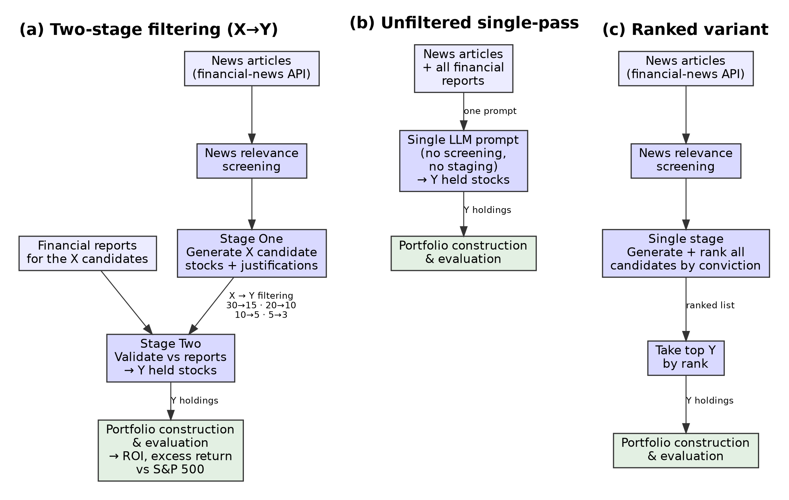

Figure 1. A Two-Stage Filtering Framework for LLM-Driven Investing. (a) The two-stage pipeline: screened news drives Stage One, which generates X candidate stocks with justifications; Stage Two then validates those against their financial reports to select the Y-stock final portfolio (the X→Y notation used throughout). (b) The unfiltered single-pass baseline analyzes all news and financial reports together in one prompt. (c) The Ranked variant screens news, then generates and ranks all candidates by conviction and takes the top Y, without a fixed Stage-One count.

Overall Framework Overview
The framework’s architecture is illustrated in Figure 1. Its central design principle is that different information sources should be evaluated sequentially rather than simultaneously: existing approaches typically provide news, financial reports, and other market information in a single reasoning step, which maximizes information availability but can dilute relevant signals. The framework instead separates opportunity discovery from financial validation.
The framework consists of four primary phases. First, historical news articles are collected from a fixed pre-analysis window. Second, these articles are used to prompt an LLM to generate a set of candidate stocks with qualitative justifications, constituting Stage One of the framework. Third, financial reports are retrieved for each candidate stock and provided to the LLM in a second analysis stage. The model then evaluates these reports and produces a smaller set of final recommendations. The notation X→Y used throughout this paper denotes this structure: X represents the number of candidate stocks identified during Stage One, while Y represents the number of final investment selections produced after financial-report validation in Stage Two. Finally, the resulting stock selections and allocation weights are used to construct and evaluate a long-only investment portfolio over a predefined investment horizon.
One exception to this general structure is the Ranked configuration. In the other configurations, the LLM is asked to return a fixed number of candidates at each stage. In Ranked, the LLM instead ranks all candidate opportunities without limiting how many it returns; the number is capped to a set value only at the final investment step.
By separating qualitative reasoning (interpreting news narratives and financial-report language) from quantitative evaluation—deterministic calculation of returns, volatility, and benchmark comparisons by external code—the framework assigns each component to the tool best suited to it, improving reliability and interpretability and allowing performance differences to be attributed to specific stages.
To evaluate the effect of structural organization of information, multiple filtering configurations were tested, including unfiltered baseline, Ranked, 30→15, 30→10, 30→5, 20→10, 20→5, 10→5, 10→3, and 5→3. Here the unfiltered baseline represents the conventional approach used in much of the existing literature, in which news articles and financial reports are analyzed simultaneously without sequential filtering.

Data Sources
Three primary categories of data are used in this study: news articles, financial reports, and historical market prices. News articles are obtained through the New York Times Article Search application programming interface, and company financial reports through the Alpha Vantage company-report endpoints; both are cached locally. For each decision date, news is drawn from a fixed 24-month window ending at that date; article publication timestamps are parsed to Coordinated Universal Time (UTC) and compared date-only against the window, and duplicate or syndicated stories are removed by exact headline match (first occurrence kept). Every news document is filtered to a publication date strictly preceding the decision date; financial reports require a stricter rule than the period end alone, given below.
Financial reports are quarterly income statement, balance sheet and cash-flow filings retrieved for each stock that passes Stage One, providing structured company-level data the LLM uses in Stage Two to validate and refine the candidate list. Because a fiscal period ending before a decision date does not mean the report was public by then, a report is admitted only if it was available strictly before that date. Availability is taken as the later of two dates: the fiscal period end plus the statutory filing deadline, and any filing date supplied by the source. The deadlines applied are 45 days for quarterly filings and 75 days for annual filings, the accelerated-filer limits, so the bound holds across the whole universe rather than only its largest constituents. Reports dated on the decision date itself are also excluded, since filings accepted after 17:30 Eastern Time are disseminated the following business day. In practice this withholds the most recent quarter from any decision falling inside its filing window. (In the unfiltered baseline, financial reports for the full union of stocks selected by any configuration are provided alongside all available news articles.)
Market data comprises daily adjusted closing prices for individual stocks and benchmark indices, introduced only after recommendations are finalized. This isolates the reasoning process from look-ahead bias, and all return calculations and risk metrics are computed externally using deterministic formulas.

News Article Relevance Screening Process
Raw news often contains material irrelevant to investment decisions—opinion pieces, general technology discussion, or political commentary without market implications. A dedicated LLM-based relevance screening step therefore precedes strategy generation: the LLM labels each article financially relevant or irrelevant under a constrained classification prompt, with no manual review or rule-based expressions, keeping screening consistent and scalable across evaluation windows.
Batches of articles are screened with a constrained prompt selecting only those with clear, direct market relevance: earnings announcements, major corporate events, regulatory changes, macroeconomic indicators, and industry-level shifts.
Screened articles are stored in a curated database and reused downstream, letting a small, high-quality input set drive strategy generation and reducing the influence of irrelevant or misleading information. Across the full corpus the relevance filter retained 1,799 of 13,183 unique articles (13.6%) under strict investment-relevance criteria. The validation sample described below is drawn from a single screening run of 1,382 articles, of which 110 (8.0%) passed.
To check the screen against human judgment, we blind-labeled a stratified sample of 180 of these articles (70 screen-passed and 110 screen-rejected) without access to the screen’s decisions. Against that first rating the screen achieved a precision of 100% (95% Wilson confidence interval [94.8, 100]), and re-weighting to the 13.6% corpus pass rate gave an estimated recall of 26% and a false-omission rate of 45%. Because a single rater is a single standard, a second rater, blind both to the screen’s decisions and to the first rater’s labels, independently labelled the same 180 articles. The two agreed on 83.3% of them (95% CI [77.2, 88.1]; Cohen’s kappa 0.67, or 0.57 re-weighted to the corpus pass rate). The disagreement was strongly asymmetric: in 29 cases the first rater judged an article relevant and the second did not, against a single case of the reverse (exact McNemar p = 6×10⁻⁸). The two raters therefore differ mainly in where they set the threshold rather than in consistency, and the term “relevant” admits a wider or narrower reading than the rubric fixes: the first rating implies that 52.1% of the corpus is investment-relevant, the second 31.9%. Precision is correspondingly threshold-dependent, 95.7% (95% CI [88.1, 98.5]) under the second rater against 100% under the first, with false-omission rates of 21.8% and 44.5% and re-weighted recalls of 41.0% and 26.2%. The screen passes 13.6% of the corpus and is thus stricter than either human reading, so on neither reading does it admit substantial off-topic material into the downstream stages, which is the property the pipeline depends on; its recall, on either reading, is well below one and we note this as a limitation. The screen is applied by the model without human adjudication during normal operation.

LLM-Based Strategy Generation
In Stage One the screened news dataset prompts the LLM to nominate candidate companies likely to benefit from the trends and events described, each with a concise justification. This stage yields the candidate pool, not the final portfolio; only the unfiltered single-pass baseline produces a portfolio in one call.
The model also assigns each candidate a percentage allocation and is instructed to make the allocations sum to 100 percent. When they do not, the execution layer renormalizes rather than rejecting the response: each allocation is divided by the sum of all allocations and rescaled to 100 percent, with the rounding remainder absorbed into the largest position. Portfolio weights are therefore always a valid distribution.
The output of each stage is a structured set of tickers, allocation weights, and qualitative explanations, enabling transparent evaluation without further LLM inference.
In the two-stage configurations Stage Two then follows. Using the X→Y notation defined in the framework overview, financial reports are fetched for each of the X candidates and provided alongside the Stage One justifications; the model evaluates each candidate against its report data and produces a final, smaller set of Y recommendations with updated justifications and weights.

Bias and Hallucination Mitigation
Large language models are known to exhibit hallucinations and implicit bias ((Y. Zhang, Y. Li, L. Cui, D. Cai, L. Liu, T. Fu, X. Huang, E. Zhao, Y. Zhang, C. Xu, Y. Chen, L. Wang, A. T. Luu, W. Bi, F. Shi, S. Shi. Siren’s song in the AI ocean: a survey on hallucination in large language models. Computational Linguistics. Vol. 51, pg. 1373–1418, 2025, https://doi.org/10.1162/coli.a.16.)), particularly when prompted with open-ended tasks or incomplete constraints. To mitigate these issues, several safeguards are integrated into the proposed framework.
First, strict temporal constraints are enforced at every stage of the pipeline. News articles provided to the LLM are published strictly before the evaluation period, financial reports are admitted only once public under the availability rule given in Data Sources, and no market price data appears in any prompt. This design blocks the principal channels of look-ahead bias: the LLM cannot receive, directly or indirectly, information about price movements that occurred after the analysis date. Without this constraint, even a subtle mention of a post-analysis event in a news article could allow the model to exploit latent knowledge from pre-training, making retrospective returns appear higher than any real investor could achieve.
Second, the LLM must justify each recommendation explicitly. Justifications serve as an internal consistency check: recommendations lacking a clear connection to the input information can be identified and excluded. In the runs reported here this check functioned as an audit of the generated output rather than a filter: no recommendation was removed by it.
Finally, the framework bars the LLM from numerical computation or return estimation, delegating all mathematics to external deterministic modules, so known weaknesses in mathematical reasoning and hallucinations cannot directly affect performance metrics.

Portfolio Construction
The investment strategies generated by the LLM are translated into portfolios using a standardized construction process, with each recommended stock weighted by its model-assigned allocation.
All portfolios are long-only, buy-and-hold: no leverage, short selling, or derivatives, with positions established at the start of the evaluation period and held without rebalancing, which aligns the strategy with realistic long-term investment behavior.
Portfolio values are computed using adjusted closing prices, which incorporate stock splits and reinvested dividends; returns are therefore total returns rather than price-only appreciation. The initial portfolio value is normalized, and each position’s return is measured from the first to the last trading day of the holding window. The S&P 500 comparison uses the SPY exchange-traded fund on the same adjusted-close (total-return) basis, so portfolio and benchmark returns are directly comparable and the excess-return figures are not inflated by a price-versus-total-return mismatch.

Permutation Analysis Framework
To evaluate robustness, a large-scale permutation analysis was conducted across models, temperatures, filtering configurations, and evaluation windows.
Three language models were evaluated: GPT-4o, GPT-4o-mini, and GPT-5.1. Each was invoked through the OpenAI API using the provider’s dated-alias model identifiers “gpt-4o”, “gpt-4o-mini”, and “gpt-5.1”; because these aliases are managed by the provider, the exact underlying snapshot is fixed by the alias at run time rather than pinned in our configuration, a reproducibility caveat we note explicitly. For GPT-4o and GPT-4o-mini, experiments were conducted at sampling temperatures of 0.3, 0.4, and 0.5 across the ten filtering configurations defined in the framework overview. For GPT-5.1 the same three runs per window and configuration were executed, but the OpenAI API does not accept custom temperature values for this model family, so all GPT-5.1 generations used the provider default; the three nominally temperature-labelled runs per cell are therefore treated as independent replicate generations at identical settings, and no temperature-level analysis is reported for GPT-5.1.
In the X→Y notation used throughout, X is the number of candidate stocks the model proposes in Stage One and Y is the number retained in the final portfolio after Stage-Two validation; the unfiltered baseline selects the portfolio in a single pass, and the Ranked configuration ranks the candidates without imposing a fixed Stage-One cap. We use moderate filtering to mean a configuration built on a mid-sized initial pool — ten or twenty candidates — narrowed to a focused portfolio (for example 20→10, 10→5, 10→3, or 20→5), and aggressive (or over-) filtering to mean a configuration built on an oversized thirty-candidate pool that is then cut steeply, such as 30→5, a six-fold reduction. These labels describe the structural settings only and make no assumption about performance.
Evaluation windows use rolling 12-month horizons with multiple start dates, exposing the framework to different market environments and reducing the chance that results reflect a single favorable period. Each valid combination of model, temperature, configuration, and window was executed independently.
Model-specific training-cutoff restrictions were enforced to reduce the risk of lookahead bias: any evaluation window whose start precedes the generating model’s training cutoff was excluded, and a request for GPT-5.1 before its cutoff fell back to a permissible model rather than running. Reported knowledge cutoffs are October 2023 for GPT-4o and GPT-4o-mini and September 30, 2024 for GPT-5.1, taken from a maintained compilation of LLM knowledge-cutoff dates that sources vendor (Azure OpenAI) documentation, because OpenAI’s own public documentation of these dates is inconsistent across sources. GPT-4o and GPT-4o-mini windows are therefore restricted to starts of June 2024 through June 2025 (thirteen windows), and GPT-5.1 windows to starts of October 2024 through June 2025 (nine windows with completed results), the latter a conservative one-month buffer beyond the stated cutoff.
The final dataset comprised 2,759 matched portfolio runs, including repeated generations within cells, decomposing as 921 runs for GPT-4o, 1,212 for GPT-4o-mini, and 626 for GPT-5.1; a full per-cell breakdown by model, window, temperature (where it applies), and configuration is provided in the Supplementary Information. Win rates are computed at the cell level: for each model, window, and — for the two older models — temperature, the mean ROI of a configuration’s runs is compared with that of the matched unfiltered baseline. This gives 27 matched comparisons per configuration for GPT-5.1 (nine windows × three generation groups, which for this model are replicate groups at the provider default rather than distinct temperatures) and up to 39 for each older model (thirteen windows × three temperatures). Because the matched-permutation design controls for model capability, temperature, and evaluation window, performance differences can be attributed to the filtering framework itself rather than to market conditions or model selection.

Evaluation Methodology
Strategy performance is evaluated using return-based, benchmark-relative, and comparative metrics. The primary performance measure is return on investment (ROI), calculated over fixed 12-month evaluation windows. Portfolio performance is compared against the S&P 500 index over the same period, allowing the calculation of benchmark-relative excess return (reported as raw excess return over the index, not risk-adjusted alpha).
Baseline win rates are also computed between each filtering configuration and the unfiltered baseline generated with the same model, temperature, and window — the percentage of windows in which the configuration achieves higher ROI — directly assessing whether sequential filtering improves portfolio quality.
Portfolio risk is evaluated from daily portfolio value series reconstructed from each portfolio’s tickers, weights and dates, and is reported as annualized volatility, maximum drawdown, and the Sharpe, Sortino and Calmar ratios alongside every return figure. Run-to-run variability is evaluated separately using standard deviation and coefficient of variation (CV), the latter a scale-independent measure of variability relative to average return, which allows performance and stability to be assessed together.
Finally, results were aggregated across all models, temperatures, configurations, and evaluation windows to discern broader performance trends and assess the interplay between model capability and the structural organization of information.

Statistical Limitations
Multiple configurations share overlapping evaluation windows, source articles, and partially overlapping candidate portfolios, so observations are not fully independent. All inferential statistics are therefore paired and distribution-free, comparing each configuration with its matched baseline within windows, and p-values are interpreted comparatively, as indicators of effect strength under the matched design, rather than as exact error rates from independent samples. Run depth is also uneven across windows for GPT-4o-mini: the September 2024 window was generated at greater depth than the rest and supplies 309 of that model’s 1,212 analyzed runs, so that model’s run-weighted mean is influenced disproportionately by a single window. The paired tests are unaffected, because they compare each configuration with its baseline inside a window before any aggregation.

Statistical Testing Strategy
For each configuration we form matched pairs with the unfiltered baseline within each model × window × generation-group cell, using the mean of the runs in that cell as its value. For GPT-4o and GPT-4o-mini the generation groups are the three sampling temperatures; for GPT-5.1, where temperature could not be varied, they are three replicate groups at the provider default. For every configuration we report the win rate with an exact binomial 95% confidence interval, an exact sign test, a Wilcoxon signed-rank test on the per-pair ROI differences, and a bootstrap 95% confidence interval on the median difference. As a conservative check for GPT-5.1, whose replicate generations share identical settings, we also collapse replicates and repeat the paired tests at the window level (n = 9). Model-level comparisons use the same paired structure across shared windows.
Because baseline win rates are computed from matched model-temperature-window combinations, they isolate the effect of sequential filtering from broader market effects; the paired tests above quantify the strength of that isolation.

Results

Key Findings
Structured two-stage filtering raised GPT-5.1’s mean ROI to 60.6%, against 45.7% for unfiltered single-pass prompting, a 15-point gain obtained at comparable risk (annualized volatility 28.1% against 27.8%; maximum drawdown −23.2% against −22.4%; median Sharpe 1.70 against 1.34), and beat that baseline in 22 of 27 matched 12-month window comparisons (81.5%; exact 95% CI [61.9, 93.7]).
The effect has a clear optimum. For GPT-5.1, performance follows an inverted-U in the size of the initial candidate pool: pools of 10–20 candidates perform best, while pools of 5 or 30 underperform; the weaker models peak at smaller pools. Because each pool size is tested with a different mix of final portfolio sizes on a coarse grid, we read this as a robust pattern in the tested configurations rather than a fitted dose-response curve.
Across the tested target sizes of five and ten, the best configuration is consistent with a simple heuristic: an initial candidate pool of about twice the target portfolio size. At a target of three the best tested ratio is larger (10→3), so we present the 2× relation as a working hypothesis consistent with the tested grid rather than a rule.
Information design rivals model choice: how the model’s input was structured affected returns about as much as which model was used.

Evaluation Setup
All results derive from the 2,759 matched portfolio runs described in the Methods: three model variants (GPT-4o, GPT-4o-mini, and GPT-5.1), three generations per cell — at temperatures 0.3, 0.4 and 0.5 for the two older models, and as replicates at the provider default for GPT-5.1 — and ten portfolio-generation structures, evaluated over rolling 12-month windows. GPT-5.1 contributes nine completed evaluation windows (starts October 2024 through June 2025) and the older models thirteen each (starts June 2024 through June 2025); consecutive windows overlap by eleven months and are therefore not independent observations. Performance is reported as ROI, excess return relative to the S&P 500, standard deviation, coefficient of variation (CV), and matched-comparison win rates against the unfiltered baseline, with exact binomial confidence intervals.
The configuration sweep tests a specific expectation: an intermediate initial pool should perform best, because too few candidates limit Stage-Two choices while too many force the model to include lower-conviction names.

Filtered vs. Unstructured Baseline
GPT-5.1 was the strongest of the three models (see Model Comparison and Configuration Selection), so configuration- and consistency-level analyses are presented for GPT-5.1 (no temperature-level analysis is reported for GPT-5.1, since the API applied a fixed default temperature to this model — see Methods); the cross-model comparison appears in Figure 5. Moderate filtering substantially outperformed the unfiltered baseline: 20→10 achieved the highest mean ROI (60.6%), followed by 10→5 (56.2%), 10→3 (54.1%), and 20→5 (50.4%), all well above the baseline’s 45.7%.
Performance declined sharply under aggressive filtering. The four configurations that draw from an oversized thirty-candidate Stage One pool or rank candidates without a validation stage — 30→5 (32.3%), 30→10 (40.1%), 30→15 (44.2%), and Ranked (38.9%) — all underperformed even the unfiltered baseline (45.7%). All ten configurations are retained and interpreted together in the analyses that follow.
The degradation is not a risk trade-off: the oversized-pool configurations give up return without buying stability, scoring lower on both raw and risk-adjusted terms (30→5 returns 32.3% at a median Sharpe of 1.30, against 60.6% at 1.70 for 20→10; Table 1). What unites these weaker methods is a single setting rather than chance: each one either begins from the oversized thirty-candidate pool (30→15, 30→10, 30→5) or applies no validated reduction at all (Ranked). As we expected, mean ROI traces an inverted-U in the initial pool size (holding the model and evaluation windows fixed) — about 42% at five candidates, 55% at both ten and twenty, and 39% at thirty — so return falls once the starting set grows past the mid-range. The most likely cause is the size of the Stage-One request itself. Asking the model for thirty candidates forces it well past the ten to twenty companies it can identify with genuine conviction; to fill the remaining slots, it nominates marginal names it would not otherwise have proposed. These low-quality additions remain in the candidate set through the second stage and into the final portfolio, where they reduce its overall return. Because the padding originates in Stage One, no choice of final size can undo it — which is why every thirty-candidate configuration trails the baseline regardless of how aggressively it is later narrowed. A smaller pool avoids this by requesting only as many candidates as the model can justify, whereas too small a pool (five) produces the opposite problem, leaving the model too few options from which to construct a strong portfolio.
Overall, for GPT-5.1 — the model a practitioner would deploy — structural organization of information is a major, controllable driver of performance: a moderate pool feeding a focused Stage Two maximizes return, while both under-structuring and over-filtering give up return that the same model could otherwise achieve.
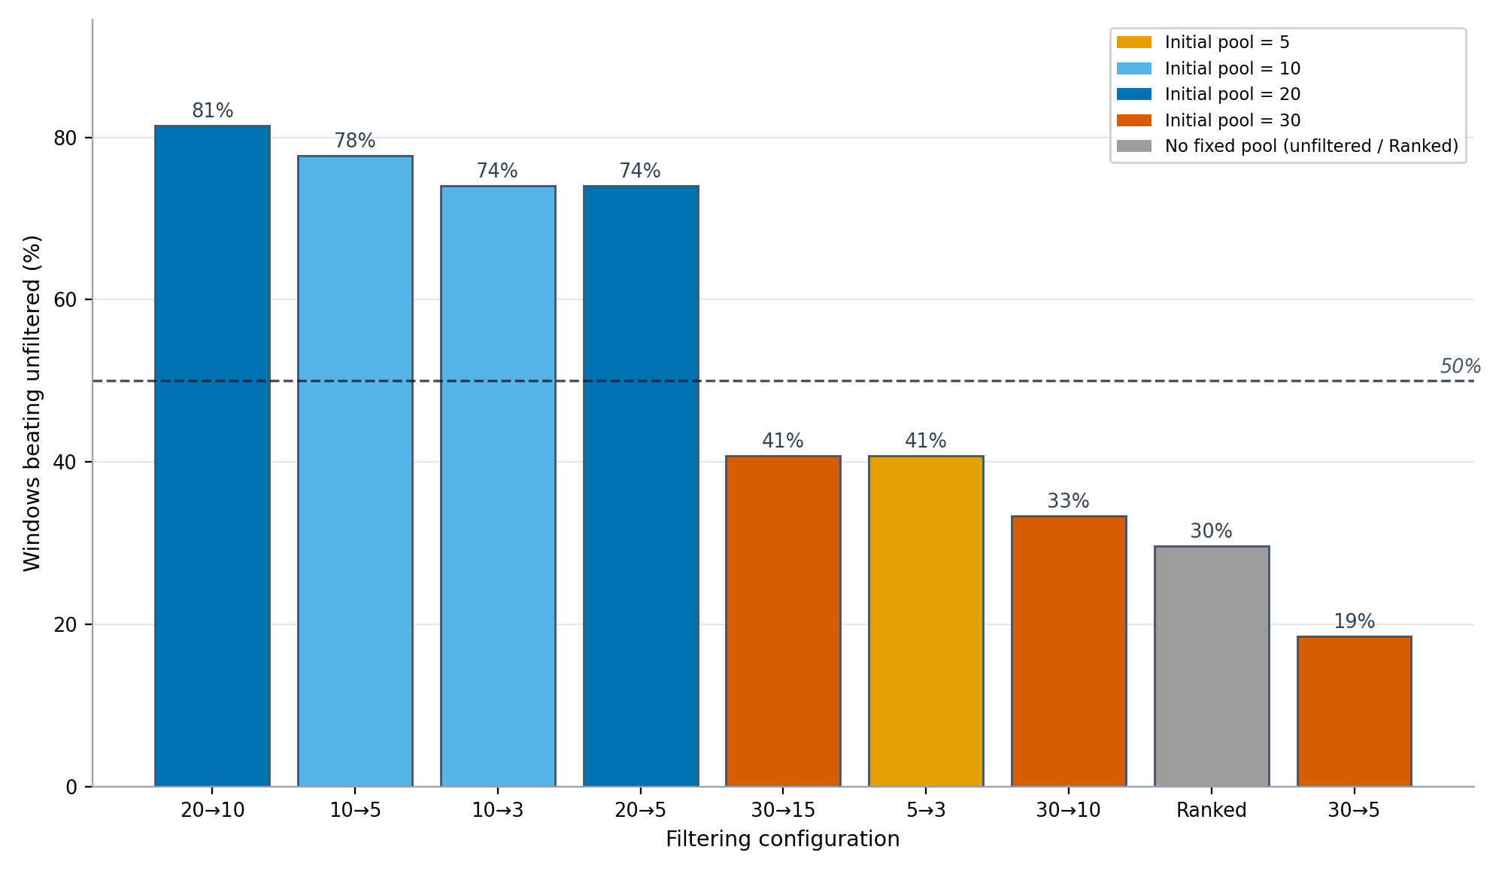

Figure 2. Percentage of matched evaluation windows in which each GPT-5.1 filtering configuration outperformed the unfiltered baseline, with bars colored by initial Stage-One pool size.
Configuration | Mean ROI (%) | Volatility (%) | Max DD (%) | Sharpe | Win vs Unfiltered (%) | 95% CI (Win %)
20→10 | 60.6 | 28.1 | −23.2 | 1.70 | 81.5 | [61.9, 93.7]
10→5 | 56.2 | 26.6 | −23.6 | 1.61 | 77.8 | [57.7, 91.4]
10→3 | 54.1 | 26.0 | −23.0 | 1.54 | 74.1 | [53.7, 88.9]
20→5 | 50.4 | 27.0 | −24.2 | 1.55 | 74.1 | [53.7, 88.9]
unfiltered | 45.7 | 27.8 | −22.4 | 1.34 | — | —
30→15 | 44.2 | 25.6 | −22.3 | 1.43 | 40.7 | [22.4, 61.2]
5→3 | 42.2 | 24.9 | −22.6 | 1.43 | 40.7 | [22.4, 61.2]
30→10 | 40.1 | 24.4 | −21.8 | 1.35 | 33.3 | [16.5, 54.0]
Ranked | 38.9 | 23.9 | −21.7 | 1.40 | 29.6 | [13.8, 50.2]
30→5 | 32.3 | 22.4 | −21.6 | 1.30 | 18.5 | [6.3, 38.1]

Table 1. GPT-5.1 mean ROI, risk, and win rate versus the unfiltered baseline, by filtering configuration (sorted by mean ROI). Volatility is annualized; maximum drawdown (Max DD) and Sharpe are medians across runs. Full per-configuration statistics for all three models are reported in the supplementary information.
Matched-comparison win rates were computed for each GPT-5.1 configuration against the unfiltered baseline, holding the evaluation window and generation group fixed.
Filtering substantially improved GPT-5.1’s performance: 20→10 beat the unfiltered baseline in 81.5% of matched window comparisons (22/27; exact 95% CI [61.9, 93.7]), followed by 10→5 (77.8%; CI [57.7, 91.4]) and 10→3 and 20→5 (both 74.1%; CI [53.7, 88.9]). The exception is the highly selective 5→3 (40.7%; CI [22.4, 61.2]), which trades return for the lowest run-to-run variability (see Return Variance and Consistency Comparison). The well-sized configurations thus beat single-pass prompting in roughly three of four matched window comparisons.
These win rates follow the same two settings, not the identity of any particular configuration. The methods that win most often share a mid-sized initial pool (ten or twenty candidates) narrowed by a moderate, roughly two-to-one ratio — the combination that gives the model enough candidates to rank meaningfully while keeping the final portfolio focused. 5→3 is the informative exception rather than an anomaly: starting from only five candidates, it has too small a pool to reach the top of the return range, so although its tight selection makes it the most stable configuration (see Return Variance and Consistency Comparison), it beats the baseline on return far less often. Initial pool size is therefore the dominant factor — mean return increases from small to mid-sized pools and decreases for oversized ones — and the reduction ratio acts mainly through how aggressively it narrows a given pool.
A component ablation tests whether the advantage over the unfiltered baseline reflects sequential structure or simply the amount of material in the prompt. Holding the candidate documents fixed for GPT-5.1’s 20→10 configuration across all nine windows (two to four generations per condition), we compared the full pipeline against a single prompt over the full candidate pool and a budget-matched single prompt over the identical shortlist. The full pipeline gave the highest mean ROI of any arm (52.4%), leading the budget-matched variant by 5.0 percentage points in six of nine windows (Wilcoxon p = 0.055). Context length is therefore not the driver: a prompt carrying the same or more material does not outperform the staged pipeline. Token counts and full paired statistics are in the Supplementary Information.
The same ablation isolates the narrowing step. Showing the reports but eliminating no candidates trailed the full pipeline by 3.7 percentage points (five of nine windows; Wilcoxon p = 0.570), and holding the entire pool trailed by 5.6 points (seven of nine; p = 0.055). Neither is significant at this sample size, so evidence that the cut itself carries the effect is suggestive rather than conclusive — consistent with the pool-size pattern above, where the gain comes from starting with a moderate candidate set rather than from how aggressively it is reduced.
Taken together, GPT-5.1 reliably benefits from moderate filtering, though because consecutive 12-month windows overlap, these comparisons should be read as matched within-window contrasts rather than as outcomes in independent years.
Formal paired statistics support these comparisons. For each configuration, the per-window ROI difference against the matched unfiltered baseline was evaluated with an exact sign test and a Wilcoxon signed-rank test, with a bootstrap 95% confidence interval on the median difference. The four moderate configurations differ significantly from the baseline (20→10: sign-test p = 0.002, Wilcoxon p < 0.001; 10→5: p = 0.006; 10→3 and 20→5: p = 0.019), the mid-table configurations are statistically indistinguishable from it, and 30→5 is significantly worse (5/27 wins; p = 0.002). As a conservative check, collapsing GPT-5.1’s three replicate generations per window and re-testing at the window level (n = 9) leaves the top configuration significant (sign test p = 0.039; Wilcoxon p = 0.027) and 30→5 significantly negative (p = 0.004). Per-configuration intervals accompany every win rate in Table 1 and the Supplementary Information.

Overall Trends
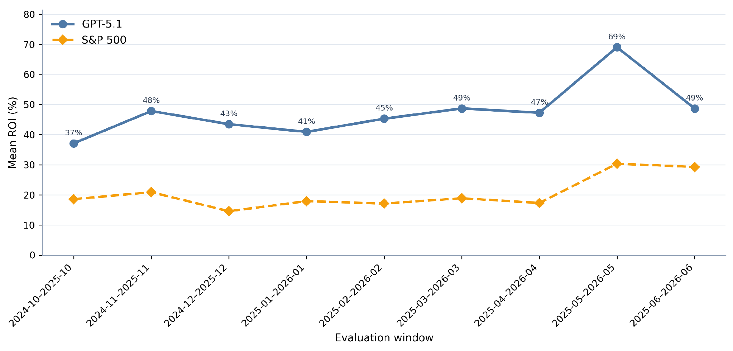

Figure 3. GPT-5.1 mean ROI across rolling 12-month evaluation windows, with the corresponding S&P 500 benchmark return.
GPT-5.1’s mean ROI exceeded the S&P 500 in every evaluation window tested, and did so on a risk-adjusted basis as well (median Sharpe 1.70 for 20→10 against 0.98 for the index over the same windows). Figure 3 plots its mean ROI across each rolling 12-month window against the benchmark; performance varied with the market environment but stayed above the benchmark throughout. Across all GPT-5.1 runs, 604 of 626 (96.5%) exceeded the S&P 500 over their holding window; because this figure counts every run rather than one per cell, it is a fraction of 626, not of the 270 window × generation-group × configuration cells.
GPT-5.1 contributes nine completed rolling windows, with start dates from October 2024 through June 2025 (end dates October 2025 through June 2026); earlier windows are excluded by the model’s training-cutoff constraint. The weakest window, October 2024 to October 2025, still returned 37.1%, and the strongest, May 2025 to May 2026, reached 69.0%, in each case well above the corresponding benchmark return.
The unfiltered baseline also beat the S&P 500 in every window, so this market outperformance reflects model and sector strength rather than the filtering itself; the contribution of the two-stage filtering is isolated in the matched comparison against that baseline (see Filtered vs. Unstructured Baseline), where the well-sized configurations win in roughly three of four windows. Benchmark returns ranged from approximately 15% to 30%, while GPT-5.1 returned between 37% and 69%, sustaining a large positive margin across all market conditions tested.

Return Variance and Consistency Comparison
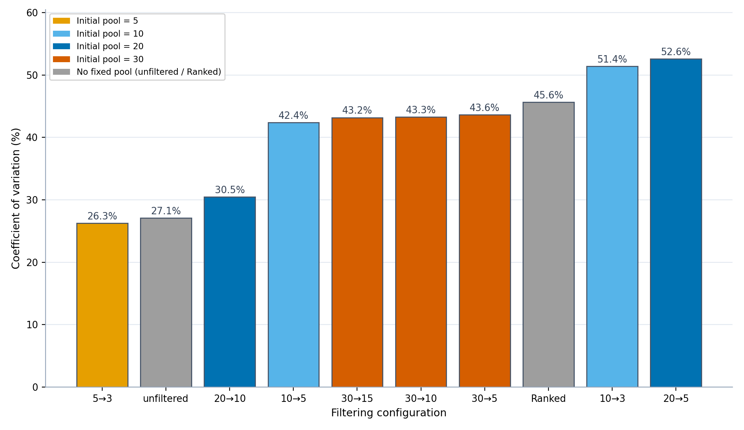

Figure 4. GPT-5.1 coefficient of variation (CV) for every filtering configuration, colored by initial Stage-One pool size; lower values indicate more stable returns.
Filtering also shaped return consistency, though not monotonically: returns were steadiest at both extremes of filtering and more variable between. Figure 4 reports each configuration’s coefficient of variation (CV); lower CV means tighter clustering around the mean.
For GPT-5.1, the most consistent configurations were the highly selective 5→3 (CV 26.3%) and the unfiltered baseline (27.1%), with 20→10 close behind (30.5%). The highest-returning configurations—10→5, 20→5, and 10→3—were moderately less consistent (CV 42–53%), so the return advantage came with somewhat wider run-to-run spread.
This ordering follows from the same structural settings that drive return, rather than being incidental. Run-to-run variability is lowest when the second stage is most decisive relative to its input — when the pool is small enough that the final choice is nearly forced (5→3) or when no filtering is imposed at all (the unfiltered baseline) — and highest for the mid-ratio configurations that carry more borderline candidates into the final portfolio. Because stability and return are shaped by the same initial-pool-and-ratio interaction, the return-maximizing 20→10 ranks just below the most stable configurations rather than among the most variable, which is what makes it a sensible default.
A note on interpretation: the configuration shapes the average level of return, not the outcome of any single run. Within a given configuration, individual runs vary more than the configurations’ means differ from one another, because most of the run-to-run variation traces to the evaluation window — the prevailing market regime — and to the model’s stochastic re-selection of stocks on each run, rather than to the configuration itself. The configuration effect is therefore assessed through averaged ROI and matched window-by-window win rates, which hold the market regime fixed and let the systematic difference emerge, rather than through the spread of individual runs.
Filtering therefore shapes not only the level of GPT-5.1’s returns but also their spread, which lets a practitioner trade a portion of return for more predictable outcomes by moving toward the more selective end of the grid.

Model Comparison and Configuration Selection
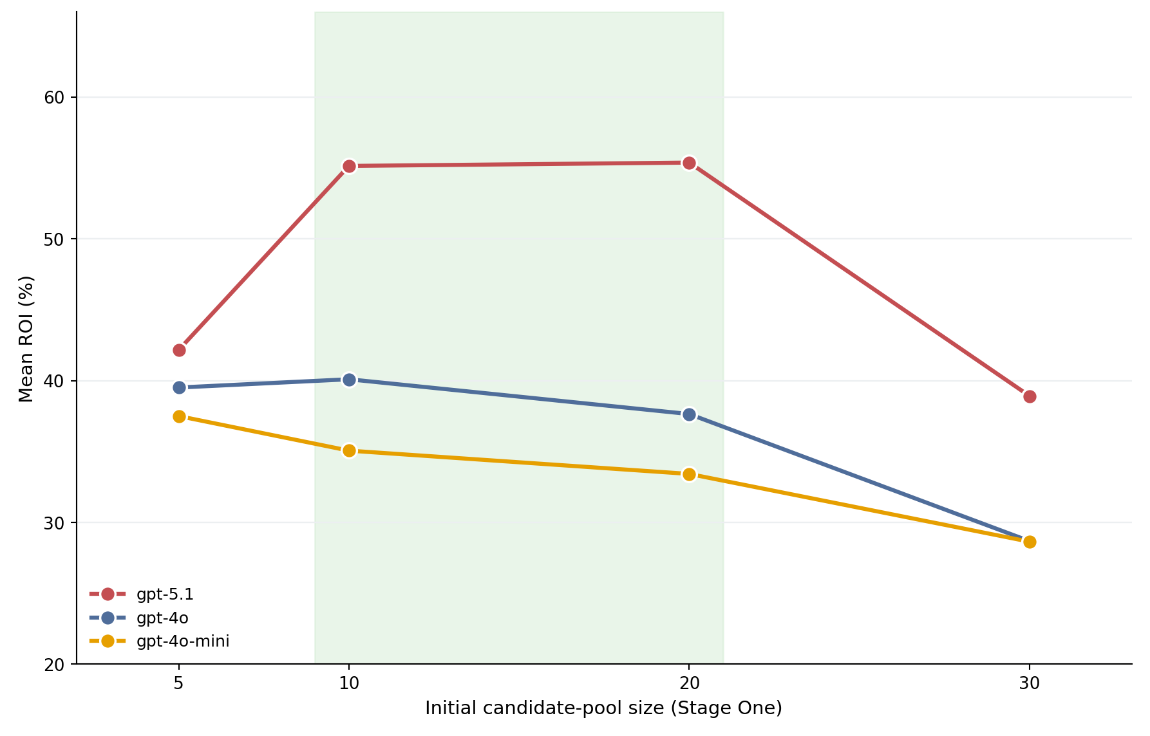

Figure 5. Mean ROI by initial candidate-pool size for each model. GPT-5.1 leads at every pool size and peaks at a moderate pool of 10–20 candidates; GPT-4o peaks at ten, and GPT-4o-mini is highest at five. All three models decline for oversized 30-candidate pools.
Two factors determine which configuration to deploy: the underlying model, and how the desired portfolio size maps onto the two stages. Figure 5 compares the three models across fixed-pool configurations, while Table 1 and the matched win rates of Figure 2 identify the best configuration per target portfolio size; the unfiltered single-pass run is the baseline throughout.
Figure 5 plots mean ROI against initial candidate-pool size for each of the three models. GPT-5.1 (red) produced the highest ROI at every pool size, averaging 47.0% across all its runs — equivalently, an unweighted 46.5% across its ten per-configuration means, or 47.5% across the eight fixed-pool configurations (Table 1) — versus run-level means of 35.0% for GPT-4o and 32.7% for GPT-4o-mini, a gap of roughly 12 to 14 percentage points that holds across pool sizes. The shape of the curve, however, differs by model: GPT-5.1 traces a pronounced inverted-U peaking at 10–20 candidates; GPT-4o peaks modestly at ten, with its five-candidate pool outperforming its twenty; and GPT-4o-mini declines monotonically from a five-candidate maximum. What all three models share is the penalty for oversized pools — every model deteriorates at thirty candidates. This pattern suggests that the optimal pool size scales with model capability: a stronger model can fill a larger candidate request with conviction, while weaker models do best when asked for only as many names as they can justify. Raw model capability sets the overall return level, and the pipeline configuration determines how much of that level is realized.
The same data indicate how the best configuration shifts with the desired portfolio size (Table 1). For a concentrated three-stock portfolio, 10→3 is best (54.1%), beating the unfiltered baseline in 74.1% of matched windows and outperforming the more selective 5→3 (42.2%). For a five-stock portfolio, 10→5 leads (56.2%, beating the baseline 77.8% of the time), ahead of 20→5 (50.4%, 74.1%). For a ten-stock portfolio, 20→10 is both the best option and the single highest-returning configuration in the study (60.6%), beating the baseline in 81.5% of matched windows. A consistent pattern emerges: the best Stage One pool is roughly twice the target portfolio size (consistent with the 2× hypothesis). The over-filtered methods identified above are dominated at every portfolio size and are not recommended.
One further ablation, before turning to why this pattern holds, asks whether the report stage contributes company-specific content or merely more structured text. Shuffling reports across tickers, so each candidate is validated against another company’s financials, produced the largest and only unambiguous degradation: 9.3 percentage points below the full pipeline, losing nine of nine windows (Wilcoxon p = 0.004). The report-validation stage therefore carries genuine company-specific signal.
The configuration-by-target-size pattern above holds for the same reason identified in the baseline comparison: a Stage One pool of about twice the target size gives the model enough candidates to rank without overwhelming the validation stage. The desired number of holdings thus selects which moderate configuration to use, but it is the moderate regime itself — a mid-sized pool gently narrowed — that produces the return advantage, not the specific label.

Sector Allocation and Realized Returns
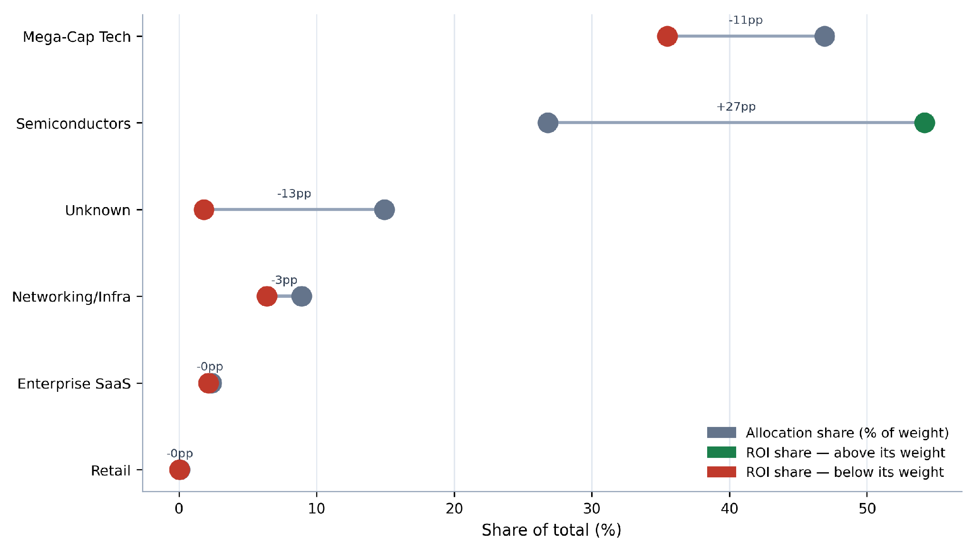

Figure 6. GPT-5.1 sector allocation versus realized ROI share. For each sector, the left marker is its share of recommended portfolio weight and the right marker its share of total realized ROI.
Beyond aggregate returns, the sector composition of GPT-5.1’s portfolios shows where its performance originated. Figure 6 compares each sector’s share of the recommended portfolio weight with its share of the realized return. GPT-5.1 allocated the largest share of capital to Mega-Cap Technology (46.9% of weight), yet that sector delivered only 35.5% of realized ROI; Semiconductors, at 26.8% of weight, contributed 54.2% of the realized return — roughly twice their allocation — making them the dominant source of performance. Networking/Infrastructure (8.9% of weight, 6.4% of ROI) and Enterprise SaaS (2.4%, 2.1%) contributed broadly in line with their weights, while a 14.9% allocation to unclassified holdings produced just 1.8% of the realized return. These results indicate that the framework’s returns were driven disproportionately by semiconductor selections, and that allocation share alone understates where performance actually originated. A sector’s share of realized return is computed as the sum, across that sector’s holdings, of each position’s initial weight times its window return, divided by the portfolio’s total return, with both quantities pooled (summed) across runs (equivalently, averaged, since the per-run count cancels); because individual contributions can be negative, a sector’s return share can exceed or fall below its weight share, and the shares sum to 100% by construction.

Benchmark Robustness, Ablations, and Weighting
The S&P 500 comparison overstates selection skill, because the eligible universe is concentrated in technology and semiconductor names that outran the broad market over the study period. Against progressively harder benchmarks, GPT-5.1’s pooled beat rate falls from 96.5% (S&P 500) to 94.3% (S&P 500 Information Technology, XLK), then to 39.6% against an equal-weighted portfolio of the eligible universe itself and 32.2% against a pure-semiconductor index (SMH), the hardest comparison because semiconductors led the sector over the study period. The filtering effect, however, survives these harder comparisons: 20→10 outperforms the equal-weighted universe in 81.4% of runs and SMH in 68.3%, and 10→5 in 64.8% and 60.0% respectively, while the unfiltered baseline does so in only 18.5% and 6.7%. All comparisons in this subsection are pooled across the full run set.
The eligible comparison set is a fixed list of 29 large-capitalization technology and semiconductor companies (Supplementary Information), used only for the unfiltered baseline and as the draw pool for the equal-weighted and random benchmarks; the filtered configurations never see it, nominating candidates freely from screened news. Every constituent was continuously listed across the full evaluation span, so none was acquired or delisted and the benchmark needs no point-in-time reconstruction. The residual exposure is omission: companies large at the earliest window starts but no longer qualifying would not appear. The set does retain constituents whose prices declined materially, so it is not a selection of winners only, but this bounds the benchmark rather than the pipeline.
Random portfolios drawn from the eligible universe, matched to each portfolio’s holding count and equal-weighted, provide a direct test of selection skill: relative to 4,000 such draws per run, the median GPT-5.1 portfolio under 20→10 sits at the 75th percentile and under 10→5 at the 69th, whereas the unfiltered baseline sits at the 40th percentile and the aggressive 30-pool configurations near the 17th–21st. Moderate two-stage filtering is thus the difference between below-random and above-random selection within the sector.
Two ablations probe the robustness of the effect. Removing the single largest return contributor from every portfolio lowers GPT-5.1’s 20→10 mean ROI from 60.6% to 52.5% and the unfiltered baseline from 45.7% to 39.4%, so the matched filtering edge narrows only modestly, from about +14.9 to +13.1 percentage points; excluding all semiconductor holdings (with weights renormalized) leaves a smaller edge of +3.0 points. The filtering advantage therefore does not rest on any single position—it survives removing each portfolio’s best contributor largely intact—but it operates substantially through semiconductor selection: once the semiconductor sector as a whole is excluded, the matched edge, while still positive, is modest.
Finally, re-scoring every portfolio at equal weights isolates stock selection from allocation weighting: GPT-5.1’s model-assigned weights cost 4.6 percentage points of mean ROI relative to equal-weighting the same picks (Wilcoxon p < 0.0001; GPT-4o −1.2, GPT-4o-mini ≈ 0). The models’ selection adds value; their position sizing subtracts from it. Sector-index returns, random-portfolio percentiles, ablation tables, and per-configuration risk metrics (annualized volatility, maximum drawdown, Sharpe, Sortino) are provided in the Supplementary Information.
Risk-adjusted performance moves in the same direction as raw return. For GPT-5.1, the best configuration (20→10) earns a median Sharpe ratio of 1.70 and Sortino of 2.66, against 1.34 and 2.04 for the unfiltered baseline and 0.98 for the S&P 500 over the same windows; the weakest configuration (30→5) falls to 1.30. Annualized volatility is similar across configurations (about 22–28%) and maximum drawdowns cluster between −22% and −24%, so the return gains from moderate filtering are not obtained by taking proportionally more risk. Full volatility, drawdown, and risk-adjusted statistics for every configuration and model are reported in the Supplementary Information.

Discussion

Implications and Significance
The results point to a single, transferable lesson: how the information given to a language model is structured is itself a determinant of investment performance, separate from the choice of model. Presenting the model with a moderate shortlist and asking it to narrow that shortlist — rather than letting it select from an unstructured prompt or forcing it to discard most of an oversized pool — consistently produced the strongest and most reliable returns. Because this gain comes from the design of the pipeline rather than from a larger or newer model, it is available to any practitioner at essentially no additional cost. A component ablation points the same way, though not all of it reaches significance: holding the documents fixed, a single-pass prompt with the same or more material does not outperform the staged pipeline, and shuffling the financial reports degrades it most — the one difference in the ablation that is unambiguous — indicating that the report-validation stage in particular carries signal.
The mechanism behind the effect is the size of the first-stage candidate pool. For GPT-5.1, returns rise and then fall as that pool grows: too few candidates leave the model with too little to choose from, while too many force it to nominate companies beyond those it can justify, filling the candidate list with weak selections that remain in the final portfolio. The practical guideline that follows is simple for frontier-class models — begin from a pool of roughly ten to twenty candidates and narrow it by roughly half; the weaker models tested peaked at smaller pools, suggesting that the optimal request scales with model capability. The reduction ratio matters mainly through how aggressively it cuts a given pool, and the final portfolio size can then be chosen to match an investor’s diversification preference without sacrificing the structural advantage. We present this padding account as a hypothesis consistent with the observed pattern rather than a directly measured mechanism; a candidate-overlap and Stage-One-rank-versus-realized-return analysis to test it directly is left to future work.
These findings also clarify what the framework does and does not establish. Because the unfiltered baseline already beat the market benchmark, the contribution specific to the two-stage design is its consistent improvement over that baseline under matched conditions, not the market outperformance itself. More broadly, the study suggests that for LLM-driven decision systems, deliberate information design is an inexpensive and model-agnostic complement to advances in model scale.

Limitations and Future Work
Several limitations bound the scope of these findings. All portfolios are long-only and buy-and-hold, and returns are computed without transaction costs, taxes, or slippage, which would modestly reduce realized performance. The investment universe is confined to the large-capitalization technology and semiconductor sector, so the sector-contribution results in particular may not generalize to broader markets. Because GPT-5.1’s evaluation windows are constrained to begin after its training cutoff, its results rest on fewer rolling windows (October 2024 onward) than the older models, and all windows fall within a broadly rising market; performance in a sustained downturn is therefore untested. Because the best configuration (20→10) was identified as the maximum mean ROI across ten configurations evaluated on the same windows used to report it, the headline 60.6% carries a degree of selection inflation; the matched-baseline win rate and its exact confidence interval, which do not depend on selecting the top configuration after the fact, are the more conservative summary. Finally, the financial-report source does not flag restatements or amendments: a restated figure carries the fiscal period end of the original filing, so it is treated as public from that date even though the corrected values appeared later. We therefore cannot rule out that a small number of report values reflect subsequent restatement.
Future work should address these gaps directly: incorporating transaction-cost modeling, extending the universe beyond technology to test sector generalization, and evaluating across bear-market windows as longer post-cutoff histories become available. Live forward-testing — deploying the recommended configuration prospectively rather than on historical windows — would provide the strongest evidence that the framework’s advantage over the unfiltered single-pass methodology persists out of sample.

Conclusion
This study set out to test whether structuring the information given to a language model could improve long-term stock selection. Across 2,759 portfolio runs, a two-stage pipeline — using news to assemble a candidate shortlist and financial reports to validate it — reliably outperformed both unfiltered single-pass prompting and aggressive over-filtering. The largest gains came from a moderate design: starting from about ten to twenty candidates and narrowing them by roughly half — a ratio we present as a working hypothesis consistent with the tested grid — added on the order of fifteen percentage points of mean ROI over the unfiltered baseline and beat it in most matched evaluation windows. The central takeaway is that information design is a distinct and inexpensive determinant of performance in LLM-based investing, comparable in importance to the choice of model. Subject to the limitations above, this points toward a broader direction for LLM agents: treating the structure of a model’s inputs as a first-class design variable rather than an afterthought.

Data and Code Availability
To support full reproducibility, the following materials are publicly available now, not only upon acceptance, at https://github.com/JathinBat/LLM-Two-Stage-Portfolio-Filtering: the news-relevance screening prompt; the Stage One and Stage Two prompts; the unfiltered single-pass and Ranked baseline prompts; the complete list of evaluation windows; the per-cell run outputs, including the selected tickers, weights, and decision dates for every run; and the analysis scripts, including the paired-difference statistics, the risk-metric reconstruction, and the benchmark-reconstruction code. News articles were obtained from The New York Times and financial reports from Alpha Vantage, each under its provider’s terms of use, and neither corpus is redistributed; the retrieval queries, date windows, and timestamp conventions needed to reconstruct the corpora are documented in the Methods and Supplementary Information.

References
1. Y. Nie, Y. Kong, X. Dong, J. M. Mulvey, H. V. Poor, Q. Wen, S. Zohren. A survey of large language models for financial applications: progress, prospects and challenges. arXiv, 2024, https://doi.org/10.48550/arXiv.2406.11903.
2. S. An, Q. Li, J. Lu, D. Yin, X. Sun. FinVerse: an autonomous agent system for versatile financial analysis. arXiv, 2024, https://doi.org/10.48550/arXiv.2406.06379.
3. A. Lopez-Lira, Y. Tang. Can ChatGPT forecast stock price movements? return predictability and large language models. SSRN. 2023, https://doi.org/10.2139/ssrn.4412788.
4. Y. Xiao, E. Sun, D. Luo, W. Wang. TradingAgents: multi-agents LLM financial trading framework. arXiv, 2024, https://doi.org/10.48550/arXiv.2412.20138.
5. H. Ding, Y. Li, J. Wang, H. Chen. Large language model agent in financial trading: a survey. arXiv, 2024, https://doi.org/10.48550/arXiv.2408.06361.
6. W. W. Li, H. Kim, M. Cucuringu, T. Ma. Can LLM-based financial investing strategies outperform the market in the long run? arXiv, 2025, https://doi.org/10.48550/arXiv.2505.07078.
7. D. Blitz, M. X. Hanauer, T. Hoogteijling, C. Howard. The term structure of machine learning alpha. The Journal of Financial Data Science. Vol. 5, pg. 40–65, 2023, https://doi.org/10.3905/jfds.2023.1.135.
8. G. Lu, S. B. Larcher, T. Tran. Hybrid long document summarization using C2F-FAR and ChatGPT: a practical study. arXiv, 2023, https://doi.org/10.48550/arXiv.2306.01169.
9. H. Naveed, A. U. Khan, S. Qiu, M. Saqib, S. Anwar, M. Usman, N. Akhtar, N. Barnes, A. Mian. A comprehensive overview of large language models. ACM Transactions on Intelligent Systems and Technology. Vol. 16, no. 5, 2025, https://doi.org/10.1145/3744746.
10. B. Cao, S. Wang, X. Lin, X. Wu, H. Zhang, L. M. Ni, J. Guo. From deep learning to LLMs: a survey of AI in quantitative investment. arXiv, 2025, https://doi.org/10.48550/arXiv.2503.21422.
11. I. Mirzadeh, K. Alizadeh, H. Shahrokhi, O. Tuzel, S. Bengio, M. Farajtabar. GSM-symbolic: understanding the limitations of mathematical reasoning in large language models. International Conference on Learning Representations (ICLR 2025). 2025, https://openreview.net/forum?id=AjXkRZIvjB.
12. Y. Zhang, Y. Li, L. Cui, D. Cai, L. Liu, T. Fu, X. Huang, E. Zhao, Y. Zhang, C. Xu, Y. Chen, L. Wang, A. T. Luu, W. Bi, F. Shi, S. Shi. Siren’s song in the AI ocean: a survey on hallucination in large language models. Computational Linguistics. Vol. 51, pg. 1373–1418, 2025, https://doi.org/10.1162/coli.a.16.
13. I. Okpala, A. Golgoon, A. R. Kannan. Agentic AI systems applied to tasks in financial services: modeling and model risk management crews. arXiv, 2025, https://doi.org/10.48550/arXiv.2502.05439.
14. G. Fatouros, K. Metaxas, J. Soldatos, M. Karathanassis. MarketSenseAI 2.0: enhancing stock analysis through LLM agents. arXiv, 2025, https://doi.org/10.48550/arXiv.2502.00415.
15. J. Cheng, P. Chin. AAPM: large language model agent-based asset pricing models. arXiv, 2024, https://doi.org/10.48550/arXiv.2409.17266.
16. C. Choi, A. Lopez-Lira, Y. Lee, J. Kwon, M. Kim, J. Hwang, M. Ha, C. Kim, J. Ha, S. Yun, J. Kim. Structuring the unstructured: a multi-agent system for extracting and querying financial KPIs and guidance. arXiv, 2025, https://doi.org/10.48550/arXiv.2505.19197.
17. T. Guo, X. Chen, Y. Wang, R. Chang, S. Pei, N. V. Chawla, O. Wiest, X. Zhang. Large language model based multi-agents: a survey of progress and challenges. Proceedings of the 33rd International Joint Conference on Artificial Intelligence (IJCAI 2024), Survey Track. 2024, https://doi.org/10.24963/ijcai.2024/890.
18. X. Han, N. Wang, S. Che, H. Yang, K. Zhang, S. X. Xu. Enhancing investment analysis: optimizing AI-agent collaboration in financial research. Proceedings of the 5th ACM International Conference on AI in Finance. 2024, https://doi.org/10.1145/3677052.3698645.
19. C. Zhang, X. Liu, M. Jin, Z. Zhang, L. Li, Z. Wang, W. Hua, D. Shu, S. Zhu, X. Jin, S. Li, M. Du, Y. Zhang. When AI meets finance (StockAgent): large language model-based stock trading in simulated real-world environments. arXiv, 2024, https://doi.org/10.48550/arXiv.2407.18957.
20. Y. Li, Y. Yu, H. Li, Z. Chen, K. Khashanah. TradingGPT: multi-agent system with layered memory and distinct characters for enhanced financial trading performance. arXiv, 2023, https://doi.org/10.48550/arXiv.2309.03736.
21. Y. Yu, H. Li, Z. Chen, Y. Jiang, Y. Li, D. Zhang, R. Liu, J. W. Suchow, K. Khashanah. FinMem: a performance-enhanced LLM trading agent with layered memory and character design. Proceedings of the AAAI Symposium Series. Vol. 3, pg. 595–597, 2024, https://doi.org/10.1609/aaaiss.v3i1.31290.
22. T. Guo, H. Shen, J. Huang, Z. Mao, J. Luo, B. Chen, Z. Chen, L. Liu, B. Xia, X. Liu, Y. Ma, M. Zhang. MASS: multi-agent simulation scaling for portfolio construction. arXiv, 2025, https://doi.org/10.48550/arXiv.2505.10278.
23. J. Li, J. Zhang, H. Li, Y. Shen. An agent framework for real-time financial information searching with large language models. arXiv, 2025, https://doi.org/10.48550/arXiv.2502.15684.
24. K. Chen, H. Ahmad, D. Goel, C. Szabo. 3S-trader: a multi-LLM framework for adaptive stock scoring, strategy, and selection in portfolio optimization. arXiv, 2025, https://doi.org/10.48550/arXiv.2510.17393.
25. T. Zhao, J. Lyu, S. Jones, H. Garber, S. Pasquali, D. Mehta. AlphaAgents: large language model-based multi-agents for equity portfolio constructions. arXiv, 2025, https://doi.org/10.48550/arXiv.2508.11152.
26. T. Zhou, P. Wang, Y. Wu, H. Yang. FinRobot: AI agent for equity research and valuation with large language models. arXiv, 2024, https://doi.org/10.48550/arXiv.2411.08804.
27. W. Zhang, L. Zhao, H. Xia, S. Sun, J. Sun, M. Qin, X. Li, Y. Zhao, Y. Zhao, X. Cai, L. Zheng, X. Wang, B. An. A multimodal foundation agent for financial trading: tool-augmented, diversified, and generalist. Proceedings of the 30th ACM SIGKDD Conference on Knowledge Discovery and Data Mining. 2024, https://doi.org/10.1145/3637528.3671801.
28. P. C. Tetlock. Giving content to investor sentiment: the role of media in the stock market. The Journal of Finance. Vol. 62, pg. 1139–1168, 2007, https://doi.org/10.1111/j.1540-6261.2007.01232.x.
29. J. Lee, N. Stevens, S. C. Han, M. Song. A survey of large language models in finance (FinLLMs). Neural Computing and Applications. Vol. 37, pg. 24853–24867, 2025, https://doi.org/10.1007/s00521-024-10495-6.
30. S. Wang, H. Yuan, L. M. Ni, J. Guo. QuantAgent: seeking holy grail in trading by self-improving large language model. arXiv, 2024, https://doi.org/10.48550/arXiv.2402.03755.
31. K. Anjum, M. A. Arshad, K. Hayawi, E. Polyzos, A. Tariq, M. A. Serhani, L. Batool, B. Lund, N. R. Mannuru, R. V. K. Bevara, T. Mahbub, M. Z. Akram, S. Shahriar. Domain specific benchmarks for evaluating multimodal large language models. arXiv, 2025, https://doi.org/10.48550/arXiv.2506.12958.
32. H. Li, Y. Cao, Y. Yu, S. R. Javaji, Z. Deng, Y. He, Y. Jiang, Z. Zhu, K. Subbalakshmi, G. Xiong, J. Huang, L. Qian, X. Peng, Q. Xie, J. W. Suchow. InvestorBench: a benchmark for financial decision-making tasks with LLM-based agents. Proceedings of the 63rd Annual Meeting of the Association for Computational Linguistics (ACL 2025). pg. 2509–2525, 2025, https://doi.org/10.18653/v1/2025.acl-long.126.

